Automation in Port Areas and Industry for Safe and Effective Management of Dangerous Goods
Tomaso Vairo, Margherita Pettinato, Evgeniia Taubert, Ahmad M. Tahir, Bruno Fabiano*
DICCA- Civil Chemical and Environmental Engineering Deprtment, University of Genova, Via Opera Pia 15, 16145, Italy
*brown@unige.it
Abstract
In the present era, the spread of cyber-physical systems within the framework Industry 4.0, is leading towards a complete automation of industrial processes, which are increasingly decentralized, smart, and require fewer and fewer frontline personnel. The storage, transportation, and handling of dangerous goods in port areas pose significant challenges due to the potential risks involved. The risk assessment process is certainly not excluded from the revolution and in perspective needs to be automatic, dynamic, and linked with the actual emerging conditions of complex systems. This paper focuses on designing an operational management system suitable to predict and reduce operational errors, improving the learning and education patterns, thus decreasing personnel vulnerability to hazardous substances. The system, based on ML algorithms and Bayesian reasoning, is constantly “learning” with the data provided by the physical system.
Keywords: Automation, Digitalization, Hazardous materials, Industrial ports, Safety 4.0
  - Introduction
The fourth industrial revolution is characterized by the appearance of cyber-physical systems, Internet of Things (IoT), smart factories, and generalized decentralized processes [1], providing new design principles and higher level of automation in the operations. The higher level of communication and autonomous systems require a risk assessment process that can keep up with dynamic and rapid information flows, moving towards RA process automatization. Emerging risks are connected to the combined action of energy transition, climate change, and digitalization [2], while control systems adopted in industry (Operational Technologies OT) need ad-hoc approaches to mitigate cyber risk [3]. Within the bustling domains of ports, hazardous materials introduce inherent risks, demanding a trade-off between efficiency and caution [4]. Italy’s strategic Mediterranean location is supported by a vital network of seaports, including the Ports of Genoa, Livorno and Naples, which proactively embraced advanced technologies to enhance operational reliability [5]. A pivotal role in managing safety in complex systems, is represented by the Safety Management System (SMS) [6] representing a challenge and an up-to-date research topic. The commitment extends to the adherence on EU regulations, prioritizing safety and reliability in handling dangerous goods through integration of advanced technologies [7]. Vairo et al. [8] outlined a framework for dealing with those networks as complex systems aiming at identifying intervention priorities. The bow-tie method is a well-established risk assessment tool, widely used within the broad context of complex systems [9,10]. However, it suffers several recognized limitations, mainly connected to the actual assessment of likelihood and interdependencies in the fault and event trees. Bow ties can be easily translated into Bayesian Networks, a robust probability reasoning method under uncertainty, providing a tool for incorporating evidence during the ongoing operations [11]. This facet can be automatized, modifying the structure, to derive from operational experience evidence updated risk parameters related to the failure probabilities and accidental scenarios occurrence [12]. Empirical results highlight the relevant contribution of human error, which is estimated 10⁻⁴ and 10⁻³, respectively for routine operations and non-routine actions, as reported in IOGP [13]. This paper is focused on building an operational management system, starting from field experience, for automatically design a predictive model, suitable to intercept and avoid common operational errors. To verify the actual capability of the approach combining data- and experience-driven concepts to anticipate system deviations, the pilot application is tested in a port terminal handling petro-chemical products by a complex pipeline network.
  - Methods
    - Bow Tie analysis
The bow-tie analysis logically combines the fault-tree analysis (FTA) and the event-tree analysis (ETA). From a top event, the fault tree extends to the left-hand side and the event tree to the right-hand side, so that it is possible connecting causes (or threats) and consequences (or outcomes) with relevant preventive or mitigating barriers.
    - Hierarchical Bayesian Nets
Bayesian hierarchical modelling is a statistical model written in multiple levels (hierarchical form) that estimates the parameters of the posterior distribution using the Bayesian method. The sub-models combine to form the hierarchical model, and Bayes' theorem is used to integrate them with the observed data and account for all the uncertainty that is present. The result of this integration is the posterior distribution as additional evidence on the prior distribution is acquired. Hierarchical modelling is used when information is available on several different levels of observational units. In the outlined framework, we consider Fault and Event Trees prior probabilities, boolean failures, and predictions on critical variables values as relevant information sources. In deriving the posterior distribution. Y is a random variable following a normal distribution with expected value θ and variance 1:
Y | θ ~ N(θ, 1) (1)
The expected value θ has a normal distribution with expected value μ and variance 1:
θ | μ ~ N(μ, 1) (2)
The expected value of (2), μ, follows, for example, a standard normal distribution, N(0, 1). The parameter μ is called the hyperparameter, while its distribution given by N(0, 1) is an example of a hyperprior distribution. The notation of the distribution of Y changes as another parameter is added, i.e.:
Y | θ, μ ~ N(θ, 1) (3)
So, in the following stage, μ, is characterized by normal distribution with expected value β and variance ε, meaning:
μ ~ N(β, ε) (4)
β and ε can be defined hyperparameters characterized by their hyperprior distributions as well. For a 3-stage hierarchical model, the posterior distribution is by:
(𝜃,𝜑, 𝑋 |𝑌) = ((𝑌 | 𝜃) (𝜃 |𝜑) 𝑃(𝜑 |𝑋) 𝑃(𝑋)) / 𝑃(𝑌) (5)
In the present framework, each hierarchical level of the Bayes net, represents a stage of the Bow Tie. The transposition from the operational safety assessment to the Bayesian nets is performed by a customized tool, using the Python library PyBNBowTie.
  - Pilot application: loading of petrochemical products from the terminal
The logical flowchart of the critical assessment allowing transfer starting are depicted in Fig. 1. Product transfer takes place according to the sequence summarized in Fig. 2.
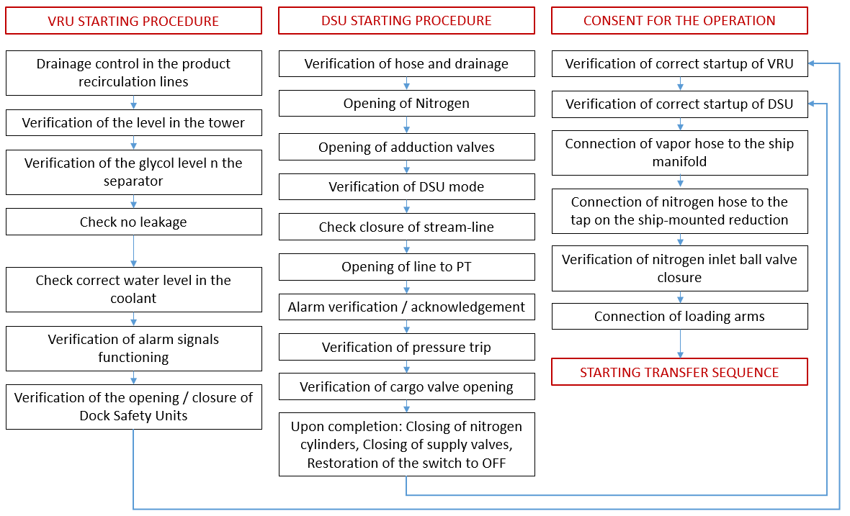
Figure 1: Flowchart for operating consent to HC transfer sequence starting.
The operation involves a series of steps to be carried out sequentially, with step-by-step conditional operational and safety verifications. Each operation may be subjected to error, either from a technological perspective (e.g., valve opening/closing failure, plant component feedback), or from a human viewpoint (incorrect, untimely, or missed actions). Each of the stages in the two flowcharts is associated with a given failure probability, used for training the model, as a priori probability. The history of failures, aggregated for the main steps, obtained by the Boolean chaining of elementary failures of each sub-steps, is represented in Table 1.
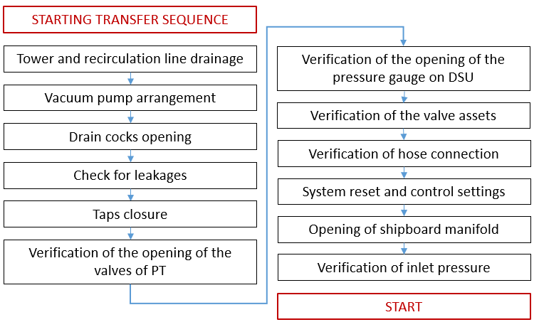
Figure 2: Flowchart for critical element checking and start of hydrocarbon transfer.
Table 1: Prior probabilities for the failures of the main sequential operative steps.
Main Step | Prior probability of failure (order of magnitude)
VRU starting procedure | 1E-5 occ./y
DSU starting procedure | 1E-4 occ./y
Consent for the operation | 1E-4 occ./y
Start of the operation | 1E-3 occ./y

The event analysis was extended over 5-years field observation and showed that the main cause of failure in the operation was human error in overriding valves or failing sequence of the different transfer pipelines. A conservative estimate of operational failures, classified into three clusters is provided in Table 2. The overall transfer reliability is estimated at 90%, with errors implying transfer interruption and no or low-severe damage.
Table 2: Human error evidence in transfer operation (occurrence probability for each step).
Error type | Occurrence probability, occ./op.
Analysis phase: Observation (observation missed; false observation; wrong identification) | 1E-4 occ./y
Analysis phase: Interpretation (faulty diagnosis; wrong reasoning; decision error; delayed or incorrect prediction) | 1E-3 occ./y
Synthesis phase: Planning (inadequate plan; priority error) | 1E-3 occ./y

The system is trained on the historical data of failures of each equipment operating for the product transfer facility (as a prior probabilities) and incorporates the signals collected on site. Starting from the safety analysis of the operation, for each operational phase different Bayesian nets are designed, where each node is “pre-trained” on failure historical data. The subsequent step is the prior probability updating by field measurements for each element of the physical system. In the following, we provide an outline of the whole process, structured into sequential nets.

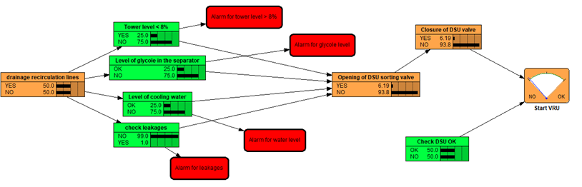
Figure 2: Start of the Vapour Recovery Unit - Net 1.
Following checks and feedback are implemented within Net 1, whose outcome is sent to Net 3. The input node of Net 1 start is the drainage control of the product recirculation lines. This is followed by a layer of parallel verifications: verification the level in the tower is less than 8% (if not, perform draining of tower); verification of the level of glycol in the separator; verification of correct water level in the coolant and evidence of leakage. Additionally following steps of verification for functioning of alarm signals, opening of Dock Safety Unit (DSU) vapour sorting valve (of activated DSU) and closure of DSU valve of standby DSU. Nets 2 and 3 are similarly arranged (Figs. 3, 4) and integrate relevant verifications and feedback. Net 3 aggregates the outcomes from previously outlined steps and includes a number of critical and final checks, before allowing the starting of hose connected (HC) transfer operations (Fig. 5).
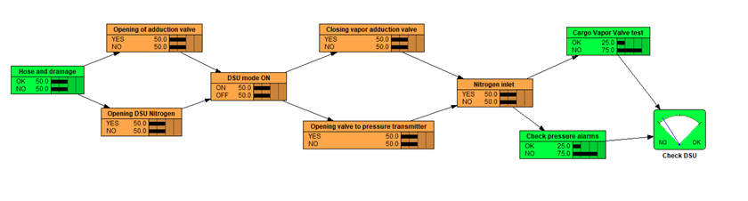
Figure 3: Start of the Dock Safety Unit – Net 2.
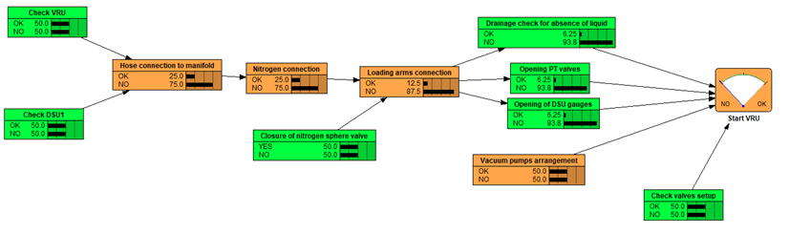Figure 4: Consent for the safe operation – Net 3.
The checks linked into a single network are continuously updated during the transmission process, providing a dynamic alert on possible emerging operative risk.
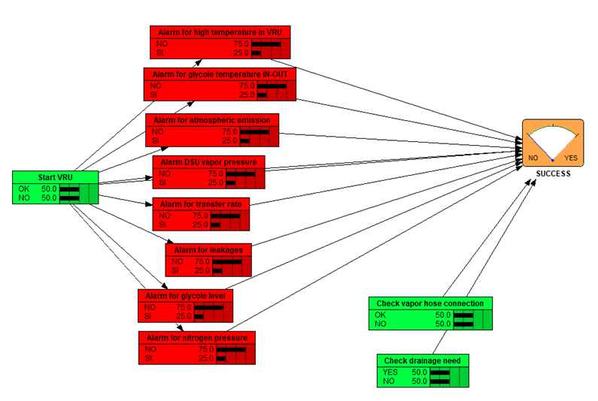
Figure 5: Starting the HC transfer under safe conditions.
Fig. 6 depicts the design of the whole safety operational control system, defined by the interconnection of the previously described operative nets. It should be underlined that OT systems are exposed to cyber threats imposing an in-depth defence strategy to be developed in accordance with the ANSI/ISA99 standard, by network segmentation into different layers with well-monitored connections and the most sensitive part at the centre.
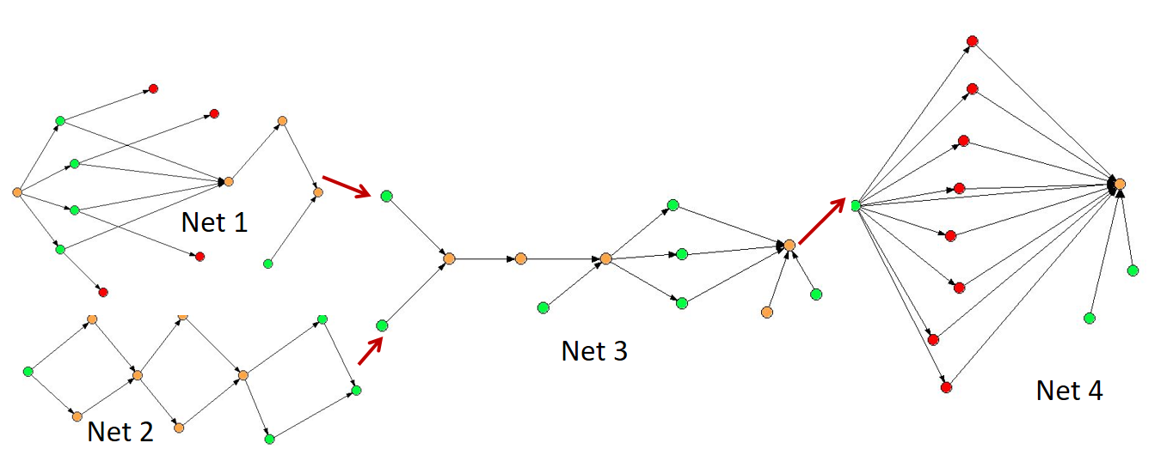
Figure 6: Schematic drawing of the predictive system addressing safety operational control.
The OT management system was tested in the pilot port terminal application, allowing to perform an operative reliability higher than 99.5 % over yearly field observations.
  - Conclusion
This paper emphasizes risk reduction by minimization of human intervention through real-time monitoring, predictive capability and increased emergency response. The framework relies on bow-tie analysis exploring the nature of interdependencies among the system components and their modification with process variable fluctuation, thus capturing the changes in operational conditions and improving the dynamic facet of risk. The approach, under current refinement with implementation of cyber vulnerability evaluation for each critical architecture element (Hw and SW), can be applied in different process plants to prevent hazardous deviations, improve safety management and contribute to sustainable and responsible practices.
Acknowledgment
The authors gratefully acknowledge funding by INAIL, within the framework of the call BRIC/2021/ID3 (Project DRIVERS - Approccio combinato data‐driven ed experience‐driven all’analisi del rischio sistemico).
References
[1] M. Hermann, T. Pentek, B. Otto, 2016, Design principles for industrie 4.0 scenarios, in: 2016 49th Hawaii international conference on system sciences (HICSS), IEEE. pp. 3928–3937.
[2] H. Pasman, E. Sripaul, F. Khan, B. Fabiano, 2023, Energy transition technology comes with new process safety challenges and risks, Process Saf. Environ. Prot. 177, 765-794.
[3] G. Assenza, L. Faramondi, G. Oliva, R. Setola, 2020, Cyber threats for operational technologies. International Journal of System of Systems Engineering, 10(2), 128-142.
[4] United Nations Conferences on Trade and Development (UNCTAD), 2022, Review of Maritime Transport, UNCTAD/RMT/2022.
[5] D’Amico, G., Szopik-Depczyńska, K., Dembińska, I., and Ioppolo, G., 2021, Smart and sustainable logistics of port cities: A framework for comprehending enabling factors, domains, and goals, Sustainable Cities and Society 69, 102801.
[6] A.S.Markowski, A. Krasławski, T. Vairo, B. Fabiano, 2021, Process safety management quality in industrial corporation for sustainable development, Sustainability 13, 9001.
[7] A. Carpenter, R. Lozano, 2020, Proposing a Framework for Anchoring Sustainability Relationships Between Ports and Cities. In: Carpenter, A., Lozano, R. (eds) European Port Cities in Transition. Strategies for Sustainability. Springer, Cham.
[8] T.Vairo, A. Bruzzone, S. Magrì, A.P.Reverberi, B. Fabiano, 2023, Understanding the vulnerability of complex systems. An integrated approach, Chemical Engineering Transactions 99, 277-282.
[9] L. Ding, F. Khan, J. Ji, 2020, Risk-based safety measure allocation to prevent and mitigate storage fire hazards. Process Saf. Environ. Prot., 135, 282-293.
[10] K.R. Brown, P. VanBerkel, F.I. Khan, P.R. Amyotte, 2021, Application of bow-tie analysis and inherently safer design to the novel coronavirus hazard, Process Saf. Environ. Prot., 152, 701-718.
[11] T. Vairo, M. Pettinato, A.P. Reverberi, M.F. Milazzo, B. Fabiano, 2023, An approach towards the implementation of a reliable resilience model based on machine learning, Process Saf. Environ. Prot., 172, 2023, Pages 632-641.
[12] T. Vairo, A.C. Benvenuto, A. Tedeschi, A.P. Reverberi, B. Fabiano, 2022, Make bow-tie dynamic by rethinking it as a hierarchical bayesian network. Dynamic risk assessment of an Lng bunkering operation, Chemical Engineering Transactions, 91, 277-282.
[13] IOGP International Association of Oil and Gas Producers, 2010, No. 434–5 Human factors in QRA. IOGP ed. London, UK.

