Data Augmentation Scheme for Raman Spectra with Highly Correlated Annotations
Christoph Lange¹, Isabel Thiele², Lara Santolin², Sebastian L. Riedel^{2,3}, Maxim Borisyak¹, Peter Neubauer^{1,2}, Mariano Nicolas Cruz-Bournazou¹
1) KIWI biolab, Technische Universität Berlin, Ackerstr. 76, Berlin 13355, Germany
2) Technische Universität Berlin, Institute of Biotechnology, Chair of Bioprocess Engineering, Berlin, Germany
3) Berliner Hochschule für Technik, Department VIII – Mechanical Engineering, Event Technology and Process Engineering, Laboratory of Environmental and Bioprocess Engineering, Berlin, Germany
Correspondence: christoph.lange@tu-berlin.de
Abstract
In biotechnology Raman Spectroscopy is rapidly gaining popularity as a process analytical technology (PAT) that measures cell densities, substrate- and product concentrations. As it records vibrational modes of molecules it provides that information non-invasively in a single spectrum. Typically, partial least squares (PLS) is the model of choice to infer information about variables of interest from the spectra. However, biological processes are known for their complexity where convolutional neural networks (CNN) present a powerful alternative. They can handle non-Gaussian noise and account for beam misalignment, pixel malfunctions or the presence of additional substances. However, they require a lot of data during model training, and they pick up non-linear dependencies in the process variables. In this work, we exploit the additive nature of spectra in order to generate additional data points from a given dataset that have statistically independent labels so that a network trained on such data exhibits low correlations between the model predictions. We show that training a CNN on these generated data points improves the performance on datasets where the annotations do not bear the same correlation as the dataset that was used for model training. This data augmentation technique enables us to reuse spectra as training data for new contexts that exhibit different correlations. The additional data allows for building a better and more robust model. This is of interest in scenarios where large amounts of historical data are available but are currently not used for model training. We demonstrate the capabilities of the proposed method using synthetic spectra of Ralstonia eutropha batch cultivations to monitor substrate, biomass and polyhydroxyalkanoate (PHA) biopolymer concentrations during of the experiments.

Keywords: Raman Spectroscopy, Convolutional Neural Network, Data Augmentation
  - Introduction
Raman spectroscopy gained popularity in biotechnology as it enables measuring process parameter online in a non-invasive manner. It tracks vibrational modes of molecules that reveal information about the cultivation all in one spectrum. While partial least squares is the model of choice to predict concentrations from spectra, convolutional neural networks are used more often (Qi et al., 2023). CNNs are able to handle non-Gaussian noise and account for beam misalignment, pixel malfunctions or the presence of additional substances. Still, due to their immense predictive power, CNNs require large amounts of training data. Hence, data augmentation is common training a CNN (Yun et al., 2019). It prevents the model from overfitting on characteristics of single observations and promotes learning underlying patterns. This additional data improves the generalization of the neural network and has a regularizing effect on the model.
Data obtained from a cultivation process typically has strong dependencies. For example, for a batch cultivation, substrate is inversely related to biomass. Machine Learning models are able to learn these dependencies, which allows them to improve biomass predictions using spectral lines of substrate. While this improvement is desirable for making predictions for similar cultivations, quality quickly degrades when the model is applied to a different process. Continuing the example, a fed-batch cultivation would not have such strong dependencies between biomass and substrate, thus, applying a model trained on a batch cultivation to data from a fed-batch cultivation would, most likely, result in biased predictions.
In this paper, we propose a method for "erasing" these dependencies from training data, thus, making the resulting model suitable for a much wider range of processes. We evaluate our approach with multiple synthetic datasets, where the scheme of the synthesis was learned from real Raman spectra recorded during cultivations of Ralstonia eutropha, which produced the biodegradable polyhydroxyalkanoate (PHA) copolymer poly(hydroxybutyrate-co-hydroxyhexanoate) [P(HB-co-HHx)], with changing monomer compositions, depending e.g. on the substrates used (Santolin and Thiele et al., 2023). As Alcântara et al. (2023) showed this is a challenging task that CNNs can provide additional benefit for.
  - Material and Methods
In this setup m-dimensional Raman spectra $X∈R^{n×m}$ are recorded during fermentation experiments like Alcântara et al. (2023). To use Raman spectroscopy as a PAT tool we use spectra to predict the concentrations of process parameters $Y∈R^{n×k}$ that will be called labels using a CNN.
    - Data Augmentation Scheme
Neural networks are almost exclusively trained on mini batches. The following algorithm is applied to each batch, hence $n$ is the batch size. We want to remove the correlations from our annotations $Y$, so we just sample new uncorrelated annotations $U∈R^{n×k}$ from uniform distributions,
$$u_{ij}∼U\left(0,max\left(\{Y_{lj},1⩽l⩽n\}\right)\right)$$ | (1)
in the range of the correlated annotations $Y$. Now we are looking for coefficients $Λ∈R^{n×n}$ that yield the sampled annotations.
$$ΛY=U$$ | (2)
We need these coefficients for combining the given spectra $X$ to newly generated spectra $ΛX$ that correspond to the uncorrelated annotations $U$. For solving Eq. (2) we use a singular value decomposition (SVD) of the original annotation matrix $Y$.
$$Y=UΣV^{T}$$ | (3)
Using a right inverse $Σ^{R}$ of $Σ$ we obtain the coefficients $Λ$ via:
$$Λ=UVΣ^{R}U^{T}$$ | (4)
The mixing procedure changes the measurement noise in a non-linear fashion. Assuming that measurement noise is homoscedastic and Gaussian with known variance $σ_{l}^{2}$, the variance of the noise for the i-th synthetic sample in the l-th component is:
$$VAR\left(\sum_{j=1}^{N}{λ_{ij}}x_{jl}\right)=\sum_{j=1}^{N}{λ_{ij}^{2}}σ_{l}^{2}=\left(\sum_{j=1}^{N}{λ_{ij}^{2}}\right)σ_{l}^{2}$$ | (5)
Analogous expressions can be derived for different kinds of noise. To match the noise of the generated samples to the original ones, we add artificial noise with variance $1-\sum_{j=1}^{N}{λ_{ij}^{2}}$. Unfortunately, that is not possible when $\sum_{j=1}^{N}{λ_{ij}^{2}}>1$ . In this case, we simply reject the sample. In the following we refer to this process as filtering.
    - Data Synthesis
For generating synthetic Raman spectra from R. eutropha cultivations, we first use real spectra $X∈R^{n×m}$ and offline measurements $Y∈R^{n×k}$ from two cultivations and decompose them with non-negative matrix factorization (NMF).
$$X≈YH$$ | (6)
Using least squares yields the spectra components $H$ that belong to the respective substance, and we generate new spectra via $c^{T}H$ with concentrations $c∈R^{k}$.
The concentrations are obtained from synthetic cultivations that are generated with the help of mechanistic models for R. eutropha producing PHA by Khanna and Srivastava (2006). We infer parameters $\hat{θ}$ of the model by least squares fit to the offline measurements from our R. eutropha cultivations (Figure 1). To diversify the set of cultivation parameters we perturb the estimated parameters $\hat{θ}$ using a gamma distribution. We set $α=β=5$ to ensure an expected value $E\left(w_{i}\right)=1$ and preserve similar cultivation dynamics as in the original model.
$$θ=w^{T}\hat{θ},w_{i}∼Γ\left(α,β\right)$$ | (7)
We use the same mechanism to perturb the initial conditions $y_{1}$.
    - Evaluation Setup
We use synthetic spectra of R. eutropha batch cultivations that produce the copolymer [P(HB-co-HHx)] with varying monomer composition depending on the available substrates. Canola oil is used for HB and HHx synthesis, whereas fructose only leads to the incorporation of HB monomers into the copolymer (Santolin and Thiele et al. (2023)). With such a procedure we model realistic changes in statistical dependencies between various substances and measure the performance under novel conditions.
      - Datasets
We use the mechanistic model described in 2.2 to generate cultivations over a period of 72 h. We use real data from two different cultivations to infer the parameters of the mechanistic model from the offline measurements of cell dry weight (CDW), residual cell dry weight (CDW without PHA), fructose, urea, HB and HHx monomer content .

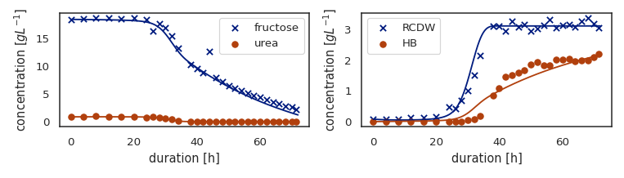Figure 1: The fit of ODE model to the observations of one cultivation. Left: Substrates. Right products. RCDW = residual cell dry weight, HB = hydroxybutyrate content of the copolymer.
For the training and validation sets we use two different cultivations. Generally, the training set and the validation sets differ in two aspects. On one hand the underlying mechanistic models have different parameters and on the other hand for some validation datasets the fraction of the two carbon substrates differs from the training set ratios according to Table 1 which leads to different ratios of HB and HHx. For comparing our algorithm against uncorrelated data, we add the dataset no_corr, where all concentrations are randomly sampled from a uniform distribution without any structure from a mechanistic model.
Table 1: An overview of the datasets used for the model evaluation. For the training dataset, the percentage is either the first number or the second within one cultivation. The validation datasets are named according to their oil content and “no_corr” refers to no correlation present. HB, HHx = hydroxybutyrate, hydroxyhexanoate content of the PHA copolymer and all % refer to wt.%.
dataset | train | val_0 | val_2 | val_4 | val_6 | val_8 | val_10 | no_corr
canola oil [%] | 0 / 100 | 0 | 20 | 40 | 60 | 80 | 100 | any
fructose [%] | 100 / 0 | 100 | 80 | 60 | 40 | 20 | 0 | any
samples | 50,000 | 10,000 | 10,000 | 10,000 | 10,000 | 10,000 | 10,000 | 50,000
HB [%] | 100 / 80 | 100 | 96 | 92 | 88 | 84 | 80 | any
HHx [%] | 0 / 20 | 0 | 4 | 8 | 12 | 16 | 20 | any
One cultivation and the mechanistic model are depicted in Figure 1. All generated cultivations contain all five labels every 3 h with the corresponding spectra. For the training set we use 2,000 cultivations and for the validation sets 400 cultivations respectively. As canola oil is difficult to measure with both Raman spectra and assays, we ignore them for parameter inference and the spectra components.
      - Model Architecture
For all evaluation procedures we use the exact same neural network structure. It is a ReZero architecture by Bachlechner et al. (2021) with minor adaptations for one spatial dimension and depthwise separable convolutions from Chollet (2017) to reduce the number of parameters. The network consists of 8 residual blocks followed by 3 fully connected layers with dropout of 0.2 to make sure the model is properly regularized.
  - Results
    - Characteristics of the Decorrelation Algorithm
Comparing the spectra from the training set obtained by the algorithm to the original spectra from the validation set in figure 2, we observe that some of the spectra look similar to the ones from the validation set.
Some spectra, however, look different, in particular, as if they were inverted. This occurs when some of the mixing coefficient are negative. While such spectra are unrealistic, they do not harm the overall performance, moreover, they might potentially have a regularizing effect on the model.
Due to the phenomenon of noise amplification according to Eq. (5) we filter samples. Looking at figure 3 we observe that a high ratio of random samples is filtered out for a batch size of 32.
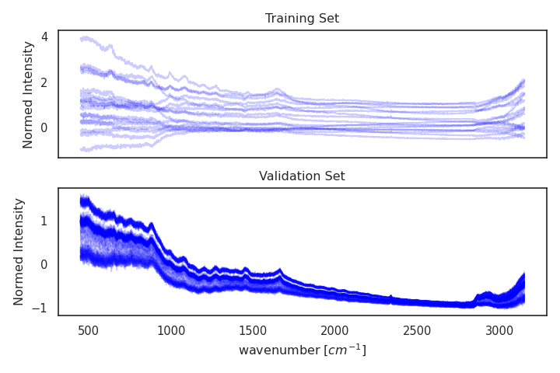Figure 2: Normalized spectra generated from the decorrelation algorithm in the training set and unchanged spectra from the validation set. | 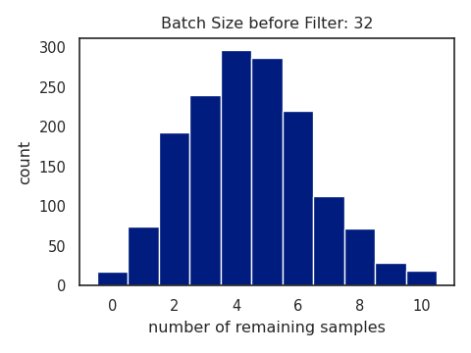Figure 3: When filtering out samples with coefficients which norm is greater than 1, we observe this distribution for batch size 32.
    - Impact on Model Performance
We use six different validation datasets that were generated as described in 2.3.1. We train four models in different training setting. For illustration purposes, we include the ideal scenario: one of the models is trained on a dataset with a priori uncorrelated labels (referred to as "no_corr"). We trained the others on correlated data for 100 epochs.
According to Table 2 the model trained on the uniform dataset is most successful at transferring its prediction capabilities to different experimental conditions. Among the models trained on the correlated experiments the decorrelation algorithm with filtering performs best. We also highlight the consistency of the proposed method across different validation sets. Not filtering the spectra with excessive noise causes the model to perform even worse than the model only trained on correlated data despite the decorrelation algorithm being in place.
  - Conclusions
We propose a data augmentation procedure that allows training robust Machine Learning models on Raman spectra. We show that the procedure "erases" unwanted dependencies in training data, and removes the corresponding biases from the models. The procedure ensures a similar performance of the models across a wide range of cultivation conditions, which dramatically simplified further analysis.
Table 2: The results of the evaluation procedure. The first three columns describe the training setup of the model. The next six columns depict the mean squared error on the normalized labels of the validation sets described in Table 1. The last column shows the mean of all validation sets.
Training Set | decorrelate | filter | val_0 | val_2 | val_4 | val_6 | val_8 | val_10 | mean
no_corr | no | no | 0.27 | 0.18 | 0.11 | 0.1 | 0.05 | 0.09 | 0.13
train | no | no | 0.42 | 0.50 | 0.41 | 0.47 | 0.42 | 0.48 | 0.45
train | yes | no | 0.54 | 0.58 | 0.52 | 0.55 | 0.53 | 0.58 | 0.55
train | yes | yes | 0.23 | 0.25 | 0.20 | 0.23 | 0.20 | 0.23 | 0.22
We demonstrated performance of our approach on datasets with correlations that differ from the training set. We used the algorithm on Raman spectra of Ralstonia eutropha, however, the algorithm exploits only the additive nature of spectral data, and, thus, is agnostic to the spectroscopy methods or the nature of the substances.
In practice with the help of our algorithm one can reuse data from old cultivation as training data for a model that infers information from the spectra of a new cultivation setup. This makes models more robust and reduces the number of cultivations needed for new experimental settings.
References
Alcântara, J.M.G., Iannacci, F., Morbidelli, M. and Sponchioni, M., 2023. Soft sensor based on Raman spectroscopy for the in-line monitoring of metabolites and polymer quality in the biomanufacturing of polyhydroxyalkanoates. Journal of Biotechnology, 377, pp.23-33.
Bachlechner, T., Majumder, B.P., Mao, H., Cottrell, G. and McAuley, J., 2021, December. Rezero is all you need: Fast convergence at large depth. In Uncertainty in Artificial Intelligence (pp. 1352-1361). PMLR.
Chollet, F., 2017. Xception: Deep learning with depthwise separable convolutions. In Proceedings of the IEEE conference on computer vision and pattern recognition (pp. 1251-1258).
He, K., Zhang, X., Ren, S. and Sun, J., 2016. Deep residual learning for image recognition. In Proceedings of the IEEE conference on computer vision and pattern recognition (pp. 770-778).
Khanna, S. and Srivastava, A.K., 2006. Computer simulated fed-batch cultivation for over production of PHB: a comparison of simultaneous and alternate feeding of carbon and nitrogen. Biochemical engineering journal, 27(3), pp.197-203.
Qi, Y., Hu, D., Jiang, Y., Wu, Z., Zheng, M., Chen, E.X., Liang, Y., Sadi, M.A., Zhang, K. and Chen, Y.P., 2023. Recent Progresses in Machine Learning Assisted Raman Spectroscopy. Advanced Optical Materials, p.2203104.
Santolin, L., Thiele, I., Neubauer, P. and Riedel, S.L., 2023. Tailoring the HHx monomer content of P (HB-co-HHx) by flexible substrate compositions: scale-up from deep-well-plates to laboratory bioreactor cultivations. Frontiers in Bioengineering and Biotechnology, 11, p.1081072.
Yun, S., Han, D., Oh, S.J., Chun, S., Choe, J. and Yoo, Y., 2019. Cutmix: Regularization strategy to train strong classifiers with localizable features. In Proceedings of the IEEE/CVF international conference on computer vision (pp. 6023-6032).

