Economic and Environmental Optimization in Sustainable Jet Fuel Production from Butanol
Angel Eduardo García-Hernández,ª Juan Gabriel Segovia-Hernández,ª Eduardo Sánchez-Ramírez,ª José Quiroz-Ramírez^{b}
ªDepartment of Chemical Engineering University of Guanajuato, Noria Alta S/N, Noria Alta,36000, Guanajuato, Gto., Mexico.
^{b}CONACyT-CIATEC A.C Center of Applied Innovation in Competitive Technologies, Omega 201, Industrial Delta, 37545 León, Gto., Mexico.
ae.garciahernandez@ugto.mx

Abstract
Within the critical context of dwindling oil reserves, the imperative to discover renewable energy alternatives to fossil fuels becomes increasingly acute. Biofuels, derived from organic substrates, emerge as a significant contender. Second-generation biofuels, utilizing non-food biomass, offer an environmentally responsible and cost-effective substitute, alleviating environmental concerns of fossil fuels without jeopardizing food resources.

A pivotal area of development is Sustainable Aviation Fuel (SAF), a biofuel variant. The conventional routes from biomass to SAF are marked by high costs and substantial energy consumption, necessitating innovative approaches that employ stochastic optimization and process intensification. The critical biomass-to-butanol segment encompasses both reaction and separation zones; the former integrates an intensified reactor for simultaneous saccharification and fermentation, guided by kinetic models within MATLAB. The separation zone employs advanced liquid-liquid extraction and distillation techniques, including an intensified column structure. Subsequently, the butanol-to-jet conversion adheres to a standardized protocol involving dehydration, oligomerization, separation, and hydrogenation, with process simulation conducted via Aspen Plus software. The application of the Differential Evolution with Tabu List (DETL) method has been instrumental in refining design and operational parameters, with the strategic aim of reducing the Total Annual Cost (TAC) and lessening the Eco-indicator 99 (EI99) environmental impact. The culmination of this research is the revelation of an optimized SAF production framework, achieving the minimal TAC and EI99, thereby marking a step forward in the quest for sustainable biofuel processes.

Keywords: butanol, SAF, lignocellulosic biomass, stochastic optimization, process intensification.

1. Introduction
Presently, as the scarcity of oil persists, there is a necessity to explore substitutes for fossil fuels, and this is where biofuels derived from biomass come into play as a potential solution. Biofuels are categorized into first-generation, second-generation, and third generation. First-generation biofuels, sourced from food, face limitations due to the potential threat to food supplies. Second-generation biofuels, primarily derived from biomass, offer an affordable, sustainable, and environmentally friendly fuel source. Third-generation biofuels, extracted from microalgae, are seen as a promising alternative, although their economic viability remains a significant challenge. Within the aviation sector, aviation biofuel has been developed, providing the advantage of reducing reliance on fossil fuels and decreasing $CO_{2}$ emissions by 80% throughout its lifecycle, owing to the carbon neutrality of biomass compared to conventional aviation fuel. The physical and chemical properties of aviation biofuel closely resemble those of conventional aviation fuel, enabling it to be easily blended with fossil fuel (aviation fuel) in various proportions without requiring modifications to aircraft and engines.

The manufacturing of second-generation biofuels via biochemical procedures involves four primary phases: pretreatment, enzymatic hydrolysis, fermentation, and separation. The separation stage typically accounts for the highest percentage of the process cost because the mixture subjected to separation is highly diluted, in addition to containing azeotropes. The "alcohol to jet" (ATJ) concept refers to the procedures involved in converting alcohols into aviation fuel. Typically, ethanol and butanol serve as feedstocks for ATJ processes. Both alcohols can be generated from lignocellulosic waste through fermentation, although butanol production technology is still in the research and development stage [1]. Regardless of the feedstock used, the ATJ process follows a uniform set of fundamental steps. It involves four main stages: dehydration, oligomerization, separation, and hydrogenation [1].

In the realm of chemical processing, myriad opportunities emerge, particularly in the domain of process intensification and optimization, pivotal for the integration of Sustainable Aviation Fuel (SAF). Process intensification involves implementing practices aimed at forging technologies that are more efficient, compact, cleaner, and energy-savvy. This encompasses strategies such as unit reduction by amalgamating multiple processes into one, enhancing mass and heat transfer through avant-garde mixing technologies and minimized diffusion pathways, innovating separation methods, and honing control strategies. Optimization, conversely, endeavors to calibrate and augment the overarching efficiency of chemical processes, guaranteeing resource utilization in the most efficacious manner, a cornerstone for the production and implementation of SAF in the aviation industry.
2. Case study
In this instance, we will examine the manufacturing process of biojet fuel derived from lignocellulosic biomass, with butanol serving as an intermediate product. The process will be divided into two segments: biomass-to-butanol and butanol-to-biojet. For the biomass-to-butanol phase, intensification techniques will be applied in both the reaction zone and the purification zone. Conversely, a conventional approach will be employed in the butanol-to-biojet process. The anticipation is that employing optimization methods alongside intensification strategies will lead to a reduction in both the total annual cost and environmental impact.

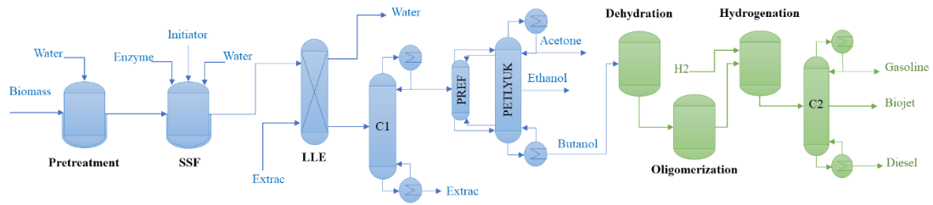
Figure 1. Biomass-biojet process.
3. Process modelling
In the year 2018, the predominant biomass sources in Mexico included sugarcane bagasse and corn straw [2]. Utilizing data from the Agricultural and Fisheries Information Service and SAGARPA (2015), sugarcane bagasse was selected as the primary raw material due to its abundant availability in Mexico during 2018. The process was formulated to extract the necessary sugars from this biomass to facilitate butanol production. The criteria for choosing the pretreatment method included achieving high glucan conversion, alcohol production, and production ratio through intensified systems such as simultaneous saccharification and fermentation (SSF). Among various pretreatment options, liquid hot water (LHW) pretreatment emerged as an effective and economically viable alternative for the chosen raw material.

3.1 Biomass-butanol process
In the reaction phase, an examination can be conducted on the integration of a simultaneous saccharification and fermentation (SSF) reactor. This study aims to decrease the energy and economic requirements of the individual operations. Moving on to the purification phase of the biomass-to-butanol process, the exploration of an intensified distillation system, such as thermally coupled systems, will be undertaken to achieve significant economic and energy efficiencies. Moreover, for the disruption of the azeotropes present, a liquid-liquid extraction system utilizing hexyl acetate as the extraction agent will be implemented.

The development of the intensified simultaneous saccharification and fermentation reactor commences with the concept of merging the two kinetic models (as described earlier) to create a unified model simulating both processes within a single unit. The novel kinetic model for simultaneous saccharification and fermentation (SSF) will be implemented in MATLAB, employing the fourth order Runge-Kutta method for its solution. The kinetic models for hydrolysis and fermentation used as a foundation were those proposed by Kadam and Shinto [3, 4].

The design of the fully thermally coupled column (Petlyuk scheme) is derived from the conventional system design. In both setups, the feed consists of the acetone-butanol-ethanol (ABE) mixture. Both systems undergo design processes using the Aspen Plus simulator. Initial designs are obtained through shortcut methods (DSTWU module), followed by more rigorous methods (RADFRAC module). The selection of the NRTL thermodynamic model is attributed to the presence of azeotropes. It is essential to incorporate a liquid-liquid extraction (LLE) column, employing hexyl acetate as the extraction agent, to disrupt the azeotrope. Furthermore, a distillation column is needed to recover the extracting agent.

3.2 Butanol-biojet process
The conventional simulation of the alcohol-to-jet (ATJ) process, utilizing butanol as the raw material, was carried out using the Aspen Plus software and the NRTL thermodynamic model. The reactors corresponding to the dehydration, oligomerization, and hydrogenation operations were simulated as yield reactors, while the distillation column with a byproduct was designed following the methodology used in the biomass-butanol process.

4. Process optimization
The conversion of lignocellulosic biomass to biojet fuel requires a nuanced multi-objective optimization to discern suitable technologies and optimize design and operational metrics, targeting economic and environmental benefits. Employing the Differential Evolution with Tabu List (DETL) method enables pinpointing of the global optimum with computational efficiency. This approach was pivotal in refining parameters and feedstock scheduling, integrating MS Excel and Aspen Plus via dynamic data exchange for decision variable analysis.

4.1 Total annual cost
In assessing the economic viability of a process under development, the Total Annual Cost (TAC) emerges as a crucial indicator. It reflects not just the final product but is intrinsically linked to the process's characteristics, offering a basis for informative comparison. TAC encompasses both operational expenses, including heating, cooling, and electricity, and capital investment in equipment. The comprehensive formula for TAC is specified in Equation 1.
$$TAC (\$USD/kg)=\frac{\frac{Capital cost}{Recovery time}+Operation cost}{F_{k}} (1)$$
Where $F_{k}$ represents the product flow.

4.2 Ecoindicator-99
The Eco-indicator 99, a life cycle analysis tool, quantitatively gauges environmental impact across a product's lifespan, from raw material to decomposition. It utilizes ecological indicators to numerically represent this impact, where higher values indicate greater detriment. This method stratifies impact into human health, ecosystem quality, and resource use, with the computational specifics presented in Equation 2.
$$EI99(ecopts/kg)=\frac{\sum_{b}{\sum_{d}{\sum_{kϵK}{δ_{d}ω_{d}β_{b}α_{b,k}}}}}{F_{k}} (2)$$
Where $β_{b}$ is the total amount of chemical b released per unit of reference flow due to direct emissions, $α_{b,k}$ is the damage caused in category k per unit of chemical b released to the environment, $ω_{d}$ is a weighting factor for damage in categories d, and $δ_{d}$ is the normalization factor for damage of category d.

4.3 Objective functions
The objective functions used to evaluate the sustainability of the process, considering both environmental and economic aspects, include the Eco-indicator-99 (EI99) and the total annual cost (TAC). The goal is to minimize both energy requirements and operational costs (TAC) while concurrently decreasing the environmental impact of the processes (EI99). These objective functions are represented by the equation:
$$F_{obj}\left(\vec{X}\right)=\left\{\min\left(TAC, EI99\right)\right.$$

5. Results
As a result of the optimization, an optimal value for the TAC of 12,614.08 USD/kg of SAF and a value for EI99 of 1.3291E+08 were found. These TAC and EI99 values correspond to a production of 45,833.48 kg/h of biojet or, in its annual equivalent, 389,584.6 tons/year, considering a working year of 8500 hours. Figure 2 shows the Pareto front obtained by plotting both objective functions, highlighting the optimal point found (A1).
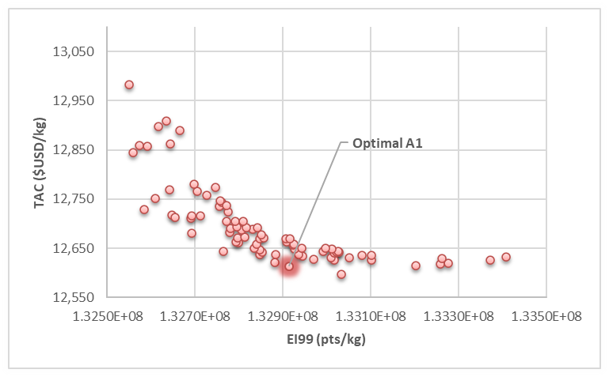
Figure 2. Pareto front for biomass-SAF process.
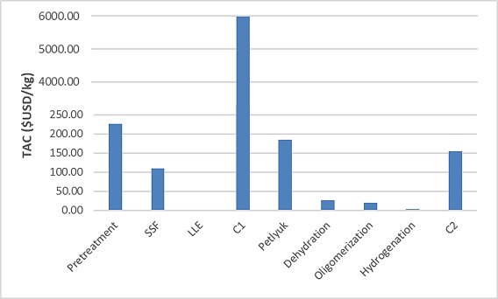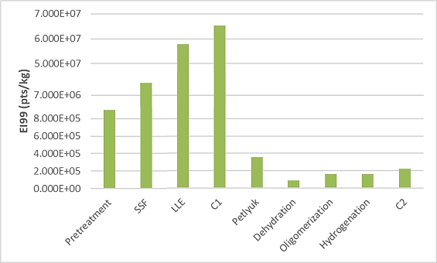

Figure 3. Contribution to the TAC per equipment.
Figure 4. Contribution to the EI99 per equipment.

Figures 3 and 4 depict the team-wise contribution to the objective functions, TAC, and EI99. It is evident that the biomass-butanol process contributes significantly more to both objective functions. Regarding TAC, column (C1), which recovers the extractant agent, has a considerable impact on the total cost. This is due to the high amount of hexyl acetate required to break the azeotrope. On the other hand, in EI99, the biomass-butanol process contributes significantly due to the use of solvent, the flows handled in the process, and consequently, the size of the equipment.
In the following table, the design parameters of the separation stage of the biomass-butanol process, LLE, C1, prefractionator, Petlyuk, are shown, as well as the parameters corresponding to column C2 for the separation stage of the ATJ process. With these separation schemes, the biomass-butanol process was able to produce 40,040.53 kg/h of acetone, 91,358 kg/h of butanol, and 13,590.84 kg/h of ethanol. All three products have a purity of 99.5% wt or higher. On the other hand, in the ATJ process, 20,820.65 kg/h of gasoline, 45,833.48 kg/h of SAF, and 25,430.98 kg/h of diesel were produced.

Table 1. Design parameters of the separation equipment
 | LLE | C1 | Prefractionator | Petlyuk | C2
Stages | 8 | 41 | 12 | 61 | 17
Feed input stage |  | 28 | 5 |  | 15
Reflux Ratio |  | 0.9098 |  | 5.5618 | 195.32
Input stage of LIF |  |  |  | 44
Input stage of VIF |  |  |  | 15
Output stage of LIF |  |  |  | 15
Output stage of VIF |  |  |  | 47
Output stage of SP |  |  |  | 29 | 8
LIF (kg/h) |  |  |  | 23,802.8
VIF (kg/h) |  |  |  | 50,449.3
SPF (kg/h) |  |  |  | 13,787.8 | 45,615.1
Distillate rate (kg/h) |  | 145,487.9 |  | 40,169.8 | 20,721.4

6. Conclusions
In the biomass-butanol conversion, two process intensification strategies were effectively employed: a simultaneous saccharification and fermentation (SSF) reactor and a Petlyuk column for enhanced thermal coupling. These adaptations facilitated the high-purity production of acetone, ethanol, and butanol. Subsequently, the biomass-derived butanol was efficiently processed via an alcohol-to-jet (ATJ) pathway, yielding 5 kg/h of Sustainable Aviation Fuel (SAF). Post-optimization analysis indicates that the most cost-effective design was achieved, minimizing both Total Annual Cost (TAC) and Eco-Indicator 99 (EI99) impacts. Nonetheless, the metrics remain suboptimal, underscoring the need for alternative intensification and separation techniques to improve sustainability.

References
- Kaltschmitt, M., & Neuling, U. (2017). Biokerosene: Status and Prospects. Springer.
- SAGARPA, (2015). https://www.gob.mx/. [Online] Available at: https://www.gob.mx/cms/uploads/attachment/file/346978/Manejo_de_residuos_Detallado.pdf
- Kadam, L., Rydholm, C., McMillan, D. (2004). Development and Validation of a Kinetic Model for Enzymatic Saccharification of Lignocellulosic Biomass. Biotchnol, 20, pp.698-705.
- Shinto, H., Tashiro, Y., Kobayashi, G., Sekiguchi, T., Hanai, T., Kuriya, Y., Okamoto, M., Sonomoto, K. (2008). Kinetic study of substrate dependency for higher butanol production in acetone–butanol–ethanol fermentation. Process Biochemestry, 43, pp.1452-1461.

