Multistage Optimal Control and Nonlinear Programming Formulation for Automated Control Loop Selection
Vasileios Mappas^{a*}, Bogdan Dorneanuª, Vassilios S. Vassiliadis^{b} , Harvey Arellano-Garciaª
ªLS Prozess, und Anlagentechnik, Brandenburgische Technische Universität Cottbus-Senftenberg Burger Chaussee 2, D-03044, Cottbus, Germany
^{b}5 Ammohostou Street, 7550 Kiti, Larnaca, Cyprus
mappas@b-tu.de
Abstract
Control loop design, as well as controller tuning, constitute the pillars of process control to achieve design specifications and smooth process operation, and to meet predefined performance criteria. Currently, state-of-the-art approaches have focused on methods that yield only the pairings between input and output methods, and are not able to incorporate path and end-point constraints. This work introduces a novel strategy based on the multistage optimal control formulation of the control loop selection problem. This approach overcomes the drawbacks of traditional methods by producing an automated integrated solution for the task of control loop design. Furthermore, it obviates the need for any form of combinatorial optimization and incorporating path and terminal constraints. The results show that the proposed solution framework produces the same control loops as in the case of traditional approaches, however the inclusion of path and end-point constraints improves the performance of the control profiles.
Keywords: Control Loop Selection, Controller Tuning, Multistage Integer Nonlinear Optimal Control Problem, Feasible Path Approach
  - Introduction
Process control plays a pivotal role in process industries, where complex integrated systems, environmental and safety regulations, and as well as economic uncertainty pose challenges to their operation. The most widely used types of controllers are of the Proportional-Integral (PI) and Proportional-Integral-Derivative (PID) types, due to their simplicity, robustness, easy realizability and non-fragility (Khandelwal and Detroja, 2020).
In real-world applications, industrial processes are described by Multi-Input Multi-Output (MIMO) systems, that are difficult to control due to the cross interactions among variables (Novella-Rodríguez et al., 2019). Several strategies, based on heuristics, machine learning techniques and statistics methods, have been proposed to handle the best allocation between the input and the output variables. Nonetheless, the state-of-the-art methods exhibit the following limitations:
- Important information or interactions between input-output pairings are not taken into consideration, leading to suboptimal results.
- Path and end-point constraints relating to operational limitations, environmental restrictions and safety specifications are not considered.
- The approximation of the differential equations using steady-state information prevents the accurate representation of the process dynamics, which affects the coupling decisions between input and output variables.

To address these drawbacks, a novel solution framework, based on Optimal Control theory, is proposed in this work that involves formulating the problems as a multistage optimal control problem for finding the control loop selection problem and controller tuning parameters, simultaneously.
  - Methodology
In this work, the control loop selection and the corresponding controller tuning parameters problems are solved simultaneously and the whole problem is formulated as a Multistage Integer Nonlinear Optimal Control Problem (MSINOCP), where each stage has different values for the parameters of the controller. A stage is determined as a part of the time horizon of the process within which the decision variables have to be decided by the solution algorithm. Each stage is described by a process model given by Differential Algebraic Equations (DAEs) system, process constraints, initial and junction conditions that link any two consecutive stages, as shown in Figure 1.
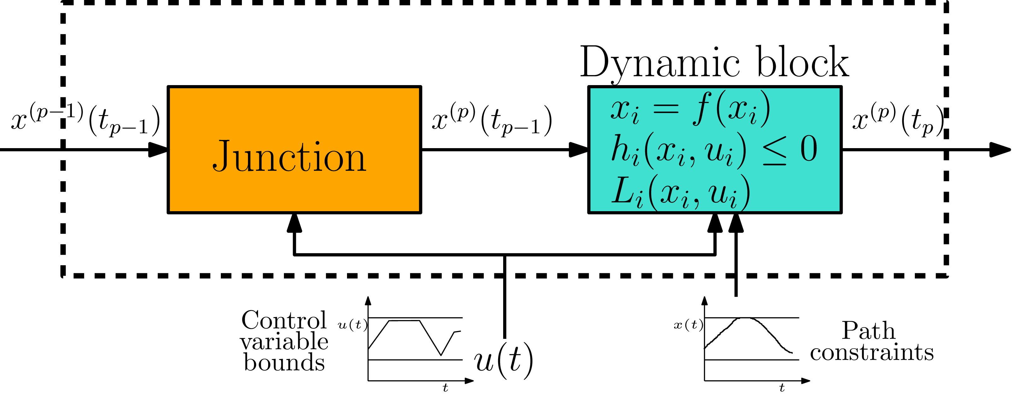
Figure 1: Graphical representation of the model for an individual stage of the control loop selection and tuning problem.
The general formulation of the Optimal Control Problem (OCP) is given by:
$$minimize$$ | $$\sum_{p=1}^{NS}{\left\{{\left[E_{1}\left(x^{\left(p\right)}\left(T\right), u^{\left(p\right)}\left(T\right)\right)\right]}^{T}u^{\left(p\right)}+E_{2}\left(x^{\left(p\right)}\left(T\right), u^{\left(p\right)}\left(T\right)\right)\right.}$$
 | $$+ \int_{t_{p-1}}^{t_{p}}{\left.\left[{\left[L_{1}\left(x^{\left(p\right)}\left(t\right), u^{\left(p\right)}\left(t\right)\right)\right]}^{T}u^{\left(p\right)}+L_{2}\left(x^{\left(p\right)}\left(t\right), u^{\left(p\right)}\left(t\right)\right)\right]dt\right\}}$$
$$subject to$$ | $${\dot{x}}^{\left(p\right)}\left(t\right)=f_{1}\left(x^{\left(p\right)}\left(t\right), u^{\left(p\right)}\left(t\right)\right)u^{\left(p\right)}+f_{2}\left(x^{\left(p\right)}\left(t\right), u^{\left(p\right)}\left(t\right)\right)$$ |  | $$p=1, 2, …, NP$$ | (1)
 | $$\left[h_{1}\left(x^{\left(p\right)}\left(t\right), u^{\left(p\right)}\left(t\right)\right)\right]u^{\left(p\right)}+h_{2}\left(x^{\left(p\right)}\left(t\right), u^{\left(p\right)}\left(t\right)\right)≤0$$ |  | $$p=1, 2, …, NP$$
 | $$\left[r_{1}\left(x^{\left(p\right)}\left(T\right), u^{\left(p\right)}\left(T\right)\right)\right]u^{\left(p\right)}+r_{2}\left(x^{\left(p\right)}\left(T\right), u^{\left(p\right)}\left(T\right)\right)≤0$$ |  | $$p=1, 2, …, NP$$
 | $$x\left(0\right)=x_{0}$$
 | $$0≤t≤T$$
where $E_{1}$ is the coefficient of the linear control and $E_{2}$ is the coefficient independent of the linear controls for the point performance index. The corresponding terms for the continuous performance index, the differential equations, the path and end-point constraints are $L_{1}$ and $L_{2}$, $f_{1}$ and $f_{2}$, $h_{1}$ and $h_{2}$ and $r_{1}$ and $r_{2}$ for stage $p$, respectively. Differential state and control variables are denoted by $x$ and $u$, respectively, while $t$ is the simulation time.
The OCP problem, defined by Eq. (1), is solved obtaining the control actions $u$ (control loop selection and corresponding controller’s tuning parameters) and satisfying the constraints for each stage.
The backbone of the proposed methodology is the property that control variables appearing linearly in the OCP tend to take values at either bound in the optimal solution, leading to a “bang-bang” behaviour. Furthermore, the control variables, $u,$ are considered as continuous, rather than discrete variables and are incorporated into the controller’s tuning parameters. Therefore, the resulting optimization problem can be solved as a Nonlinear Programming (NLP) optimization problem, using a feasible path approach and without the use of mixed-integer optimization techniques. The proposed OCP formulation constitutes a superstructure that permits various connections between the control and the manipulated variables, with the optimizer allowing more than one coupling to occur between them.
The benefits of the proposed solution scheme are summarised below:
- The MSINOCP framework has the ability to select the “best” control loop between the manipulated and control variables and find the optimal tuning parameters of the controllers at the same time.
- The control variables are considered as continuous variables leading to a NLP reformulation of the problem. This reformulation obviates the need of utilising mixed-integer techniques with the challenges associated with their combinatorial nature.
- The MSΙNOCP solution framework can handle and use dynamic models of any complexity and nonlinearity that describe the system’s behaviour as well as path and terminal constraints imposed on the system.
  - Computational results
In the following section, two commonly used case studies are examined using the methodology proposed above, to introduce the implementation of the MSINOCP approach and formulation to obtain the “best” control loops and the optimal tuning parameters for the corresponding controllers without the need of combinatorial solution frameworks.
The following assumptions are applied for all of them:
- The type of controller is assumed to be PI.
- The continuous control variables $u\left(t\right)$ are considered to be piecewise constant.
- The control loop selection problem is regarded as a single stage of a multistage OCP. Therefore, the total number of stages is assumed to be one.
All the simulations are performed in MATLAB R2020a, where the functions fmincon and ode15s are used for solving the optimization problem and the system of DAEs, respectively. For all case studies investigated, the results obtained from the proposed solution scheme are compared to the Relative Gain Array (RGA) and Ziegler-Nichols methods. RGA is a well-established method for evaluating the controllability of a process with multiple inputs and outputs (Juneja et al., 2023), while the Ziegler-Nichols method is one of the most widely used and cited methodologies for tuning controller’s parameters (Huba et al., 2021).

    - Case study 1
A liquid tank with two inlet streams and a single outlet stream is considered, as shown in Figure 2. The mass and the energy balance of the liquid tank model are given by:

$$\frac{dh}{dt}=\frac{1}{A}F_{c}\left(t\right)+\frac{1}{A}F_{h}\left(t\right)-\frac{1}{A}c_{1}\sqrt{h}$$ | (2)
$$\frac{dT}{dt}=\frac{1}{A}\frac{F_{c}}{h}\left(T_{c}\left(t\right)-T\left(t\right)\right)+ \frac{1}{A}\frac{F_{h}}{h}\left(T_{h}\left(t\right)-T\left(t\right)\right)$$ | (3)
where $h$ is the height of the liquid tank inside the tank, $F_{c}$ and $F_{h}$ are the inlet flowrates of the cold and hot streams, respectively, $c_{1}$ is the coefficient of the outlet flowrate, $T$ is the temperature inside the liquid tank, $T_{c}$ and $T_{h}$ denote the temperatures of the cold and the hot inlet streams, respectively and $A$ is the cross sectional area of the tank.

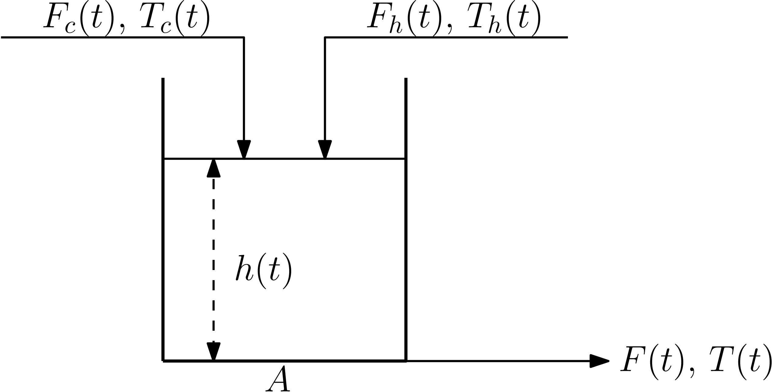
Figure 2: Liquid tank process representation.
The manipulated variables are the inlet flowrate of the cold and hot streams, while the volume and the temperature of the tank are the controlled variables. The pairings between the controlled and the manipulated variables are not known in advance. The possible pairings that can be considered are any combination linking $F_{c}$ and $F_{h}$ with outputs $T$ and $h$.
The objective function for the MSINOCP optimization problem is to minimize the Integral Square Error (ISE) for the height and the temperature. Furthermore, path constraints for the controlled and the manipulated variables, as well as for the controller’s tuning parameters are imposed.

    - Case study 2

In this case, the system described by the following $3×3$ transfer function matrix is examined and is given by

$$G\left(s\right)=\left[\begin{matrix}\frac{-2e^{-s}}{10s+1} & \frac{-1.5e^{-s}}{s+1} & \frac{e^{-s}}{s+1} \\ \frac{1.5e^{-s}}{s+1} & \frac{e^{-s}}{s+1} & \frac{-2e^{-s}}{10s+1} \\ \frac{e^{-s}}{s+1} & \frac{-2e^{-s}}{10s+1} & \frac{-1.5e^{-s}}{10s+1}\end{matrix}\right]$$ | (4)

A Padé approximation is used to overcome the dead time which transforms the matrix into a system of differential equations that can be handled by the proposed MSINOCP solution scheme. To find the best pairings and the optimal tuning parameters for the corresponding controller, two reformulations are considered based on first and second order Padé approximations.
The initial condition of the system is set to zero and the aim is to react to the new set-point which has the value of 1. In the MSINOCP problem formulation, the objective is to minimize the ISE for the state variables$x_{1}-x_{3}$, while path constraints for the controlled and the manipulated variables, and for the tuning parameters of the controllers are taken into consideration.
  - Results and Discussion
    - Case study 1
Different scenarios are considered. Table 1 demonstrates the parameter values of an example scenario selected to test the ability of the solution framework to satisfy the path and end-point constraints.
Table 1: Initial and target values for Case study 1
 | Values
 | Initial | Target
$$h \left(m\right)$$ | 3.0 | 1.0
$$T \left(℃\right)$$ | 35.0 | 15.0

The proposed methodology and the classical method (RGA) give the same control loops, as shown in Figure 3. The pairings given by the MSINOCP solution scheme confirm the theoretical prediction of bang-bang optimal control behaviour. Furthermore, the proposed methodology reaches the target values, obeying the constraints of the problem.
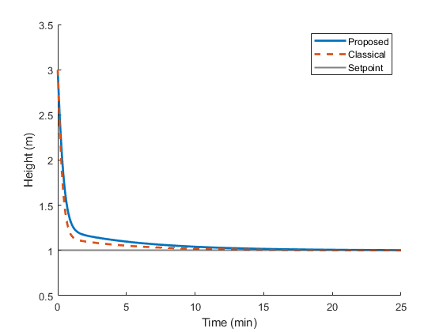 | 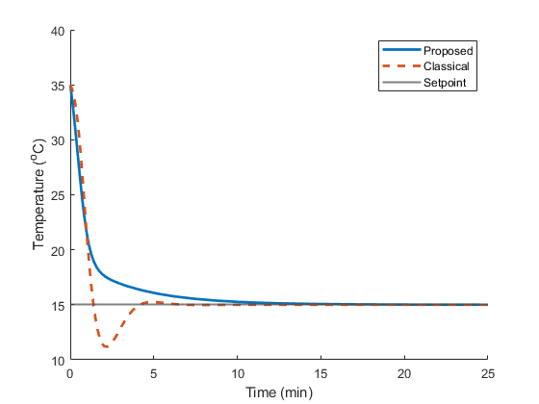
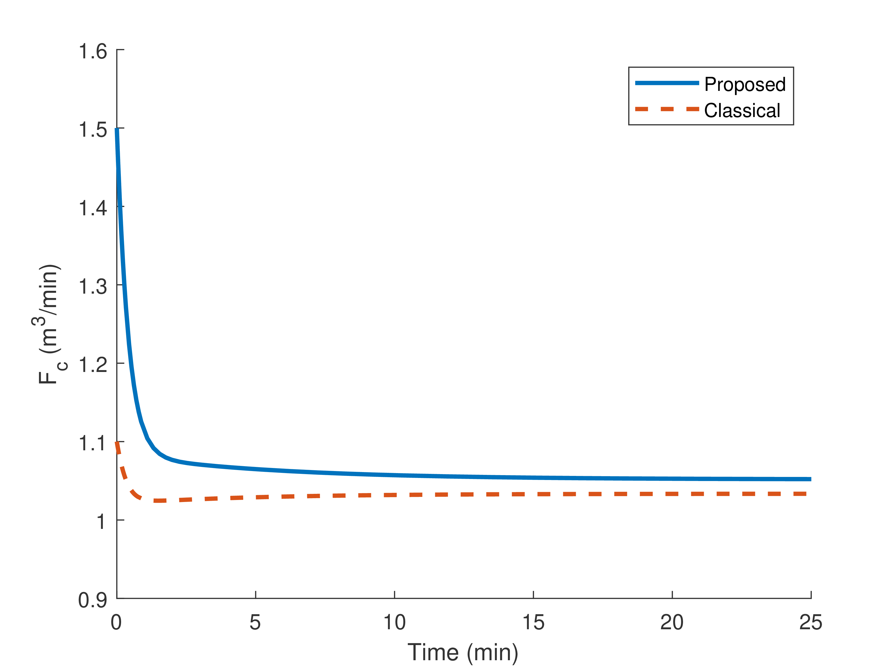 | 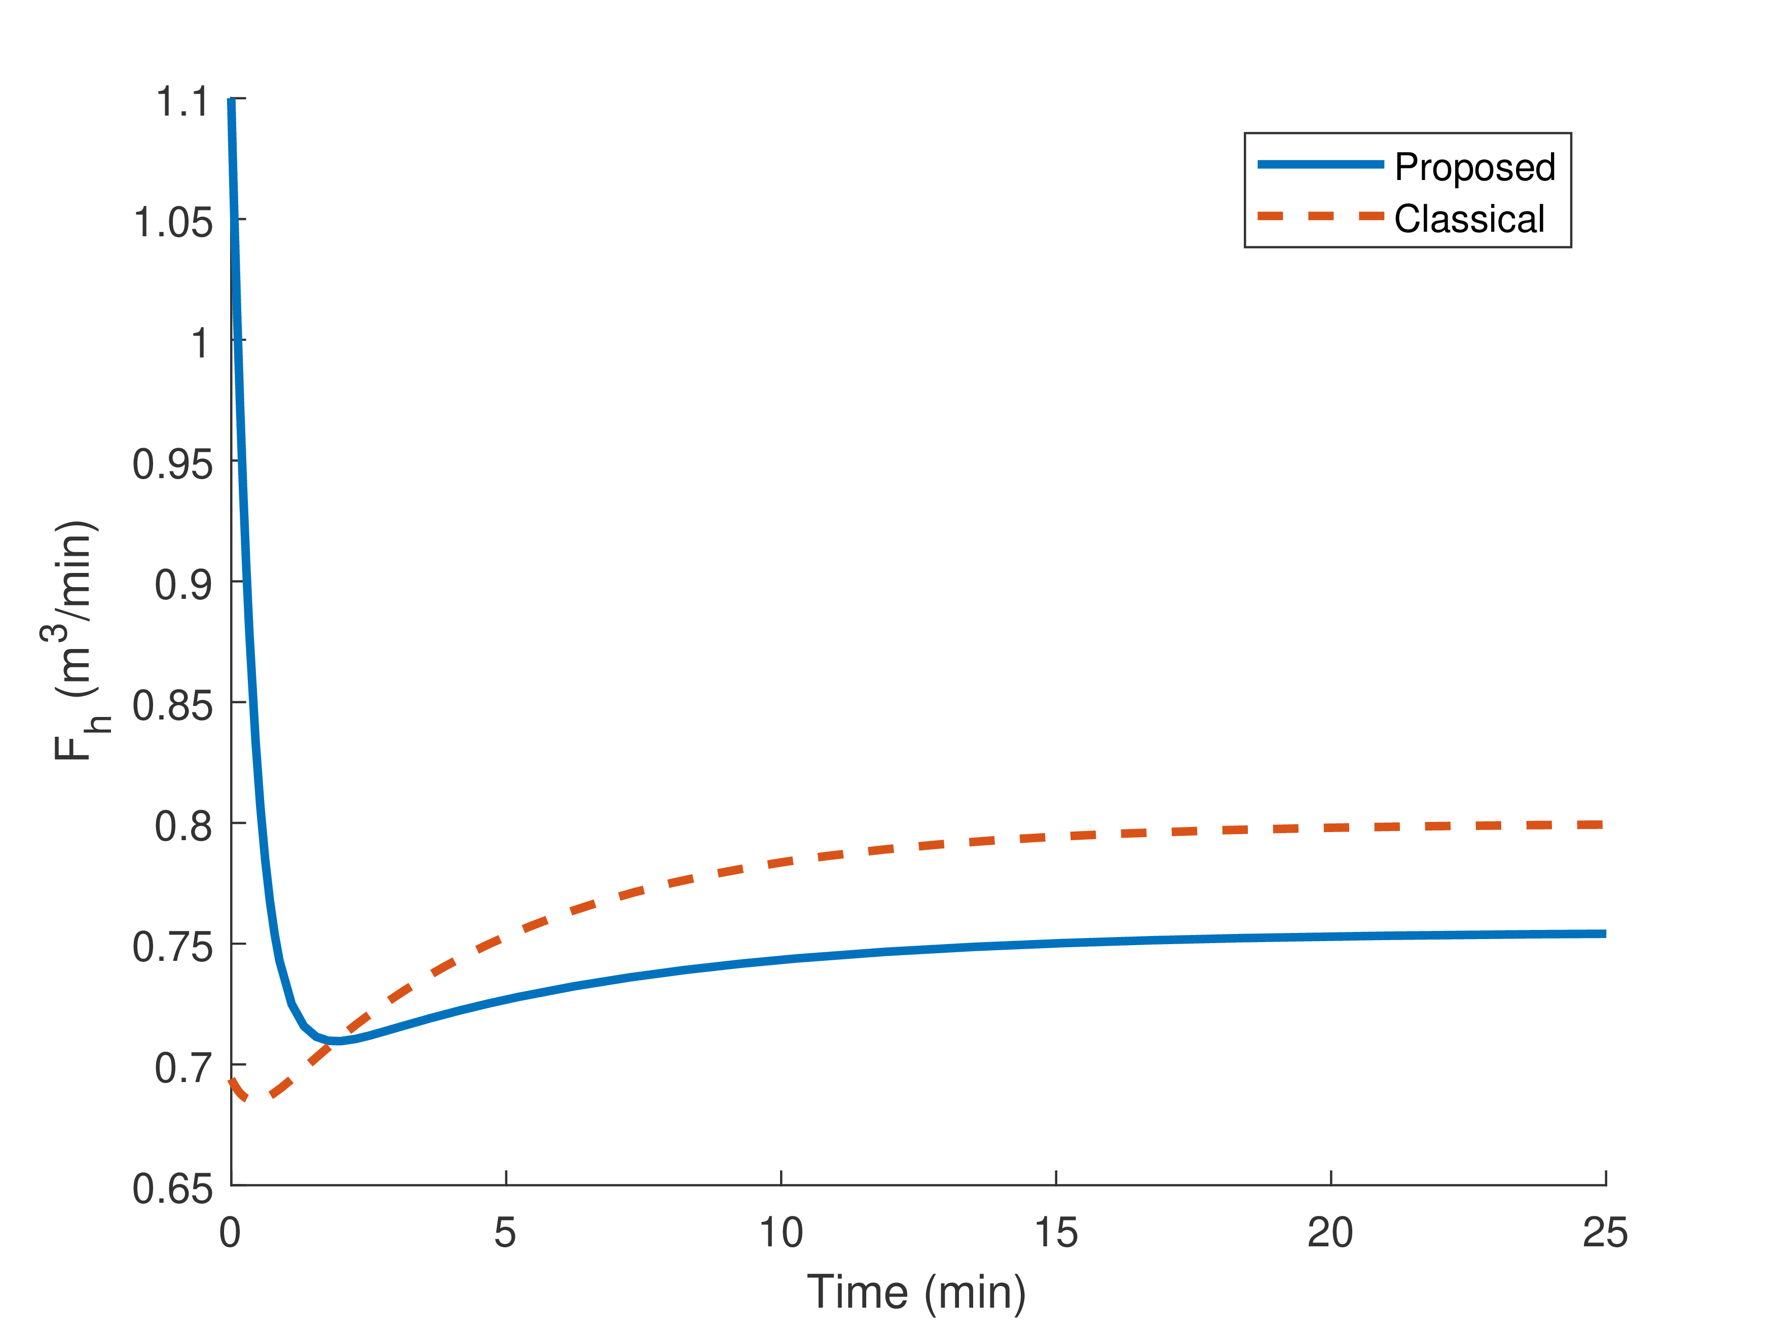
Figure 3: Trajectories for controlled and manipulated variables for Case study 1.
It can be observed that the obtained control tunings and the resulting control profiles do not have the same values, due to the fact that the OCP-based solution scheme considers and solves the control loop selection and controller tuning problem simultaneously compared to the classical method that solves each one separately. Specifically, the temperature trajectory violates the path constraint for the temperature in the case of the classical tuning (Ziegler-Nichols), as shown in Figure 3.
    - Case study 2
The MSINOCP methodology produces the same control loops with the RGA methods, as shown in Figure 4. It can be seen that both methods reach the new set-points after approximately 10 min. Specifically, an underdamped response is observed for the state variable $x_{2}$ using the Ziegler-Nichols methods compared to the proposed solution scheme, as shown in Figure 4.
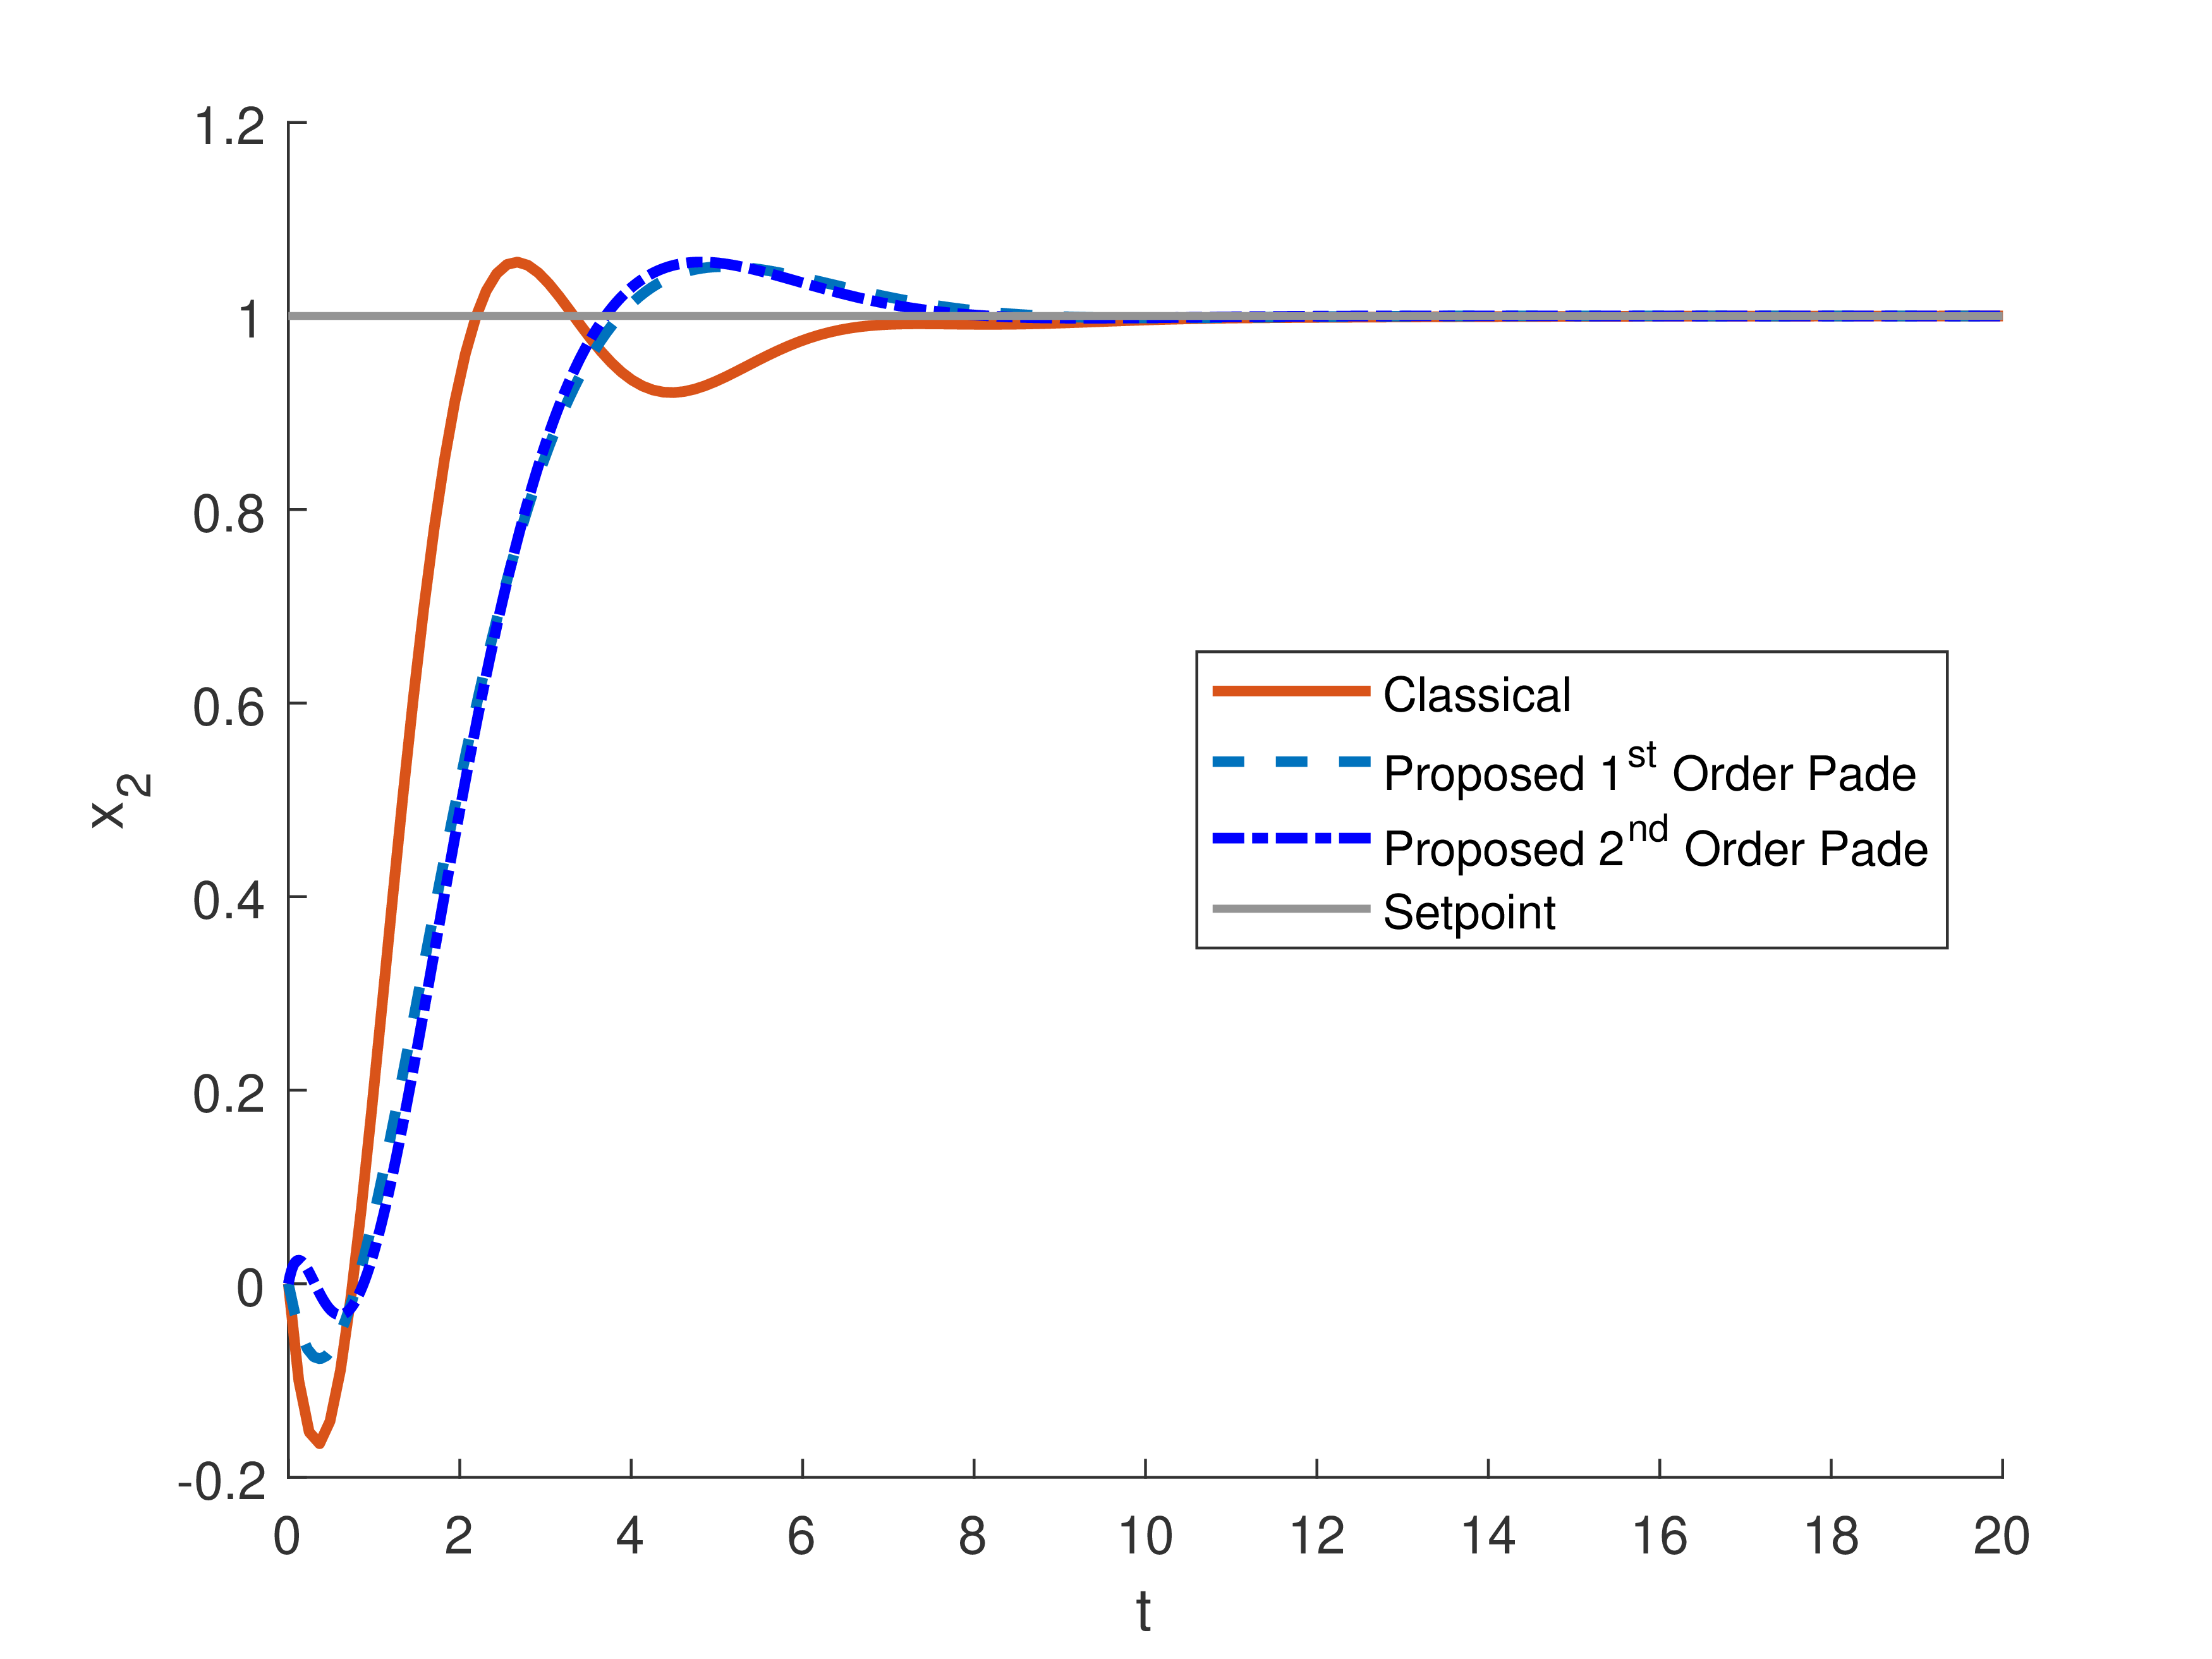 | 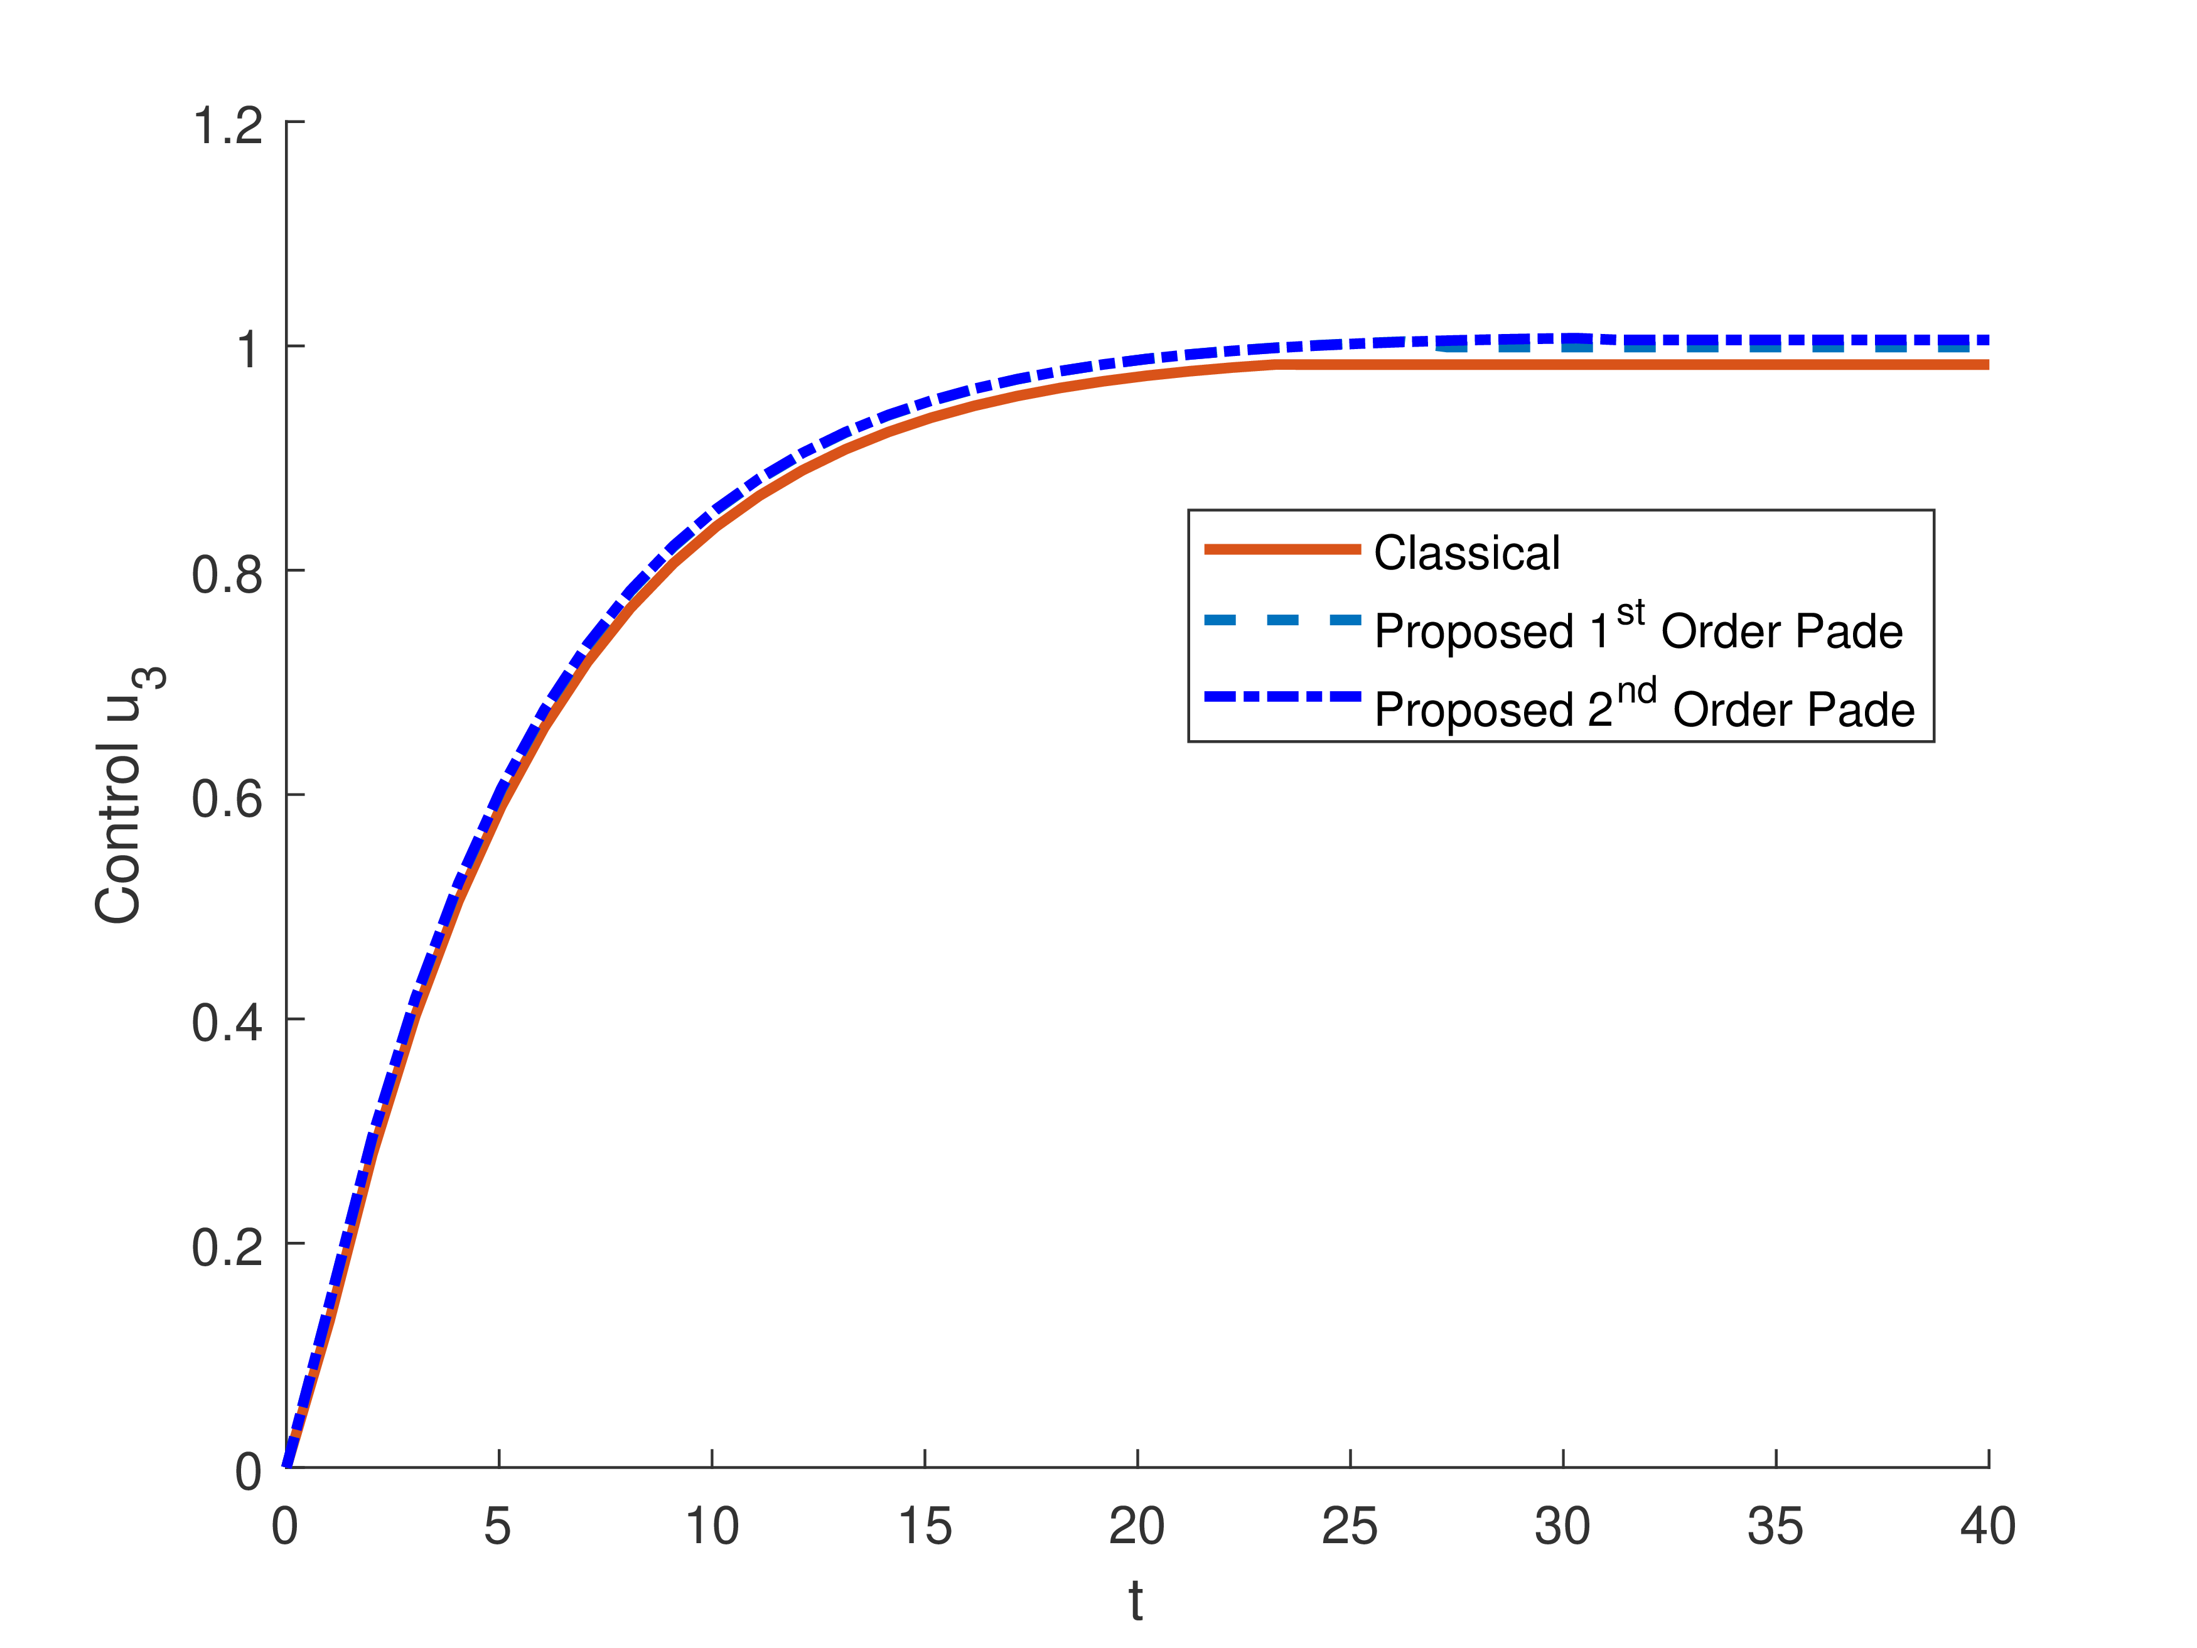
Figure 4: Trajectories for state and control variables for Case Study 2.
This behaviour can be explained by the implementation of the path constraints in the optimization problem, which are not considered by the classical method. Furthermore, the order of the Padé approximation plays a minor role in the system’s behaviour, as shown in Figure 4. Therefore, a first order Padé approximation can be used for obtaining the optimal control pairings and their tuned controller parameters leading to the reduction of the computation burden compared to the second order Padé approximation.
  - Conclusions
In this work, a new approach for the automatic control loop selection and simultaneous controller tuning using Optimal Control theory is presented. The proposed solution scheme is based on the property that control variables appearing linearly in the OCP lead to bang-bang control behaviour, which is confirmed for the examined case studies. The numerical results indicate that the MSINOCP methodology is practical and effective to handle set-point switching and is able to satisfy path and end-point constraints. Furthermore, the solution framework yields one-to-one coupling of inputs to outputs variables which are in agreement with the classical methods. This methodology can be extended to larger/industrial case studies or experimental set-ups to determine the “best” control loops and the optimal tuning parameters for the corresponding controllers and the obtained results will be compared with real-time data.
References
A. Rodríguez-Molina et al., 2020, Multi-objective meta-heuristic optimization in intelligent control: A survey in the controller tuning problem, Applied Soft Computing, vol. 93, 106342.
S. Khandelwal & K.P. Detroja, 2020, The optimal detuning approach based centrilized control design ofr MIMO processes, Journal of Process Control, vol. 96, pp. 23-36.
P.K. Junejaet al., 2023, Interaction analysis of a multivariable process in a manyfacturing industry – A review. In: V. Suma, P. Lorenz, Z. Baig (eds) Inventive Systems and Control. Lecture Notes in Networks and Systems, 672, Springer, Singapore.
M. Hubaet al., 2021, Making the PI and PID controller tuning inspired by Ziegler and Nichols precise and reliable, Sensors 2021, vol. 21, 18, 6157.
Z.Y. Nie et al., 2022, A unifying Ziegler-Nichols tuning method based on active disturbance rejection. Int. J. Robust. Nonlinear Control, vol. 32, pp. 9525 – 9541.

