Adaptive Physics-Informed Neural Network for Prediction with Evolving Process Parameters
Devavrat Thosar,^{a,*} Abhijit Bhakte,^{b} Zukui Li,ª Arvind Rajendran,ª Rajagopalan Srinivasan,^{b} Vinay Prasadª
ªDepartment of Chemical and Materials Engineering, Donadeo Innovation Centre for Engineering (ICE), University of Alberta, Edmonton, Alberta T6G 1H9, Canada
^{b}Department of Chemical Engineering, Indian Institute of Technology Madras, Chennai 600036, India
*thosar@ualberta.ca
Abstract
Deep learning models are widely favored for their ability to model complex processes. These models are data-driven and lack physics-based knowledge. To address this limitation, Physics-Informed Neural Networks (PINNs) have emerged as a promising solution to integrate first principles knowledge, particularly in complex processes like Pressure Swing Adsorption (PSA). Presently, PINNs are predominantly employed for processes with constant process parameters. However, real-world processes may face variation in parameters due to exogenous factors, such as adsorbent degradation. Such changes can compromise performance of the model. This motivates a need to update the PINN model dynamically. In this work, an adaptive PINN framework is developed, that monitors changes in process parameters, using residual loss function of the PINN. Once a significant process change is detected, the PINN model is re-trained. The efficacy and capability of the proposed method is demonstrated on a PSA process.
Keywords: Physics-Informed Neural Network, Process Monitoring, Pressure Swing Adsorption, Deep Learning, Hybrid Modelling
  - Introduction
With increasing digitalization driven by Industry 4.0, big data has become abundantly available in chemical industry. This has led to the widespread adoption of data-driven models, with specific attention being paid to artificial neural networks, known for their ability of ‘universal approximation’ to model complex process data. However, these are black-box models that lack an inherent understanding of the underlying physics. To address this limitation and incorporate essential physics-based knowledge into such models, Physics-Informed Neural Networks (PINNs) (Raissi et al., 2019) have emerged as a compelling solution to model complex chemical processes such as Pressure Swing Adsorption (PSA) (Subraveti et al., 2022).
To incorporate physics knowledge, PINNs leverage residual errors obtained from the governing equations through automatic differentiation and add them to the loss function as a soft constraint during model training. Despite their significant advantages in terms of greater generalizability and ability to work with limited data, PINNs require prior knowledge of the process's governing equations, including structural details and parameters, such as activation energy, heat transfer coefficients etc. Presently, PINNs are primarily utilized for processes with constant process parameters. In our previous work, we successfully demonstrated the application of PINNs in modeling each individual step of a PSA process, assuming a constant set of process parameters, such as adsorption isotherms, kinetic parameters etc., (Subraveti et al., 2022). However, PSA processes may experience variations in one or more of these parameters due to evolving environmental conditions. These changes may result from physical transformations in equipment or materials, such as the degradation of adsorbents or reduction in bed voidage due to attrition. Such changes can lead to a decline in the performance of the predictive model, necessitating the need for model updating and parameter identification.
The term Adaptive PINN is used in the field of computational physics, where the adaptation refers to the selection of domain to sample collocation points for training a PINN (McLenny and Braga-Neto, 2022, Subramanian et al., 2022), and has not been used in the field of Chemical Engineering. To address the need for model updates due to changes in process parameters, several approaches have been published in the process control literature. For instance, Darsha Kumar et al. (2018) developed a framework for re-identification of process model in reactor systems to accommodate changes in reaction parameters. Similarly, Oshima et al. (2022) proposed a method for re-identification of process model in an MPC framework. However, most methods use simple system identification models which may not be applicable to complex nonlinear and cyclic processes. Additionally, parameter identification utilizes process data to deduce the values that yield the optimal fit to the observed data. Various methodologies, as documented in the literature use PINNs to estimate the updated process parameters. Raissi et al. (2019) demonstrated the inverse problem of parameter identification using PINN to estimate parameters of PDE equations from observed data. To the best of our knowledge, a framework combining process monitoring, model updating and parameter estimation using residuals in PINN has not been addressed previously in chemical engineering.
This study proposes an adaptive PINN approach to dynamically monitor and integrate real-time changes in a set of process parameters during the changing environmental conditions. Section 2 provides a detailed description of the proposed methodology. Section 3 outlines the PSA process, reports original PINN performance results, subsequent monitoring, and adaptation. The concluding Section 4 offers a brief discussion on takeaways and future research directions.
  - Adaptive PINN
Consider a process represented by a set of partial differential equations $F=\{f_{1}, f_{2},…, f_{m}\}$ as given in Eq. (1) describing dynamics of $m$ output variables,
${\dot{y}}_{i}=f_{i}\left(x,y,θ\right) ∀ i=1, 2,…,m$ | (1)
where $x∈R^{d}$ , $y∈R^{m}$ and $θ$ represent the sets of the input vector, output vector and process parameters, respectively. The system thus consists of $d$ input variables and $m$ process outputs. A PINN model, $g$, is employed to predict the output variables, such that, $\hat{y}=g\left(x,θ_{NN}\right)$, where $θ_{NN}$ are the neural network parameters (weights and biases). PINN integrates physics-based knowledge by penalizing model outputs inconsistent with underlying physics of the process. This is accomplished by introducing a physics term to the training loss function $(L)$ as given in Eq. (2),
$L= L_{LD}+{λL}_{PDE}$ | (2)
where $L_{LD}$ is the mean-squared error between the PINN model prediction and the labelled data, $L_{PDE}$ is the loss associated with the residuals of differential equations. The parameter λ is the weighting hyper-parameter, imparting significance to the residual loss values. The terms in the overall loss function can be as given in Eqs. (3) and (4),
$L_{LD}= \frac{1}{n}\sum_{j=1}^{n}{{\left(y_{j}-{\hat{y}}_{j}\right)}^{2}} ,$  $L_{PDE}= \sum_{i=1}^{m}{\frac{1}{n_{res}}\sum_{j=1}^{n_{res}}{{({{\dot{\hat{y}}}_{ij}-f}_{i}\left(x_{j},{\hat{y}}_{j},θ\right))}^{2}}}$ | (3)  (4)
where, $n$ indicates the number of labelled data points, $n_{res}$ indicates the number of internal collocation points sampled to incorporate physics-based constraints in PINN, ${\dot{\hat{y}}}_{ij}$ is the gradient of predicted output $y_{i}$ for sample $j$ obtained using automatic differentiation. The PINN is trained by minimizing the loss function in Eq. (2) using an appropriate optimizer to obtain the optimal values of $θ_{NN}$. Once trained, the PINN model $g$ is deployed online to predict $\hat{y}$. As discussed previously, one or more parameters in $θ$ may change over time, due to changing process conditions, leading to variations in the true values of $θ$. As the PINN model deployed online is trained on the original set of parameters, it fails to capture the evolving parameters, resulting in a degradation of model performance. To address this challenge, we propose a two-step methodology:
Step 1: Monitoring using residual loss
As the process undergoes a change in parameters, performance of the PINN model is expected to gradually deviate from its original state. To monitor this shift in PINN predictions, residual losses are computed by utilizing measurements from the process, along with the corresponding gradients ($\dot{\hat{y}}$) calculated through automatic differentiation. Considering $y_{c}⊆y$ as the set of measured output variables and $y_{c}^{'}$ as the set of unmeasured variables, the residual loss ${\hat{L}}_{k}$, intended for monitoring purposes for the $k^{th}$ sampling instance, can be calculated using Eq. (5).
${\hat{L}}_{k}= \sum_{i=1}^{m}{{\left({{\dot{\hat{y}}}_{ik}-f}_{i}\left(x_{k},{\left[\begin{matrix}y_{c} \\ {\hat{y}}_{c}^{'}\end{matrix}\right]}_{k},θ\right)\right)}^{2}}$ | (5)
To monitor this deviation, a threshold value $δ$ is introduced. $δ$ can be considered as a tuning parameter, signifying a tolerance on the degrading performance of the PINN model. This strategic use of the residual loss enables the direct identification of deviations that may not be entirely captured by the current PINN model. In the course of real-time operation, if the computed residual loss surpasses this predefined threshold $({\hat{L}}_{k}>δ )$, a significant process change is detected. This, in turn, triggers the updating of the model.
Step 2: Re-training PINN model and parameter estimation
Since performance of PINN model $g$, trained using the set of original process parameters $θ$, starts degrading, there is a need to systematically re-train the PINN model to effectively adapt to the evolving process conditions. This adaptation is achieved by first collecting historical data $X^{h}$ and then re-training the model using $X^{h}$ as labelled data. Data is collected over a window of samples from either the start of the process or the time instance of the previous threshold breach, until the current time instant. The re-training is achieved by initializing the weights of the neural network with the existing PINN model and minimizing the loss function given in Eq. (2), as discussed previously. To facilitate parameter estimation concurrently with model training, the process parameters $θ$ are treated as trainable entities in Eq. (4). The resulting updated PINN model, $g_{new}$​, incorporates the knowledge of the evolving process conditions and the set of estimated process parameters obtained during re-training is denoted as $θ_{new}$. The new model is deployed if ${\hat{L}}_{k}\left(g_{new},θ_{new}\right)≤{\hat{L}}_{k}\left(g,θ\right)$. The proposed methodology is demonstrated through a case study on a PSA process.
  - Case Study: Pressure Swing Adsorption
$$v_{feed}$$ | 0.7 | 0.27 | 0.1 | 0.75 | 0.5
$$t_{ads}$$ | 35 | 25 | 35 | 25 | 45
Table 1: Operating conditions to get training data
Pressure Swing Adsorption (PSA) is a nonlinear cyclic process for gas mixture separation utilizing a selective adsorbent material. Its potential for enhanced energy efficiency compared to traditional methods makes PSA an attractive choice for researchers to pursue. The PSA process involves a bed filled with adsorbent material undergoing cyclic stages of adsorption and desorption. In this work, an axially dispersed, isothermal PSA for separation of a gas mixture of CO₂+N₂ with IISER MOF 2 as an adsorbent is considered. The steps in a single bed- four step PSA cycle for post-combustion carbon capture consists of Pressurization, Adsorption, Blowdown and Evacuation in that order. The governing PDEs for axially dispersed, isothermal PSA, the corresponding boundary conditions for each step and values of the process parameters are as given in (Subraveti et al., 2022). The output variables are gas phase composition of CO₂ $(y_{1}$), pressure ($\overline{P}$), solid loading for CO₂ (${\overline{q}}_{1}$) and solid loading for N₂ (${\overline{q}}_{2}$). Non-dimensionalized variables are indicated by a bar above their symbol.
To generate simulation data, the spatial coordinates are discretized using a Total Variation Diminishing scheme with a Van-Leer Flux Limiter, dividing the bed into fifty grid points. Resulting ODEs are solved using ‘ode23s’ in MATLAB. The parameter $ε$, representing bed voidage, is assumed to be changing over time, to emulate the degradation of bed particles caused by attrition. The initial value of parameter $ε=0.37$. Comparing with Eqs. (1) and (5), $θ= ε$, $y= {\left[\begin{matrix}y_{1} & \overline{P} & {\overline{q}}_{1} & {\overline{q}}_{2}\end{matrix}\right]}^{T}$ and $y_{c}=y$, assuming that all variables are measured at inlet ($z=0$) and outlet $(z=L)$ of the bed. The initial condition for a step of PSA is the state of the bed at the previous step. These conditions, therefore, act as inputs to the system. Therefore, $x= {\left[\begin{matrix}y_{1,1}^{0} & … & y_{1,50}^{0}\end{matrix}\right]}^{T}$. Ideally, initial conditions of other three output variables should also be added as inputs. These are excluded in this work to reduce the complexity of the neural network and are included as labelled data instead. The residual equations for PSA process can be given as:
$f_{1}=\frac{∂(y_{1}\overline{P})}{∂\overline{t}}+c1\left(\overline{v}\overline{P}\frac{∂y_{1}}{∂\overline{z}}+y_{1}\overline{P}\frac{∂\overline{v}}{∂\overline{z}}+y_{1}\overline{v}\frac{∂\overline{P}}{∂\overline{z}}\right)-c2\frac{∂^{2}\left(y_{1}\overline{P}\right)}{∂{\overline{z}}^{2}}+c3\frac{∂{\overline{q}}_{1}}{∂\overline{t}}$,$f_{2}=\frac{∂\overline{P}}{∂\overline{t}}+c1\left(\frac{∂(\overline{P}\overline{v})}{∂\overline{z}}\right)-c3(\frac{∂{\overline{q}}_{1}}{∂\overline{t}}+\frac{∂{\overline{q}}_{2}}{∂\overline{t}})$, where $c1= \frac{v_{0}t_{0}}{L}$ , $c2= \frac{D_{L}t_{0}}{L^{2}}$, $c3= \frac{RT_{0}q_{s0}}{P_{0}}\frac{1-ε}{ε}$, are the constants as given in (Subraveti et al., 2022). It is also shown in (Subraveti et al., 2022) that the PINN for a PSA can be trained without using the adsorption isotherm information. Therefore, the equations for ${\overline{q}}_{1}$ and ${\overline{q}}_{2}$ are not used as residual equations for PINN training and subsequent process monitoring assuming that isotherm information is not known.
    - Training PINN for PSA
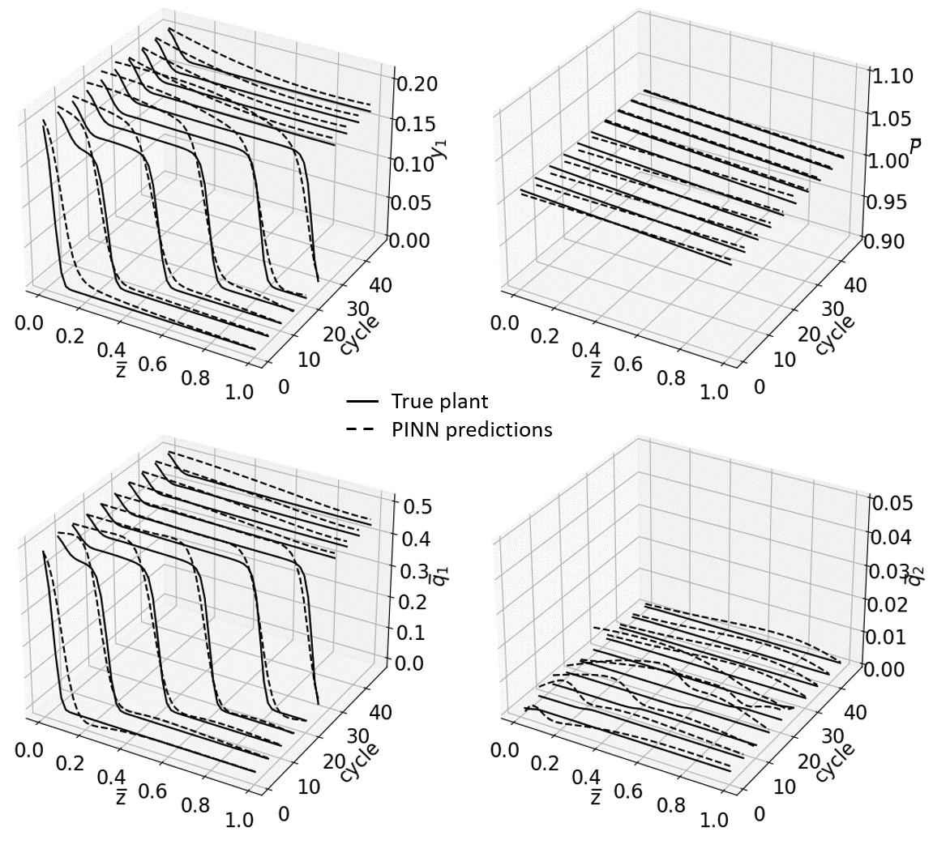
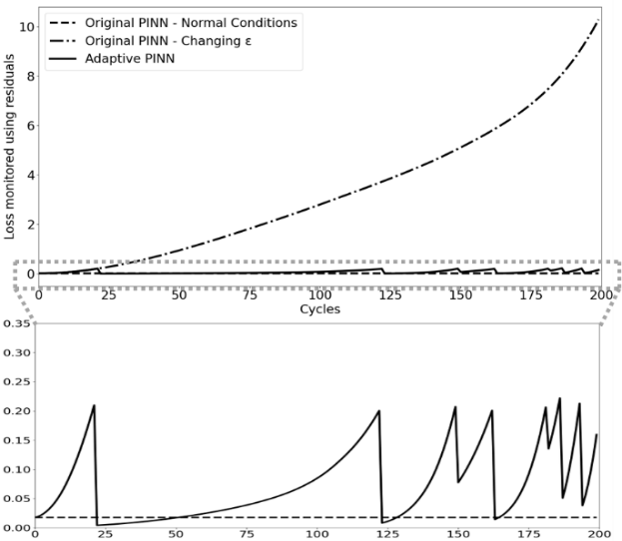
In this study, particular emphasis is placed on the adsorption step, which serves as the focal point for demonstrating the proposed methodology. The detailed model simulation was carried out for five sets of operating conditions given in Table (1), with an empty bed simulated until cyclic steady state for each operating condition, with corresponding initial condition profiles collected for subsequent analysis. $v_{feed}$ is the feed velocity, in $m/s$, at bed inlet and $t_{ads}$ is the adsorption time in seconds. Next, the adsorption step is simulated independently for each initial condition, for 50 cycles each, with $t_{ads}=25 s$ and $v_{feed}=0.5 m/s$, which are the operating conditions of interest. To emulate an actual experimental setup, the non-dimensionalized data for output variables at the feed and outlet boundaries and at initial conditions inside the bed are used for training the PINN. For every cycle, 250 random spatiotemporal collocation points are sampled within the bed using Latin Hypercube sampling to incorporate physics-based residual constraints in the PINN. The PINN architecture consists of 1 input layer with 52 neurons ($\overline{z}$, $\overline{t}$ and initial gas phase composition values at fifty grid points), 8 hidden layers with 100 neurons and one output layer with 4 neurons. Activation function for all hidden layers, except the last hidden layer, are set to “Tanh”. The model is trained using L-BFGS optimizer. A test data set is created by simulating the process again from an empty bed until cyclic steady state at $t_{ads}=25 s$ and $v_{feed}=0.5 m/s$. The testing results for each cycle at $t= t_{ads}$, for first 50 cycles are given in Fig. (1). It can be seen from the figure that the spatiotemporal profiles are predicted to a good extent using the trained PINN, even at the points within the bed where labelled data is not used. The trained model is deployed to monitor the PSA process.
Figure 1: PINN prediction performance
    - Process monitoring using PINN and model re-training
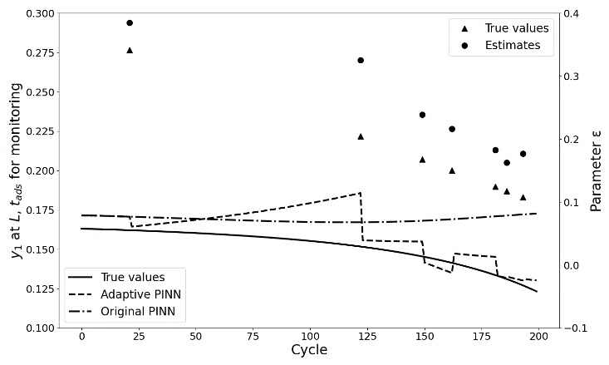
The process is simulated using the procedure discussed previously. It is assumed that the process has reached cyclic steady state and is operating under normal operating conditions with bed voidage $ε=0.37$. Cycle time for PSA is considered as sampling time for monitoring. The residual loss for monitoring is calculated according to Eq. (5) at every sampling instance by using values of $y_{1}$ and $\overline{P}$ at outlet of the bed as measurements. The loss at normal operating conditions are denoted by dashed line in Fig. (2). To emulate changes in values of process parameters, a ramp change is introduced in bed voidage in true plant simulation according to the equation $ε= -0.001357k+0.37$, where $k$ is the sampling instance. The monitoring losses calculated with the simulated change in parameter, are in Fig. (2) as dashed-dot line. As expected, the value keeps increasing with time. To evaluate the performance of model prediction, the values of gas-phase composition of CO₂ at $z=L$ and$t=t_{ads}$ are plotted in Fig. (3). Loss value reaches 0.2 at seven instances. In six of these instances, prediction improves compared to original PINN. The values of actual bed voidage $ε$ and parameter estimates obtained during re-training are also given in Fig. (3). Parameter estimation captures the trend of the changing parameter and generates values with a bias. These results demonstrate the ability of the proposed methodology in identifying parameters that cause a change in model predictions.
Figure 2: Loss monitoring using residuals
Figure 3: Parameter estimation during model re-training and comparison of adaptive PINN predictions
  - Conclusions
This study introduces an adaptive PINN framework for dynamic processes, demonstrated through a case study on PSA. The proposed method successfully detects and adapts to the changes in process parameters ensuring the model's resilience in real-world scenarios. By integrating physics-based knowledge with machine learning, the adaptive PINN methodology offers a promising solution for industries seeking robust models capable of monitoring and adapting to the evolving environmental conditions. In the future, our proposed methodology will be applied across all the four steps of the PSA process. We will also focus on multiple process parameters evolving simultaneously.
References
Darsha Kumar, D.M., Narasimhan, S., Bhatt, N., 2018. Detection of model-plant mismatch and model update for reaction systems using concept of extents. Journal of Process Control. 72, 17-29
https://doi.org/10.1016/j.jprocont.2018.08.005
McLenny, L., Braga-Neto, U., 2022. HyperPINN: Self-Adaptive Physics-Informed Neural Networks using a Soft Attention Mechanism. arXiv:2009.04544
Oshima, M., Kim, S., Shardt, Y.A.W., Sotowa, K., 2022. Effective Re-Identification of a Multivariate Process under Model Predictive Control Using Information from Plant-Model Mismatch Detection. Computer Aided Chemical Engineering. 49, 361–366.
https://doi.org/10.1016/B978-0-323-85159-6.50060-9
Raissi, M., Perdikaris, P., Karniadakis, G.E., 2019. Physics-informed neural networks: A deep learning framework for solving forward and inverse problems involving nonlinear partial differential equations. Journal of Computational Physics 378, 686–707. https://doi.org/10.1016/j.jcp.2018.10.045
Subramanian, S., Kirby, R.M., Mahoney M.W., Gholami A., 2022. Adaptive Self-supervision Algorithms for Physics-informed Neural Networks. arXiv:2207.04084.
Subraveti, S.G., Li, Z., Prasad, V., Rajendran, A., 2022. Physics-Based Neural Networks for Simulation and Synthesis of Cyclic Adsorption Processes. Ind. Eng. Chem. Res. 61, 4095–4113. https://doi.org/10.1021/acs.iecr.1c04731

