Dynamic analysis of reductant feed method on NH₃ synthesis from exhaust NO gas using NO-CO-H₂O-H₂ reaction
Huichan HWANG ª, Hideyuki MATSUMOTO ^{a,b*}, Teruoki TAGOª,
Yuichi MANAKA^{a,b}, Tetsuya NANBA^{b}
ªDepartment of Chemical Science and Engineering, Tokyo Institute of Technology, Tokyo 152-8550, JAPAN
^{b} Renewable Energy Research Center, AIST, Kooriyama 963-0215, JAPAN
*Corresponding Author’s E-mail: matsumoto.h.ae@m.titech.ac.jp
Abstract
In recent years, a novel nitrogen cycling process known as NOx to Ammonia (NTA) has gained attention as a means to convert NOx from exhaust gases into ammonia (NH₃) for resource utilization. When adsorber of NO is installed upstream of the NTA reactor and the concentration of NO flowing out changes with time, the time variation for feed concentration of the reductant should be controlled in order to maximize the NH₃ yield. In the present study, we experimentally analyze influence of feeding reductant to behavior of NH₃ production in the NO-CO-H₂O-H₂ reaction using Pt/TiO₂ catalyst. Next, two different models for reaction rate equation are derived by changing the set of elementary reactions and mass balance equation for coverage of reaction intermediates on surface of catalyst. The two different models based on the Langmuir-Hinshelwood mechanism were derived on the assumption that formates were formed on the catalyst in the elementary reaction step. When the influence of existence of H* on formate dissociation was considered, the derived model has showed higher accuracy for estimation of the yields of NH₃ and N₂. Also, we have developed dynamic simulation system by combining the plug flow reactor model including the derived reaction rate equation with a one-dimensional simulation model for NO adsorption/desorption.

Keywords: nitrogen cycle, kinetic analysis, modelling and simulation, dynamic simulation
  - Introduction
The emission of reactive nitrogen oxides from combustor has become a significant cause of environmental pollution and climate change. In recent years, a novel nitrogen cycling process known as NOx to Ammonia (NTA) has gained attention as a means to convert NOx from exhaust gases into ammonia (NH₃) for resource utilization. The synthesis and evaluation of various NTA process systems have been investigated. In previous study (T. Nanba et al., 2008), production of NH₃ using NO-H₂ reaction has been reported. Then, K. Kobayashi et al. (2019) have developed NO-CO-H₂O reaction process using Pt/TiO₂ to convert NO into NH₃. When feeding CO produced by reforming of methane, it is necessary to consider the effective use of the generated hydrogen. Therefore, we propose to apply NO-CO-H₂O-H₂ reaction process in which feed ratio of H₂ to CO (H₂/CO) is controlled through a combination of different reforming processes of methane. If the concentration of NO feeding from the outlet of adsorber to the NTA reactor changes over time, the time variation for feed concentration of the reductant should be optimized in order to maximize the NH₃ yield.

An aim of this study is to analyze influence of unsteady operation of feeding reductant to behavior of the overall process system for NH₃ synthesis in the NO-CO-H₂O-H₂ reaction by dynamic process simulation. To develop the NTA reactor model for the simulation analysis, reaction data were experimentally collected by the pack bed reactor with Pt/TiO₂ catalyst. Subsequently, two different models for reaction rate equation was derived by changing the set of elementary reactions and mass balance equation for coverage of reaction intermediates on surface of catalyst. Then we will discussed on applicability of the developed NTA reactor models.
  - Data acquisition for NO-CO-H₂O-H₂ reaction
Figure 1 shows a schematic diagram for the experimental setup for acquisition of kinetic data. To derive rate equations for NO-CO-H₂O-H₂ reaction based on the Langmuir-Hinshelwood (L-H) mechanism, not only reactor temperature but also H₂/CO in the feed reductant gas were changed by using packed bed reactor with 0.25 g of 1 wt% Pt/TiO₂ (rutile-type). The temperature was changed in the range from 175 ℃ to 325 ℃. The ratio of H₂/CO was varied from 1 to 3 by considering application of combination of the methane steam reforming and the methane dry reforming.

Figure 2 (a) and (b) showed relationships between temperature and reaction efficiency for the case when H₂/CO was 2. The composition of feed gas was NO: 0.6 %, CO: 0.5 % H₂O: 0.9 %, H₂: 1 %. As the temperature increased, it was shown that the conversion of NO and CO increased and reached nearly 100 % at temperature over 275 °C. Moreover, there was a noticeable steep increase in the yield of NH₃ with increase in temperature. However, over 275 °C, change in the yield of NH₃ exhibits very small, whereas the yield of N₂ shows an increasing behaviour. The formation of a tiny amount of N₂O was also observed under condition of low temperature.
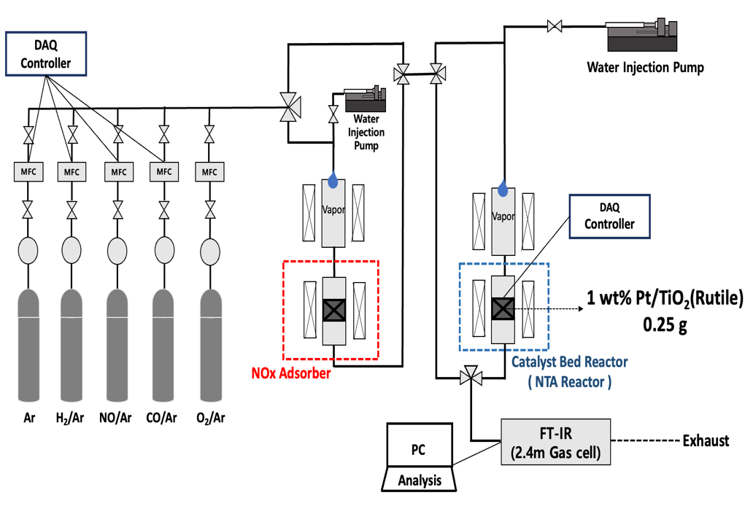
Figure 1 Experimental setup for acquisition of kinetic data
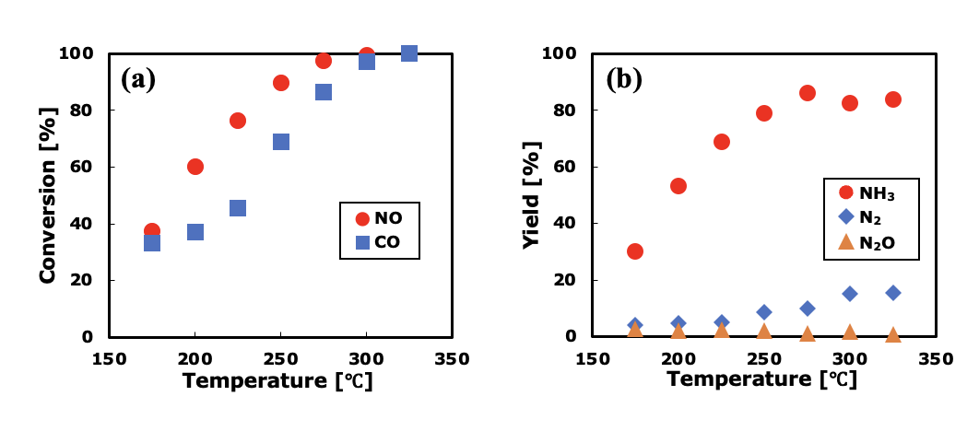
Figure 2 Relationships between temperature and reaction efficiency for the case when H₂/CO was 2; (a) Conversions of NO and CO, (b) Yields of NH₃, N₂, N₂O

For the case when the H₂/CO was 3, the conversion of NO and CO increased with increase in temperature and reached nearly 100 % at temperature over 275 °C, which was similar to the case when the H₂/CO was 2. It was showed that the yield of NH₃ increased with increase in temperature, while the yield slightly decreased over 300 °C. The cause of the decreasing trend in yield will be discussed in the next section using a reaction rate model. Hence, it has been demonstrated that behaviour of NH₃ formation could be controlled by the reaction temperature and the composition ratio of the reductant feed.
  - Derivation of reaction rate equations for NTA reactor model
In order to derive reaction rate equations based on the L-H mechanism, we investigated combination of multiple elementary reactions for the NO-CO-H₂O-H₂ reaction, as shown in Table 1. For NO-CO-H₂O reaction using Pt/TiO₂ catalyst, K. Kobayashi et al (2019) has reported formation of formate, which acted as the most abundant surface intermediates (MASI), could progress formation of ammonia. Thus, in order to develop the reaction rate equation model for NO-CO-H₂O-H₂ reaction, it was also considered that several chemical reactions on surface of the Pt/TiO₂ catalyst involved the adsorption of NO and CO, as well as intermediate reactions such as formate formation.

Reactions Ai ~ Ci in Table 1 represent the adsorption of NO and CO, dissociative adsorption of H₂O and H₂, and intermediate reactions including nitrogen hydride groups NH_{x}* related to NH₃ formation. Di represents the elementary reaction step for formation of N₂ as side reactions. It has been reported that the energy barrier to breaking N-O on the surface of Pt catalyst is high (Y. Bai and M. Mavrikakis 2017). Since direct dissociation of NO tends to proceed, it is necessary to consider reaction intermediates derived from NO* in the elementary reaction steps. Therefore, the reaction
“ NO* + N* → N₂O”can be considered,but as shown in Fig. 2(b), the concentration of N₂O produced is extremely small, so we did not include the formation of N₂O in the elementary reaction step in the present study. And formation of NH₃ (Eq. (11)) and N₂ (Eq. (12)) has assumed as the rate-determining step (RDS), respectively.

In the present paper, two models (model A and model B) were derived by setting the different assumption for coverage of reaction intermediates on surface of catalyst. In derivation of the model A, we assumed a mass balance equation written in Eq. 13, for coverage of chemical species on the the catalyst active sites.
$$θ_{CO*}+θ_{NO*}+θ_{H*}+θ_{OH*}+θ_{COOH*}+θ_{NHx*}+θ_{*}=1$$ | (13)
Table 1 Elementary reactions and reaction rate equations
Reaction |  | Rate expression | Eq
A1 | NO(g) + * ↔ NO* | $$θ_{NO*}=k_{A,1}θ_{*}P_{NO}$$ | (1)
A2 | H₂O(g) + * ↔ H₂O* | $$θ_{H2O*}=k_{A,2}θ_{*}P_{H2O}$$ | (2)
A3 | H₂(g) + 2* ↔ 2H* | $$θ_{H*,1}=θ_{*}\sqrt{k_{A,3}P_{H2}}$$ | (3)
A4 | H₂O* + * ↔ H* + OH* | $$θ_{H*,2}=k_{A,4}\frac{θ_{H2O*}θ_{*}}{θ_{OH*}}$$ | (4)
A5 | CO(g) + * ↔ CO* | $$θ_{CO*}=k_{A,5}P_{CO}θ_{*}$$ | (5)
B1 | CO* + OH* ↔ COOH* + * | $$θ_{COOH*}=k_{B,1}\frac{θ_{CO*}θ_{OH*}}{θ_{*}}$$ | (6)
B2 | COOH* H* + CO₂(g) | $$θ_{H*}=k_{B,2}θ_{COOH*}$$ | (7)
C1 | NO* + H* ↔ NOH* + * | $$θ_{NOH*}=k_{C,1}\frac{θ_{NO*}θ_{H*}}{θ_{*}}$$ | (8)
C2 | NOH* + H* ↔ NH* + OH* | $$θ_{NH*}=k_{C,2}\frac{θ_{NOH*}θ_{H*}}{θ_{OH*}}$$ | (9)
C3 | NH* + H* ↔ NH₂* + * | $$θ_{NH2*}=k_{C,3}\frac{{θ_{NH*}θ}_{H*}}{θ_{*}}$$ | (10)
C4 | NH₂* + H* NH₃(g) + 2* | $$r_{NH3}=k_{C,4}{θ_{NH2*}θ}_{H*}$$ | (11)
D1 | NH* + NO* N₂(g) + OH* + * | $$r_{N2}=k_{D,1}θ_{NH*}θ_{NO*}$$ | (12)

Then, in model B, adsorption and reaction of H* and OH* that were not involved in reaction step B_{i} were also considered, and two reaction rate equations (Eqs. (15) and (16)) were introduced in addition to Eq. (14) including $θ_{OH*,2}$ and $θ_{NHx*,2}$. By introducing such an assumption, we observed a slight improvement in predictive performance compared to the model A.
$$θ_{CO*}+θ_{NO*}+θ_{H*}+θ_{OH*}+θ_{OH*,2}+θ_{COOH*}+θ_{NHx*}+θ_{NHx*,2}+θ_{*}=1$$ | (14)
$$θ_{OH*,2}=k_{OH*,2}{P_{H2O}}^{1}{P_{H2}}^{-1.5}θ_{*}$$ | (15)
$$θ_{NHx*,2}=k_{NHx*,2}{ P}_{NO} {P_{H2O}}^{-1}{P_{H}}^{α} θ_{*}$$ | (16)
Furthermore, we supposed that dynamics of dissociation of formate on the catalyst influenced the rate of formation of NH₃, since formation of formate was largely related to NH₃ production that K. Kobayashi et al. (2019) have described. Thus, for rate expression of dissociation of formates (step B2 in Table 1), the influence of existence of H* on formate dissociation was considered in derivation of model B. In this study, the rate expression in step B2 was replaced with the rate equation for the equilibrium reaction.

Reaction rate expressions for formation of NH₃ and N₂ given by Eqs. (17) ~ (19) were drived for model B. Since influence of partial pressure of CO, H₂O on NH₃ synthesis step considered in model B, parameter β was introduced in the term related to NH* adsoprtion in Eq. (19). Also, regarding model A, some terms in the denominator of Eqs. (17) and (18) were different from model B. Furthermore, exponent of the denominator was set as
x = 4 in model B, while x = 2 in model A.

$$r_{ NH3,model B}=\frac{(k_{NH3f,1}P_{NO}{P_{CO}}^{2.5}{P_{H2O}}^{1.5}+k_{NH3f,2}{ P}_{NO} {P_{H2}}^{2.5})}{{f(P_{j})}^{x}}$$ | (17)
$$r_{N2,model B}= \frac{{(k}_{N2f,1}{{ P}_{NO}}^{2} {P_{CO}}^{y}+k_{N2f,2}{{ P}_{NO}}^{2} {P_{H2}}^{z})}{{f(P_{j})}^{2}}$$ | (18)
$f(P_{j})= 1+k_{NO*}P_{NO}+k_{CO*}{ P}_{CO}+\frac{k_{H*}{P_{H2O}}^{0.5}{P_{CO}}^{0.5}}{{P_{CO2}}^{0.5}}+\frac{k_{OH*}{P_{H2O}}^{0.5}{P_{CO2}}^{0.5}}{{P_{CO}}^{0.5}}+k_{OH*,2}P_{H2O}{P_{H2}}^{-1.5}$ | (19)
$${+ k}_{COOH*}{P_{H2O}}^{0.5}{P_{CO2}}^{0.5}{P_{CO}}^{0.5}+\frac{k_{NH*}{ P}_{NO} {P_{H2O}}^{β-0.5}{P_{CO}}^{β+0.5}}{{P_{CO2}}^{0.5}}+\frac{k_{NHx*,2}{ P}_{NO} {P_{H2}}^{2.5}}{{ P}_{H2O}}$$
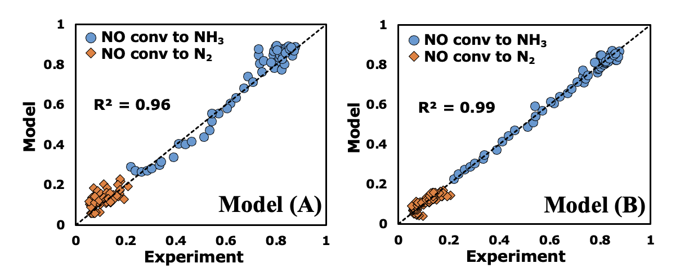
Figure 3 Results of parameter estimation for model A and model B

Figure 3 illustrates the differences between the model in terms of yield. Through parameter fitting using the above mentioned process data in Figure 2 (b) , the model B showed higher accuracy (R² = 0.99) for estimation of the yields of NH₃ and N₂ than the model A. In particular, application of Model B improved the predictive performance of ammonia yield in the temperature range of 275°C or higher. In this study, we employed a model where the reaction orders for the partial pressures of CO and H₂ were denoted as y and z on numerator following in Eq. (18) to investigate the influence of the H₂/CO supply ratio on the side reaction. As a result, the partial pressure of CO and H₂ that was assigned a reaction order represented y = -0.68 and z = -0.94 in model B as parameter estimation results. On the other hand, the derived reaction orders y and z were almost 0 in model A, which does not show any other effect of CO and H₂ feed.
  - Conclusion
We experimentally analyzed influence of feeding reductant to behavior of NH₃ production in the NO-CO-H₂O-H₂ reaction using Pt/TiO₂ catalyst. Next, two different models (model A, model B) for reaction rate equation are derived by changing the set of elementary reactions and mass balance equation for coverage of reaction intermediates on surface of catalyst. When the influence of existence of H* on formate dissociation was considered in deriving model B, the model B has showed higher accuracy for estimation of the yields of NH₃ and N₂ than model A. Also we have developed dynamic simulation system by combining the plug flow reactor model including the derived reaction rate equation with a one-dimensional simulation model for NO adsorption/desorption. Figure 4 shows an example of the results of the outlet gas concentration that were acquired by using the dynamic simulation system. In future work, methods for optimization of unsteady operation of flow rate and composition of reductants (CO, H₂, H₂O) for maximizing NH₃ yield and CO consumption will be investigated by the developed dynamic simulation system.

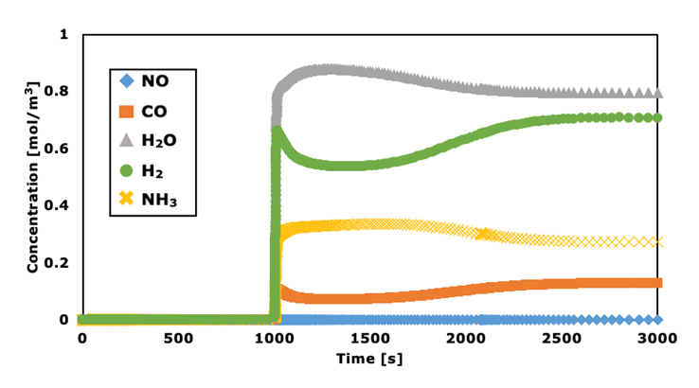
Figure 4 The result of outlet concentration using dynamic simulation for a case when H₂/CO ratio was 2 and the reactor temperature was 300°C
References
T. Nanba et al., 2008, Formation of Ammonia during the NO−H₂ Reaction over Pt/ZrO₂, J. Phys. Chem. C, 112, 46, 18157–18163.

K. Kobayashi et al., 2019, Effect of the TiO₂ crystal structure on the activity of TiO₂-supported platinum catalysts for ammonia synthesis via the NO–CO–H₂O reaction, Catal. Sci. Technol., vol. 9, no. 11, pp. 2898–2905.

Y. Bai and M. Mavrikakis 2017, Mechanistic Study of Nitric Oxide Reduction by Hydrogen on Pt(100) (I): A DFT Analysis of the Reaction Network, J. Phys. Chem. B, 122, 2, 432–443.

