Modelling Natural Gas Dehydration by Adsorption under High CO₂ Conditions
Yuri Alvesª, Felipe R. Pintoª, Felipe C. Cunhaª, Argimiro R. Secchiª, Dárley Melo^{b}, Amaro G. Barreto Jr.ª*
ªPostgraduate Program in Chemical and Biochemical Process Engineering – EPQB, Universidade Federal do Rio de Janeiro, Brazil
^{b}Petrobras - Research, Development, and Innovation Center - CENPES, Rio de Janeiro, Brazil
amaro@eq.ufrj.br
Abstract
This study aims to gather information on high-pressure gas dehydration, intending to model, compare, and simulate breakthrough curves, evaluating their performance in a binary mixture of H₂O/CO₂. Our approach considers the presence of other components in calculating the water fugacity in the gas phase under high pressure. The water adsorption process using zeolite 4A under high-pressure conditions is simulated, and the results are meticulously compared. The findings underscore the significance of this consideration, revealing differences of up to 24 hours compared to models that overlook this factor.
Keywords: adsorption, natural gas dehydration, modelling, high pressure.
  - Introduction
Natural gas conditioning aims to remove impurities such as water (H₂O), carbon dioxide (CO₂), nitrogen (N₂), hydrogen sulphide (H₂S), and other contaminants. In this regard, there is a need for some treatment or conditioning processes to ensure compliance with industry specifications, safety standards, and transportation of natural gas (NG). Among these contaminants, water in gas streams can pose a significant challenge to the primary stages of natural gas processing. Thus, moisture removal is crucial to prevent two common problems in high-pressure and low-temperature gas streams: hydrate formation and corrosion.
Adsorption dehydration emerges as a viable option and is widely employed when there is a requirement to achieve very low levels of water vapour content (1 ppm) in large gas flows. In this context, solid desiccants such as zeolites, silica gel, and alumina are preferred for natural gas dehydration. The adsorption operation is carried out through cyclic processes with two main steps: an adsorption step (in which water molecules are retained by the adsorbent) and regeneration step (in which water molecules are removed from the adsorbent). The adsorbent regeneration can be achieved through temperature swing adsorption (TSA) or pressure swing adsorption (PSA). TSA-based processes appear to be the most viable alternative for water vapour removal in gas streams for offshore oil industry operations under high-pressure conditions.
Berg et al. (2019) reviewed adsorptive processes used in industrial natural gas processing and concluded that TSA is an established and essential process, but thermodynamic and kinetic principles still need to be fully understood. More recently, Cavalcante and Pessoa (2023) presented a simulation study regarding the effects of adsorbent aging. However, in addition to high-pressure operations, a high CO₂ content can also become a challenge in some oil and gas exploration fields. In this context, the state-of-the-art phenomenological modelling of TSA processes has seldom explored such field operation conditions (Gholami et al., 2010).
TSA process modelling requires a deep understanding of adsorption equilibrium and the transport of components in the porous media. In this scenario, experimental adsorption equilibrium data for CO₂ are available in the literature in a wide range of pressures and temperatures for several adsorbents. However, such data are scarce for water vapor, and existing data are in sub-atmospheric conditions for a few temperatures and adsorbents (Wynnyk, 2019; Wilkins et al., 2021).
Therefore, this work aims to develop a theoretical/computational model to simulate the natural gas dehydration process. In the obtained simulations, the feed stream consists of a mixture containing water and CO₂ at a temperature of 40 °C. Two molar fractions of water were used in the feed stream: 7.1×10⁻⁴ at 1 bar and 1.4×10⁻⁵ at 50 bar, with both cases corresponding to a concentration of 36.8 mmol/m³ of water. The adopted approach considers the impact of increasing pressure on calculating water fugacity in the gas phase. For this purpose, the Peng-Robinson equation of state is employed to consider this effect. The main goal of this study is to deepen the understanding of the effects of water vapor adsorption in the presence of CO₂ at high pressure through the analysis of breakthrough curves obtained from modeling that utilizes the Peng-Robinson equation of state.
  - Methods
    - Mathematical modeling
The mathematical description of a fixed bed adsorption process encompasses principles of mass, energy, and momentum conservation coupled with thermodynamic models. The solution to this problem involves the numerical resolution of a system of partial differential equations (PDEs) for each adsorption and regeneration stage sequentially, with appropriate boundary conditions to reflect the sequence of steps in each cycle of an interconnected column system. In this study, the focus is on understanding the adsorption operation in a single column. The simulation of the adsorption column considered the following hypotheses: constant mass and heat transfer coefficients, negligible pressure drop, constant superficial velocity, mass transfer of components between fluid and solid phases described by the Linear Driving Force (LDF) model, and the Peng-Robinson equation of state for the bulk phase.
Additionally, the numerical resolution of the PDE system was performed by the finite difference method in the axial coordinate, and numerical integration was performed using DASSLC (Differential-Algebraic System Solver in C) for Backward Differentiation Formula (BDF) in the temporal coordinate. The EMSO software was utilized to implement and solve the model (Soares and Secchi, 2003). Given the principles of adsorption, the basic equation to describe the dynamics of a fixed bed is derived from an infinitesimal mass balance per component in the gas phase:
$$D_{z,i}\frac{∂^{2}C_{i}}{∂z^{2}}+\frac{∂\left(uC_{i}\right)}{∂z}+\frac{∂C_{i}}{∂t}+\left(\frac{1-ϵ}{ϵ}\right)ρ_{s}\frac{∂{\overline{q}}_{i}}{∂t}=0$$ | (1)
In which, $D_{z,i}$ is the effective axial dispersion coefficient, $C_{i}$ is the concentration of component i in the fluid phase, u is the fluid velocity, ε is the bed void fraction, $ρ_{s}$ is the density of the adsorbent, and $\overline{q_{i}}$ is the average concentration in the adsorbed phase. For the mass balance in the solid phase, the Linear Driving Force (LDF) model is presented:
$$\frac{∂{\overline{q}}_{i}}{∂t}=k_{i}(q_{i}^{*}-{\overline{q}}_{i})$$ | (2)
In which, $k_{i}$ is a global coefficient of mass transfer resistance, and $q_{i}^{*}$ is the concentration of species i in the adsorbed phase in equilibrium with the concentration of the fluid phase. There are various proposals for the calculation of the coefficient $k_{i}$ depending on the dominant resistance type in the system. Equation 3 describes the energy balance in the gas phase:
$${-λ}_{L}\frac{∂^{2}T_{g}}{∂z^{2}}+ρ_{g}C_{g}\frac{∂\left(uT_{g}\right)}{∂z}+ρ_{g}C_{g}\frac{∂T_{g}}{∂t}+\left(\frac{1-ϵ}{ϵ}\right)h_{f}a_{s}\left(T_{g}-T_{s}\right)+\frac{4h_{w}}{ϵd_{int}}\left(T_{g}-T_{w}\right)=0$$ | (3)
wherein $λ_{L}$ is the effective axial thermal dispersion, $T_{g}$ is the temperature of the gas, $T_{s}$ is the temperature of the solid, $T_{w}$ is the temperature of the wall, $ρ_{g}$ is the density of the gas, $C_{g}$ is the heat capacity of the gas, $h_{f}$ is the heat exchange coefficient between gas and adsorbent, $a_{s}$ is the ratio of external surface area to volume of the particle, $h_{w}$ is the coefficient of internal convection heat transfer between the gas and the column wall, and $d_{int}$ is the internal diameter of the column. Finally, the energy balances in the solid phase and on the wall of column are given by Eqs. 4 e 5:
$$ρ_{s}C_{s}\frac{∂T_{s}}{∂t}=h_{f}a_{s}\left(T_{g}-T_{s}\right)+\sum_{i=1}^{n}{(-ΔH_{i})\frac{∂{\overline{q}}_{i}}{∂t}}$$ | (4)
$$ρ_{w}C_{w}\frac{∂T_{w}}{∂t}=h_{w}a_{w}\left(T_{g}-T_{w}\right)+Ua_{a}(T_{∞}-T_{w})$$ | (5)
wherein $C_{s}$ is the heat capacity of the adsorbent, H_{i} is the enthalpy of adsorption of component i, $C_{w}$ is the heat capacity of the column wall, $ρ_{w}$ is the density of the column wall, $a_{w}$ is the ratio of the internal surface area to volume of the column wall, U is the overall external heat transfer coefficient, $a_{a}$ is the ratio of the external surface area to volume of the column wall, and $T_{∞}$ is the ambient temperature.
The initial and boundary conditions are the following:
 | Mass balance | Energy balance
t = 0: | $$C_{i}=0, {\overline{q}}_{i}=0$$ | $$T_{g}=T_{i}^{0},T_{s}=T_{i}^{0},T_{w}=T_{∞}$$
z = 0: | $$D_{z,i}\frac{∂C_{i}}{∂z}=u_{0}[C_{i}-C_{i}^{0}]$$ | $$λ_{L}\frac{∂T_{g}}{∂z}=ρ_{g}C_{g}u[T_{g}-T_{g}^{0}]$$
z = L: | $$\frac{∂C_{i}}{∂z}=0$$ | $$\frac{∂T_{g}}{∂z}=0$$

Table 1 provides information regarding the fixed bed considered for simulation, along with some properties treated as constants. Further constitutive equations of the model are presented by Braun (2019).
Table 1 - Column parameters
Bed length ($L$) | 0.5 m | Thermal conductivity ($k_{w}$) | 17 W/m/K
Bed diameter ($d_{int})$ | 0.038 m | Heat capacity ($C_{w}$) | 500 J/kg/K
Bed specific mass ($ρ_{w}$) | 8000 kg/m³ | Bed void fraction ($ϵ$) | 0.42
Volumetric flow ($Q$) | 0.5 m³/h
    - Adsorption isotherm

Proper modelling of the adsorption isotherm is crucial for evaluating the type of adsorbent and understanding the behaviour of beds containing porous materials. This study employed a Langmuir-type model for water adsorption on zeolite. The pressure information has been replaced by the fugacity of the component in the isotherm model to adapt the modelling to high-pressure and high CO₂ content conditions.
$$q_{i}^{*}=n^{∞}\frac{Kf_{i}}{1+Kf_{i}}, where K=K_{0}\exp\left(-\frac{ΔH}{RT}\right)$$ | (6)
Although the isotherm model considers both components for adsorption, the water’s equilibrium constant, K, is significantly higher than that of CO₂. This reflects the greater affinity of water for the adsorbent, resulting in a situation where there is minimal competition for adsorption sites. Water molecules have a stronger tendency to displace CO₂ molecules and occupy the available sites. Therefore, we assume that only water is being adsorbed. Lastly, parameter estimation employed a hybrid procedure that combines a nondeterministic method, such as Particle Swarm Optimization (PSO), with a deterministic Newton-like method.

  - Results and Discussion
From the experimental equilibrium data presented in Wynnyk (2019), parameters were obtained to construct the water adsorption isotherm at temperatures of 298, 323, 348, 373, and 398K. The obtained parameters are presented in Table 2. It is important to emphasize that the estimation was performed using the entire set of experimental data, and Figure 1 illustrates the fit of the modified Langmuir model.
Table 2 - Estimated parameters for Langmuir isotherm model
Parameter | 4A
$n^{∞}$(mol/kg) | 13.3
$K_{0}$(1/bar) | 7.14×10⁻⁴
$ΔH$(J/mol) | 4.158×10⁻⁴
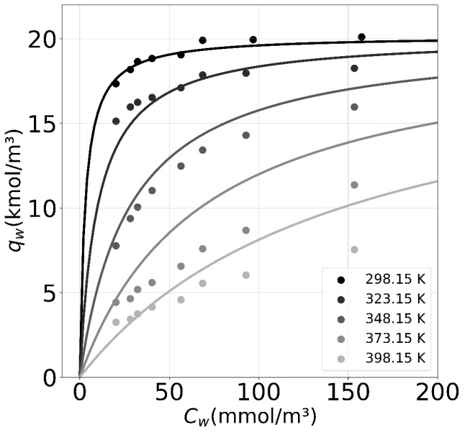
Figure 1 - Calculated adsorption isotherms for water vapor adsorption on zeolite 4A at different temperatures. Experimental data are represented by markers (Wynnyk, 2019).
Using the estimated parameters for water adsorption on zeolite 4A, a series of simulations were conducted to evaluate a fixed-bed adsorption column. Based on data obtained at low pressures, the model was developed for application over a broader range, considering the pressure effect on the fugacity of each component in the mixture that forms bulk phase. Consequently, breakthrough curves were obtained at 1 bar and 50 bar pressures. Figure 2a displays the critical results obtained.
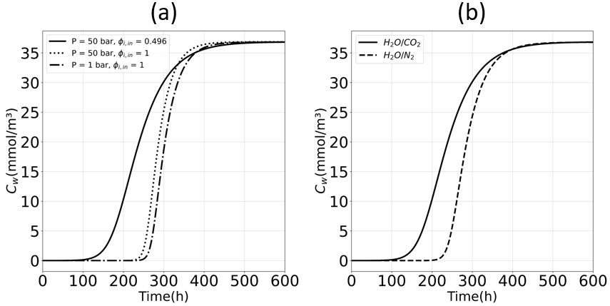
Figure 2 - (a) Breakthrough curves at 313K H2O/CO2 in different conditions (b) Breakthrough curves at 40 °C and 50 bar for H2O/N2 and H2O/CO2 mixtures

In Figure 2a, it is possible to observe three breakthrough curves at different pressures, each associated with distinct fugacity coefficients in the feed, given that f_{i} = x_{i} φ_{i} P, and φ_{i} is a function of P and x_{i}, causing f_{i} to vary along z and t. The difference between the solid curve, representing breakthrough at high pressure considering the pressure effect, and the dashed curve, also at high pressure assuming the fugacity coefficient is equal to 1 (i.e., ideal gas), is approximately 24 hours. Under industrial operating conditions, this time difference could mean a significant cost increase. Another observed effect is the increase in pressure when considering the fugacity coefficient as 1. Thus, precise calculation becomes evident when dealing with water adsorption at high pressures.
To demonstrate the effect of fugacity in the mixture, Figure 2b compares the breakthrough curves when feeding the column with H₂O/N₂ and H₂O/CO₂ mixtures under high-pressure conditions (50 bar). It can be observed that bed saturation occurs more rapidly when CO₂ is present in the gas stream. This is attributed to the lower fugacity coefficient for water in the H₂O/CO₂ mixture, which is 0.49, compared to the H₂O/N₂, which is 0.75.
  - Conclusion
A computational model was developed to simulate natural gas dehydration at high pressure in the presence of CO₂, using experimental data of zeolite 4A available in the literature. The model generated relevant breakthrough curves, and the results highlighted the crucial importance of calculating the fugacity coefficient in the operation time of the process. This consideration can lead to differences of up to 24 hours compared to models that do not consider this factor. A common area for improvement in the literature is using low-pressure data, extrapolating to high pressure with a correction only in the isotherm parameters, neglecting the correction in fugacity. As demonstrated in this work, this approach can lead to prediction errors, resulting in higher operational costs. Therefore, the findings and information provided by the computational model contribute significantly to an enhanced understanding of natural gas dehydration processes.
  - Acknowledgements
The authors gratefully acknowledge Conselho Nacional de Desenvolvimento Científico e Tecnológico (CNPq), Fundação de Amparo à Pesquisa do Estado do Rio de Janeiro (FAPERJ), Brazil, Coordenação de Aperfeiçoamento de Pessoal de Nível Superior (CAPES), Brazil, and Petrobras-ANP (Agência Nacional do Petróleo) for the financial support.
References
Berg, F., Pasel, C., Eckardt, T., & Bathen, D. (2019). Temperature Swing Adsorption in natural gas processing: A concise overview. ChemBioEng Reviews, 6(3), 59-71.
Braun, F. E. (2019). Modelagem e otimização de projeto de unidades de desidratação de gás natural por adsorção. MSc Dissertation. Federal University of Rio de Janeiro, Brazil.
Gholami, M., Talaie, M. R., & Roodpeyma, S. (2010). Mathematical modeling of gas dehydration using adsorption process. Chemical Engineering Science, 65(22), 5942-5949.
Cavalcante, C. J., & Pessoa, P. de A. (2023). Modeling and simulation of an industrial adsorption process of dehydration of natural gas in 4A molecular sieves. Results in Engineering, 18, 101144.
Soares, R. D. P., & Secchi, A. R. (2003). EMSO: A new environment for modelling, simulation and optimisation. In Computer Aided Chemical Engineering, Vol. 14, pp. 947-952. Elsevier.
Wilkins, N. S., Rajendran, A., & Farooq, S. (2021). Dynamic column breakthrough experiments for measurement of adsorption equilibrium and kinetics. Adsorption, 27(3), 397-422.
Wynnyk, K. G. (2019). High-pressure Adsorption Equilibria Aimed at Optimizing Sour Gas Conditioning. Thesis Phd. University of Calgary, AB, Canada.

