Haber-Bosch process alternatives for the production of green ammonia
João Leitãoª, A. Amorimª, Catarina G. Braz^{b}, Henrique A. Matosª
ª Centro de Recursos Naturais e Ambiente, Instituto Superior Técnico, Universidade de Lisboa, Av. Rovisco Pais 1, 1049-001 Lisboa, Portugal
^{b}Industrial Process and Energy Systems Engineering (IPESE), École Polytechnique Fédérale de Lausanne, Lausanne, Switzerland
henrimatos@tecnico.ulisboa.pt
Abstract
This work focuses on the simulation with Aspen Plus V11 of a conventional Haber-Bosh (HB) and an absorbent-enhanced HB process (AE-HB) to produce green ammonia. Both simulations can be divided into three separate parts, the hydrogen synthesis, through water electrolysis, the nitrogen production, accomplished with a cryogenic air separation unit, and the ammonia synthesis loop, which can be absorbent-enhanced or not.
To evaluate the energy requirements of these production processes, an energy analysis was performed for each simulation and further heat integration was explored using Aspen Energy Analyzer.
Keywords: Haber-Bosch, green ammonia, water electrolysis, heat integration, Aspen Plus.

Introduction
Climate change is one of the largest problems of the next decades and countries are starting to be legally obliged to tackle it. The European Parliament has adopted the European Climate Law, in which the EU must reduce net greenhouse gas emissions by at least 55 % by 2030 and achieve climate neutrality by 2050.
Ammonia is a vital compound in the agricultural industry due to its large application in nitrogen-based fertilisers. More recently, it has been considered a promising hydrogen carrier, due to its low pressure and temperature storage conditions combined with its high volumetric hydrogen content, 121 kg H2/m3, which is almost two times higher than liquid hydrogen. Which is why it’s seen as a key player in achieving the decarbonization goals set by the European Union.
The most common ammonia production pathway is the Haber-Bosch process, accounting for over 1 % of total carbon emissions, emphasizing the need for its carbon footprint minimization.
With this in mind, the development and optimization of large-scale green ammonia production processes are of the utmost relevance to ensure green ammonia can substitute current ammonia synthesis processes and help decarbonise some of the biggest GHG emitting industries.
One of the current challenges in green ammonia production is reducing its energy consumption, where the separation of ammonia by absorption is seen as a possible alternative. Absorption requires elevated temperatures, unlike separation by condensation, which requires cryogenic temperatures, eliminating the necessity to use so much energy in the cooling of the reactor effluent.

Methodology
The development of a large-scale green ammonia production plant was simulated in Aspen Plus V11, with three main process sections. The hydrogen synthesis through alkaline water electrolysis, the nitrogen production, in a cryogenic air separation unit, and the ammonia synthesis loop, which can be carried out with absorption or without. A green NH₃ production of 200 kt/y was set as a production goal, meaning that 35.5 kt/y of green H₂ and 164.5 kt/y of N₂ are necessary.
The air separation unit was adapted from a model developed by Amorim (2023), whilst the hydrogen production section was simulated using an electrolyser model imported from Aspen Custom Modeler, which was adapted from the work of Amores et al (2021).
Regarding the energy analysis of the process, Aspen Energy Analyser was used to retrieve the energy consumption values of each process section and to perform heat integration when necessary.

Results

Nitrogen production
Focusing first on the nitrogen production section, a cryogenic Air Separation Unit (ASU) was chosen as the appropriate method due to its prevalence in the industry and elevated capacity, which will be required throughout this process. The flowsheet for this section is represented in Figure 1.
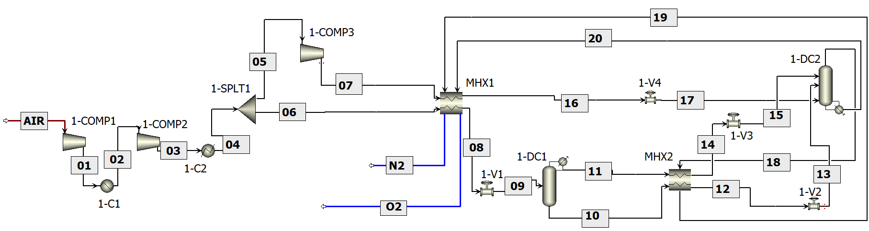
Figure 1 - Flowsheet of the ASU section.
Multiple sensitivity analyses were performed on the different equipment in order to reach the best conditions that maximize N₂ production and purity, with the final results being shown in Table 1.
Table 1 – Main parameters of the ASU.
Parameter | ASU
Total N₂ flow (kt/y) | 163.6
N₂ purity (%_{wt}) | 99.1
Process yield (%) | 99.3

The two-column design for the ASU proved to be satisfactory, with the N₂ flow produced being 0.5 % below the desired value, while the nitrogen purity obtained is acceptable regarding ammonia production.

Hydrogen production
The next step towards green ammonia production is the hydrogen synthesis section. Alkaline water electrolysis was chosen as the appropriate technology for water electrolysis since it is well-documented, with low costs, and the most common process to produce green hydrogen. The H₂ production flowsheet is represented in Figure 2.
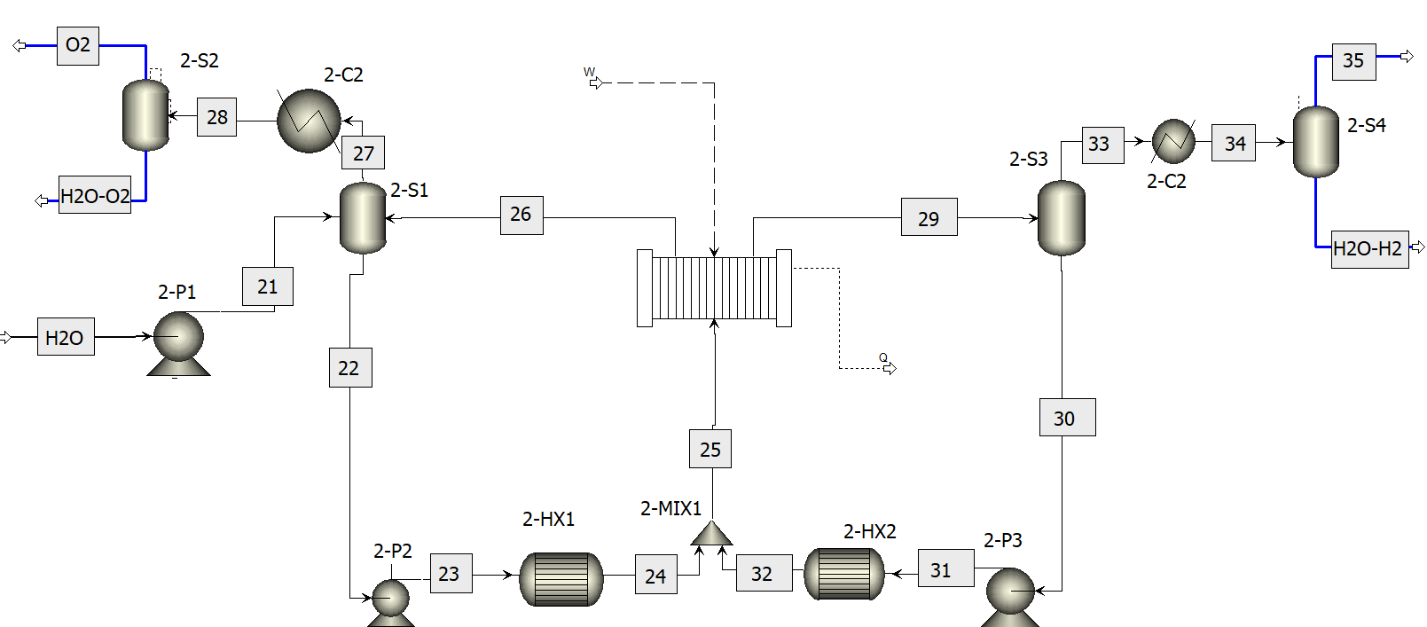
Figure 2 - Flowsheet of the AWE.
The electrolyser model was defined by specifying four different parameters – fraction of heat lost to surroundings, pressure, number of cells and area of each cell. To control the hydrogen flow that was produced, the power of the electrolyser also had to be defined. Different simulations were performed to obtain the best electrolyser conditions, and the results for the hydrogen production section are shown in Table 2.

Table 2 - Main parameters and results of the H₂ production section
Parameter | AWE | Result | AWE
Fraction of heat lost | 0.1 | Total H₂ flow (kt/y) | 34.9
Pressure (bar) | 6.7 | H₂ purity (%wt) | 99.2
Number of cells | 770 | HTO (%)) | 1.5
Area of each cell (m²) | 3.1 | Energy efficiency (%) | 72.4
Power (MW) | 200 | Faraday efficiency (%) | 88.4

The results obtained for the H₂ production are satisfactory, with the flow being 1.6 % below desired and the purity being acceptable for NH₃ production. It is important to mention the Hydrogen to Oxygen (HTO) diffusion rate being lower than 2 % since HTO’s higher than this value can lead to explosive mixture.

Green ammonia production
The final step to complete the large-scale green ammonia production plant is the ammonia synthesis loop, shown in Figure 3.
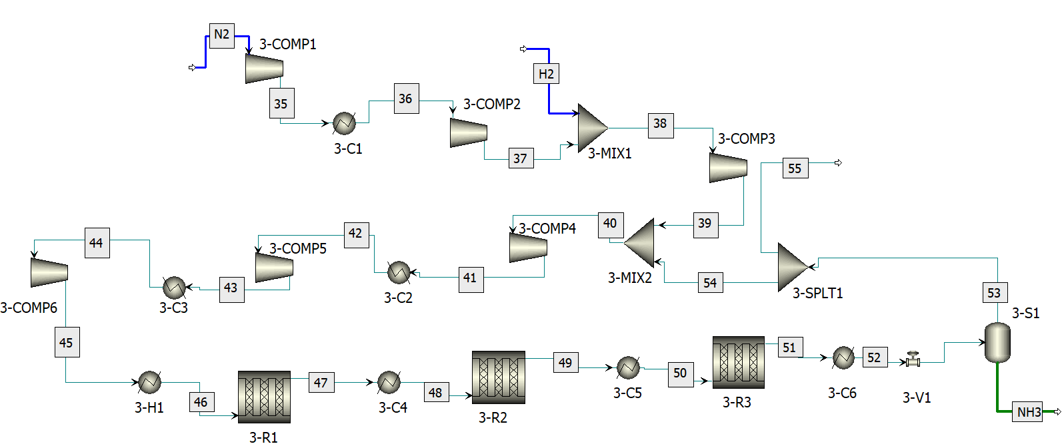
Figure 3 - Flowsheet of the HB process.
An alternative to this process was also developed, the absorbent-enhanced HB process (AE-HB), where the separation of ammonia occurs by absorption instead of condensation, using MgCl₂ as an absorbent, as represented in Figure 4.
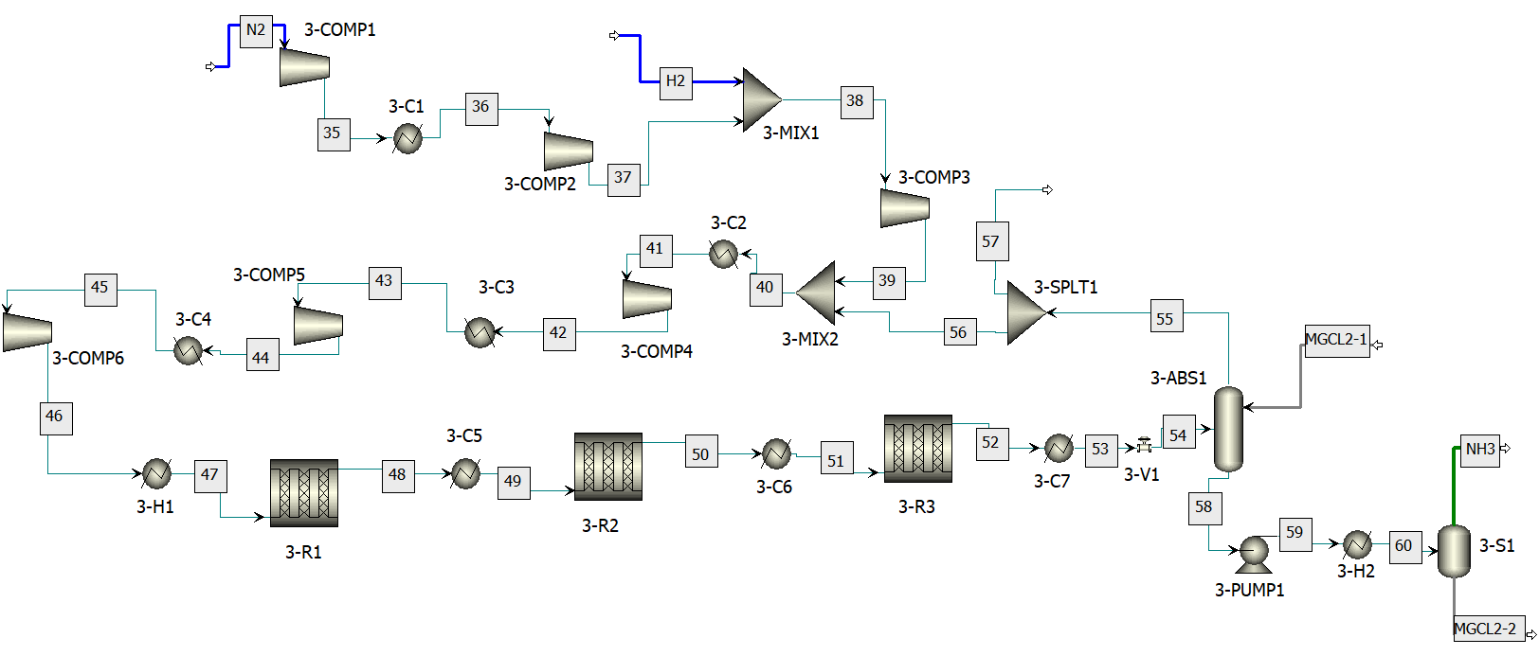
Figure 4 - Flowsheet of the AE-HB process.
The results for both simulations are presented in Table 3. It is clear that the HB process obtained satisfactory results, with high purity and conversion values, and a production 5 % below its goal. As for the AE-HB process, the absorption process led to too many inefficiencies which not only affected the final product purity but also its total production.
Table 3 – Main parameters for the HB and AE-HB processes.
Parameter | HB | AE-HB
Total N₂ flow (kt/y) | 190.9 | 178.1
NH₃ purity (%wt) | 99.7 | 90.7
NH₃ conversion (%) | 97.0 | 90.4

Energy consumption
An energy analysis was performed for each section of the process mentioned previously, with the results being shown in Figure 5.

Figure 5 - Energy consumption values for the different production processes.
The energy results show that the nitrogen and hydrogen production processes are comparable to those practised in real production plants, whereas the synthesis loops have accentuated differences regarding the literature values. The changes between the initial and final values for the ASU are related to enhancements in the utility usage in the process, whereas the synthesis loops’ initial and final differences are related to the heat integration performed for those processes. Furthermore, although heat integration proved to be successful for the synthesis loops, (it significantly reduced the heat consumption of these processes) they are still quite distant from literature values. This could be explained by inefficiencies related to steam utilization and poor use of the purges in the process since they are not burned to save energy. However, the energy consumption differences for both the synthesis loops could also be related to the large scale of this process, since the literature considers that energy consumption scales linearly, which may not be the case for processes with such scale.

Conclusions and Future Work
In this work, large-scale HB and AE-HB processes were simulated. High flowrates of nitrogen and green hydrogen were successfully obtained withpurity and conversion values similar to the literature. Nonetheless, more studies need to be performed on maximizing efficiency in these processes, particularly regarding large-scale alkaline water electrolysis. Good conversion and purity values were also obtained for the HB synthesis loop, while for AE-HB, more studies are necessary.
The specific energy consumption values of both the HB and the AE-HB process simulations are far from the literature values, meaning that further studies on the process variables and improvements in energy integration are needed.
Acknowledgments: The authors gratefully acknowledge the support received for this work from Project co-financed by the PRR - Recovery and Resilience Plan by the European Union, in particular, the Mobilizing Agenda "Moving2Neutrality" (Project no. 32, with reference no. C644927397-00000038). Additionally, appreciation is extended for the support provided by CERENA (strategic project FCT-UIDB/04028/2020).
References
A. Amorim, “Modeling and design of the calcium-looping process for carbon capture,”, 2023, IST, Lisboa, Portugal.
E. Amores, M. Sánchez, N. Rojas, and M. Sánchez-Molina, “Renewable hydrogen production by water electrolysis,” in Sustainable Fuel Technologies Handbook, Elsevier, 2021, pp. 271–313.
K. H. R. Rouwenhorst, A. G. J. Van Der Ham, G. Mul, and S. R. A. Kersten, Renew. Sustain. Energy Rev., vol. 114, p. 109339, Oct. 2019

