A Fuzzy Interval Type 2 Logic Approach with Bow-tie Technique and Sensitivity Analysis
Vitor A. O. Silvaª, Raphael A. Santanaª, Raphael I. Tsukadaª, Savio S. V. Viannaª, Flavio Vasconcelos da Silvaª
ªUniversity of Campinas, School of Chemical Engineering, Chemical Systems Engineering Department – Albert Einstein Ave., 500, Campinas – SP, 13083-852, Brazil
v188321@dac.unicamp.br
Abstract
In the context of risk management in the process industries, a major concern arises due to the scarcity of data about frequencies of events, failure probabilities, and other critical parameters, largely dependent on operator and specialist experience. A fuzzy logic system designed for handling uncertain and vague information is proposed to address this issue. The study integrates fuzzy interval type-2 logic into the Bow-tie diagram, a visual tool depicting risk sources and control barriers. Moreover, the paper discusses applying sensitivity analysis techniques to support decision-making based on the Bow-tie model with fuzzy interval type-2 inference systems. Two sensitivity analysis methods — variance-based analysis (Sobol' method) and derivative-based analysis (method of Morris) — are considered to understand how uncertainty in input parameters affects output uncertainty. The proposed methodology is applied to a case study in the oil and gas industry, specifically focusing on the transportation of hydrocarbons through flexible pipelines (risers). This comprehensive approach is expected to enhance risk management practices in complex industrial processes, facilitating more informed decision-making and contributing to safer and more reliable operations.
Keywords: Process Safety, Risk Analysis, Bow-tie, Fuzzy Logic, Sensitivity Analysis.

Introduction
Accident prevention through risk assessment is crucial to risk management (Khan et al., 2020). There are various methods to quantify event frequencies and their risks. Bow-tie (Figure 1) is a well-known semi-quantitative method. This method employs a diagram in the shape of a bow-tie, where the right side represents initiating events that could develop into a major accident and the preventive barriers to avoid this, and the left side depicts consequences and their mitigation barriers. However, assessing these events involves inherent uncertainties due to imprecise information from insufficient data and specialist knowledge.
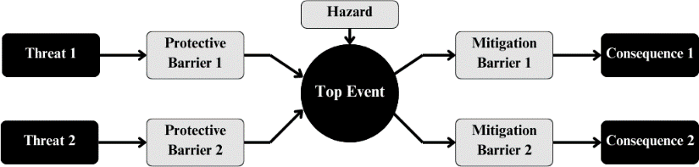

Figure 1. Simplified Bow-tie diagram.
The fuzzy logic emerges as a viable solution to deal with uncertainties in risk analysis. Almeida et al. (2023) used the Bow-tie to build a Mamdani fuzzy logic system, combining fault and event tree methods. Within this framework, they introduced “AND” and “OR” nodes, described by 49 rules outlining the relationships between events pairwise. This approach allows the estimation of frequency results considering the uncertainty. Once the uncertainty is addressed with a fuzzy logic system, a comprehensive approach is necessary to understand the importance of each barrier on risk control. This understanding aids in making assertive decisions and enhances the system safety performance. In this regard, Ferdous et al. (2013) also proposed the Bow-tie model as a combination of a fault tree and an event tree. However, Bayesian updating was used to assign the likelihood of undesirable events and a local sensitivity analysis was applied. The approach used Spearman's rank correlation coefficients to assess the contribution of each input event to the risk. While both referenced works utilized fuzzy type-1, this ongoing study advances by adopting fuzzy interval type-2 for a more robust treatment of uncertainty. Furthermore, this research incorporates and compares two distinct methods of global sensitivity analysis (Sobol indices method and method of Morris) to enhance the assessment of the importance of protective barriers. Given the significant impact these issues have on decision-making processes, this study aims to contribute to making the risk management system in process safety more informed and effective.
This work applies the developed framework in a case study on the loss of containment in risers, crucial components that link the seafloor to production and drilling facilities in the offshore oil and gas industry (Figueredo et al., 2023).

Fundamentals and Proposed Framework

Fuzzy Interval Type-2
A fuzzy set is an element grouping taken from a universe of discourse, represented through membership functions (µ_{A}). These functions assign a degree of belongingness to each observation. The fuzzy interval type-2 is derived from the fuzzy type-2 membership function, which can be mathematically described as ((x,u), µ_{A}(x,u))|∀x ∈ X,∀u ∈ Jx ⊆ [0,1], where 0 ≤ µ_{A}(x,u) ≤ 1. To derive the fuzzy interval type-2, µ_{A}(x,u) = 1,∀u ∈ Jx ⊆ [0,1]. This membership function comprises an upper membership function (UMF) and a lower membership function (LMF). Together, these curves define a region known as the footprint of uncertainty. This mathematical construct serves as a tool for describing linguistic variables employed in classifying objects, particularly when uncertainties exist regarding their values. Figure 2 visually represents a simple triangular membership function (Castillo and Melin, 2008).
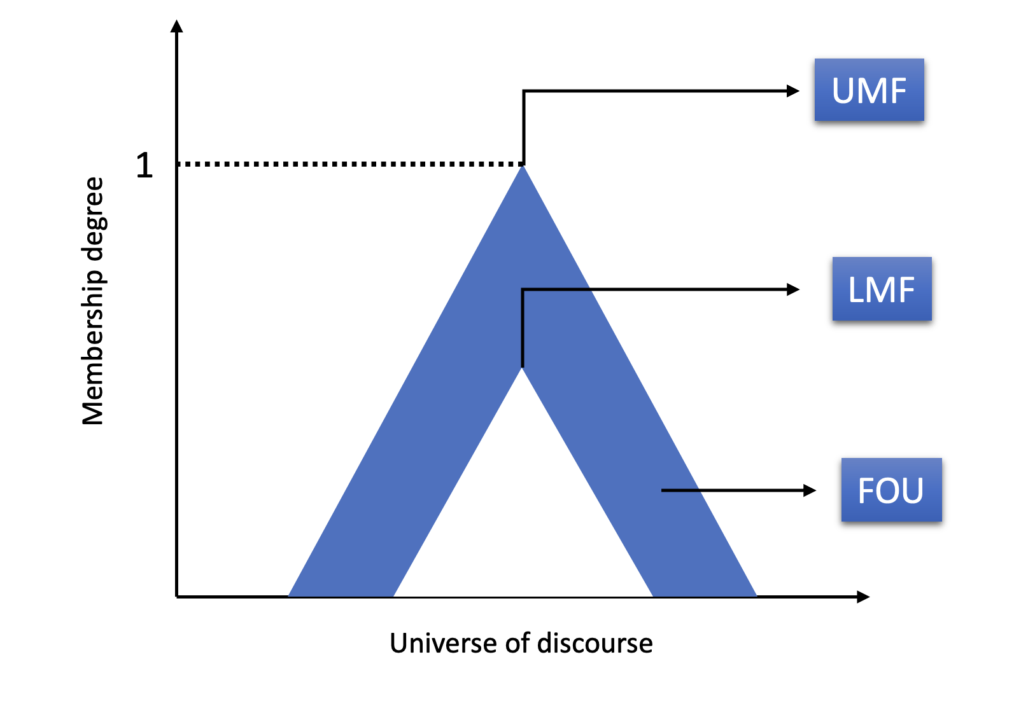
Figure 2. Simple representation of triangular interval fuzzy type membership function

After defining the fuzzy membership function, the subsequent stage involves applying a fuzzy logic system. This system is structured by:
- Fuzzifier: Considering the membership functions previously defined by the specialists, the membership degree of each input is obtained.
- Rule base: Specialists establish rules for the fuzzy logic system, structured as “IF input 1 is A AND/OR input 2 is B THEN output is C”, with A, B, and C representing membership functions.
- Fuzzy inference engine: Each rule generates firing strength based on fuzzified inputs, the fuzzy operator (‘OR’ or ‘AND’), and the implication operator (‘MIN’ or ‘PRODUCT’). The engine aggregates these strengths.
- Output processor: The aggregated result is reduced to a type-1 fuzzy system and the final crisp value is obtained through defuzzification.
  - Interval Type 2 Fuzzy Logic Bow-tie (IT2FLB)
The IT2FLB employs fuzzy inference nodes in each Bow-tie diagram connection based on the Layers of Protection (LOPA). Along each pathway linking a threat to the top event, inferences are performed representing nodes “AND” (with specific fuzzy set and rule base): the frequency of the threat is combined with the Probability of Failure on Demand (PFD) of the subsequent barrier, resulting in a new frequency. This new frequency is then combined with the PFD of the next barrier. After conducting inferences along the pathways, an “OR” inference is performed, aggregating pairwise the frequencies obtained to determine the frequency of the top event. The same reasoning used to obtain the frequencies of each pathway is applied to obtain the frequencies of consequences.

  - Sensitivity analysis
Sensitivity Analysis studies how the influence of uncertainty in a model's response is distributed among the various sources of input uncertainty. Sensitivity analysis assesses its robustness and clarifies complex relationships by offering a comprehensive understanding of a model. This work delves into two distinct sensitivity analysis methods.

Sobol indices method
The Sobol' indices is a variance-based global sensitivity analysis method that decomposes the variance of the model output into contributions from individual input factors and their interactions (Saltelli et al., 2010). The total sensitivity index equation for the Sobol' method is as follows (Equation 1).

$$S_{Ti}=\frac{E_{j≠i}(V_{ij})}{V}$$ | (1)

Where $V_{ij}$ is the variance of the model output due to the interaction between the i-th and j-th input factors, and $E_{j≠i}(V_{ij})$ is the expected value of $V_{ij}$ over all possible combinations of the i-th and j-th input factors. Saltelli's sampling scheme is employed with 1024 samples in this work to explore the universe of input values.

Method of Morris
This derivative-based method involves conducting a sequence of randomized one-factor-at-a-time experiments given by optimized trajectories across p selected levels in the space of the input factors, where changes in the output are attributed to specific changes in the input parameters. The elementary effect $d$ at point X of each factor X_{i} is calculated as shown in Equation 2 (Campolongo et al., 2007).

$$d_{i}(X)=\left(\frac{y\left(X_{1},…,X_{i-1},X_{i}+Δ,X_{i+1},…,X_{k}\right)-y(X)}{Δ}\right)$$ | (2)
Where Δ is a perturbation value. Then, from the distribution of the absolute values of the elementary effects we denote the estimated mean, μ*, which provides a reliable ranking of factors in terms of their importance. In this work, using the SALib library (Ruano et al., 2012), the analysis has four levels and 1024 trajectories.

Framework
The framework was developed using the Python programming language and leverages function libraries such as pyit2fls, SALib, Numpy, Pandas, and Matplotlib.
The case study Bow-tie is based on CCPS (2018) and Figueredo et al. (2023). For simplicity, this work aims to know the importance of each barrier in preventing the occurrence of the top event. So, the focus is on the left side of the diagram (Figure 3).

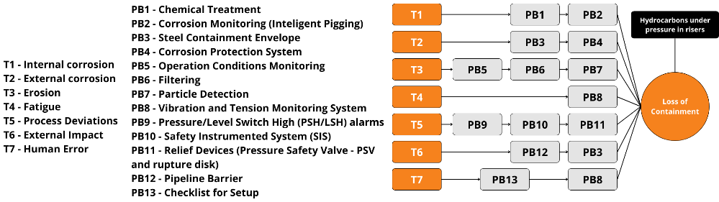
Figure 3. Bow-tie diagram (left side) for oil and gas flow under pressure in risers.

Applying the IT2FLB model in the constructed diagram, the framework involves:
- Input sets of samples (varying in [10⁻⁴,10⁰]) and obtain sensitivity indices for each sensitivity analysis method based on the outputs.
- Generate a ranking of protective barriers with sensitivity indices, from highest to lowest, for each sensitivity analysis method.
- Compare the two rankings using the Rank Biased Overlap (RBO) concordance measure (Equation 3), where X_{d} is the length of the overlapping list, n is the number of ranked observations, and p is set to 90% in this case, indicating that the top 4 ranks contribute 60.64% to the RBO.

$$RBO=\frac{X_{n}}{n}⋅p^{n}+\frac{1-p}{p}\sum_{d=1}^{n}{ }\frac{X_{d}}{d}⋅p^{d}$$ | (3)

Results
Drawing on the authors' expertise, a fuzzy set for input 1 and output (frequency), a fuzzy set for input 2 (PFD) (Figure 4), and the rule bases (for “AND” and “OR” nodes, with 36 rules each), have been established. Subsequently, the framework was implemented.

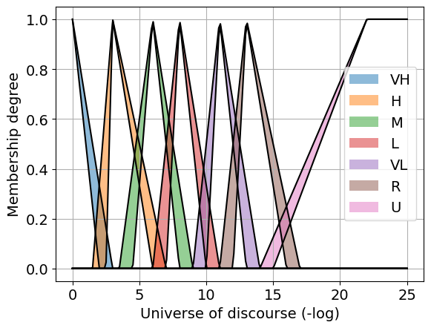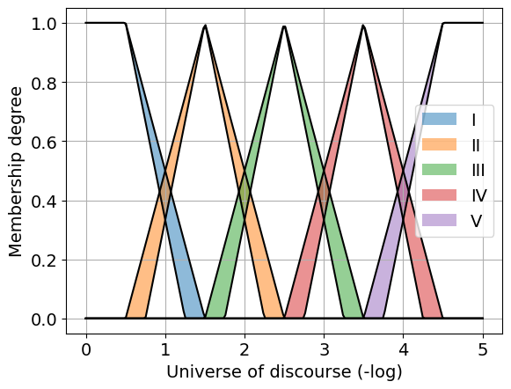
(b)
(a)
Figure 4. (a) Fuzzy set for input 1 and output. (b) Fuzzy set for input 2.
The normalized sensitivity indices obtained make it possible to view the importance of the protective barriers on the top event frequency reduction (Figure 5).

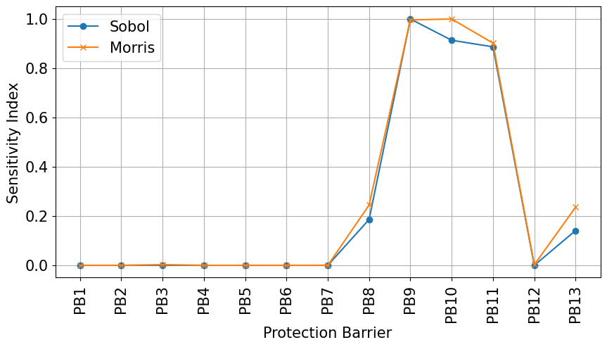
Figure 5. Normalized sensitivity indices for Sobol’ and Morris.

With notable advantages, barriers PB9, PB10, and PB11 emerge as the most globally significant. It is inferred that this specific analysis prioritizes barriers associated with the threat of higher frequency, “Process Deviations” (0.003 year⁻¹), placing them at the forefront. Subsequently, PB8 and PB13 exhibit relevance. It's worth highlighting that PB8 functions as a barrier in multiple pathways, those associated with “Fatigue” and “Human Error” threats. Meanwhile, PB13 is within the “Human Error” pathway, with a threat frequency of 0.002 year⁻¹ Moving down the list, barriers PB12 and PB3 stand out despite their tendency toward zero. In Sobol’ method, they have sensitivity indices of 1.04⋅10⁻⁶ and 2.96⋅10⁻⁷, respectively, with others in the range of 10⁻¹³ and lower. Similarly, their sensitivity indices in the method of Morris are 2.14⋅10⁻³ and 2.77⋅10⁻³, respectively, compared to others with values in the order of 10⁻⁶ and lower., respectively, compared to others with values in the order of 10⁻⁶ and lower.
The respective rankings and the RBO measure are presented in Table 1.

Table 1. Rankings of protective barriers by the sensitivity analysis and the RBO.
Sobol’ Method | Method of Morris | RBO [%]
PB9, PB10, PB11, PB8, PB13, PB12, PB3, PB7, PB5, PB2, PB6, PB1, PB4 | PB10, PB9, PB11, PB8, PB13, PB3, PB12, PB1, PB2, PB5, PB7, PB6, PB4 | 86.89

With an RBO of 86.89%, it is reasonable to consider the rankings as highly concordant. Therefore, the decision regarding method selection for applications can be based on either profiling or the availability of application tools.
To operationalize these findings, let's consider a practical scenario in the oil and gas industry: designing a maintenance plan for risers, establishing a schedule, and managing a limited budget to ensure process safety. Using the IT2FLB built and the Sobol method, the prioritization order for protective barriers could be as follows: (1) PB9: Pressure and Level Switch High alarms (PSH and LSH), (2) PB10: Safety Instrumented Systems (SIS), and (3) PB11: Relief devices. Notably, the top three barriers are associated with process control systems and physical elements, underscoring the critical importance of maintaining these systems. This systematic approach should be applied across all systems within the plant to manage and control risks effectively.

Conclusion
The proposed approach, integrating fuzzy interval type-2 logic with the Bow-tie technique and sensitivity analysis, holds promise for enhancing decision-making in risk management. Identifying the most influential barriers preventing the top event proved consistent and effective in guiding risk management. The robustness of the framework was demonstrated by comparing two different sensitivity analysis methods, as evidenced by the agreement in rankings of preventive barriers. Future applications to real plants are recommended to assess the system's effectiveness.

Acknowledgements
The authors would like to thank the National Council for Scientific and Technological Development (CNPq) grant number 130523/2020-8 and the National Petroleum Agency (ANP). Thanks are also due to Shell Brasil S.A.

References
Almeida, R. S., Vasconcelos da Silva, F., & Vianna, S. S. V. (2023). Combining the bow-tie method and fuzzy logic using Mamdani inference model. Process Safety and Environmental Protection, 169, 159–168. https://doi.org/https://doi.org/10.1016/j.psep.2022.11.005
Campolongo, F., Cariboni, J., & Saltelli, A. (2007). An effective screening design for sensitivity analysis of large models. Environmental Modelling & Software, 22(10), 1509–1518. https://doi.org/https://doi.org/10.1016/j.envsoft.2006.10.004
Castillo, O., & Melin, P. (2008). 3 Type-2 Fuzzy Logic. In Type-2 Fuzzy Logic: Theory and Applications (pp. 29–43). Springer Berlin Heidelberg. https://doi.org/10.1007/978-3-540-76284-3_3
CCPS. (2018). Bow Ties in Risk Management: A Concept Book for Process Safety. Wiley-AIChE.
Ferdous, R., Khan, F., Sadiq, R., Amyotte, P., & Veitch, B. (2013). Analyzing system safety and risks under uncertainty using a bow-tie diagram: An innovative approach. Process Safety and Environmental Protection, 91(1), 1–18. https://doi.org/https://doi.org/10.1016/j.psep.2011.08.010
Figueredo, A. K. M., Coelho, D. G., Miranda, P. P., de Souza Junior, M. B., Frutuoso e Melo, P. F. F., & Vaz Junior, C. A. (2023). Subsea pipelines incidents prevention: A case study in Brazil. Journal of Loss Prevention in the Process Industries, 83, 105007. https://doi.org/https://doi.org/10.1016/j.jlp.2023.105007
Khan, F. I., Amyotte, P. R., & Amin, Md. T. (2020). Chapter One - Advanced methods of risk assessment and management: An overview. In F. I. Khan & P. R. Amyotte (Eds.), Advanced Methods of Risk Assessment and Management (Vol. 4, pp. 1–34). Elsevier. https://doi.org/https://doi.org/10.1016/bs.mcps.2020.03.002
Ruano, M. V, Ribes, J., Seco, A., & Ferrer, J. (2012). An improved sampling strategy based on trajectory design for application of the Morris method to systems with many input factors. Environmental Modelling & Software, 37, 103–109. https://doi.org/https://doi.org/10.1016/j.envsoft.2012.03.008
Saltelli, A., Annoni, P., Azzini, I., Campolongo, F., Ratto, M., & Tarantola, S. (2010). Variance based sensitivity analysis of model output. Design and estimator for the total sensitivity index. Computer Physics Communications, 181(2), 259–270. https://doi.org/https://doi.org/10.1016/j.cpc.2009.09.018

