Comparing the sustainability level of biofuels with Data Envelopment Analysis
Richard Cabreraª, Fatemeh Rostamiª, Laureano Jiménezª, Carlos Pozoª
ªDepartament d’Enginyeria Quimica, Universitat Rovira i Virgili, Av. Països Catalans 26, 43007 Tarragona, Spain.
corresponding author: carlos.pozo@urv.cat
Abstract
Liquid biofuels are an alternative to a more sustainable transport sector, providing an interim solution before the required infrastructure for electric vehicles is in place. With a myriad of biofuel production options available today, decisions regarding fuel type, blend, conversion process, and carbon source significantly impact the cost and environmental footprint of the final product. Hence, a comprehensive multi-criteria decision-making approach is essential to identify the most suitable biofuels, considering economic, environmental, and social dimensions.
This study combines life cycle assessment with Data Envelopment Analysis (DEA) to assess the performance of 72 biofuel routes using 12 sustainability metrics. DEA allows to systematically combine the 12 sustainability metrics into a single efficiency score, facilitating the ranking of the biofuel alternative routes, and avoiding the need to predefine subjective weights between the indicators.
Our findings reveal that among the biofuel routes analysed, 35 perform more efficiently, with renewable diesel proving superior to ethanol-based blends or biodiesel. Waste biomass stands out as a preferable choice over cellulosic biomass or bio-oil. The selection of the carbon source emerges as a critical decision, emphasizing the need to consider regional factors like soil and climate conditions.
Overall, this work provides a powerful framework for holistic assessments that could help policymakers develop better-informed regulations and achieve, in this way, the emission reduction targets of current environmental policies for the transportation sector.
Keywords: Sustainable development, Data envelopment analysis, Life cycle assessment, Transport, Biofuels.
  - Introduction
The continued growth of global population and increased living standards have driven energy demand to unprecedented heights. Transport, a dominant energy-consuming sector reliant on fossil fuels (92% of fuel demand), stands as the third major contributor to greenhouse gas emissions, emphasizing the unsustainable nature of current transport sector. In 2018, less than 4% of transport fuel demand was met by renewable energy, predominantly biofuels (93%). Biofuels like biodiesel and bioethanol are considered pivotal for sustainable development, aligning with environmental policies such as the Paris Agreement and the European Green Deal(European Commission, n.d.).
In the current landscape, a plethora of alternatives exist for biofuel production, each influenced by critical decisions regarding fuel type, blend, conversion process, and carbon source. These decisions wield substantial influence over the final cost and environmental impact of the biofuel product.
This contribution evaluates the sustainability of 72 biofuels routes, considering their entire life cycle from cultivation to combustion in vehicles (cradle-to-wheel). To address the sustainability of biofuels comprehensively. A multi-criteria decision-making tool, DEA, is employed. DEA is chosen for its ability to integrate multiple indicators into a single performance score, providing a holistic assessment of biofuels. During the last years, some authors have combined Life Cycle Assessment (LCA) with DEA to assess the overall level of sustainability of alternatives, enabling the identification of efficient processes with a focus on their sustainable performance for different applications, including: the production of liquid fuels (Rodríguez-Vallejo et al., 2019) energy storage alternatives (Rostami et al., 2022) or bioenergy systems (González-García et al., 2012) among others.
  - Methodology
    - Data acquisition
We first obtain the data required to compute the indicators that will be used to assess the sustainability performance of the biofuels. This requires the collection of different types of data, from mass and energy balances for biofuel production processes to traditional LCA data and complementary information such as costs.
Specifically, 19 types of biological feedstocks are considered as carbon sources, together with four types of biofuel production processes. The resulting biofuels can be used in five different blends: ethanol (blended with gasoline in 10-90% (E10) or 85-15% (E85) proportions), biodiesel (blended with diesel in a 20-80% fuel (BD20)), and two types of renewable diesel, one based on the super cetane process (RDI) and another based on fluid catalytic cracking technology (RDII). RDI and RDII can be used as standalone fuel in compression ignition direct injection engines, avoiding blends with fossil fuels.
For each of these 72 biofuels, 12 performance metrics covering the three sustainability dimensions from a cradle-to-wheel approach are considered as follows. The economic dimension is assessed through the cost and the distance that can be traveled with the biofuel; the environmental dimension is evaluated through eight life-cycle impacts; and the performance in the social dimension is based on water use and land occupation since the shortage of these resources can trigger social conflicts(Pozo et al., 2020).
We next describe how these data from the performed LCA and complementary information are used in DEA to benchmark the sustainability performance of the different biofuels studied.
    - Data envelopment analysis model
Data Envelopment Analysis (DEA) is a mathematical programming technique (Charnes et al., 1978), with the aim of comparing and evaluating a homogeneous set of decision-making units (DMUs) in a production system with multiple inputs and multiple outputs.
DEA stands out from other multi-criteria assessment methods due to its ability to combine various indicators into one performance score without the need to establish subjective weights between the indicators. This is particularly useful in sustainability assessments that always create controversy. Also, it enables the integration of indicators covering all three sustainability dimensions into a single metric, allowing for easy identification of efficient and inefficient alternatives.
In this contribution, each of the 72 biofuel alternatives is modelled as a DMU whose relative performance is evaluated based on the 12 sustainability indicators and classified as either inputs or outputs. These sustainability indicators are depicted in Figure 1.

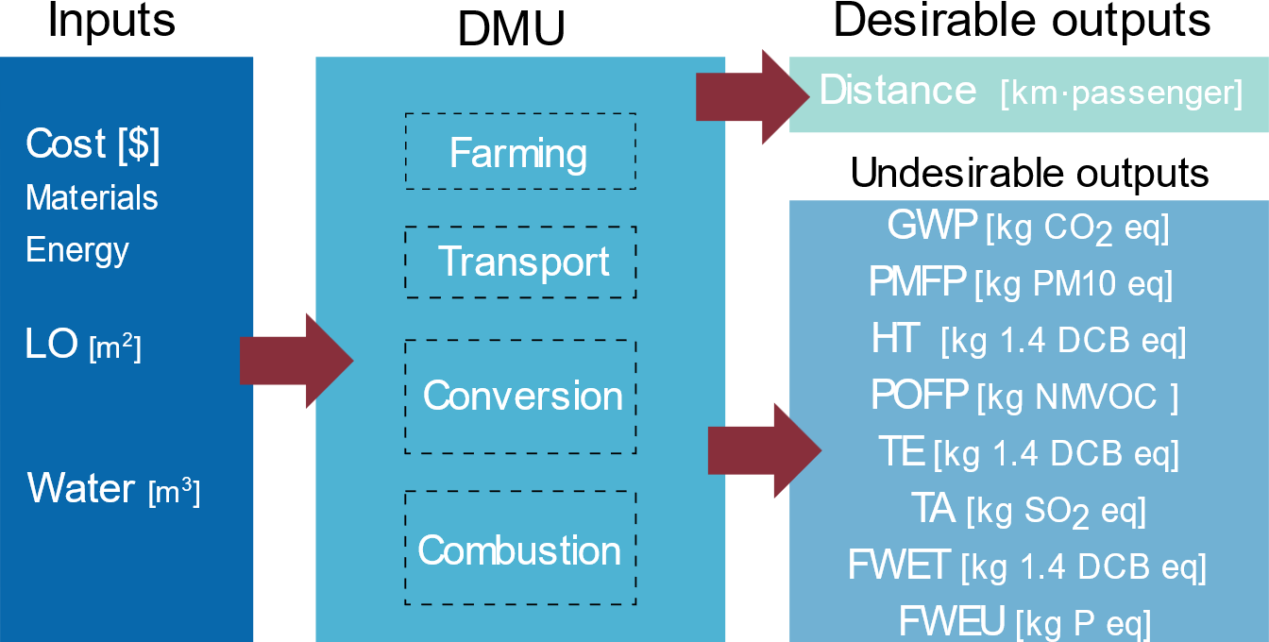
Figure 1. Inputs and (desirable and undesirable) outputs considered for each biofuel (DMU).. LO: land occupation; Water: water used in farming plus water depletion; GWP: global warming potential; PMFP: particulate matter formation potential; HT: human ecotoxicity; POFP: photochemical oxidant formation potential; TE: terrestrial ecotoxicity; TA: Terrestrial acidification; FWET: freshwater ecotoxicity; PMFP: fine particulate matter formation; FWEU: freshwater eutrophication.
Among the different DEA models available, we opt for a non-oriented slack-based model (SBM), as presented in Eq. (1), to combine the sustainability indicators into a single performance score (i.e., efficiency score). This score lies between 0 and 1, so that DMUs (i.e., biofuels) with a score of 1 are referred to as efficient, while DMUs with a score strictly lower than 1 are considered inefficient.
$$ρ^{*}=\min{\frac{1-\frac{1}{m}\sum_{i=1}^{m}{\frac{s_{i}^{-}}{x_{i0}}}}{1+\frac{1}{k}\sum_{r=1}^{k}{\frac{s_{r}^{+}}{y_{r0}}}}}$$ |  | Eq. (1)
s.t. | $$\sum_{j=1}^{n}{λ_{j}x_{ij}+s_{i}^{-}}=x_{i0} i=1, 2,…, m$$
$$\sum_{j=1}^{n}{λ_{j}y_{rj}-s_{r}^{+}}=y_{r0} r=1, 2, … ,k$$
$$s^{-}≥0, s^{+}≥0$$
$$λ_{j}≥0 j=1, 2,… ,n$$
In this model, ρ is the SBM-efficiency score, x_{ij} is the value of input i of DMU j, y_{rj} is the value of output r of DMU j, and x_{io} and y_{ro} are the values of input i and output r of the DMU o under evaluation. In turn, $s_{i}^{-}$ and $s_{r}^{+}$ are the input and output slacks, providing the distance from the DMU assessed to the so-called efficient frontier (i.e., the multi-dimensional frontier that would be obtained by linearly combining efficient DMUs). Slack variables in non-oriented SBM models provide information regarding the degree of inefficiency attained by each input and output individually (Tone, 2001).
In addition to the SBM model, we employ a super-efficiency DEA model (Tone, 2002), which assigns efficiency scores above one to efficient alternatives, thus providing an additional option to distinguish among efficient DMUs. DMUs assigning to each of them efficiency scores beyond one. This is obtained by assuming that the DMU to be evaluated is excluded from the reference set.The model formulation is as follows:
$$δ^{*}=min\frac{\frac{1}{m}\sum_{i=1}^{m}{\frac{{\overline{x}}_{i}}{x_{i0}}}}{\frac{1}{k}\sum_{r=1}^{k}{\frac{{\overline{y}}_{r}}{y_{r0}}}}$$ |  | Eq.(2)
s.t. | $$\overline{x}≥\sum_{j=1,≠0}^{n}{λ_{j}x_{j}}$$
$$\overline{y}≤\sum_{j=1,≠0}^{n}{λ_{j}y_{j}}$$
$\overline{x}≥x_{0}$, $\overline{y}≤y_{0}$ , $λ≥0$
  - Results and discussion
    - Efficiency assessment
Fig. 2 provides the combined results for the efficiency and super-efficiency DEAs, with inefficient biofuels being represented based on their efficiency score and efficient biofuels depicted based on their super-efficiency score. Results reveal that 48% of the 72 biofuels analyses are efficient. The highest efficiency score, standing at 1.61, is achieved by the blend using 85% of ethanol from municipal solid waste (MSW), owning to different factors such as its low cost, and the water and land use requirements attributed to MSW compared to other raw materials. On the contrary, the lowest efficiency score (0.26) is achieved by a blend using 85% of ethanol derived from corn (E85) from combined dry and wet milling corn. This outcome can be attributed to its low mileage efficiency (8.63 km per litre, compared to 14.57 km for any renewable diesel), and increased requirements for water use and land occupation.
When comparing the five types of fuel studied (E10, E85, BD20, RDI, RDII), it becomes evident that there is, at least, one efficient biofuel for each. However, this does not imply equal performance across all fuel types: while almost all BD20, RDI, and RDII fuels demonstrate efficiency, only 30% of ethanol-based fuels (15 out of 50) achieve this status. This underscores the importance of considering, not only the fuel type, but also the carbon source for comprehensive sustainability assessments.
On average, both renewable diesel exhibits the highest efficiency scores at 1.03, outperforming biofuels based on lignocellulosic biomass (e.g., sorghum, standing at 0.91 average efficiency score) and first-generation biomass (e.g., corn, 0.56). These results are attributed to the lower fuel consumption of engines using E10 and E85 blends, compared to those fuelled by BD20, RDI or RDII.
In conclusion, these findings advocate for promoting the use of renewable diesel (RDI and RDII) over bioethanol (E10 and E85) due to its lower GWP under a cradle-to-wheel LCA, owing mainly to reduced fuel consumption per km. The continuous evolution of enzymes for the degradation of lignocellulosic materials into simple fermentable sugars is making them more competitive, to the point that they achieve better performance and lower costs than first regeneration ethanol feedstocks (e.g., corn).

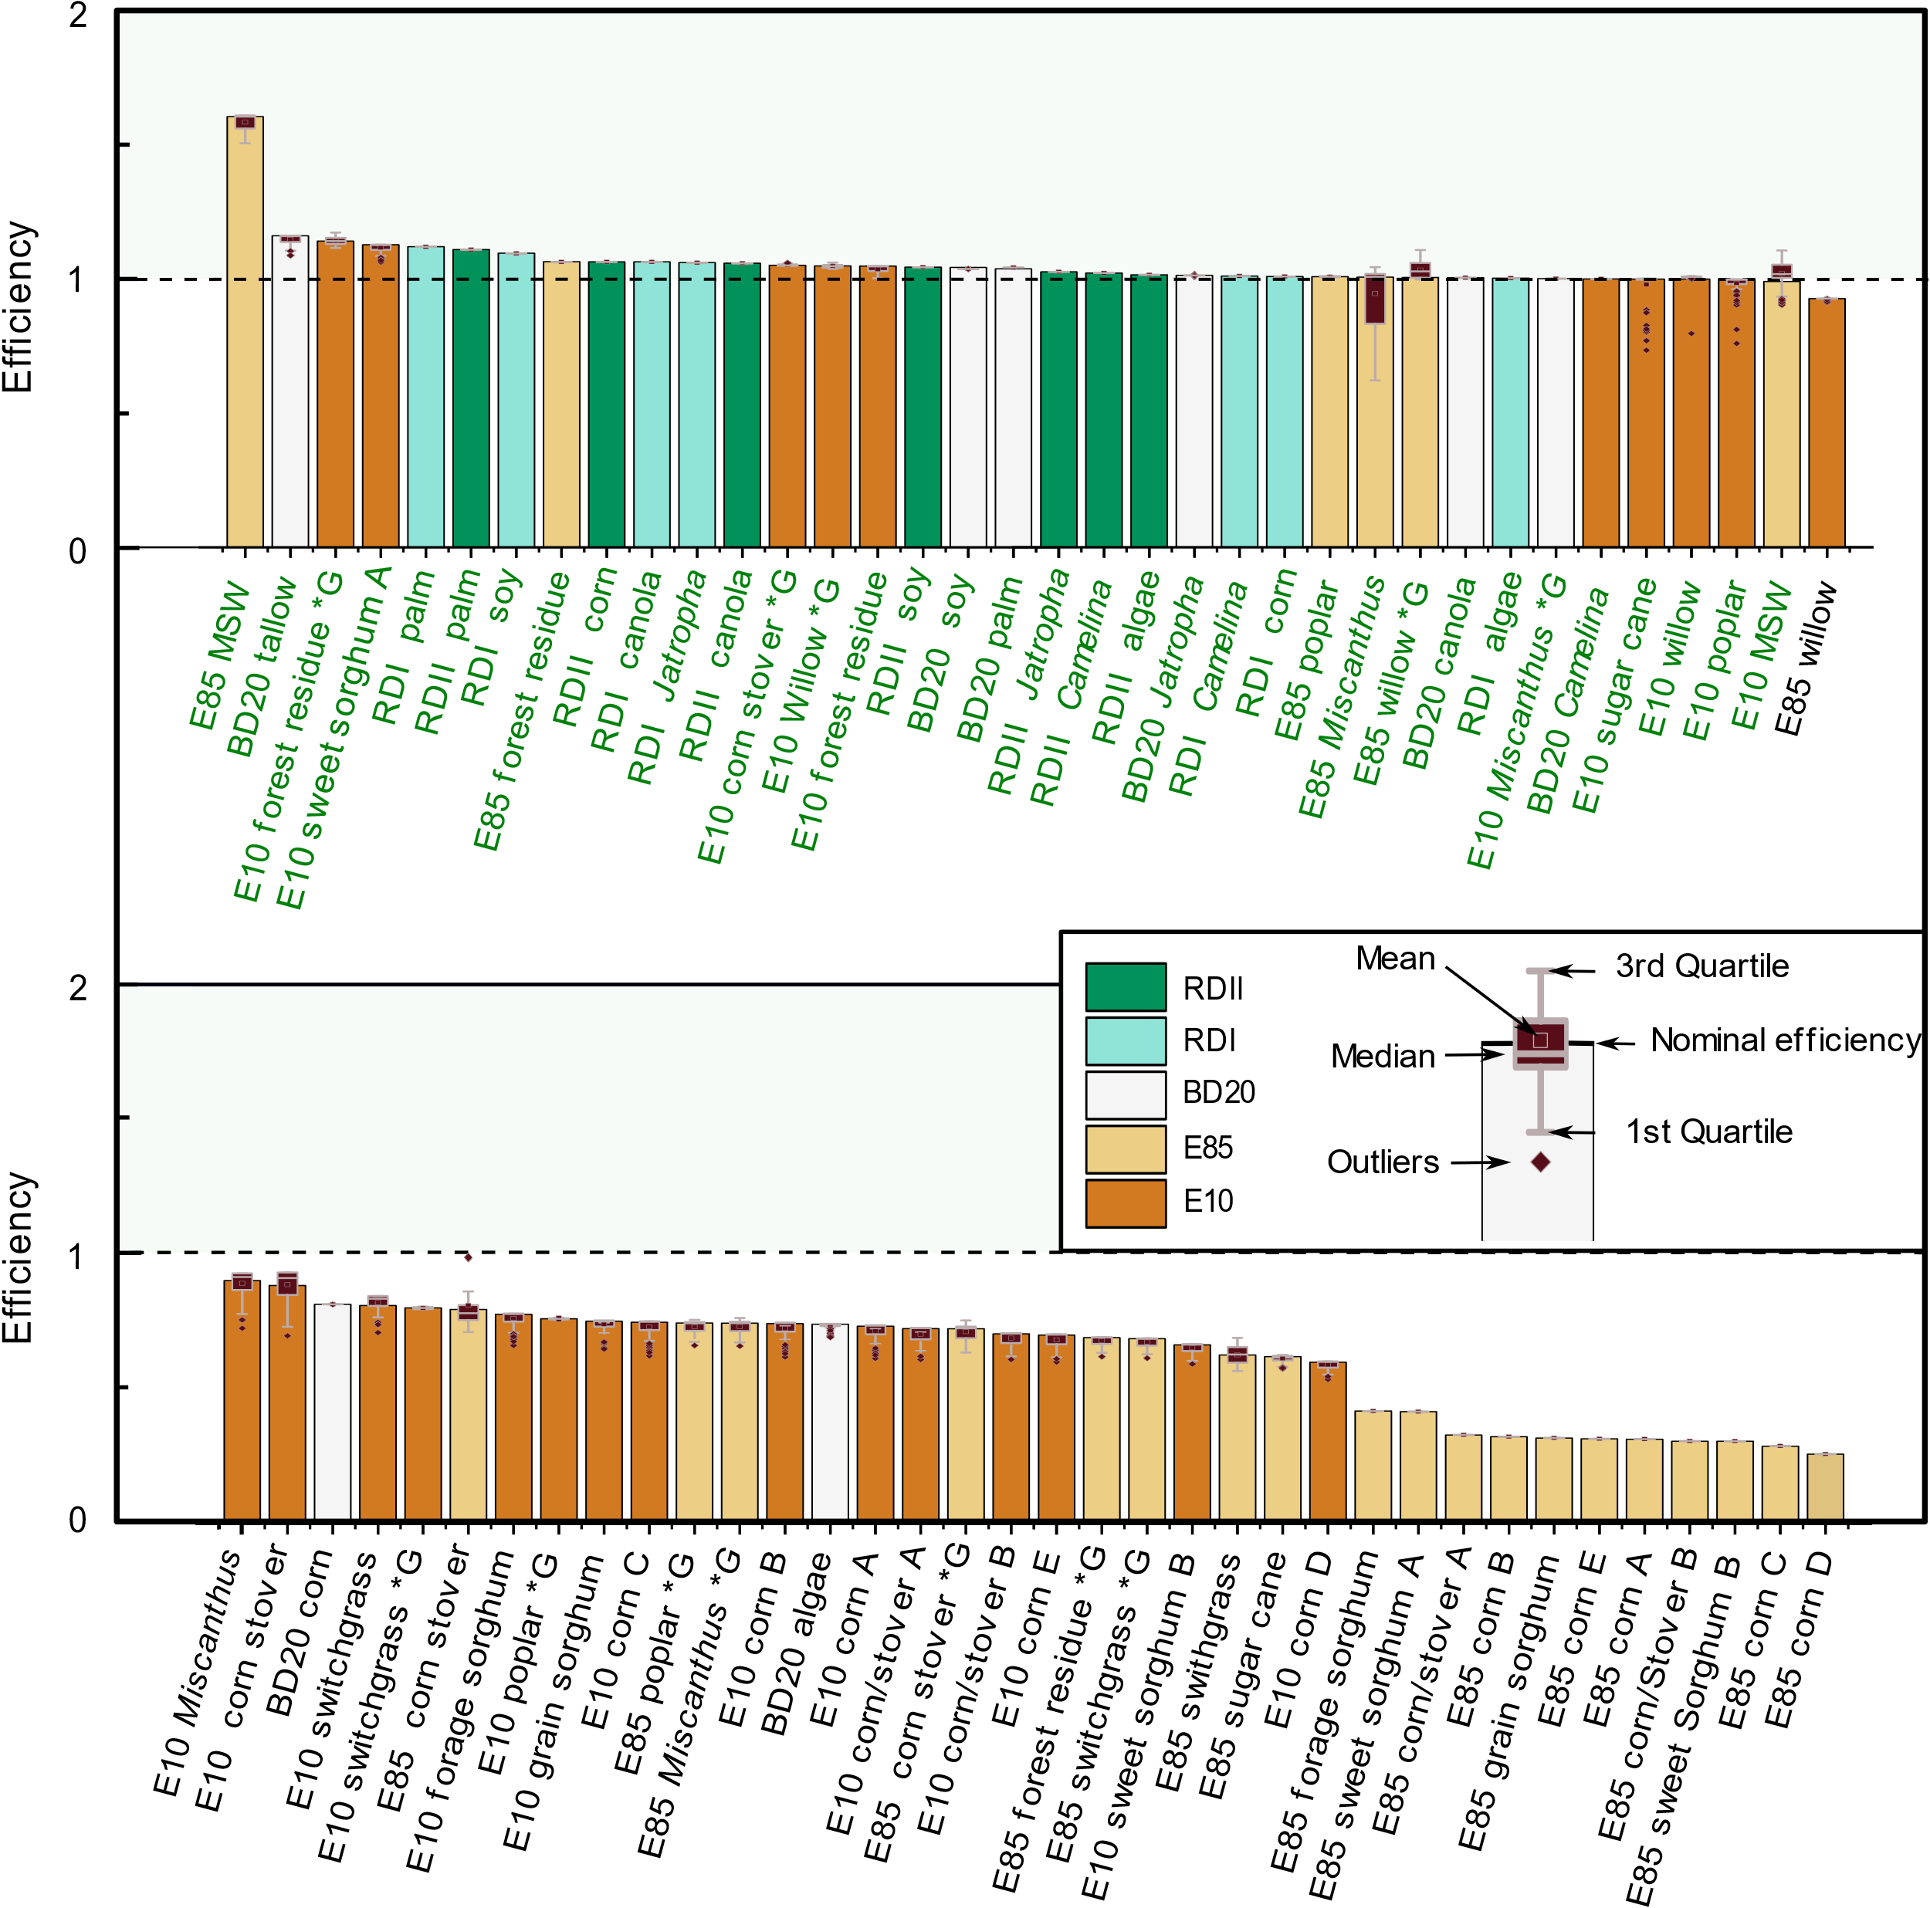
Figure 2. Efficiency scores for biofuels. (Super)efficiency scores for the 72 biofuels routes are provided as vertical bars in subplot, with biofuels sorted in decreasing order of efficiency and efficient biofuels depicted with a green label. Corn A: Dry mill corn without oil extraction; Corn B: Dry mill corn with oil extraction; Corn C: Wet milling corn; Corn D: combined dry and wet milling corn; Corn/stover A: integrated corn/stover ethanol (associated with corn); Corn/stover B: integrated corn/ stover ethanol (associated with stover); Corn E: Gen dry milling corn with oil extraction; Sweet sorghum A: Conventional; Sweet sorghum B: Integrated; *G: ethanol produced by gasification. BD20: Diesel fuel with up to 20 %v/v FAME content; E10: Gasoline fuel with up to 10 %v/v bioethanol content; E85: Gasoline fuel with up to 85 %v/v bioethanol content; RDI: Renewable Diesel Production Based on SuperCetane; RDII: Renewable Diesel Production Based on fluid catalytic cracker technology.
  - Conclusions
Multi-criteria approaches, exemplified in this contribution by combining LCA with DEA, provide a robust framework for conducting sustainability studies. Such methodologies have the capacity to minimize burden-shifting episodes and offer valuable insights to policymakers for the development of well-informed and effective policies. In this contribution, we used such an approach to assess the performance of 72 biofuels based on 12 sustainability indicators, to identify trends that can be used to inform policymakers.
The biofuel alternative with the highest efficiency score was based on MSW, which suggests that residues should be prioritized among carbon sources. Fuels from natural oils also show a promising performance, with 20 of the 22 units analysed deemed efficient. Among the remaining carbon sources, results support the recent trend of promoting cellulosic material for ethanol production. In terms of fuel type, our results suggest that policies should favour the widespread adoption of renewable diesel over traditional ethanol or biodiesel, since the former achieved the best performance thanks to a higher fuel economy and a higher biogenic carbon content in the fuel. The fuel type, however, was not found as impactful as the carbon source in achieving high efficiency scores.
References

Charnes, A., Cooper, W. W., & Rhodes, E. (1978). Measuring the efficiency of decision making units. European Journal of Operational Research, 2(6), 429–444. https://doi.org/10.1016/0377-2217(78)90138-8
European Commission. (n.d.). Sustainable transport | Mobility and Transport. Retrieved February 11, 2021, from https://ec.europa.eu/transport/themes/sustainable_en
González-García, S., Iribarren, D., Susmozas, A., Dufour, J., & Murphy, R. J. (2012). Life cycle assessment of two alternative bioenergy systems involving Salix spp. biomass: Bioethanol production and power generation. Applied Energy, 95, 111–122. https://doi.org/10.1016/J.APENERGY.2012.02.022
Pozo, C., Galán-Martín, A., Cortés-Borda, D., Sales-Pardo, M., Azapagic, A., Guimerà, R., & Guillén-Gosálbez, G. (2020). Reducing global environmental inequality: Determining regional quotas for environmental burdens through systems optimisation. Journal of Cleaner Production, 270, 121828. https://doi.org/10.1016/J.JCLEPRO.2020.121828
Rodríguez-Vallejo, D. F., Galán-Martín, Á., Guillén-Gosálbez, G., & Chachuat, B. (2019). Data envelopment analysis approach to targeting in sustainable chemical process design: Application to liquid fuels. AIChE Journal, 65(7), e16480. https://doi.org/10.1002/AIC.16480
Rostami, F., Kis, Z., Koppelaar, R., Jiménez, L., & Pozo, C. (2022). Comparative sustainability study of energy storage technologies using data envelopment analysis. Energy Storage Materials, 48, 412–438. https://doi.org/10.1016/J.ENSM.2022.03.026
Tone, K. (2001). Slacks-based measure of efficiency in data envelopment analysis. European Journal of Operational Research, 130(3), 498–509. https://doi.org/10.1016/S0377-2217(99)00407-5
Tone, K. (2002). A slacks-based measure of super-efficiency in data envelopment analysis. European Journal of Operational Research, 143(1), 32–41. https://doi.org/10.1016/S0377-2217(01)00324-1

