Modeling Hydrothermal Gasification of Digestate Sludge: Reaction Kinetic from Molecular Simulations
Do Tuong Haª, Khanh-Quang Tran^{b*}, Thuat T. Trinh^{c*}

ªFaculty of Applied Sciences, Ton Duc Thang University, Ho Chi Minh city, Vietnam
^{b}Department of Energy and Process Engineering, Norwegian University of Science and Technology - NTNU, Norway
^{c}Porelab, Department of Chemistry, Norwegian University of Science and Technology - NTNU, Norway
* khanh-quang.tran@ntnu.no; thuat.trinh@ntnu.no

Abstract
Hydrothermal gasification (HTG) has emerged as a promising technology for converting wet digestate residue from anaerobic digestion processes to valuable fuel gases including hydrogen and methane. To design and optimize HTG reactors for such digestate feedstock, accurate kinetic parameters are essential. Such kinetic parameters can be gained via reactive molecular dynamics simulations, which are the objective of the work presented in this paper. For this purpose, the method of reactive force field (ReaxFF) was employed. Influences of process parameters including temperature, pressure, reactant compositions on the process of digestate HTG were investigated. The obtained activation energy of 141 kJ/mol and product distribution shed light on the mechanistic aspects of the gasification process. The ability to predict reaction kinetics for complex HTG reactions from this work opens new possibilities for optimizing process and advancing sustainable waste-to energy technologies.
Keywords: Molecular simulation, ReaxFF, hydrothermal gasification, digestate sludge, reaction kinetics.
  - Introduction

It is important to optimize the thermal and chemical conversion of biomass (Tran et al., 2020; Mahmoodinia et al., 2017), such as digestate sludge, for sustainable waste-to-energy technologies. Anaerobic digestion (AD) is a common technology for energy recovery form wet and low-cost biomass resources such as sewage sludge from wastewater treatment plants. AD process involves the breakdown of biodegradable organic materials by microorganisms in the absence of oxygen, leading to generation of combustible gas mixtures containing chiefly methane and carbon dioxide (Li et al., 2011). Digestate is a byproduct or residue of AD processes, containing non-digestible organic matter and valuable nutrients such as nitrogen and phosphorus. Digestate sludge can be utilized as fertilizer in agriculture (Mata-Alvarez et al., 2014). However, challenges associated with the application of digestate sludge include variability in composition due to factors such as feedstock type and pretreatment methods used during anaerobic digestion (Nkoa, 2013) and potential risks related to contaminants like heavy metals and pathogens (Verstraete and Vlaeminck, 2011). Because of these challenges, researchers continue to explore new opportunities for utilizing digestate sludge effectively, one of which is hydrothermal gasification.

Hydrothermal gasification (HTG) is a gasification process in supercritical water typically at temperatures within 500-700ºC (without catalyst) and their corresponding pressures (Promdej and Matsumura, 2011). The use of water as the reaction environment makes HTG very suitable for valorization of wet feedstock like digestate. This process has garnered increasing attention also due to its potential for producing hydrogen-rich syngas with reduced environmental impact compared to conventional gasification techniques. The product gas from HTG can be combusted directly for heat and power generation. It can also be fed back to the AD reactor in an AD-HTG integrated system to improve the carbon conversion and bio-methane production.

To design and optimize HTG reactors for digestate feedstock, accurate kinetic parameters are essential. Reaction conditions, such as temperature and pressure, also significantly impact the kinetics of hydrothermal gasification reactions. Increasing both temperature and pressure generally leads to an acceleration in reaction rates due to the increased solubility of gases in water under these conditions (Kruse, 2008). However, high-temperature and high-pressure environments can also lead to unwanted side reactions, such as char and coke formation, which may cause fouling or reduce the efficiency of gasification processes (Karayildirim et al., 2008). Therefore, careful optimization of reaction conditions is essential for achieving optimal hydrothermal gasification performance.

The primary objective of this research is to explore the effects of various process parameters such as temperature, and reactant compositions on the HTG of digestate sludges. Employing reactive force field method, our goal is not only to gain insight into the underlying mechanisms but also to predict reaction kinetics for complex HTG reactions. This approach will contribute towards optimizing processes and further advancing sustainable waste-to-energy conversion technologies.
  - Models and Methods

It is a common practice to select specific model compounds to study the kinetic behavior of HTG processes via molecular dynamic (MD) modelling and simulation. In this case, three simple model compounds were chosen for investigation: aspirin (acetylsalicylic acid), xylylenediamine, and sacrylamide (as shown in Figure 1). These representative model compounds were selected as they are presented in digestate sludge solutions (He et al., 2022). By investigating the reactivity, synergy, and kinetics of these three model compounds under HTG conditions, researchers can gain valuable insights into the behavior of more complex feedstocks such as agricultural crops, wood wastes, food processing residues during HTG.

The method of ReaxFF molecular dynamics simulation was employed for this present study due to its ability to accurately describe molecular interactions and chemical reactions. Unlike the method of non-reactive force field, ReaxFF considers dynamic bond length and angle changes in response to alterations in the chemical environment. For a more detailed description of the ReaxFF force field and its underlying methodology, interested readers should be referred to the original paper introducing ReaxFF (van Duin et al., 2001).

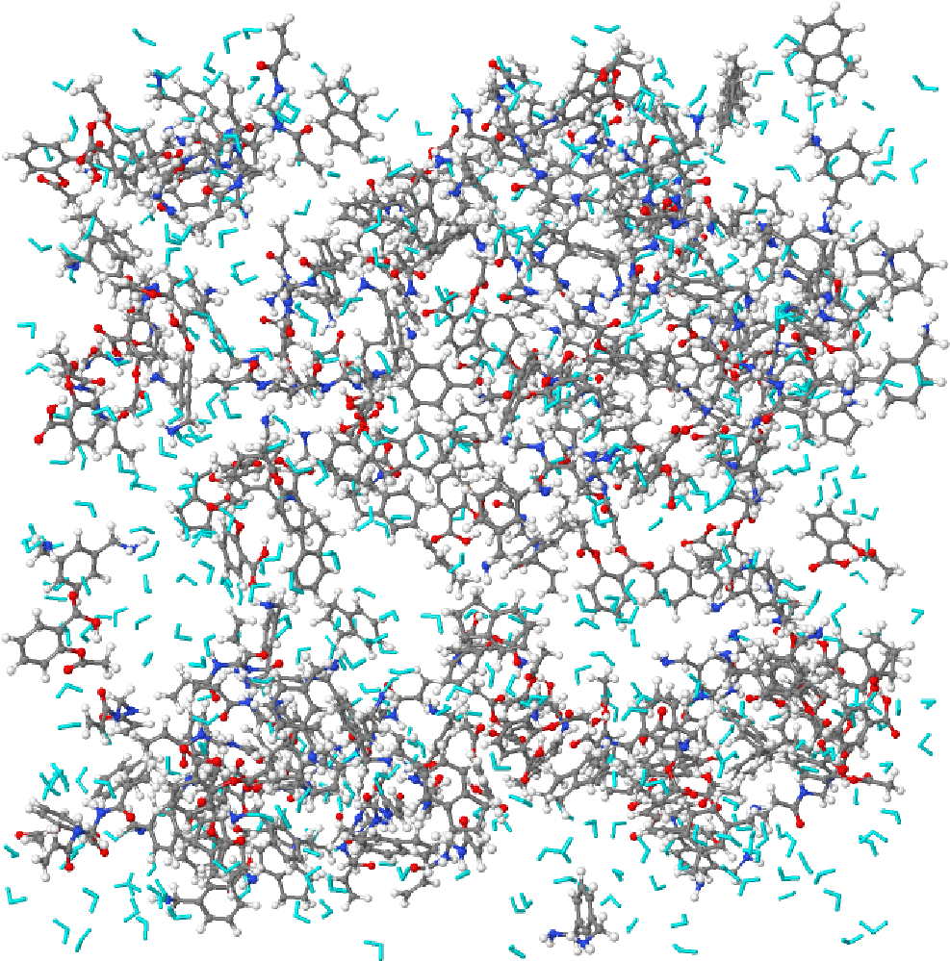
Figure 1: A model digestate sludge used in ReaxFF MD simulation of HTG process.
In this study, we utilized the potential function parameters proposed by (Vashisth et al., 2018). In order to accelerate the reaction kinetics and to overcome the time and length scale limitations, a commonly employed technique in MD is to simulate the system at temperatures higher than that reported in the literature of experimental conditions (Saha and Schatz, 2012; Jiang et al., 2009; Kowalik et al., 2019). The temperature range employed for the HTG simulations of this present work is from 3000 K to 4000 K. A similar temperature range was previously applied in HTG simulation (Liu et al, 2020). The total simulation time was 250 ps with a time step of 0.25 fs. In order to calculate the activation energy values in this study, we utilized the Arrhenius equation.
  - Results and Discussions
    - Yield of gaseous products

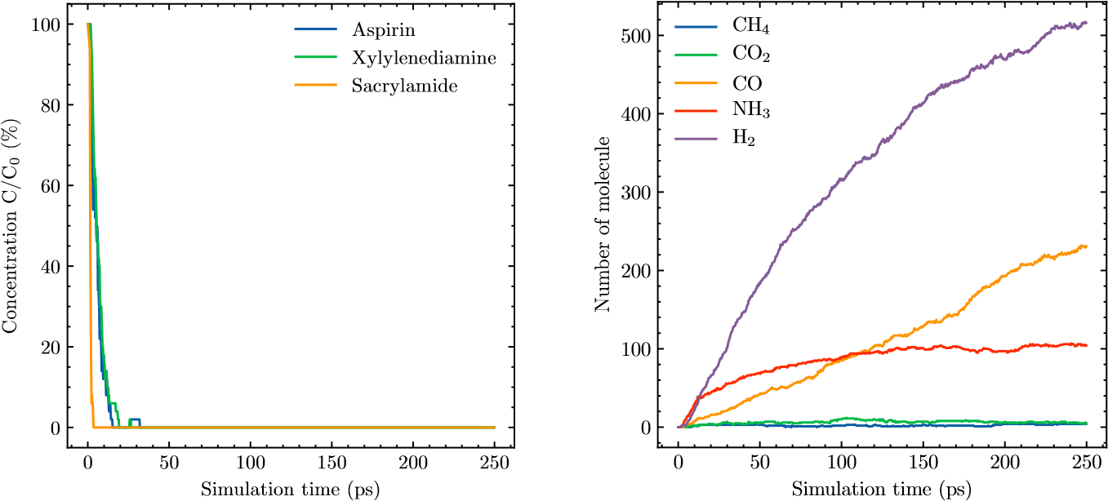
(a) Reactant consumption (b) Formation of gases
Figure 2: Evolution of reactants concentration (a) and formation of gases (b) during HTG simulation. C₀ = initial concentration, C = concentration at simulation time.
The evolution of reactants and gaseous products and intermediates during the HTG simulation, as depicted in Figure 2, provides some insights into the reaction kinetics and product distribution under supercritical water conditions. It is evident that the concentration of all three reactants of the model compounds decreases over time as they are decomposed and converted to intermediates or products. The formation of hydrogen gas is observed to be the most significant among the various gases produced during the HTG process, which aligns with previous research findings (Promdej and Matsumura, 2011) highlighting the potential for hydrothermal gasification to generate high-quality hydrogen-rich syngas from diverse feedstocks. However, it should be noted that the formation of CH₄ and CO₂ gases is minor compared to hydrogen production.

Another important observation is the formation of ammonia gas during the HTG process. This result is consistent with experimental observations and supports previous studies (Kruse, 2008) indicating that nitrogen-containing compounds can play a crucial role in HTG processes by forming stable intermediates or participating in redox reactions.
    - Effect of temperature

Figure 3 shows the evolution of intermediates and products in different phases - gas, liquid, and solid - during HTG simulations conducted at two different temperatures 3000K and 3600K. Initially, all reactants are present in their liquid state. As the HTG progresses, the liquid fraction gradually decreases as it is converted into gaseous products through decomposition and partial oxidation reactions.

According to Figure 3.a, the mass fraction of gas during the simulation at 3000 K reaches roughly 66% after 250 ps of simulation time. This indicates that the process is representative of a typical HTG process in which gasification takes place in supercritical water conditions. As the temperature increases to 3600 K (Figure 3.b), the gas fraction further increases to around 78%. This pattern indicates that increasing the temperature minimizes undesirable side reactions like char formation while increasing the efficiency of converting organic resources into syngas.

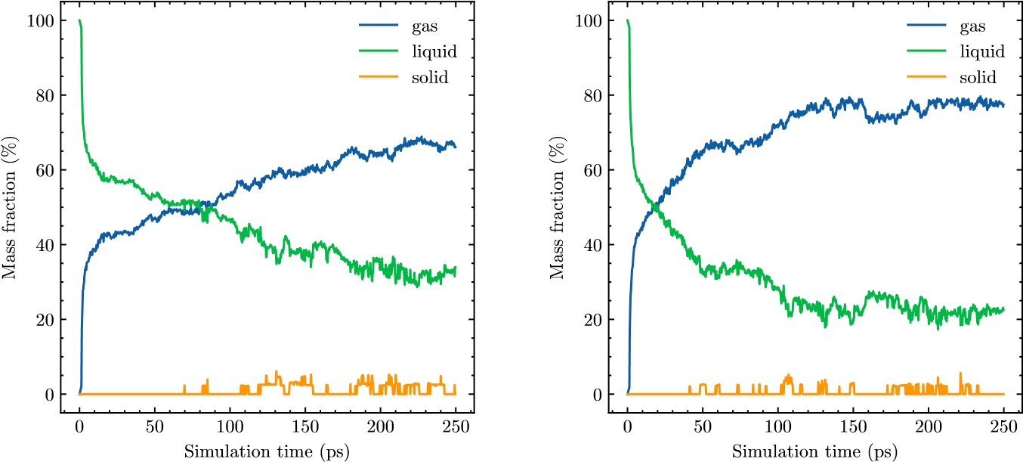
(a) T = 3000 K (b) T = 3600 K
Figure 3: Evolution of different phases during HTG simulation
We observed that the formation of solid or the solid residue during the HTG process is negligible. The trends observed for the revolution of the products in three phases - gas, liquid, and solid during HTG simulations, as depicted in Figure 3, agree with the experimental data obtained from similar studies involving various feedstocks under supercritical water conditions (Promdej and Matsumura, 2011). This consistent behavior across different systems provides convincing evidence that the model compounds chosen for investigation can effectively represent more complex organic materials found in biomass or coal-derived residues.
    - Activation barrier of HTG process

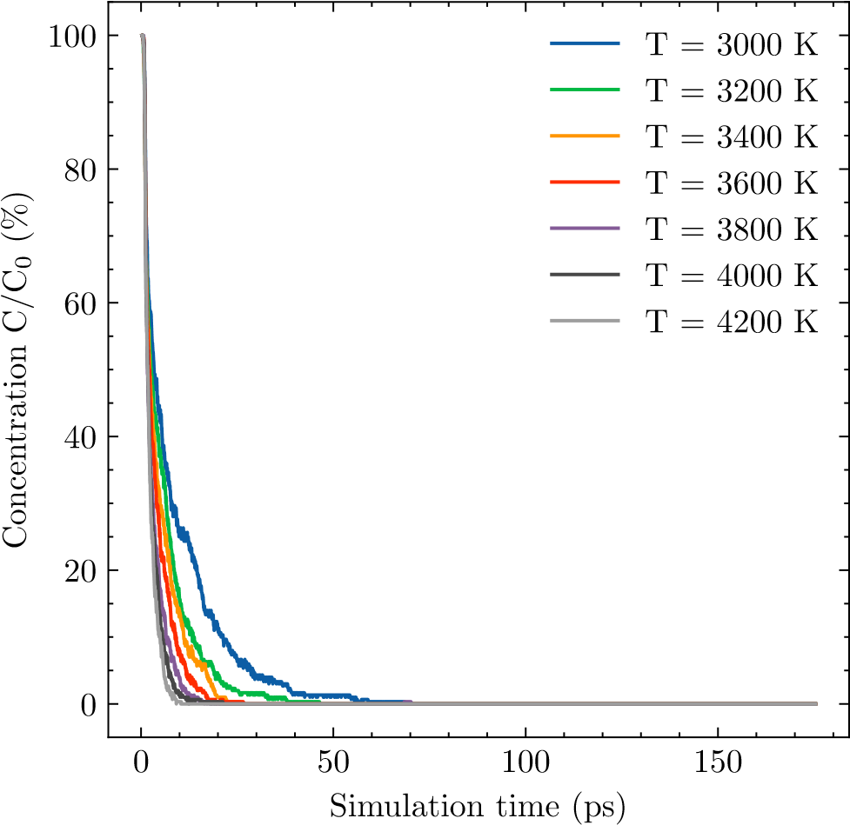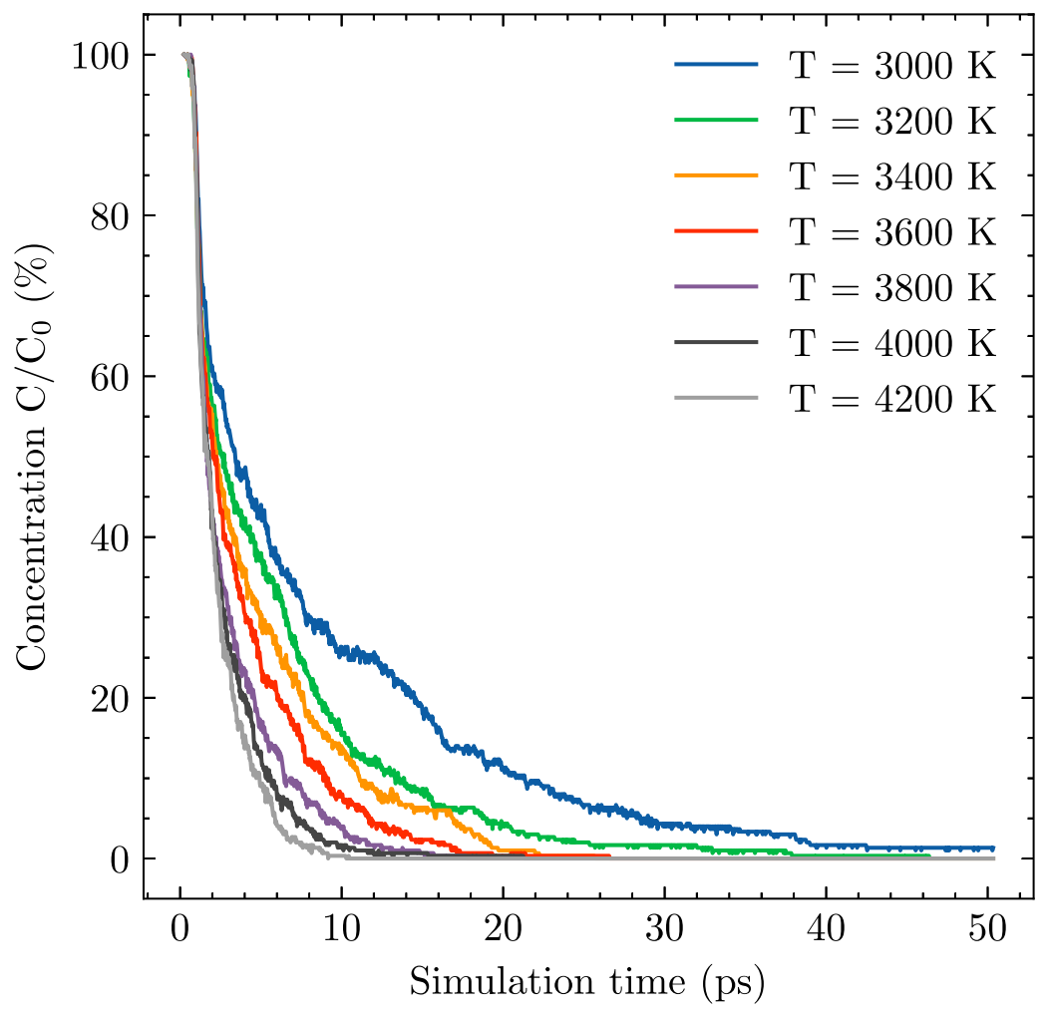
Figure 4: Evolution of reaction concentration at different temperature
To investigate the reaction kinetics, the concentration of reactants over time under varying temperature conditions was monitored (as shown in Figure 4). By assuming a pseudo first-order kinetic model for these reactions, it is possible to calculate the rate constants associated with each of individual steps (such as hydrolysis, dehydration, decarboxylation, and oxidation) in the HTG pathway. The rate constant values obtained at different temperatures can then be used to determine the activation energy barrier. The obtained results show that the activation energy is around 141 kJ/mol, which agrees with experimental findings reported in previous study (Wei et al, 2021).
  - Conclusions
This study has demonstrated the capacity of ReaxFF in investigating HTG of complex organic compounds such as digestate sludge. By employing computational modeling techniques, we can gain valuable insights into the reaction mechanism, kinetics, activation energies, and product yields associated with HTG processes. This can provide essential inputs for more advanced micro-kinetics models employed in chemical engineering applications.
Acknowledgements
The research leading to these results has been co-funded by the Norway Grants 2014-2021 via the National Center for Research and Development, within the frame of the project: “Negative CO2 emission gas power plant” - NOR/POLNORCCS/NEGATIVE -CO2-PP/0009/2019-00 which is co-financed by program “Applied research” under the Norwegian Financial Mechanisms 2014-2021 POLNOR CCS 2019 - Development of CO2 capture solutions integrated in power and industry processes. TTT acknowledge funding from the Research Council of Norway (RCN), the Center of Excellence Funding Scheme, Project No. 262644, PoreLab. Co-financing and support from Ton Duc Thang University and Norwegian University of Science and Technology are gratefully acknowledged.
References
van Duin et al., 2001, ReaxFF: A Reactive Force Field for Hydrocarbons, J. Phys. Chem. A, 105(20), 4663-4672.
He et al., 2022, Molecular diversity of liquid digestate from anaerobic digestion plants for biogenic waste. Bioresource Technology, 347, 126373.
Huelsman and Savage, 2012, Intermediates and kinetics for phenol gasification in supercritical water, Phys. Chem. Chem. Phys., 14(3), 1587-1594.
Jiang et al., 2009, Simulating the Initial Stage of Phenolic Resin Carbonization via the ReaxFF Reactive Force Field, J. Phys. Chem. A, 113(25), 6891-6894.
Karayıldırım et al., 2008, Char and Coke Formation as Unwanted Side Reaction of the Hydrothermal Biomass Gasification. Chemical Engineering & Technology, 31(11), 1561–1568.
Kruse, 2008, Supercritical water gasification. Biofuels, Bioproducts and Biorefining, 2(5), 415–437.
Kowalik et al., 2019, Atomistic Scale Analysis of the Carbonization Process for C/H/O/N-Based Polymers with the ReaxFF Reactive Force Field, J. Phys. Chem. B, 123(25), 5357-5367.
Li et al., 2011, Solid-state anaerobic digestion for methane production from organic waste, Renewable Sustainable Energy Rev., 15(1), 821-826.
Liu et al., 2020, Understanding lignin gasification in supercritical water using reactive molecular dynamics simulations, Renewable Energy, 161(12), 858-866.
Mahmoodinia et al., 2017, Geometrical flexibility of platinum nanoclusters: Impacts on catalytic decomposition of ethylene glycol, Phys. Chem. Chem. Phys., 19(42), 28596-28603.
Mata-Alvarez et al., 2014, A critical review on anaerobic co-digestion achievements between 2010 and 2013, Renewable Sustainable Energy Rev., 36(None), 412-427.
Nanda et al., 2017, An assessment of pinecone gasification in subcritical, near-critical and supercritical water, Fuel Process. Technol., 168(), 84-96.
Nkoa, 2013, Agricultural benefits and environmental risks of soil fertilization with anaerobic digestates: A review, Agron. Sustain. Dev., 34(2), 473-492.
Promdej and Matsumura, 2011, Temperature Effect on Hydrothermal Decomposition of Glucose in Sub- And Supercritical Water, Ind. Eng. Chem. Res., 50(14), 8492-8497.
Saha and Schatz, 2012, Carbonization in Polyacrylonitrile (PAN) Based Carbon Fibers Studied by ReaxFF Molecular Dynamics Simulations, J. Phys. Chem. B, 116(15), 4684-4692.
Tran et al., 2020, Fuel characterization and thermal degradation kinetics of biomass from phytoremediation plants, Biomass Bioenergy, 134, 105469
Wei et al. 2021, Effect of hydrothermal carbonization temperature on reactivity and synergy of co-gasification of biomass hydrochar and coal. Applied Thermal Engineering, 183, 116232.
Vashisth et al., 2018, Accelerated ReaxFF Simulations for Describing the Reactive Cross-Linking of Polymers, J. Phys. Chem. A, 122(32), 6633-6642.
Verstraete and Vlaeminck, 2011, ZeroWasteWater: Short-cycling of wastewater resources for sustainable cities of the future, International Journal of Sustainable Development & World Ecology, 18(3), 253-264.

