Use of dynamic Flux Balance Analysis for evaluation of the poly-3-hydroxybutyrate production potential of recombinant Escherichia coli
Willians O. Santos,ª Rafael David de Oliveira,^{b} José Gregorio Cabrera Gomez,^{c} Galo A. C. Le Rouxª
ªDepartment of Chemical Engineering Polytechnic School University of São Paulo, Av. Prof. Lineu Prestes 580, São Paulo 05508-220, Brazil
^{b}Department of Chemical Engineering Norwegian University of Science and Technology (NTNU), Torgarden 7491, Trondheim 8900, Norway ^{c}Institute of Biomedical Sciences University of São Paulo, Av. Prof. Lineu Prestes 2415, São Paulo 05508-000, Brazil
Galoroux@usp.br
Abstract
Environmental problems due to plastic disposal have been a major concern. Bioplastics are considered as possible alternatives because of their biodegradability, but given their high production cost, optimization is required. For this purpose, many works have been done with the intention of engineering strains capable of greater product yields. But for certain products, there is a trade-off between biomass and product formation. Not only the yield but also titer and productivity have to be considered. A method known as dynamic Flux Balance Analysis (dFBA) allows computation of the final yield, titer and productivity, through simulations. This work presents an approach using dFBA simulations together with an economic metric for the analysis of the bioplastic production potential of recombinant Escherichia coli using glucose, xylose and glycerol as carbon sources. The proposed economic metric calculates the monthly gross profit based on the estimation of the production costs as a function of the product yield, biomass yield, titer and productivity. By estimating the monthly profit of each simulated scenario, the set of yield, titer, and productivity that would maximize profitability in the case of growth associated bioplastic production, and the ideal point to shift from the growth phase to the bioplastic production phase in the case of non-growth associated bioplastic production were found, setting potential targets for future synthetic biology and metabolic engineering strategies.
Keywords: Dynamic Flux Balance Analysis, bioplastics, Escherichia coli, monthly gross profit.
  - Introduction
In the last decades, bioprocesses have seen great developments, due to increasing concerns with environmental impacts. For instance, the search for more sustainable processes led to an increase of interest in the production of bioplastics as potential replacement for conventional plastics in some applications (Dürr et al., 2021; Ioannidou et al., 2020). But the economic viability remains a problem for bioprocesses (Wang et al., 2023), such as in the production of bioplastics like the well-known poly-3-hydroxybutyrate (PHB) (Amadu et al., 2021; Duvigneau et al., 2021). In order to make bioprocesses more economically viable, many studies have used mathematical models (Wang et al., 2023) and metabolic engineering techniques to build strains capable of greater yields, or capable of using cheaper carbon sources (Bodor et al., 2019; Sen et al., 2019). The use of genome-scale metabolic models of microorganisms and mathematical methods like flux balance analysis (FBA) is validated in the literature and very common in metabolic engineering strategies, and provides relevant information that can assist in the strain design process (Hohenschuh et al., 2015). However, most of these studies focus on improving product yield, without much regard for other important bioprocess parameters, such as the titer and productivity (Zhuang et al., 2013). Since there can be a trade-off between product and biomass formation in the case of products that share a common precursor with biomass and products that accumulate inside the cell, methods that can keep track of both yield, titer and productivity are better suitable for evaluation of bioprocesses of industrial interest, and this can be done using the mathematical method known as dynamic Flow Balance Analysis (dFBA) (Zhuang et al., 2013), which expands upon classic FBA by using uptake kinetic expressions, and mass balance equations for the external metabolites. By introducing a suitable economic metric that takes into consideration the impact of the yield, titer and productivity, this study expands upon the literature (Zhuang et al., 2013) and presents an approach that allows pre-assessment of the production potential and optimization of bioprocesses of industrial interest through dFBA simulations. Using the production of PHB by recombinant Escherichia coli as a case study, the proposed approach estimated the monthly gross profit of each scenario simulated and identified the set of yield, titer and productivity that would lead to the theoretical maximum PHB production profitability with each carbon source tested, thus setting potential goals for metabolic engineering and synthetic biology strategies.
  - Material and Methods
The series of dFBA simulations were carried out in a program written in MATLAB. The E. coli K-12 MG1655 model iML1515 (Monk et al., 2017) with addition of the PHB synthesis pathway from the bacteria Cupriavidus necator (Duvigneau et al., 2021) was used in the simulations. Figure 1 illustrates how a dFBA simulation works.

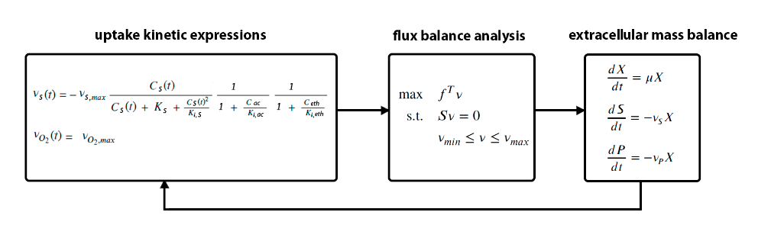
Figure 1: dynamic flux balance analysis framework. Kinetic expressions determine the substrate uptake at each time step, as a function of substrate and inhibiting products concentration. The uptake rate is used as input for the flux balance analysis, which is essentially a linear optimization problem with constraints based on available genome-scale models of microorganisms, such as E. coli. The result of the flux balance analysis, the growth rate, is then fed into the mass balance equations, which updates the concentration of the external metabolites. The external metabolites concentrations are then used in the next time step to recalculate the uptake rate.

Based on data available in the literature, a maximum glucose uptake rate of 10.5, maximum glycerol uptake rate of 13, maximum xylose uptake rate of 7.5, and maximum oxygen uptake rate of 15 mmol/gCDW.h were used in the simulations (Varma and Palsson, 1994). Both the growth associated and the non-growth associated set of simulations were run as batch processes with volume of 200 m³ and initial conditions of 25 g/L of carbon source (glucose, or glycerol or xylose) and 0.25 g/L biomass. Figure 1 illustrates the procedure used for the simulations of each PHB production type.

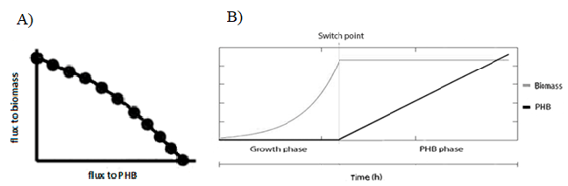
Figure 1: A) Growth associated PHB production simulations, each point is a different yield and its respective set of titer and productivity, that was simulated in order to explore the trade-off between biomass and product formation. B) Non-associated PHB production simulations, each simulation varied the point to switch from growth to PHB production phase.

In the case of growth associated PHB production, the compromise between biomass and product formation was explored by carrying out a series of simulations with growth as the objective function, but with each subsequent simulation also fixing an increasingly higher flow to the PHB synthesis reaction, thus ranging from a flow for PHB synthesis of zero all the way up to the maximum flow possible predicted by the microorganism model, given the carbon source consumption rate used. For the case of non-growth associated PHB production, sets of two-phase simulations were carried out. The first phase of each set had growth as the objective function, representing a phase where ideal conditions for growth are provided for the bacteria. The second phase of each set had PHB synthesis as objective function, representing the point where the ideal conditions for PHB synthesis, such as nitrogen limitation and excess carbon (Kaur, 2015), are provided for the bacteria. Working with the same total amount of carbon source as used in the growth associated simulations, each two-phase simulation varied the fraction of this total amount that was given to the growth phase and to the PHB production phase.

The proposed metric used to evaluate the simulations was the monthly gross profit. To obtain the monthly gross profit, the upstream and downstream costs and the revenue with PHB sales were estimated as a function of the product yield, titer, cultivation time, and final biomass obtained in each simulation. Prices of USD 0.77/kg (Alvarez Chavez et al., 2022), USD 0.53/kg (Alvarez Chavez et al., 2022) and USD 0.44/kg (Manker et al., 2022) were used for glucose, glycerol and xylose, respectively, and a PHB selling price of USD 5.5/kg (Pavan et al., 2019).
  - Results and Discussion
As a result of the simulation, sets of biomass, yield, titer, productivity and monthly gross profit were obtained for each carbon source. As an example, the set of results obtained for growth associated PHB production with glucose as a carbon source are presented in Table 1. Table 1 indicates that the scenario that would result in the highest monthly gross profit, taking into consideration the maximum PHB accumulation in microorganisms of around 85% (wt) shown experimentally in the literature (Chen and Jiang, 2018; Raza et al., 2018), is obtained when reaching a yield of around 0.47 g PHB/g glu, and its set of titer of 11.74 g/L and productivity of 0.88 g PHB/L.h, leading to a monthly gross profit of about 22 thousand USD/month, for the conditions used in the simulations. It can be noted from Table 1 that the highest theoretical monthly gross profit is not achieved in the scenario with the highest possible yield, but rather in the scenario where the set of yield, titer and productivity, when analysed in terms of upstream and downstream costs, and revenue with the product, actually results in the best performance, something that can be identified mathematically with the proposed approach, setting therefore better targets for future metabolic engineering strategies. The results for non-growth associated PHB production with glucose are shown in Table 2.

Table1: Growth associated PHB production with Escherichia coli using glucose as the carbon source

flux to  PHB | Final biomass | Final  yield | Final  titer | Final  productivity | PHB content | monthly gross profit
mmol/gCDW.h | g/L | g PHB/g glc | g PHB/L | g PHB/L.h | % | USD/month
0 | 11.15 | 0.01 | 0.25 | 0.04 | 2.19 | -371903
1 | 10.45 | 0.06 | 1.43 | 0.24 | 12.02 | -347917
2 | 9.83 | 0.11 | 2.68 | 0.46 | 21.42 | -306451
3 | 9.28 | 0.15 | 3.78 | 0.65 | 28.95 | -267775
4 | 8.79 | 0.19 | 4.76 | 0.82 | 35.13 | -229540
5 | 8.04 | 0.23 | 5.87 | 0.94 | 42.22 | -184936
6 | 7.09 | 0.28 | 7.05 | 1.02 | 49.85 | -140087
7 | 6.12 | 0.33 | 8.22 | 1.07 | 57.31 | -92963
8 | 5.07 | 0.38 | 9.39 | 1.06 | 64.96 | -50374
9 | 4.00 | 0.42 | 10.57 | 1.00 | 72.54 | -10931
10 | 2.93 | 0.47 | 11.74 | 0.88 | 80.02 | 22058
11 | 1.86 | 0.52 | 12.91 | 0.70 | 87.38 | 44239
12 | 0.79 | 0.56 | 14.07 | 0.41 | 94.71 | 46163
12.909 | 0.25 | 0.59 | 14.67 | 0.28 | 98.32 | 40313

Table 2: Non-growth associated PHB production with Escherichia coli using glucose as the carbon source

percentage of glucose to growth phase | Final biomass | Final  yield | Final  titer | Final  productivity | PHB content | monthly gross profit
% | g/L | g PHB/g glc | g PHB/L | g PHB/L.h | % | USD/month
100 | 11.15 | 0.01 | 0.25 | 0.04 | 2.19 | -372407
90 | 9.99 | 0.06 | 1.47 | 0.25 | 12.81 | -352383
80 | 8.83 | 0.12 | 2.93 | 0.50 | 24.93 | -305433
70 | 7.69 | 0.18 | 4.40 | 0.76 | 36.40 | -252287
60 | 6.55 | 0.23 | 5.87 | 1.00 | 47.23 | -198498
50 | 5.44 | 0.29 | 7.33 | 1.24 | 57.41 | -141296
40 | 4.34 | 0.35 | 8.80 | 1.42 | 66.96 | -83338
30 | 3.27 | 0.41 | 10.27 | 1.52 | 75.85 | -26502
20 | 2.23 | 0.47 | 11.73 | 1.44 | 84.06 | 25666
10 | 1.22 | 0.53 | 13.20 | 1.07 | 91.55 | 63421
0 | 0.25 | 0.59 | 14.67 | 0.28 | 98.32 | 40174

It can be seen in Table 2 that, for the maximum PHB content of around 85% (wt) (Chen and Jiang, 2018; Raza et al., 2018), the best performance is obtained when using 20% (mol) of the total available glucose for growth and the remaining 80% (mol) for PHB synthesis, resulting in a final yield of also 0.47 g PHB/g glu, but with a respective titer of 11.73 g/L and productivity of 1.44 g PHB/L.h. This scenario indicates what would be potentially the ideal moment to switch from the growth phase to the production phase, pointing therefore, targets for future bioprocess optimization and synthetic biology strategies. This switch is often accomplished with limitation of nutrients such as phosphorus or nitrogen (Kaur, 2015), but can also be accomplished with the use of genetic toggle-switches (Batianis et al., 2023). The simulations also mathematically show that, by having a dedicated growth phase and production phase, less total time is required to achieve the same yield and titer, resulting then in higher productivity.

Summarizing the results obtained for all carbon sources, Figure 3 illustrates the maximum theoretical performance that can be obtained for both growth and non-growth associated PHB production in the conditions of the simulations.
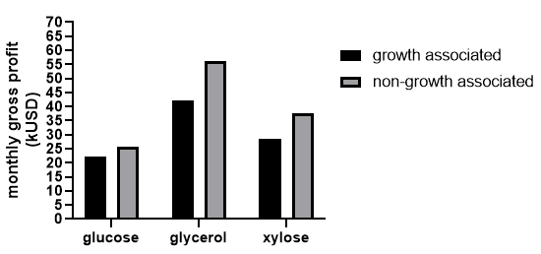
Figure 3: Maximum monthly gross profit for growth and non-growth associated PHB production with different carbon sources

It can be seen in Figure 3 that both glycerol and xylose lead to a higher maximum production potential than glucose, where glycerol displayed the best potential, especially on non-growth associated production, in the conditions of the simulations.
  - Conclusions
Using the growth associated and non-growth associated PHB production with recombinant E. coli on different carbon sources as a case study, this work shows how the proposed approach can be used for pre-assessment of bioprocesses in different scenarios and to find the conditions that would lead to the maximum theoretical profit possible, thus establishing potential goals for metabolic engineering and synthetic biology techniques, as well as bioprocess optimization strategies. The approach also pointed glycerol has the highest production potential between the carbon sources tested, for PHB production with E coli in the conditions simulated.

Acknowledges
This research was financially supported by the Coordination of Superior Level Staff Improvement (CAPES) grant no. 88887.464619/2019-00, PROEX program and RCGI/FAPESP (2020/15230-5). The following productivity fellowships from National Council for Scientific and Technological Development CNPq are also acknowledged: J. Gregorio C. G. (308714/2019-9) and Galo A.C. L. R. (311550/2022-3).
References
B. Alvarez Chavez, V. Raghavan, B. Tartakovsky, 2022. A comparative analysis of biopolymer production by microbial and bioelectrochemical technologies. RSC Advances 12 (25), 16105–16118.
A. A. Amadu, S. Qiu, S. Ge, G. N. D. Addico, G. K. Ameka, Z. Yu, W. Xia, A.-W. Abbew, D. Shao, P. Champagne, S. Wang, feb 2021. A review of biopolymer (Poly-β -hydroxybutyrate) synthesis in microbes cultivated on wastewater. Science of The Total Environment 756, 143729.
C. Batianis, R. P. van Rosmalen, M. Major, C. van Ee, A. Kasiotakis, R. A. Weusthuis, V. A. Martins dos Santos, jan 2023. A tunable metabolic valve for precise growth control and increased product formation in Pseudomonas putida. Metabolic Engineering 75, 47–57.
Z. Bodor, S. Lanyi, B. Albert, K. Bodor, A. C. Nechifor, I. Miklossy, dec 2019. Model Driven Analysis of the Biosynthesis of 1,4-butanediol from Renewable Feedstocks in Escherichia coli. Revista de Chimie 70 (11), 3808–3817.
G. Q. Chen, X.-R. Jiang, oct 2018. Engineering microorganisms for improving polyhydroxyalkanoate biosynthesis. Current Opinion in Biotechnology 53, 20–25.
R. Dürr, S. Duvigneau, A. Kienle, 2021. Microbial Production of Polyhydroxyalkanoates – Modeling of Chain Length Distribution. Vol. 50. Elsevier Masson SAS.
S. Duvigneau, R. Dürr, L. Kranert, A. Wilisch-Neumann, L. Carius, R. Findeisen, A. Kienle, 2021. Hybrid Cybernetic Modeling of the Microbial Production of Polyhydroxyalkanoates Using Two Carbon Sources. Vol. 50. Elsevier Masson SAS.
W. Hohenschuh, R. Hector, G. S. Murthy, jul 2015. A dynamic flux balance model and bottleneck identification of glucose, xylose, xylulose co-fermentation in Saccharomyces cerevisiae. Bioresource Technology 188, 153–160.
S. M. Ioannidou, C. Pateraki, D. Ladakis, H. Papapostolou, M. Tsakona, A. Vlysidis, I. K. Kookos, A. Koutinas, jul 2020. Sustainable production of bio-based chemicals and polymers via integrated biomass refining and bioprocessing in a circular bioeconomy context. Bioresource Technology 307 (November 2019), 123093.
G. Kaur, jul 2015. Strategies for Large-scale Production of Polyhydroxyalkanoates. Chemical and Biochemical Engineering Quarterly 29 (2), 157–172.
L. P. Manker, G. R. Dick, A. Demongeot, M. A. Hedou, C. Rayroud, T. Rambert, M. J. Jones, I. Sulaeva, M. Vieli, Y. Leterrier, A. Potthast, F. Maréchal, V. Michaud, H. A. Klok, J. S. Luterbacher, 2022. Sustainable polyesters via direct functionalization of lignocellulosic sugars. Nature Chemistry 14 (9), 976–984.
J. M. Monk, C. J. Lloyd, E. Brunk, N. Mih, A. Sastry, Z. King, R. Takeuchi, W. Nomura, Z. Zhang, H. Mori, A. M. Feist, B. O. Palsson, oct 2017. iML1515, a knowledgebase that computes Escherichia coli traits. Nature Biotechnology 35 (10), 904–908.
F. A. Pavan, T. L. Junqueira, M. D. Watanabe, A. Bonomi, L. K. Quines, W. Schmidell, G. M. de Aragao, jun 2019. Economic analysis of polyhydroxybutyrate production by Cupriavidus necator using different routes for product recovery. Biochemical Engineering Journal 146 (November 2018), 97–104
Z. A. Raza, S. Abid, I. M. Banat, jan 2018. Polyhydroxyalkanoates: Characteristics, production, recent developments and applications. International Biodeterioration Biodegradation 126 (September 2017), 45–56.
K. Y. Sen, M. H. Hussin, S. Baidurah, 2019. Biosynthesis of poly(3-hydroxybutyrate) (PHB) by Cupriavidus necator from various pretreated molasses as carbon source. Biocatalysis and Agricultural Biotechnology 17, 51–59.
A. Varma, B. O. Palsson, oct 1994. Stoichiometric flux balance models quantitatively predict growth and metabolic by-product secretion in wild-type Escherichia coli W3110. Applied and Environmental Microbiology 60 (10), 3724–3731.
H. Wang, C. Kontoravdi, E. A. del Rio Chanona, 2023. A Hybrid Modelling Framework for Dynamic Modelling of Bioprocesses. Vol. 52. Elsevier Masson SAS.
K. Zhuang, B. R. Bakshi, M. J. Herrgård, sep 2013. Multi-scale modeling for sustainable chemical production. Biotechnology Journal 8 (9), 973–984.

