Assessment of the sustainability of intensified CO₂ capture schemes
Melanie Coronel-Muñozª , Ana Gabriela Romero-Garcíaª, Brenda Huerta-Rosasª, Eduardo Sánchez-Ramírez^{a*}, Juan Gabriel Segovia-Hernándezª
ªDepartment of Chemical Engineering, Universidad de Guanajuato, Campus Guanajuato, Guanajuato, 36050, Mexico
eduardo.sanchez@ugto.mx
Abstract
The CO₂ capture process is related to Sustainable Development Goals (SDGs) 7, 9, 12 and 13 of the 2030 Agenda. CO₂ capture involves the use of solvents such as Mono ethanolamine (MEA). Currently there are theoretically more sustainable alternatives such as deep eutectic solvents (DES). In this work two schemes for the CO₂ capture process are evaluated, the first scheme considers Mono-ethanolamine (MEA) and the second scheme considers a DES (ChCl/ urea (1:2)) as green solvent, considering in both schemes the use of natural gas, biogas and coal as fuels that originate the CO₂ flux. The dynamics of the process play an important role when is evaluating the implementation of the new alternatives. Likewise, the evaluation of both alternatives should be considered within a sustainability framework that guarantees the generation of process schemes that comply with the aspects indicated in the United Nations (UN) 2030 Agenda. The results indicate that for both solvents, the alternative that considers coal as fuel in the combustion stage showed the best sustainability indicators evaluated. Also, in a direct comparison between both solvents, it was concluded that DES capture is the best in cost and environmental terms.

Keywords: CO₂ capture, carbon capture, MEA, Deep eutectic solvents, dynamic properties.
  - Introduction
One of the most pressing problems in the world today is climate change, due to various anthropogenic activities that contribute significantly to the release of greenhouse gases (GHG) into the atmosphere, especially CO₂. The Sustainable Development Goals (SDGs) established by the 2030 Agenda have as their main objective to redirect economic, political, and social activities with an approach that prioritizes environmental sustainability. Due to the urgent need to mitigate climate change, various alternatives have been studied to diminish CO₂ emissions, with CO₂ capture being the main option in the industrial sector. Capture technologies in industrial smokestacks are classified into post-combustion, pre-combustion, and oxy-fuel combustion. Post-combustion capture (PCC) technology is more technologically mature and has shown relatively good results in CO₂ capture processes, the classic chemical absorbent for CO₂ separation applications is aqueous Mono-ethanolamine (MEA), due to its great CO₂ capture capacity, commercial availability, relatively low cost, fast absorption rate and extensive research in industrial applications. Despite its high efficiency, MEA is considered highly toxic, so its implementation entails a high environmental impact. Given these drawbacks, there is an opportunity to study new solvents that may be able to replace MEA in the CO₂ capture process. A novel alternative is the implementation of green solvents called deep eutectic solvents (DES) with selective absorption capacity towards CO₂. Previously, several studies have been conducted on the applicability of both solvents for CO₂ capture from combustion processes. For example, Romero-García et al. (2022) evaluated the performance of MEA in a multi-objective optimization framework with several performance indicators. Although promising results were obtained, several indicators that could broaden the perspective of the process in terms of process sustainability were left out. Using a green solvent, Martinez-Lomovskoi et al. (2023) optimized a power generation plant obtaining a minimum of 95 % CO₂ recovery. To evaluate the performance of the capture plant, they used environmental and economic indicators. As a result, the process using coal in the combustion section presented a value of EI99 lower by 56.1 % and 72.8 % with respect to natural gas and biogas. However, the lack of an analysis of the dynamics of the process or a safety evaluation, leaves the results obtained by Martínez-Lomovskoi et al. (2023) relatively incomplete under the light of more performance indexes, since although we could have a plant with a high sustainability index, but highly risky, that is why to achieve a comparative analysis of the use of the DES versus the MEA it is necessary to broaden the approach to other indicators.

Although the use of both solvents was promising due to the capture capacity that was observed, during the exploration of both alternatives, sustainability indicators that allow comparing both alternatives were not jointly evaluated. According to what is proposed by the sustainable development goals of the UN 2030 Agenda, there are several indicators that can provide information regarding their sustainability. For example, the dynamic properties of the process, the inherent safety, as well as the economic and environmental impact. In order to determine the criteria for the implementation of a CO₂ capture process, a comparative analysis was carried out in this article within the framework of sustainability, which is generated by evaluating controllability, economic, environmental, and safety indicators for each of the cases evaluated in the articles by Romero-García (2022) and Martinez-Lomovskoi (2023), taking sample points at different conditions, to compare the feasibility of using DES versus MEA.
  - Case Study
The post-combustion capture process (PCC) consists of removing CO₂ from the flue gas after flaring has been performed. Romero-García et al. (2022) performed a multi-objective optimization project of a power plant coupled to a PCC CO₂ capture process, considering coal, natural gas, associated gas and biogas for electricity production. The CO₂ capture plant used an aqueous solution of Mono-ethanolamine (MEA) at 30 % by weight as solvent. The process consists of an absorption column and a desorption column at the end of the process.
To implement environmentally responsible CO₂ solvents, the use of deep eutectic solvents (DEPs) was proposed, which have advantages over amines, particularly due to the non-toxic and non-corrosive nature of many of them and their high thermal and oxidative stability. Martínez-Lomovskoi et al. (2023), carried out the design and optimization of a carbon capture plant taking up the case study of Romero García et. al. (2022) but now using novel green DES aqueous ChCl/ urea (1:2), under a sustainability scheme, as a first in the reported literature. The process is composed of an absorber and desorber as the traditional process but with the implementation of two flash tanks to treat the DES prior to desorption. Both cases reported their results in a Pareto front as shown in Figure 1. In the traditional process (Figure 1-b), the use of coal stands out as the most viable alternative with respect to environmental and controllability conditions, but with a low return on investment (ROI). While in the implementation of the green solvent (Figure 1-a), Martinez-Lomovskoi highlights the use of coal (C) as the most optimal design obtained, since in terms of environmental impact it presents values 21.9 %, 56.1 % and 72.8 % lower than associated gas (AG), natural gas (NG) and biogas (BG) respectively and also exhibits a higher ROI as well as the best overall performance considering all environmental and economic parameters simultaneously.

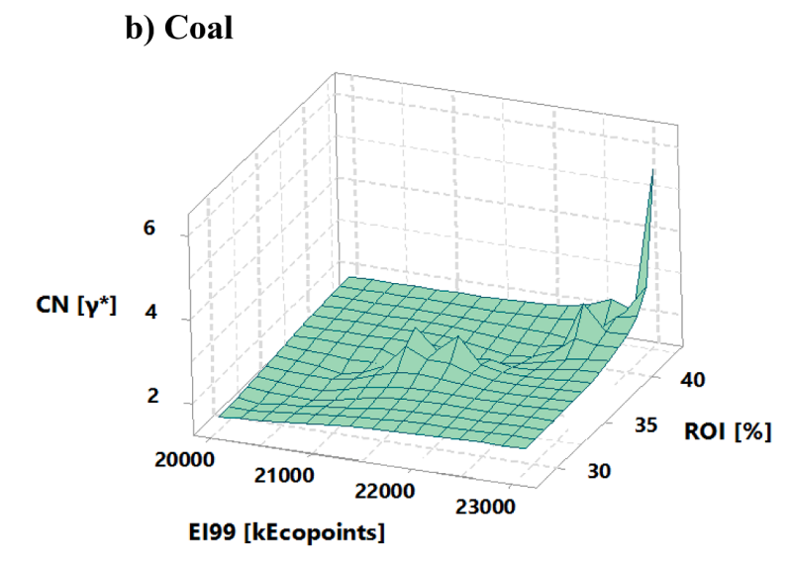
Figure 1. Excerpts from the Pareto fronts reported by Romero-García et al. (2022) and Martínez-Lomovskoi et al. (2023). Being coal (C), associated gas (AG), natural gas (NG) and biogas (BG).

Taking both cases as a precedent, in this article a comparative analysis model was established supported by the evaluation of control and safety indicators, necessary indicators to achieve the integrated evaluation of the designs in a sustainability framework, the evaluation was performed in three crucial points specific to the Pareto fronts, in reference to the cost, that is, a point in the highest, central and cheapest cost for biogas, coal, and natural gas fuels, from the results obtained by Romero-Garcia et al. (2022) and Martinez-Lomovskoi et al. (2023).
  - Performance Indexes and Methodology
Creating or modifying processes towards sustainability requires assessing the feasibility of proposed innovations based on economic, energy, environmental, and control indicators to provide a sustainable manufacturing process and achieve material efficiency.
In this article, a set of metrics was selected for the evaluation of environmental impact (Eco-indicator 99, EI99), economic feasibility (Total annual cost, TAC), dynamic process behavior (Condition number), and safety (Risk index, IR).

3.1 Eco-indicator 99 (EI99)
Eco-indicator 99 (EI99) is one of the most widely used environmental impact estimation methods and consists of a quantitative analysis of the life cycle evaluated from beginning to end. The calculation is performed using Eq. (1). Where ω represents the damage weight factor (Pts/kg), Ci represents the impact value for each of the categories i, and α is the value of subcategory j (kg/year).
$$EI99=\sum_{i}{\sum_{j}{ω∙C_{i}∙α_{j}}}$$ | (1)
3.2 Total annual cost (TAC)
The TAC assumes the annualization of the investment cost of the main process equipment over a 10-year amortization period. To calculate it, Eq. (2) is used. Where $C_{TM,i}$ is the capital cost of the equipment in dollars ($),$r$ represents the payback period in years, and $C_{ut,j}$ is the cost of cooling and heating services, in dollars per year ($/year).
$$TAC=\frac{\sum_{i=1}^{n}{C_{TM,i}}}{r}+\sum_{j=1}^{n}{C_{ut,j}}$$ | (2)
3.3 Condition number (CN)
The Condition Number quantifies the sensitivity of the system to inaccuracies in process parameters and mode errors. Systems with small condition numbers present better control properties. Its calculation is performed as shown in Eq. (3), where ($σ_{*}$) is associated with the direction in which the system has more difficulty moving. On the other hand, the magnitude of ($σ^{*}$) indicates the easiest direction the system will move to.
$$γ^{*}=\frac{σ^{*}}{σ_{*}}=\frac{maximum singular value}{minimum singular value}$$ | (3)
3.4 Individual risk (IR)
The IR identifies the risk that a person faces based on his position, including the likelihood of an accident resulting in death or serious injury. The IR is defined as shown in Eq. (4). Where, $f_{i}$ represents the recurrence that one accident will occur, and $P_{x,y}$ is the likelihood that the accident will occur in a particular location.
$$IR = \sum{f_{i}P_{x,y}}$$ | (4)
In the methodology of this project, the instantaneous and continuous risk analysis was performed for each of the equipment involved in the CO₂ capture process that is in contact with the solvent of interest. Catastrophic events such as Boiling Liquid Expanding Vapor Explosion (BLEVE), Unconfined Vapor Cloud Explosion (UVCE), Jet Fire, Flash fire, and toxic explosion were evaluated using specific mathematical models for each case reported in the literature.
  - Results
In this section we present the results of the evaluation of the parameters mentioned in the case study and described in the methodology. In Figure 2-a, the behavior between TAC, EI99, and CN, has a similar trend, so a more sustainable process implies a lower cost and better controllability. At the selected point on the front of Pareto with the highest TAC value for the use of coal as fuel, the total annual cost is lower by 135.34 % and 218.18 % compared to the use of natural gas (NG) and biogas (BG) respectively. At the midpoint of the Pareto front with a central TAC, for coal as fuel, is the lowest CN with 133.0002, while the maximum CN is 6537.4 at the top of the Pareto front with the highest TAC value in the use of NG as fuel. In terms of safety, coal presents the best conditions due to several factors, including lower reboiler heat duty. In Figure 2-b, the relationship EI99 and CN, shows that a more sustainable process is the one with the best controllability. The use of coal with the highest TAC value has the lowest results of CN and EI99 results about the use of natural gas (NG) and biogas (BG) respectively. From the evolution of the sustainability indicators in both schemes, the best designs were obtained for those using coal as fuel in the combustion stage, since it generates a greater flow of CO₂, and greater ease of capture was observed in the face of these CO₂ concentrations.

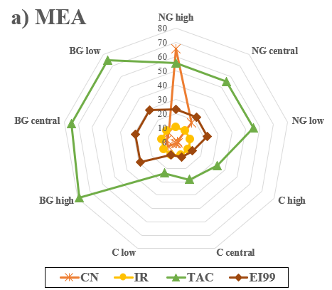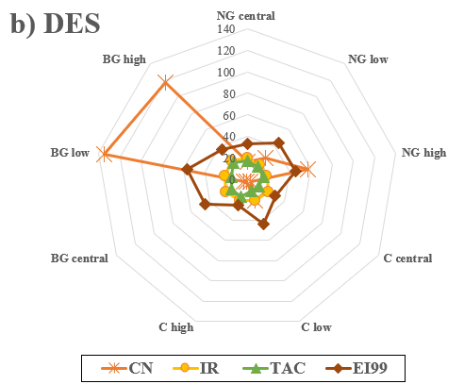

Figure 2. Radial graphs for CO₂ capture with a) MEA and b) DES as solvents. Using natural gas (NG), coal (C) and biogas (BG). Evaluating the indicators of condition number (CN), individual risk (IR), total annual cost (TAC) and eco-indicator 99 (EI99).

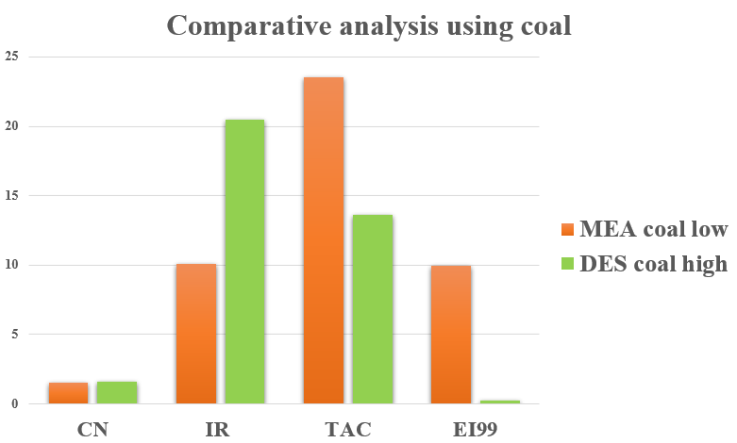
Figure 3. Comparison of the best designs of both schemes using coal (C) as fuel.

In Figure 3.for the same process of post-combustion capture (PCC) with coal, a lower TAC and EI99 were obtained in the use of DES compared to MEA, due to lower equipment costs, operation and lower energy consumption. While DES is more expensive than MEA, the cost of operation is reduced due to the energy used. A higher IR in the case of DES use is due to the implementation of two flash tanks and although the desorption column in the DES PCC process is smaller than the MEA process, reducing the number of stages by about 50 % so, in the flash tanks and in the desorption column occur the pressure drops which significantly influences the individual risk. Regarding condition number, the use of MEA is slightly lower since the controllability of CPC using DES was also affected by the use of the two flash tanks. Finally, for the selection of the best process, the results of Figure 3 were taken into consideration. Therefore, the process with the best results of the indicators is high carbon, in a CPC with the use of DES as a solvent. The process conditions are shown in Figure 4.

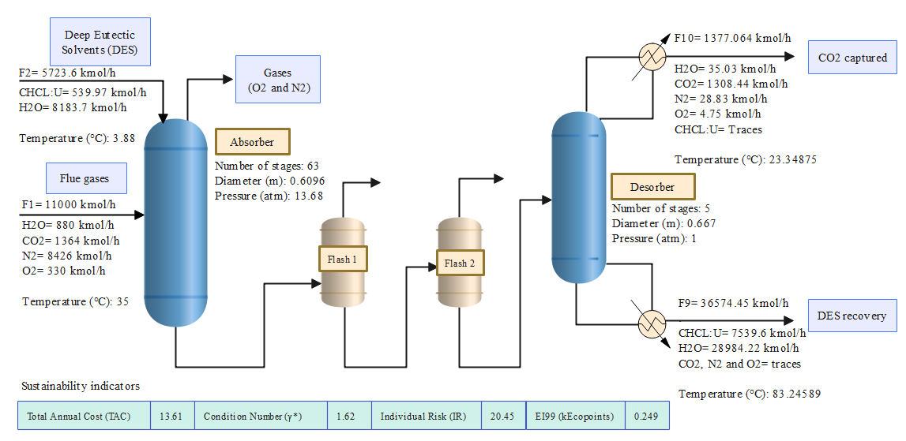

Figure 4. Best proposed scheme of post-combustion CO₂ capture process using high carbon as fuel in a DES scheme as solvent without consider the combustion stage.
  - Conclusions
Regarding the comparative analysis of CO₂ capture using coal as fuel and the conventional solvent MEA as compared to the proposal of a DES solvent, it can be concluded that the model with the best sustainability indexes presents lower costs, good controllability of the process and whose environmental impact is lower compared to the traditional CO₂ capture process. However, in terms of safety, the IR is considerably increased due to pressure drops with the use of flash tanks in the process of treating the DES. After all the analysis it was concluded that the best design is the DES scheme with the use of coal as fuel in your point high the analysis. By implementing this green solvent, it leads to the improvement of existing processes that meet the objectives of the 2030 Agenda, from one of the most used fuels in the production of electricity such as coal.
References
C. Da Silveria Cachola, M. Ciotta, A. Santos and D. Peyerl. 2023. Deploying of the carbon capture technologies for CO2 emission mitigation in the industrial sectors. Carbon Capture Science & Technology, 7, 100102. https://doi.org/10.1016/j.ccst.2023.100102
A. Martinez Lomovskoi, A. G. Romero García, E. Sánchez Ramírez and J.G. Segovia Hernández. 2023. Desing and multi-objective optimization of a CO2 capture plant using deep eutectic solvents. Chemical Engineering Research and Desing, 192, 570-581. https://doi.org/10.1016/j.cherd.2023.03.006.
A. G. Romero García, N. Ramírez Corona, E. Sánchez Ramírez, H. Alcocer García, C. De Blasio and J.G. Segovia Hernández. 2022. Sustentability assessment in the CO2 capture process: multi-objective optimization. Chemical Engineering and Processing-Process Intensification, 182, 109207. https://doi.org/10.1016/j.cep.2022.109207.
G. J. Ruiz Mercado, R.L. Smith and M.A. Gonzalez. 2012. Sustainability Indicators for Chemical Processes: i. Taxonomy. Industrial & Engineering Chemistry Research, 51(5), 2309-2328. https://doi.org/10.1021/ie102116e.

