Optimum Green Clean Water Solution for Remote Islands
Aggelos Kaldellisª, Christofis Koroneos^{b}, Emilia. Kondili^{c}, John K. Kaldellisª
ªSoft Energy Applications & Environmental Protection Lab., UNIWA, Greece
^{b}Nisyros Municipality, Nisyros, Greece
^{c}Optimisation of Production Systems Lab., UNIWA, Greece
email for correpondence: jkald@uniwa.gr
Abstract
Water and energy are two fundamental resources with the supply of one highly dependent on the availability of the other. The recognition that their scarcity underpins socio-economic development has resulted in a growing interest of policy makers in the so-called "Water-Energy Nexus". The water-energy supply problem affects all types and sizes of contemporary communities around the world due to the spatial characteristics of the water availability, also challenged by the availability and the security of energy supply. Remote islands’ communities in the Mediterranean area suffer from significant water scarcity on top of their electricity generation problems due to the utilization of expensive thermal power stations. These problems are much more intense during the summer-touristic period, where the total islands population increases by almost one order of magnitude, strongly testing the capacity of the corresponding infrastructures. On the other hand, the entire Mediterranean region possesses excellent solar potential. In this context, the current paper investigates the opportunities for the autonomous operation of a clean water production scheme using only the available solar potential and an appropriate energy storage unit, paying also special attention in order to stabilize the operation of the water production sub-system. For this purpose, a reliable and user-friendly numerical model is developed to optimize the parameters of the proposed solution. The applied optimization procedure is based on scenarios’ analysis targeting maximum clean water production, uninterrupted operation of the desalination unit and minimum installation/operation cost, based on exclusive solar potential exploitation.
Keywords: Desalination, RES exploitation, energy storage, energy-water nexus.
  - Introduction
The existence of more than 85,000 islands consists a particular trait of the global geography. Focusing on the East Mediterranean region, the Aegean Archipelagos is an area of great interest, where one may find an extensive number of islands, 7% of them being inhabited. A semi-arid climate (Pnevmatikos and Katsoulis, 2006), the lack of local conventional energy resources (Kaldellis et al., 2007) as well as the relatively long distance from the mainland consist the main characteristics of most of these remote islands. Moreover, due to the specific climate type, significant water resources scarcity for both domestic and agricultural use is present for the vast majority of these islands, deteriorating the life quality of inhabitants and visitors, especially during the summer. Actually, in most remote islands electricity generation problems exist due to the utilization of expensive and heavily polluting outdated autonomous thermal power stations (APS). Actually, the water and electricity demand maximizes from June to August, strongly testing the performance of the corresponding infrastructures. The problem becomes much more severe in cases of electricity generation black out, since the existing desalination units will also stop their operation. Fortunately, the Mediterranean region possesses high solar potential, which is almost unexploited for various reasons.

In this context, the present work investigates the opportunities of an autonomous clean water solution including one photovoltaic (PV) generator and an appropriate energy storage device in order to fulfil the electricity demand of a typical desalination unit, paying also special attention in order to stabilize the operation of the water production system. For this purpose, a reliable and user-friendly numerical model has been developed to optimize the parameters of the proposed solution. The applied optimization procedure is based on scenarios’ analysis targeting maximum clean water production, uninterrupted operation of the desalination unit and minimum installation/operation cost, based on exclusive solar potential exploitation. According to the results obtained from the application of the proposed solution to a representative medium-sized Aegean Sea island, the continuous operation of the desalination unit is obtained by an appropriate combination of photovoltaics and battery storage units, providing green clean water quantities mainly during the high touristic season at a rational first installation cost.
  - Problem Description
The problem to be analyzed concerns the optimum sizing of a PV-battery based system able to provide the necessary electricity input for a reverse osmosis (RO)-desalination plant supporting its continuous (uninterrupted) operation. In figure (1) the proposed installation is schematically described. Note that for every cubic meter of clean water produced the energy required is "ε" (kWh/m³), depending mainly on the pressure and the water volume flow rate "Q" of the high-pressure pumps and on the feed water salinity.

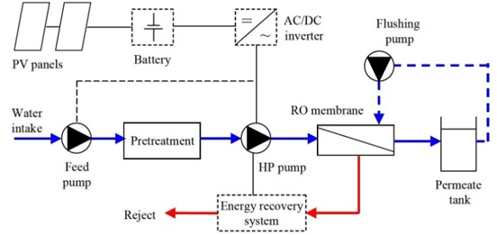

Figure 1: Schematic presentation of the proposed PV-battery water desalination solution
At the same time the renewable energy based solution selected -as the most appropriate (Kaldellis et al., 2007)- for very small islands is the exploitation of the existing solar potential via high efficiency photovoltaic panels. For this purpose, one needs data concerning the available solar irradiance and the ambient temperature time series. Furthermore, the PV panels output depends also on their inclination (tilt) angle in relation to the horizontal plane and the cleanliness index of the PV surface. Finally, the battery bank is characterized by its maximum useful energy to be provided to the consumption, its maximum depth of discharge (DOD_{max}) and its maximum charging and discharging rate as well as its charging and discharging efficiency (Kaldellis et al., 2009). In view of the configuration of figure (1), one may face the following operation cases (Table I):
R1 | Operation | The solar potential is high enough to provide the appropriate power and energy in order to operate the desalination plant, while any energy excess is forwarded to the system batteries. The desalination plant operates at its maximum flow rate "Q_{max}".
R2 | Operation | The solar potential is not high enough to provide the appropriate energy in order to operate the desalination plant, hence any additional energy is complemented by the battery bank, assuming that the DOD of the battery is lower than the DOD_{L}. This limit is lower than the DOD_{max}, (e.g. DOD_{L}=65% vs. DOD_{max}=80%) in order to protect the batteries and prolong their service period, normally is provided by the battery manufacturer. The desalination plant operates at maximum flow rate "Q_{max}".
R3 | Partial Operation | The solar potential is not high enough to provide the appropriate energy in order to operate the desalination plant, however the battery bank DOD is higher than a first security limit (DOD_{L}) but it is still lower than the DOD_{max}. The desalination plant continues its operation but at a lower flow rate than "Q_{max}", being however higher than the minimum flow rate "Q_{min}" of the installation (technical minimum).
R4 | Non-operation | The solar potential is not high enough to provide the appropriate power and energy in order to operate the desalination plant and the battery bank DOD is higher or equal to DOD_{max}. The desalination plant suspend its operation for the rest of the day. Any energy yield of the PV panels is used to charge the installation batteries and to decrease the corresponding DOD value. Finally, in case of total clean water shortage the desalination plant may be connected to the local electrical grid.
Table I: Available operational modes of the proposed clean water production solution

The proposed operation strategy is definitely a sustainable green solution, since the entire energy consumption of the desalination process is provided by the exploitation of solar potential. Hence, the target is to maximize the potable water production without jeopardizing the service period of the desalination plant components, i.e. by eliminating the successive start and stop orders, protecting at the same time the system battery.
  - Proposed Methodology
For the estimation of the necessary PV panels’ number and the appropriate capacity of the battery bank, in view of the sustainable operation of existing desalination unit, a new optimization model has been developed, taking into consideration the local water consumption needs, the land availability and the available budget or equivalently the corresponding clean water production cost vs. the elimination of CO₂ emissions.
    - Model Development
The approach that is implemented here is to operate a RO desalination plant in order to cover the water needs of an arid remote region integrating sustainability principles into traditional fossil fuels based applications and addressing complex interdependencies between various energy production components. The proposed model has been developed to address the complex interactions between various elements of solar energy exploitation -solar irradiance utilization, ambient temperature impact, battery bank depth of discharge (DOD) and uninterrupted operation- all under the sustainability strategy. The first step is to identify the critical elements affecting the uninterrupted sustainable operation of a desalination unit, maximizing the clean water production without the consumption of fossil fuels. Then a large number of scenarios (i.e. combinations of PV panels peak power P_{pv} and battery storage "E_{ss}") have been examined using long-term time series of solar irradiance along with ambient meteorological parameters (temperature, seawater salinity, etc.). Based on these input parameters and taking into account the existing constraints, the model defines several potential solutions that can be evaluated on the basis of minimum life cycle water production cost, minimum greenhouse gas emissions, maximum clean water production or any combination of all these criteria.
    - The Objective function
The optimization model developed combines the PV generator power output, the battery bank DOD in the course of time and the clean water production by the RO-desalination unit. The objective function is to achieve an optimal balance between cost, sustainability and clean water production. At the core of the model is a multi-objective function, as given in Eq. (1), including three primary objectives, i.e.: minimizing the water production cost "c_{w}", the CO₂ emissions "e" and the water deficit between the society needs and the desalination yield "d"(=Demand-Clean Production). The objective function is expressed:
$$Minimize Φ=αc_{w}+βe+γd$$ | (1)
In this context, "Φ" symbolizes the total weighted impact of the RES-based autonomous clean water production. The water production cost takes into account the PV-battery autonomous power system turnkey cost as well as the operation and maintenance cost of the proposed installation in present values divided by the clean water production volume of life cycle basis. Regarding the carbon dioxide emissions "e", these depend on the specific emissions coefficients per energy unit consumed (gr/kWh_{e}) by the desalination plant (e.g. 750 gr CO₂/kWh_{e} produced by oil vs. 35 gr CO₂/kWh_{e} by the PV panels) along with CO₂ emissions related with the battery bank and the necessary auxiliary equipment.

Additionally "d", as defined in Eq. (2), describes the maximum clean water production throughout the RO process, thus the minimum deficit between clean water demand "D" of the local society and the capability of the proposed solution "S" to fulfil the water demand. Thus, the corresponding water balance is investigated on daily basis "j".
$$d=\sum{\left(D_{j}-S_{j}\right)} (j=1,365)$$ | (2)
The weighting factors (α, β and γ) included in Eq. (1) indicate the varying significance of distinct factors aligned with the strategic priorities and policy decisions for any remote consumer. These factors underline the importance of water production cost, local market decarbonization and local society clean water needs fulfilment. They are determined based on objectives related to sustainability within the EU and national policy decisions, regulatory requirements and local society standard of living.
    - Variables and Constraints
For every optimization model it is important to define the variables and acknowledge the major constraints. Normally, variables include decision variables such as the clean water production quantities "Q", the PV generator peak power "P_{pv}", the battery capacity "E_{ss}" (and the permitted DOD_{max}), as well as operational variables. Constraints are formulated to enclose the limitations and requirements like the land availability, the maximum budget available, the maximum clean water demand on a monthly basis "D_{mo}" and the maximum existing water reservoirs capacity. The variables and constraints are designed to balance cost-efficiency, decarbonisation performance and clean water production.

      - Constraints
First, the constraint of land availability is introduced. This constraint aims for optimal use of the available land. Following that, the constraint of the available budget is also introduced since the initial investment cost should not exceed the capital availability. Finally, the clean water production should not exceed the corresponding clean water demand, including the local water storage potential, especially during low demand periods. Summarizing the above mentioned constraints may be summarized as follows:
$$A_{c}\left(P_{pv}\right)≤Available Land$$ | (3)
$${IC}_{o}≤Available Initial Capital$$ | (4)
$${Smo}_{i}≤{Dmo}_{i} i=1,12 for every month$$ | (5)
      - Variables
The main variables of the problem under investigation are the photovoltaic generator peak power "P_{pv}", the battery bank energy capacity "E_{ss}" and the clean water production "Q" of the desalination unit. In this context, the PV generator characteristics along with the solar irradiance, the PV panels tilt angle and the other meteorological parameters define the energy yield available for the desalination unit at every moment. Moreover, the battery bank capacity along with the corresponding DOD determine (Kaldellis et al., 2009) the opportunity to support the desalination plant operation during low solar potential periods (eliminating the unnecessary stop and start operation) and absorb any energy surplus due to the PV generator operation. Finally, the potable water production is based (Papapostolou et al., 2019) on the green energy availability and scopes to cover the everyday clean water demand of the local society, including the high tourism periods.
  - Results and Discussion

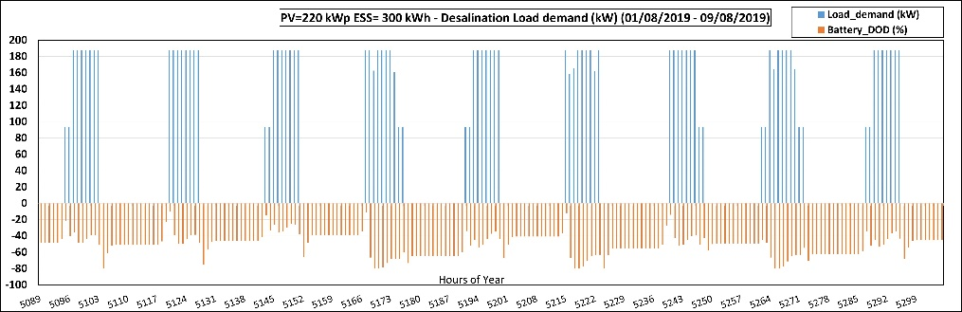
Figure 2: Operational characteristics vs. time for the proposed PV-battery based solution
The model developed is applied to a medium sized island of approximately 1000 permanent habitants, possessing high solar potential (≈1800 kWh/m²/year) and covering its total energy needs up to now using diesel oil (~500 MWh_{e} per year for the desalination units), Kaldellis et al., 2022. In order to estimate the optimum solution of equation (1) under the constraints of section three, a detailed scenarios analysis has been carried out, testing a large number of combinations (P_{pv} and E_{ss}). The resulting clean water quantity "Q" as well as the carbon dioxide emissions savings "e" and the corresponding clean water production cost "c_{w}" are estimated on an annual basis. Thus, by selecting a pair of (P_{pv} and E_{ss}) the hourly PV generator power output is calculated and compared with the power demand of the desalination unit on the basis of Table I operation modes. If the R4 situation appears, the proposed combination is excluded from the potential solutions. In figure (2) one may find the desalination plant load demand fulfilled by the operation of a 220 kW_{p} (i.e. P_{pv}=220 kW_{p}) solar generator and the corresponding Li-ion batteries (E_{ss}=300 kWh_{e}, DOD_{max}=80%) along with the (DOD) value of the system proposed batteries vs. time.

In figure (3) one may find the summary of the calculation results, concerning the annual clean water production for several combinations of (P_{pv} and E_{ss}) that guarantee the non-stop and start operation of the existing desalination plant on a daily basis. According to the results obtained it is clear that the existence of even a small battery bank remarkably increases the clean water production. However, after the 200 kWh_{e} of battery capacity the clean water production increase is minimal. Moreover, the gradual increase of PV generator peak power leads to an analogous increase of the clean water production and the corresponding carbon dioxide emissions reduction. At the same time, the first installation (turnkey) cost is also increasing, while the continuous increase in the PV generator size may raise land availability issues. Recapitulating, the optimum clean energy solution for each case study investigated depends strongly on the solar potential and the water demand profile of each candidate island as well as on the value of coefficients "α", "β" and "γ" selected by the local authorities and the local community.

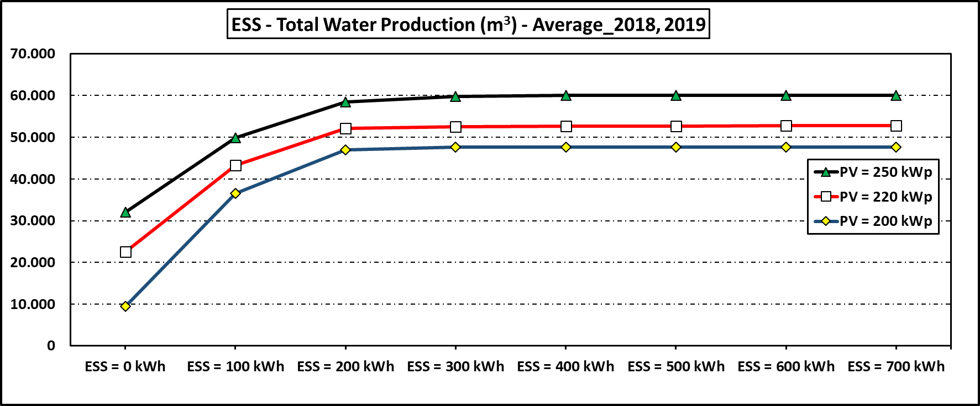

Figure 3: Potential energy autonomous optimal configurations based on scenarios analysis
  - Conclusions
The present work investigates the possibility of covering the energy requirements of remote arid islands’ desalination units in a sustainable manner, proposing the installation of photovoltaic power stations. For this purpose an optimization model has been developed offering a comprehensive approach for policy makers and local authorities to address the complexities of clean-green production, balancing financial, decarbonization and water demand considerations to achieve the most sustainable and efficient configurations. This optimization model is adaptable to different island cases and can be applied to prioritize specific targets, with the aim of guiding local societies to select more environmental friendly and lower production cost solutions. In any case, the proposed model may serve as a decision making tool and determines the foundations for encouraging clean green water production solutions in areas of similar specifications in the wider Mediterranean region.
Aknowledgements
This research has been funded under the investment support action "Flagship actions in interdisciplinary scientific areas with a special interest in the connection with the productive tissue" / Resilience, Inclusiveness and Development: Towards a Just Green and Digital Transition of Greek Regions – TAEDR-0537352. The action is implemented within the framework of the National Recovery and Resilience Plan Greece 2.0 with funding from the European Union - NextGenerationEU.
References
Kaldellis J.K., Kavadias K.A., Koronakis P.S., 2007, "Comparing Wind and Photovoltaic Stand-Alone Power Systems Used for the Electrification of Remote Consumers", Journal of Renewable and Sustainable Energy Reviews, Vol.11(1), pp.57-77.
Kaldellis J.K., Koroneos Chr., Triantafyllou P., Kaldellis A., Kollas P., 2022, " Clean energy solution for remote islands. The case of Nisyros island", Int. Journal of Sustainable Energy.
Kaldellis J.K., Zafirakis D., Kavadias K., 2009, "Techno-economic comparison of energy storage systems for island autonomous electrical networks", Renewable and Sustainable Energy Reviews, Vol. 13(2), pp.378-392.
Papapostolou Chr., Kondili E., Tzanes G., 2019, Optimisation of the integrated water - energy systems: a review with a focus in Process Systems Engineering, Computer Aided Chemical Engineering, 2019, 46, Pages 1621-1626
Pnevmatikos, J.D. and Katsoulis, B.D. (2006). The changing rainfall regime in Greece and its impact on climatological means. Meteorol Appl, 13(4), pp. 331-345.

