Modeling of Slurry Bubble Column Reactor for Hydrogenolysis of PET waste
Jae Hwan Choiª and Jong Min Lee^{a*}
ªSchool of Chemical and Biological Engineering, Seoul National University, 1 Gwanak-ro, Gwanak-gu, Seoul 08826, KOREA
jongmin@snu.ac.kr
Abstract
The modeling of slurry bubble column reactor (SBCR) for hydrogenolysis of polyethylene terephthalate (PET) was conducted. The axial dispersion model is commonly employed for modelling SBCRs. However, its suitability for application to PET hydrogenolysis reactors may be limited due to extremely viscous molten PET and high operating pressure, distinguishing them from conventional reaction systems Therefore, a model incorporating both axial and radial dispersion was employed. The partial differential equations of the model were approximated using a finite difference scheme and solved by iterative method. Through this approach, we found that the radial velocity and radial gradients of concentration and axial velocity are negligible. And sensitivity analysis revealed that the axial dispersion coefficient has a greater impact on PET conversion compared to the radial dispersion coefficient.
Keywords: modelling, slurry bubble column reactor, hydrogenolysis, PET recycle
  - Introduction
Over 300 million tons of plastics are manufactured annually, with PET ranking as the fourth most produced. Currently, thermal degradation is the predominant method for recycling PET, but it compromises some thermal and mechanical properties of PET. Consequently, there is a need to investigate more efficient and economical PET recycling techniques. Hydrogenolysis of PET, known for its cost-efficiency, has gained significant attention (Wu, 2021). This process, characterized by relatively slow reaction rates, high pressure, and high viscosity, differs from conventional three-phase reaction systems. Thus, reactor design for PET hydrogenolysis requires consideration of numerous unique factors, yet research in this area remains sparse.
Among the diverse three-phase reactors, the stirring reactors are suitable for highly viscous system but are challenging to implement in industrial-scale reactors at high pressure. Similarly, the trickle bed reactor, commonly employed in industrial applications, is unsuitable for highly viscous system and therefore, not a suitable choice for PET hydrogenolysis reactors. Consequently, this research modeled a PET hydrogenation reactor based on the SBCR, capable of handling both high pressure and viscous system. Then, instead of the axial dispersion model commonly used for SBCR modeling, we employed a model that accounts for both axial and radial dispersion. Through this model, we analyzed the velocity and concentration in the radial direction and the radial gradient of the axial velocity. Finally, a sensitivity analysis of the dispersion coefficient was performed.
  - Mathematical model
    - Governing equations
The process of PET hydrogenolysis is relatively slow which requires a low liquid flowrate to achieve sufficient conversion. Given that the catalyst particles are sufficiently small, it is deemed suitable to use a homogeneous model. Additionally, fluctuations in gas partial pressure and mass transfer limitations are negligible since the reactor is operated under high pressure (100 bar). Taking all these factors into account, an isothermal and steady-state reactor model was developed, incorporating mole, mass and momentum balance as shown below.
$$-∇∙\left(C_{i}\vec{u}\right)+∇∙\left(\vec{D}∙∇C_{i}\right)+r_{i}=0$$ | (1)
$∇∙\left(ρ\vec{u}\right)=0$ | (2)
$-∇∙\left(ρ\vec{u}\vec{u}\right)+ρ\vec{g}-∇P+ ∇∙τ=0$ | (3)
$τ= ∇∙(μ_{eff}$ ($∇\vec{u}+ ∇{\vec{u}}^{T}))$ | (4)
where $r_{i}$ is generation rate of species i, $τ$ is the stress tensor, $C_{i}$ is the concentration, $\vec{u}$ is the velocity vector, $\vec{D}$ is the dispersion coefficient, $ρ$ is the density of liquid, $\vec{g}$ is the gravity acceleration vector and $μ_{eff}$ is the effective viscosity of liquid.
The radial and axial dispersion coefficient was represented as follows, based on the work of Kim (1928) and Kang (1986), respectively.
$Pe_{l}= \frac{d_{p}U_{l}}{D_{z}}=20.19{\left(\frac{d_{p}}{D_{column}}\right)}^{1.66}{ \left(\frac{U_{l}}{U_{l}+U_{g}}\right)}^{1.03}$ | (5)
${Pe}_{r}= \frac{d_{p}U_{l}}{D_{r}}=28.3\left(\frac{d_{p}}{D_{column}}\right){\left(\frac{U_{l}}{U_{l}+U_{g}}\right)}^{1.16}$ | (6)
    - Reaction kinetics
The product of PET hydrogenolysis reaction depend on the catalyst. In this study, we assumed xylene as final product based on the study of Wu (2021). Also, the reaction was simplified with assuming direct conversion of PET into xylene by the 1st order reaction.
$$PET+H_{2}→Xylene+2CO_{2}$$ | (7)
As mentioned above, mass transfer limitation was negligible. So, the concentration of $H_{2}$ and ${CO}_{2}$ was expressed by follows.
$C_{i}=P_{i}*He_{i}$ | (8)
where ${He}_{i}$ is the Henry constant of the component i. Then, the reaction rate can be expressed by
$r_{PET}= -kC_{PET}C_{H_{2}}w_{cat}$ | (9)
where $w_{cat}$ is the mass of the catalyst. The reaction rate constant ($k$) was assumed to be 0.000340 $m^{3}/mol∙s∙kgcat$, which is equivalent to 10 grams of PET being converted to 99.99 mol% within 12 hours in the batch reactor experiment.
    - Model solution
Boundary conditions of the system are below.
$z=0, v=inlet condition$ | (10)
$z=L, u_{r}=0, \frac{∂u_{z}}{∂z}= 0$ , $\frac{∂P}{∂z}= 0, \frac{∂C_{i}}{∂z}= 0$ | (11)
$r=0, u_{r}=0, \frac{∂u_{z}}{∂r}= 0$ , $\frac{∂P}{∂r}= 0, \frac{∂C_{i}}{∂r}= 0$ | (12)
$r=R, u_{r}=0, u_{z}= 0$ , $\frac{∂P}{∂r}= 0, \frac{∂C_{i}}{∂r}= 0$ | (13)
where v stands for the all variables. Then, the partial derivatives in the radial and axial coordinates are approximated by finite difference method. In general, simulations of reactor systems employ 2nd order central difference or backward Euler for the computational simplification. However, in this study, a 4th order central difference scheme was employed to minimize errors, particularly when sparse grids were used. The approximated nonlinear equations were implemented in Python, utilizing Pyomo, and solved by interior point method with IPOPT (Hart et al., 2017).
  - Result and Discussion
    - Laboratory-scale simulation
For the laboratory-scale reactor simulation, the reactor diameter and height were assumed to be 0.5 m and 2 m, respectively. Then simulations were carried out with varying grid sizes, and the results are presented in Figure 1 and Figure 2.
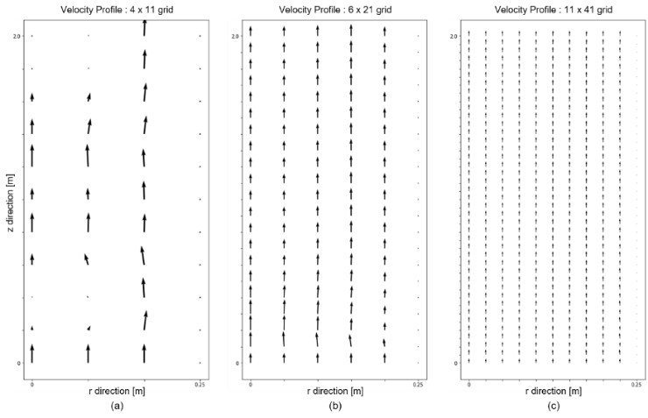
Figure 1. Velocity profile of the reactor. (a), (b), (c) correspond to grid sizes of 4 x 11, 6 x 21, and 11 x 41 in the radial (r) and axial (z) directions, respectively
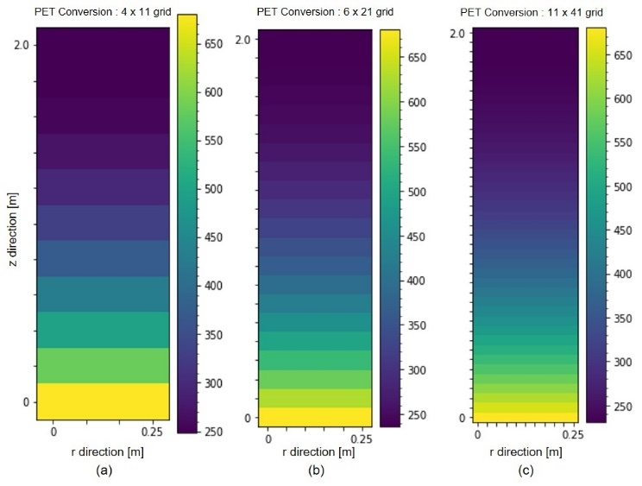
Figure 2. PET concentration profile of the reactor. (a), (b), (c) correspond to grid sizes of 4 x 11, 6 x 21, and 11 x 41 in the radial (r) and axial (z) directions, respectively.
In Figure 1.a, for small grid number, a distorted velocity field is observed, transitioning into a plug flow configuration as the grid number increases. This transition is attributed to the error of the 4th order central difference method, where the leading error is proportional to the fourth power of the grid size, resulting in a smaller error with a larger grid number. Notably, in Figure 1.c, radial velocity is nearly absent, underscoring the suitability of employing an axial dispersion model for the laboratory-scale reactor that disregards radial dispersion.
Figure 2 shows concentration profiles exhibiting a more regular pattern in contrast to the velocity field. However, the observed conversions stand at 63.4 mol%, 65.2 mol%, and 66.0 mol% in Figure 2.a, 2.b and 2.c, respectively. This discrepancy is likely due to grid size-related errors. Nevertheless, when the grid size is increased to 21 x 51, the conversion is recorded at 66.0 mol%, indicating that an 11 x 41 grid size yields a sufficiently low error for the laboratory-scale reactor simulation.
    - Effect of the dispersion coefficient
Diverse correlations for dispersion coefficients have been proposed, but none have specifically addressed systems characterized by high viscosity and high pressure, as in our present study. Furthermore, many dispersion coefficient correlations tend to lose accuracy under different system conditions (Pham, 2022). Due to the uncertainty associated with the dispersion coefficients derived from Eq. (5) and Eq. (6), a sensitivity analysis on the dispersion coefficient was conducted to analyze its impact on the system.
      - Radial dispersion coefficient
As shown in Figure 3, the impact of changes in the radial dispersion coefficient, $D_{r}$, on PET concentration was negligible. This trend is consistent with analogous observations in the velocity field. Therefore, applying an axial dispersion model to an SBCR reactor for PET hydrogenolysis is a suitable choice.

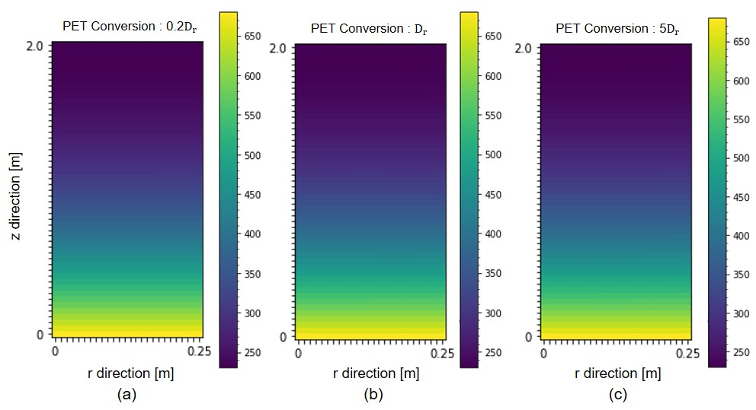
Figure 3. PET concentration profile in the reactor with changing the radial dispersion coefficient. (a), (b), (c) corresponds to radial dispersion coefficients scaled by 0.2, 1(unchanged) and 5, respectively.
      - Axial dispersion coefficient
The impact of the axial dispersion coefficient on the conversion of PET in the reactor is greater than that of the radial dispersion coefficient (Figure 4). With the dispersion coefficient calculated by Eq. (5), the conversion rate was found to be 0.6 in mol. However, when the dispersion coefficient was varied to 0.2 times and 5 times its calculated value, the conversion rates are measured at 0.65 and 0.55, respectively. While these variations have a minimal impact on the velocity field, their significant influence on the concentration within the reactor underscores the importance of selecting an appropriate axial dispersion coefficient.
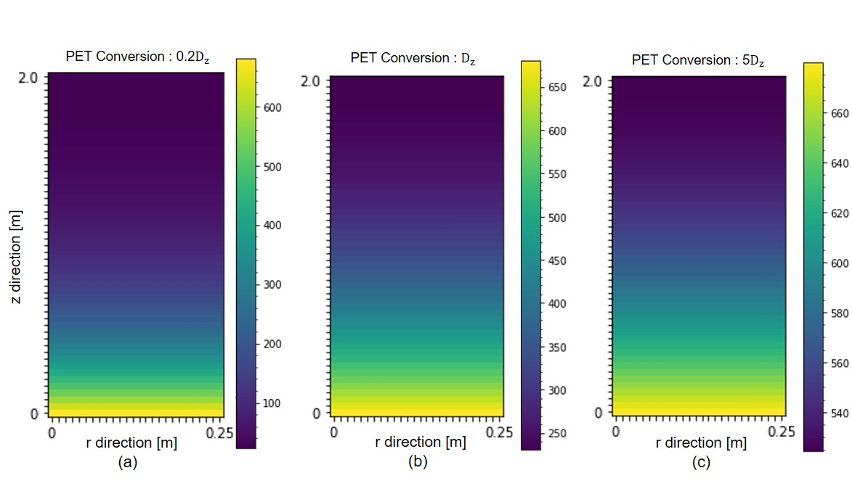
Figure 4. PET concentration profile in the reactor with changing the axial dispersion coefficient. (a), (b), (c) corresponds to radial dispersion coefficients scaled by 0.2, 1(unchanged) and 5, respectively.
In the majority of dispersion coefficient correlation studies, the coefficient is expressed in terms of the superficial velocities of gas and liquid which are constant along the reactor. Even in cases where this is not explicitly stated, many studies assume a constant dispersion coefficient throughout the SBCR for computational simplification. Under such circumstances, the $\vec{D}$ in Eq. (1) is treated as a constant, eliminating the need for gradient calculation. However, as demonstrated in the above, the axial dispersion coefficient has a significant impact on the concentration profile in the reactor, which can make the model less accurate in the above case. Consequently, for a more precise and accurate model, it is essential to employ a correlation that consider changes in the axial dispersion coefficient.
  - Conclusion
In this study, we show that the impact of radial dispersion in the SBCR for PET hydrogenolysis can be neglected. Utilizing a sufficient number of grid points to simulate the SBCR, radial velocity approached nearly zero, and the radial gradient of concentration and axial velocity was negligible. Furthermore, with significant variations in the radial dispersion coefficient from the original calculated values, its influence was confirmed to be negligible. Therefore, the commonly employed axial dispersion model for SBCR modeling can be applied to this highly viscous system. However, the influence of the axial dispersion coefficient is relatively large on the concentration profile of the reactor, unlike the radial dispersion coefficient. Particularly, considering that correlations established in prior research may not align well with the characteristics of a given system, it is crucial to utilize an appropriate correlation tailored to the specific system for accurate modeling.
Acknowledgements
This research was supported by the program of Development of Eco-friendly Chemicals as Alternative Raw Materials to Oil through the National Research Foundation of Korea (NRF) funded by the Ministry of Science and ICT (2023M3J5A1092133).
Reference
Pengyu Wu, Guoping Lu, and Chun Cai. "Cobalt–molybdenum synergistic catalysis for the hydrogenolysis of terephthalate-based polyesters." Green Chemistry 23.21 (2021): 8666-8672Z.

S. D. Kim, and C. H. Kim. "Axial dispersion characteristics of three phase fluidized beds." Journal of chemical engineering of Japan 16.3 (1983): 172-178.

Y. Kang and S. D. Kim. "Radial dispersion characteristics of two-and three-phase fluidized beds." Industrial & Engineering Chemistry Process Design and Development 25.3 (1986): 717-722.

Hart, W. E., Laird, C. D., Watson, J. P., Woodruff, D. L., Hackebeil, G. A., Nicholson, B. L., and Siirola, J. D. Pyomo-optimization modeling in python. Vol. 67. Berlin: Springer, 2017.

Cristian Maretto and Rajamani Krishna. "Modelling of a bubble column slurry reactor for Fischer–Tropsch synthesis." Catalysis today 52.2-3 (1999): 279-289.

H. H. Pham, S. H. Lim, K. S. Go, N. S. Nho, E. H. Kwon, K. H. Kim, Y. I. Lim, H. J. Ryu and S. Y. Park. "Modeling and simulation of a bench-scale bubble column reactor for slurry phase hydrocracking of vacuum residue." Fuel 310 (2022): 122481.

