A data-driven approach for constructing the prediction bounds on the output variables using a modified loss function and analysing information retained during development of the model
Waqar Muhammad Ashraf, Vivek Dua*
The Sargent Centre for Process Systems Engineering, Department of Chemical Engineering, University College London, Torrington Place, London WC1E 7JE, UK.
*E-mail: v.dua@ucl.ac.uk
Abstract
The model-based simulated responses are plagued by prediction errors for models obtained by using machine learning (ML) techniques, thereby leading to the need to estimate the prediction bounds around the model-simulated responses. Here in this work, we propose a novel method utilizing the iterative values of the model parameters obtained during model development to construct the prediction bounds around the model-simulated responses using artificial neural network (ANN) model. The loss function of the ANN model includes the least-mean squared error and is also augmented with the standard deviation between the true and model-simulated responses. During the training and development of ANN model, the values of connection weights and the biases associated with the working layers of the ANN model are stored and at the end of the training these values are deployed to construct the prediction bounds around the model-simulated responses. The proposed methodology is applied to energy efficiency cooling and energy efficiency heating (bench-mark dataset from University of California – Irvine database for ML). The developed ANN model showed superior modelling performance having following predictive errors: energy efficiency cooling (RMSE_test = 1.40%) and energy efficiency heating (RMSE_test = 0.46%) compared with those of feedforward neural network reported in literature (RMSE_test = 1.63% and RMSE_test = 0.63% respectively). The width of prediction bounds made by the proposed technique is found to be comparable to those of input perturbation method. The proposed SWARM approach for drawing the prediction bounds can be applied to different real-life applications, facilitating the decision makers to incorporate these bounds for optimal decision making.
Keywords: Data-driven prediction bounds; Machine Learning; Uncertainty Quantification.
  - Introduction
With the explosion in utilizing machine learning (ML) models for different applications, it has become imperative to estimate the range of variability or the prediction bounds around the model predicted responses to account for the uncertainty. Computer vision, object detection and natural language processing are some of the popular application domains of ML [1]. However, regression-based applications for industrial applications are reported less in literature. Furthermore, the techniques developed for drawing the prediction bounds for regression-based modelling algorithms are also different than those of classification-based ML models.
Bayesian method and ensemble approach are the probabilistic techniques for drawing the prediction bounds. Gaussian process regression models work well in conjunction with the Bayesian method and can include the domain knowledge of the system to improve the prior estimate for the characterization of the underlying distribution in the data [2]. However, the modelling performance of the Bayesian method deteriorates when the modelling assumptions are violated. On the other hand, ensemble method can be considered as an approximate of the Bayesian method where each model can be understood as a point in the hyperparameter space. However, ensembles may not explicitly model the uncertainty in a probabilistic sense and lack the formal probabilistic interpretation of the uncertainty.
Conformal prediction is another class of prediction bound construction methods and it draws the prediction bounds for the dataset using the non-conformity measure [3]. The method is computationally intensive since the model is to be trained for each datapoint. The variant of conformal prediction method called inductive conformal prediction offers reduced computational efforts [3]. However, there is a trade-off between the accuracy of the prediction bounds drawn by the two techniques considering the computational resource utilization. Direct interval estimation method [3] modifies the loss function and incorporates a fixed confidence level for drawing the prediction bounds. However, the change in the confidence-level requires retraining the model thus limiting the flexible utilization of the technique for drawing the prediction bounds for any confidence level.
In this work, we propose a novel data-driven approach called Storage of Weights And Retrieval Method (SWARM) to construct the prediction bounds around the model predicted responses for artificial neural network (ANN) model. The SWARM approach for drawing the prediction bounds is implemented on the energy efficiency cooling and energy efficiency heating performance of the buildings, and the dataset is taken from the University of California Irvine open-source datasets for ML [4]. The SWARM method offers a flexible approach to compute the prediction bounds using the parameters information stored during the ANN model development and thus eliminating the need to carry out extensive post-model computational experimentation to estimate the prediction bounds.
  - Data-driven approach to construct the prediction bounds using ANN
ANN is a universal function approximator and can model the nonlinear function space with a reasonable accuracy. The weight connections in the different layers of ANN are processed with the feeding information to simulate a response [5]. Our SWARM approach is inspired by the working of direct interval estimation method, and we have modified the loss function to include the least mean square error and standard deviation between the actual and model predicted response. The loss function customized in this work for the development of ANN model is given as:
$L = \frac{(D – {Z)}^{2}}{2}+ \frac{\left|D – Z \right|}{\sqrt{2}}$ (1)
Here, $D$ and $Z$ represent the true and model simulated observations. The first term in the loss function in the least mean squared error while the second term measures the standard deviation between $D$ and $Z$. The online training mode of development for ANN model is implemented [6] where one input vector is fed from the training dataset for the parameters update and the whole dataset is passed-on in the sequential approach for the extensive parameters update. The standard deviation is minimized between $D$ and $Z$ for each observation that also contributes to the parameters update in the iterative training of ANN model. The parameters update across the hidden and output layers of ANN by gradient descent with momentum algorithm is given as follows [7]:
$W_{1}^{new} = W_{1}- η {Vw}_{1}$ (2)
$V_{w1} = β{Vw}_{1}- (1-β)\frac{∂L}{∂W_{1}}$ (3)
$W_{2}^{new} = W_{2}- η((1-β)\frac{∂L}{∂W_{2}})$ (4)
$b_{1}^{new} = b_{1}- η ((1-β)\frac{∂L}{∂b_{1}})$ (5)
$b_{2}^{new} = b_{2}- η ((1-β)\frac{∂L}{∂b_{2}})$ (6)
here, $W_{1}$, $W_{2}$, $b_{1}$ and $b_{2}$ are the matrices containing the weight connection and bias values from input to hidden and hidden to output layer of ANN respectively. $η$ and $β$ are the learning rate and momentum parameter respectively. $V_{w1}$ is the velocity matrix having the same dimensions as that of $W_{1}$ and initialized as zero.
The iterative training of the ANN model updates the parameters and upon completion of the model training, the model predicted response is computed which is represented as $Z^{*}$. The prediction bound around the model predicted responses can be calculated as follows:
$Prediction bound = Z^{*} ± CL × σ{(Z)}_{ζ}$ (7)
here, $CL$ represents the confidence level that is taken as 3 corresponding to 99% confidence interval for this work, and it can be specified by the user for the desired level of confidence interval (e.g., 95% or some other value) to construct the prediction bounds; $ζ$ refers to the fraction of the parameters extracted for drawing the prediction bounds and $σ(Z)$ is the standard deviation in the model simulated responses ($Z$). As the ANN model’s training starts, the value of the weights fluctuate a lot and possess large variance. However, as the iterative training proceeds, the weights’ update tends to be smooth. Thus, the fraction of weights, that starts from $Z^{*}$,
can be extracted from the stored parameters space to compute the model-simulated responses for $Z$ and the prediction bounds around each observation of $Z$ can be constructed using equation (7).
The predictive performance of the ANN models is computed by coefficient of determination (R²) and root-mean-squared-error (RMSE). Mathematically, the terms are expressed as follows:
$R^{2}=1- \frac{{\sum_{i}^{N}{(Z_{i}- D_{i}})}^{2}}{{\sum_{i}^{N}{(D_{i}- }{\overline{D}}_{i})}^{2}}$ (8)
$RMSE=\sqrt{\frac{1}{N}\sum_{i=1}^{N}{{\left(Z_{i}-D_{i}\right)}^{2}}}$ (9)
where R² is a measure of modelling accuracy and varies from zero to one and RMSE indicates the mean deviation between the true and model-predictive responses.
  - Results and Discussion
    - Modelling performance of the ANN models for the case study
The energy efficiency cooling (ENC) and energy efficiency heating (ENH) dataset consists of 768 observations associated with the variables. A feedforward neural network (FFNN) is reported in literature having 10 hidden layer neurons for ENC and ENH dataset. Thus, we also deploy the same number of hidden layer neurons for building the ANN models for ENC and ENH; $η$ and $β$ are taken as 0.01 and 0.9 respectively. The stopping conditions to terminate the model development include: loss function value on testing dataset is equal to 0.01 or the maximum number of epochs are achieved. The modelling algorithm of ANN is implemented in MATLAB 2019 b version.
Figure 1 shows the predictive performance of the trained ANN models for ENC and ENH for training and testing dataset. Overall, a good match between the actual and model predicted responses for the output variables is observed. The ANN models achieved R² and RMSE values of 0.98 and 1.28 % & 0.29% for ENC and ENH respectively on the training dataset. Whereas, the performance metrics on the test datasets are as follows: [R²_test = 0.98, RMSE_test = 1.40%]_{ENC} and [R²_test = 0.98, RMSE_test = 0.46%]_{ENH}. The R² values for the trained ANN models are reasonably high along with marginal error values both for training and testing datasets for ENC and ENH that demonstrates the good predictive performance of the models.
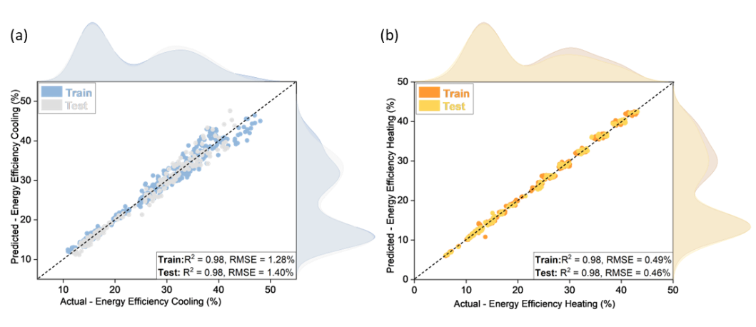
Figure 1. Predictive performance of the developed ANN models for energy efficiency cooling and energy efficiency heating on training and testing dataset.
    - Performance comparison of the trained ANN models with those of FFNN
The predictive performance of the trained ANN models for ENC and ENH is compared with those of a FFNN reported in literature [8]. RMSE is computed on the testing dataset for the two output variables and shown on Figure 2. It is noted that RMSE_test computed on the FFNN for ENC and ENH are 1.63% and 0.63% which are higher than those of ANN models developed in this work. This demonstrates the better generalization performance of the ANN models trained in this work to predict the profiles of ENC and ENH than that reported in the literature.
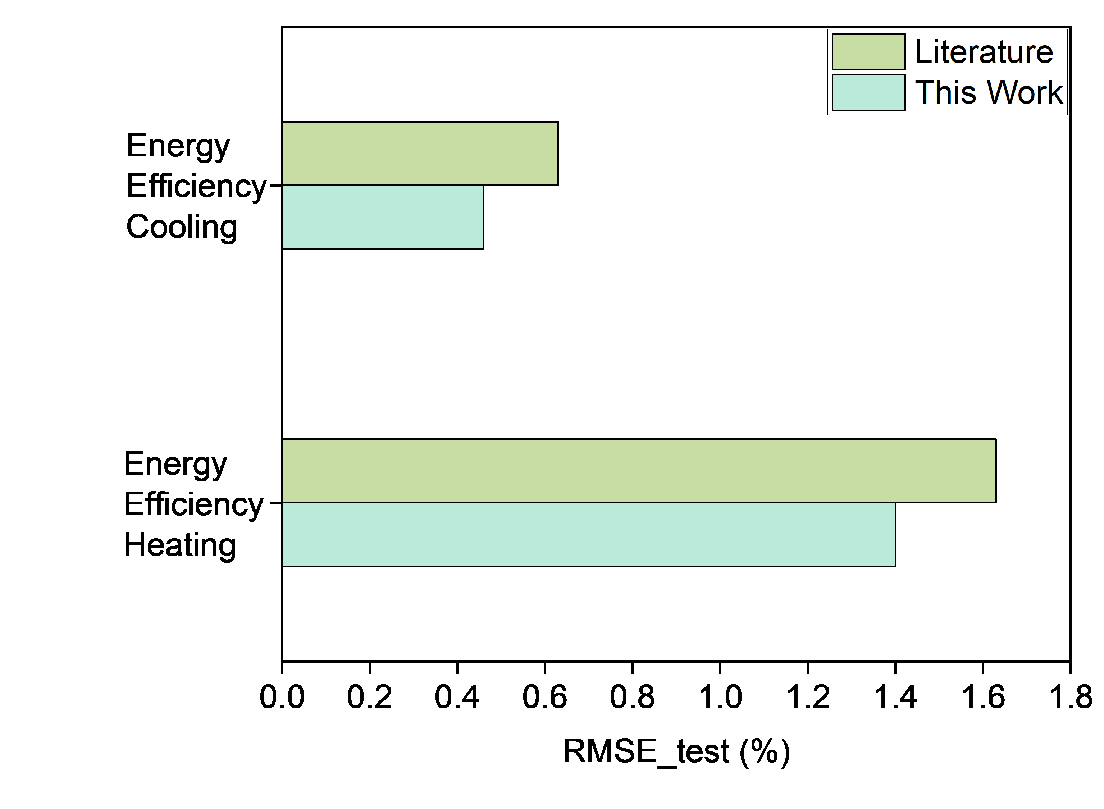
Figure 2. Comparison of the modelling performance of the ANN models trained in this work with those of FFNN model reported in literature [8].
    - Comparison of the prediction bound by the SWARM and input perturbation method
The model-based prediction bounds are constructed by the SWARM on ζ =95%. Whereas, different values of the noise levels are tried to find the comparable width of prediction bounds by the input perturbation method. Thus, 0.05% of minimum value of the input variables is found as the noise level for the design of 10000 simulated experiments for each input vector by input perturbation technique. The procedure is applied for the two output variables and the prediction bounds around for the training and testing datasets with 99% confidence for ENC and ENH are presented on Figure 3 and Figure 4 respectively. The true and model simulated responses are also presented along with the prediction bounds. It is noted that prediction bounds seem to cover the true as well as model predicted responses within its shaded region not only for training but also for the testing dataset. This shows the reasonable accuracy of the SWARM method to draw the prediction bounds. Furthermore, the width of the prediction bounds method to
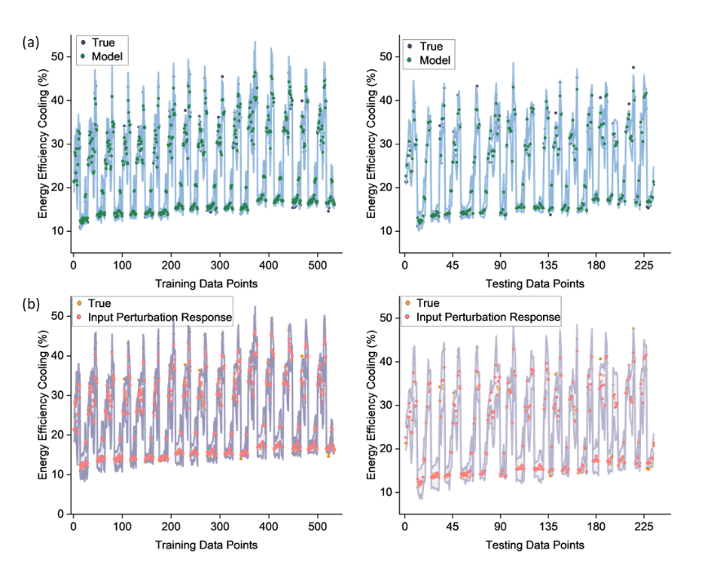
Figure 3. Construction of prediction bounds around the model predicted responses for training and testing datasets for energy efficiency cooling by a) SWARM and b) input perturbation method.
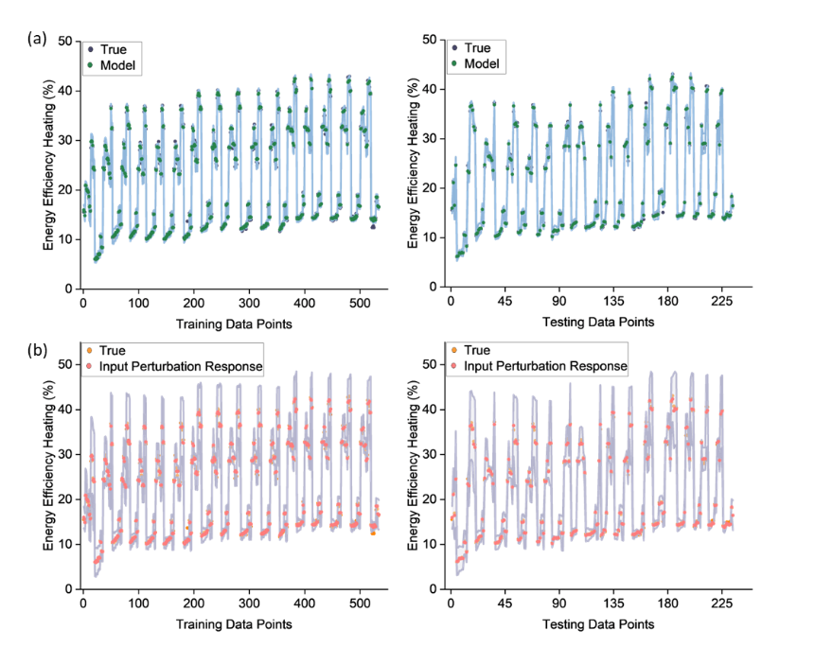
Figure 4. Construction of prediction bounds around the model predicted responses for training and testing datasets for energy efficiency heating by a) SWARM and b) input perturbation method.
draw the prediction bounds. Furthermore, the width of the prediction bounds made by the SWARM is compared with those of input perturbation technique that shows that the SWARM can produce the similar results as those of input perturbation method when the noise level is taken as 0.05% of the minimum value. Thus, the parameters information stored during the ANN model development can be readily deployed for the construction of prediction bounds without further computational analysis to draw the prediction bounds.
  - Conclusions
In this work, we proposed a novel data-driven approach to construct the prediction bounds around the ANN model based simulated responses using the parameters information stored during model development. The loss function is modified to include the least mean squared error and standard deviation term between the true and model simulated responses. The algorithm is applied on the energy efficiency cooling and energy efficiency heating dataset taken from an open-source database. The results show not only the superior modelling performance of the ANN models trained in this work compared with those of FFNN reported in literature, but the comparable width of the prediction bounds is observed with those of input perturbation technique when noise level was taken as 0.05% of the minimum values of the input variables. This work presents the utilization of the parameters information stored during the ANN model development for drawing the prediction bounds and can be applied for different real-life applications.
References

1. Ou, X., et al., A Hyperspectral Image Change Detection Framework With Self-Supervised Contrastive Learning Pretrained Model. IEEE Journal of Selected Topics in Applied Earth Observations and Remote Sensing, 2022. 15: p. 7724-7740.
2. Teye, M., H. Azizpour, and K. Smith. Bayesian uncertainty estimation for batch normalized deep networks. in International Conference on Machine Learning. 2018. PMLR.
3. Dewolf, N., B.D. Baets, and W. Waegeman, Valid prediction intervals for regression problems. Artificial Intelligence Review, 2023. 56(1): p. 577-613.
4. Tsanas, A. and A. Xifara, Accurate quantitative estimation of energy performance of residential buildings using statistical machine learning tools. Energy and buildings, 2012. 49: p. 560-567.
5. Ashraf, W.M. and V. Dua, Machine learning based modelling and optimization of post-combustion carbon capture process using MEA supporting carbon neutrality. Digital Chemical Engineering, 2023. 8: p. 100115.
6. Haykin, S., Neural networks and learning machines, 3/E. 2009: Pearson Education India.
7. Ng, A., Improving deep neural networks: Hyperparameter tuning, regularization and optimization. Deeplearning. ai on Coursera, 2017.
8. Arnaldo, I., U.-M. O'Reilly, and K. Veeramachaneni. Building predictive models via feature synthesis. in Proceedings of the 2015 annual conference on genetic and evolutionary computation. 2015.

