Decomposition method to evaluate district heating/cooling network potential at urban scale
Catarina G. Braz*, Raphaël Briguet, Luc Girardin, Bingqian Liu, François Maréchal
Industrial Process and Energy Systems Engineering (IPESE), École Polytechnique Fédérale de Lausanne, Rue de l'Industrie 17, 1951 Sion, Switzerland
catarina.braz@epfl.ch
Abstract
In this work, a tool to design district heating networks (DHN) is presented and applied to the city of Lausanne as a case study. The evaluation of the buildings’ heat/cooling demand is performed using a Geographic Information System (GIS) database, built from different public databases, national norms, and real consumption measurements.
In a first approach, the city is decomposed into smaller districts, then heat and cooling demands of each district are determined, and the investment and operational costs of the DHN calculated using a parameterized empirical formula. The costs of the pipes that connect the districts to the heating source are computed by routing the primary network using the Minimum Spanning Tree (MST) algorithm.
This methodology was calibrated for the city of Lausanne, and the influence of the system design and supply/return temperature levels on heat and cooling distribution costs was studied considering the current buildings connected to the DHN.
Keywords: District heating/cooling network, Urban Systems, Geographical database, Sustainable energy supply.
  - Introduction
With approximately 149,000 inhabitants, Lausanne is the 4th largest city in Switzerland in terms of population. In 2020, heat consumed during winter was supplied by the district heat network (25 %) natural gas network (40 %) and fuel oil (35 %) (SiL, 2020).
District heating and cooling are considered to have an important contribution in the transition from the current energy systems to the future energy solutions. 5th generation district heating networks in particular use temperature levels close to ground temperature, minimising thermal losses throughout the grid and having the extra advantage that they can be used for cooling residential buildings with a different type of fluid. The development of DHN into cities has been however hindered by large investment costs.
  - Methodology
    - Evaluation of the energy demand of the city of Lausanne
The energy demand was determined using a GIS database (Girardin, 2012) with the stock of buildings in the city of Lausanne. The city is characterized from an energy point of view, using two SIA (Société Suisse des ingénieurs et architects) standards, the SIA 2024 and the SIA 380/1. The first is the standards for Space usage data for energy and building facilities, and the second is the standards for Heat requirements for heating. The information about the buildings is gathered mainly from three databases:
- RegBL: a geographic point containing information like the EGID, affectation, date of construction, number of floors, etc.
- SwissTLM3D: 2D polygon representing the footprint of the buildings
- SwissBuildings3D: 3D modelling of the buildings, giving information on the orientation of the roofs and area of the facades
The heating demand of a building, $\dot{Q}$, is the sum of the demand for space heating, ${\dot{Q}}^{SH}$, and the demand for domestic hot water, $Q^{HW}$. Space heat demand was estimated through a heat balance on the building, as presented in Eq. (1). ${\dot{Q}}_{s}$, $Q_{p}$, and ${\dot{Q}}_{e}$ represent the internal gains from solar irradiation, people, and appliances, respectively. ${\dot{Q}}_{loss}$ and ${\dot{Q}}_{vent}$ are the heat losses through the walls and the air renewal, respectively.
$${\dot{Q}}^{SH}={\dot{Q}}_{e}+{\dot{Q}}_{p}-{\dot{Q}}_{s}-{\dot{Q}}_{loss}-{\dot{Q}}_{vent}$$ | (1)
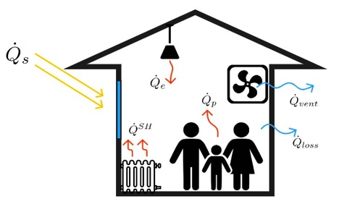
Figure 1 – Heat flows within a building.
      - Heat consumption validation
The heat consumption in each building was calculated considering the efficiency of the energy system installed, Eq. (2).
$${\dot{Q}}_{supply}={{\dot{Q}}_{fuel}^{SH}}/{η_{fuel}^{SH}}+{{\dot{Q}}_{fuel}^{HW}}/{η_{fuel}^{HW}}$$ | (2)
Table 1 presents the efficiencies considered for each energy system.
Table 1 – Heating systems efficiency (Genève, 202).
 | Space heating | Hot water
Gas boiler | 0.86 | 0.54
Fuel oil boiler | 0.86 | 0.54
DHN | 0.95 | 0.65
The database results were validated using billing data from 2019 provided by the local urban gas and DHN supplier. Since fuel oil is not sold by Lausanne’s heat supplier, their value is also an estimation based on the SIA norms. The results of the validation are shown in Figure 2. The database estimated consumption values are very close to the supplier, with an average deviation of 21, 17 and 5 % for fuel oil, gas and DHN, respectively.

Figure 2 – Estimated total heat consumption compared with the values from the heat supplier.
    - Model of the heating network within a district
The modelling of the DHN within a district followed the methodology presented by Briguet (2022), where the estimation of the pipe’s length within a given district is based on the area and the number of buildings, assuming that buildings are equidistantly distributed over a given area (Girardin, 2012), Figure 3. Eq. (3) gives the network route length, $L$ for a pair of pipes, in function of the area of the district, $A$, the number of buildings, $n_{b}$, and the shape factor, $K$. The latter is a coefficient that accounts for the street typology, that had to be calibrated for the city of Lausanne, using the existing DHN.
$$L=\left(n_{b}-1\right)K\sqrt{A/{n_{b}}}$$ | (3)
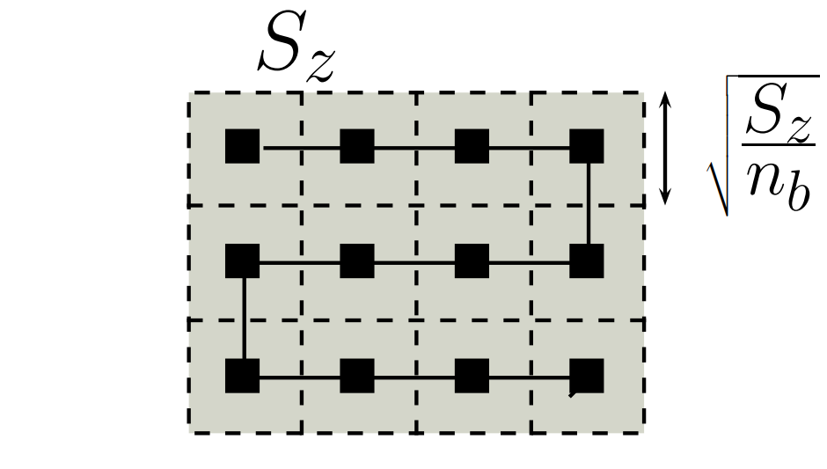
Figure 3 – Representation of the equidistance assumption (Girardin, 2012).
The districts were defined using a meshing algorithm applied in the areas with a connection to the DHN. First, the buildings connected to Lausanne’s DHN were selected (Figure 4 (a)), then a mesh with several sizes was applied and the length of pipe within the district was calculated (Figure 4 (b) and (c)). For each mesh size, $K$ was optimized using Excel solver to set the difference between the sum of real pipe length within the districts, and the sum of the lengths calculated by Eq. (3) equal to zero.
This procedure was repeated for meshes with sizes (length of the hexagon faces) between 100 and 300. The results are presented in Table 2. The average relative deviation, $\overline{σ}$, was calculated with Eq. (4). The best results are obtained for a mesh with size 125.
$$\overline{σ}=\frac{\sum_{i=1}^{N_{d}}{{abs(L_{real}-L)}/{L_{real}}}}{N_{d}}$$ | (4)
The total demand of the network was assumed to be equally distributed among the number of buildings in the district and that there is a linear decrease of the mass flow of heating fluid as the energy is distributed, and, consequently, a decrease of the diameter of the pipe per connection of buildings. Piping costs included a fixed cost that accounts for civil engineering works and a variable that depends on the diameter of the pipe. Total cost was assumed to follow the same linear regression as for the city of Geneva (Henchoz, 2016).
$$c_{pipe}=\left(5670D+613\right)×L$$ | (5)
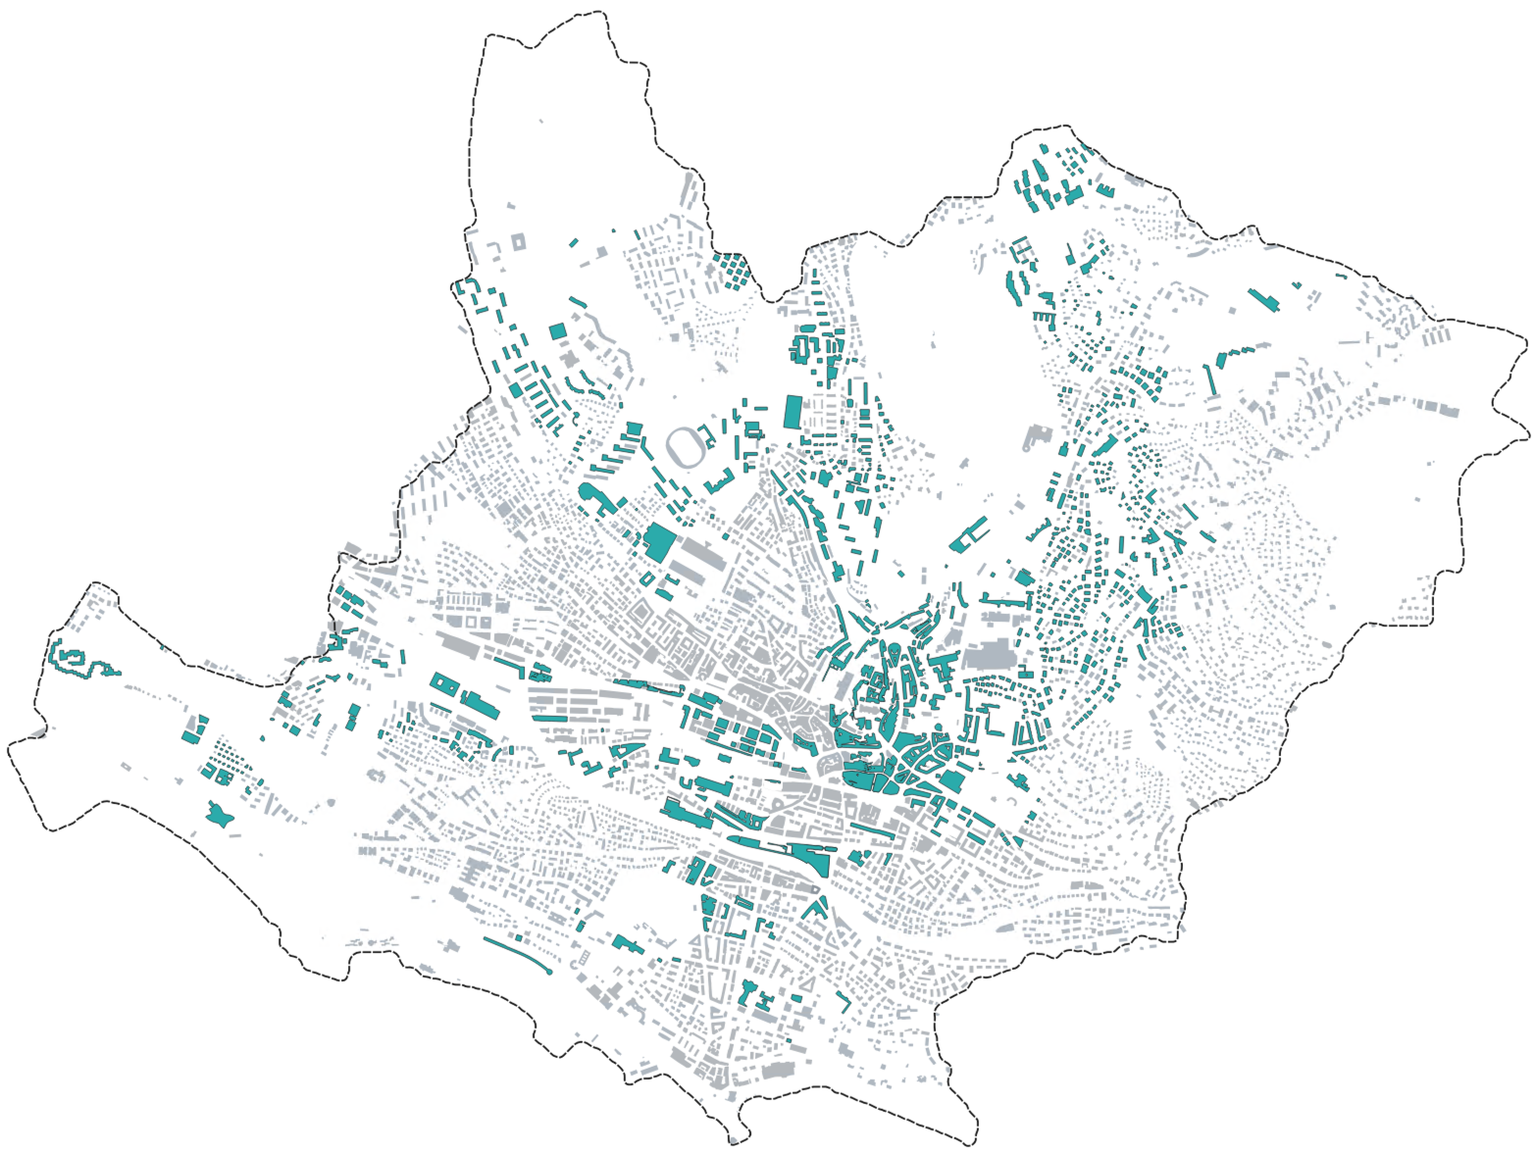  (a) | 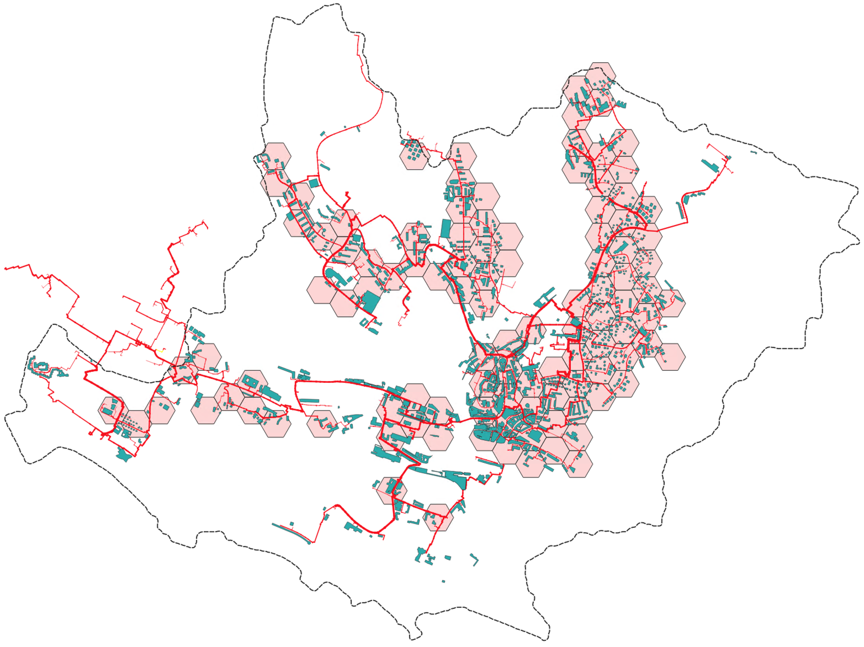  (b)
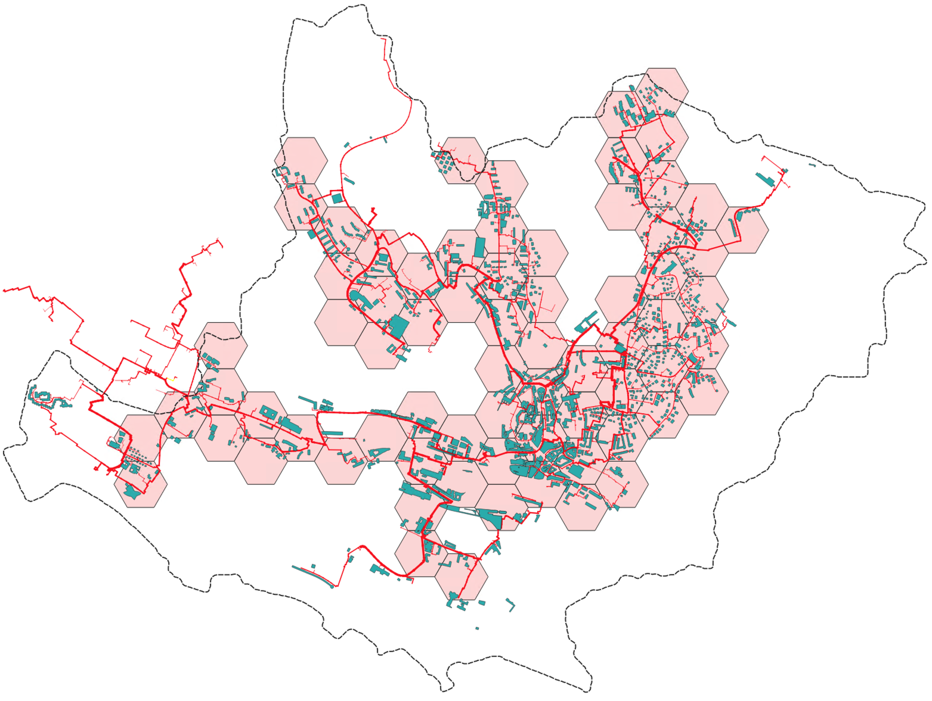  (c) | 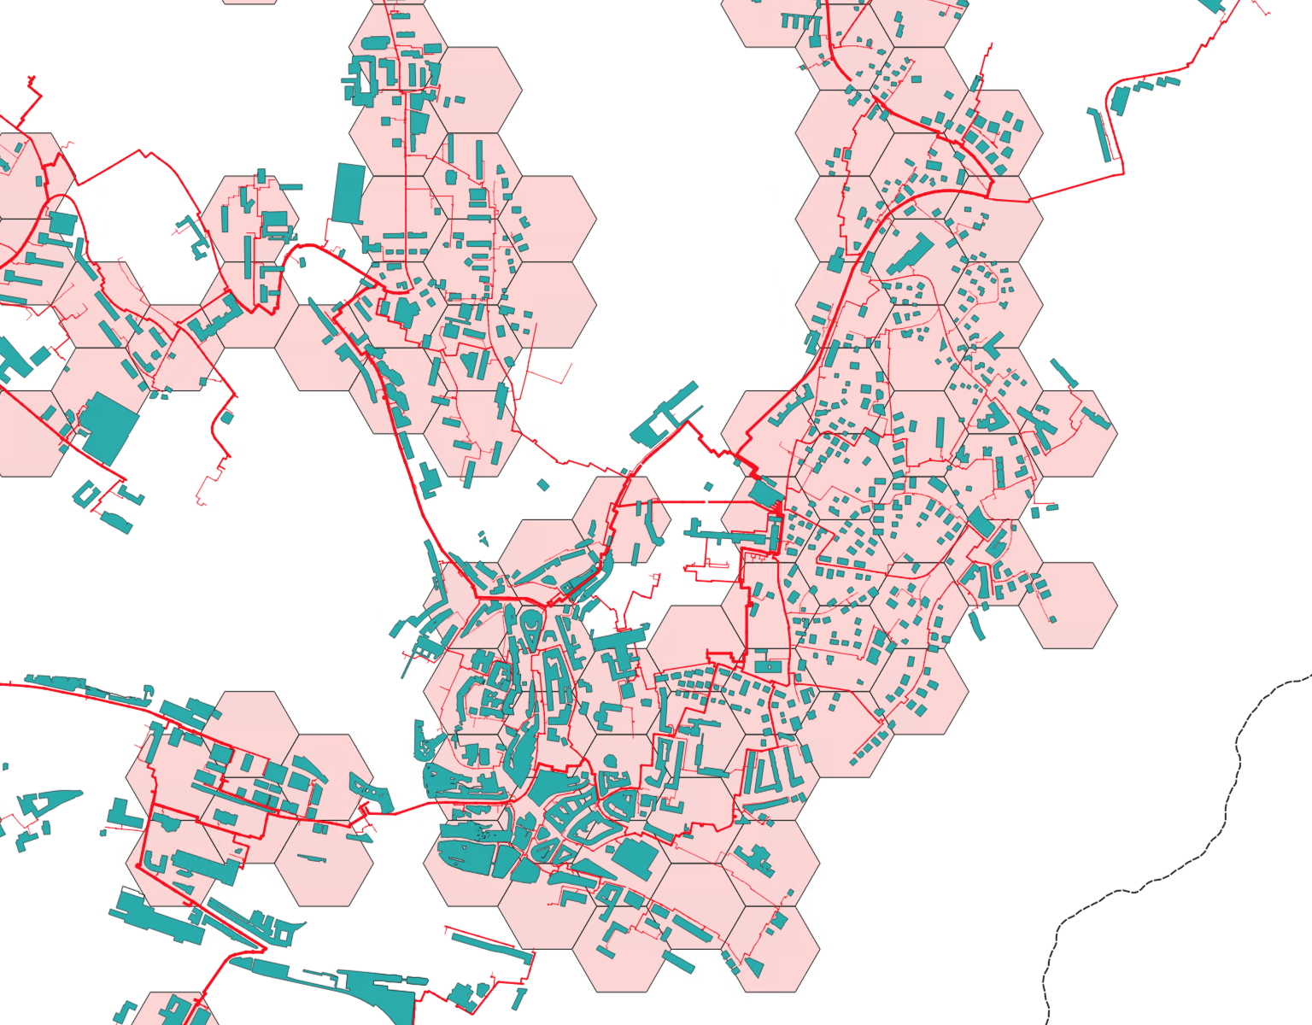  (d)
Figure 4 – District definition using a hexagon-shaped mesh. a) Selection of the buildings connected to the DHN. b) Application of a mesh with size 125. c) Application of a mesh with size 200. d) Zoom in on mesh 125. The red line represents the real DHN.
Table 2 – Results per mesh size.
 | Area (ha) | $$K$$ | $\overline{σ}$ (%)
mesh_100 | 2.6 | 1.00 | 56
mesh_125 | 4.1 | 0.97 | 40
mesh_150 | 5.8 | 0.93 | 45
mesh_175 | 8.0 | 0.85 | 53
mesh_200 | 10 | 0.80 | 47
mesh_225 | 13 | 0.78 | 68
mesh_250 | 16 | 0.75 | 64
mesh_275 | 20 | 0.75 | 50
mesh_300 | 23 | 0.73 | 47
    - Cost of the district connecting pipes
The routing of the primary network that connects all districts was performed according to the methodology described by Briguet (2022). The path is determined using the MST algorithm, which together with the Python API of Open Street Map allows us to obtain the shortest route to connect two geographic points. Once the route taken by the network is calculated, the total cost of the infrastructure, $C_{p}$, can be estimated by Eq. (6), Where, $c_{p,i}^{d}$ and $c^{c}$ are the cost of piping in each district and the cost of district connection, respectively.
$$C_{p}=\sum_{i}^{N_{d}}{c_{p,i}^{d}}+c^{c}$$ | (6)
  - Results
After determining the mesh that best estimates the network length inside the districts, the heating and cooling demands and the cost of DHN pipes within the districts were calculated for a supply/return temperature (T_{s}/ T_{r}) of 175/75 °C, Figure 5.
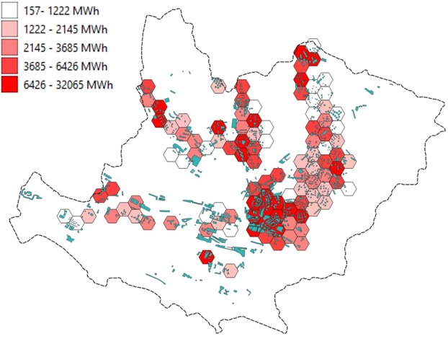  (a) |  | 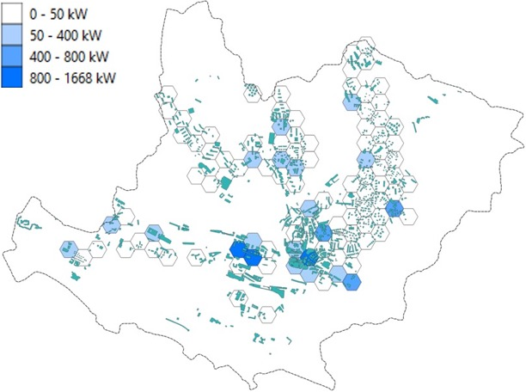  (b)
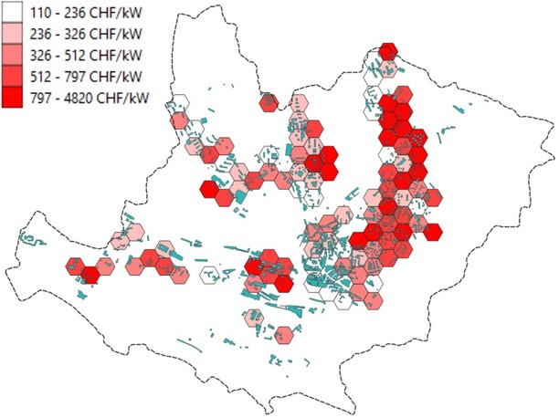
(c)
Figure 5 – (a) District heat demand for the buildings connected to the DHN. (b) District power cooling demand. (c) Cost of piping for a temperature level of 175/75 °C.
The districts were connected using the MST described in Section 2.3. As an approximation, it was considered that Pierre de Plan was the only heating source of the city of Lausanne. The results are presented in Figure 6. The total length of the DHN is 218 km, which is very close to the length of the real DHN installed (204 km).
The same methodology was applied to different supply/return temperature levels of the DHN. The results can be seen in Table 3. As expected, the lower the temperature levels, the higher the infrastructure costs due to the need for higher pipe diameters.
Table 3 – DHN infrastructure results for different supply/return temperature levels.
 | Total cost of the DHN (MCHF)
T_{s} = 175 °C; T_{r} = 75 °C | 89.4
T_{s} = 130 °C; T_{r} = 70 °C | 98.2
T_{s} = 95 °C; T_{r} = 70 °C | 119.7
T_{s} = 70 °C; T_{r} = 50 °C | 127.2
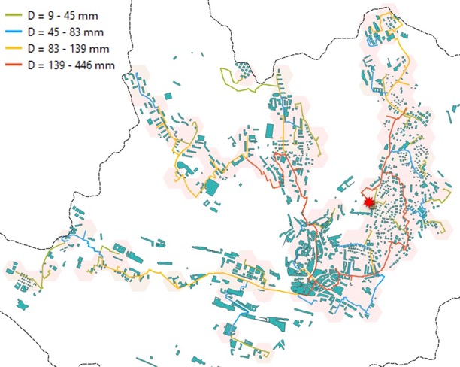
Figure 6 – Results of the DHN routing from Pierre de Plan.
  - Conclusions and future work
In this work, a methodology to assess the investment cost of a DHN has been presented. The methodology was calibrated for the city of Lausanne and validated using real consumption data and the currently installed DHN. In the future, the operation costs of the DHN will be integrated to assess the advantage of decreasing the supply/return temperature levels. Additionally, future scenarios where network coverage is expanded will be studied and the option of centralised or decentralised auxiliary units to operate the network at lower temperature levels, thus with higher exergy and energy efficiency.
Acknowledgements
This research was carried out in the frame of the “UrbanTwin: An urban digital twin for climate action: Assessing policies and solutions for energy, water and infrastructure” project with the financial support of the ETH-Domain Joint Initiative program in the Strategic Area Energy, Climate and Sustainable Environment.
References
2021, SIA 2024/202- Données d’utilisation Des Locaux Pour l’énergie Et Les Installations Du Bâtiment, Collection Des Normes
R. Briguet, 2022, District energy network potentials in a city territory, Master project report
Brüttisellen-Zurich, Marcel Rossi, 2016, SIA 380/1/2016 Besoins de Chaleur Pour Le Chauffage, Collection Des Normes
Genève, 2023, Calculer l'indice de dépense de chaleur admissible : Bâtiment neuf, https://www.ge.ch/node/29458 (accessed 2023-12-01)
L. Girardin, 2012, A GIS-Based Methodology for the Evaluation of Integrated Energy Systems in Urban Area, PhD Thesis
S. Henchoz, 2016, Potential of refrigerant based district heating and cooling networks, PhD Thesis
SiL, 2020, Les SiL en 2021 et 2022, Anual report

