Thermodynamic approach to simulate the HydroDeOxygenation process of Lignin
Aristide Giulianoª, Aniello Di Giacomo^{b}, Nicola Pierroª, Isabella De Bariª, Diego Barletta^{b*}
ªENEA, Italian National Agency for New Technologies, Energy and Sustainable Economic Development, S.S. 106 Ionica, km 419+500, Rotondella, MT, Italy
^{b}Dipartimento di Ingegneria Industriale, Universitá degli Studi di Salerno, Via Giovanni Paolo II 132, I-84084 Fisciano SA, Italy
dbarletta@unisa.it
Abstract
The high availability of lignin as a renewable carbon source, coupled with its chemical structure rich in aromatic compounds, offers a potential opportunity to convert lignin into chemicals, fuels and other valuable building blocks. Within this context, the hydrogenation process was considered a good pathway to obtain profitable compounds converting lignin. In the present work, a novel thermodynamic approach was carried out by lignin hydrogenation simulation. First, a lignin property model was developed in the process simulation software Aspen Plus® and based on its chemical structure and thermodynamic properties. Subsequently, a set of reactions was considered for the hydrogenation process, and the “temperature approach" was used to fit the reactor's yield experimental data available in the literature with the reaction network model predictions. This procedure enabled the replication of the results obtained in the reactor without the need to directly consider the reaction kinetics. The results showed that there is a good approximation between experimental and modelling results for each of the four different catalysts tested in the literature works data. The main potential utilization of the model consists in the forecasting of the lignin HDO process individuating the hydrogen needs and the best pressure to use to maximize the yields to aromatics also testing several kinds of lignin sources.
Keywords: lignocellulosic biomass, HDO, temperature approach, lignin modelling, aromatics
  - Introduction
Lignin is the most abundant natural resource among the aromatics yet, it is largely unexploited for this purpose. It has a lower oxygen content compared with cellulose and hemicellulose (Mastrolitti et al., 2021). These properties make lignin an attractive feedstock for chemicals and fuels. The lignin matrix is bound together through a variety of carbon-carbon and ether linkages, unlike most natural polymers, which consist of single inter-monomeric bondings. Lignin's polymer network consists of p-hydroxyphenyl (H), guaiacyl (G), and syringyl (S) units, derived from the dehydrogenation and polymerization of three different hydroxycinnamyl alcohols (monolignols) (Yang et al., 2023). Among the substructures, the β-O-4 (8-O-4, aryl ether) inter-unit linkage is the most predominant and readily cleaved one, either chemically or biochemically, providing a basis for the deconstruction of the polymeric framework in various industrial processes and several analytical methods. Other linkages, such as β–5, β–β, 5–5, 5–O–4, and β–1, are more resistant to both kinds of degradation processes. Many different conversion technologies have been proposed for the depolymerization of lignin into its derived aromatic compounds (Robinson et al., 2022). In particular, reductive depolymerization can break the β-O-4 and α-O-4 bonds and the hydroxyl groups of the side chain (Laskar et al., 2014). The function of the catalyst is to prevent polymerization reactions and condensation of alkenes and carbonyl groups. On the other hand, reductive catalysts are unable to break C-C bonds and the efficiency of depolymerization depends only on the number of ether bonds that can be broken. Nowadays, lignin is only modeled as an inert solid, and therefore, does nothing more than absorb or provide heat. The main approach can be found in the work of (Wooley and Putsche, 1996), which is relevant because it describes a database for all lignocellulosic biomass compounds and defines them in Aspen Plus using their physical properties. In particular, lignin is considered as a solid and its molecular weight, enthalpy of formation at 298 K, density and heat capacity are used to describe it. In the work of Mabrouk et al. (2018), the data given by Wooley and Putsche (1996) were employed to define lignin and experimental data was used for the design of a yield reactor. Finally, in the work by (Shahbaz et al., 2022) lignin was defined as a non-conventional solid and "proximate and ultimate" analysis is used. Nevertheless, non-conventional solids defined in Aspen Plus cannot participate directly in chemical reactions and therefore this approach is not used for reactor design. The possibility of developing models able to predict the behavior of lignin under specific reaction conditions stands as a major challenge in current research, finalized to perform a process simulation and design strategies (Giuliano et al., 2015). In this work, a novel thermodynamic approach will be carried out by lignin hydrogenation simulation based on experimental data and a temperature approach procedure. Hydrogen partial pressure, hydrogen-to-carbon ratio and lignin moisture will be evaluated as main process parameters influencing the lignin hydrogenation.
  - Lignin modelling by thermodynamics approach
    - Lignin Modelling in Aspen Plus
In this work, the modelling of lignin using Aspen Plus, its chemical structure was studied in detail, in terms of the monomer’s composition, the linkages present in the polymer and the probability of breaking each of these bonds. On the other hand, experimental data on the thermodynamic properties of the biopolymer was collected.
Table 1. Oligomers description (MR, monomers ratios; LR, linkages ratios)
 | Lig1 | Lig2 | Lig3 | Lig4 | Lig5 | Lig6 | Lig7
Formula | C₃₀H₃₆O₁₁ | C₄₀H₄₈O₁₅ | C₂₇H₃₂O₁₀ | C₃₉H₄₄O₁₄ | C₃₈H₄₄O₁₄ | C₃₀H₃₆O₁₁ | C₃₁H₃₈O₁₂
MW (g/mol) | 572 | 768 | 516 | 772 | 724 | 572 | 602
MR (H/G/S) | (1/1/1) | (1/2/1) | (1/1/1) | (0/2/2) | (0/3/1) | (0/3/0) | (0/2/1)
LR  (β-O-4/β-1/5-5) | (2/0/0) | (3/0/0) | (1/1/0) | (2/1/0) | (1/1/1) | (2/0/0) | (2/0/0)

Laskar et al. (2014) studied the distribution types of linkages in different types of lignin. With this information, it is possible to state that the aryl-ether linkage (β-O-4) is the most abundant bond in the polymer structure, followed by the β-1 linkage. On the other hand, given the lignin depolymerization processes, it can be assumed that the β-O-4 bond is the weakest since it is likely to be attacked by the different depolymerizing agents. Hence, known the variable composition of lignin and, to introduce its chemical structure into the software, a battery of oligomers of between 3 and 4 monolignols with different kinds of linkages are used. As depicted in the figure below, seven different oligomers were designed with different monomer ratios (MR) and linkages ratios (LR). Each one of these is described in Table 1. The main advantage of using a battery of oligomers instead of a single molecule lies in the fact that there are hundreds of different lignins, with diverse monomers ratio and linkages ratio. Thus, representing lignin by employing different types of oligomers allows us to define certain mixtures during the design phase, enabling us to carry out approximation processes to obtain models in line with the kind of lignin desired. To determine the correct thermodynamic properties that represent lignin, it is necessary to assign accurate characteristics to each oligomer. To begin with, oligomers are defined as solids in Aspen Plus, hence, for temperature-sensitive properties such as heat capacity and density, the values reported in the article by Wooley and Putsche (1996) are employed. Finally, for the definition of the solid enthalpy of formation at 298 K and the standard Gibbs free energy, the values obtained by Azad et al. (2020), are employed. In this paper, authors modeled a lignin oligomer consisting of ten coniferyl units linked through nine β-O-4 bonds. In addition, they calculated standard thermodynamic properties, including enthalpy of formation, entropy, and Gibbs free energy for a wide range of temperatures from 25 K to 1000 K and for oligomers ranging from one to ten monomer units. Thermodynamic properties are obtained through experimental techniques, classical approaches (i.e., equation of state and GE model) and computational approaches (Azad et al., 2020).
    - Hydrogenation of lignin in an equilibrium reactor
Following the modelling of lignin, the design of a set of reactions to carry out the depolymerization and hydrogenation of the oligomers has to be performed. For this purpose, two equilibrium reactors were used. The stoichiometric matrix was employed to calculate the number of independent reactions required for each reactor. The main objective of this reactor is to produce the depolymerization of the oligomers so that the complete hydrogenation process can be carried out in the next reactor. It should be noted that all the reactions present in this first set are exothermic. Between the first and the second reactor, the non-depolymerized oligomers are separated, while the products and the unreacted hydrogen encounter are subject to a second set of reactions, shown in Figure 1, to finally obtain the ultimate hydrogenation products. Subsequently, another 15 reactions are added, leading to a total of 25 reactions and 28 possible products. Among the added reactions, the most remarkable ones are the production of alkyl phenolics, such as Cresol, and the generation of various types of cyclic and linear alkanes, which are products of interest in the hydrogenation of lignin. In addition, reactions for the generation of aromatic aldehydes, such as p-hydroxybenzaldehyde, vanillin and syringaldehyde, were also included. Finally, there is also the generation of oxygenated gaseous products (CO and CO₂) and organic acids, such as acetic acid and formic acid.
    - Experimental data fitting
Given the set of reactions and their known behavior inside the equilibrium reactor, it is possible to use the "temperature approach" to take into account non-equilibrium conditions. This method enables modification of the temperature at which the equilibrium constants of each reaction are calculated with the objective of fitting the results obtained in the second reactor to the experimental data available in the literature. In particular, in the present project, the approximation has been carried out by employing the data obtained in Kumar et al. (2015). The investigation mentioned uses a known type of Kraft lignin, called "Indulin-AT", and carries out its hydrogenation process by making use of different kinds of catalysts and supports.
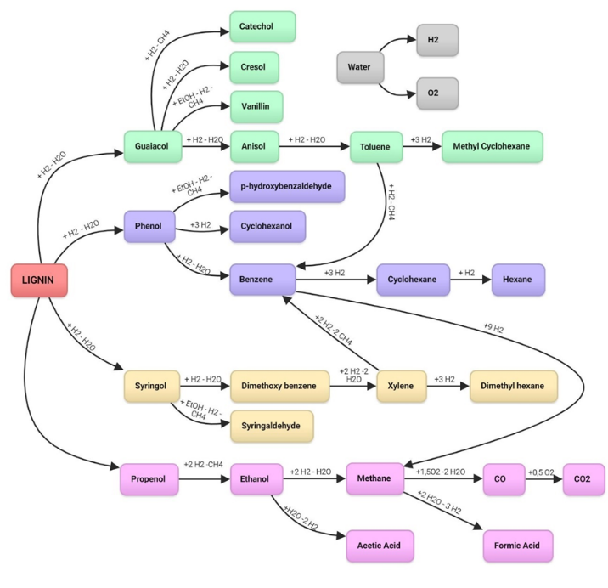
Figure 1. The set of reactions considered in the first reactor
    - Optimization method for the Temperature approach parameter fitting
As has already been mentioned, the system is constituted by 25 reactions and 28 species, which are initially assumed at chemical equilibrium inside the reactor. Within this project, the strategy followed consists of altering that equilibrium by employing the Temperature approach, to obtain yield values that are close to the ones reported in the literature. In addition, this approach does not require to consider the kinetics involved in this complex reaction network. The procedure described above entails the need to vary the temperature of all 25 reactions present in the system. However, being able to determine the temperature shifts for each reaction is not an easy task. For that reason, the following optimization method was developed. The temperature of 22 out of the 25 reactions was varied, excluding the reactions with O₂. Provided that the oxidation reaction equilibrium is shifted towards the products, the variation of the temperature approach should not have a significant impact on the yield.
Table 2. Lignin and a mixture of oligomers considered in this work
 |  | Kumar et al. (2015) | This work
Lignin |  | Indulin-AT, Kraft Lignin, Softwood | 33.3 % Lig5 – 66.7% Lig6
Composition | H | 0 % | 0 %
 | G | 90-95 % | 90 %
 | S | 5-10 % | 10 %
Linkages | β-O-4 | 74 % | 71 %
 | β-1 | 11 % | 14 %
 | 5-5 | 15 % | 14 %
On the other hand, O₂ is produced through the hydrolysis of water and as the reactor works with an excess of H₂, this reaction practically does not take place. To define the objective function, the quadratic errors of the product's yields obtained in Aspen Plus concerning the product's yields given in the literature were calculated. Finally, the objective function is defined as the sum of all the errors.
  - Thermodynamics approach modeling results
Before the temperature approach application, the equilibrium reactor was performed the lignin was converted into gas products (i.e., Methane, CO and CO₂) and water. The total yield to products greater than 100 % is because this is calculated only considering the weight of lignin. Using the optimization procedure described in the previous section, comparison results shown in Figure 2 were obtained. The model is a good fit for Kumar et al. (2015) experimental data, especially when the catalyst favors the production of alkyl phenolics and aromatics. However, excessive water production can cause problems for the fit when it is not followed by the simultaneous generation of other compounds. This is observed in the case of CoMo/Al₂O₃, for which the adjustment shows appreciable errors in the amount of water produced. In the case of NiMo/MgO-La₂O₃, the best fit can be observed, which has a production of alkyl phenolics as the main product and water and aromatics as by-products. This also occurs in the case of NiMo/ZSM-5. This could indicate that using catalysts more selective towards the generation of some product such as alkyl phenolics or aromatics, improves the performance of the model.
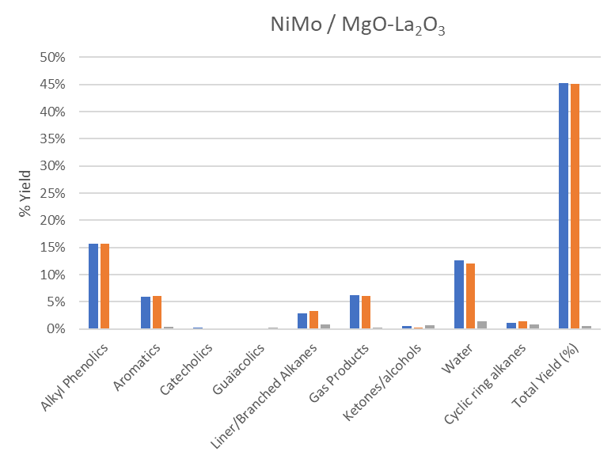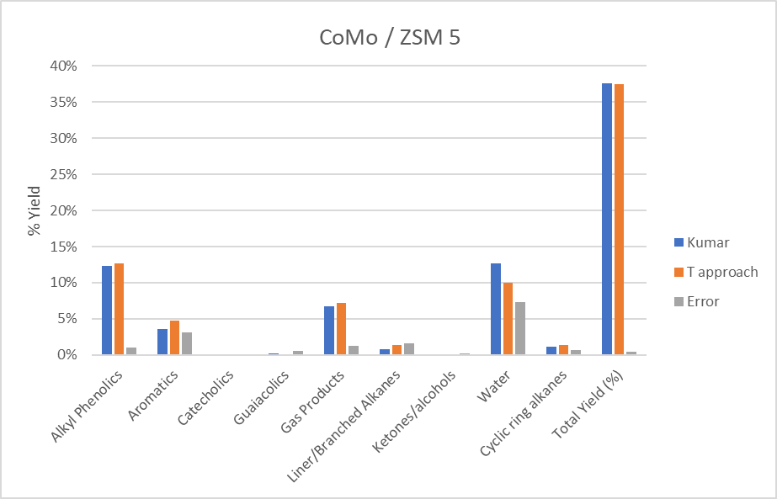
(d)
(c)
(a)
(b)
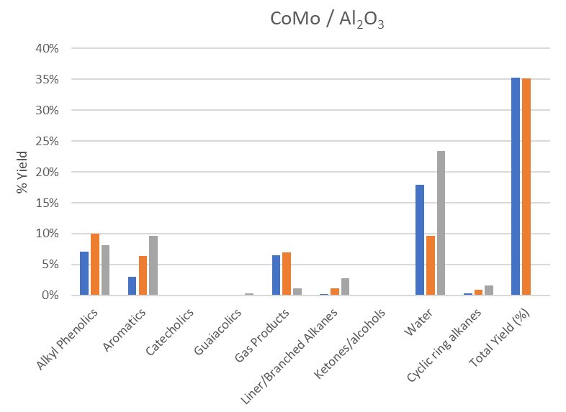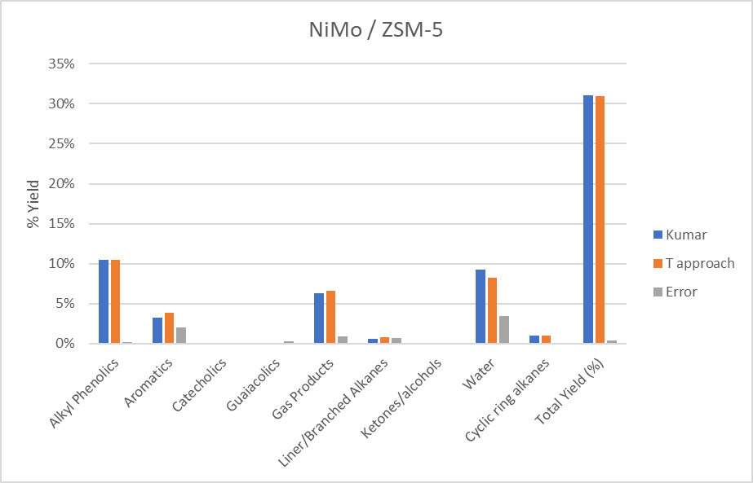
Figure 2. Adjustment of the equilibrium reactor using as catalysts: (a) NiMo/MgO-La₂O₃, (b) CoMo/ZSM-5, (c) CoMo/Al₂O₃, (d) NiMo/ZSM-5
  - Conclusions and Future Perspectives
The lignin modelling procedure described in this work can well simulate the HydroDeOxygenation process in determined conditions and using specific literature catalysts. The model allows to vary both the intrinsic composition of the lignin entering the reactor and the operating parameters of the hydrogenation process. In the future, through a dedicated optimization analysis will be possible to determine the optimal conditions of pressure and H/C ratio, as well as the moisture content and the optimal chemical structure that the lignin should present to increase the production of target products, such as aromatic monomers. It could be determined that the increase of the H/C ratio enhances the conversion of lignin and consequently, the production of alkyl phenolics increases.
Acknowledgments
The authors deeply acknowledge the current national representatives of IEA task 42 ‘Biorefining in a Circular Economy’ from Austria, Denmark Germany, Ireland, the Netherlands and USA for useful debate and discussions. Prepared by Aristide Giuliano, Nicola Pierro, Isabella De Bari (ENEA, Italy), on behalf of IEA Bioenergy Task42.
References
Azad, T., Schuler, J.D., Auad, M.L., Elder, T., Adamczyk, A.J., 2020. Model Lignin Oligomer Pyrolysis: Coupled Conformational and Thermodynamic Analysis of β-O-4′ Bond Cleavage. Energy Fuels 34, 9709–9724. https://doi.org/10.1021/acs.energyfuels.0c01573
Giuliano, A., Poletto, M., Barletta, D., 2015. Process Design of a Multi-Product Lignocellulosic Biorefinery, in: Computer Aided Chemical Engineering. Elsevier B.V., pp. 1313–1318. https://doi.org/10.1016/B978-0-444-63577-8.50064-4
Kumar, C.R., Anand, N., Kloekhorst, A., Cannilla, C., Bonura, G., Frusteri, F., Barta, K., Heeres, H.J., 2015. Solvent free depolymerization of Kraft lignin to alkyl-phenolics using supported NiMo and CoMo catalysts. Green Chem. 17, 4921–4930. https://doi.org/10.1039/C5GC01641J
Laskar, D.D., Tucker, M.P., Chen, X., Helms, G.L., Yang, B., 2014. Noble-metal catalyzed hydrodeoxygenation of biomass-derived lignin to aromatic hydrocarbons. Green Chemistry 16, 897–910. https://doi.org/10.1039/c3gc42041h
Mabrouk, A., Erdocia, X., Alriols, M.G., Labidi, J., 2018. Economic analysis of a biorefinery process for catechol production from lignin. Journal of Cleaner Production 198, 133–142. https://doi.org/10.1016/j.jclepro.2018.06.294
Mastrolitti, S., Borsella, E., Giuliano, A., Petrone, M.T., Bari, I.D., Gosselink, R., van Erven, G., Annevelink, E., Triantafyllidis, K.S., Stichnothe, H., 2021. Sustainable lignin valorization 194.
Robinson, A.J., Giuliano, A., Abdelaziz, O.Y., Hulteberg, C.P., Koutinas, A., Triantafyllidis, K.S., Barletta, D., De Bari, I., 2022. Techno-economic optimization of a process superstructure for lignin valorization. Bioresource Technology 364, 128004. https://doi.org/10.1016/j.biortech.2022.128004
Shahbaz, M., AlNouss, A., Parthasarathy, P., Abdelaal, A.H., Mackey, H., McKay, G., Al-Ansari, T., 2022. Investigation of biomass components on the slow pyrolysis products yield using Aspen Plus for techno-economic analysis. Biomass Conv. Bioref. 12, 669–681. https://doi.org/10.1007/s13399-020-01040-1
Wooley, R.J., Putsche, V., 1996. Development of an ASPEN PLUS Physical Property Database for Biofuels Components. Victoria 1–38.
Yang, X., Zhang, Y., Ye, M., Tang, Y., Wen, Z., Liu, X., Li, C.C., 2023. Renewable lignin and its macromolecule derivatives: an emerging platform toward sustainable electrochemical energy storage. Green Chem. 25, 4154–4179. https://doi.org/10.1039/D3GC00565H

