Second-generation biorefinery location selection in Europe using satellite data and crop calendars
Varun Punnathanamª, Raunak Bardiaª, Shirish Potuª, Nicole Elliott^{b}, Jose Maria Gonzalez Martinez^{c}
ªShell India Markets Private Limited, Bengaluru 562149
^{b}Shell International Petroleum Company Limited, London SE17NA
^{c}Shell Global Solutions International B.V., Amsterdam 1031HW
Varun.Punnathanam@shell.com
Abstract
The feasibility of large-scale second-generation biofuel production is largely dependent on feedstock availability. Agricultural residue based feedstock have temporal variation in addition to regional variation, as these residues are primarily available during the harvesting season. This work utilizes the open-source database EUCROPMAP to generate a map of biomass availability throughout the 27 EU countries by down-sampling from the original 1.75 x 10¹¹ pixels of resolution 10 m to 2.7 x 10⁶ pixels of resolution 2.56 km without loss of land use information. The residue generated per pixel is then calculated as a function of the crop yield using the residue-to-product ratio formula. This is followed by accounting for collectability and availability of the residues using crop-specific factors from literature. Lastly, heatmaps are generated that showcase the total quantity of biomass that can be procured within a specified collection radius. The seasonal variation in feedstock is incorporated by utilizing European crop calendars. Each crop in each country is assigned a harvesting season using this database. The biomass availability hotspots and the seasonality data are then utilized to recommend biorefinery locations that minimize feedstock storage and transport. A case study of France is presented, considering barley, maize, rapeseed, sunflower, and wheat to be crops of interest. Using seasonality information was shown to drastically change the recommended biorefinery location and reduce inventory capacity requirement and average feedstock storage by 9.7% and 20%, respectively. The presented information and methodology can help biofuel producers to de-risk upstream supply chains for biorefinery investments.
Keywords: Second generation biofuels, feedstock mapping, biorefinery location
  - Introduction
Renewable fuels of biological origin offer the most immediate and achievable pathway to decarbonize hard-to-abate transport sectors such aviation and marine. Of these, biomass-derived fuels such as cellulosic ethanol, biodiesel, and sustainable aviation fuel have the highest gap to potential, but have challenges due to uncertainties in feedstock availability and supply chain cost. Reducing this cost and the risk associated with procuring feedstock from thinly distributed sources will help stimulate global biorefinery investments needed to meet companies’ and governments’ climate targets and associated biofuel demand. A primary challenge in addressing this risk lies in reliable information on agricultural feedstock availability in a region of interest.
In this paper, we consider the European Union (EU) as the region of interest and present a methodology to generate a map of biomass availability at a resolution of 2.56 km² using open source EUCROPMAP (d’Andrimont, et al., 2021) data and provide a case study of biorefinery site recommendation for France from a feedstock availability point of view. Section 2 discusses a data assimilation methodology for bio-feedstock mapping without loss of land use information and provides the estimated residue available for collection in the EU along with heatmaps to identify feedstock hotspots. Section 3 provides a framework to recommend optimal biorefinery location taking seasonal variation of feedstock, harvesting cycle, feedstock collection radius, storage, and transport into consideration. Section 4 presents details on the case study of France, followed by results and conclusions in Section 5 and Section 6, respectively.
  - Biomass feedstock mapping
Mapping of residue requires an understanding of the geospatial distribution of the crops grown in the EU region. This distribution is available as an open-source database from the European Commission at a spatial resolution of 10 m (d’Andrimont, et al., 2021). This implies that data is available for over 175 billion data points for the European region. The land use pattern information is classified into forest, wasteland, arable land, agricultural land, and urban land categories. Relevant to this work the agricultural land is further sub-categorized to specify the type of crop grown.
    - Crop area mapping
While information is available at the fine resolution of 10 m, it is not practically relevant to assess agricultural residue grown within a country or in a region at that scale. To make the database more tractable for practical use, the information is aggregated over an area of 2.56 km x 2.56 km. Each coarse pixel aggregates information of 65,536 original 10 m pixels by summing up the number of 10 m land parcels for each classification presented above. After aggregation, the total number of coarse pixels for the EU region is ~2.7 million. Area under each crop (j) for each coarse pixel (i) is given by Equation 1.
$A_{i,j}=10×10×N_{ij} m^{2},$ | (1)
Where, $N_{ij}$ refers to the number of 10 m pixels that correspond to the $j^{th}$ crop classification in $i^{th}$ coarse pixel. A representation of the most prominent common wheat crop in the EU region is show in Figure 1. Each pixel position is identified by its latitude and longitude position. However, to make the analysis comprehensible, this information is also translated into geographical nomenclature used for statistics, often termed as NUTS regions (NUTS - GISCO - Eurostat, n.d.). This translation is done by locating each [lat, long] position in individual NUTS shapes.
    - Estimating biomass available for biorefineries
The raw data for area under a crop available at each pixel can be converted to available biomass at each pixel from each crop in the following manner (Chakraborty, et al., 2022):
$α=A×Y×RPR×CF×AF,$ | (2)
Where $α$ refers to the available biomass, $A$ is the area under cultivation, $Y$ is the yield of crop, $RPR$ is the residue production ratio, $CF$ is the collection factor, and $AF$ is the availability factor of the biomass. Note that the evaluation of $α$ can only be an estimate and is dependent on highly variable climatic and agricultural factors that cannot be precisely controlled or predicted. Area information for each pixel is defined from Section 2.1 for individual crops separately. Yield is crop and region specific and was taken from the Food and Agriculture Organization database (FAOSTAT, 2019). The key component
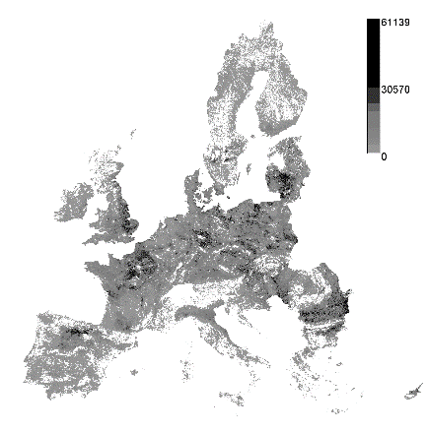
Fig. 1. Geospatial distribution of wheat cropping area in the EU region at $2.56×2.56 km^{2}$ resolution. Colour bar represents the number of 10 m pixels.
to convert crop information to biomass is an estimation of the amount of residue generated, which is highly variable and dependent on plant variety, climate conditions, farming practices, and cutting height. This data is often reported as a ratio compared to the crop yield and is referred as RPR. An approximate estimate of RPR has been defined as an exponential relationship with crop yield by (Karan & Hamelin, 2021). Appropriate assumptions are made in case of mismatches in crop categorizations. While RPR converts crop information to the amount of generated residue, about 50% to 60% residues cannot be collected due to equipment and terrain limitations (Monforti, Bódis, Scarlat, & Dallemand, 2013). Additionally, of the collected residues, about 10% to 20% is usually utilized in-situ for applications such as animal bedding or mulching (Monforti, Bódis, Scarlat, & Dallemand, 2013). Although these numbers may have significant regional and temporal variations, they are incorporated to provide a more realistic estimate of available biomass.
The available biomass is then utilized to a generate heatmap of the feedstock collectable within a collection radius, assumed to be 80 km for this study. For each of pixel in Figure 2 (a), the neighboring pixels within this collection radius is identified. This search is conducted smartly and is sped-up by GPU-based parallelization. Next, the total biomass procurable at each point is calculated as the summation of the biomass available at each neighboring point. As a result, each point from Figure 2 (a) now has an associated biomass availability within the collection radius. This value can be utilized to visualize the biomass hotspots, as shown in Figure 2 (b).
  - Location selection and optimization
For the present study, the only criterion on selection of biorefinery location is assumed to be the feedstock collectable within the collection radius. For this purpose, the first step is to identify the points that meet a threshold on the feedstock available at each harvest season. The amount of feedstock procured in each harvest should be at least enough to sustain the biorefinery production till the subsequent harvest. For instance, for a region with two harvests a year in July and October, the annual requirement of feedstock is divided such that the procurement in July sustains for at least 3 months and the procurement in October sustains for at least nine months. All points that satisfy these thresholds have the possibility of having a balanced feedstock inventory profile at the biorefinery. Among these points, the point with the most biomass available is the recommended biorefinery location.
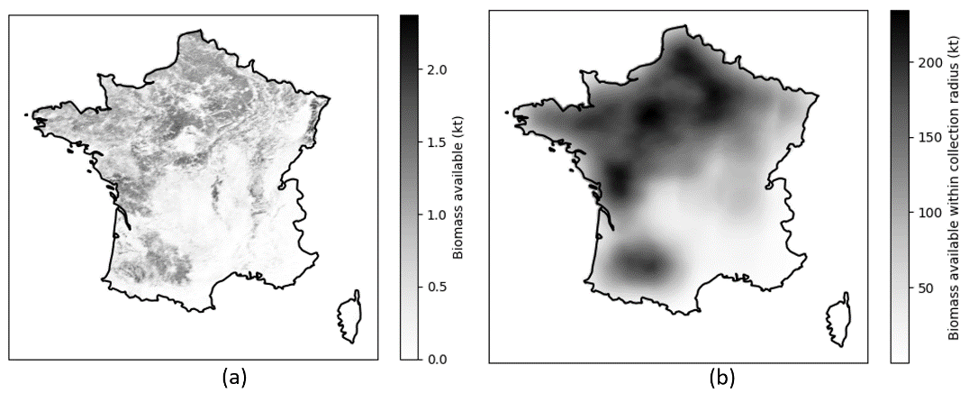
Fig. 2. Annual biomass availability (a) at each pixel and (b) collectable within a radius of 80 km
The impact of selecting the biorefinery location in this manner is studied by solving a simple optimization problem with the objective of minimizing the transport and inventory costs while meeting the demand for feedstock at the biorefinery. The time periods are defined based on harvest seasons. The objective function is shown in Equation 3.
$\text{Min} z=w^{tr}\sum_{p,t}{D_{p}f_{p,t}}+w^{inv-c}C_{in}+w^{inv-o}\sum_{t}{i_{t}}$ | (3)
Where, $w^{tr}$, $w^{inv-c}$ and $w^{inv-o}$ are the weights associated with transportation and CAPEX and OPEX associated with feedstock storage. Note that the weights may be replaced with costs as applicable. $D_{p}$ is the distance from biomass source p to biorefinery, $f_{p,t}$ is the feedstock procured from biomass source p at time t, $C_{in}$ is the capacity of inventory required, obtained as the maximum feedstock stored at any time period, and $i_{t}$ is the feedstock in the inventory at time t. Here, all pixels within the collection radius of the biorefinery location are biomass sources.
The constraints to the optimization problem are the limit of feedstock available from each biomass source, the inventory balance at each biorefinery, and the demand for feedstock at each time period, and are given in Equation 4, Equation 5, and Equation 6. respectively.
$f_{p,t}≤F_{p,t}$ | (4)
$i_{t}={k_{t-1}i}_{t-1}+\sum_{p}{f_{p,t}}-d_{t}$ | (5)
$$d_{t}=D_{t}$$ | (6)
Where, $F_{p,t}$ is the feedstock available in biomass source p at time t, $k_{t-1}$ is the feedstock loss factor at time t-1, $d_{t}$ is the feedstock processed the biorefinery at time t, and $D_{t}$is the demand for feedstock at time t. Note that the intention of the optimization problem is primarily to demonstrate the implications of the biorefinery selection and not to perform economic analysis of biofuel production.
  - Case study
The data and method proposed in this work is demonstrated for France. Residues from barley, maize, rapeseed, sunflower, and wheat are considered in this work as they account for about 98% production in the country. Based on the cropping calendars (U.S. Department of Agriculture, 2023), the harvest periods of these crops were assumed to be as follows: July for wheat, barley and rapeseed, and October for corn and sunflower. The feed requirement at the biorefinery is assumed to be 160 ktpa of agricultural residues with a minimum 15 kt feedstock in storage at any time period and a storage loss of 12% pa. To provide a comparative study, two cases are presented in this work: an annual case and a seasonal case where the recommendations are based on the annual and seasonal availability data, respectively. For the annual case, the point with the highest biomass available within the collection radius is recommended for setting up the biorefinery.
  - Results and discussion
Figure 3 (a) represents the feedstock availability heatmap on enforcing a minimum threshold of 160 ktpa for the annual case. For the seasonal case, the thresholds were 40 kt and 120 kt for July and October, respectively, and the heatmap is presented in Figure 3 (b). For the annual case, the heatmap is primarily spread across a large region in the north-west of France. On the other hand, the hotspot is a relatively small region in the south-west of France for the seasonal case. As a result, the recommended biorefinery location is significantly different for both these cases.
The implications of the biorefinery location selection are obtained by solving the optimization problem. Figure 4 showcases the expected feedstock inventory for both cases. In the annual case, seasonality was not considered, and hence, the biorefinery was located in a region that had very high feedstock availability in July, but less so in October. In order to meet the demand for feedstock throughout the year, the biorefinery would require to procure large quantities of feedstock in the July that would be carried forward throughout the year, resulting in a requirement of inventory of capacity 154 kt, annual average storage of 99 kt of feedstock, and peak procurement of about 135 kt in July. On the other hand, the biorefinery location in the seasonality case is such that it would procure similar quantities of feedstock in both months, with larger procurement in October to account for monthly production till the next harvest season in July. As a result, the inventory capacity requirement would be 139 kt (9.7% lower), annual average storage would be 79 kt (20% lower), and peak procurement would be around 100 kt in October (26% lower). Thus, the seasonal case solution would incur lesser inventory CAPEX and OPEX, lesser feedstock lost at storage, and easier logistics in terms of peak procurement.
  - Conclusions
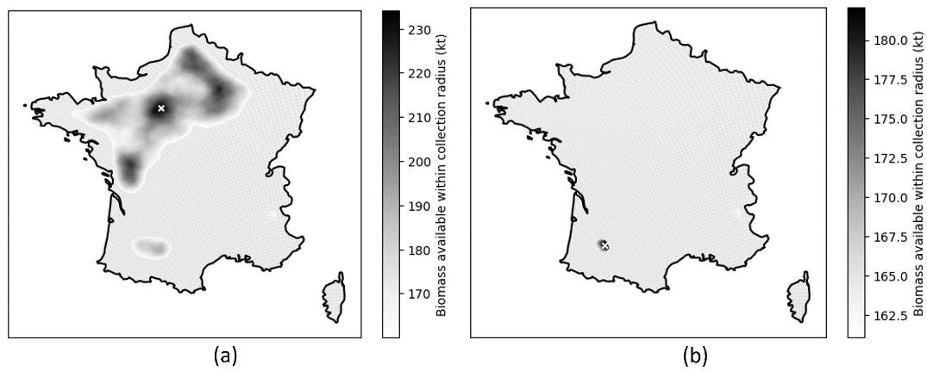
This work presents a methodology to recommend biorefinery locations considering the regional and temporal variation in agricultural residue availability using publicly available data. The 10 m resolution information from EUCROPMAP was aggregated to a courser resolution of 2.56 km to improve tractability of mapping feedstock in the EU.
Fig. 3. Heatmap for regions that meet the threshold on (a) annual and (b) seasonal availability and resulting biorefinery location shown as a white cross.

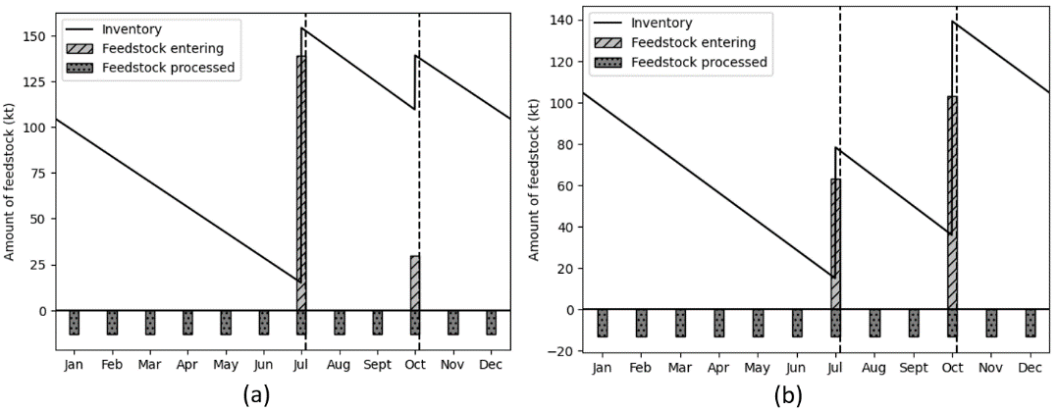
Fig. 4. Feedstock inventory at biorefinery for (a) annual and (b) seasonal case. Positive bars represent the feed entering (at harvest season), negative bars represent the feed processed at each month, and the solid line is the inventory level.
A case study of France is presented considering residues from barley, maize, rapeseed, sunflower, and wheat to provide feedstock for a biorefinery. Two solutions are presented, using annual and seasonal feedstock availability information. The recommended biorefinery location was observed to be different for both cases, with the annual and seasonal case recommending north-west and south-west of France, respectively. The seasonal case was observed to result in a better inventory profile, with 9.7% lower inventory capacity requirement and 20% lower average inventory storage as compared to the annual case. Hence, accounting for seasonality was shown to be critical for agricultural residue-based biofuel production and should be considered while deciding asset locations. The data utilized and the methods presented in this work can be replicated for any other country or combination of countries in the EU. Moreover, for designing a large-scale multi-echelon supply chain, the presented method can be used to locate pre-processing facilities rather than biorefineries.

References
Chakraborty, A., Biswal, A., Pandey, V., Shadab, S., Kalyandeep, K., Murthy, C. S., . . . Chowdhury, S. (2022). Developing a spatial information system of biomass potential from crop residues over India: A decision support for planning and establishment of biofuel/biomass power plant. Renewable and Sustainable Energy Reviews, 165, 112575.
d’Andrimont, R., Verhegghen, A., Lemoine, G., Kempeneers, P., Meroni, M., & Van der Velde, M. (2021). From parcel to continental scale–A first European crop type map based on Sentinel-1 and LUCAS Copernicus in-situ observations. Remote sensing of environment, 112708.
FAOSTAT. (2019). (Food and Agriculture Organization fo the United Nations) Retrieved from https://www.fao.org/faostat/en/#data/QCL
Karan, S. K., & Hamelin, L. (2021). Crop residues may be a key feedstock to bioeconomy but how reliable are current estimation methods? Resources, Conservation and Recycling, 164, 105211.
Monforti, F., Bódis, K., Scarlat, N., & Dallemand, J.-F. (2013). The possible contribution of agricultural crop residues to renewable energy targets in Europe: A spatially explicit study. Renewable and Sustainable Energy Reviews, 19, 666-677.
NUTS - GISCO - Eurostat. (n.d.). (European Commission – Eurostat/GISCO) Retrieved from https://ec.europa.eu/eurostat/web/gisco/geodata/reference-data/administrative-units-statistical-units/nuts

