Exergoeconomical and Ecological Analysis of Biogas Valorization Pathways – Comparing a Combined Heat & Power Plant with a Pressurized Water Process
Fizza Tahir^{a,d} , Burcu Aker^{b} , Sven Nater^{c} , Keren Djuffo Jiofackª, Jens-Uwe Repke^{d} , Jan Schönebergerª

ªBerliner Hochschule für Technik, 13353 Berlin, Germany
^{b}Chemstations, 11000 Richmond, Houston
^{c}DAH Guppe, 16515 Oranienburg, Germany
^{d}Technische Universität Berlin,10623 Berlin, Germany
Jan.Schoeneberger@bht-berlin.de
Abstract
The production of biogas is an important stepstone on the pathway to a climate neutral economy and society. This paper conducts a thorough investigation about comparative analysis of two distinct biogas valorization pathways: cogeneration (A) and production of biomethane in a Pressurized Water Process (B). The investigation is based on a careful examination of three linked aspects: thermodynamic efficiency (exergy), economic feasibility, and environmental effect. This Exergoeconomical and Ecological Analysis (EEEA) is performed by combining rigorous first-principle flowsheet simulation and empirical insights gained from operational biogas facilities. The resulting validated and consistent mass and energy balances serve as the foundation for a comprehensive life cycle assessment (LCA) focusing climate change category. The findings showed that exergetic efficiency of scenario A is 34% and for scenario B it is 76%, the economic benefit of A is 168 €/h and for B it is 296 €/h. The upgrading of the biogas (B) is thermodynamically favorable. Moreover, LCA analysis showed that upgrading (B) has less impact on the climate change as compared to cogeneration (A). The proposed method proved to be a comprehensive procedure to analytically evaluate the viability of biogas plants.
Keywords: Biomethane, Cogeneration, Thermodynamic analysis, Economic analysis, Life cycle assessment
Introduction
In recent years, the rising need for environmentally friendly and sustainable energy sources has boosted interest in biogas and biomethane production as feasible options for both energy generation and waste management. Biogas, obtained from the anaerobic digestion of organic materials, and biomethane, its purified equivalent can be pumped into natural gas pipelines, utilized as a transportation fuel, or to generate power contributing to cleaner and more sustainable energy options.
Several studies have emerged focusing on the exergy and energy concept. Sevinchan et al. (2019) examined a biogas-powered multigeneration system and concluded energy efficiency of 72.5% and a maximum exergy efficiency of 30.44%, with considerable exergy destruction in the combustion chamber. Gong and Lunelli (2023) investigated agro-industrial and urban organic waste for energy production via anaerobic digestion, with an emphasis on biogas generation. The continuous stirred tank reactor (CSTR) biodigester was responsible for 57.2% of the overall exergy destruction, while the heat exchanger exhibited the highest exergy efficiency at 99.95%. Siefert et al. (2014) studied exergy and economics of a power plant that uses biogas from a thermophilic anaerobic digester (AD) to power a solid oxide fuel cell (SOFC). Vilardi et al. (2020) analyzed three biogas upgrading systems (amine scrubbing, water scrubbing, and membrane separation) for exergy and energy performance. These technologies converted biogas into biomethane. The authors concluded that water scrubbing had the highest exergy efficiency (94.5%) and methane recovery (99%), membrane separation had the lowest efficiency (90.8%) and the highest specific energy usage (0.94 kWh/m3 STP). Amine scrubbing used a lower amount of energy (0.204 kWh/m3 STP) and had a high exergy efficiency (91.1%). Xiao et al. (2019) compared untreated, hydrothermally pretreated, and solar-driven hydrothermally pretreated biogas generation techniques. Solar-driven hydrothermal pretreatment had the highest exergy efficiency of 40.85%, outperforming untreated (26.2%) and hydrothermally pretreated (35.98%) procedures. Notably, biogas residue contributed considerably to exergy losses, ranging from 35.13% to 60.58% of total exergy input in the various processes. Therefore, as per our knowledge, no literature has cumulatively focused on exergy analysis, cost analysis and life cycle assessment for upgrading and cogeneration process of biogas plant. This study bridges the gap by providing comparative analysis on two biogas valorization pathways: cogeneration and upgrading through Pressurized Water Process. The objectives of the research are investigation of thermodynamic efficiency, economic cost and life cycle assessment of biogas plant focusing climate change impact category.

2. Methodological approach
The biogas facility under consideration is at the DAH plant in Vehlefanz, Germany. Primary data from the site were collected, including design specifications, operating conditions, feedstock kinds, and production rates. A combined Exergoeconomical and Ecological Analysis (EEEA) is performed as proposed by Schöneberger et al. (2011), using the above-mentioned plant data and rigorous flowsheet simulation. For the latter the flowsheet simulator CHEMCAD from Chemstations Inc. is used. Two scenarios have been identified for the analysis; (A): all biogas is fed to a combined heat and power plant (CHP) and upgradation is switched off and (B): 65% of the biogas is send to a pressurized water plant while the rest is fed to a CHP.
2.1. Economic analysis
A simplified economic analysis is used, considering only product income and feed cost flows. The depreciation of investment costs is neglected because the scenarios compare different operation modes of an existing plant. Operation and maintenance costs are assumed to be small compared to the feed costs. The revenues for the fermentation residues are not calculated explicitly, but lower feedstock costs are considered assuming that the residues are used company internally as fertilizer.
2.2. Thermodynamic analysis
Thermodynamic analysis concentrated on energy conversion efficiency for electricity generation as well as exergetic efficiency, which included heat as a valued output. To compare the efficiency of the electricity production it is assumed that the biomethane is sent to a combined cycle power plant (CCPP) with an electric efficiency of 55 % (higher heating value - HHV based). The exergies are calculated from enthalpies and entropies at process and at ambient conditions using the the Volume Translated Peng Robinson (VTPR) equation of state to calculate phase equilibria and physical properties, see Tsai & Chen (1998) for details. Chemical exergies must also be considered because chemical reactions take place in the CHP.
2.3. Eco-balance analysis
LCA is a comprehensive approach for assessing the environmental implications of a product, process, or system over the course of its life cycle. In this analysis, Gabi LCA software has been utilized for the modeling and calculation processes. The goal of the study is to evaluate the environmental impacts generated from the biogas plant focusing the defined scenarios. The functional unit selected for the study is 1Nm³ of biogas produced from feedstock. The system boundary selected for the study is "cradle to gate", which encompasses activities related to biogas production and its subsequent conversion into biomethane, electricity and heat as shown in Fig.1.
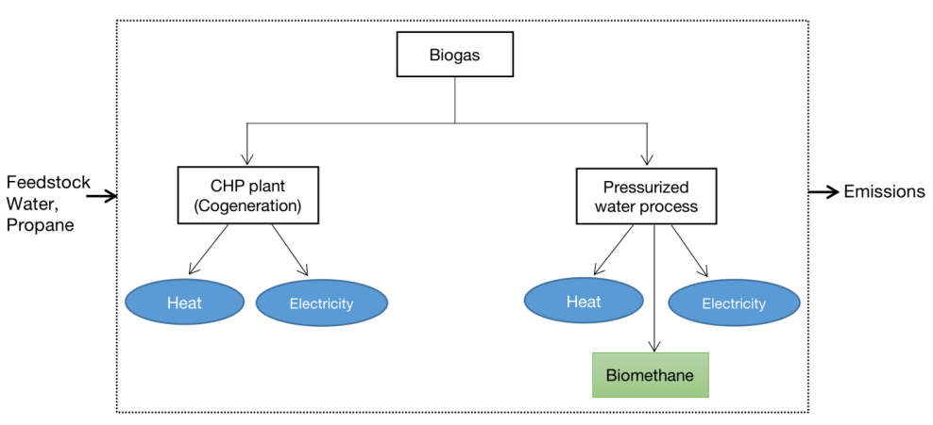
Fig. 1 Schematic flow chart of the chosen system boundary
It does not extend to consider any downstream applications. It's important to note that the initial stage of biogas production is a shared component between both investigated pathways (pressurized water upgrading and cogeneration). The processes are modelled using Ecoinvent databases. A system boundaries expansion (or avoided burden approach) is also applied: the avoided production of natural gas that can be substituted from biomethane is accounted for. For this study, the global warming potential has been evaluated.
3. Process description and model assumptions
The process flowsheet is depicted in Fig. 2. An amount of 12.2 t/h of biomass are fed to the fermenter (U1), which requires 100 kW of electricity and 500 kW of heat for operation. The biomass is composed of 50% maize silage and 50% gras silage by weight. This feed leads to a dry gas production of 2020 Nm³/h while the remaining 7.3 t/h give the fermentation residues. The dry biogas composition is 53.6% CH₄ 46.4% CO₂ with 90 ppm H₂S by mol. The gas is saturated at the fermenter conditions (50°C, 1 bar abs.) which gives an additional water flowrate of 230 kg/h. A part of the biogas (S4) is cooled down and sent to the CHP plant, where H₂S is removed with activated carbon before it is used in the combustion engine to produce heat and electricity. The engine is modelled as a combination of compressors, expanders, and an equilibrium reactor. The model gives an electric efficiency around 38% (HHV based), which fits well with the empirical values for CHP plants.
The gas that is sent to the upgrading process (S13) is compressed in three stages to the absorber pressure of 8 bar abs. For the compressors (U8, U10, and U13) an adiabatic efficiency of 75% is assumed. The coolers (U3, U9 and U11) are modelled as compression machines with a COP of 3. The absorber (U14) is set-up with 8 equilibrium stages. Before the biomethane can be injected into the natural gas grid it is dried and its heating value is adjusted by adding propane (S22). The loaded wash water (S24) is flashed in order to recover absorbed methane (S25) before it is sent to the stripper column (U17). Ambient air (S27) is used for stripping the loaded water in 8 equilibrium stages. The stripping air (S28) contains the H₂S and rests of CH₄ and is transported to a regenerative thermal oxidation unit (RTO, U19) with blower U18, where all residues are oxidized to H₂O, CO₂, and SO₂. The regenerated wash water (S31) is cooled, compressed, and sent back to the absorber. The chiller (U23) must reach lower temperatures than the coolers and therefore is modelled with a COP of 2. In scenario A all gas is send to the CHP plant (S4=S2) and the pressurized water plant (PWP) is shut down. In scenario B 65% of the biogas is fed to the PWP (S13 = 1500 Nm³/h wet). In Table 1 the main production and consumption data for both scenarios are summarized.
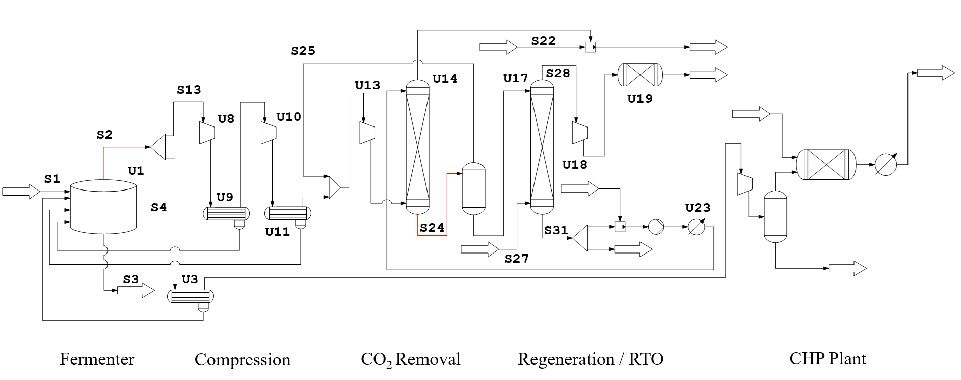

Fig. 2 Process flowsheet of the biogas production and valorization process as implemented at the DAH plant site in Vehlefanz.

Table 1. Main production and consumption data for both scenarios

 | Electricity consumption | Electricity production | Net electricity production | Biomethane production | Biomethane production | Economic benefit
A | 0.7 MW | 4.5 MW | 3.8 MW | 0 Nm³/h | 0.0 MW (HHV) | 168 €/h
B | 0.6 MW | 1.6 MW | 1.0 MW | 740 Nm³/h | 7.7 MW (HHV) | 296 €/h
5. Results and Discussion
  - Economic analysis
In scenario A, 3.8 MW of electricity are produced which leads to an income of 760 €/h. The income for scenario A is 528 €/h. In scenario B 1 MW of electricity and 7.7 MW of biomethane (HHV base) are produced, which generate an income of 969 €/h. This income is reduced by the costs for propane, which is used to adjust the heating value of the biomethane. 60 kg/h propane are added resulting in an additional cost flow of 18 €/h. In both scenarios the feed costs of 360 €/h must be subtracted. With these parameters, the benefit for scenario A is 168 €/h and for scenario B 296 €/h. At an electricity to gas price ratio of 2.5 scenario A becomes economically more attractive than scenario B, because under these conditions selling the electric power creates a larger benefit than using it for the biogas upgrading process.

  - Thermodynamic analysis
This gives an electric efficiency of 38% for scenario A and of 44% for scenario B. The upgrading of the biogas is thermodynamically favorable because electricity can be produced more efficiently in a CCPP than in a CHP, which predominates the losses during the upgrading process. In order to avoid the assumption of the usage of the biomethane in a CCPP the exergetic efficiency of both processes can be compared.
Table 2 has depicted the main exergy flows. The flows are summarized into inputs, outputs, and losses. The difference of these values gives the exergy destruction that occurs during the specific scenarios. The exergetic efficiency of scenario A is 34% and of scenario B 76%. This confirms the result based on the electric efficiency. Furthermore, it points out that the losses related to the CHP off gas have a considerable effect on the exergetic efficiency of the process.

Table 2. Main exergy flows summarized into inputs, outputs, and losses.
 | Input |  |  | Output |  |  | Loss
 | Biogas | Electricity | Propane | Biomethane | Electricity | Heat | Off gas
A | 11.2 MW | 0.7 MW | 0.0 MW | 0.0 MW | 4.5 MW | 26 kW | 2.8 MW
B | 11.2 MW | 0.6 MW | 0.8 MW | 8.0 MW | 1.6 MW | 26 kW | 0.9 MW

  - Eco-balance analysis
Table 3 shows the life cycle inventory table used for calculating the life cycle impact assessment.
Table 3. Life cycle inventory

 | Scenario A | Scenario B
 | CHP | PWP and CHP
Inputs
Biogas | 2,850 kg/h (wet) | 2,850 kg/h (wet)
Active carbon | 0.62 kg/h | 0.22 kg/h
Water | - | 5 m³/d
Propane | - | 30 Nm³/h
Outputs
Carbon dioxide | 3,966 kg/h | 2,578 kg/h
Nitrogen | 32,457 kg/h | 12,368 kg/h
Nitric oxide | 15.7 kg/h | 5.6 kg/h
Sulphur dioxide | - | 0.3 kg/h
Electricity | 3,800 kW | 1,002 kW
Heat | 500 kW | 500 kW
Biomethane | - | 581 kg/h (8.5 MW HHV)

The upgrading process produces less impact on climate change whereas cogeneration produces a higher amount of electricity. This is due to the fact that upgrading leads to the production of biomethane, a clean and renewable fuel with reduced CO₂ emissions when compared to the combustion of raw biogas in cogeneration.
Considering mean CO₂ emissions of 0.4 kg/kWh for electricity production and 2.75 kg CO₂ emissions for utilizing 1 kg of natural gas, net CO₂ reductions of 1,520 kg/h in scenario A and 1,999 kg/h in scenario B are achieved.
- Conclusion and way forward
This study has performed a thorough Exergoeconomical and Ecological Analysis comparing cogeneration (scenario A) and biomethane production via pressurized water scrubbing (scenario B) for biogas valorization. The analysis includes thermodynamic efficiency, economic feasibility, and life cycle assessment. The results indicate that scenario A exhibited an exergetic efficiency of 34% and an economic benefit of 168 €/h, while scenario B demonstrated higher exergetic efficiency at 76% and generates a higher economic benefit of 296 €/h. For an electricity price to gas price ratio of higher than 2.5 scenario A becomes economically more attractive. Upgrading the biogas is thermodynamically advantageous and has a higher CO₂ reduction potential than cogeneration. The market prices for natural gas and electricity can still force owners and operators of biogas plants to go for the cogeneration.
These results develop an insight towards policy making and implement scientific and empirical research to achieve environmental and energy sustainability through biogas generation. Future research can be carried out on the sustainable feedstock scoring, comprehensive life cycle assessment considering multiple environmental and social factors and conducting analysis on different upgrading technologies to know which is better in terms of sustainability.
References
Gong, R., & Lunelli, B. H. (2023). Exergy Analysis of Biogas Production from Sugarcane Vinasse. BioEnergy Research.
Nsair, A., Onen Cinar, S., Alassali, A., Abu Qdais, H., & Kuchta, K. (2020). Operational parameters of biogas plants: A review and evaluation study. Energies, 13(15).
Schöneberger, J., Arellano-Garcia, H. and Wozny, G. (2011), Inverse exergo-ökologisch-ökonomische Prozessanalyse von Abgasbehandlungsprozessen. Chemie Ingenieur Technik, 83.
Siefert, N. S., & Litster, S. (2014). Exergy & economic analysis of biogas fueled solid oxide fuel cell systems. Journal of Power Sources, 272.
Sevinchan, E., Dincer, I., & Lang, H. (2019). Energy and exergy analyses of a biogas driven multigenerational system. Energy, 166.
Thrän, D., Schaubach, K., Majer, S., & Horschig, T. (2020). Governance of sustainability in the German biogas sector—adaptive management of the Renewable Energy Act between agriculture and the energy sector. Energy, Sustainability and Society, 10.
Theuerl, S., Herrmann, C., Heiermann, M., Grundmann, P., Landwehr, N., Kreidenweis, U., & Prochnow, A. (2019). The future agricultural biogas plant in Germany: A vision. Energies, 12(3).
Tsai, J.-C., Chen, Y-P. (1998) Application of a volume-translated Peng-Robinson equation of state on vapor-liquid equilibrium calculations, Fluid Phase Equilibria, 145(2).
Vilardi, G., Bassano, C., Deiana, P., & Verdone, N. (2020). Exergy and energy analysis of three biogas upgrading processes. Energy Conversion and Management, 224.
Xiao, C., Liao, Q., Fu, Q., Huang, Y., Xia, A., Shen, W., ... & Zhu, X. (2019). Exergy analyses of biogas production from microalgae biomass via anaerobic digestion. Bioresource technology, 289.

