Enhancing systems models of pharmaceutical tablet manufacturing using life cycle assessment approaches
Flora Bouchierª, Astrid Boje^{b}, Gavin Reynoldsª
ªOral Product Development, Pharmaceutical Technology & Development, Operations, AstraZeneca, UK
^{b}Digital Science, Sustainable Innovation & Transformational Excellence, Pharmaceutical Technology & Development, Operations, AstraZeneca, Sweden
flora.bouchier@astrazeneca.com
Abstract
Pharmaceutical drug products in the form of tablets are produced via a series of manufacturing steps, transforming powder blends to compacted granules with carefully selected properties such as tensile strength and dissolution time. Typical manufacturing routes include roller compaction and continuous direct compression (CDC). Design of each process step is required to achieve end-product quality for the specific material properties and available equipment, although design decisions are typically made without a quantitative understanding of the impact on product environmental footprint. Using a ‘cradle to gate’ life cycle assessment (LCA) methodology, a quantitative sustainability comparison has been made between standard oral solid dosage (OSD) form manufacturing platforms. Data from these models has been combined with systems models of the manufacturing processes. These combined models are used to demonstrate the optimisation of processes to meet robust product quality attribute targets whilst identify opportunities to minimise the impact of global warming potential.
Keywords: Pharmaceutical Processing, Tablets, Life Cycle Assessment, Systems Modelling
  - Introduction
Pharmaceutical drug products in the form of tablets are produced via a series of manufacturing steps, transforming powder blends to compacted granules with carefully selected properties such as tensile strength and dissolution time. Typical manufacturing routes include roller compaction and continuous direct compression (CDC). Design of each process step is required to achieve end-product quality for the specific material properties and available equipment. Increasingly, experimental development is complemented by predictive simulations with the aim to support robust process design and optimization with minimal API-, energy- and labour-intensive physical trials. Connected, calibrated mechanistic process models (so-called process digital twins) for multiple manufacturing stages provide an effective system description, enabling prediction of end-product critical quality attributes as a function of material properties and process settings. As this approach to design becomes more established, the scope of systems modelling can be widened to provide a more wholistic assessment of the end-to-end manufacturing process.
Life cycle assessment (LCA) evaluates the environmental impacts a product has over its lifetime, producing a quantitative measure which can be used to drive sustainable development (Hadinoto, Tran et al. 2022). Using a ‘cradle-to-gate’ LCA methodology, a quantitative sustainability comparison has been made between standard oral solid dosage (OSD) form manufacturing platforms, roller compaction, direct compression, high shear granulation and CDC.
With the growing focus on sustainability, it is attractive to use systems models as a tool to understand and reduce the environmental cost of pharmaceutical manufacture. As a proof of concept, the LCA methodology and models were incorporated into systems models of tablet manufacturing processes, with a specific example of continuous direct compression presented here. These combined models were used to demonstrate the optimisation of processes to meet robust product quality attribute targets whilst identifying opportunities to minimise the impact of global warming potential.
  - Materials and Methods
    - LCA Methodology
A ‘cradle-to-gate’ approach was used to define the system boundary for the LCA, with the functional unit consisting of the production of 1 kg coated tablets. The scope of the LCA is demonstrated in Figure 1. Life cycle inventory data was sourced from the Ecoinvent database where possible for excipients, auxiliary materials and electricity (Wernet, Bauer et al. 2016). For excipients not available within the ecoinvent database, a similar material with LCI data was used as a ‘surrogate’. API contribution was modelled using a value of 1500 kgCO₂eq/kg, based on medium emission API data obtained from the Association of the British Pharmaceutical Industry Blister Pack Carbon Evaluation Tool (ABPI and CarbonTrust). Models for each manufacturing platform were analysed using SimaPro 9.4 LCA software (Pré Sustainability B.V.), along with the The ReCiPe 2016 Midpoint (H) V1.05 / World (2010) H calculation method, to calculate the global warming potential (GWP) as the key impact category for this assessment. A generic coated tablet formulation was used for all platforms to measure the influence of process yields alongside non-material sources of GWP. Typical process yields were incorporated into each unit operation, with the impact of yield loss material disposal assessed through a hazardous waste incineration step, sourced the EcoInvent database, modified to account for molecular carbon release being calculated separately, assuming complete combustion.
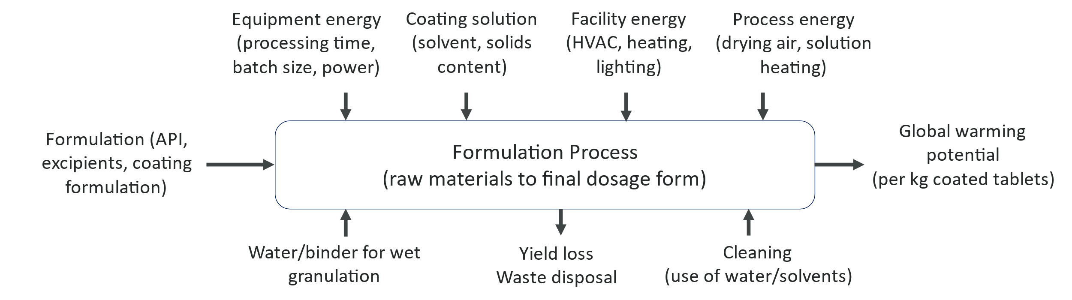
Figure 1 Outline of LCA scope
Energy consumption was assessed both on a unit operation basis, considering unit operation energy requirements, in addition to a facility basis, considering the energy requirement of heating, lighting and air handling within the production facility. Unit operation energy use was calculated using three key methods. The first method relates to equipment where the motor component is the main contribution to power consumption, for example in screw feeders. Assuming that the maximum equipment power is reached at the maximum motor speed, a linear correlation is used to estimate equipment power at given operating parameters. For equipment typically operated at fixed speeds and for a set duration where the major power contributor is torque, such as blenders, a similar method was applied, although maximum power is correlated with maximum load. Finally, for equipment with a heating or drying element, such as coaters, it is assumed that primary energy contribution is required to heat the incoming air. Power use is therefore calculated based on an enthalpy balance of the air, and the subsequent electricity requirement assuming a heater with 100 % efficiency. Facility energy contribution was modelled using a ‘building energy intensity’ value, calculated using annual electricity meter and building footprint data from a representative OSD manufacturing facility. Space requirements for each unit operation were estimated based on an assumed constant ‘dirty room’ area, plus a ‘clean room’ area scaled for relative equipment size and complexity. Facility energy contribution calculated using the building energy intensity and room size, multiplied by processing or cleaning durations, to account for overheads during both stages. Cleaning contribution was built into the models using LCA data from a commercial coater, with solvent use and carbon emissions scaled for other equipment according to relative size and complexity.
    - Systems Modelling
Pharmaceutical process design and optimization is increasingly guided by digital activities such as systems modelling. System models are created by the connection of process models for multiple unit operations, connected as in the physical system. This enables simulation of the relationship between material properties and process settings across different process stages, and end-product qualities. Inclusion of LCA models in system models is a natural extension, allowing a more holistic assessment that includes the impact of material and process choices on the sustainability of the overall process.
Here, we demonstrate this approach for the example of a continuous direct compression (CDC) system model for manufacture of 100 mg tablets (Table 1). A number of such CDC system models have been described in the recent literature, for example by García-Muñoz et al. (García-Muñoz, Butterbaugh et al. 2018), Tian et al. (Tian, Koolivand et al. 2021), and Moreno-Benito (Moreno-Benito, Lee et al. 2022). For the purpose of demonstration, the system model was developed in gPROMS Formulated Products (v2023.1.0, Siemens), using the standard model libraries without customization.
Table 1: Tablet composition and LCA contributions
Component | Mass fraction | CO2e per kg
API | 0.200 | 1500
MCC | 0.504 | 71.69
Lactose | 0.231 | 0.96
Crospovidone | 0.050 | 6.71
Magnesium Stearate | 0.015 | 0.48

The CDC system model (Figure 2) comprises individual material feeders for each component, with API, fillers and disintegrant fed into blender 1, and the ensuing powder blend combined with lubricant in blender 2. The feeders were modelled as continuously stirred tank reactors with gravimetric screw control and a fixed feed factor of 2 g/rev. Feed factor variability was introduced in the API feeder to assess its impact on the sustainability calculations, whilst variability was neglected for the other feeders. The two horizontal blenders were modelled using the axial dispersion model, with mean residence time calculated based on the total throughput and residence mass. Tablet compression in the tablet press was modelled using the Reynolds (2017) (Reynolds, Campbell et al. 2017) model to calculate tablet porosity and tensile strength, based on generic compressibility properties for the blend. The API content of the tablets was monitored, and the time spent out of specification was recorded to determine the quantity of acceptable material produced during operation. The operating window was defined by excluding the first three residence times to approximate onset of steady state operation and calculating the end time needed to achieve a fixed mass of material. LCA calculations were performed for the material (emissions per kilogram) and the process (emissions due to feeder, blender, and tablet press operation).
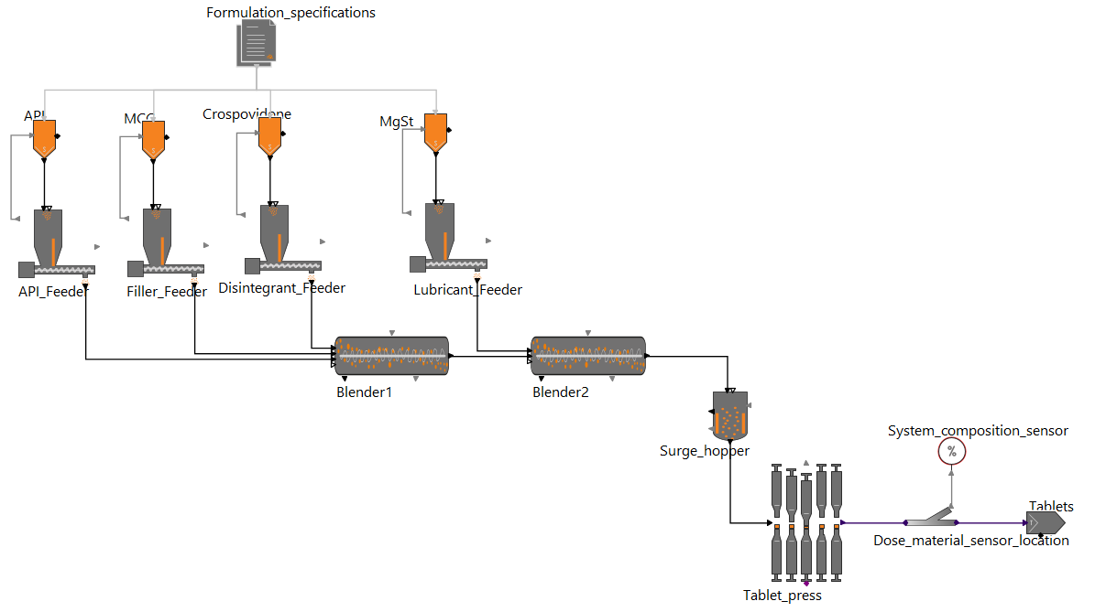
Figure 2: Flowsheet for CDC system model developed in gPROMS Formulated Products 2023.1.0.
  - Results and discussion
    - OSD platform comparison
When performing the LCA, all impacts were normalised per kg coated tablets, to allow for comparison to be made across batch sizes. Figure 3 shows the global warming potential added to the baseline formulation contribution for production of one kg of coated tablets across each manufacturing platform and batch size. The results demonstrate that at small batch sizes CDC is the most carbon intensive manufacturing process, although this is highly dependent on batch size, with CDC having the lowest GWP impact at batch sizes above 200 kg. This batch size dependency results from the fixed start up loss assumptions made for process yield, and since API typically has the largest contribution to GWP, increased process yields result in significant GWP reductions. For other platforms, larger batch sizes are favourable for carbon emission reduction as fixed contributions such as cleaning become relatively lower per kg at larger batch sizes.
When assessing batch manufacturing platforms, direct compression has the lowest GWP when compared to granulation processes such as roller compaction. This is largely due to the cumulative effect of additional unit operations on the overall process yield, although in the case of high shear granulation, there is also the influence of the energy intensive drying process.

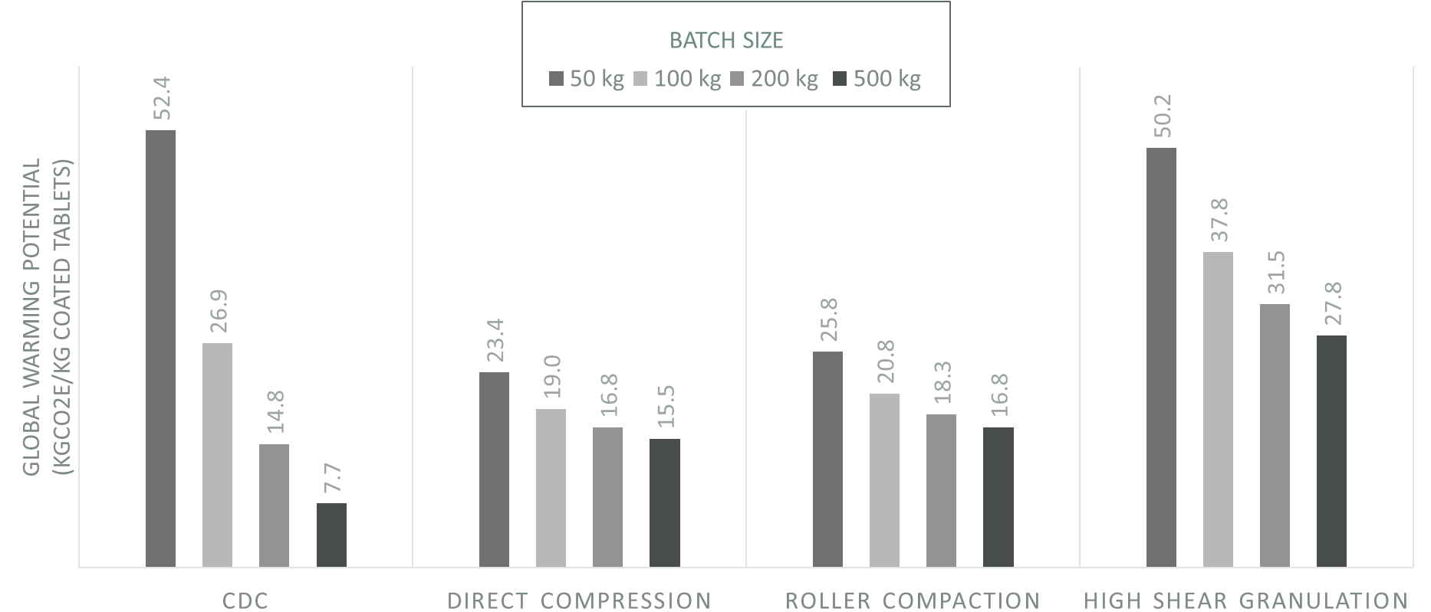
Figure 3 Comparison of global warming potential impacts from different OSD manufacturing platforms and batch sizes. The baseline formulation contribution of 325 kgCO₂eq per kg coated tablets has been removed to allow better visualisation of differences as it is constant for all results.
    - System model analysis
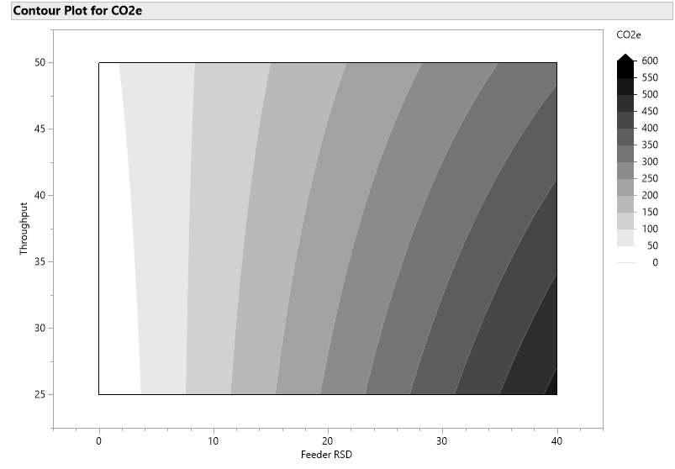
Figure 4 Contour plot of predicted global warming potential (in kg CO2e per kg of formulated tablets) as a function of throughput and feeder variability (RSD). The baseline formulation contribution has been subtracted for visualization.

To illustrate the output from the system model, the influence of the overall process throughput and the RSD of the API feeder on GWP is shown in Figure 4. In this example, the model was run to process the same amount of material (100 kg) across all conditions, with a constant residence mass. The figure shows that the variability from the feeder has a significant influence on the global warming potential of the product. As the variability in the feeder increases, the composition of the resultant tablets starts to deviate from the control limits, resulting in rejection and therefore an increase in waste from the process. There is also an interaction with throughput observed. At low feeder variability, throughput has very little influence on the global warming potential of the product. In this case, the time to steady state (3 mean residence times) scales resulting in the same mass of wasted tablets (equivalent to 3 residence masses). At low feeder variability there is zero or limited waste from out of specification tablets. At higher feeder variability, a higher throughput typically produces a lower global warming potential. This is due to the overall process running for a shorter period of time and therefore reducing the frequency of composition excursions and rejected tablets. Although additional contributions from the LCA were not included in the system model for this illustration, a higher throughput would also be expected to result in lower facility energy contribution due to a shorter production time.
Further development of the system model can include the addition of factors related to equipment set-up and operation, which would influence the residence mass and therefore the degree of mixing in the process as well as inclusion of additional LCA contributions.
  - Conclusions
A detailed cradle to gate life cycle analysis of pharmaceutical tablet manufacturing has been developed. The LCA methodology has included contributions from raw materials, process equipment energy, facilities, cleaning and waste. This has been used to compare the global warming potential of several typical tablet manufacturing platforms. Data and models from the LCA have been incorporated into a system model of a continuous direct compression process to demonstrate how optimisation of these processes can include a quantitative assessment of the global warming potential of the product. This approach provides an enhanced capability to support the development of more sustainable pharmaceutical manufacturing processes.
References
ABPI and CarbonTrust. "Blister Pack Carbon Evaluation Tool." Retrieved 21/08/2023, from https://www.abpi.org.uk/r-d-manufacturing/abpi-blister-pack-carbon-footprint-tool/
García-Muñoz, S., A. Butterbaugh, I. Leavesley, L. F. Manley, D. Slade and S. Bermingham (2018). "A flowsheet model for the development of a continuous process for pharmaceutical tablets: An industrial perspective." AIChE Journal 64: 511-525.
Hadinoto, K., T.-T. Tran, A. Chua and W. S. Cheow (2022). "Comparing environmental impacts of direct compaction versus wet granulation tableting methods for drugs with poor flowability by life cycle assessment." Chemical Engineering Research and Design 183: 439-451.
Moreno-Benito, M., K. T. Lee, D. Kaydanov, H. M. Verrier, D. Blackwood and P. Doshi (2022). "Digital twin of a continuous direct compression line for drug product and process design using a hybrid flowsheet modelling approach." International Journal of Pharmaceutics 628.
Reynolds, G. K., J. I. Campbell and R. J. Roberts (2017). "A compressibility based model for predicting the tensile strength of directly compressed pharmaceutical powder mixtures." International Journal of Pharmaceutics 531(1): 215-224.
Tian, G., A. Koolivand, Z. Gu, M. Orella, R. Shaw and T. F. O'Connor (2021). "Development of an RTD-Based Flowsheet Modeling Framework for the Assessment of In-Process Control Strategies." AAPS PharmSciTech 22: 1-10.
Wernet, G., C. Bauer, B. Steubing, J. Reinhard, E. Moreno-Ruiz and B. Weidema (2016). "The ecoinvent database version 3 (part I): overview and methodology." The International Journal of Life Cycle Assessment 21: 1218-1230.

