Sequential Design of Experiments for Parameter Estimation with Markov Chain Monte Carlo
Xinyu Caoª, Xi Chen^{a,*}, Lorenz T. Biegler^{b}
ªState Key Laboratory of Industrial Control Technology, College of Control Science and Engineering, Zhejiang University 310027, Hangzhou China.
^{b} Chemical Engineering Dept., Carnegie Mellon University, Pittsburgh, PA 15213, United States
xi_chen@zju.edu.cn
Abstract
Parameter estimation involves deducing unknown parameters from empirical data or observational measurements. By iteratively selecting informative experiments based on current knowledge about the parameters, sequential design of experiments (DoE) is a useful tool to estimate parameters efficiently and precisely. Aiming at more efficient use of resources with reliable and accurate results, sequential DoE with updated parameter uncertainties obtained by Markov Chain Monte Carlo (MCMC) is proposed in this study. Bayesian model updating accomplished by MCMC offers a comprehensive approach to enhance model accuracy by integrating observational data into the modeling and simulation processes. Consequently, both the variance of estimated parameters and measurement noise can be updated iteratively to optimize the operation conditions and parameters for the next batch. The proposed method is applied to kinetic parameter estimation for a batch reactor system described by differential-algebraic equations. Comparative analysis demonstrates the superior accuracy of this approach over traditional sequential DoE methods without the MCMC technique.
Keywords: MCMC, Sequential design of experiments.

Introduction
Parameter estimation from empirical data or observational measurements has long captivated researchers and engineers, prompting the development of various strategies over time (Biegler et al., 1986). Bayesian parameter estimation (BPE) stands prominently among these methods. By combining the “prior” and “data distributions” through Bayes' theorem, Bayesian statistics allows us to update our beliefs about the parameters in light of the observed data and obtain the "posterior" distribution, which represents our updated knowledge about the parameters after taking the data into account.
While the choice of estimation strategies holds significance, the role of experimental data in augmenting parameter accuracy cannot be overstated. Conducting experiments within an industrial context proves resource-intensive, demanding both time and cost investments. Moreover, the quality of experimental data significantly influences parameter estimation outcomes. Hence, design of experiments (DoE) emerges as an invaluable mathematical framework encompassing the planning, execution, analysis, and interpretation of experiments (Durakovic, 2017). In numerous instances, a single experiment is inadequate to accurately estimate the model parameters. Therefore, the process of experimental design, execution, and parameter estimation needs to be conducted iteratively until a satisfactory fit to the experimental data is achieved (Barz et al., 2010). Despite the systematic approach, uncertainties like measurement noise skew the parameter estimates. To address these challenges, this study proposes an efficient approach by integrating Markov Chain Monte Carlo (MCMC) into DoE for parameter estimation, accounting for measurement noise and parameter uncertainties. An isothermal batch reaction process is presented to validate the efficacy of this method.

Methodology
Sequential DoE for parameter estimation basis
Parameter estimation adjusts the parameters to make the simulated model output as close as possible to the real measurement. Consider a set of experimental data that includes various measurement values ${\hat{y}}_{i,t}∈R (i=1,2,3,…,N_{y})$ measured at time $t$. For each measurement value, we make assumptions that the measurement errors $ϵ_{i}(i=1,2,3,…,N_{y})$ are additive, independent and normally distributed. To make it easier to analyze and apply in various process applications, the state variables are divided into differential variables $z(t)$ and algebraic variables $x\left(t\right)$. The $i$^{th} calculated output at time $t$ under parameters set as $θ$ is defined as $y_{i}\left(t_{k},θ\right)$. The sum of squares of the residuals is minimized for the estimation of the model parameters, weighted by the inverse of the variances.
In a parameter optimization problem, operating conditions $u\left(t\right)$ can affect the estimate result as a part of that. Enhancing parameter precision in the context of statistical modeling entails reducing the uncertainty of model parameters. Mathematically, this reduction corresponds to diminishing the elements of the parameter variance-covariance matrix. To uphold dimensional coherence, Thompson et al.(Thompson et al., 2009) created a matrix representing the scaled local sensitivity, ${\overline{Q}}_{i}$, as defined in Eq. (1):
$${\overline{Q}}_{i}=\left[\begin{matrix}\begin{matrix}\frac{∂y_{i}(t_{1})}{∂θ_{1}}.\frac{σ_{θ_{1}}}{σ_{i}} \\ \frac{∂y_{i}(t_{2})}{∂θ_{1}}.\frac{σ_{θ_{1}}}{σ_{i}}\end{matrix} & \begin{matrix}… & \frac{∂y_{i}(t_{1})}{∂θ_{N_{θ}}}.\frac{σ_{θ_{N_{θ}}}}{σ_{i}} \\ … & \frac{∂y_{i}(t_{2})}{∂θ_{N_{θ}}}.\frac{σ_{θ_{N_{θ}}}}{σ_{i}}\end{matrix} \\ \begin{matrix}… \\ \frac{∂y_{i}(t_{N_{t}})}{∂θ_{1}}.\frac{σ_{θ_{1}}}{σ_{i}}\end{matrix} & \begin{matrix}… & … \\ … & \frac{∂y_{i}(t_{N_{t}})}{∂θ_{N_{θ}}}\end{matrix}.\frac{σ_{θ_{N_{θ}}}}{σ_{i}}\end{matrix}\right], i=1,2,3,…,N_{y}$$ | (1)
where $σ_{θ_{k}}$ signifies a scaled factor linked to the uncertainty of the $k$th model parameter (which is standard deviation in this paper) and $σ_{i}$ represents a user-provided estimation of the standard deviation to the $i$^{th} measurement noise. The Fisher information matrix ($FIM$) can be calculated using the scaled local sensitivity matrix(Shahmohammadi et al., 2019):$FIM={\overline{Q}}^{T}.\overline{Q}$, where $\overline{Q}$ is composed of ${\overline{Q}}_{i}(i=1,2,3,…,N_{y})$. The inverse of $FIM$ provides an estimate of the variance-covariance matrix that will be obtained after that experiment with the operating condition $u\left(t\right)$. When performing sequential DoE calculations, $\overline{Q}$ contains two parts, i.e., $\overline{Q}={\left[{\overline{Q}}_{old},{\overline{Q}}_{new}\right]}^{T}$ and the resulting nonlinear program is solved with respect to $u\left(t\right),$ and with $θ$ fixed. Popular choices of the objective function Φ(FIM) in DoE include A-(minimize trace of variance-covariance matrix), D-(minimize determinant of variance-covariance matrix), and E-(minimize the largest eigenvalue of variance-covariance matrix) design criteria. Among these, D-optimal designs are widely regarded as highly effective when compared to other optimality criteria (Kessels et al., 2006). Thus, in this study, designing the operating conditions for the next batch uses the following objective function that minimizes the determinant of the variance-covariance matrix:$min \left(FIM\right)={\det\left({FIM}^{-1}\right)}.$ Typically, model-based DoE and parameter estimation are carried out together in a sequential manner, including three phases: 1) experimental design phase, 2) complete execution of the experiment, and 3) parameter estimation phase.
The MCMC-based Strategy
Both sequential DoE and parameter estimation processes are central to obtaining accurate and reliable models (Bock et al., 2013). However, the standard deviations of the $k$^{th} model parameter $σ_{θ_{k}}(k=1,2,…,N_{θ})$ and $i$^{th} measurement noise $σ_{i}(i=1,2,…,N_{y})$ in DoE and parameter estimation are not directly available from the model. The values of these hyperparameters are often unknown. Thus, they need to be either estimated using statistical methods or directly determined by experimenters. Bayes' rule relates the prior, posterior, likelihood, and the scaling factor. Usually, directly computing the posterior distribution is difficult due to its complex and high-dimensional nature. Specifically, when the conditioning variable ($θ$ in this study) is continuous, the summation or integration becomes an integral, which can be challenging to solve analytically. Instead, MCMC (Brooks, 1998) can indirectly obtain inference on the posterior distribution using computer simulations. Thus, MCMC is integrated into the iterative cycle to give an approximation for them. As shown in the left segment of Fig.1, the MCMC-based method begins with design of experiments, which is pivotal for establishing the conditions for the next batch. The execution of the experiment follows, and then progresses to the MCMC phase. Subsequently, the process of parameter estimation is carried out, where parameters are inferred from the collected data. The completion of the method is then marked by reaching the predetermined iteration threshold.
Figure 1: The MCMC-based strategy for DoE and parameter estimation.
The upper-middle segment of Fig.1 elucidates the process of calculating the likelihood within a two-layer Bayesian modeling approach employed in the MCMC-based method. The original estimated parameters $θ∈R^{N_{θ}}$ are extended to generalized parameters [$θ,σ_{1},σ_{2},…,σ_{N_{y}}$]$∈R^{N_{θ}+N_{y}}$ under Bayesian model structure through the likelihood function. The experimental data ${\hat{y}}_{i,t_{k}}$ follows the Gaussian distribution, given all the extended parameters. Its mean is $y_{i}\left(t_{k},θ\right)$ and its variance is the same as that of independent white noise ${σ_{i}}^{2}$. Thus, given the prior of the generalized parameters, the posterior can be obtained with the help of MCMC. It needs to be clarified that not only the probability density distribution of $θ$ but also that of $σ_{i}$ can be updated once the new experimental data is obtained, as both constitute the likelihood function and have prior forms. As a result, the variance of parameters ${σ_{θ_{i}}}^{2}(i=1,2,…,N_{θ})$ and the variance of measurement noise ${σ_{j}}^{2}\left(j=1,2,…N_{y}\right)$ can be updated. Once they are estimated, the scaled factors in the numerator and denominator can be obtained for DoE, as shown in top-right section in Fig. 1. On the other hand, the weights in the objective function can be updated for parameter estimation, as shown in the bottom-right segment. Additionally, to bolster the reliability of parameter estimation results in noisy environments, the 95% confidence intervals of the marginal distribution of θ serve as the upper and lower bounds in the parameter estimation problems. This step further enhances the credibility of the parameter estimation outcomes.

Results and discussion
To verify the effectiveness of the above-proposed method, this section presents an application for dynamic scenarios. The model of the Dow Chemical batch reactor describes a kinetic model of an isothermal batch reactor system (Biegler et al., 1986). Assume that four measured concentrations can be obtained with independent white noise and the true parameters exist. Detailed information is listed in Tables 1 & 2.
Table 1. Measured concentrations and corresponding white noise
index | $$y\left(t,θ\right)=h(z\left(t\right),x\left(t\right))$$ | distribution of $ϵ$ | the true value of $σ$
1 | $$y_{1}=x_{1}+ϵ_{1}$$ | $$ϵ_{1}\sim N\left(0,{σ_{1}}^{2}\right)$$ | $$σ_{1}=0.1$$
2 | $$y_{2}=x_{2}+ϵ_{2}$$ | $$ϵ_{2}\sim N\left(0,{σ_{2}}^{2}\right)$$ | $$σ_{2}=0.2$$
3 | $$y_{3}=x_{3}+ϵ_{3}$$ | $$ϵ_{3}\sim N\left(0,{σ_{3}}^{2}\right)$$ | $$σ_{3}=0.1$$
4 | $$y_{4}=x_{4}+ϵ_{4}$$ | $$ϵ_{4}\sim N\left(0,{σ_{4}}^{2}\right)$$ | $$σ_{4}=0.01$$
Table 2. Parameters and their values
index | parameter | true value | index | parameter | true value
1 | $$k_{10}$$ | $$2.45×{10}^{0}$$ | 5 | $$E_{2}$$ | $$1.90×{10}^{4}$$
2 | $$k_{20}$$ | $$2.67×{10}^{0}$$ | 6 | $$E_{-1}$$ | $$2.69×{10}^{4}$$
3 | $$k_{-10}$$ | $$4.47×{10}^{3}$$ | 7 | $$K_{1}$$ | $$1×{10}^{-16}$$
4 | $$E_{1}$$ | $$1.91×{10}^{4}$$
In this case, the batch temperature is determined by DoE sequentially. To ensure fairness, 5 batches of data were used for each method. Each batch lasts for 200 h and the sampling time is fixed for every 20 h, where the measurement data for $y_{1}-y_{4}$ is obtained. To design experiments sequentially and to unify the experimental objective function, the first batch temperature is fixed at 70$℃$. Then the temperature of the 2nd, 3rd, 4th, and 5th batches are sequentially optimized. The probability density function (pdf) of the estimated parameters after these batches are shown in Fig. 2. We observe that as the number of batches increases in a sequential experimental setup, the confidence interval tends to shrink. Herein the MCMC-based method is compared with the traditional method where MCMC is neither used in DoE nor parameter estimation. Specifically, the parameter variance ${σ_{θ_{i}}}^{2}$ becomes three times larger than the parameter itself, the noise variance ${σ_{j}}^{2}$ is uniformly set to 1, and the boundary constraint of parameter estimation vanishes. To ensure that the outcomes of our study remain relatively independent of any specific set of initial assumptions, each method is conducted 15 times with different random initial parameters. A global accuracy index $I_{α}$, which considers the contribution of relative errors, is introduced as defined in Eq.(2) to assess the quality of the estimated parameters (Galvanin et al., 2009).
$I_{α}=\sqrt{\sum_{k=1}^{N_{θ}}{{\left(\frac{{\hat{θ}}_{k}-θ_{k}}{θ_{k}}\right)}^{2}}}$ | (2)
In Fig. 3, a box plot serves as a visual representation summarizing the distribution of the global accuracy index $I_{α}$. A smaller $I_{α}$ value denotes superior estimation results. Within the traditional sequential DoE approach, $I_{α}$ spans a range from 0.24 to 7.02. Instead, employing the MCMC-based method condenses the $I_{α}$ range considerably, narrowing it down to a more favorable 0.05 to 0.44. Simultaneously, this integration reduces the median value from 0.96 to 0.23. A noticeable disparity emerges between the methods with and without MCMC. As seen in Figure 3, the traditional DoE exhibits a greater number of outliers in the final global accuracy index. In essence, the introduction of MCMC into the DoE for parameter estimation yields substantial enhancements in both the accuracy and reliability of the parameter estimation outcomes, mainly due to the robustness conferred upon estimated results by the confidence intervals obtained through MCMC in Bayesian models.
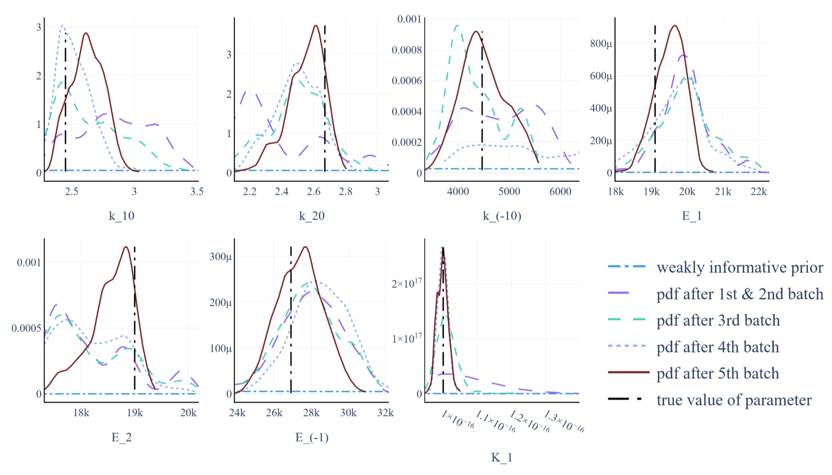
Figure 2. MCMC results for 7 parameters.
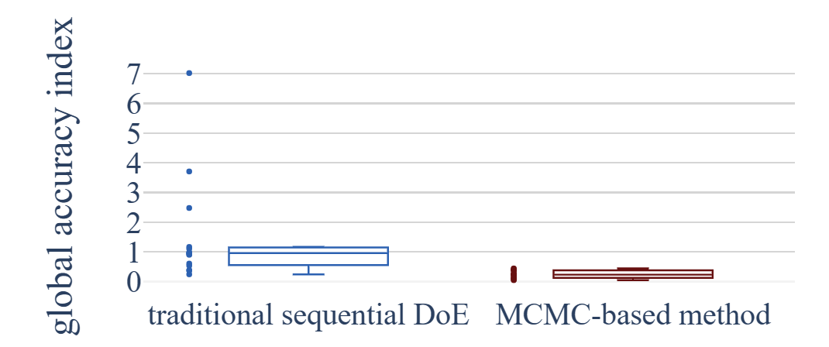
Figure 3. Box plot of global accuracy index of two methods.

Conclusions
This study proposes a parameter estimation method with DoE and Bayesian techniques. By iteratively selecting informative experiments based on the current knowledge about the parameters, this method allows for more efficient use of resources while obtaining accurate and reliable estimates of the parameters. It turns out that the proposed MCMC-based method obtains better parameter estimation results compared with traditional sequential DoE methods. However, there are still challenges to be considered in the future of the MCMC-based method. For example, the implementation of MCMC requires a significant amount of time, though this can be reduced by considering the time and resource costs of experiments. According to Bayesian parameter estimation, future work can focus on faster acquisition of the posterior distribution. Also, how to deal with over-parameterized systems is still challenging. Design of experiments, as a useful tool to detect parameter estimability and to save resources, can guide these advances.

Reference
Barz, T., Arellano-Garcia, H., & Wozny, G. (2010). Handling Uncertainty in Model-Based Optimal Experimental Design. Industrial & Engineering Chemistry Research, 49(12), 5702-5713. doi:https://doi.org/10.1021/ie901611b
Biegler, L. T., Damiano, J. J., & Blau, G. E. (1986). Nonlinear parameter estimation: A case study comparison. AIChE Journal, 32(1), 29-45. doi:https://doi.org/10.1002/aic.690320105
Bock, H. G., Carraro, T., Jäger, W., Körkel, S., Rannacher, R., & Schlöder, J. P. (2013). Model based parameter estimation: theory and applications (Vol. 4): Springer Science & Business Media.
Brooks, S. (1998). Markov chain Monte Carlo method and its application. Journal of the Royal Statistical Society: Series D (The Statistician), 47(1), 69-100. doi:https://doi.org/10.1111/1467-9884.00117
Durakovic, B. (2017). Design of experiments application, concepts, examples: State of the art. Periodicals of Engineering and Natural Sciences, 5(3). doi:http://dx.doi.org/10.21533/pen.v5i3.145
Galvanin, F., Barolo, M., & Bezzo, F. (2009). Online Model-Based Redesign of Experiments for Parameter Estimation in Dynamic Systems. Industrial & Engineering Chemistry Research, 48(9), 4415-4427. doi:https://doi.org/10.1021/ie8018356
Kessels, R., Goos, P., & Vandebroek, M. (2006). A comparison of criteria to design efficient choice experiments. Journal of Marketing Research, 43(3), 409-419. doi:https://doi.org/10.1509/jmkr.43.3.409
Liu, Y., Li, L., & Chang, Z. (2023). Efficient Bayesian model updating for dynamic systems. Reliability Engineering & System Safety, 236, 109294. doi:https://doi.org/10.1016/j.ress.2023.109294
Shahmohammadi, A., & McAuley, K. B. (2019). Sequential Model-Based A-Optimal Design of Experiments When the Fisher Information Matrix Is Noninvertible. Industrial & Engineering Chemistry Research, 58(3), 1244-1261. doi:https://doi.org/10.1021/acs.iecr.8b03047
Shahmohammadi, A., & McAuley, K. B. (2020). Using prior parameter knowledge in model-based design of experiments for pharmaceutical production. AIChE Journal, 66(11), e17021. doi:https://doi.org/10.1002/aic.17021
Smid, S. C., McNeish, D., Miočević, M., & van de Schoot, R. (2020). Bayesian Versus Frequentist Estimation for Structural Equation Models in Small Sample Contexts: A Systematic Review. Structural Equation Modeling: A Multidisciplinary Journal, 27(1), 131-161. doi:https://doi.org/10.1080/10705511.2019.1577140
Thompson, D. E., McAuley, K. B., & McLellan, P. J. (2009). Parameter estimation in a simplified MWD model for HDPE produced by a Ziegler‐Natta catalyst. Macromolecular Reaction Engineering, 3(4), 160-177. doi:https://doi.org/10.1109/9.395

