Economic optimization of intensified processes to produce bioethanol from lignocellulosic biomass.
Yulissa M. Espinoza-Vázquez, ª Fernando Israel Gómez-Castro, ^{a*} Eduardo Sánchez-Ramírez, ª Araceli Guadalupe Romero-Izquierdo, ^{b}
ª Departamento de Ingeniería Química, División de Ciencias Naturales y Exactas, Universidad de Guanajuato, Noria Alta S/N, Guanajuato, Guanajuato 36050, México. fgomez@ugto.mx
^{b} Facultad de Ingeniería, Universidad Autónoma de Querétaro, Campus Amazcala, Carretera a Chichimequillas S/N km. 1, Amazcala, El Marqués, Querétaro, Querétaro 76010, México.
Abstract
In this work, the optimization of a conventional and two intensified processes to produce bioethanol from sorghum residues is developed. The intensification of the production process is applied to the separation zone and includes the whole biomass transformation process in a biorefinery scheme. The process was simulated in the software Aspen Plus, using thermally coupled columns. Then, the optimization is carried out using the total annual cost (TAC) as the objective function, with differential evolution with tabu list (DETL) as the optimization algorithm. DETL was coded in Python and linked with Aspen Plus using the PyWin32 library. The developed tool allows obtaining the optimal design for each process after iterating during approximately 30 hours, with a population of 120 and 200 generations as parameters of the optimization algorithm. It has been found that the optimized conventional system has slightly lower total annual costs than the intensified systems, but the intensified schemes require less equipment.
Keywords: bioethanol, optimization, differential evolution, process intensification.
  - Introduction
In 2021, the use of fossil fuels represented 77% of the world energy system, the same percentage as 30 years ago (Ritchie et al., 2022). These resources are non-renewable, and their deposits are depleted daily, generating greenhouse gases’ emissions. To address this situation, the concept of biofuels stands up, which are renewable fuels generated by processing biomass, reducing CO₂ emissions in the transportation sector (Alam and Tanveer, 2020). They can be used in blends with conventional fuels. Bioethanol is a fuel that can be obtained from biomass; it can be mixed with gasoline in proportions up to 10 vol% to run internal combustion engines. It is important to mention that lignocellulosic residues are usually burned after the grain has been harvested (Law Corner, 2021), therefore it is important to consider routes of use and valorization for these residues. The production of bioethanol from biomass requires pretreatment, hydrolysis, and fermentation processes. Of the possible routes, Conde-Mejía et al. (2012) have shown that acid hydrolysis with H₂SO₄ followed by separate hydrolysis and fermentation achieve higher yields and lower costs.
The production of biofuels from biomass is not fully profitable. Particularly, bioethanol production costs are too high compared to the current prices of fossil fuels (Reboredo et al., 2017). In this context, process intensification (PI) plays a key role as it could help to have more compact, energy efficient, safer, and environmentally friendly processes. With respect to the intensification of the conversion process, several proposals have been presented (Hernández, 2022). In this work, we will focus on the purification zone. Regarding bioethanol purification, various intensification proposals have been reported. Torres-Ortega and Rong (2016) studied the separation of a fermentation broth with a dividing wall system, generating a 21.42% reduction in total annual cost compared to the conventional separation train. On the other hand, Espinoza-Vázquez et al. (2023) proposed intensified schemes for bioethanol purification, including thermally coupled columns and column bonding, performing an analysis of heat duty and key product recoveries, concluding that using a thermally coupled column could enhance the process. However, this comparison is made on non-optimized schemes, with no evaluation of economic indices. Therefore, in this work the rigorous optimization of intensified bioethanol purification schemes is proposed, including the design of the biomass conversion step. The proposed schemes in this work are optimized through the hybrid stochastic algorithm differential evolution with tabu list (DETL), taking as objective function the total annual cost (TAC).
  - Case study
The case study is based on the work of Espinoza-Vázquez et al. (2023), where a feed stream of 87, 539 kg/h of sorghum residues has been considered. The mass composition for the feed stream is 27.56% cellulose, 15.37 % hemicellulose, 14.11 % lignin and 42.93 % carbohydrates (Conde-Mejía et al., 2013). The reactions and conditions for the pretreatment process, hydrolysis and fermentation process have been defined according to Espinoza-Vázquez et al. (2023). All the proposed configurations have been simulated using Aspen Plus. The NRTL equation has been selected as the thermodynamic model to represent the phase equilibrium. In Figure 1, the equipment that can be optimized is marked in blue, corresponding either to the heat exchangers or the separation columns; such units have degrees of freedom. This study analyzes three configurations for the purification section: one conventional (CS) and two intensified schemes (TCC and CTC). All the schemes are evaluated using economic indexes. The two intensified schemes were proposed following the systematic procedure to generate intensified configurations from simple column sequences proposed by Errico and Rong (2016), and their configuration is described next.
    - Conventional Scheme (CS)
This scheme consists of four columns in the separation train, shown in Figure 1 A). C-1 is a distillation column for the separation of volatile gases and heavy compounds. A side stream with bioethanol, water and other products is fed to an additional distillation column (C-2), where non desired products are removed at the bottom. A stream consisting of a mixture of bioethanol and water in the azeotropic point is fed to an extractive distillation column (C-3), using glycerol as solvent in a mass ratio 1:1 regarding the amount of bioethanol in the feed stream. C-4 is a glycerol recovery column.

    - Thermally Coupled Column (TCC)
This scheme proposes a thermally coupled column to replace the glycerol recovery column (C-4), as shown in Figure 1 B).

    - Coupling of two columns (CTC)
This scheme consists of merging column 2 and 3 of the conventional scheme into a single column to reduce the number of equipment; this new column is labeled as C-2. In addition, a column labeled as C-3 is proposed for the recovery of the solvent, as shown in Figure 1 C).

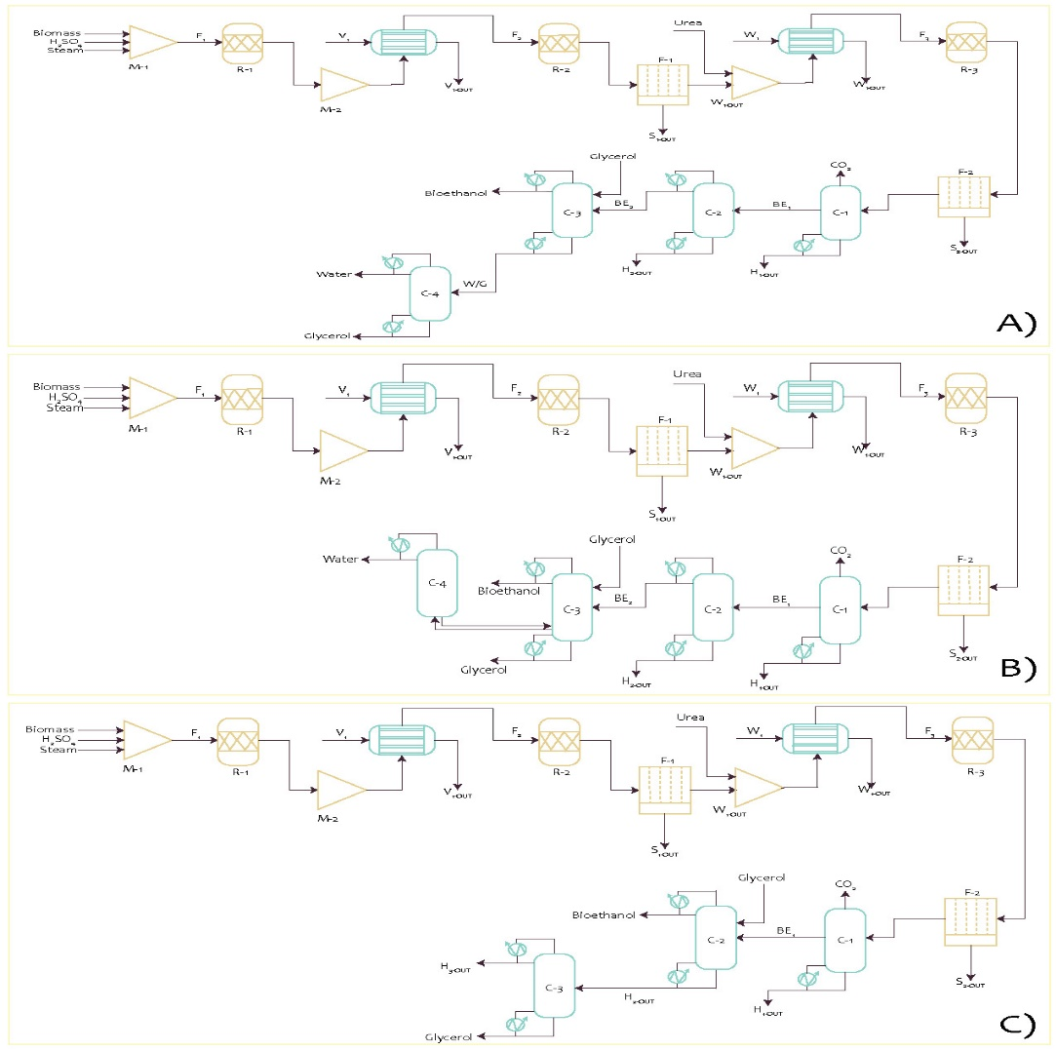
Figure 1: Process flowsheet for: A) CS, B) TCC, C) CTC.
  - Methodology
The objective function considered for this analysis is the TAC, this involves capital and operating costs related to the construction and operation of a chemical process (Turton et al., 2008). The Guthrie method was used to calculate the TAC (Guthrie, 1969), estimating the cost per unit of the process, as shown in Eq. 1.
$$TAC=CO+\frac{CC}{PP}$$ | (1)
where CO is the cost of the services, CC is the capital cost of the plant and PP is the payback period, assumed as 5 years (Susmozas et al., 2018). The minimization of this objective is constrained by the temperatures, recoveries and purities required in each equipment and process stream:
$$Min\left(TAC\right)=f(TH_{in}, FH, N_{s}, N_{f}, B_{R}, N_{ss},F_{ss},D_{R},R_{R}, F_{L}, F_{V})$$ | (2)
Subject to: $y_{b}≥x_{b}$ $w_{b}≥u_{b}$ $y_{g}≥x_{g}$ $w_{g}≥u_{g}$

where $TH_{in}$ is the inlet temperature of the utility’s stream of the heat exchangers used, $FH$is the mass flow rate for the exchangers, $N_{s}$ is the number of stages of each distillation column, $N_{f}$ is the column feed stage, $B_{R}$ is the bottoms flow rate, $N_{ss}$ is the side outlet or inlet stage (in the case of the extractive columns), $F_{ss}$ is the mass flow for each side outlet or inlet, $D_{R}$ is the distillate flow rate,$R_{R}$ is the reflux ratio, $F_{L}$ is the interconnection liquid flow rate and $F_{V}$ is the interconnection vapor flow rate. In addition, the optimization problem is constrained by the purities of bioethanol ($y_{b}$) and glycerol ($y_{g}$), that must be equal to or greater than $x_{b}$ and $x_{g}$, respectively. Moreover, the recoveries of bioethanol ($w_{b}$) and glycerol ($w_{g}$), must be equal to or greater than $u_{b}$ and $u_{g}$, respectively. Due to the large number of local solutions and the nonlinearity of the model of the process, the use of a stochastic search algorithm is proposed. DETL was used as the optimization algorithm since it has demonstrated its ability to solve constrained optimization problems common in chemical engineering (Sánchez-Ramírez et al., 2015). To implement the optimization algorithm, Aspen Plus was linked to Python with data storage in Excel. The DETL algorithm was coded in Python with the PyWin32 library, allowing the access to the Windows Component Object Model (COM). Pandas’ library was used for the analysis and storage of data in Excel. Therefore, in this work the proposed schemes were optimized using DETL method through a link using Python and Aspen Plus. The decision variables are sent from Python to Aspen via COM technology for evaluation. After the simulation is performed, Aspen returns the values needed for the calculation of the objective function to Python and new decision variables are proposed according to the optimization method used. Finally, the data of the variables and objective functions are saved in a vector and sent to an Excel file for analysis. For the optimization of the process, the following parameters are used for the DETL method: 120 individuals, 200 generations, a taboo list of 50% of the total individuals, a Taboo radius of 0.0001, 0.3 of amplification factor and 0.9 of crossover rate (Alcocer-García et al., 2019).
  - Results
This section presents the main results of the economic optimization for all the schemes. For the three cases, the first heat exchanger operates with a flow rate of 122,621.1 kg/h at 233 ºC, while the second heat exchanger operates with a flow rate of 397,702.6 kg/h at 24 ºC. In the case of the first column, it has 25 stages with a feed flow rate of 1,157,377.6 kg/h, having the side outlet located in stage 7 with a flow rate of 28,000.2 kg/h. The configurations for the other columns are shown in Table 1. Figure 2 shows the results regarding the total heat duty of the optimized equipment for each scheme as well as the total TAC in thousands of dollars per year. In the three cases, the highest cost is derived from the capital cost, representing 85% of the total TAC, due to the magnitude of the process, which can recover up to 12,242.4 kg/h of bioethanol. In the two intensified schemes, 99% bioethanol purity and 99% glycerol recovery and purity are achieved. However, in the case of bioethanol recovery, it is observed that with respect to the total amount that leaves the conversion process, the CTC scheme only has a 96.5% recovery, while the other two schemes have a recovery of 97%. The conventional scheme has the lowest thermal load with a value of 38.5 kW/kg of bioethanol, in defiance of the efforts to reduce the load in the proposed schemes. Concerning the TAC, the TCC scheme is the closest to the CS, with a TAC increase of 0.18 % but reducing the use of a column and a cost of 2.91 USD/kg of bioethanol.
Table 1: Comparison of schemes.
 | Variable | CS | TCC | CTC
Column 2 | Number of stages | 19 | 19 | 22
 | Distillate rate (kg/h) | 13,215.1 | 13,215.1 | -
 | Reflux ratio | 3.03 | 3.03 | 3.54
 | Feed stage | 12 | 12 | 18
 | Bottoms rate (kg/h) | - | - | 28,121.9
 | Feed Stage Glycerol | - | - | 2
Column 3 | Number of stages | 17 | 21 | 10
 | Distillate rate (kg/h) | 12,050 | 11,924.3 | -
 | Feed stage | 5 | 14 | 3
 | Reflux ratio | 0.30 | 0.30 | 0.30
 | Feed Stage Glycerol | 2 | 4 | -
 | Bottoms rate (kg/h) | - | - | 12,185
 | Liquid flow stage | - | 19 | -
 | Vapor flow stage | - | 19 | -
 | Mass flow of vapor | - | 1,176.1 | -
Column 4 | Number of stages | 29 | 10 | -
 | Bottoms rate (kg/h) | 12,125.8 | 1,171.9 | -
 | Feed stage | 2 | - | -
 | Reflux ratio | 0.30 | 24.1 | -

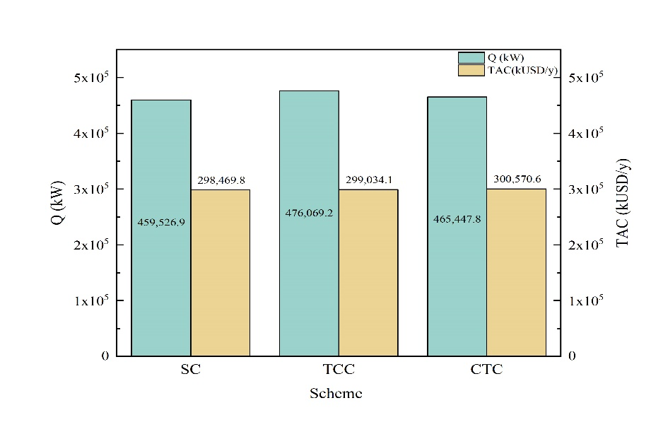
Figure 2: Comparation of heat duty and TAC of schemes.
  - Conclusions
The optimization of a conventional scheme and two intensified schemes to produce bioethanol from lignocellulosic wastes has been carried out using the DETL method. It has been observed that the conventional scheme is the one that has shown the lowest total annual cost as well as the lowest heat duty with a cost of 2.91 USD/kg of bioethanol and 38.5 kW/kg of bioethanol, respectively; however, the TCC scheme is the one that has shown a similarity in cost and thermal load with the advantage of reducing one processing equipment. During this study, an attempt has been made to reflect the benefits of process intensification in economic terms, however, it is interesting that process intensification does not always produce large savings. This means that through process intensification it is not always possible to design schemes that can reduce the cost and heat duty of the process. For future work, it is proposed to implement alternative intensification schemes to achieve a minimization of the TAC with respect to the conventional scheme. Likewise, it is proposed to use another objective function such as the environmental aspect, to obtain information not only related to costs but also on which configuration has less environmental impact, therefore having a more detailed comparison.
References
M. S. Allan and M. S. Tanveer (2020). Conversion of biomass into biofuel: a cutting-edge technology. In Bioreactors, 55–74.
H. Alcocer-García, J. G. Segovia-Hernández, O. A. Prado-Rubio, E. Sánchez-Ramírez and J. J. Quiroz-Ramírez (2019). Multi-objective optimization of intensified processes for the purification of levulinic acid involving economic and environmental objectives. Chem Eng Process, 136, 123-137.
C. Conde-Mejía, A. Jimenez-Gutiérrez and M. El-Halwagi (2012). A comparison of pretreatment methods for bioethanol production from lignocellulosic materials. PSEP, 90, 189–202.
C. Conde-Mejía, A. Jimenez-Gutiérrez and M. El-Halwagi (2013). Assessment of combinations between pretreatment and conversion configurations for bioethanol production. ACS Sustain. Chem. Eng., 1(8), 956–965.
M. Errico and B.G. Rong (2016). Systematic synthesis of intensified distillation systems. In Process Intensificacion in Chemical Engineering: Desing, Optimization and Control, 35-64.
Y. M. Espinoza-Vázquez, F.I. Gómez-Castro, E. Sánchez-Ramírez and A. G. Romero-Izquierdo (2023). Development and assessment of intensification alternatives on the lignocellulosic bioethanol production process. Comput. Aided Chem. Eng.. 52, 2735-2740.
K. M. Guthrie (1969). Capital cost estimation. Chemical Engineering, 24, 114–142.
S. Hernández (2022). Process intensification in biofuels production. In Biofuels and Biorefining, 2, 1-40. Elsevier.
Law Corner (2021). Stubble burning – a trouble to the environment. https://lawcorner.in/stubble-burning-a-trouble-to-the-environment/, last consulted on November, 2023.
F. H. Reboredo, F. C. Lidon, J. C. Ramalho and M. F. Pessoa (2017). The forgotten implications of low oil prices on biofuels. Biofpr, 11(4), 625–632.
H. Ritchie, M. Roser and P. Rosado (2020). CO₂ and greenhouse gas emissions. Our World in Data. https://ourworldindata.org/co2-and-greenhouse-gas-emissions, last consulted on November, 2023.
E. Sanchez-Ramírez, J. G. Segovia-Hernandez and A. Bonilla-Petriciolet (2015). Process alternatives for biobutanol purification: design and optimization. Ind. Eng. Chem. Res., 54(1), 351–358.
A. Susmozas, A. D. Moreno, J. M. Romero-García, P. Manzanares and M. Ballesteros (2018). Designing an olive tree pruning biorefinery for the production of bioethanol, xylitol an antioxidants: A techno-economic assessment. Holzforschung, 73(1), 15–23.
C. E. Torres-Ortega and B. G. Rong (2016). Intensified separation processes for the recovery and dehydration of bioethanol from an actual lignocellulosic fermentation broth. In Comput. Aided Chem. Eng., 38, 727-732. Elsevier.
R. Turton, R. C. Bailie, W. B. Whiting and J. A. Shaeiwitz (2008). Analysis, synthesis and design of chemical processes. Pearson Education.

