Towards pH Swing-based CO2 Mineralization by Calcium Carbonate Precipitation: Modeling and Experimental Analysis

Chinmay Hegde1,*; Andreas Voigt2; Kai Sundmacher1,2

1Institute of Process Engineering, Otto von Guericke University, Magdeburg, Germany 2Max Planck Institute for Dynamics of Complex Technical Systems, Magdeburg Germany

* corresponding author: chinmay.hegde@ovgu.de

Abstract

In an effort to stop adverse climatic changes, greenhouse gas emissions must be reduced together with removing already-emitted CO2 from the atmosphere. Mineral carbon sequestration is an effective way of storing carbon permanently. The most common alkaline earth metals, calcium, and magnesium, found in mineral compounds can be used as feedstocks. Our work illustrates the formulation of a model and the experimental validation for CO2 capture as calcium carbonate (CaCO3) precipitate using mine wastes. The model aims to facilitate the development of an adaptive controller that should enhance the productivity of precipitated carbonate particles while adhering to predefined particle size specifications. The precipitation is implemented via a liquid phase pH swing process. The factors influencing the efficiency of the process to precipitate CaCO3 preferentially are investigated using dissolved Ca2+ ions solution in the presence of Mg2+ ions. Furthermore, the study of the influence of CaCO3 seed particles on the particle size distribution and crystal growth kinetics indicated that kinetics significantly impact the precipitation, which could alter particle morphology. Though calcite seeds were used to induce crystal growth, morphology is dictated by primary nucleation. In the absence of impurities, both vaterite and calcite are precipitated, while the presence of Mg2+ ions delays the primary nucleation and leads to the preferred precipitation of smaller nucleates as aragonite. The pH of the solution is regulated in a semi-batch operating mode for the selective precipitation of desired carbonates. A novel model has been formulated to simulate this process.

**Keywords**: pH swing, calcium carbonate, nucleation, seed particles, crystal growth

* 1. Introduction

Ex situ mineral carbonation is regarded as a promising method for carbon dioxide capture and storage (CCS) because (i) the captured CO2 can be permanently stored and (ii) industrial wastes, such as cement and lime kiln dust, steel and stainless-steel slags, and coal fly ash, can be recycled and turned into value-added carbonate materials by managing the polymorphs and properties of the mineral carbonate. Calcium and magnesium are the most abundant alkaline earth metals in nature as minerals and industrial wastes, and the mineral carbonates of CaCO3 and MgCO3 are particularly of interest. These can be produced in both direct and indirect processes. Owing to the high-purity products and higher conversion rates (Bobicki et al. 2012), indirect techniques are preferred. They can be accomplished via gas-solid mineral carbonation, the pH swing process, the molten salt process, acid extractions, and bioleaching. pH swing process is a liquid phase carbonation method involving four steps: (1) liquid-solid extraction of metal ions (Mg2+, Ca2+), (2) solid-liquid separation by filtration, (3) carbonation of the metal ions by use of CO­2, (4) separation of solid carbonate particles.

[Precipitation of CaCO3 is a significant process in the fields of geology, environmental science, and industrial applications](https://bing.com/search?q=precipitation+of+CaCO3). The ability to manufacture CaCO3 with speciﬁc morphology, structure, and particle size is invaluable due to its wide application as ﬁller in composite materials such as plastics, rubbers, paper, or paints. [The precipitation of CaCO3 is influenced by several factors, including the calcium concentration, the carbonate concentration, the pH value of the environment, and the presence of nucleation sites](https://docslib.org/doc/5304945/microbial-caco3-precipitation-for-the-production-of-biocement). The stoichiometric equation for calcium carbonation in the liquid phase is given as:

|  |  |  |
| --- | --- | --- |
| $$Ca^{2+}\left(aq\right)+CO_{3}^{2-}\left(aq\right)⇌CaCO_{3}(aq)$$ |  | (1) |

The Ca2+ ions also react with $HCO_{3}^{-}$ to form $CaHCO_{3}^{-}$, but this reaction is not preferred kinetically, and thus $CaHCO_{3}^{-}$ concentrations are negligible (Koutsoukos & Kontoyannis 1984). The most important factor for CaCO3 precipitation is the supersaturation $S$, which is the driving force for both nucleation and crystal growth:

|  |  |
| --- | --- |
| $$S=\sqrt{\frac{a\left(Ca^{2+}\right)∙a(CO_{3}^{2-})}{k_{sp}}}$$ | (2) |

where $k_{sp}$ is the solubility product of CaCO3, and and $a(CO_{3}^{2-})$ are the liquid phase activities of calcium ions and carbonate ions, respectively. The activity of the ions is dependent on temperature, pH and ionic strength. This investigation focuses on the controllability of the solubility based on the pH, the variation of which is provided in Figure 1(a). The change in the supersaturation influences the precipitation kinetics, which results in different crystal phases of CaCO3, namely Calcite, Vaterite and Aragonite. The precipitation of CaCO3 has been investigated in various studies. Liendo et al. (2022) observed, that when using Na2CO3 and CaCl2 as starting chemicals, at high supersaturation the CaCO3 crystallization was dominated by vaterite formation, which transformed to thermodynamically stable calcite over time. However, using (NH4)2CO3 resulted in a stable vaterite formation without transformation to calcite. In another study conducted by Park et al. (2008), in the presence of Mg2+ ions, the metastable aragonite is preferred rather than vaterite along with calcite precipitation. Increasing the Mg2+ ion concentration resulted in aragonite dominance. While the presence of potassium ions resulted in the formation of calcite, which was shown in a study by Falini et al. (2009).

Controlling the precipitation kinetics not only influenced the crystal structure but also dictated the crystal sizes. Feng et al. (2007) found in their research that the average particle size in CaCO3 precipitation is in the range of 1 - 3 µm. This was reduced by the decrease in the CO2 bubble sizes. For the carbon capture, gaseous CO2 is used to form carbonates which, when dissolved in an ionic solution, dissociates. Equations (3) - (6) summarise the reactions of CO2 dissolution and dissociation. The concentration of the carbonates is pH dependent, as shown in Figure 1(b) (Bjerrum plot).

|  |  |  |
| --- | --- | --- |
| $$CO_{2}\left(g\right)⇌CO_{2}(aq)$$ | $$K_{h}$$ | (3) |
| $$CO_{2}\left(aq\right)+H_{2}O\left(l\right)⇌H_{2}CO_{3}(aq)$$ | $$K_{0}$$ | (4) |
| $$H_{2}CO_{3}\left(aq\right)⇌HCO_{3}^{-}\left(aq\right)+H^{+}\left(aq\right)$$ | $$K_{a1}$$ | (5) |
| $$HCO_{3}^{-}\left(aq\right)⇌CO_{3}^{2-}\left(aq\right)+H^{+}\left(aq\right)$$ | $$K_{a2}$$ | (6) |

 

Figure 1: (L to R) (a) Solubility vs. pH plot for CaCO3, (b) species’ concentrations vs. pH (Bjerrum plot).

In this study, we focus on model development for the precipitation process of CaCO3 in a semi-batch operation and experimental investigation of it. The ultimate goal is to develop a self-learning adaptive controller to produce calcium and magnesium carbonates selectively, starting from mine wastes. For controlling particle growth, we intend to add seed crystals in a well-dosed manner in such a way that nucleation in the solution, which is often difficult to control, should be largely suppressed.

* 1. Experimentation and Methods
     1. Preparation of Calcium carbonate

The following reagents were used: HCl, CaCl2, MgCl2, CO2(g), Ca(OH)2 and CaCO3 seed particles. A cylindrical vessel made of Pyrex glass with a 7.5 cm diameter and 500 ml volume was used as a reactor. Magnetic stirring was applied to homogenize the reaction mixture. The pH was monitored by the use of a Seven2Go meter (Mettler Toledo).

For the first set of experiments, different amounts of CaCl2 were dissolved in HCl solution at pH 3. CO2 was bubbled into this acidic solution through a gas flowmeter until saturation was reached. Since the carbonate precipitation takes place at higher pH values, saturated Ca(OH)2 at pH 12.5 was added at a constant flow rate of 3 ml/min through a diaphragm pump. At pH 7, 60 mg of calcite seeds were added to the mixture. The reactor was stirred at 350 rpm. In the second set of experiments, along with CaCl2, different amounts of MgCl2 were dissolved in the HCl solution to study the impact of Mg on the CaCO3 precipitation. The experiments were conducted at room temperature of 20 °C.

The precipitated particles formed were analyzed using X-ray diffraction (D2 Phaser, Bruker) and thermogravimetric analysis (TGA/DSC3, Mettler Toledo). The initial and final concentrations of the dissolved ions were evaluated using ion chromatography (Dionex Aquion, Thermo scientific). The particle size distributions were measured using laser diffraction (Mastersizer 30cc00, Malvern).

* + 1. Methodology and Modeling

For a simple batch precipitation process, the population balance equation (PBE) reads:

|  |  |
| --- | --- |
| $$\frac{∂n(t,x)}{∂t}+\frac{∂(G\left(t,x\right)∙n(t,x))}{∂x}=\dot{B}(t,x)-\dot{D}(t,x)$$ | (7) |

where $n$ is the number density (#/m3 of the solution), $G$ is the growth rate, and $\dot{B}$ and $\dot{D}$ are the birth and death rates, respectively, due to nucleation, agglomeration and breakage. For selective precipitation and high purity of the produced carbonates, it is desirable that the precipitation is dominated by the growth of the seeds added, rather than by nucleation. If this would be the case, assuming size-independent growth and an initial boundary condition for seeding, $n\left(t=0, x\right)=n_{0}(x)$, the PBE reads:

|  |  |
| --- | --- |
| $$\frac{∂n(x,t)}{∂t}+G(t)\frac{∂n(x,t)}{∂x}=0$$ | (8) |

The dynamics of the liquid phase concentration $c(t)$ is described by:

|  |  |  |
| --- | --- | --- |
| $$\frac{dc(t)}{dt}=-ρ^{m}k_{v}G\left(t\right)m_{2}(t)$$ | (9) |  |

where $ρ^{m}$ is the molar density of the solid, $k_{v}$ is the shape factor and $m_{2}$ is the second moment of the number density distribution, corresponding to the total surface area of the particle population. A similar approach was used to model the shape-specific crystal growth under controlled supersaturation by Eisenschmidt *et al.* (2015). For ideal batch operation of seeded selective precipitation of carbonates, the simulated dynamics of crystal growth and the simultaneous change of liquid phase concentration for a monodispersed solution are depicted in Figure 2, based on typical parameters taken from literature. The growth rates for the two types of crystals are different, the crystal with a larger rate grows more quickly than the other.

 

Figure 2: (L to R) (a) Crystal growth of two different carbonate species with different growth rates. (b) Simultaneous decay of the liquid concentration due to particle growth.

* 1. Results and Discussion
     1. Particle size distribution

In order to extract the metallic ions from mine waste, the feedstocks were exposed to an acidic solution (HCl). This extraction process was investigated by researchers at the Karlsruhe Institute of Technology (KIT). The extracted solution was filtered and the ion-rich filtrate was supplied for carbonate precipitation in the authors’ laboratory.

For the present study, however, pure substances at concentrations, similar to the concentrations obtained in the mine waste extraction solutions, were used. Carbonate precipitation was carried out by the pH swing method, i.e. by shifting the solution pH from 3 to 11 by addition of saturated Ca(OH)2 solution at 3 ml/min. The resulting final particle size distribution of the precipitated carbonates was measured. To achieve a controlled precipitation of calcium carbonate, crystal growth was initiated by seeding of particles (secondary nucleation). For this purpose, 60 mg of Calcite seeds with a nominal size of 60-100 µm were added to the solution at pH 7, where the solubility of CaCO3 was about 10­-4­ mol/L (see Figure 1(a)) such that the seeds did not dissolve.

The measured number density-based particle size distributions (PSD) are shown in Figure 3. The seed size of 60 -100 µm (Figure 3(a)) was chosen to be able to distinguish clearly between seed particles and possibly formed nuclei. When the pH was increased from 7 to 9, the precipitation of CaCO3 proceeded via primary nucleation. This is evident from Figure 3(b), where nuclei were formed spontaneously, and consequently, the PSD shifted to the lower size class (towards the right). As the pH of the solution was further increased, the solution became turbid due to pronounced primary nucleation. The nuclei formed were in the range of 0.6 – 4 µm with a mean size of 0.9 µm, see Figure 3(c).

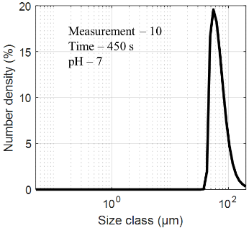 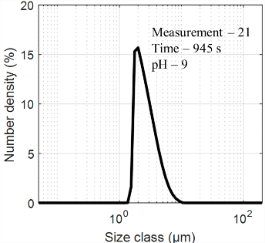 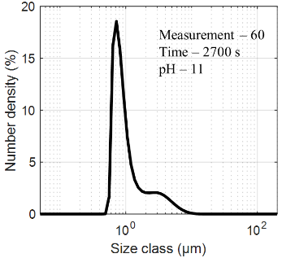

Figure 3: Particle size distribution (PSD) from the Mastersizer (a) Calcite seed crystals added. (b) Big number of small nuclei formed spontaneously. (c) PSD dominated by nuclei population.

As discussed in Section 2.2, the initial model assumes a batch precipitation process which is controlled by particle growth, starting from seeds. But the experimental results clearly indicate the need for a nucleation term to be incorporated in the PBE. In addition, we consider now a semi-batch reactor and then obtain the following model equations:

|  |  |
| --- | --- |
| $$\frac{∂n(x,t)}{∂t}=-G\left(t\right)\frac{∂n\left(x,t\right)}{∂x}-J\left(t\right)f_{nuc}(t)$$ | (10) |
| $$V\left(t\right)\frac{dc\left(t\right)}{dt}=-c\left(t\right) {\dot{V}}_{in}+r V\left(t\right)-ρ^{m}k_{v} G\left(t\right) m_{2}\left(t\right)-ρ^{m} v_{nuc} J(t)$$ | (11) |

where $J$ is the rate of nucleation. A possible approach for calculating $J$, along with the method of its experimental measurement, is described in detail by Liendo et al. (2022). $r$ stands for the rate of the chemical reaction, ${\dot{V}}_{in}$ is the feed rate of the base used for the pH swing, i.e. Ca(OH)2. Eqs. (10) and (11) along with the initial boundary condition for seeding, $n\left(t=0, x\right)=n_{0}(x)$ as mentioned before, can be used for the development of a suitable process controller.

* + 1. Crystal morphology

As discussed in the previous section, precipitation was found to be dominated by primary nucleation, not by the growth of the seeds. One of the reasons for this observation could be the difference of the morphologies of the nuclei formed and the calcite seeds added. This difference is evident from the XRD analysis as well as the imaging of the precipitated particles. To investigate this further, two sets of precipitation measurements were performed: 1) with only CaCl2 and 2) MgCl2 along with CaCl2. It was observed that for the first set, vaterite is precipitated predominantly, which over time, transforms to calcite. But, when the Mg2+ ions were introduced, metastable aragonite precipitates along with some amount of calcite. The XRD analysis for this material is shown in Figure 4. The size of the nuclei formed was, however, slightly smaller with than without Mg2+ ions. This could be due to the smaller size of the needle-like aragonite crystals compared to the orthorhombic vaterite crystals.

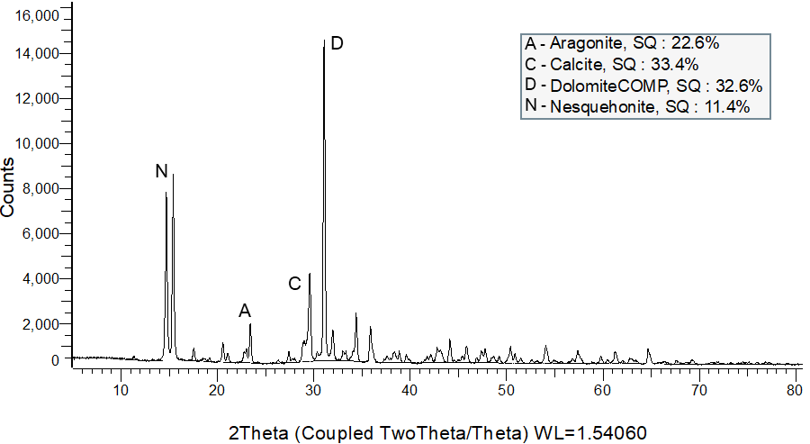

Figure 4: XRD analysis of calcium carbonate precipitates obtained in the presence of Mg2+ ions.

* 1. Conclusion

The experimental investigation of CaCO3 precipitation showed that the precipitation is highly dependent on the kinetics of the reaction which is not only dependent on the Ca2+ and ion concentrations but also affected by the presence of other ions. Depending on the reaction, nucleation, and growth kinetics, the morphology of the formed precipitate changes. The most important aspect is whether the precipitation of particles happens either via primary nucleation or via secondary nucleation (growth of seeds). In the absence of impurities, vaterite and calcite nuclei are formed, whereas by addition of Mg2+ ions aragonite is the preferred morphology. The nuclei formed were in the size class from 0.6 to 4.0 µm. At a pH level above 10, resulting in a correspondingly very high supersaturation $S$, the nuclei formed strongly dominate the particle size distribution. Therefore, the primary nucleation phenomenon needs to be incorporated in the model equations along with a suitable growth rate expression for calcium carbonate.

* 1. Acknowledgement

Funded by the Deutsche Forschungsgemeinschaft (DFG, German Research Foundation) - SPP 2364 “*Autonomous Processes in Particle Technology – Research and Testing of Concepts for Model-based Control of Particulate Processes*” - project no. 504852622.

* 1. References

Bobicki ER, Liu Q, Xu Z, Zeng H. 2012. Carbon capture and storage using alkaline industrial wastes. *Progress in Energy & Combustion Sci.* 38(2): 302-320.

Eisenschmidt H, Voigt A, Sundmacher K. 2015. Face-specific growth and dissolution kinetics of potassium dihydrogen phosphate crystals from batch crystallization experiments. *Cryst. Growth Des*. 15(1):219–227.

Falini G, Fermani S, Tosi G, Dinelli E. 2009. Calcium carbonate morphology and structure in the presence of seawater ions and humic acids. *Cryst. Growth Des*. 9(5):2065–2072.

Feng B, Yong AK, An H. 2007. Effect of various factors on the particle size of calcium carbonate formed in a precipitation process. *Materials Science and Engineering: A*. 445–446:170–79

Koutsoukos PG, Kontoyannis CG. 1984. Precipitation of Calcium Carbonate in aqueous solutions. *J. Chem. Soc. - Faraday Transactions I.* 80:1181-1192.

Liendo F, Arduino M, Deorsola FA, Bensaid S. 2022. Nucleation and growth kinetics of CaCO3 crystals in the presence of foreign monovalent ions. *J. Cryst. Growth* 578:126406.

Park WK, Ko SJ, Lee SW, Cho KH, Ahn JW, Han C. 2008. Effects of magnesium chloride and organic additives on the synthesis of aragonite precipitated calcium carbonate. *J. Cryst. Growth* 310(10):2593–2601.