A simulation-based approach for energy-flexible scheduling of integrated energy process systems
R. Michael Kalpagé ^{a*}, Wei Yuª, Martin Atkins^{b}, Brent Youngª
ªDepartment of Chemical and Materials Engineering, The University of Auckland, 22 Symonds Street, Auckland 1010, New Zealand
^{b} Energy Systems Integration Group, School of Engineering, University of Waikato,
Hamilton 3216, New Zealand
rkal282@aucklanduni.ac.nz
Abstract
The shift towards green process engineering poses the challenge of adopting sustainable practices, notably in the context of intermittent renewable energy sources, while still meeting operational needs. To meet this challenge, hybrid utility systems are potential solutions that are expected to be more effective together than their individual components, ensuring reliability while advantageously engaging in demand response. This paper proposes a simulation-based scheduling approach, with intent for further development into a digital twin, with application to different asset lifecycle stages. Non-uniform configurations were found to be more appropriate for design and retrofit purposes, with optimal sizing determined. Demand response regimes that aligned with the energy cost ratio demonstrated superior performance. The proposed approach can be further extended to explore more energy flexible components such as energy storage and on-site generation.
Keywords: digital simulation, demand response, energy flexibility, integrated energy systems, renewable energy
  - Background
To address climate change and achieve decarbonization, transitioning the industrial sector toward integration with renewable energy sources is essential, especially for process heat generation. New Zealand’s (NZ’s) grid is already significantly integrated with renewable energy sources, incentivising electrification as a sustainable approach. However, renewable energy sources suffer from intermittency, thus increasing variability of grid supply. Industrial processes require continuous heat and secure energy supply, especially in sectors like dairy processing. Hybrid utility systems present a promising solution, combining energy sources like electric and biomass boilers in smart plants. Biomass boilers provide stability to the overall energy system and electric boilers allow sites to participate in demand response. Greater energy flexibility can also be achieved through storage integration and production shifting (Pierri et al., 2021).
Given the investment required and potential changes to operational strategy, digital methods such as simulation and digital twins are an appropriate approach to exploring potential solutions. These methods allow for virtual testing of hypothetical scenarios to de-risk changes at low cost. The majority of research in demand response has focused on mathematical programming methods, which have been noted to be challenging for industry adoption (Bank et al., 2019; Howard et al., 2021). Simulation and digital twin approaches provide alternatives focused on operability, thought to be more conducive to practical application.
This paper presents a novel simulation-based approach for energy flexible scheduling of multi-energy process systems, with a focus on biomass-electricity hybrid utility systems. Research on biomass-electric energy systems is also lacking. A model of the system is developed with scenario-based evaluation conducted for applications to design, retrofit and operations. Case studies considered are dairy processing plants in NZ of various magnitudes of energy demand.
  - Approach
    - Hybrid utility system
The chosen system consists of an electric boiler (EB) and a biomass boiler (BB), working in tandem to produce steam to meet the site’s required demand. A uniform steam demand is considered throughout this work, but non-uniform steam demands can be managed. The key boiler parameters are outlined in Table 1. The boilers are not allowed to turn off, to avoid concerns associated with start-up (e.g., cold starts). It has also been noted that in practice, biomass boilers should not operate below 40% of their maximum duty (Salman et al., 2021), hence the minimum operating limit specified. The scheduler is responsible for determining the set points for the boilers’ duties, based on the system’s state and various demand response regimes. In this paper, historical data of wholesale electricity prices is provided to the scheduler to aid in decision making, as opposed to inclusion of a forecasting model. The price of biomass is assumed to be a fixed value due to stability.
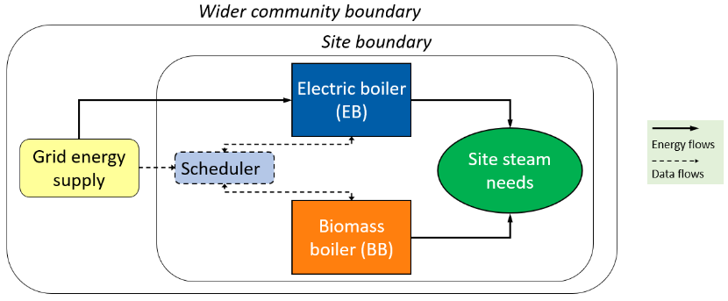
Figure 1 – Hybrid utility system diagram
A multiple steady state approach is taken, meaning that the system variables, such as duty, change instantly at each time step, thus not being a ‘true’ dynamic model. This was chosen to align with process scheduling, where set points of process variables are determined for the system to be driven towards by process control (Baader et al., 2022). The exclusion of boiler start-up also satisfies this approach. A temporal fidelity of 30-minute time steps was chosen as it is thought to be more practical, ruling out rapid changes in duty, and be more conducive to implementation in industrial practice.

Table 1 – Key boiler parameters for simulation
 | Biomass boiler (BB) | Electric boiler (EB)
Thermal efficiency (EECA, 2019) | 90% | 98%
Allowable duty operating range | 40% to 100% | 10% to 100%
Two types of system configurations were considered. The first is where the BB and EB are equivalent in size, which shall be referred to as uniform configurations. The second, termed non-uniform configurations, are where the BB is sized so that it can meet the full site demand by itself (accounting for efficiency), and the size of the EB is a free variable. The non-uniform configuration is thought to be more practical for industry, providing a greater level of certainty on energy supply given the volatility of grid supply.
This system is digitally modelled in Python, with the CoolProp package used for thermodynamics. The model is further verified using an Aspen HYSYS simulation of the system.
    - Simulation framework
A modular structure was adopted with the simulation model and the algorithm constructed as independent entities. Firstly, the unit operations and material stream conditions were defined using object-oriented programming. The look-ahead window and time period of the simulation were then specified, with values of 30 minutes and the historical data of 2022 being used for the main results of this paper. The steam demand and the system configuration specifications (i.e., unit operations, materials streams) are passed to the simulation as parameters.
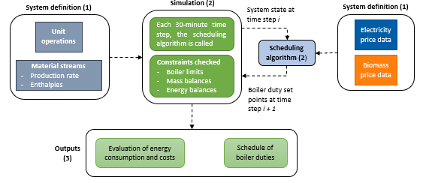
Figure 2 – Modular simulation framework with sequence indicated in brackets
The algorithm was called at every time step, to emulate application in live operation, as opposed to determining a longer-term schedule all at once. The scheduling algorithm takes into consideration the system state at the current time step, and the price data for the time step dictated by the look-ahead window. The future duties of the EB and BB for the next time step were determined by the following demand response regime specified:

${EB duty}_{t+1}={EB duty}_{t} ±α{EB duty}_{max}$ (1)

${EB duty}_{t+1}=(1-β\frac{Future electricity price}{Biomass price}+β){EB duty}_{t}$ (2)

${EB duty}_{t+1}=(\frac{Biomass price}{Future electric price})^{γ}{EB duty}_{t}$ (3)

Eq. (1) represents a regime where the duty changes by a fixed percentage of the maximum duty of the specified EB, ${EB duty}_{max}$, with an increase in duty corresponding to the electricity price being lower than the biomass price and vice versa. Eq. (2) and (3) represent regimes where the magnitude of the duty change depends on the ratio of the biomass price and electricity price. The regimes of Eq. (1) to (3) are referred to as Fixed, Varying A and Varying B. The parameters 𝛼, β and 𝛾 denote tuning factors to adjust the sensitivity of the duty changes to future price changes, with different ranges for each regime’s parameter ($0.1≤α≤0.4, 0.25≤β≤2, 0.1≤γ≤2)$. A price tolerance was also implemented, with a default value of ± $1/MWh.
The duties were passed to the simulation, where the constraints were checked before implementing the changes to the system. The evaluation criteria were then calculated, with these being returned at the end of each simulation run. The average run time for a simulation period of one year was of the order of 2 seconds on a desktop PC. Simulations were run individually for each permutation/various combinations of size and configuration of hybrid system. A baseline system of approximately 15 MW of steam demand was chosen based on a real-life dairy plant, with other systems also considered based on industrial cases.
  - Results and discussion
    - Application to design and retrofit
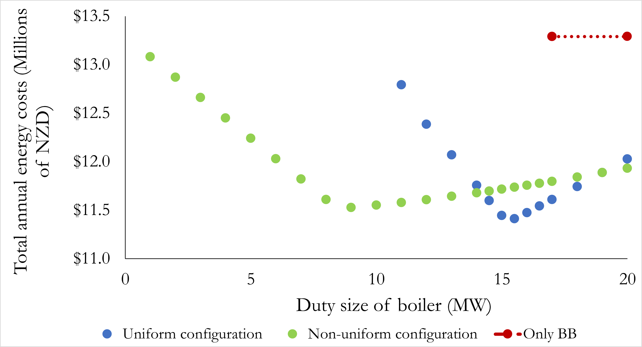
Figure 3 - Energy consumption costs of different system configurations and sizing for a 15 MW steam demand site using a ‘Fixed 𝛼 = 0.1’ demand response scheme
As shown by Figure 1, both configuration series appear convex over the range considered. The decline towards the minima is due to the increased size of the EB, allowing for greater energy flexibility and more steam produced from the EB. The subsequent increase in costs with increasing boiler size is due to the increasing minimum boiler duties, since the lower limit is a percentage of the maximum duty. The gradient is less steep for non-uniform configurations, since the BB size remains constant and thus only the increase in EB size has an effect.
The costs of a system with only a BB act as a reference, indicating the savings from the hybrid system configurations. The minimal/optimal uniform configuration achieves a greater reduction in energy consumption costs compared to that of the non-uniform configuration (14.13% and 13.27% respectively relative to the BB-only system). However, the optimal uniform configuration for the 7 MW and 40 MW sites performed worse than their non-uniform counterparts (Figure 4).
With sites that are currently retrofitting existing boilers to run on biomass, the non-uniform configuration displays the value in adding on a smaller EB. In a complete greenfield design, the non-uniform configuration should be more practical. This is because the BB can provide a secure base load, while the EB advantageously performs demand response. Implementation of energy storage could also reduce the size of the boilers, aiding with exploitation of low electricity costs.
Two other sites were selected with different demand magnitudes to the base case site: 7 MW and 40 MW. The shape of the curves was found to be roughly the same across different site demands. Energy savings were found to increase with site demand, as shown in Figure 4. The non-uniform configuration was found to perform better at the largest demand considered, with negligible differences in performance at the smallest demand.
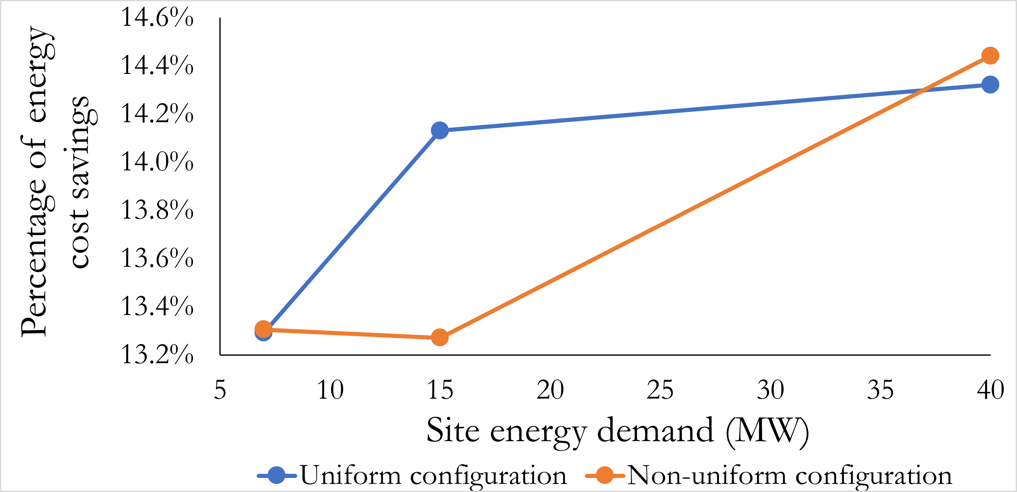
Figure 4 - The energy savings of optimal configurations, compared with an only BB system, across different site demands
    - Application to operations
Due to the points above, demand response regimes were examined with respect to non-uniform configurations only. Table 2 shows a selection of schemes considered. Overall, the best performing regime was the ‘Varying B’ regime, with performance being similar across 𝛾 values. Taking the ‘Fixed 𝛼 = 0.1’ scheme as a benchmark, the optimal configuration for the ‘Varying B’ regime reduced annual costs by approximately 0.75% ($88,500). The ‘Fixed 𝛼 = 0.3’ scheme also performed well (reducing costs by 0.71%), with greater divergence from the ‘Varying B’ schemes with larger EB sizes. The ‘Varying A' schemes were found to perform worse than the benchmark scheme. The ‘Varying B’ regime was found to perform best across all sizes, likely due to the magnitude of demand response adjusting for future price, as opposed to being constant. However, this is dependent on the accuracy of the future price value and price volatility, thus more extensive investigation should be undertaken.
With respect to tuning factors, non-linear relationships were found between their values and performance. The value of 𝛾 appeared to have a negligible effect on the performance of the ‘Varying B’ regime, as opposed to the value of 𝛼 and the ‘Fixed’ regime. This is likely due to the influence of the price ratio dwarfing the tuning factor effects and/or the simulation constraints bounding the effects of ‘Varying B’ more than the ‘Fixed’ regime. More extreme 𝛾 values should be examined to further improve the performance of ‘Varying B’ schemes.
Table 2 - Comparison of demand response regimes and tuning factor values
Demand response regime | Tuning factor value | Total annual energy costs of optimal non-uniform system configuration
Fixed | 𝛼 = 0.1 | $11,526,656
 | 𝛼 = 0.3 | $11,444.895
Varying A | β = 0.5 | $11,585,552
 | β = 1 | $11.541,162
Varying B | 𝛾 = 0.5 | $11,450,747
 | 𝛾 = 1 | $11,438,154
  - Conclusions
Hybrid utility systems show great potential for the transition towards decarbonisation, especially when engaging in demand response. A simulation-based approach is proposed to evaluate applications of these systems for design, retrofit and operations. Non-uniform system configurations were found to be more appropriate for application. Demand response schemes with magnitudes proportional to the energy cost ratio were found to perform best. The proposed approach is thought to be conducive for industry adoption, with further development into a digital twin.

Work is currently underway to examine the integration of energy storage (both electrical and thermal) and on-site renewable generation. which would increase the energy flexibility of the overall system. Techno-economic assessment, as well as environmental assessment and operability considerations should be incorporated into the methodology for a more holistic evaluation.
Acknowledgment
This research has been supported by the programme “Ahuora: Delivering sustainable industry through smart process heat decarbonisation”, an Advanced Energy Technology Platform, funded by the New Zealand Ministry of Business, Innovation and Employment.
References
Baader, F. J., Bardow, A., & Dahmen, M. (2022). Simultaneous mixed-integer dynamic scheduling of processes and their energy systems. https://doi.org/10.1002/aic.17741
Bank, L., Rösch, M., Unterberger, E., Roth, S., Rohrer, A., Köberlein, J., Braunreuther, S., & Schilp, J. (2019). Comparison of simulation-based and optimization-based energy flexible production planning. https://doi.org/10.1016/j.procir.2019.03.051
EECA. (2019). Electrode and Electric Resistance Steam Generators and Hot Water Heaters for low carbon process heating.
Howard, D. A., Ma, Z., & Jorgensen, B. N. (2021). Evaluation of Industrial Energy Flexibility Potential: A Scoping Review. https://doi.org/10.1109/ICIT46573.2021.9453652
Pierri, E., Hellkamp, D., Thiede, S., & Herrmann, C. (2021). Enhancing Energy Flexibility through the Integration of Variable Renewable Energy in the Process Industry. https://doi.org/10.1016/j.procir.2020.12.001
Salman, C. A., Li, H., Li, P., & Yan, J. (2021). Improve the flexibility provided by combined heat and power plants (CHPs) – a review of potential technologies. https://doi.org/10.1016/j.prime.2021.100023

