Dynamic Modeling and Validation of an Industrial Vacuum Thermodeasphalting Column for the Regeneration of Used Oil
Francesco Negri^{a,b}, Kristiano Prifti^{b}, Simone Caspani^{b}, Francesco Galloª, Flavio Manenti^{b,*}
ªItelyum Regeneration S.p.A., Via Tavernelle 19, Pieve Fissiraga 26854, Lodi, Italy
^{b}Politecnico di Milano, CMIC Dept. “Giulio Natta”, Piazza Leonardo da Vinci 32, Milan 20133, Italy
*flavio.manenti@polimi.it
Abstract
Dynamic process simulation is a valuable strategy to enhance the reliability of transient operations in chemical plants. Deviations from normal operating conditions may be necessary to perform corrective actions against any external disturbance that may alter the performance of some process units. Moreover, some standard plant operations are intrinsically transient in nature, such as start-up and shut-down procedures. Used oil waste re-refining industry is beginning to explore this strategy, which could lead to successful outcomes, similarly to what has been observed in the crude oil refining industry. This work proposes a modeling approach for the dynamic simulation of a thermodeasphalting column for the regeneration of used oil, currently operative in the Itelyum Regeneration re-refining facility in Pieve Fissiraga. The modeling strategy introduces a discretization of the column sections, a reasoned choice of appropriate thermodynamic methods, and the calculation of the main equilibrium and transport parameters necessary to solve mass, energy, and momentum balances on the column sections. The model is validated with experimental data, showing good agreement regarding both manipulated and controlled variables, thus becoming a valuable tool for the aprioristic evaluation of critical transient operations such as start-up, shut-down, and accidents simulation.
Keywords: AVEVA Dynamic Simulation, Dynamic modelling, Revivoil, Thermodeasphalting, Used oil.
  - Introduction
Historically, the complexity of operations in chemical plants was governed by relying on steady-state simulation tools, which are representative of normal operations. However, transient operations are also critical for the correct conduction of a chemical plant, they occur in extremely delicate timeframes during which the change from a stable, steady-state condition to a new one may lead to problematic events. Management of these transient timeframes that may occur during normal operations is a research topic that identifies dynamic process simulation suites as the main tool to assist plant personnel (Srinivasan et al., 2005). The domain of crude oil refining has shown significant advancements in dynamic simulation, including case studies regarding typical unit operations such as crude oil atmospheric distillation (Sotelo et al., 2019), and hydrogen purification through PSA systems (Agarwal et al., 2009), but also alternative applications such as fouling monitoring (Díaz-Bejarano et al., 2015) and personnel training (Vasconcelos et al., 2005). The domain of used oil waste re-refining, which has a large number of technologies already available and operating on the market (Kupareva et al., 2013), is much less developed in this sense, showing only preliminary approaches centered around the dynamic validation of controllers response (Haura et al., 2017). This paper introduces a new, important step in the domain of dynamic modeling within the used oil re-refining industry, by developing a methodology for the modeling and validation of a thermodeasphalting column, key process component of the Revivoil® process that is currently run in the Itelyum Regeneration re-refining facility (Gallo, 2016).
  - Materials and Methods
The thermodeasphalting (TDA) section of the Revivoil® process is a crucial step for the proper regeneration of used oil. The TDA section performs the separation of dehydrated used oil into semi-finished base lube oil cuts, those being spindle, light, and heavy lubricant fractions (SLF, LLF, HLF, respectively). Vacuum gasoil (VGO) and bitumen (VISCOFLEX) are also produced as byproducts (Gallo, 2016). The T-401 vacuum column of the section is a packed column that is internally divided into sectors, each one dedicated to the separation of adjacent cuts. It is possible to identify five different sections, each one having a liquid collection device at the bottom. Each section has one or multiple beds composed of several types of structured packing, being of different type and height. The authors of this work propose a modeling approach for the dynamic simulation of the T-401 column that describes it as a discrete ensemble of five distinct sections, each one interconnected with the two adjacent ones and representing the real sections into which the column is divided. The software chosen for the dynamic modeling is AVEVA Dynamic Simulation (AVEVA, 2023). The modeling strategy can be implemented in the software by building each section as a discrete entity having three components: a sump to represent the liquid collection system, pack equilibrium stages to model structured packing, and vertical tubes to represent the empty space above each section in which vapor and liquid flow towards adjacent sections. The conceptual representation of this modeling approach is shown in Figure 1 with simplified diagrams.
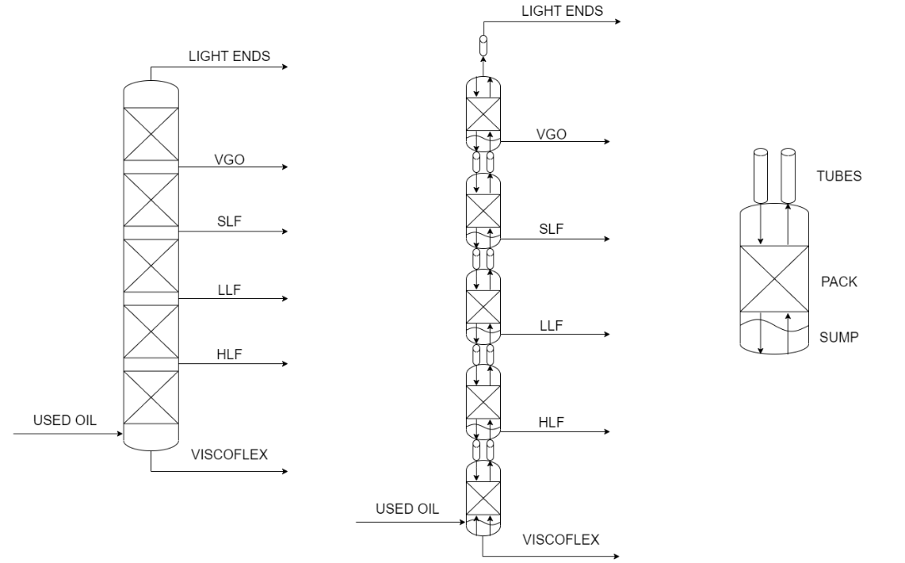
Figure 1. Simplified schemes for T-401 column (left), discrete modeling approach (middle), and detail of the fundamental simulation block (right)
Input data required for the dynamic simulation of T-401 include two different types, the first being thermodynamic data and the second one being design and operative data of the equipment to be simulated. Some data require preliminary information about the column to be available, such as temperature and pressure profiles. While some of these data can be retrieved directly from field instrumentation, this is not true for all the required entries. To overcome this limitation, the authors have considered an already functioning steady-state simulation developed in Aspen HYSYS® software (AspenTech, 2023) as the source of the missing data, since this simulation is currently used in the plant with good agreement with experimental data. Thermodynamic data include ASTM D1160 curves considered at the atmospheric equivalent temperature (AET), available as sets of experimental laboratory data, which are converted by the simulation software into 31 pseudo-components to simulate correctly the real mixtures. The Peng-Robinson cubic equation of state is used to describe almost all of the properties of the mixtures (Peng and Robinson, 1976). Some exception with their alternative methods are liquid density, calculated using Rackett method, molecular weight, critical pressure, critical temperature, and acentric factor, all calculated using both the standard and the extended Twu method, and liquid viscosity, calculated using the Bergmann-Sutton method. AVEVA Dynamic Simulation also requires data to solve mass, energy, and momentum balances for each discrete section in which the column is divided. Mass balances can be solved by assigning a certain number of ideal equilibrium stages to each packed section, also referred to as Equivalent Theoretical Plates (ETP), values that can be obtained from the Aspen HYSYS® simulation. Energy balances can be solved by calculating both the external (h_{e}) and the internal (h_{i}) liminal heat transfer coefficients. The h_{e} parameter is calculated by considering natural convection from the metal surface to the environment according to Eq. (1), where k_{air} is the thermal conductivity of air, H is the height of the packed section, Ra is the Rayleigh number (Bird et al., 2007).
$${\text{h}}_{\text{e}} \text{=} \text{0.13∙}\frac{{\text{k}}_{\text{air}}}{\text{H}}\text{∙}{\text{Ra}}^{\frac{\text{1}}{\text{3}}}$$ | (1)
The h_{i} parameter is calculated using Carpenter-Colburn’s expression, which describes a forced vapor flowrate in counter current with a descending liquid film, according to Eq. (2), where all the parameters are referred to the vapor, G is the mass velocity, f is the friction coefficient, C_{p} is the specific heat, k is the thermal conductivity, μ is the dynamic viscosity, and v is the superficial velocity (Green and Southard, 2019).
$${\text{h}}_{\text{i}}\text{ = 0.065 ∙G∙ }\sqrt{\text{f∙}\frac{{\text{C}}_{\text{p}}\text{∙k}}{\text{2∙}\text{μ}\text{∙v}}}$$ | (2)
Momentum balances can be solved by calculating pack flow rate conductance (K), which describes how easily the vapor can flow through a certain packed section, according to Eq. (3), where all the physical parameters refer to the vapor and the geometrical ones refer to the packed sections, v is the superficial velocity, f is the friction coefficient, ε is the void fraction, ρ is the density, H is the height, ΔP is the pressure drop, and D_{eq} is the characteristic dimension.
$$\text{K = v∙ }\sqrt{\frac{\text{3}}{\text{4}}\text{∙}\frac{\text{f∙}\frac{\text{1-ε}}{{\text{ε}}^{\text{4.65}}}\text{∙ρ∙H}}{\text{1000∙ΔP⸱}{\text{D}}_{\text{eq}}}}$$ | (3)
The parameters introduced previously allow to solve the balances on the column, thus solving the main body of the T-401. Ancillary units such as pumps, heat exchangers, pipes, and valves are modeled by selecting the appropriate type among the list available in the simulation software, and introducing design and operations data from P&IDs. Controller parameters are directly taken from the control room DCS. Numerical values calculated for the main parameters of the T-401 column balances are reported in Table 1, where each section is named after the product exiting from the corresponding bottom sump.
Table 1. Main parameters for mass, energy, and momentum balances for T-401
Packed section | ETP  [n.] | h_{e}  [W/m²/K] | h_{i}  [W/m²/K] | K  [-]
VISCOFLEX | 3.00 | 9.2 | 19.9 | 0.2632
HLF | 1.00 | 9.1 | 24.1 | 0.8532
LLF | 3.78 | 8.7 | 28.7 | 1.8844
SLF | 6.12 | 7.4 | 23.9 | 2.3815
VGO | 4.00 | 4.6 | 14.8 | 3.1358
  - Results and Discussion
The detailed view of the LLF section is shown in Figure 2 as a case study. It is possible to notice the discrete modeling approach as introduced previously, with the combination of sump, packed section, and tubes. The LLF pack includes controllers, recirculation pump, and a split between the LLF product sent to storage and the LLF reflux that is used in the adjacent HLF section below. It is also possible to notice the SLF flowrates exiting from the corresponding section above, which is similarly divided into product to be stored, and a reflux to be fed to the LLF section. This kind of topology is common among vacuum-based, used oil re-refining technologies (Kupareva et al., 2013).
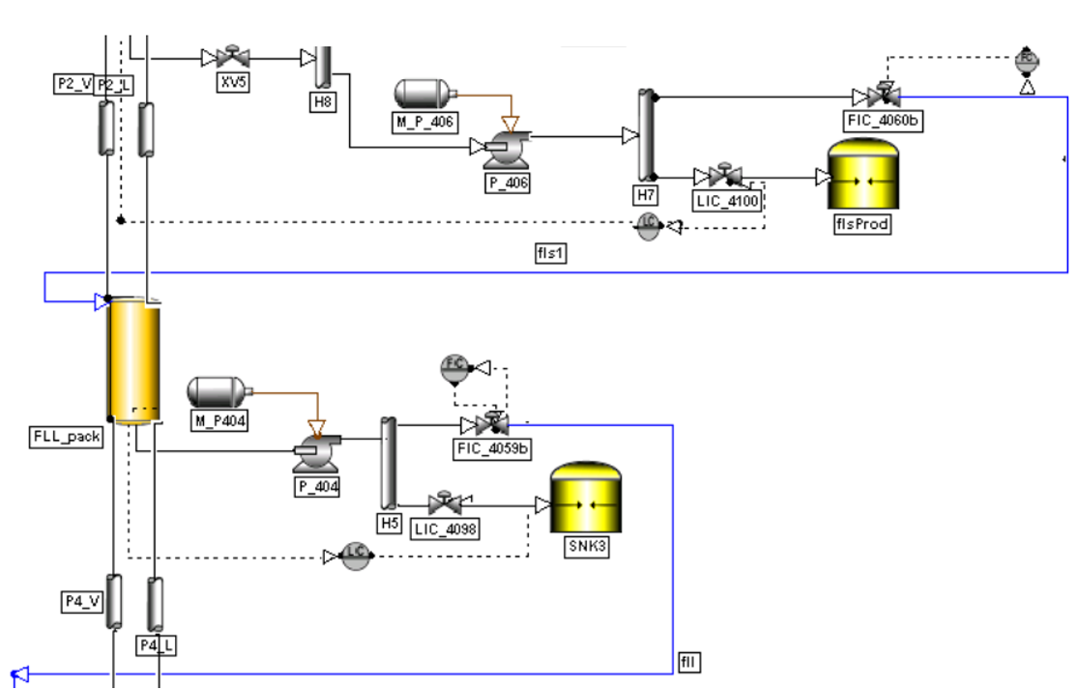
Figure 2. Detail of the LLF section including SLF reflux from the adjacent top section
It is possible to analyze the performance of simulated sections by considering a transient operation that was executed by plant operators, in which the feedstock to the TDA column was increased by 20%. The chosen indicator will be the normalized deviation of appropriate variables from their initial value (δ), defined as in Eq. (4), where x(t) and x⁰ are the variables as a function of time and the corresponding initial value, respectively.
$$\text{δ(t) = }\frac{\text{x}\left(\text{t}\right)\text{-}{\text{x}}^{\text{0}}}{{\text{x}}^{\text{0}}}$$ | (4)
The first parameter to be analyzed is the responsiveness of the simulated control loops, which refers to manipulated variables that are determined by the user in the simulation. The SLF reflux to the LLF pack is shown in Figure 3 for this purpose. There is good agreement between simulation and experimental values.
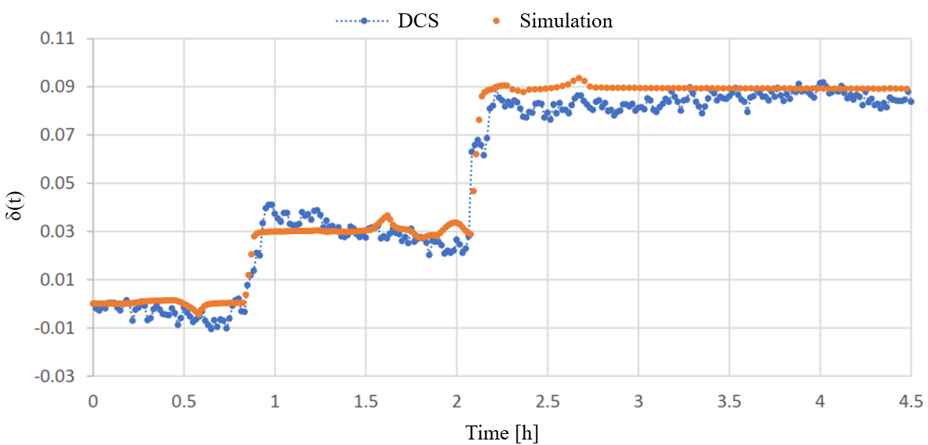
Figure 3. Comparison between DCS and simulation for SLF flowrate, manipulated variable
The second parameter to be analyzed is the dynamic evolution in time of the controlled variables, that are not determined by the user and that are automatically calculated by the software. The LLF liquid sump temperature is shown in Figure 4 for this purpose. There is good agreement between simulation and experimental values. Results similar to what is shown in Figures 3 and 4 are obtained for all the simulated column sections.
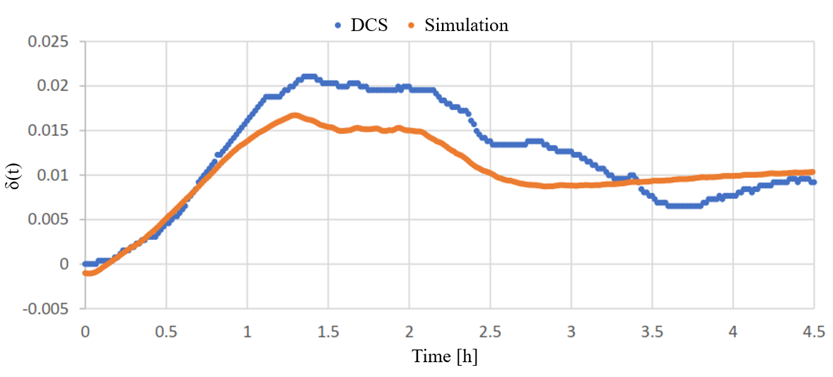
Figure 4. Comparison between DCS and simulation for LLF sump temperature, controlled variable
  - Conclusions
This work introduced a methodology to build a dynamic process simulation for the thermodeasphalting T-401 column currently operating in the Itelyum Regeneration re-refining facility located in Pieve Fissiraga, Lodi, Italy. A discrete, equation-based modelling approach was followed, introducing appropriate thermodynamic methods and showing the main results for equilibrium and transport parameters. Validation of the model has been carried out by comparing the output from the simulation with real plant data from the DCS. Good agreement between simulated time-dependent profiles and real DCS data is shown both for manipulated and controlled variables. The case of the LLF pack is shown here as a meaningful example, in which the evolution in time of the SLF reflux and the LLF sump temperature are shown. The dynamic simulation is a reliable tool that can be used for the aprioristic study and evaluation of transient operations such as start-up, shut-down, or even the simulation of accidents caused by equipment failure.
References
A. Agarwal, L.T. Biegler, S.E. Zitney, 2009. Simulation and optimization of pressure swing adsorption systems using reduced-order modeling. Industrial and Engineering Chemistry Research 48, 2327–2343.
AspenTech, 2023. Aspen HYSYS | Process Simulation Software | AspenTech. https://www.aspentech.com/en/products/engineering/aspen-hysys.
AVEVA, 2023. DYNSIM Dynamic Simulation - Setting New Standards for Rigor, Robustness, and Ease of Use. https://www.aveva.com/en/products/dynamic-simulation/
R.B. Bird, W.E. Stewart, E.N. Lightfoot, 2007. Transport Phenomena, 2nd ed. Wiley, New York.
E. Díaz-Bejarano, F. Coletti, S. Macchietto, 2015. Detection of changes in fouling behavior by simultaneous monitoring of thermal and hydraulic performance of refinery heat exchangers. Computer Aided Chemical Engineering 37, 1649–1654.
F. Gallo, 2016. Procedimento di rigenerazione di olii usati. ITUB20151298A1.
D.W. Green, M.Z. Southard (Eds.), 2019. Perry’s Chemical Engineers’ Handbook, 9th Edition. ed. McGraw-Hill Education, New York.
A.L. Haura, K.Q. Ma’mun, J.P. Sutikno, R. Handogo, 2017. Re-refinery used oil vacuum distillation column control by using internal model control. Chemical Engineering Transactions 56, 1471–1476.
A. Kupareva, P. Mäki-Arvela, D.Y. Murzin, 2013. Technology for rerefining used lube oils applied in Europe: A review. Journal of Chemical Technology and Biotechnology 88, 1780–1793.
D.-Y. Peng, D.B. Robinson, 1976. A New Two-Constant Equation of State. Industrial and Engineering Chemistry Fundamentals 15, 59–64.
D. Sotelo, A. Favela-Contreras, C. Lozoya, F. Beltran-Carbajal, G. Dieck-Assad, C. Sotelo, 2019. Dynamic simulation of a crude oil distillation plant using Aspen-Hysys®. International Journal of Simulation Modelling 18, 229–241.
R. Srinivasan, P. Viswanathan, H. Vedam, A. Nochur, 2005. A framework for managing transitions in chemical plants. Computers and Chemical Engineering 29, 305–322.
C.J.G. Vasconcelos, R.M. Filho, R. Spandri, M.R. Wolf-Maciel, 2005. Dynamic models towards operator and engineer training: Virtual environment. Computer Aided Chemical Engineering 20, 565–570.

