Dynamic Modelling and Surrogate-based Optimization of Auto-thermal Reforming for Enhanced Hydrogen Production
Hao Chen,^{a *} Konstantinos Kyprianidisª
ªSchool of Business, Society and Engineering, Mälardalen University, SE 72123 Västerås, Sweden
Hao.Chen@mdu.se
Abstract
Hydrogen energy has been considered as one of the solutions to achieve the net-zero emission scenario by 2050. Steam methane reforming is a widely used industrial process for producing hydrogen from natural gas or methane nowadays. Considering that methane could be utilized as a suitable carrier for hydrogen energy, it is anticipated that steam methane reforming will still play an important role in the future energy sector when it comes to hydrogen production, storage, and transportation. In this work, a one-dimensional dynamic model is established to simulate the performance of an auto-thermal reforming reactor, which allows for capturing the localized phenomena inside the reactor over time. A set of input parameters is selected based on the Latin Hypercube Sampling method to generate the training data for the surrogate model development. Singular value decomposition and Gaussian Process regression are then implemented on the training data to construct a surrogate model of the reformer. This surrogate model is subsequently utilized in the optimization process to enhance hydrogen production and lower the maximum catalyst temperature within the reactor. The results show that the surrogate model, developed by using singular value decomposition and Gaussian Process, exhibits a high level of accuracy when compared to the physics-based reformer model. Furthermore, the optimization framework built upon surrogate modelling offers the potential to substantially reduce the computational expenses associated with the optimization process, while preserving the precision of the optimization results. This method could efficiently serve as a tool for parameters optimization of such reactors and could be used to guide the operation of these systems toward improved performance.
Keywords: auto-thermal reforming, dynamic modelling, multi-objective optimization, surrogate modelling.
  - Introduction
Hydrogen finds extensive utilization in many critical industrial processes, including but not limited to petroleum refining, the production of methanol, and the synthesis of ammonia (Kojima and Tahara, 2001). Hydrogen is also a clean energy carrier and has great potential to help decarbonize a range of hard-to-abate sectors, including long-haul transport, chemicals, and iron and steel (Noussan et al., 2020). Today, hydrogen production is still dominated by natural gas reforming (Younas et al, 2022). Given the increasing attention on the Power-to-Methane concept (Blanco et al, 2018), it is envisaged that methane reforming will persist in maintaining an important role in the processes of hydrogen production and utilization.
Autothermal reforming (ATR) combines the steam reforming reaction and partial oxidation reaction into a single unit (Lamb et al, 2020). In this process, the exothermic partial oxidation of methane generates the necessary heat to support the endothermic methane reforming reactions (Brett et al, 2012). Optimization and simulation are widely adopted approaches to obtain insights into the complicated heat and mass transfer process coupled with chemical reactions inside the reactor (Wang et al., 2021). Simulation conducted within at least a one-dimensional (1D) domain is imperative for capturing localized phenomena within the reactor. This necessity, particularly when integrated with optimization algorithms demanding iterative processes, increases the computational cost and makes it unfavorable for implementation.
In this work, a dynamic 1D model of an auto-thermal reforming reactor is established by solving the governing heat and mass transfer equations, coupled with chemical reactions within the ATR process. A surrogate model built on singular value decomposition (SVD) and Gaussian Process (GP), by using the training data obtained from different operating parameters, is developed to reduce the computational cost of simulation with the capability to capture the localized phenomena inside the reactor. Subsequently, a multi-objective Genetic Algorithm is applied to the surrogate model for the purpose of optimizing the autothermal reforming process. The proposed approach holds promise for efficient and effective exploration of optimal operating parameters of the ATR process with enhanced computational efficiency.
  - Dynamic modelling of ATR reactor
A one-dimensional dynamic ATR reactor model accounting for mass transfer in solid and gas phases, and heat transfer across the entire reactor is constructed. Only those dominating reactions in the overall ATR process are considered in this work. The main chemical reactions used in the simulation are shown below:
$R1: {CH}_{4}+2O_{2}↔{CO}_{2}+2H_{2}O, ∆H_{298K} = -802.7 kJ/mol$ | (1)
$R2: CO+H_{2}O↔ {CO}_{2}+H_{2}, ∆H_{298K} = -41.1 kJ/mol$ | (2)
$R3: {CH}_{4}+H_{2}O↔ CO+3H_{2}, ∆H_{298K} = +206.2 kJ/mol$ | (3)
$R4: {CH}_{4}+2H_{2}O↔ {CO}_{2}+4H_{2}, ∆H_{298K} = +164.9 kJ/mol$ | (4)
The rate equations for total oxidation reaction (R1), water-gas shift reaction (R2), and steam methane reforming reactions (R3, R4) based on Langmuire Hinshelwood methodology are given below, according to Xu and Froment (1989).
$$R_{1}=\frac{k_{1a}p_{CH_{4}}p_{O_{2}}}{{\left(1+K_{CH_{4}}^{C}p_{CH_{4}}+K_{O_{2}}^{C}p_{O_{2}}\right)}^{2}}+\frac{k_{1b}p_{CH_{4}}p_{O_{2}}^{0.5}}{1+K_{CH_{4}}^{C}p_{CH_{4}}+K_{O_{2}}^{C}p_{O_{2}}}$$ | (5)
$$R_{2}=\frac{k_{2}}{p_{H_{2}}}\left(p_{\text{CO}}p_{H_{2}O}-\frac{p_{H_{2}}p_{\text{C}{\text{O}}_{2}}}{K_{\text{I}}}\right)×\frac{1}{Ω^{2}}$$ | (6)
$$R_{3}=\frac{k_{3}}{p_{H_{2}}^{2.5}}\left(p_{\text{C}{\text{H}}_{4}}p_{H_{2}O}-\frac{p_{H_{2}}^{3}p_{\text{CO}}}{K_{II}}\right)×\frac{1}{Ω^{2}}$$ | (7)
$$R_{4}=\frac{k_{4}}{p_{H_{2}}^{3.5}}\left(p_{\text{C}{\text{H}}_{4}}p_{H_{2}O}^{2}-\frac{p_{H_{2}}^{4}p_{\text{C}{\text{O}}_{2}}}{K_{III}}\right)×\frac{1}{Ω^{2}}$$ | (8)
$$Ω=1+K_{\text{CO}}p_{\text{CO}}+K_{H_{2}}p_{H_{2}}+K_{\text{C}{\text{H}}_{4}}p_{\text{C}{\text{H}}_{4}}+K_{H_{2}O}\frac{p_{H_{2}O}}{p_{H_{2}}}$$ | (9)
Where R is the reaction rate; P is the partial pressure of gas specie; k denotes the Arrhenius kinetic parameters; $K_{I},$ $K_{\text{II}}$, $K_{\text{III}}$ are the reaction equilibrium constants; $K_{\text{CO}}$, $K_{H_{2}}$, $K_{\text{C}{\text{H}}_{4}}$, $K_{H_{2}O}$, $K_{O_{2}}^{C}$, $K_{CH_{4}}^{C}$are the Van’t Hoff parameters for species adsorption. More details about these parameters are available in Halabi et al. (2008). According to energy and mass balance, the governing equations in the ATR reactor can be summarized as follows:
In the gas phase:
$$ε_{b}\frac{∂C_{i}}{∂t}+\frac{∂\left(uC_{i}\right)}{∂X}+k_{g,i}a_{v}\left(C_{i}-C_{i,s}\right)= ε_{b}D_{X}\frac{∂^{2}C_{i}}{∂X^{2}}$$ | (10)
$$ε_{b}ρ_{g}C_{p,g}\frac{∂T}{∂t}+uρ_{g}C_{p,g}\frac{∂T}{∂X}=h_{f}a_{v}\left(T_{s}-T\right)+λ_{X}^{f}\frac{∂^{2}T}{∂X^{2}}$$ | (11)
In the solid phase:
$$k_{g,i}a_{v}\left(C_{i}-C_{i,s}\right)+\frac{∂C_{i,s}}{∂t}=(1-ε_{b})ρ_{cat}r_{i}$$ | (12)
$ρ_{cat}C_{p,cat}\frac{∂T_{s}}{∂t}+h_{f}a_{v}\left(T_{s}-T\right)=\left(1-ε_{b}\right)ρ_{cat}\sum{\left(ΔH_{rxn,j}n_{j}R_{j}\right)}$ | (13)
Where $u$ is the average gas viscosity; $C_{i}$ denotes the concentration of gas species in the mainstream; $C_{i,s}$ is the concentration of gas component i in the catalyst; $ε_{b}$ is the bed porosity; $ρ_{cat}$ and $ρ_{g}$ are the density of catalyst and gas mixture respectively; $C_{p,g}$ and $C_{p,cat}$ are the heat capacity of gas mixture and catalyst; $a_{v}$ is the external surface area per unit volume of catalyst bed; $k_{g,i}$ is the gas to solid mass transfer coefficient of component i; $D_{X}$ is the axial dispersion coefficient; $λ_{X}^{f}$ is the effective thermal conductivity; $r_{i}$ is the rate of formation or consumption of species i; $h_{f}$ is the gas to solid heat transfer coefficient; the $ΔH_{rxn,j}$ is the reaction heat of reaction j; $n_{j}$ denotes the effectiveness factor of reaction j; $R_{j}$ denotes the rate of reaction j. More details about the parameters used in the governing equations, and the geometric parameter of the ATR reactor can be found in De Smet et al. (2001).
Based on the governing equations established above, finite volume method is employed to discretize these partial differential equations and solve them in Matlab/Simulink environment. The entire domain along the reactor length is divided into 200 intervals to obtain the independent results of discretization.
  - Surrogate-based modelling and optimization
In this work, the training data matrix, M, for surrogate model development is obtained from the results (catalyst temperature distribution and H₂ composition distribution) of the physics-based ATR model under a range of inlet parameters. The inlet parameters investigated in this study are shown in table 1.

Table 1 selected inlet parameters for the ATR model
Inlet parameters | Range (which are also the boundary constraints for optimization)
Steam to carbon ratio | 2.0 - 6.0
Oxygen to carbon ratio | 0.1 - 1.0
Inlet gas temperature | 673 - 973 K
Inlet gas mass flowrate | 0.1 - 0.55 kg/(m²s)
To effectively explore the parameter space, Latin hypercube sampling is employed to obtain training data from a range of inlet parameters (Chen et al., 2017). After obtaining the data from the physics-based ATR model, the training data matrix is decomposed to find the principal components (PCs) by using singular value decomposition (SVD), which is illustrated by equation (14).
$$M=UΣV^{T}$$ | (14)
Here, U and V are left- and right-singular vectors of matrix M, and $Σ$= diag (s₁, s₂, ..., s_{n}) indicates singular values of the data matrix. Then, the i^{th} row of $V^{T}$ could be considered as the i^{th} principal components of the training data matrix with a principal score as s_{i}. The training data can be represented as the linear combination of all the principal components.
After identifying the PCs, Gaussian Process (GP) prediction, also known as Kriging prediction, is used to predict the PC scores based on different inlet parameters. More details about the Gaussian Process prediction can be found in our previous work (Chen et al., 2022). The surrogate ATR reactor model is then constructed by using SVD to identify the PCs and by using GP prediction to predict the PC scores.
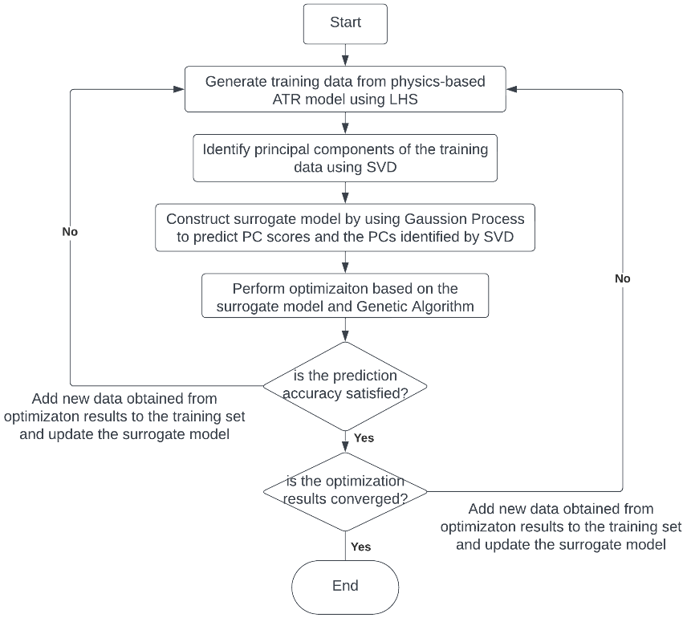
Figure 1 Process diagram of the surrogate-based optimization
Once the surrogate model is established, Multi-objective Genetic Algorithms will be applied to optimize the performance of the ATR reactor. In this work, maximum catalyst temperature and outlet H₂ composition are considered as the two objective functions for the optimization (Maximize H₂ composition, minimize catalyst temperature). It is worth noting that after each optimization, the obtained optimal results will be compared with the results from the physics-based model. The new data generated from the physics-based model will be added to the training data to update the surrogate model until results converge. The entire process diagram of the surrogate-based optimization is illustrated in Figure 1.
  - Results and discussion
The initial training data size was set at 320 in this work. LHS was then performed on the parameter space to select inlet parameters for the physics-based ATR model to obtain training data. By using SVD to decompose the training data matrix, the principal components of the catalyst temperature distribution profile and H₂ composition distribution profile are identified. Figure 2 shows the 2 most important PCs of the catalyst temperature distribution profile, which captures 98% of the variation in the training data.
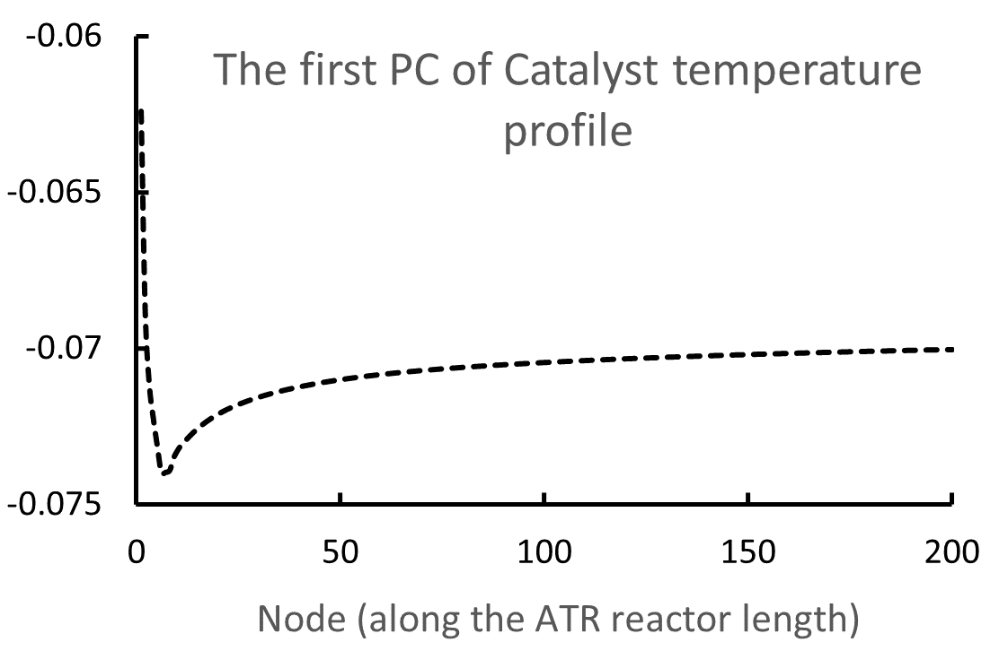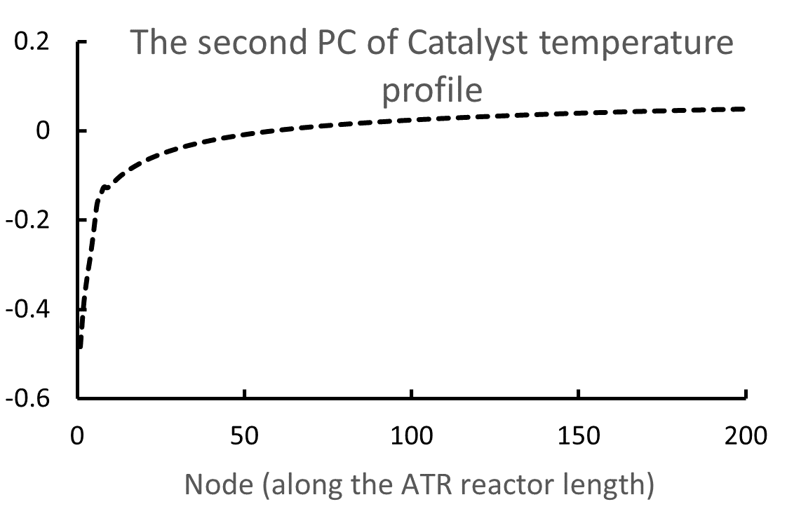
Figure 2 The first 2 principal components of the catalyst temperature profile
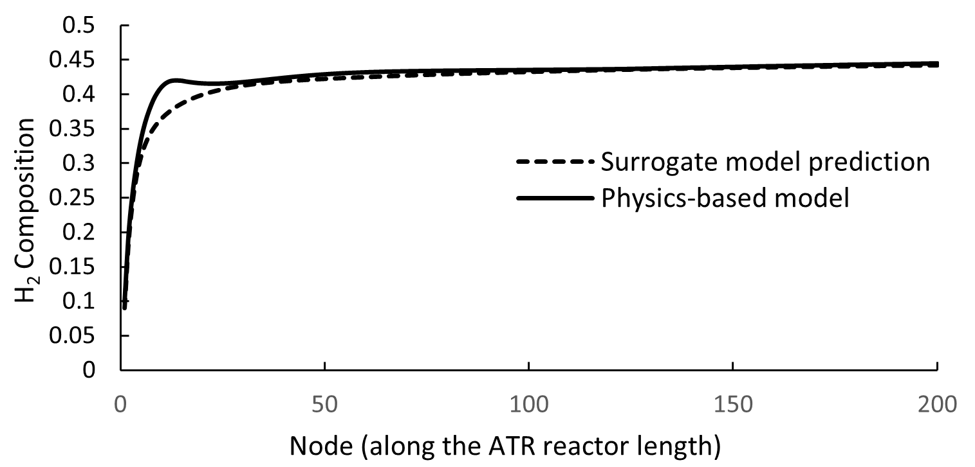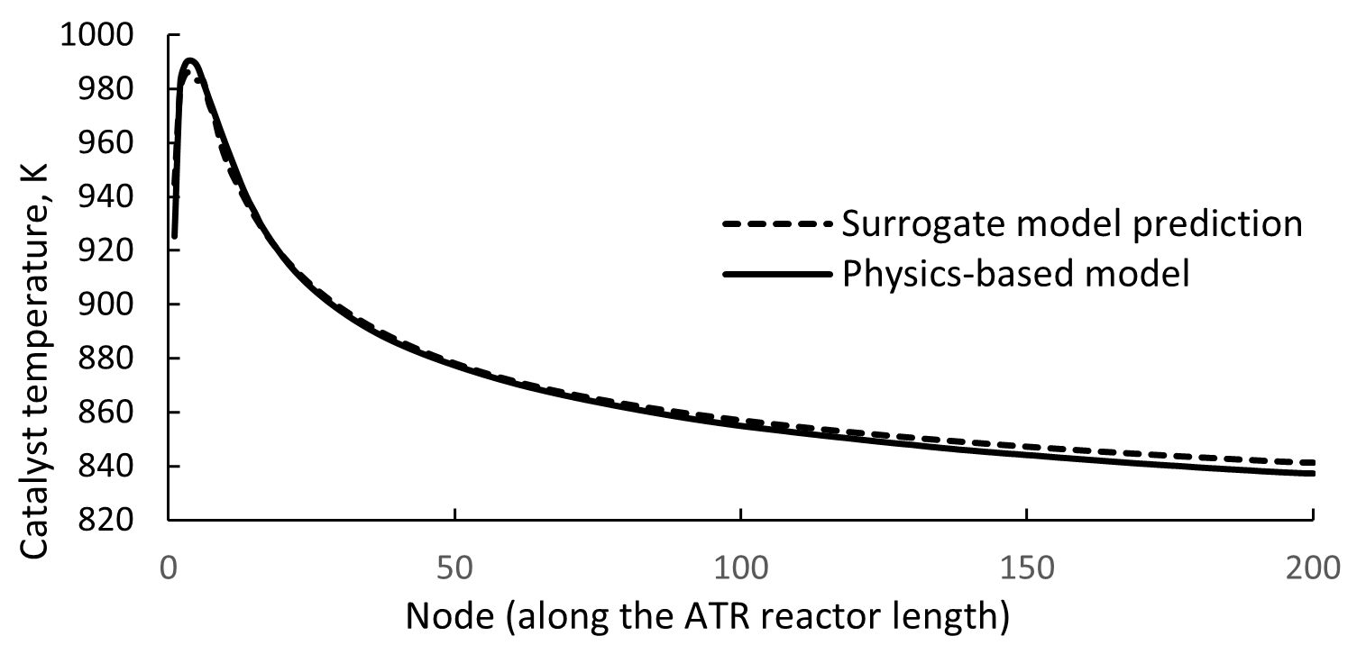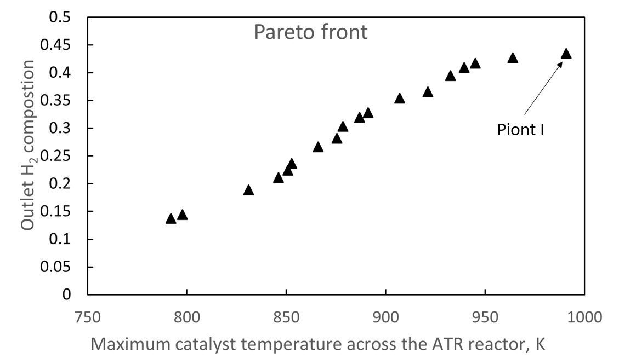

Figure 3 Pareto front obtained from surrogate-based optimization and the comparison of results predicted by the surrogate model and the physics-based model for Point I in the Pareto front.
Figure 3 shows the Pareto front obtained from the surrogate-based optimization. It is noted from the Pareto front that, to increase the H₂ composition at the reactor outlet, the cost would be the increase of the catalyst temperature, which might lead to higher degradation of the catalyst. As shown in the right of Figure 3, the surrogate model shows good accuracy in predicting the H₂ composition distribution profile and catalyst temperature distribution profile across the ATR reactor.
  - Conclusions
A surrogate-based modelling and optimization framework is proposed in this work to improve the performance of an ATR reactor. The surrogate model built on SVD and GP could considerably reduce the computation cost of optimization without losing the capability to capture the localized phenomena across the reactor. Combined with the Multi-objective Genetic Algorithm, this approach could serve as a tool for parameters optimization of such reactors and could be used to guide the operation of these systems toward improved performance.
Acknowledgment
This work was carried out in the IFAISTOS project (Intelligent electroFuel production for An Integrated STOrage System), which is funded under the framework of the joint programming initiative ERA-Net Smart Energy Systems.
References
T. Kojima, K. Tahara, 2001. Refinement and transportation of petroleum with hydrogen from renewable energy. Energy conversion and management, 42(15-17), pp.1839-1851.
M. Noussan, P.P. Raimondi, R. Scita, and M. Hafner, 2020. The role of green and blue hydrogen in the energy transition—A technological and geopolitical perspective. Sustainability, 13(1), p.298.
M. Younas, S. Shafique, A. Hafeez, F. Javed, and F. Rehman, 2022. An overview of hydrogen production: current status, potential, and challenges. Fuel, 316, p.123317.
H. Blanco, W. Nijs, J. Ruf, and A. Faaij, 2018. Potential of Power-to-Methane in the EU energy transition to a low carbon system using cost optimization. Applied energy, 232, pp.323-340.
J.J. Lamb, M. Hillestad, E. Rytter, R. Bock, A.S. Nordgård, K.M. Lien, O.S. Burheim, and B.G. Pollet, 2020. Traditional routes for hydrogen production and carbon conversion. In Hydrogen, biomass and bioenergy (pp. 21-53). Academic Press.
D.J.L. Brett, E. Agante, N.P. Brandon, E. Brightman, R.J.C. Brown, M. Manage, and I. Staffell, 2012. The role of the fuel in the operation, performance, and degradation of fuel cells. In Functional materials for sustainable energy applications (pp. 249-278). Woodhead Publishing.
J. Wang, S. Wei, Q. Wang, and B. Sundén, 2021. Transient numerical modeling and model predictive control of an industrial-scale steam methane reforming reactor. international journal of hydrogen energy, 46(29), pp.15241-15256.
J. Xu, and G.F. Froment, 1989. Methane steam reforming, methanation, and water‐gas shift: I. Intrinsic kinetics. AIChE journal, 35(1), pp.88-96.
M.H. Halabi, M.H.J.M. De Croon, J. Van der Schaaf, P.D Cobden, and J.C. Schouten, 2008. Modeling and analysis of autothermal reforming of methane to hydrogen in a fixed bed reformer. Chemical Engineering Journal, 137(3), pp.568-578.
C. R. H. De Smet, M. H. J. M. De Croon, R. J. Berger, G. B. Marin, and J. C. Schouten. "Design of adiabatic fixed-bed reactors for the partial oxidation of methane to synthesis gas. Application to production of methanol and hydrogen-for-fuel-cells." Chemical Engineering Science 56, no. 16 (2001): 4849-4861.
H. Chen, C.Yang, K. Deng, N. Zhou, and H. Wu, 2017. Multi-objective optimization of the hybrid wind/solar/fuel cell distributed generation system using Hammersley Sequence Sampling. International Journal of Hydrogen Energy, 42(12), pp.7836-7846.
H. Chen, Y. Zhou, Q. Li, Z. Liu, F. Qi, C. Ma, B. Zhao, and Y. Huang, 2022. Multi‐objective optimization design of U3Si2–FeCrAl accident tolerant fuel elements based on Gaussian process and genetic algorithm. International Journal of Energy Research, 46(9), pp.12108-12121.

