Multi-objective optimisation of an integrated cultivation-aggregation model for mAb production
Wil Jones, Dimitrios I. Gerogiorgis*
Institute for Materials and Processes (IMP), School of Engineering, University of Edinburgh, EH9 3FB, UK
*D.Gerogiorgis@ed.ac.uk
Abstract
The proteinaceous structure of mAbs imply susceptibility to irreversible aggregation, shown to seriously impact drug efficacy and patient safety (van der Kant et al., 2017). Dynamic simulation and optimisation are widely employed in order to drive and visualise the effect of manipulating cell culture inputs (temperature, pH, media composition) on bioreactor performance for mAbs (Jones & Gerogiorgis, 2022) and many other biologics. This study presents an integrated dynamic model accounting for both mAb cultivation and aggregation phenomena, combining a temperature-dependent Chinese Hamster Ovary (CHO) cell cultivation model (Kumar et al., 2022) and a Smoluchowski Population Balance Model (PBM) describing aggregation behaviour in detail (Bansal et al., 2020). The integrated model is first employed for dynamic simulation and visualisation of the temperature manipulation and feeding control strategies, leading to a series of plots which demonstrate the clear trade-off between the two conflicting objectives, namely mAb throughput maximisation and aggregation minimisation. A series of multi-objective optimisations are conducted in order to obtain bioreactor operating strategies which can simultaneously maximise mAb mass and minimise the degree of irreversible aggregation.
Keywords: Multi-objective optimisation; CHO cultivation; Protein aggregation; mAbs.
  - Introduction
Monoclonal antibodies (mAbs) are genetically engineered proteins acting as therapeutics against numerous ailments (Haidar and Mellors, 2021): their high demand accounts for USD 217 billion of the biopharmaceutical market, as mAb therapies are now approved for treating Alzheimer’s disease and certain cancer types (Sirasitthichoke et al., 2023). Nevertheless, mAbs have an inherent tendency to aggregate into clusters which have no therapeutic value, seriously hindering drug efficacy and possibly affecting patient safety. Current good manufacturing practice (cGMP) aims to overcome production challenges by Design of Experiments (DOE), to achieve operating strategies reducing aggregation without compromising plant throughput (Bollin et al., 2011; Millán-Martín et al., 2023).
Dynamic evolution of mAb aggregation can be studied via Population Balance Models, relying on well-calibrated aggregation sensing and parameterisation over a wide design space, to thus quantify how operation affects irreversible clustering (Bansal et al., 2020). This study presents an integrated mAb cultivation-aggregation model based on literature precedents, analysing how temperature and culture feed manipulation affect aggregation. An initial dynamic simulation analysis for an array of operating strategies is followed by multi-objective optimisation cases (with variable weights) to trace the Pareto front (mAb mass maximisation vs. aggregate minimisation) and identify superior operating strategies.
  - Integrated Dynamic Model for mAb Cultivation-Aggregation
    - Differential-Algebraic Equation (DAE) System
A complete overview of the integrated system of equations is given below in Eqs. (1-21). The temperature-dependent Chinese Hamster Ovary (CHO) cultivation model is the basis for mAb production simulation in batch and fed-batch bioreactors (Kumar et al., 2022). Our assumption here is that all mAbs secreted from the culture are monomer molecules, and aggregation of monomers, dimers and higher can only occur after the mAb secretion. Aggregation has been assumed to take place as a result of Brownian motion, shown to be an accurate representation of small molecule cluster interactions (Bansal et al., 2020).
The published Population Balance Modelling (PBM) framework of Bansal et al. (2020) assumes reversible aggregation occurs for monomer-monomer and monomer-oligomer interactions, whilst irreversible aggregation occurs for oligomer-oligomer interactions. Pentamer data are for tetramers, due to the absence of the latter in Bansal et al. (2020). This assumption is valid for analysing small oligomer interactions (Brummitt et al., 2011) and model parameter values have been estimated again via MATLAB (fminsearchbnd).

$$\frac{k_{a}}{W}\left(T\right)=\frac{k_{a}}{W}∙\frac{T}{298}$$ | (1) | $$f_{lim}=\frac{GLC}{GLC+(K_{GLC}{∙X}_{V})}$$ | (6)
$$λ=1-\left(\frac{1}{D_{f}}\right)$$ | (2) | $$f_{inh}=\frac{{KI}_{LAC}}{LAC+{KI}_{LAC}}∙(1-{KI}_{mAb}∙N_{1}^{*})$$ | (7)
$$P_{i,j}={\left(ij\right)}^{λ}$$ | (3) | $$μ=μ_{max}∙f_{lim}{∙f}_{inh}$$ | (8)
$$B_{i,j}=\frac{\left(i^{1/D_{f}}+j^{1/D_{f}}\right)\left(\frac{1}{i^{1/D_{f}}}+\frac{1}{j^{1/D_{f}}}\right)}{4}$$ | (4) | $$μ_{d}=μ_{d,max}$$ | (9)
$$k_{i,j}=\frac{k_{a}}{W}\left(T\right)∙P_{i,j}{∙B}_{i,j}$$ | (5) | $$q_{GLC}=-\frac{μ}{Y_{\frac{X}{GLC}}}-m_{GLC}$$ | (10)
$$q_{LAC}=\left(\frac{μ}{Y_{\frac{X}{LAC}}}+(Y_{\frac{LAC}{GLC}}∙q_{GLC})\right)∙\left(\frac{{LAC}_{max1}-LAC}{{LAC}_{max1}}\right)+m_{LAC}∙\left(\frac{{LAC}_{max2}-LAC}{{LAC}_{max2}}\right)$$ |  |  | (11)
$$q_{mAb}=Y_{mAb/X}∙μ+m_{mAb}$$ |  |  | (12)
$$\frac{dV}{dt}=Q_{i}+Q_{k}-Q_{os}-Q_{or}$$ |  |  | (13)
$$\frac{dX_{V}}{dt}=\left(μ∙e^{\frac{-K_{1}}{T}}-μ_{d}e^{\frac{-K_{2}}{T}}\right)X_{V}-Q_{os}\frac{X_{V}}{V}-\frac{dV}{dt}\frac{X_{V}}{V}$$ |  |  | (14)
$$\frac{dX_{D}}{dt}=\left(μ_{d}e^{\frac{-K_{2}}{T}}\right)X_{V}-Q_{os}\frac{X_{D}}{V}-\frac{dV}{dt}\frac{X_{D}}{V}$$ |  |  | (15)
$$\frac{dGLC}{dt}=\left(Q_{i}\frac{{GLC}_{i}}{V}\right)+\left(Q_{k}\frac{{GLC}_{k}}{V}\right)-\left(\left(Q_{os}+Q_{or}\right)\frac{GLC}{V}\right)+\left(q_{GLC}∙X_{V}\right)-\left(\frac{dV}{dt}\frac{GLC}{V}\right)$$ |  |  | (16)
$$\frac{dLAC}{dt}=\left(Q_{i}\frac{{LAC}_{i}}{V}\right)+\left(Q_{k}\frac{{LAC}_{k}}{V}\right)-\left(\left(Q_{os}+Q_{or}\right)\frac{LAC}{V}\right)+\left(q_{LAC}∙X_{V}\right)-\left(\frac{dV}{dt}\frac{LAC}{V}\right)$$ |  |  | (17)
$$\frac{dN_{1}^{*}}{dt}=\left(-Q_{os}\frac{N_{1}^{*}}{V}\right)+\left(q_{mAb}∙X_{V}\right)+2k_{1}{N_{1}^{*}}^{2}+2k_{-1}N_{2}^{*}-k_{2}N_{1}^{*}\left(N_{2}^{*}+N_{3}^{*}\right)+k_{-2}\left(N_{3}^{*}+N_{4}^{*}\right)-\frac{dV}{dt}\frac{N_{1}^{*}}{V}$$ |  |  | (18)
$$\frac{dN_{2}^{*}}{dt}=k_{1}{N_{1}^{*}}^{2}-k_{-1}N_{2}^{*}-k_{2}N_{1}^{*}N_{2}^{*}+k_{-2}N_{3}^{*}-k_{2,2}{N_{2}^{*}}^{2}-\frac{dV}{dt}\frac{N_{2}^{*}}{V}$$ |  |  | (19)
$$\frac{dN_{3}^{*}}{dt}=k_{2}N_{1}^{*}N_{2}^{*}-k_{-2}N_{3}^{*}-k_{2}N_{1}^{*}N_{3}^{*}+k_{-2}N_{4}^{*}-\frac{dV}{dt}\frac{N_{3}^{*}}{V}$$ |  |  | (20)
$$\frac{dN_{4}^{*}}{dt}=k_{2}N_{1}^{*}N_{3}^{*}-k_{-2}N_{4}^{*}+k_{2,2}{N_{2}^{*}}^{2}-\frac{dV}{dt}\frac{N_{4}^{*}}{V}$$ |  |  | (21)

The CHO cultivation model is temperature-dependent, but the aggregation model is not. An Arrhenius relationship (Eq. 22) is used to generalise it: we use data from two acetate buffer experiments of Bansal et al. (2020), to perform a linear (Eq. 23) regression for each of the reversible and irreversible aggregation kinetic constants (: $k_{1}$, $k_{-1}$, $k_{2}$, $k_{-2}$, $k_{2,2}$).
$$K=k_{0}e^{\frac{-E_{a}}{RT}}$$ | (22) | $$\ln\left(K\right)=\ln\left(k_{0}\right)-\frac{E_{a}}{RT}$$ | (23)
    - Multi-Objective Dynamic Optimisation Methodology
Exploring trade-offs between mAb product maximisation and aggregation minimisation can be tackled via multi-objective dynamic optimisation (Jones and Gerogiorgis, 2022), where varying weight factors can be used to assess the relative importance of each of the objectives: normalised values of the latter must be used (Rodman and Gerogiorgis, 2016). This is done by scaling both objective function values by dividing each of the two by the average values for monomer and tetramer masses seen in the dynamic simulation analysis. The weights for our objectives take 3 values: $α,β=$ {0.25, 0.5, 0.75} (sum is always 1). The resulting Nonlinear Programming (NLP) problem is solved using the IPOPT solver (APMonitor web environment) due to its great robustness (Jones and Gerogiorgis, 2022).
  - Results
    - Dynamic Simulation for Varying Temperature and Feeding Strategies
Culture productivity for protein manufacturing is shown to benefit from hypothermic conditions (Kumar et al., 2022): the temperature range tested here is hence 303–306 K. To match experimental conditions therein, the initial bioreactor volume is 5.65 L, with an upper volume bound of 10 L. A typical fed-batch operating time (15 days) is employed. The upper flowrate bound is fixed at 4‧10^{–4} L.day^{–1}, as operating continuously with the 0-4 midpoint (2‧10^{–4} L.day^{–1}) yields a final volume of 9.97 L, respecting the upper bound.
The CHO culture must never be glucose-starved at any point during bioreactor operation, as this compromises mAb quality (Fan et al., 2015). For our dynamic simulation analysis, bioreactor temperature and feed flowrates are manipulated simultaneously at given times. Table 1 presents all set points, with all possible combinations used in this initial analysis (the set point values can be be manipulated at three time points: day 0, day 5 and day 10).
Table 1: All set points for dynamic analysis of the cultivation-aggregation system.
Set point | Inlet flowrate (L day^{–1}) | Temperature (K)
1 | 0‧10^{–4} | 303.0
2 | 2‧10^{–4} | 304.5
3 | 4‧10^{–4} | 306.0
The ensemble of initial/mid-course set points comprises 729 distinct operation strategies, to visualise cultivation-aggregation phenomena with acceptable computational demand.
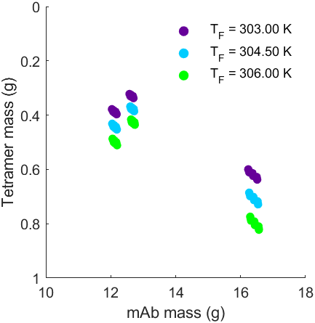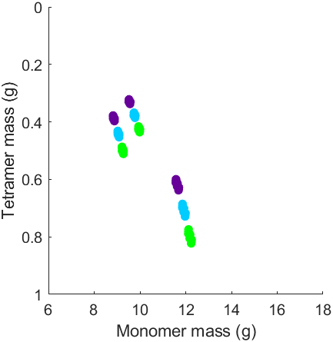
Figure 1: Dynamic simulation results (colour refers to final temperature shift value).
Only 81 of the said 729 strategies tracked are shown as successful: the rest fail since the volume is exceeded, the culture becomes glucose-starved, or both constraints are violated. Figure 1 depicts these 81 points, their colour denoting the final temperature shift values. A low (or decreasing) temperature value at the final time point (day 10) induces less irreversible aggregation, with almost negligible consequence on total mAb concentration. The monomer (desirable for manufacturing) mAb fraction (Fig. 1 right) is distinctly lower than the total mAb mass (Fig. 1 left), without great benefit from temperature reduction (for each plot cluster, monomer mass is actually reduced for decreasing final temperature, a small price to pay for the clear tetramer reduction signifying aggregation mitigation).
The preliminary conclusion emerging is that for any given feeding strategy, a final stage shift to a lower temperature leads to lower monomer and lower tetramer concentrations with no major consequence on total mAb throughput, thus more reversible aggregation. The industrial potential for process intensification in mAb manufacturing must however be examined by means of a more theoretically comprehensive and computationally robust method: we thus use multi-objective dynamic optimisation to address aggregation issues.

    - Multi-Objective Dynamic Optimisation
All said constraints probed during dynamic simulation are implemented here as well, and the complete dynamic optimisation NLP problem formulation is illustrated in Table 2. Bioreactor temperature and inlet flow are now continuous manipulation variables, but their levels can change only at specific time points discussed previously (days 0, 5, 10). More elaborate (fully continuous) temporal manipulations are possible, but our purpose here is to facilitate meaningful comparisons vs. the operational space shown in Figure 1.
Our goal here is to improve on NLP problem outputs for mAb and tetramer throughputs in comparison to those depicted in Figure 1 from our exploratory dynamic simulations. To host both operational goals (mAb mass maximisation and tetramer minimisation) within the same objective function, we consider the weight factors α and β, respectively.
Table 2: A summary of the multi-objective optimisation problem for mAb production.
Multi-objective optim. function: | $$\max_{u\left(t\right), t_{f} = 15 days}\left(α\frac{\left[mAb\right]\left(t_{f}\right)∙V\left(t_{f}\right)}{13.7295}-β\frac{600∙{10}^{6}N_{4}\left(t_{f}\right)∙V\left(t_{f}\right)}{0.5098}\right)$$
s.t.:
Process model: | $X_{i}=f_{i}(X_{j}(t), u(t), t)$ $i, j=1…10$
Inequality constraints: | $$5.65 L≤V≤ 10 L$$  $$[GLC]>0$$
Manipulation  (control)  vector: | $$u(t) = [Q_{i}\left(t\right),T(t)]$$  with $0 {L min}^{-1} ≤ Q_{i} ≤ 4∙{10}^{-4} {L min}^{-1}$  and $303 K ≤ T ≤ 306 K$
Initial state  variable  conditions: | $$V_{0}=5.65 L; X_{V,0}=0.7 × {10}^{6} cells mL^{-1};$$  $$X_{D,0}=0.07 × {10}^{6} cells mL^{-1}; {\left[GLC\right]}_{0}=5.36 g L^{-1};$$  $${[LAC]}_{0}= 0.12 g L^{-1}; {[mAb]}_{0}={[N_{1}]}_{0}={[N_{2}]}_{0}={[N_{3}]}_{0}={[N_{4}]}_{0}=0$$

The NLP problem is solved for all three α-β weight factor combinations that sum up to 1. Both manipulation (temperature, flowrate) trajectories for all cases are given in Figure 2. Clearly, optimal strategies for {$α$ = 0.25,$β$ = 0.75}, and {$α$ = 0.5, $β$ = 0.5} are identical. For {$α$ = 0.75, $β$ = 0.25}, i.e. mAb mass prioritised, the feed peaks at day 10 (not day 5), but tetramers rise. The final temperature in all cases emerges as T=303 K, agreeing with our observation that irreversible aggregation decreases with decreasing final temperature.
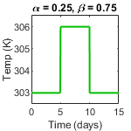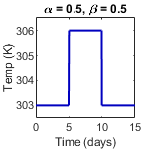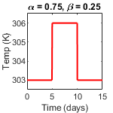
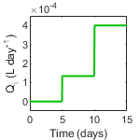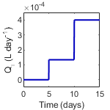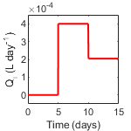
Figure 2: Temperature and flowrate trajectories for the multi-objective optimisations.

Multi-objective optimisation results are compared to early simulation results in Figure 3. Both {$α$ = 0.25,$β$ = 0.75} and {$α$ = 0.5, $β$ = 0.5} cases are both successful in achieving a strategy with a lower tetramer concentration than those seen in our exploratory analysis. The {$α$ = 0.75, $β$ = 0.25} optimisation case, which prioritises total mAb mass throughput and penalises aggregation (tetramer production) much less than the other two cases, only manages a minor performance improvement vs. the 303 K plot clusters seen in Figure 1. Multiobjective dynamic optimisation clearly shows that priorities (weights) matter a lot, but also that higher-DOF (fully continuous) manipulation signals may improve outcomes.
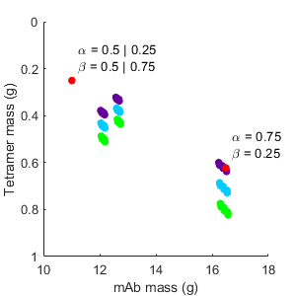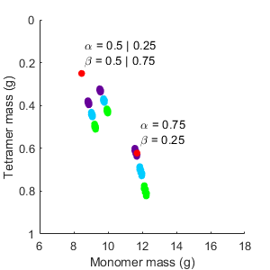
Figure 3: Multi-objective optimisation results (red points) superimposed on Fig. 1.
  - Conclusions
An integrated mAb cultivation-aggregation model has been formulated on the basis of two papers describing each of the phenomena (Kumar, 2022; Bansal, 2020; respectively); An Arrhenius relationship is used to generalise the population balance model of the latter. The DAE system model is first tested via an array of dynamic simulations in which manipulation strategies (feed-temperature combinations) are screened to elucidate their potential to simultaneously improve mAb throughput and reduce irreversible aggregation.
Multi-objective optimisation is also employed to the same end, considering continuous temperature and flowrate manipulations but only at specific times of a 15-day operation: three {a,β} weight combinations are used to vary the importance of the two objectives. Two of the said three weight sets yield the same operation protocol which successfully reduces tetramer output to a value much lower than all previous (at mAb mass penalty); the third (prioritising mAb mass) only manages a very minor tetramer output reduction. A more detailed multi-objective optimisation with more freedom degrees (e.g. fully continuous manipulation signals) can further improve optimal mAb bioreactor operations.
Acknowledgements
The authors gratefully acknowledge UKRI and the Engineering and Physical Sciences Research Council (EPSRC) Doctoral Training Partnership (DTP) PhD Scholarship awarded to W.J., and a Royal Society Industrial Fellowship (2020-22) awarded to D.I.G.
Financial support via another UKRI-EPSRC grant (RAPID: ReAltime Process ModellIng & Diagnostics–Powering Digital Factories EP/V028618/1) is also hereby acknowledged.
References
R. Bansal, P. Srivastava, A. S. Rathore, P. Chokshi. (2020). Population balance modelling of aggregation of monoclonal antibody based therapeutic proteins. Chem. Eng. Sci., 216, 115479.
F. Bollin, V. Dechavanne, L. Chevalet. (2011). Design of Experiment in CHO and HEK transient transfection condition optimization. Protein Expres. Purif., 78, 61-68.
R.K. Brummitt, D.P. Nesta, L. Chang, A.M. Kroetsch, C.J. Roberts. (2011). Nonnative aggregation of an IgG1 antibody in acidic conditions, part 2: nucleation and growth kinetics with competing growth mechanisms. J. Pharm. Sci., 100, 2104-2119.
Y. Fan, I. Jimenez Del Val, C. Müller, A.M. Lund, J.W. Sen, S.K. Rasmussen, C. Kontoravdi et al. (2015). A multi‐pronged investigation into the effect of glucose starvation and culture duration on fed‐batch CHO cell culture. Biotechnol. Bioeng., 112, 2172-2184.
G. Haidar, J.W. Mellors. (2021). Improving the outcomes of immunocompromised patients with coronavirus disease 2019. Clin. Infect. Dis., 73, e1397-e1401.
W. Jones, D.I. Gerogiorgis. (2022). Dynamic simulation, optimisation and economic analysis of fed-batch vs. perfusion bioreactors for advanced mAb manufacturing. Comput. Chem. Eng., 165, 107855.
D. Kumar, N. Gangwar, A.S. Rathore, M. Ramteke. (2022). Multi-objective optimization of monoclonal antibody production in bioreactor. Chem. Eng. Proc.-Proc. Intensif., 180, 108720.
A.D. Rodman, D.I. Gerogiorgis. (2016). Multi-objective process optimisation of beer fermentation via dynamic simulation. Food Bioprod. Proc., 100, 255-274.
S. Millán-Martín, C. Jakes, S. Carillo, R. Rogers, D. Ren, J. Bones. (2023). Comprehensive multi-attribute method workflow for biotherapeutic characterization and current good manufacturing practices testing. Nature Protocols, 18, 1056-1089.
C. Sirasitthichoke, D. Hoang, P. Phalak, P.M. Armenante, B.I. Barnoon, I. Shandil. (2023). Computational prediction of blend time in a large‐scale viral inactivation process for monoclonal antibodies biomanufacturing. Biotechnol. Bioeng., 120, 169-183.
R. van der Kant, A.R. Karow-Zwick, J. van Durme, M. Blech, R. Gallardo, D. Seeliger, K. Aßfalg, P. Baatsen, G. Compernolle, A. Gils. (2017). Prediction and reduction of the aggregation of monoclonal antibodies. J. Mol. Biol., 429, 1244-1261.

