Virtual Reality and Digital Twins for Enhanced Learning in Chemical Engineering
Andrea Galeazzi,ª Paolo Marenghi,^{b} Lamberto Duò,^{c} Maurizio Galardo,^{d} Renato Rota,ª Susanna Sancassani, ^{b} Flavio Manenti,^{a,}*
ªPolitecnico di Milano, CMIC Department “Giulio Natta”, Piazza Leonardo da Vinci 32, 20133 Milano, Italy
^{b}Politecnico di Milano, METID, Piazza Leonardo da Vinci 32, 20133 Milano, Italy ^{c}Politecnico di Milano, Department of Physics, Piazza Leonardo da Vinci 32, 20133 Milano, Italy
^{d}AVEVA / Schneider-Electric, Via Macchi 35, 20124 Milano, Italy
*flavio.manenti@polimi.it
Abstract
This study explores the implementation of digital twin technology in engineering education at Politecnico di Milano, through the EYEducation Project in collaboration with AVEVA/Schneider-Electric. The project integrates immersive virtual reality and digital twins into the M.Sc. chemical engineering program at Politecnico di Milano, utilizing Dynsim for dynamic simulation of chemical processes and AVEVA XR for 3D plant experiences. A case study involving a valve switch in a process line illustrates the practical application and benefits of digital twins. This approach significantly enhances the educational experience by providing students with a realistic, interactive learning environment. It effectively bridges the gap between theoretical knowledge and practical skills, showcasing the transformative potential of digital twins in modern engineering education. The integration of this technology marks a pivotal advancement in preparing students for real-world industrial operations.
Keywords: Digital twin, Immersive environment, Process dynamics, Series of Operations, Digitalization in education programs.
  - Introduction
In recent years, Virtual Reality (VR) has emerged as a significant trend in the educational sector, recognized for its potential to transform learning experiences. Despite its promising aspects, particularly in establishing connections between research and education, VR has yet to realize its full impact in technical higher education. VR creates immersive experiences that transport users to a dimension entirely distinct from the physical world. However, its effective application in educational settings, along with the implications for teaching methodologies, remains a topic of exploration.
The effectiveness of VR in education is contingent on integrating it into curricula designed to achieve specific learning outcomes. This requires a reevaluation of teaching and learning practices to leverage the new types of content VR offers. Innovative pedagogies are essential to harness the potential of VR, with an emphasis on blending practical and theoretical aspects of learning.
A cognitive perspective on pedagogy views knowledge as a combination of information and process structures, vital for skills such as reasoning, problem-solving, comprehension, and language use. Learning, from this perspective, is seen as an evolution of cognitive structures through internal mental activities. It involves students in recursive processes that blend experiences, abstractions, inference, problem solutions, and information recombination. This approach moves beyond linear learning models to a recursive, networked vision where direct experience plays a central role.
The teacher's role is crucial in creating an environment conducive to learning, linking knowledge to practical and experiential domains, and fostering student autonomy. VR can be an effective tool in this context, facilitating a transformative learning process as described in the Kolb Cycle. This cycle suggests that learning is a process of knowledge creation through the transformation of experience, connecting theoretical concepts through observation and reflection on experiences.
Further, the application of pedagogical methods like Inquiry-Based Learning (IBL) and Problem-Based Learning (PBL) can be enhanced with VR. These methods focus on autonomous research by students and learning through problem-solving, respectively. Scenario-Based Learning (SBL) also benefits from VR, where learning is encouraged through simulated scenarios requiring students to perform actions based on different roles.
These pedagogical approaches, combined with VR, can provide a learning experience that goes beyond content reference to actual interaction within a 'real' learning environment. The integration of VR in learning processes presents new opportunities and challenges, necessitating a reassessment of content-sharing approaches and student engagement strategies. As VR becomes more prevalent, educational environments may evolve to accommodate more interactive and collaborative methods, potentially redefining traditional classroom settings to allow direct interaction with virtual 3D content (Halabi, 2020; Liljaniemi and Paavilainen, 2020; Paravizo and Braatz, 2019).
  - Digital Twin
In engineering terms, a "digital twin" represents the digital manifestation of a physical entity. This concept transcends traditional boundaries, finding relevance in diverse engineering fields such as process/chemical, electric/electronic, and mechanical engineering. Digital twins can span in terms of complexity and representativeness of the physical asset, depending on the specific application. In this work, it is intended as a dynamic, interactive representation that reflects the multifaceted behavior of a plant across various operational scenarios, including complex processes like start-ups and emergency shutdowns. In this case, it goes beyond providing a mere realistic field representation, evolving into a fully immersive environment where interactions with unit operations and instrumentation are seamlessly linked with the process simulation.
The essence of a digital twin lies in its integration of four key areas of digitalization: Process Simulation, Data Analytics, Immersive Environment, and Decision-Making Process. Process simulation, the core component, accounts for the constant dynamic state of plants, driven by various internal and external factors. Data analytics play a critical role in ensuring the reliability and accuracy of the digital twin by analyzing, interpreting, and reconciling plant data. The immersive environment component is vital for creating a realistic virtual plant experience, requiring high-quality visualizations and advanced gaming technology for implementation. Finally, the decision-making process in a digital twin involves an intricate series of operations and controls that dictate the actions and effects within the plant, achieved through integrated process control systems within the simulation environment. This comprehensive blend of simulation, data analysis, immersive technology, and decision-making processes forms the cornerstone of the digital twin concept, transforming it into a pivotal tool in modern engineering education and practice.
To understand more in detail how the digital twin technology is built it is necessary to have an overview of the whole digital twin framework, from raw plant data acquisition to process decision implementation. Such a framework is schematized in Figure 1 and it is possible to grasp the link with raw process data. However, one of the key enablers of the digital twin technology is data analysis (Romagnoli and Sanchez, 1999) coupled with machine learning methods (Ferranti et al., 2021; Galeazzi et al., 2022, 2021). This whole pipeline, shown in Figure 1, is beneficial to immersive reality experiences, providing more accurate representations of real industrial assets and operations, thus aiding in education or operators training and finally, decision making.
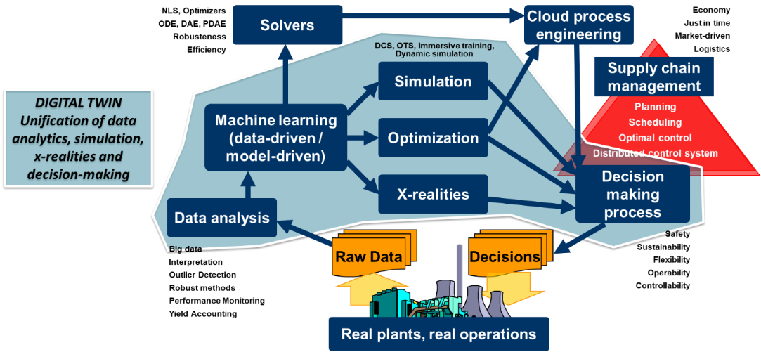
Figure 1. Flow diagram of a digital twin system, integrating data analytics, simulation, and decision-making in cloud engineering.
  - Implementation
Implementing a VR-based learning environment requires careful planning to meet specific technological and spatial requirements. The initial step involves setting up a demo station that's compatible with the simulation software. The learning space is designed to support immersive experiences for groups of up to four, allowing for both interaction and observation.
The VR software architecture is structured simply yet encompasses complex interdisciplinarity for case studies and scenarios. It includes a dynamic simulation suite for plant behavior, complete with control logic and user interaction capability, and a high-level virtual simulation suite for a realistic 3D plant model. These are linked via custom bridging software.
For hardware, a robust workstation with an advanced processor, ample RAM, significant storage, and a high-quality graphics card is essential. The chosen Oculus Rift S headset offers a cost-effective, immersive VR experience and requires a PC connection.
Classrooms are set up on two campuses, equipped with necessary technical infrastructure, ensuring enough space for safe movement and interaction with the VR system. Workstations are designed for both individual and collaborative work on simulations, as
Figure 2. Example usage of the digital twin VR system. | 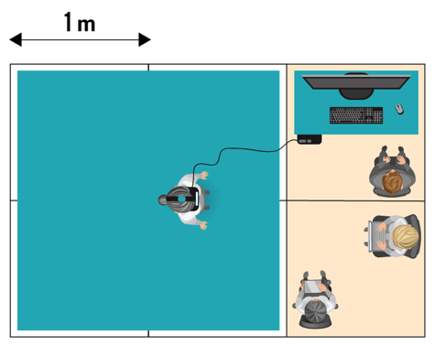  Figure 3. VR workstation representation for a working group of students.
shown in Figure 2 and 3, with clear space delineations and storage solutions for equipment when not in use.

  - Case study
The selected case study for M.Sc. students, a valve line bypass switch, underscores the disparity between their programming proficiency and real-world field operations. Many students tend to initiate models with impractical operational conditions, either employing premixed or segregated feeds directly into reactors, often overlooking practical aspects like pre-mixing in collectors. This gap in understanding also extends to valve switch systems within industrial settings, as students using process simulators typically neglect the significance of valves, concentrating solely on essential units and disregarding the operational context. However, as the emphasis shifts towards operational efficiency and sustainability, the need to consider a more realistic environment becomes paramount, and this is where digital twins play a pivotal role.
The digital twin valve switch exercise offers students an immersive VR-based tutorial, enabling them to gain practical experience in simulated plant operations. In this virtual environment, students step into the shoes of avatars equipped with standard safety gear, collaborating closely with a virtual DCS engineer. Together, they embark on a series of tasks aimed at bypassing a malfunctioning automatic flowrate control valve (FV_10540), shown in Figure 4.
This hands-on operation sequence entails identifying the correct intervention points, ensuring that the flowrate remains within specified limits, and proficiently managing both automatic and manual valves to redirect the flow through a designated bypass line. Within this interactive VR setting, students have access to all the necessary equipment, can engage in real-time communication, and make critical adjustments in coordination with the control room. The process includes isolating the automatic valve by closing adjacent manual valves, opening the bypass valve, and draining the liquid from the isolated section. Upon successful completion of these tasks, students verify the operation's success with the control room and, if necessary, make adjustments to the flowrate. This immersive
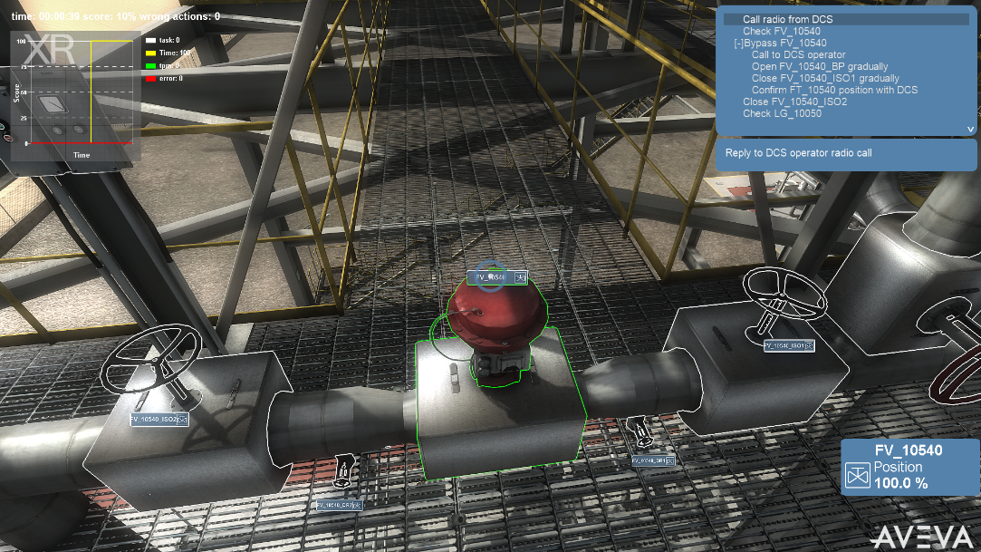
Figure 4. Interactive training scenario showcasing a valve bypass operation. The central red valve, identified as FV_10540, is the target of the exercise due to its malfunction. To successfully navigate the tutorial, participants must isolate this valve by adjusting the neighboring manual isolation valves and initiate flow through the bypass by engaging the manual wheel valve located on the extreme right of the scene.
exercise, typically completed within a timeframe of 22 to 28 minutes, significantly enhances students' practical understanding of process management and control in field operations.

  - Impact
The effectiveness of incorporating digital twins into engineering education was assessed through a questionnaire administered after the VR-based valve switch exercise conducted at Politecnico di Milano, involving 69 M.Sc. students. The primary objective of this survey was to gauge how the VR experience impacted the students' understanding of chemical plant operations and its efficacy as an instructional tool.
The questionnaire encompassed a range of inquiries aimed at evaluating the extent to which the VR environment enhanced the students' comprehension of chemical plant operations, process operation management, and unit operations. It also sought to ascertain the perceived value of VR as both an educational and training resource, along with its capacity to provide unique insights when compared to traditional classroom instruction, laboratory exercises, and real-world plant visits. Additionally, the survey explored the student’s perceived benefits of VR in terms of its contribution to ongoing education, future career prospects, and overall knowledge acquisition, including its ability to clarify the structural intricacies of chemical plants and the sequencing of unit operations. However, understanding the actual benefits is no simple task and it would require a meta-analysis on the application of such tools, or, possibly, asking in the future to the same group of people how and if they received a career benefit through the usage of these immersive experiences.
The findings from the survey underscored a strong endorsement of the VR experience among the students. A significant majority recognized its role in enhancing their knowledge, which is directly applicable to their academic pursuits and future professional endeavours. Most students found VR to be a valuable tool for comprehending the complexity of plant structures and operations, surpassing traditional learning methods. However, they also acknowledged the irreplaceable value of real plant visits. The feedback provided insights into potential enhancements of VR, particularly in terms of its collaborative features to better simulate real-world teamwork in plant operations. With a remarkable positive response rate exceeding 90%, this study signifies a significant advancement in engineering education, demonstrating the successful integration of digital twin technology. Furthermore, students reflected on how the VR experience reshaped their perception of operation timelines, emphasized the importance of teamwork, and indicated their comfort and proficiency with VR technology.
Table 1. Average questionnaire results from the mandatory answers of 23 questions asked to a sample of 69 M.Sc. students after the VR-based valve bypass experience.
Strongly disagree | Disagree | Agree | Strongly agree
0.3 % | 9.4 % | 51.6 % | 38.6 %
  - Conclusions
In summary, the EYEducation Project at Politecnico di Milano successfully integrated digital twins into the M.Sc. curriculum using Schneider-Electric/Aveva's software in a 3D environment. This pioneering approach received positive feedback from 69 Chemical Engineering M.Sc. students, highlighting its efficacy in bridging theory and practical knowledge. Challenges identified include improving virtual team collaboration. The project convincingly demonstrated the practicality of tasks like valve switching, emphasizing their real-world importance. Future efforts will expand digital twin integration in advanced engineering education, marking a promising step forward in preparing students for modern industry demands.
References
F. Ferranti, F. Manenti, G. Vingerhoets, M. Vallerio, 2021. Value chain planning optimization: a data driven digital twin approach. 16th IFAC Symposium on Advanced Control of Chemical Processes ADCHEM 2021 54, 572–577.
A. Galeazzi, R. Nasti, G.L. Bozzano, L. Verotta, S. Marzorati, F. Manenti, 2021. A Cloud Computing Application for the Supercritical Carbon Dioxide Extraction Using Coffee Grounds Silverskin, 31 European Symposium on Computer Aided Process Engineering. Elsevier, pp. 1035–1040.
A. Galeazzi, K. Prifti, F. Gallo, F. Manenti, 2022. A Methodology for The Optimal Surrogate Modelling of Digital Twins Using Machine Learning, 32 European Symposium on Computer Aided Process Engineering. Elsevier, pp. 1543–1548.
O. Halabi, 2020. Immersive virtual reality to enforce teaching in engineering education. Multimed Tools Appl 79, 2987–3004.
A. Liljaniemi, H. Paavilainen, 2020. Using Digital Twin Technology in Engineering Education – Course Concept to Explore Benefits and Barriers. Open Engineering 10, 377–385.
E. Paravizo, D. Braatz, 2019. Using a game engine for simulation in ergonomics analysis, design and education: An exploratory study. Applied Ergonomics 77, 22–28.
J.A. Romagnoli, M.C. Sanchez, 1999. Data processing and reconciliation for chemical process operations. Elsevier Science & Technology.

