Green Hydrogen Production from Solar-powered Electrolysis: A Novel Optimization Methodology
Andrea Isella, Davide Manca*
PSE‐Lab, Process Systems Engineering Laboratory, Dipartimento di Chimica, Materiali e Ingegneria Chimica “Giulio Natta”, Politecnico di Milano, Piazza Leonardo da Vinci 32, 20133 Milano, Italy
*davide.manca@polimi.it
Abstract
Today, hydrogen production still relies primarily on fossil fuels. Indeed, over 99% of the hydrogen produced in 2022 was synthesized via highly carbon-intensive processes such as steam methane reforming and coal gasification (IEA, 2023). This represents a primary problem in the chemical engineering scenario as hydrogen is the raw material of a plethora of commodities that are produced in tremendous amounts every year. Thus, hydrogen production is accountable for the vast majority of chemical industry carbon dioxide emissions along with the oil refining sector (Isella and Manca, 2022). In this perspective, being ever closer to entering a fully green economy, renewable-powered water electrolysis represents an increasingly valid alternative to produce hydrogen. However, properly sizing the renewable power plant (e.g., a solar or wind farm) and the electrolyzer may be challenging since many features should be considered. Facilitating such a task is the main aim of this work, which proposes a novel methodology to optimally design green hydrogen production facilities. Specifically, starting from renewable energy availability time profiles in the location of interest, this criterion allows for the optimal evaluation of the installed capacities of both renewable power plant and electrolyzer which minimize the plant's total costs (both capital and operative expenditures).
Keywords: photovoltaics, electrolyzers, renewable energy, environmental sustainability, climate change mitigation.
  - Introduction
In 2022, about 95 Mt/y of hydrogen were produced globally. Like the previous year, low-emission hydrogen was less than 1% and almost entirely based on conventional fossil routes combined with carbon capture, storage, and utilization (CCUS) technologies. Water electrolysis, instead, simply accounts for 0.1% of current hydrogen production worldwide (IEA, 2023), but installed capacity and industrial facilities are rapidly increasing. That is the case of the REPowerEU Plan by the European Commission, which set the objective to deliver 65 GW of electrolysis capacity in Europe by 2030, plus 41 GW of wind and 62 GW of solar in additional capacity for the related renewable electricity supply (European Commission, 2022). Producing hydrogen through renewable-powered electrolyzers is indeed the only available-to-date synthetic pathway that allows total decoupling of hydrogen production from fossil feedstocks. This allows for eliminating at the same time both upstream Scope 3 (i.e. corporate value chain) emissions associated with fossil fuel extraction and all Scope 1 (i.e. direct) and 2 (i.e. indirect) emissions, given that renewable sources and electricity are used for meeting the energy demand of the whole process (MPP, 2022). The primary drawback of entirely renewable-based (i.e. “green”) processes, however, relies upon their complete dependence on renewable power generation (such as solar, wind, hydropower, etc.). Indeed, being these energy sources generally strongly subject to daily (even hourly) fluctuations and seasonal behavior, they tend to convey such discontinuous trends to the whole process they are connected to. Feeding green (i.e. intermittent) electric power to an electrolyzer results in fact in equally intermittent green hydrogen mass flows generated from such a unit. Moreover, the overall trends provided by renewable energy sources can also vary from year to year, causing even more difficulties in properly estimating essential sizes such as the power capacities for the renewable power plant and the electrolyzer. This work introduces a new criterion to design green hydrogen production facilities both optimally (i.e. providing the installed capacities that minimize the levelized cost of hydrogen, LCOH, or of the final product, LCOX, for a specific location and time horizon) and robustly (i.e. providing the installed capacities needed to satisfy the same requirements throughout several years of operation).
  - Methodology
Solar-powered green hydrogen production facilities (i.e. renewable power from solar energy only), which represent the control volume of our methodology, call for a solar power plant to produce the renewable energy needed for electrolysis; an electrolyzer to convert the renewable electric energy harvested by the solar farm into green hydrogen mass flows; and a hydrogen buffer storage to provide the produced hydrogen to downstream processes/utilizations.
Consequently, to optimally design green hydrogen production facilities, the following optimization procedure is proposed:
Namely, and are the installed capacities of the solar plant and the electrolyzer, respectively; is the instantaneous renewable power generated by the solar plant while is the instantaneous power consumed by the electrolyzer, that corresponds to the electricity generated by the solar plant but is bounded above by the nominal capacity of the electrolyzer itself; and are the target green hydrogen production rate and the electric power required by the electrolyzer to generate it, respectively; is the green hydrogen mass flow withdrawn from the storage for downstream utilization, and is the total timespan covered by the optimization procedure (e.g., one year). Finally, , , and are the capital and operative costs of the solar plant, the electrolyzer, and the hydrogen storage system, respectively, whose sum constitutes the objective function to minimize.
Few input data are needed: namely, the power generation solar profiles from the location of interest (and the installed capacity of such a reference dataset), and techno-economic data regarding the costs (i.e. CapEx and OpEx) and the operative requirements of solar plants, electrolyzers, and hydrogen storage systems to be installed. To solve the optimization problem, one may simply consider a grid search minimization within an arbitrarily defined investigation domain of solar plant installed capacities (i.e. ranging from the minimum to the maximum installed capacity values defined by the user) and according to the physical limit of non-negative installed capacities. Specifically, for each point of the grid (i.e. for each different configuration of solar plant installed capacity): (i) the corresponding power generation profile is estimated by scaling up/down the reference solar power profiles to the actual solar plant installed capacity; (ii) the corresponding electrolyzer size is estimated through Equation (1b) and, if no solution is found, it means that the solar plant installed capacity of such a configuration cannot produce the sufficient amount of electric energy required by the electrolyzer to meet the target specifications (i.e. it falls into the unfeasibility region and must be discarded); (iii) the power consumption profile of the electrolyzer is then estimated through Equation (1d); (iv) the green hydrogen profile originating from the electrolyzer is evaluated from the electrolyzer consumption profile and its operating specifications given as input data; (v) The green hydrogen storage size and its outlet mass flow profile are estimated according to Equation (1c); and (vi) the CapEx and OpEx of the corresponding solar plant, electrolyzer, and hydrogen storage are estimated. Precisely, for each process unit, such costs are evaluated by multiplying the intensive input costs data (e.g., CapEx and OpEx per MW installed, or per t_{H2} stored) by the computed sizes. At the end of the whole procedure, once every single solar plant installed capacity scenario has been assessed, the optimal configuration is the one satisfying Equation (1a), i.e. resulting in the lowest total costs.
  - Case study
Our methodology is now validated by performing a feasibility study of a green hydrogen production plant in California, USA. As we want to estimate the lowest LCOH attainable with our criterion, we consider the system depicted in Figure 1, which refers to the green hydrogen generation section and neglects any further downstream utilization feature (that is why no hydrogen storage has been included neither in the system nor in the objective function, as its operation completely depends on the user’s requirements).
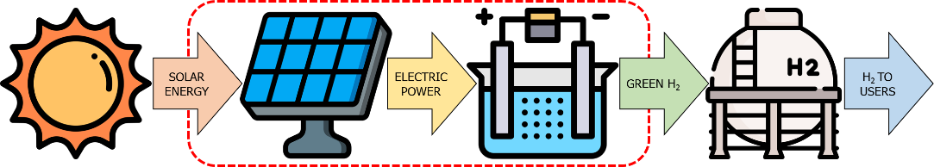
Figure 1: System and control volume of the case study.
Specifically, an average yearly target production rate equal to 1 t_{H2}/h is assumed, and Californian solar hourly profiles from 2022 (CAISO, 2023) are considered as input data. Furthermore, Table 1 reports the reference techno-economic data for the (photovoltaic, PV) solar plant and the (alkaline) electrolyzer.
Table 1: Techno-economic data for the case study. From DEA (2022) and Nel Hydrogen (2021).
 | Life  [y] | CapEx [€₂₀₂₀/MWe] | OpEx [€₂₀₂₀/MWe/y] | Power consumption [kWh/Nm³_{H2}]
Solar plant | 20 | 520,000 | 9,700 | –
Electrolyzer | 10 | 700,000 | 2% of [CapEx/y] | 4.5
Thus, we apply the optimization procedure described by Equation (1) by implementing it on MATLAB™ R2022a and selecting an investigation region ranging from = 0 MW to = 300 MW. Moreover, to directly estimate the LCOH values corresponding to each solar installed capacity, the objective function (i.e. Equation (1a)) is divided by the target hydrogen production rate. Panels A and B of Figure 2 show the final results of the assessment.
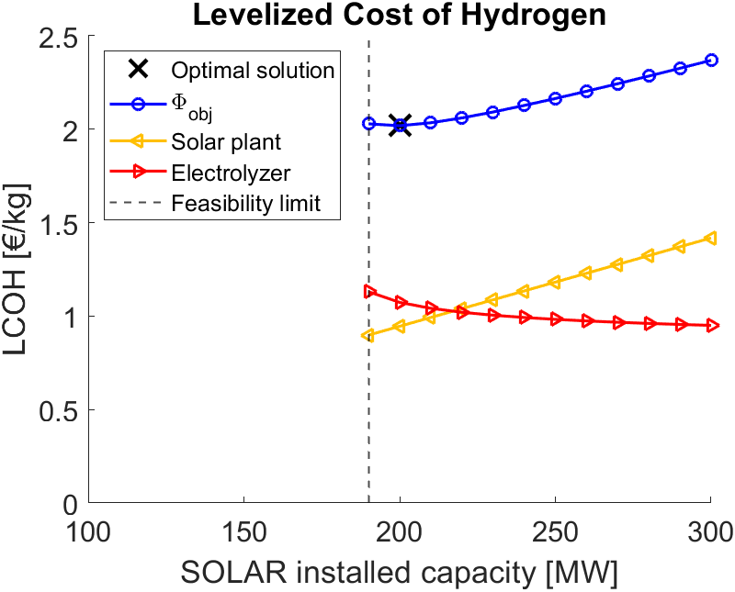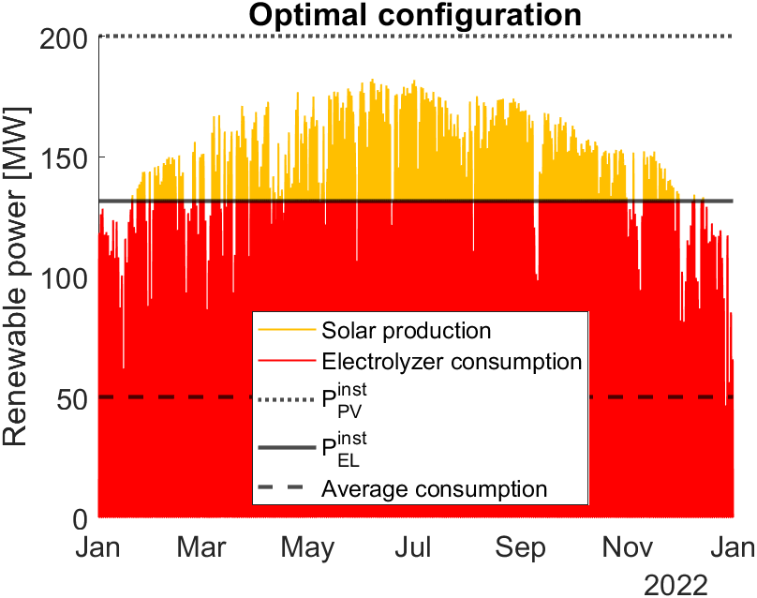
A
B
Figure 2: Optimization results. (Panel A) Objective function. (Panel B) Optimal configuration.
Focusing on Panel A, the objective function predictably interrupts way before (i.e. 0 MW), as too small installed capacities of the solar plant cannot produce the sufficient amount of electric energy required by the electrolyzer to meet the 1 t_{H2}/h yearly average production rate specification (see step (ii) in the previous section): precisely, 190 MW is the smallest feasible solar plant installed capacity. However, that is not the optimal point as smaller solar plants typically call for bigger electrolyzers: indeed, when less renewable energy is produced, the electrolyzer must be oversized to consume the highest possible fraction of it. Such a trade-off leads to an optimal configuration corresponding to a solar plant installed capacity of 200 MW, which calls for an electrolyzer installed capacity equal to 131.67 MW and ensures an LCOH of 2.02 €/kg, i.e. the cheapest one. By focusing on Panel B, instead, the effect of Equation (1b) within the optimization routine becomes evident. Indeed, the winning configuration shows an average electrolyzer consumption rate equal to 50.06 MW (i.e. ), that is (considering the power consumption specification of the electrolyzer as reported in Table 1) the required electric power input for a production rate of 1 t_{H2}/h. Interestingly, such an optimal configuration calls for an electrolyzer sized to fully accommodate the solar production profiles in the off-season (i.e. winter) while curtailing the high-season (i.e. summer) production peaks.
  - Sensitivity analysis
To give more robustness to the results reported in the preceding section, the same case study was assessed by also considering Californian solar hourly profiles from the previous 4 years (i.e. since 2018). By doing so, the proposed optimization methodology gives the optimal values for each one of the investigated years, allowing the user to compare them and evaluate how the final installed capacities should change from year to year to minimize the overall production costs. Indeed, due to the high variability that characterizes renewable power generation, the design of renewable-based plants strongly reflects (and suffers from) such an undesirable behavior. As an example, the capacity factor of renewable power plants (CF, i.e. the dimensionless ratio of the actual electrical energy output over a certain time to the electrical energy output if theoretically operating at full capacity over the same period) might change considerably over the years. However, it is reasonable to expect that it should oscillate around a characteristic value according to the geographical location.
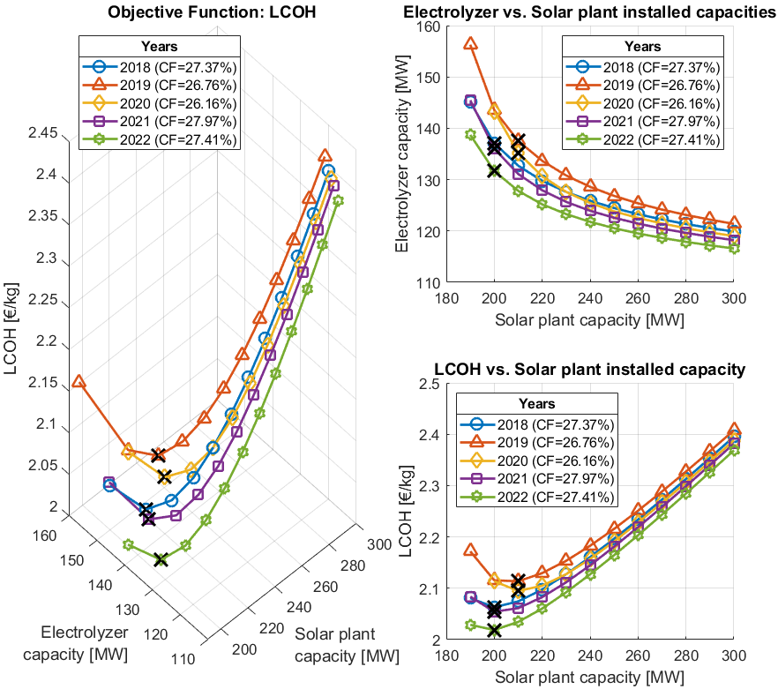
C
B
A
Figure 3: (Panel A) Objective function profiles resulting from the 2018-to-2022 assessment (the corresponding yearly solar capacity factors are reported within the legend); (Panel B) Investigated solar plant installed capacities and corresponding electrolyzer installed capacities; (Panel C) Objective function dependence on solar plant installed capacities. Black crosses refer to the minima points, i.e. the economically optimal configuration for each year.
Figure 3 shows the results of such a 5-year assessment: precisely, Panel A displays the topology of the multiple objective functions concerning both solar plant and electrolyzer installed capacities; Panel B focuses on the trade-off between the required solar plant and electrolyzer installed capacities; and Panel C highlights the objective function dependence on the solar plant installed capacity (analogously to Panel A of Figure 2). As expected, the variability of the input solar power profiles (as it can be partially verified from the different capacity factors associated with each investigated year, as they are an index of how much renewable power has been harvested over a certain time frame but do not give any information concerning the distribution of the power production throughout that period) reflects on the optimal results. Indeed, the optimal solar plant installed capacity is 200 MW for 2018, 2021, and 2022 but rises to 210 MW for 2019 and 2020. Analogously, different electrolyzer installed capacities have been obtained: 137.11 MW in 2018; 137.52 MW in 2019; 135.21 MW in 2020; 136.04 MW in 2021; and 131.67 MW in 2022. This implies that a lower-than-average solar power availability occurred in 2019 and 2020 (as it could also be inferred a priori from their respective capacity factors, which are the smallest ones provided), and therefore higher installed solar plant capacities are needed to meet the specified production requirements.
  - Conclusions
By entering the so-called “green economy”, the manufacturing sector increasingly pushes for decarbonization. Green hydrogen might then represent the key raw material for many processes that currently depend heavily on fossil fuels in procuring hydrogen feedstocks. This work presented a novel methodology to design green hydrogen production facilities both optimally (i.e. providing the installed capacities that currently minimize the levelized cost of hydrogen or other downstream chemicals, if any) and robustly (i.e. also providing the optimal results referring to multiple years of operation). It requires just a few input data: namely, the input solar power profiles from the location of interest and the techno-economic data (such as the costs and the operative variables) of the main process units to be installed (i.e. the solar plant and the electrolyzer). In this regard, a case study was assessed, first considering a 1-year time frame and then a 5-year one. By doing so, more conservative estimations for the installed capacity requirements for both the solar plant and the electrolyzer were made possible, as the methodology was able to consider the different solar power availability of each year.
References
CAISO (2023). California Independent System Operator. Available at: http://www.caiso.com/Pages/default.aspx (accessed Nov 7th, 2023).
DEA (2022). Technology Data for Generation of Electricity and District Heating. Danish Energy Agency. Available at: https://ens.dk/en/our-services/projections-and-models/technology-data/technology-data-generation-electricity-and (accessed Oct 30th, 2023).
European Commission (2022). REPowerEU: Affordable, secure and sustainable energy for Europe. European Commission. Available at: https://commission.europa.eu/strategy-and-policy/priorities-2019-2024/european-green-deal/repowereu-affordable-secure-and-sustainable-energy-europe_en (accessed Dec 13th, 2023).
IEA (2023). Global Hydrogen Review 2023. International Energy Agency. Available at: https://www.iea.org/reports/global-hydrogen-review-2023 (accessed Oct 19th, 2023).
Isella, A., & Manca, D. (2022). GHG Emissions by (Petro)Chemical Processes and Decarbonization Priorities—A Review. Energies, 15(20), 7560.
MPP (2022). Making Net-Zero 1.5°C-Aligned Ammonia Possible. Mission Possible Partnership. Available at: https://www.energy-transitions.org/publications/making-net-zero-ammonia-possible/ (accessed Oct 20th, 2023).
Nel Hydrogen (2021). Nel Hydrogen Electrolyzers The World’s Most Efficient and Reliable Electrolysers. Available at: https://nelhydrogen.com/wp-content/uploads/2020/03/Electrolysers-Brochure-Rev-D.pdf (accessed Oct 30th, 2023).

