Present Status of Mixed Plastic Waste Pyrolysis: Plant Simulation through Aspen Hysys
Stefano Redaelliª, Maurizio Masi^{a,}*, Davide Alberti^{b}, Edoardo Vitto^{b}, and Flavio Manentiª
ªPolitecnico di Milano, CMIC department, piazza Leonardo da Vinci 32, Milan 20133, Italy
^{b}a2a S. p. A., Corso di Porta Vittoria 4, Milan 20122, Italy
*corresponding author. E-mail: maurizio.masi@polimi.it
Abstract
The widespread use of plastics results in plastic waste generation. After reuse, recycling is the preferred pathway to reduce the need for virgin feedstock. Concerning mechanical recycling, pyrolysis, consisting of heating the feedstock to promote the thermal degradation of polymers, allows to process Mixed Plastic Wastes (MPW) which cannot be easily sorted. Nowadays, chemical recycling through pyrolysis has reached the demonstration scale, but it is still challenging its further scale-up. In this work, a simulation of a MPW pyrolysis plant coherent with the present technology status is presented. The simulation was performed on Aspen Hysys v11. Unit operations composing the system were chosen according to literature and patent reviews. The process flow diagram of the system is composed of 4 lines in parallel, each one constituted by a reactor, one or more condensation (flash) steps, and a water scrubber (ex-situ dehalogenation) for incondensable gases before their combustion to sustain the reactor energy demand. Each line processes 5000 t/y, representing current scalability limits. The MPW feedstock mass composition assumed is the following: 45 % for both polypropylene (PP) and polyethylene (PE), 8 % for polystyrene (PS), and 1 % each for polymethylmethacrylate (PMMA) and polyvinylchloride (PVC). The reactor has been modeled as a conversion reactor which satisfies the conservation of atoms yielding gaseous, liquid, and solid products of 20, 70, and 10 % of the feedstock mass respectively. After the condensing units, a single distillation column collects the oil produced by each line. The influence of changing the number of condensation (i.e., flash) steps has been investigated. The maximum condensate production was observed for one flash unit. Employing fewer flash units allows to obtain more condensate, paying a slightly larger reboiler duty.
Keywords: chemical recycling, pyrolysis, plastic waste, steady-state simulation
  - Introduction
Current waste treatment solutions are energy recovery, landfilling, and mechanical recycling, end-of-life of 42, 35 and 23 % of plastic wastes respectively. As highlighted in scientific reports commissioned by the European Union (Garcia-Gutierrez et al., 2023), after waste prevention and reuse, material recycling is the preferred path to reduce the environmental impact of plastic wastes. Mechanical recycling, the current strategy for plastic wastes, is a well-established process but it requires single-sorted polymers, and it induces degradation of the polymeric material due to β-scissions following undesired formation of radicals (Schyns & Shaver, 2021). Therefore, to increase the recycling rate in Europe researchers are looking for alternatives. In the literature, several processes are proposed. Among others, chemical recycling processes gained interest. They are all characterized by a common element. Differently from current recycling, polymers degradation is promoted, producing monomers or complex hydrocarbon mixtures. Some processes focus on single polymers. They are depolymerizations (i.e., pyrolysis) and solvolysis of polyethylene terephthalate (PET), where the output is constituted by monomers. Other chemical recycling processes, gasification, and pyrolysis allow to process Mixed Plastic Wastes (MPW). Gasification allows to obtain syngas from MPW. It is a versatile process, since it is possible, for instance, to convert the syngas obtained to base chemicals such as methanol, but it is not expected to be economically viable in the next decades in Europe (Garcia-Gutierrez et al., 2023). Pyrolysis is expected to be the preferred route in the next decades for MPW chemical recycling. It consists in heating the feedstock in an inert environment at temperatures spanning from 400 to 800 °C. In these conditions carbon chains constituting polymeric backbones are broken, owing to complex hydrocarbon mixtures. Some companies achieved a scale of ten thousand t/y (Soni et al., 2021). However, limitations related to poor heat transfer inside the polymeric matrix and high feedstock viscosity hinders its further scale-up. The objective of this work is to simulate present conditions of MPW pyrolysis, trying to represent a realistic MPW pyrolysis plant. Several authors produced relevant works on the simulation of plastic waste pyrolysis. They focused on different feedstocks, mainly plastic wastes constituted by carbon and hydrogen, and different outputs, from heavy oil substitutes (Fivga & Dimitriou, 2018) to hydrocarbon gases (Somoza-Tornos et al., 2020). Here it is proposed, through a simple conversion reactor as first modeling attempt, simulation of a complex MPW feedstock has been addressed. Pyrolysis is expected to play a relevant role in recycling mixed plastics since better alternatives for single polymers already exist.
  - Process description
Pyrolysis consists of heating a carbon-containing feedstock in inert conditions to promote the formation of a hydrocarbon mixture that ranges from gases to char. Focusing on plastic wastes, with respect to other conversion strategies, pyrolysis is of interest for MPW, although they must have a sufficiently high olefinic content, otherwise product distribution would shift towards coke and aromatics. A model MPW mixture has been selected according to this principle and consistent with the composition of wastes obtained after sorting processes. The polymeric composition of the model MPW is the following (expressed in mass fractions): 45 % for both PP and PE, 8 % for PS, and 1 % each for PMMA and PVC. The presence of PVC allows to include the impact of HCl formation on downstream separation units. Simulation is performed on Aspen Hysys v11. To model the plastic feedstock, a hypothetical solid is created. Specific heat was determined averaging the specific heat of each polymer with respect to its mass fraction in the inlet stream. Figure 1 shows a block flow diagram of the modeled process. Concerning simulation boundaries, this work focuses on MPW assumed to be already shredded and ends with the production of three streams of raw pyrolysis oil after distillation. Stream 1, MPW, contains the polymeric mixture with 1 % of moisture. It enters the pyrolysis reactor, working at 450 °C, which is a common operating temperature of most patented processes (Fareid Erik, 2018). Under these conditions, mixed plastics are converted to a hydrocarbon mixture consisting of paraffins, olefins, naphthenes, and aromatics. Due to the high complexity of the reacting system, constituted by a wide variety of reactions involving radicals, proper reactor simulation is not straightforward. For this reason, it has been chosen, as a first attempt, to employ a simple conversion reactor yielding 20, 70, and 10 % of gaseous, liquid, and solid products.
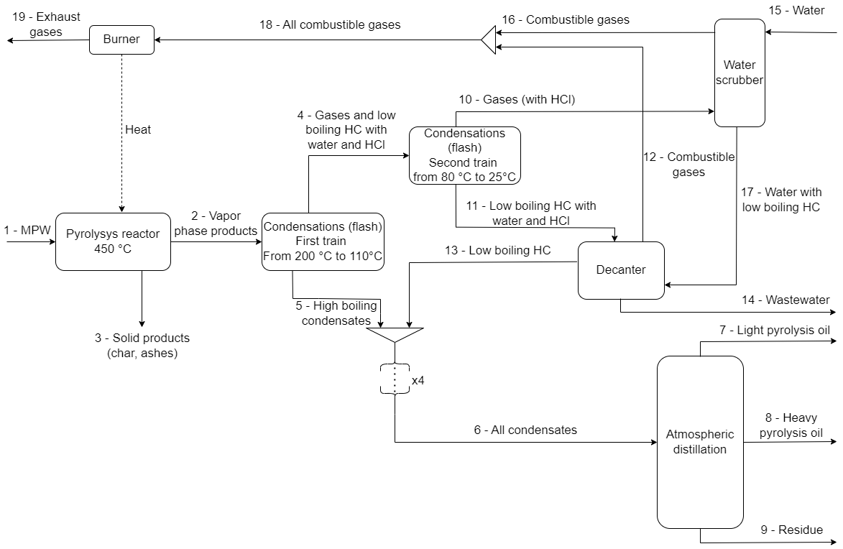
Figure 1: block flow diagram of the MPW pyrolysis process simulated in this study.
Products were selected to fulfil the constraint of the conservation of atoms between reactants and products.
Table 1: composition of stream 2.
Species | Molar fraction | Species | Molar fraction
Water | 0.053 | Styrene | 0.047
HCl | 0.015 | n-Nonane | 0.031
Methane | 0.029 | n-Decane | 0.019
Ethane | 0.107 | n-C11 | 0.017
Ethylene | 0.114 | 1-Undecanol | 0.001
Propane | 0.073 | n-C12 | 0.026
n-Butane | 0.148 | n-C13 | 0.044
n-Pentane | 0.012 | n-C20 | 0.030
Benzene | 0.144 | 1-Eicosanol | 0.015
n-Heptane | 0.045 | n-C25 | 0.025
1-Heptanol | 0.002 | n-C30 | 0.004

It has been assumed complete conversion of plastics to products. To represent the gaseous and liquid products, 22 species ranging from c1 to c30 are selected. Table 1 shows the composition of stream 2. 1-heptanol, 1-undecanol, and 1-eicosanol are selected to balance oxygen atoms. Solid products are assumed to be constituted by char and ashes, present in equal amounts (yield of 5% each) in the solid products stream. Reaction enthalpy has been evaluated forcing the MPW pseudo-component (polymers are not present in Aspen Hysys) to have a formation enthalpy that satisfies an overall pyrolysis energy demand of 5.4 MJ/kg, 50 % larger than a value found in the literature (3.6 MJ/kg) (Dogu et al., 2021). After the reactor, condensation steps are needed to obtain the liquid hydrocarbon product. The Peng-Robinson-Stryjek-Vera (PRSV) equation of state was selected to model both condensation and downstream decanting and distillation units, due to the co-presence of hydrocarbons and oxygenated compounds. Condensation is a sequence of flash units. The first train of flash units cools down vapors to 110 °C. These liquids do not have significant quantities of hydrogen chloride or water and can be sent to a distillation column. In addition, a stepwise condensation might be necessary to avoid wax deposition. Variations in the number of flash units in the first and the second condensation trains have been explored. Their impact is analyzed in the next paragraph. Vapors from the first flash units are sent to additional condensation steps achieving 25 °C. Stream 11 contains water and most of HCl. Acid water and hydrocarbons are separated by using a decanter. PRSV does not model properly migration of HCl to the water stream. For this reason, two-component splitters are modeled after the decanter to assume the complete migration of HCl to water from both liquid and gaseous hydrocarbon streams. Stream 13, constituted by low-boiling hydrocarbons, is mixed with 5 and sent to the distillation column. Due to the relatively small dimensions of a pyrolysis reactor according to the present technological level, it has been assumed to employ a single column for 4 lines to simulate a 20 kt/y plant. For this reason, streams 5 and 13 have been multiplied by 4 before entering the column. It has been modeled as an atmospheric distillation column. Degrees of freedom were saturated imposing component recoveries on distillate and residue of 0.85 (of n-nonane and n-eicosane) and 3 kmol/h as side draw flow rate. In this way, it is possible to impose a sharp separation between top and bottom streams. Then, the column feed plate, side draw plate, and the number of stages were optimized according to the minimization of the condenser and reboiler power without achieving a temperature larger than 350 °C in the bottom tray (to avoid cracking of hydrocarbons). According to this methodology, a column with 18 trays, and with feed and side draw in the middle tray, has been obtained. The column produces three streams: a heavy hydrocarbon residue (c20>), an intermediate (between c12 and c20), and a light pyrolysis oil (c12<). Gaseous stream 10, containing residual HCl, is sent to a three-stage absorption column with water. Water flow rate have been minimized. Absorber stages were selected to allow obtaining rather low quantities of hydrogen chloride (less than 10⁻¹⁹) in the outlet gas stream. In addition, water promotes the condensation of residual hydrocarbons. For this reason, it is sent to the decanter before wastewater treatment. Electrolyte-NRTL equation of state is selected to model water absorption. After the absorber, gaseous streams are mixed with gases coming from the decanter and sent to a burner, modeled as a Gibbs reactor, providing heat to sustain the pyrolysis reactor. The Peng-Robinson equation was employed in this unit. The flow of air has been selected according to the lowest threshold limit for temperature inside burners (750 °C) presented in the Best Available Techniques (Lecomte et al., 2017).

  - Energetic and material considerations
In this section, the most relevant results related to energy and material balances are presented. However, it must be highlighted that these are preliminary results and proper reactor simulation is needed to obtain a finer estimation of energy and mass flows.
Firstly, reactors are the energetic hotspots of the process. A single MPW pyrolysis reactor needs 822 kW to process 5000 kt/y of plastics, while the column reboiler, processing condensates coming from 4 lines, needs between 305 and 307 kW according to different number of flash units. The choice to simulate different flash configurations is related to the fact that is common practice in patents to consider multiple condensation steps working in series at progressively lower temperatures. Table 2 summarizes the configurations explored. Table 3 shows some relevant parameters associated with different flash configurations.
Table 2: flash configurations explored.
Number of the simulation | Flash configuration | Temperatures first train [°C] | Temperatures second train [°C]
1 | 2-2 | 200-110 | 80-25
2 | 1-2 | 110 | 80-25
3 | 2-1 | 200-110 | 25
4 | 3-2 | 200-155-110 | 80-25
5 | 2-3 | 200-110 | 80-50-25
Table 3: summary of relevant parameters according to different simulations.
Parameter | Simulation 1 | Simulation 2 | Simulation 3 | Simulation 4 | Simulation 5
Stream 7 flow rate [kg/h] | 584.2 | 586.6 | 599.6 | 583.7 | 567.6
Stream 9 flow rate [kg/h] | 487.4 | 487.4 | 487.5 | 487.4 | 487.2
Reboiler duty [kW] | 305.9 | 306.1 | 306.6 | 305.9 | 305.3
Air flow rate [kg/h] | 6202.8 | 6174.0 | 6000.9 | 6231.7 | 6433.6
Water flow rate [kg/h] | 18.8 | 18.8 | 18.3 | 18.8 | 18.0
Wastewater flow rate [kg/h] | 24.6 | 24.5 | 24.3 | 24.6 | 23.4
When the number of flash units is reduced, stream 7 mass flow rate progressively increases, with a maximum obtained for simulation 3, being 5.7 % larger than its lowest value, observed in simulation 5. A stream with a larger flow rate is subjected to a lower temperature of the considered condensation train. Conversely, a higher fraction of hydrocarbons remains in the gas phase when multiple condensations are employed. This justifies the behavior of the air flow rate, which is opposite to stream 7, with its minimum value corresponding to simulation 3. Species contributing largely to this phenomenon are hydrocarbons such as n-butane and n-pentane, which, for instance, have, respectively, mass flow rates of 28.7 and 8.52 kg/h in simulation 4, while 29.7 and 8.64 kg/h in simulation 2. The opposite is found for the increasing number of flash units. Accordingly, reboiler power increases for decreasing number of flash units (more low boiling hydrocarbons present in the column feed). In common patents design, the choice of employing multiple flash units in series is probably related to the proper design of condensation units, to avoid the need for a single unit with large dimensions.
  - Conclusions
Plastic waste pyrolysis would play a significant role in processing mixed plastics only, since conventional (i.e., mechanical) recycling or other novel processes allow to process single sorted plastics in a more effective way than pyrolysis. For this reason, when simulating or modeling plastic pyrolysis, it is necessary to focus on mixed polymeric feedstocks. To perform an analysis about energy and material balances in MPW pyrolysis, a steady-state simulation of a MPW pyrolysis plant was done. Particular attention is paid to PVC, which produces hydrogen chloride during the heating step. Although with some simplistic approximations, the simulation performed allowed to estimate the energetic consumption of the units composing the system, highlighting the fact that the reactor is the energetic hot spot. In addition, the impact of multiple flash unit in series, common practice to reduce unit dimensions, have been explored. More flash units result in lower pyrolysis oil production. A further step would be proper modeling of the pyrolysis reactor, needed to allow estimate in a more defined way energy consumptions and process yield, and to explore influence of reactor temperature variations on process performances.
References
Dogu, O., Pelucchi, M., Van de Vijver, R., Van Steenberge, P. H. M., D’hooge, D. R., Cuoci, A., Mehl, M., Frassoldati, A., Faravelli, T., & Van Geem, K. M. (2021). The chemistry of chemical recycling of solid plastic waste via pyrolysis and gasification: State-of-the-art, challenges, and future directions. In Progress in Energy and Combustion Science (Vol. 84). Elsevier Ltd. https://doi.org/10.1016/j.pecs.2020.100901
Fareid Erik. (2018). Production of hydrocarbon fuels from waste plastic (Patent WO2020008050A1).
Fivga, A., & Dimitriou, I. (2018). Pyrolysis of plastic waste for production of heavy fuel substitute: A techno-economic assessment. Energy, 149, 865–874. https://doi.org/10.1016/j.energy.2018.02.094
Garcia-Gutierrez, P., Amadei, A. M., Klenert, D., Nessi, S., Tonini, D., Tosches, D., Ardente, F., Saveyn, H., & European Commission. Joint Research Centre. (2023). Environmental and economic assessment of plastic waste recycling : a comparison of mechanical, physical, chemical recycling and energy recovery of plastic waste.
Lecomte, T., Félix Ferrería de la Fuente, J., Neuwahl, F., Canova, M., Pinasseau, A., Jankov, I., Brinkmann, T., Roudier, S., & Delgado Sancho, L. (2017). Best Available Techniques (BAT) Reference Document for Large Combustion Plants - Industrial Emissions Directive 2010/75/EU (Integrated Pollution Prevention and Control).
Schyns, Z. O. G., & Shaver, M. P. (2021). Mechanical Recycling of Packaging Plastics: A Review. In Macromolecular Rapid Communications (Vol. 42, Issue 3). Wiley-VCH Verlag. https://doi.org/10.1002/marc.202000415
Somoza-Tornos, A., Gonzalez-Garay, A., Pozo, C., Graells, M., Espuña, A., & Guillén-Gosálbez, G. (2020). Realizing the Potential High Benefits of Circular Economy in the Chemical Industry: Ethylene Monomer Recovery via Polyethylene Pyrolysis. ACS Sustainable Chemistry and Engineering, 8(9), 3561–3572. https://doi.org/10.1021/acssuschemeng.9b04835
Soni, V. K., Singh, G., Vijayan, B. K., Chopra, A., Kapur, G. S., & Ramakumar, S. S. V. (2021). Thermochemical Recycling of Waste Plastics by Pyrolysis: A Review. In Energy and Fuels (Vol. 35, Issue 16, pp. 12763–12808). American Chemical Society. https://doi.org/10.1021/acs.energyfuels.1c01292

