Methodology for qualitative analysis of atmospheric carbon dioxide removal through mineralization technologies
Corre Soline ^{a*}, Dimitrova Zlatina ^{b}, Harambat Fabien ^{b}, Zoughaib Assaad
ª EPFL, 17 route de l’industrie, 1950 Sion, Switzerland
^{b} Stellantis, 2bd de l’Europe, 78300 Poissy, France
soline.corre@epfl.ch
Abstract
This article focuses on comparing qualitatively using a decision-aid method technological solutions to address climate change, such as Carbon Capture and Storage (CCS) technologies. The research explores technological-based CCS solutions and has revealed a wide range of available technologies for CCS, each with varying efficiency and global capacity. Factors influencing the selection of CCS technologies include price, energy efficiency, environmental impact, and societal acceptance. Given the lack of a global methodology for comparing different CCS technologies, this article develops a qualitative methodology, inspired by certification standards and regulatory frameworks. Following this methodology, a qualitative analysis of mineralization technologies is presented. Enhanced rock weathering (ERW) applications in agricultural lands, oceanic/coastal environments, and underground storage of CO₂ via mineralization are explored. The criteria are applied to assess the state-of-the-art research. The results show that ERW on agricultural lands and underground storage of CO₂ via mineralization are mature and qualitatively suitable under certain conditions, while ERW in oceanic and coastal environments requires further research. The study suggests improving the decision-aid method by incorporating new key performance indicators based on economic, life cycle assessment, and thermodynamic analyses of various CCS methods.
Keywords: carbon dioxide, enhanced rock weathering, qualitative analysis.
  - Introduction
CCS technologies can be classified into two categories: the nature-based solutions, with methods of afforestation/reforestation, peatland, and the technological-based solutions, such as direct air capture (DAC) or point-source capture, combined with storage, enhanced rock weathering (ERW) on agricultural lands or coastal/oceanic areas, and biochar. Each of these technologies has its limits and needs to be carefully thought, with not only their feasibility but also their integration into their environment. Their efficiency and worldwide capacity differ, for example for the ERW on agricultural lands techniques and biochar the potential is estimated at 0.5 to 2GtCO₂y⁻¹, for soil organic carbon sequestration it varies from 0.5 to 5 GtCO₂y⁻¹ (Beerling et al., 2020). To decide which technology to choose amongst the different available, criteria such as price, energy efficiency, environmental impact, and acceptance of the technology at different levels (global, local) have to be taken into account. The question now is how to compare the different technologies on such diverse criteria, considering that there is no global methodology existing to compare them. Trying to complete this methodological shortcoming, this work presents a qualitative decision-aid method, based on certification standards (Arcusa et al., 2022), on the emerging laws from the European Parliament (European Parliament, 2022), and on societal analysis (Selma et al., 2014). To illustrate the decision-aid method, that can be used on every CCS technology, it is applied in this work to mineralization.
  - Definition of the decision-aid method
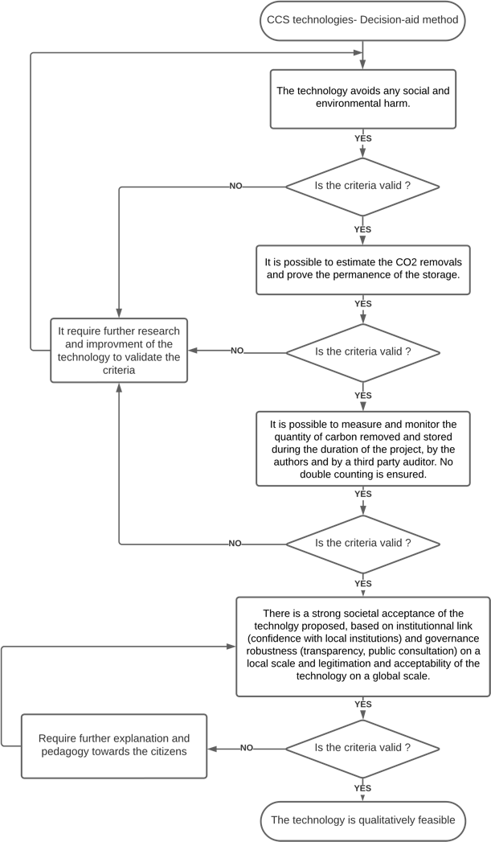
The decision-aid method, illustrated in Figure 1, helps in tracking through four simple steps whether a proposed technology is qualitatively viable or not. The first step, “the technology avoids any social and environmental harm”, verifies that the project does not provoke any social or environmental harm. It ensures compliance with basic human rights and laws, avoids socially and environmentally sensitive areas, and prevents the generation of any social or environmental harm. The second step states that “it is possible to estimate the CO₂ removals and prove the permanence of the storage. The categories of impact from the Life Cycle Assessment (LCA) are considered in the estimation”. This step applies to the development phase of the project (thinking phase), where estimation and previous analysis of potential impacts are made. It entails estimating CO₂ removals using a robust and clear calculation methodology, undergoing peer review. The estimation process considers all impacts, aligning with the principles of LCA (such as global warming potential, ozone depletion, eutrophication, acidification, depletion of abiotic resources, water and land use, and ecotoxicity). It is also based on “permanence”, which requires demonstrating permanent reductions in GHG emissions and proving the absence or reversal of such emissions. The third step requires the validation of the following sentences: “It is possible to measure and monitor the quantity of carbon removed and stored during the duration of the project, by the authors and by a third-party auditor. No double counting is ensured”. This step is linked to the ongoing phase of the project: the measures done during the project, by the authors or by a third-party auditor. The concept of “measurability and monitoring” is used to emphasize the importance of transparent and demonstrated measurement practices and strong monitoring throughout the project's duration. These practices should be carried out by a trusted local player. “Verifiability” is another crucial indication, that necessitates professional verification of the project by tird-party auditor (preferably with specific accreditation). The verification process occurs from the starting date and is repeated, with publicly available audit results. Finally, the notion of “ownership and unicity” ensures that no double counting occurs, and the ownership of credits is enforceable. If the first three criteria are not validated, further research and improvement of the technology to validate the criteria must be carried out. The fourth step stipulates that “there is a strong societal acceptance of the technology proposed, based on the institutional link (confidence with local institutions) and governance robustness (transparency, public consultation) on a local scale and acceptability of the technology on a global scale”. If it appears to be incomplete, the project should be modified or further explanation towards citizens should be conducted. To maintain the “governance robustness”, the project should have strong overall program governance, transparency regarding the project’s progress, and public consultation. A complaints appeal policy should be in place, and the project's methodologies and registry design should operate independently from commercial activities. Lastly, “institutional link” highlights the importance of integrating the project into the local institutional ecosystem.
Figure 1: Decision-aid qualitative methods of CCS technologies.
  - Mineralization technologies
ERW is an inorganic carbon sequestration technique with the capacity to store CO₂ for over 100,000 years (Beerling et al., 2020). It is used on agricultural lands and oceanic areas. ERW works according to the following steps: crushed silicate rock is spread in soil or on coastal environments/ocean and dissolves, liberating base cations (as Mg²⁺, Ca²⁺). These cations generate alkalinity that draws down CO₂ from the atmosphere by forming principally carbonate ions. There is an increase in the seawater alkalinity resulting in additional CO₂ uptake from the atmosphere, occurring also with ERW on agricultural lands, as some of the minerals are washed to the ocean via soil drainage waters.
Storing underground via mineralization the CO₂ already captured in large quantities consists of injecting underground (in reactive rocks, such as mafic and ultramafic rocks) CO₂ dissolved in water, requiring twenty-five tons of water for one ton of CO₂ injected (Delerce and Oelkers, 2022). The solution reacts with reservoir rocks to trap CO₂ in the form of carbonate minerals. Solubility trapping occurs immediately, and most of the CO₂ injected reacts and reaches a stable form within two years (Snæbjörnsdóttir et al., 2020).
  - Analysis of the mineralization technologies with the decision-aid method
    - Analysis of ERW on agricultural lands
The step one of the decision-aid method, “avoiding social and environmental harm”, faces a lack of knowledge in the actual state of the art that impeaches to fulfil it. The main risk is the contamination of lands, crops, and groundwaters with heavy metals and toxic substances, such as nickel and chromium, present in the rocks (Schuiling and Krijgsman, 2006). Moreover, the project leaders should be careful that there is no trade-off between carbon sequestration and crop production, as ERW could decrease the organic carbon content in soils and threaten food security (Lehman and Possinger, 2020). Then, the local impact of mines to extract the rocks is also to be analysed via an LCA study, as it destroys locally the environment. Another provenance of rocks (via industrial alkaline waste) would reduce this impact (Castro-Amoedo et al., 2023). Therefore, the criteria “Avoiding Social and Environmental harm” require further investigation and mitigation to be sure that there is no risk at all. Concerning step two, the estimation of the storage permanence, the storage has been established with the state-of-the-art study, that attests that once mineralized the carbon is stable and trapped for geological time spans (Beerling et al., 2020). The estimation of the carbon removal, and its validation will depend on the method proposed to assess the quantity of CO₂ that will be captured. Concerning step three, e. g. the measurability and the monitoring of carbon removal during the project, it seems possible to extend and realize a proper estimation method, verifiable by a third party. Samples of rocks can be analysed before the spreading and after a few months to assess the quantity of carbon removed. Step four, or governance robustness and institutional link have not been established yet, due to a lack of regulation of this specific practice.
4.2 Analysis of ERW on coastal environments and oceans
The criteria one, avoidance of social and environmental harm, has not been fulfilled. It is due to a lack of knowledge over the possible addition of toxic substances in the ocean as nickel and its impact on marine ecosystems. The impact of the increase in rates of some metals as Mg²⁺, Si, Fe^{2+,} and Ni²⁺ has to be assessed as well (Bach et al., 2019). The local impact of mines to extract the rocks is also to be analysed via an LCA study, as it destroys locally the environment. Concerning step two, e.g. estimation of the CO₂ removal and the permanence of the storage, it is impeached by the occurrence of secondary reactions, making olivine dissolution's effectiveness in CO₂ sequestration under oceanic conditions uncertain (Montserrat et al., 2017). This aspect requires further investigation. To finish with, the LCA must be carefully conducted, as the small size of grains required to achieve effective mineralization requires a consequent energetic consumption (Hangx and Spiers, 2009). Step three is not validated as well: at this stage, it is impossible to monitor (due to the absence of an indicator) or even estimate the quantity of atmospheric CO₂ effectively captured. Furthermore, the possible co-reactions make it impossible to statute on the permanence of the storage (Montserrat et al., 2017). Concerning step four, the potential of toxicity of this technology and the knowledge gaps could impeach societal acceptance (Bach et al., 2019). No law concerning ERW in oceanic areas has been stated in Europe as far as we are aware. There is a high risk of social contestations if the beaches turn green due to the dispersion of olivine. To be qualitatively feasible, this technology thus requires further investigations on a scientific level, treating all the subjects mentioned before.
4.3 Analysis of CO₂ underground storage via mineralization
This technology has been judged as avoiding any social or environmental harm, as there is no risk of CO₂ leakage during storage (Delerce and Oelkers, 2022). Step one is therefore completed. The major blocking point is the decarbonized electricity required for the DAC and the need for a huge amount of fresh water. Due to these needs, this technology can be achieved in Iceland mostly, however, it is critical for other countries. Concerning step two, it is considered that a proper estimation of the quantity of carbon removed could be established before the project with models and calculations. The permanence of the project has been validated through the state-of-the-art study, attesting that carbon dioxide is mineralized and stable for geological time spans (Delerce and Oelkers, 2022). Furthermore, for step three, the measurability and monitoring can be achieved easily according to the CO₂ captured and then injected underground. This step is verifiable by a third part. To finish, as underground carbon storage can be criticized and impeached by local protests (O’Neill et al., 2012), it has not been established whether the social acceptance criteria (step four) is fulfilled or not. This point might require further investigations concerning the implantation of the technology in new areas. The global conclusion is positive at the state-of-the-art level of research.
  - Conclusions
Different mineralization technologies for CCS have been examined and a qualitative methodology to compare them has been proposed. This methodology includes criteria such as social and environmental impacts, storage permanence, measurability, and monitoring, as well as social acceptance. For ERW on agricultural lands, several criteria have been met, but uncertainties remain regarding the potential risks of soil and crop contamination by metals present in the rocks. The question of the impact on food production should also be considered. Social acceptance and specific regulations are still in development. Coastal and marine ERW faces uncertainties related to secondary reactions and requires scientific research on this point. Aspects related to measuring the quantity of captured CO₂ and the permanence of storage remain to be clarified. Moreover, potential toxicity and social risks related to the dispersion of rocks on beaches require further study. Underground CO₂ storage via mineralization appears promising but faces challenges related to the availability of decarbonized electricity and fresh water in certain regions. It seems to address major concerns related to social and environmental impacts, including the avoidance of CO₂ leakage. The decision on which technology to prioritize among various CCS options requires a thorough evaluation based on criteria such as cost, energy efficiency, environmental impact, thermodynamic indicators, and social acceptance. The qualitative decision-aid method presented here provides a first step toward a more comprehensive assessment. Clear regulations and standards are imperative to guide the choice of CCS technologies and ensure responsible implementation.
References
Arcusa, S. and Sprenkle-Hyppolite, S., 2022. Snapshot of the Carbon Dioxide Removal certification and standards ecosystem (2021–2022). Climate Policy, 22(9-10), pp.1319-1332.
Bach, L.T., Gill, S.J., Rickaby, R.E., Gore, S. and Renforth, P., 2019. CO₂ removal with enhanced weathering and ocean alkalinity enhancement: potential risks and co-benefits for marine pelagic ecosystems. Frontiers in Climate, 1, p.7.
Beerling, D.J., Kantzas, E.P., Lomas, M.R., Wade, P., Eufrasio, R.M., Renforth, P., Sarkar, B., Andrews, M.G., James, R.H., Pearce, C.R. and Mercure, J.F., 2020. Potential for large-scale CO₂ removal via enhanced rock weathering with croplands. Nature, 583(7815), pp.242-248.
Bouckaert, S., Pales, A.F., McGlade, C., Remme, U., Wanner, B., Varro, L., D'Ambrosio, D. and Spencer, T., 2021. Net zero by 2050: A roadmap for the global energy sector.
Castro-Amoedo, R., Granacher, J., Abou Daher, M. and Maréchal, F., 2023. Integrating CO₂ Mineralization in Industrial Clusters: The Benefits of Material and Heat Integration. Proceedings of FOCAPO/CPC.
Delerce, S. and Oelkers, É.H., 2022, January. Le potentiel du stockage géologique du CO₂ par minéralisation. In Annales des Mines-Responsabilité et environnement (No. 1, pp. 57-62).
Delerce, S., Marieni, C. and Oelkers, E.H., 2023. Carbonate geochemistry and its role in geologic carbon storage. Surface Process, Transportation, and Storage, pp.423-477.
European Parliament, 2022. A union certification framework for carbon removals. EU legislation in progress, pp.1-8.
Hangx, S.J. and Spiers, C.J., 2009. Coastal spreading of olivine to control atmospheric CO₂ concentrations: A critical analysis of viability. International Journal of Greenhouse Gas Control, 3(6), pp.757-767.
Lehmann, J. and Possinger, A., 2020. Removal of atmospheric CO₂ by rock weathering holds promise for mitigating climate change.
Montserrat, F., Renforth, P., Hartmann, J., Leermakers, M., Knops, P. and Meysman, F.J., 2017. Olivine dissolution in seawater: implications for CO2 sequestration through enhanced weathering in coastal environments. Environmental Science & Technology, 51(7), pp.3960-3972.
O’Neill, R.N. and Nadaï, A., 2012. Risque et démonstration, la politique de capture et de stockage du dioxyde de carbone (CCS) dans l’Union européenne. VertigO-la revue électronique en sciences de l'environnement, 12(1).
Roelich, K. and Giesekam, J., 2019. Decision making under uncertainty in climate change mitigation: introducing multiple actor motivations, agency and influence. Climate policy, 19(2), pp.175-188.
Schuiling, R.D. and Krijgsman, P., 2006. Enhanced weathering: an effective and cheap tool to sequester CO₂. Climatic Change, 74(1-3), pp.349-354.
Selma, L., Seigo, O., Dohle, S. and Siegrist, M., 2014. Public perception of carbon capture and storage (CCS): A review. Renewable and Sustainable Energy Reviews, 38, pp.848-863.
Snæbjörnsdóttir, S.Ó., Sigfússon, B., Marieni, C., Goldberg, D., Gislason, S.R. and Oelkers, E.H., 2020. Carbon dioxide storage through mineral carbonation. Nature Reviews Earth & Environment, 1(2), pp.90-102.

