A Method of Generating Transition Pathways to a Future Refinery
Yi Zhao,^{a*} Pullah Bhatnagar,ª Hayato Hagi,^{b} Bruno Delahaye,^{c} François Maréchalª
ªIndustry Process and Energy Systems Engineering, École Polytechnique Fédérale de Lausanne, Rue de l’industrie 17, 1950 Sion, Switzerland
^{b}TotalEnergies Research & Technology, TotalEnergies OneTech, 76700 Harfleur, France
^{c}TotalEnergies Hybrid & Storage, TotalEnergies OneTech, 92078 Cedex, France
*yi.zhao@epfl.ch
Abstract
In the context of a global imperative for industries to achieve net-zero emissions, this work introduces a methodological framework for establishing possible transition pathways with interim targets aimed at reducing emissions and minimizing costs. The methodology begins by generating different pathways through a multi-period mixed-integer linear programming formula, which takes into account market evolutions such as natural gas prices, renewable energy penetration, and future technology developments. Subsequently, a multi-criteria analysis is applied to select the most promising transition pathways based on predefined key performance indicators (KPIs) and decision metrics. To validate the methodology's effectiveness, a Blueprint oil refinery case study is conducted. The results demonstrate that a net emission reduction over the entire lifespan can be achieved through the implementation of carbon capture and/or electrification technologies at appropriate time steps. The methodology highlights the potential investment decision strategies according to the selected KPI, under predefined assumptions, offering insights for industry stakeholders and policymakers.

Keywords: Transition Pathway, Investment planning, Technology evolution, Refinery.
  - Introduction
The Sixth Assessment report by the Intergovernmental Panel on Climate Change (IPCC) emphasizes the formidable task of limiting the global average temperature rise to 1.5-2°C since 1850, requiring a substantial reduction in cumulative emissions (Masson 2021). While there has been a global effort to achieve net zero, spanning numerous industries and sectors, the significance of optimal transition pathways has not received adequate attention. Industrial sector, responsible for a quarter of global emissions, must evolve to reduce emissions during its lifespan and foster a low-carbon future.
However, determining an optimization pathway for industrial sector faces the following challenges:
- Exhaustive decarbonization options: Overlooking certain potential clean technologies and methods may lead to local suboptimal solutions.
- Market Uncertainty: Fluctuations in costs and the demand for critical utilities, such as natural gas, significantly impact industrial decision-making.
- Technology Evolution: As technology continually evolves, so do associated costs and carbon footprints. A comprehensive understanding of these trends is essential when integrating future technologies.
Valuable research has been carried out in the field of investment planning, including the work of Barkitzi et al. (2012), which emphasizes the advantages of long-term planning for flexibility in decision-making, and Butun et al. (2019), who integrated Investment Planning models into process integration to estimate investment costs of infrastructure demolition at the end-of-life. However, there remains a gap in methodologies tailored to transitional pathways that consider uncertainties and changing tax implications related to emissions. In this work, we present an approach that leverages stochastic optimization addressing uncertainties on markets and future technology costs. This approach facilitates the estimation of the most promising transition pathways based on predefined decision metrics, filling the gap in existing literature and providing a valuable tool for addressing the pressing challenges faced by the industry in the context of climate change mitigation.
  - Methodology
As illustrated in Figure 1, the optimization framework comprises two key sections: a configuration generation section using multi-period mixed integer linear programing (MILP) and a solution ranking section based on selected key performance indicators (KPIs) and decision metrics. During the configuration generation stage, a superstructure is first established combining the industrial sectors and potential decarbonization options with mass and heat integration. This combined superstructure is then solved with a multi-period MILP formula, leading to an unique configuration featuring a collection of decarbonization options that are optimally integrated within the refinery by allowing site-wide heat flows matching.
Multiple market conditions, including electricity price and carbon footprint, natural gas prices and future technology costs are given as incentives to the MILP formula to systematically generate a set of good configurations. In the multi-criterial solution ranking stage, key performance indicators for those different configurations are calculated considering investment planning constraints, including technology construction, resize and decommission. The configurations are then ranked based on the pre-defined decision metrics from the most promising to the least preferred under certain market conditions.

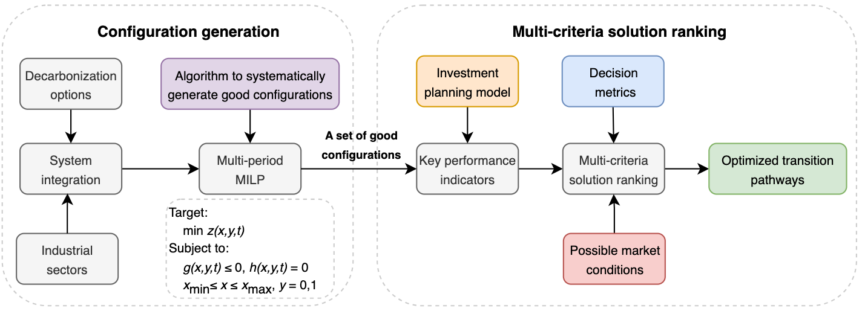
Figure 1. Methodology framework of generating optimal transition pathways. A multi-period MILP formula consists of optimization targets (z), continuous variables(x) and binary variables (y), as well as inequality and equality constraints (g and h).
A systematic method for generating future market scenarios is crucial to produce a diverse range of viable configurations. The transition of an industrial sector is propelled by both exogenous drivers, such as increasingly stringent environmental regulations, and endogenous forces, including decreasing technology and energy costs. In this study, we employed a kinetic evolution model to simulate renewable penetration, future energy costs and decarbonization targets. This kinetic model, also known as the 'S' curve, has been validated by Li et al. (2023) in the field of energy system modeling. As depicted in Eq. (1), with the initial and final states predefined, the model is governed by two critical parameters: c and k, representing the speed and smoothness of the transition, respectively.
$S\left[k,c\right]= \frac{1}{1+e^{k(c-t)}}$ (1)
By adjusting the values of k and c (typically k ranges from 0.1 to 1 and c ranges from 10 to 30 dependent on the initial and final status), a broad spectrum of market conditions and decarbonization targets can be generated. In this stage, the primary focus is not on achieving precise market condition predictions. Instead, we make reasonable assumptions and apply a wide range of possible market conditions to generate a database consisting of a set of viable configurations from which decision-makers can choose. An illustrative example of future market conditions is presented in Figure 2.
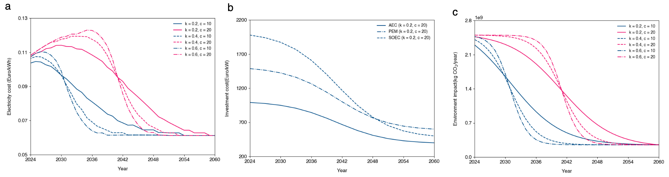
Figure 2. (a) Electricity cost calculated based on renewable penetration evolution under assumptions of final renewable penetration of 90% in 2060 with various k and c values and electricity technology costs from IEA; (b) Future costs of AEC, PEM, and SOEC electrolysis technologies; (c) Decarbonization targets at different time periods.

An investment planning model was integrated into the multi-period MILP process integration formula to generate diverse transition pathways. For a specific configuration consisting of a set of units with sizes represented as f_{u,t} at the i-th year, the net present values of its investment costs encompass both the cost of acquiring new units (Cinv^{buy}) and the expenses associated with dismantling these units (Cinv^{renew}) when they reach the end of their lifespan for each unit u in U and each time period t in T , where i is the interest rate considered for the investment (Eq. (4)).
$Cinv=\sum_{t=1}^{T}{\sum_{u=1}^{U}{\left({Cinv}_{u,t}^{buy}+{Cinv}_{u,t}^{renew}\right)∙\frac{1}{{(1+i)}^{t}}}}$ (2)
Precisely, the investment cost for the initial period is less than 25% of the total investment over the entire project's lifespan.
$\sum_{u=1}^{U}{\left({Cinv}_{u,1}^{buy}+{Cinv}_{u,1}^{renew}\right)∙\frac{1}{(1+i)}}≤0.25∙Cinv$ (3)
Similarly, the net present value of its operating cost (Cop) is calculated in Eq. (4), where t_{op} is the operating time for each time period t.
$Cop=\sum_{t=1}^{T}{\sum_{u=1}^{U}{({Cop}_{u,t}∙t_{op}∙\frac{1}{{\left(1+i\right)}^{t}})}}$ (4)
The total system emissions (Imp) are quantified by Eq. (5), which calculates the integral of emissions over the entire lifespan.
$Imp=\sum_{t=1}^{T}{\sum_{u=1}^{U}{({Imp}_{u,t}∙t_{op})}}$ (5)
Different solutions are subsequently ranked based on predefined decision metrics, assigning distinct weight factors to the KPIs as outlined in Eq. (6). Weight factors are defined with realistic requirements. In this work, we assign the values w₁ and w₂ as 1, and designate w₃ as the carbon tax factor. This way, different configurations are ranked based on their net present value, which accounts for the costs associated with the implementation of carbon tax.
$Metrics=w_{1}∙Cinv+w_{2}∙Cop+w_{3}∙Imp$ (6)
To mitigate the impact of uncertainties, we can take into account a range of potential market conditions during the ranking process and select the configuration that exhibits the best overall performance across all these conceivable market conditions.
  - Case study and results
The methodology was validated with the Blueprint refinery model (Cervo et al. 2020), representing the average European refining profile using crude oil as the primary feedstock (Figure 3). The use of public resources and databases may limit specificity for individual industrial stakeholders. However, the framework is designed to enable stakeholders to customize inputs for relevance to their specific requirements. In this context, various options were explored for decarbonizing the current refining assets, such as energy efficiency approaches, clean hydrogen production, renewable energy feedstock, and carbon capture. Each decarbonization option is characterized by its mass balance, heat cascade, investment cost, and carbon footprint. Investment cost data is available in Li et al. (2023), while carbon footprints are sourced from the Ecoinvent database. Table 1 provides a summary of the techno-economic assumptions for these decarbonization options.
Table 1. Techno-economic assumptions of the decarbonization technologies considered in the oil refinery adapted from Li et al. (2023)
Decarbonization option | Assumptions
Gas turbine | Heat efficiency: 55%; Electrical efficiency: 30%; Investment: 2500 €/kW_{eq}
Biogas boiler | Investment cost: not considered; Biogas price: 5 times of natural gas price
Hydrogen recycling | Investment cost: calculated based on compressor and hydrogen purifiers
Heat pump | Carnot efficiency: 55%; Investment: 500 €/MW_{eq} of heat available.
Electric heater | Investment: 300 €/kW_{eq}
AEC | System efficiency: 60%; Operating at 80 °C; Investment: 1000~500 €/kW_{eq}
PEM | System efficiency: 70%; Operating at 80 °C; Investment: 1500~600 €/kW_{eq}
SOEC | System efficiency: 85%; Operating at 800 °C; Investment: 2000~400 €/kW_{eq}
Carbon capture (MEA) | Capture efficiency: 90%; Heat: 3.8 MJ/ton CO₂; Investment: 2 M€/(t/h) CO₂
Carbon capture (Oxy) | Capture efficiency: 95%; 226 kWh/ton O₂, Investment: 0.6 M€/(t/h) CO₂
CO₂ compression | Energy demand: 120 kWh/ton CO₂; Investment: 3500 €/kW_{eq}
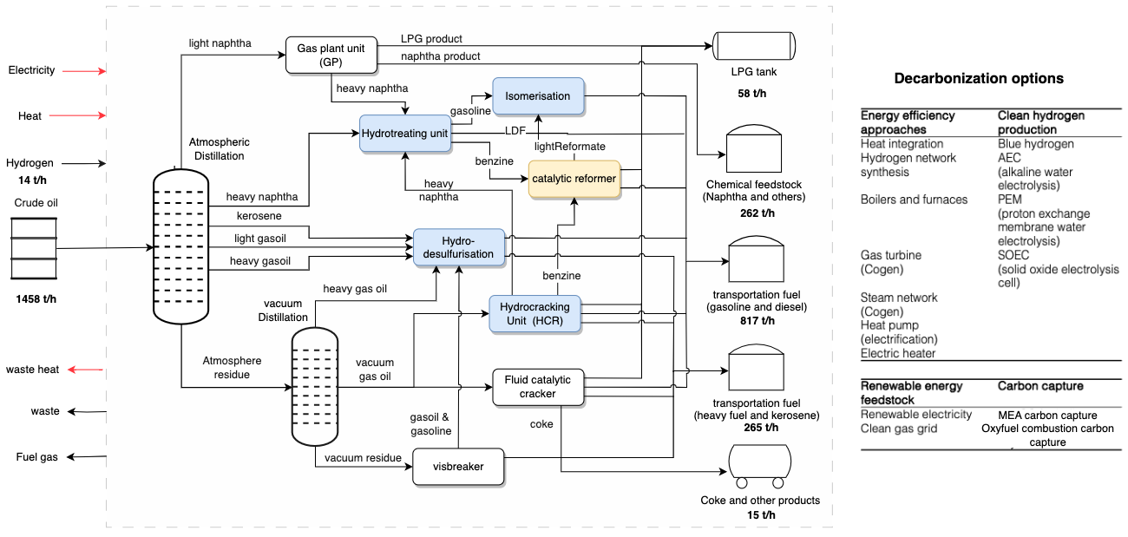
Figure 3. The superstructure of the Blueprint refinery with decarbonization options.
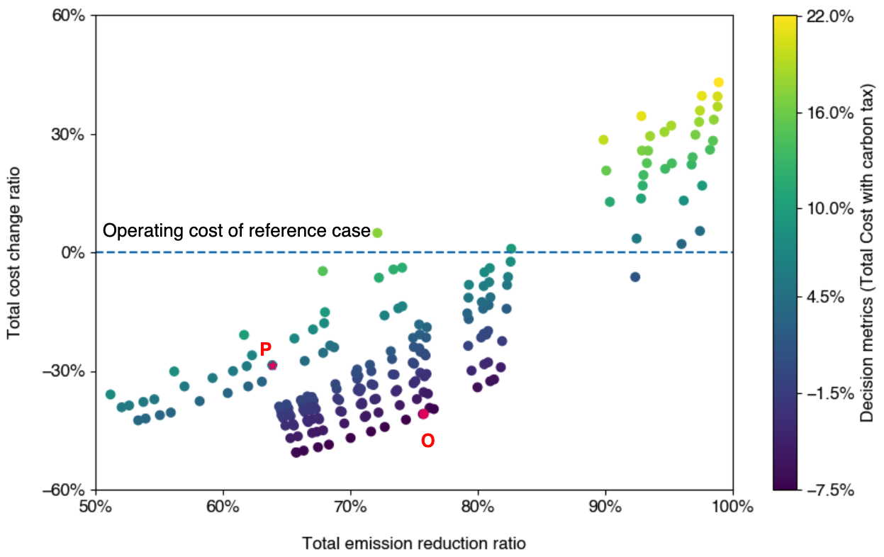
Figure 4: Average net present total cost change ratio against average total carbon emissions reduction ratio over the lifespan of the refinery, considering a market condition with a final renewable penetration of 90%, k = 0.2, and c = 10. Each data point represents a unique configuration. Decision metrics is calculated using Eq. (5).

In this study, 200 different energy market conditions (electricity, natural gas prices and emission constraints) were applied to generate a diverse range of configurations, resulting in a number of unique configurations after sorting and clustering. These unique configurations were subsequently ranked based on selected market scenarios and predefined decision metrics, which are illustrated in Figure 4. A clear trade-off between emission savings and total costs is observed compared to the reference case. The assumption of decreasing natural gas and electricity prices results in a significant number of configurations exhibiting lower total costs than those observed today.
The decision metrics identify configuration O as the optimal, with a minimum equivalent total cost reduction of 40%. Figure 5(a) provides insights into investment values and their distribution among different technologies and periods of configuration O. The optimizer prioritizes taking actions in the initial period, activating technologies such as carbon capture, hydrogen recycling, and heat pumps. Notably, the heat pump is used to fulfil the heat demand for solvent regeneration in the desorption column. These prompt actions lead to 50% of emission reductions in refineries. Another substantial investment is foreseen around 2050 marked by investments on carbon capture on biogenic emissions to meet zero emission target in 2060 as a negative emission solution. This shift is further illustrated in Figure 5 (b). In this proposed configuration, preference is given to carbon capture technologies. However, it is crucial to acknowledge that carbon capture costs and efficiencies can vary significantly based on the emission source in refineries. Neglecting considerations in this study for CO₂ transportation and storage may result in an overestimation of carbon capture potentials. In our analysis, approximately 40% of onsite carbon emissions were captured and compressed to 110 bars in 2024. However, the downstream treatment could be deemed unrealistic today due to limited infrastructure for utilization and storage. This aspect should be approached with further careful consideration.
When considering a faster transition (higher k value) of renewable penetration, configuration P emerges as the better option. Instead of relying on carbon capture, electrification is predominantly observed through green hydrogen production and electric heaters. Solid Oxide Electrolysis Cell (SOEC) outperforms Alkaline Electrolysis Cell (AEC) and Proton Exchange Membrane (PEM) due to its high efficiency and capability to utilize waste heat in refineries for steam generation. With a further decrease in electricity prices and carbon footprints, oxyfuel combustion starts to be applied. However, as a negative emission solution, carbon capture on biogenic emissions continues to dominate post-2050 to offset onsite emissions, achieving zero emission targets in 2060.
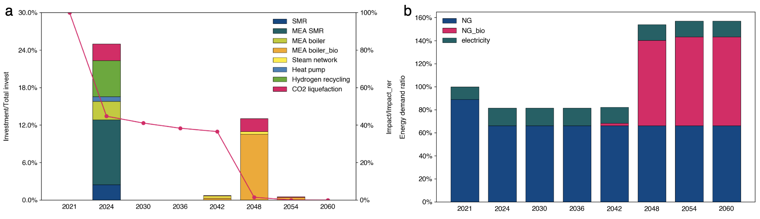
Figure 5: Share of (a) investment of different technologies and (b) natural gas, biogas and electricity imports at different time periods of configuration O 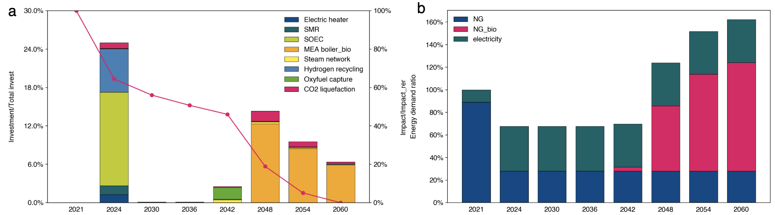
Figure 6: Share of (a) investment of different technologies and (b) natural gas, biogas and electricity imports at different time periods of configuration P
  - Conclusions
In this study, we have developed a robust methodology for evaluating investment strategies in the industrial sector, specifically focusing on the generation and selection of optimal transition pathways. This method has been applied successfully to an oil refinery case study, where investment strategies were generated and pathways leading to the minimization of predefined decision metrics under the given hypotheses were determined and analyzed. In comparison to the base case scenario in 2023, the identified pathways prioritized initial investments in carbon capture or electrification technologies according to the selected energy markets assumptions and decision metrics, resulting in a net emission reduction over the entire lifespan of the refinery. Our future work involves more realistic considerations about heat integration constraints than can be encountered in real industrial assets along with completing the superstructure for refinery decarbonization.
References
V. Masson-Delmotte, P.Zhai, A. Pirani, 2021, Climate change 2021, Voulume 2
G.A. Bakirtzis, P.N Biskas, and V. Chatziathanasion, 2012, Generation expansion planning ny milp considering mid-term scheduling decisions, Electric Power Systems Research, volume 86, 98-112
H.Butun, I. Kantor, and F. Marechal, 2019, An optimization approach for long-term industrial investment planning, Energies, Volume 12, no. 21, p.4076.
X. Li, & F., Maréchal, 2023, Deep excavation of the impact from endogenous and exogenous uncertainties on long-term energy planning. Energy and AI, 11, 100219.
H., Cervo, J. H., Ferrasse, B., Descale, and G. Van Eetvelde, 2020, Blueprint: A methodology facilitating data exchanges to enhance the detection of industrial symbiosis opportunities–application to a refinery. Chemical Engineering Science, 211, 115254.
Ecoinvent, Allocation, cut-off by classification, 2021, ecoinvent database version 3.8

