A Simulation-based Integration of Carbon Capture and Utilization in a Urea Production Process
Christopher Varela,^{a,*} Fernando Zea,ª Oris Correa,^{b} Kyle V. Camarda^{b}
ªEscuela Superior Politécnica del Litoral, ESPOL, Facultad de Ciencias Naturales y Matemáticas, Centro de Energías Renovables y Alternativas, Campus Gustavo Galindo km. 30 Via Perimetral, Guayaquil, P.O. Box 09-01-5863, Ecuador
^{b}Department of Chemical and Petroleum Engineering, University of Kansas, 1530 West 15th Street, Lawrence, KS 66045, USA
covarela@espol.edu.ec
Abstract
In this work, we address a novel method to produce urea from CO₂ and ammonia. This proposal allows for a high level of integration of energy and materials, reducing the costs of carbon capture and utilization. In this process, ammonia is produced via green hydrogen, nitrogen is removed from the air, and CO₂ is captured from flue gases using aqueous ammonia. Thus, ammonia is used both as a reactant and sorbent. We evaluate through simulation the direct use of the rich solvent in the urea synthesis loop, compared with conventional urea production which uses pure CO₂ and ammonia. A techno-economic analysis demonstrates that the capital and operational expenditures decrease with our proposed process by 49.2 % and 38.8 %, respectively. This substantial decrease occurs as there is no need for solvent regeneration and compression of CO₂, allowing the removal of the stripping column and multistage compression. Instead, a significant amount of water that enters the urea synthesis loop is removed via vacuum evaporation before the urea granulation. While the conventional process demands 134 GJ/h at the stripper, the evaporation units only require 75 GJ/h. The fact that renewable energy sources and renewable-based chemicals can be used for all units within the process means that the novel system provides a urea production solution that is cheaper and has a smaller environmental footprint.
Keywords: Carbon capture and utilization, green urea production, green ammonia, process integration, techno-economic assessment.

  - Introduction
Carbon capture and utilization (CCU) is a key technology within the energy transition framework. IEA (2020) stated that CCU will contribute to reducing around 4% of global emissions by 2030, mainly through newly introduced capture plants in the power and industry sectors. While there are commercial sorbents to capture CO₂ from flue gases, namely MEA and MDEA, there is currently an increased focus on aqueous ammonia solutions as a renewable replacement for fossil amines. Bak et al. (2015) conducted an experimental study on carbon capture with an ammonia sorbent at low temperature, while Zea et al. (2023) introduced different process configurations to enhance the operational performance of a simulated capture facility, including rich-solvent flashing, lean-vapor compression, and a novel crystallization unit. In addition to its role as a sorbent, ammonia plays a crucial part in producing nitrogen-based fertilizers. Urea, a highly utilized fertilizer globally, forms when CO₂ and ammonia combine, via the intermediate ammonium carbamate. This highlights a potential for integrating the carbon capture and utilization processes, offering a promising alternative to decrease overall costs.

Alfian et al. (2019) investigated various technologies to reduce the cost of producing green urea, utilizing syngas derived from biomass gasification as a raw material. In a related study, Antonetti et al. (2016) examined the utilization of municipal solid waste as an input for the urea production process. In this contribution, we present an innovative approach that utilizes the rich solvent of carbon capture (post-combustion absorption) as feed for a urea reactor. This novel method eliminates the requirement for the energy-intensive stripper column, leading to a substantial reduction in capture costs. In addition, this approach yields a valuable product, urea, from the combination of green ammonia and CO₂ sequestrated from flue gases. This results in a process with negative emissions, showing a high potential to greatly improve the fertilizers industry while capturing the emissions within a hard-to-abate sector of the chemical industry.

  - Methodology
The integration of carbon capture and urea production is assessed using the process simulators ASPEN PLUS ® and PRO/II ®. The key component is green ammonia, as it is utilized as a sorbent in post-combustion carbon capture and as a feed to a urea reactor. Ammonia is obtained via a traditional Haber-Bosch process, with the hydrogen created efficiently and at high purity from an electrolysis unit and the nitrogen recovered from air via pressure-swing absorption. Thus, the simulation includes several processes, namely alkaline water electrolysis, air separation, ammonia synthesis, post-combustion carbon capture, urea synthesis, and urea granulation. The process flowsheets and supplementary material can be found on the project website: https://co2tourea.github.io/index.html.

The evaluation is based on a comparison of capital expenditure (CAPEX) and operating expenditure (OPEX) for the base case process, denoted as conventional process, and for our proposed process, denoted as integrated process, for a fixed production capacity of 300 kilotons of urea per year. The differences between these processes are depicted in Figure 1. On the one hand, the process on the left side of Figure 1 presents a conventional urea synthesis, which uses CO₂ from flue gases captured with aqueous ammonia. This is the base case for carbon capture and utilization, where CO₂ is absorbed from flue gases, stripped out of the solvent, and compressed at high purity to feed the urea reactor. On the other hand, the process on the right side of Figure 1 presents our proposal for integration, where the rich solvent stream is directed to the urea reactor, bypassing the energy-intensive stripping section. There is a higher content of water in the urea reactor compared to the conventional process, requiring additional evaporators to be installed before the granulation section. This major modification requires adapting the operating conditions of the absorption column and urea synthesis loop. However, we expect a significant reduction in operating costs as the stripping column and the multistage compression are no longer required.

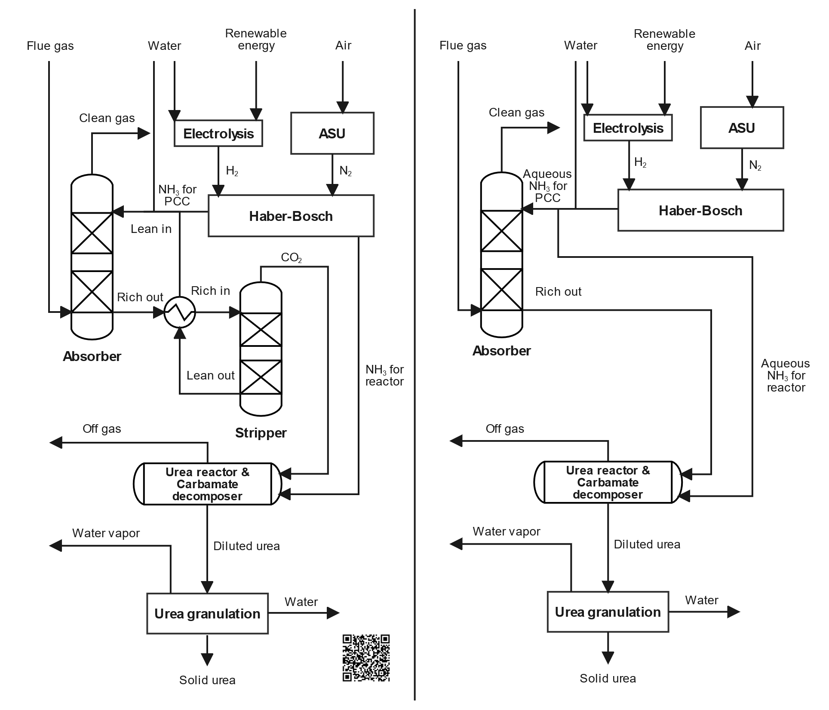

Figure 1: Base case for CCU in urea synthesis (left) and integrated process (right). The QR code directs to the project website, where detailed process flow diagrams and supplementary information can be found.

  - Results
The conventional and integrated processes enable the production of 300 kilotons per year of granular urea, by utilizing CO₂ captured from flue gases and green ammonia as main raw materials. To comprehensively assess the performance of both processes, we propose the key performance indicators (KPIs) with corresponding values provided in Table 1.

The reboiler at the stripper demands 134.1 GJ/h of heat for the conventional process, whereas the integrated process eliminates this requirement but instead demands 74.98 GJ/h of heat to concentrate the urea solution. This strategic shift in the energy demand for solvent regeneration from the capture section to the solution concentration units at the urea synthesis results in a substantial reduction in overall heat requirements. CO₂ separation from water and ammonia at the stripper takes place at around 135 °C, while water separation from urea (comprising combined CO₂ and ammonia) at the evaporators occurs at less than 100 °C using a vacuum system. Despite challenges due to the thermodynamics that govern the chemical systems of water-ammonia-CO₂ and urea-water, we find that the selection of a thermal separation that removes water from a non-reacting system yields a more effective outcome than the conventional CO₂ stripping. Thus, for this case of carbon capture and utilization in the urea synthesis, evaporating water from the urea solution is more efficient compared to stripping the CO₂ out of the ammonia sorbent.

Table 1: Comparison between the conventional and integrated CCU for urea synthesis.
KPI | Conventional  process | Integrated  process
Carbon capture rate in the absorber (%) | 81.1 | 78.5
Regeneration energy (MJ/kg_{CO2}) | 3.64 | -
Reboiler duty (GJ/h) | 134 | -
Evaporation energy (MJ/kg_{H2O}) | - | 2.41
Evaporators total duty (GJ/h) | - | 75.0
CAPEX* (MUSD) | 63.75 | 32.34
OPEX* (MUSD/year) | 35.97 | 22.39
*These calculations consider the post-combustion carbon capture, CO2 compression, urea synthesis, and urea granulation solely.

The processes present significant differences in both CAPEX and OPEX. The cost shares of the individual processes are depicted in Figures 3 and 4. While extensive discussions have centered around the stripper in the conventional process, it is crucial also to highlight the compression of CO₂ from nearly atmospheric pressure to a supercritical state at 40 bar in that process. This requires the addition of several compressors and interstage coolers. Also, a large volume of gases (mainly NH₃) must be liquified at around -25 °C to be recycled back to the reactor after the decomposition of carbamate. Therefore, conditioning the streams for the urea reactor requires a large CAPEX and OPEX. In contrast, the process integration we propose keeps the CO₂ in the liquid phase, combined with ammonia, after the absorption stage. This approach allows the process to feed the urea reactor at the required pressure with a reduced cost, as it requires pumps instead of compressors. This proposal yields a potential decrease in CAPEX by 49.2 % and OPEX by 38.8 %.

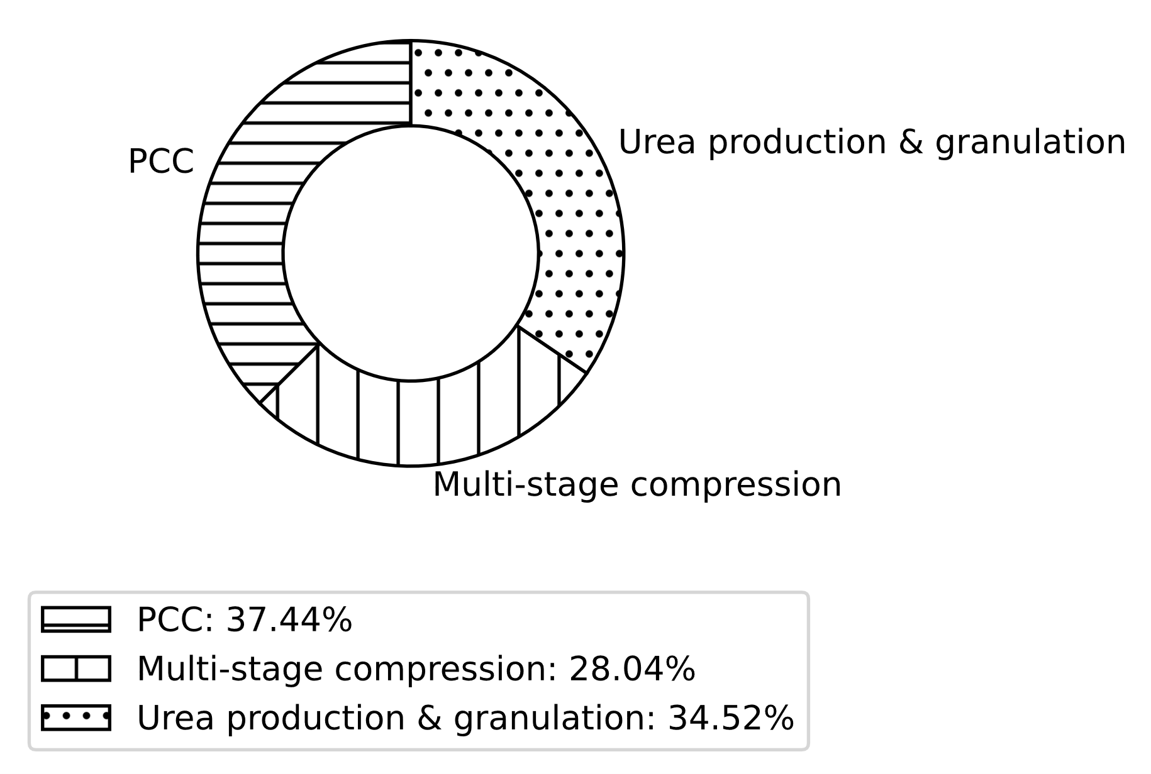  63.75  MUSD | 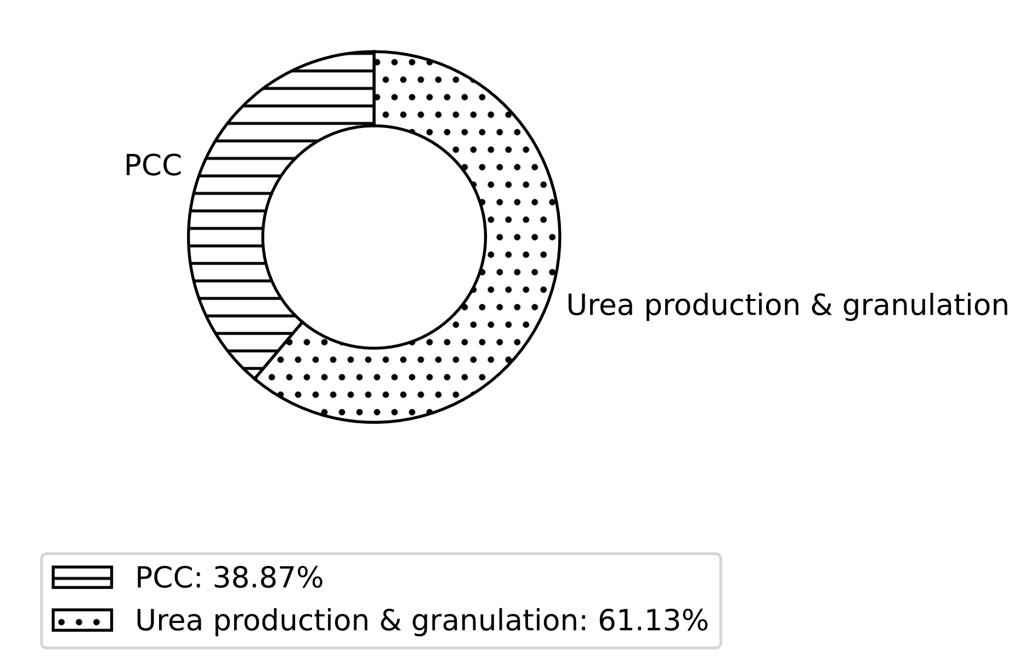  32.34  MUSD

Figure 2: CAPEX of the conventional process (left) and integrated process (right).

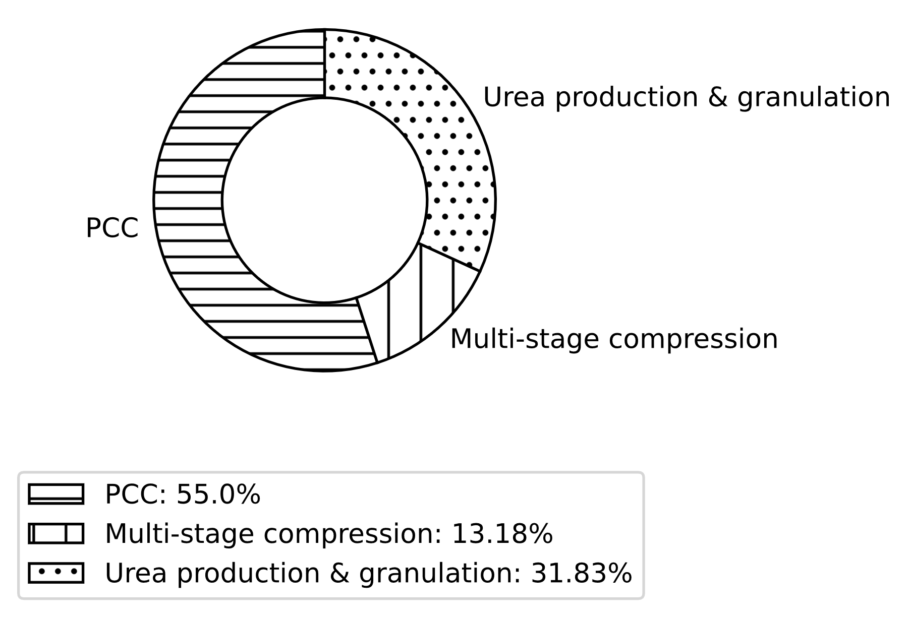  35.97  MUSD | 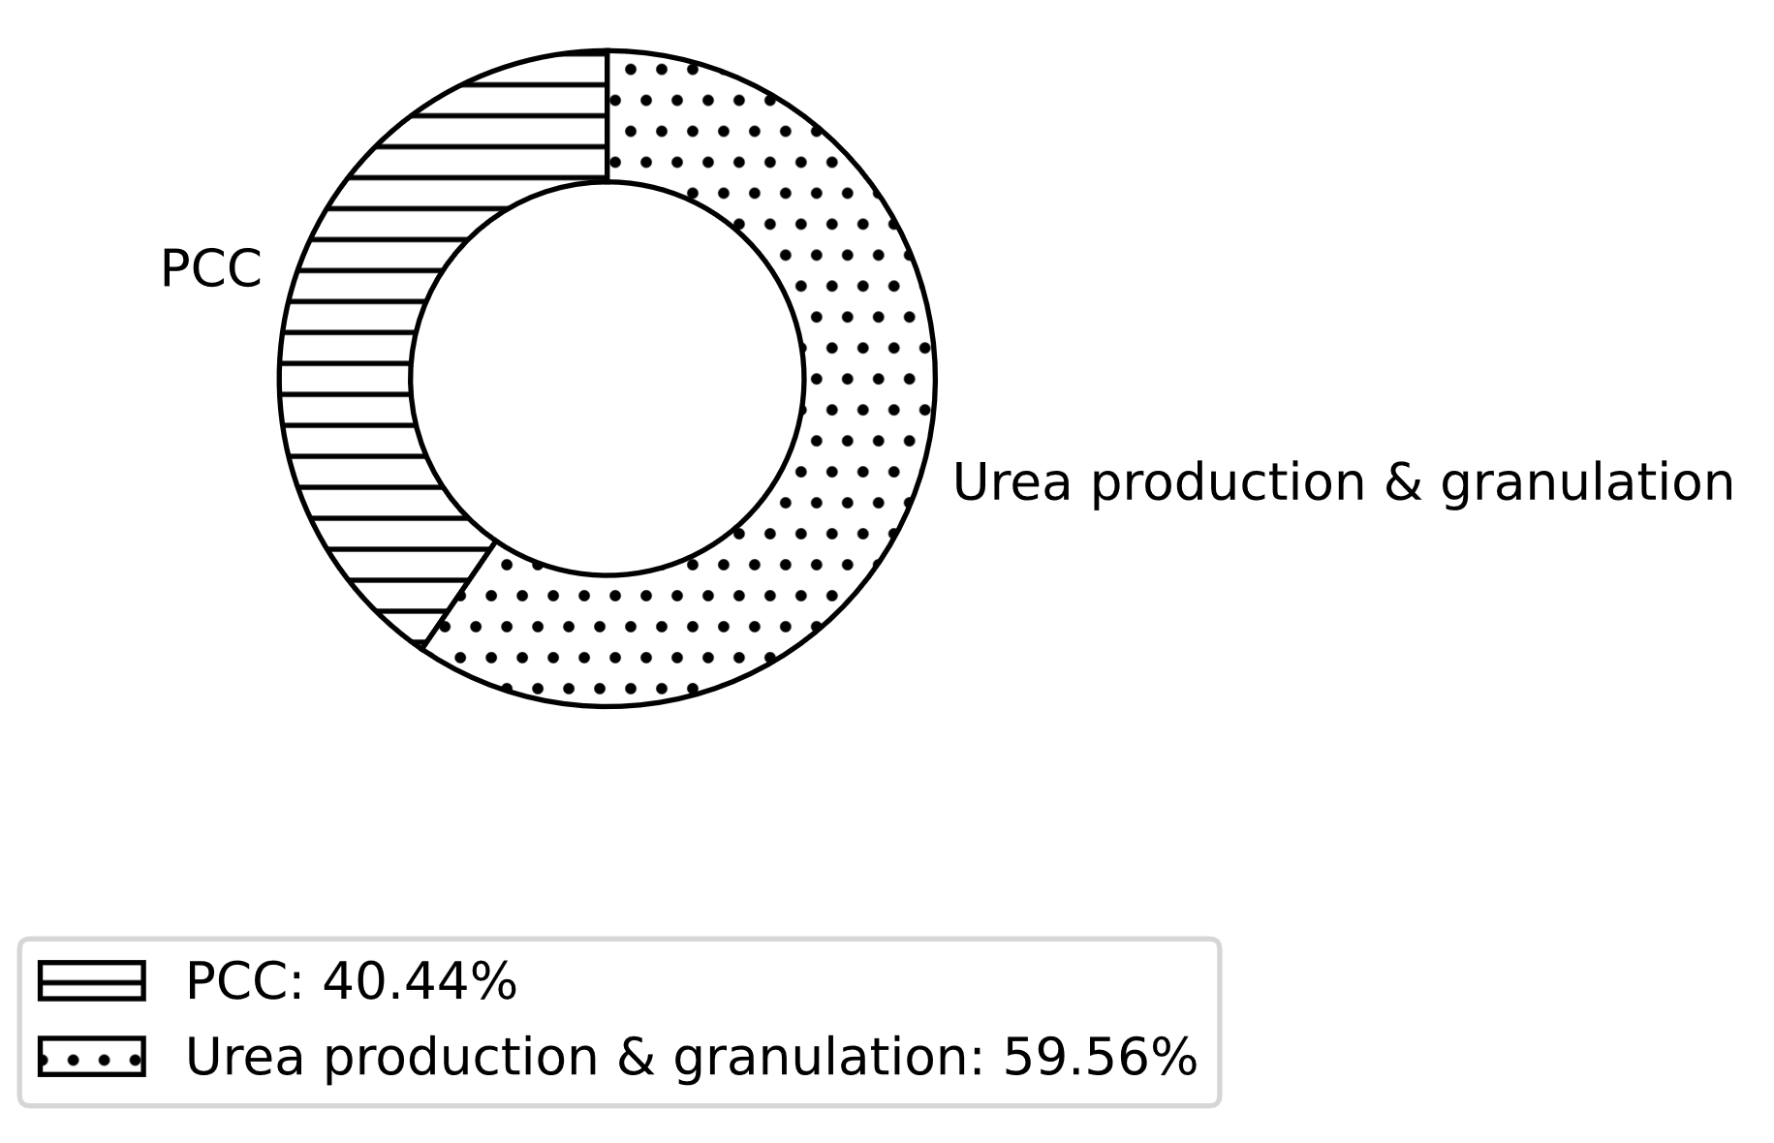  22.39  MUSD
Figure 3: OPEX of the conventional process (left) and integrated process (right).

The stripping column accounted for approximately 35% of the CAPEX in the post-combustion capture (PCC) system. The primary CAPEX reduction, amounting to 14.4 million USD, was achieved by eliminating the multistage compression. Notably, the most significant impact on OPEX was observed in the PCC process, where process integration led to a 50% reduction due to the elimination of regeneration energy requirements. Moreover, the conditioning of CO₂ and ammonia, constituting 24% of the OPEX in the conventional process, was shifted to the evaporation section in the proposed process integration. This adjustment resulted in an almost 50% increase in the OPEX of urea synthesis. However, it still represented a notable reduction compared to the conventional case.

  - Conclusions and outlook
This study introduces an integrated process for carbon capture and utilization in urea synthesis to lower the OPEX and CAPEX. Our focus is on eliminating the stripping column, which demands a significant energy input for solvent regeneration in the traditional process. Instead, the novel process benefits from the composition of the rich solvent (CO₂-ammonia-water) to directly supply the urea reactor. This approach also allows for the avoidance of the compression of CO₂ to supercritical conditions. The strategic shift allows for the elimination of costly components in the process, such as the stripping section, multistage compressors, and ammonia liquefaction equipment. However, it is to be noted that this approach yields urea with a lower concentration when it leaves the reactor due to the high content of water. This leads to additional energy demand in the implemented evaporation stage before granulation. The outcome of this study is that there is a potential decrease in CAPEX by 49.2 % and OPEX by 38.8 %.

In future work, we intend to develop advanced models for the urea reactor that consider the modified feed composition involving dissolved CO₂ in aqueous ammonia solutions. This will allow us to understand the behavior of the chemical system and optimize the operating conditions, aiming to increase the conversion. Furthermore, it is required to validate our proposal through experiments, given that the current study relies on simulations.

Acknowledgments
The authors would like to thank James Sturgill for assistance with the economic calculations, and the Department of Chemical and Petroleum Engineering at the University of Kansas and the Faculty of Natural Sciences and Mathematics at Escuela Superior Politécnica del Litoral for access to computing resources.

References
IEA, 2020, Energy Technology Perspectives 2020 - Special Report on Carbon Capture Utilisation and Storage, OECD.
C. u. Bak, M. Asif, W. S. Kim, 2015, Experimental study on CO2 capture by chilled ammonia process, Chemical Engineering Journal, vol. 265, pp. 1–8
F. Zea, D. Tinoco, C. Varela, 2023, A techno-economic evaluation of post-combustion carbon capture using renewable ammonia with different process configurations, Case Studies in Chemical and Environmental Engineering, vol. 8, p. 100502
M. Alfian, W. W. Purwanto, 2019, Multiobjective optimization of green urea production, Energy Science and Engineering, 7(2), 292-304
E. Antonetti, G. Iaquaniello, A. Salladini, L. Spadaccini, S. Perathoner, G. & Centi, 2017, Waster-to-Chemicals for a Circular Economy: The Case of Urea Production (Waste-to-Urea), ChemSusChem, 10(5), 912-920

