Estimating the potential of sustainable aviation fuel enabled aviation decarbonization in China: An integrated resource-technology-economy-environment analysis framework
Wubin Yan^{a,b}, Fangwei Cheng^{c}, Xiaonan Wang^{d}, Chuan Zhang^{a,e*}
ªInstitute of Energy, Peking University, Beijing 100871, China
^{b}College of engineering, Peking University, Beijing 100871, China
^{c}Andlinger Center for Energy and the Environment, Princeton University, Princeton, NJ 08544, USA
^{d}Department of Chemical Engineering, Tsinghua University, Beijing 100084, China
^{e}Institute of Carbon Neutrality, Peking University, Beijing 100871, China
czhang@pku.edu.cn
Abstract
The decarbonization of aviation sector has aroused extensive attention in China. Sustainable aviation fuel is widely considered as a promising strategy for aviation decarbonization. However, a realistic estimation of China’s sustainable aviation fuel enabled decarbonization potential has not been achieved so far. In order to fill this gap, system analysis including resource potential evaluation, conversion process simulation, techno-economic analysis, and environmental impact assessment are conducted to evaluate the decarbonization potential of sustainable aviation fuel in China’s aviation sector. In this study, sustainable aviation fuel is produced from six conventional crop straws in China via Gasification-Fischer-Tropsch conversion pathway. Among these straws, cotton straw and corn straw are promising feedstocks for sustainable aviation fuel production from the perspective of decarbonization cost. Considering their reserves in China, cotton straw is suitable for early industrial production of sustainable aviation fuel, while corn straw can support future large scale sustainable aviation fuel application. When the blending ratio of sustainable aviation fuel reaches 50 %, about 60 Mt CO₂e emission can be reduced, which accounts for 43 % of the emission for China’s aviation sector in 2023, showing the huge decarbonization potential of sustainable aviation fuel.
Keywords: sustainable aviation fuel, agricultural biomass, Fischer-Tropsch synthesis, techno-economic analysis, decarbonization potential.
  - Introduction
Aviation is one of the most difficult-to-decarbonize sectors among the net-zero energy transitions. China’s 2060 carbon neutrality commitment, plus the likely increasing aviation demand in the long run, further emphasizes the importance of aviation decarbonization. Replacing petroleum jet fuel (PJF) with sustainable aviation fuel (SAF) is widely considered as a promising aviation decarbonization pathway(Cavalett and Cherubini, 2018), while other strategies, such as electric and hydrogen fuel cell commuter aircrafts, are limited in their short range and technical challenges(Vardon et al., 2022).
Currently, several SAF production pathways have been certified by ASTM standards, e.g., gasification and Fischer-Tropsch (G-FT), hydroprocessed esters and fatty acids (HEFA), alcohol to jet (ATJ), and sugar to jet (STJ)(Okolie et al., 2023). Among these strategies, researchers paid constant attention to G-FT synthesis method due to its universal adaptability to feedstocks and larger life cycle CO₂ mitigation effect(Vardon et al., 2022). Besides the investigation of SAF production pathways, the assessments of SAF from environmental and economical perspectives are also meaningful, since they can help researchers understand the prospects and challenges of SAF manufacture in the future. However, previous studies mostly focused on single biomass feedstock (Alherbawi et al., 2021; Lee et al., 2023; Li et al., 2019), and there is a limited work on the comparative evaluation of SAF production from different feedstocks.
In this study, we conduct an integrated resource-technology-economy-environment analysis (RTEEA) framework to evaluate the decarbonization of SAF in China’s aviation sector, as shown in Figure 1. Six conventional crop straws, e.g., rice straw, wheat straw, corn straw, peanut straw, cotton straw, and beans straw, are selected as the feedstocks to produce SAF via G-FT synthesis pathway. By combining the results of crop straws investigation, chemical process simulation, technology-economy analysis, and life cycle emission analysis, crop straws suitable for SAF production are recommended. Finally, the decarbonization potential of SAF can be evaluated under such optimal straw feedstocks.
Figure 1. Framework of the integrated resource-technology-economy-environment analysis (RTEEA) for evaluating the decarbonization potential of sustainable aviation fuel (SAF).
  - Methods
2.1 Resource investigation
Resource investigation is the first step in the RTEEA framework, since it can provide necessary databases to support the following chemical process simulation, technology-economy analysis, and life cycle emission analysis, as shown in Figure 1. In this section, we focus on the investigation of major agricultural biomass residues in China, e.g., rice straw, wheat straw, corn straw, peanut straw, cotton straw, and beans straw. The crop straw collection potential can be calculated using Eq. (1):
$$Straw collection potential=\sum{{GY}_{i}}*STG*CF$$ | (1)
Where i is the province in China, GY is the corresponding grain yield (taken from China Statistical Yearbook 2022), STG is the straw to grain ratio(Gao et al., 2016), and CF is the collection factor of crop straw(Gao et al., 2016).
The component attributes of investigated crop straws are summarized from published literatures, and they are important parameters for the proximate and ultimate analysis in process simulation. The straw selling price database is built according to the current straw market condition in China. The crop farming investigation mainly focuses on the materials input and energy consumption during the farming process(Chen et al., 2021).
2.2 Process simulation
The production process of SAF from crop straws via G-FT synthesis is simulated on Aspen Plus software. Straws are defined as non-conventional components, and their proximate and ultimate attributes are listed in Table 1. The whole simulation process is mainly divided into 4 parts, including straw drying step, straw gasification to syngas, syngas cleaning up, and SAF production from regulated and cleaned syngas via Fischer-Tropsch reaction.
In the drying step, the moisture content of straws is regulated to 5 wt.%. Steam gasification, which has a higher exergy efficiency and can provide an optimum H₂/CO ratio for FT synthesis(Alherbawi et al., 2021), is selected to conduct the gasification of dry straws in this study. Besides CO and H₂, raw syngas usually contains H₂O (g), HCl, H₂S, NH₃, and CO₂, which may be not conducive to the following FT reaction. In the cleaning up step, HCl and H₂S are absorbed by Na₂CO₃ and ZnO respectively, NH₃ is decomposed into N₂ and H₂ catalyzed by dolomite, CO₂ is captured via organic amine solvents, and H₂O (g) is removed via condensation. Finally, the cleaned syngas (n(H₂)/n(CO) ≈ 2) is converted into hydrocarbons via FT reaction catalyzed by Co/γ-Al₂O₃. The distribution of hydrocarbons is simulated based on the Anderson-Schulz-Flory (ASF) model(Alherbawi et al., 2021).

Table 1. Proximate and ultimate analysis of different crop straws in China
Content (wt.%) | Rice straw | Wheat straw | Corn straw | Peanut straw | Cotton straw | Beans straw
Moisture | 8.11 | 8.63 | 9.31 | 8.56 | 7.66 | 9.34
Fixed carbon | 16.91 | 16.37 | 16.35 | 17.12 | 20.11 | 17.23
Volatile matter | 66.49 | 70.00 | 69.18 | 72.90 | 72.95 | 76.06
Ash | 16.60 | 13.63 | 14.47 | 9.97 | 6.94 | 6.71
C | 37.81 | 40.37 | 39.35 | 39.28 | 43.91 | 41.93
H | 6.02 | 6.26 | 5.68 | 7.00 | 6.52 | 6.70
N | 0.68 | 0.56 | 0.91 | 2.01 | 1.04 | 0.92
Cl | 0.05 | 0.05 | 0.05 | 0.05 | 0.05 | 0.05
S | 0.28 | 0.31 | 0.19 | 0.27 | 0.25 | 0.19
O | 38.56 | 38.83 | 39.35 | 41.42 | 41.29 | 43.49

2.3 Techno-economic analysis
In the techno-economic analysis (TEA) of SAF, we build a virtual biomass refinery factory with a typical 0.25 Mt/y of feedstock processing capacity. The net present value (NPV) method is applied to calculate the minimum selling price (MSP) of SAF product. NPV calculation relies on the investigation of cash flow (Wang et al., 2022).
2.4 Life-cycle assessment
The life-cycle assessment (LCA) of SAF is conducted on GREET software and some emission factors are adjusted to the context of China according to China Products Carbon Footprint Factors Database (CPCD). A typic well-to-wheel (WTW) LCA boundary contains well-to-pump (WTP) stage and pump-to-wheel (PTW) stage. As shown in Figure 2, the whole LCA boundary of SAF can be divided into 6 processes: crop farming and harvesting process, straw collection and transportation process, straw pretreatment process, straw conversion to SAF via G-FT synthesis, transportation of SAF to refueling station, and SAF combustion in aero-engine (PTW). In the transportation of straws, we assume that the straws are transported to the biorefinery 60 km away by means of the heavy-duty truck with a loading capacity of 25 t. It should be noted that CO₂ emission from combustion of biomass-derived fuels is offset by CO₂ uptake from the atmosphere by plants, so CO₂ emission in PTW stage can be ignored in the LCA of SAF.

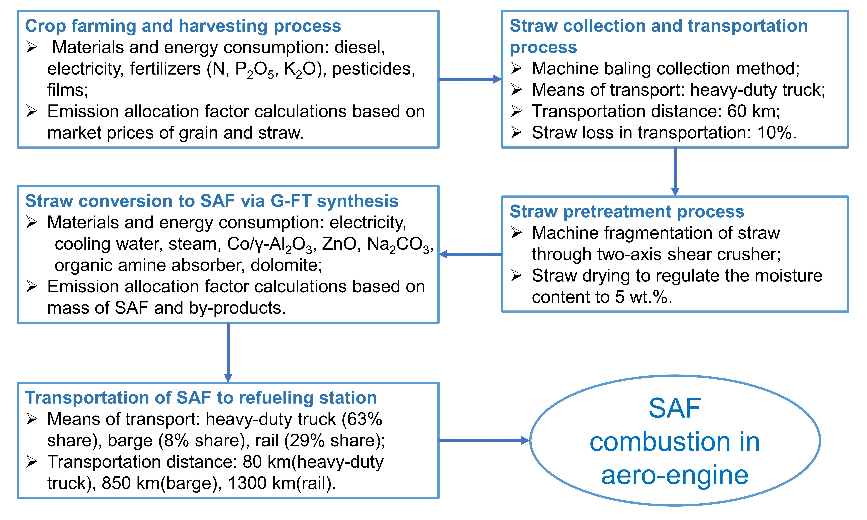
Figure 2. Life-cycle analysis boundary of sustainable aviation fuel from crop straws via G-FT synthesis.
  - Results and Discussion
The province-level distribution of major crop straws collection potential in China is shown in Figure 3a. Heilongjiang, Henan, and Shandong are the three provinces with the highest collection potential of straw biomass, since they are major agricultural provinces in China. Besides, straw collection potential in Jinlin, Xinjiang, Anhui, Hebei, Inner Mongolia, and Jiangsu province, is also considerable (over 30 Mt/y). Overall, the northern provinces produce more corn straw and wheat straw, while rice straw is the major crop straw in southern provinces. From the national perspective, corn straw accounts for the largest proportion, followed by rice straw and wheat straw, while the other crop straws occupy much smaller proportion, as shown in Figure 3b.

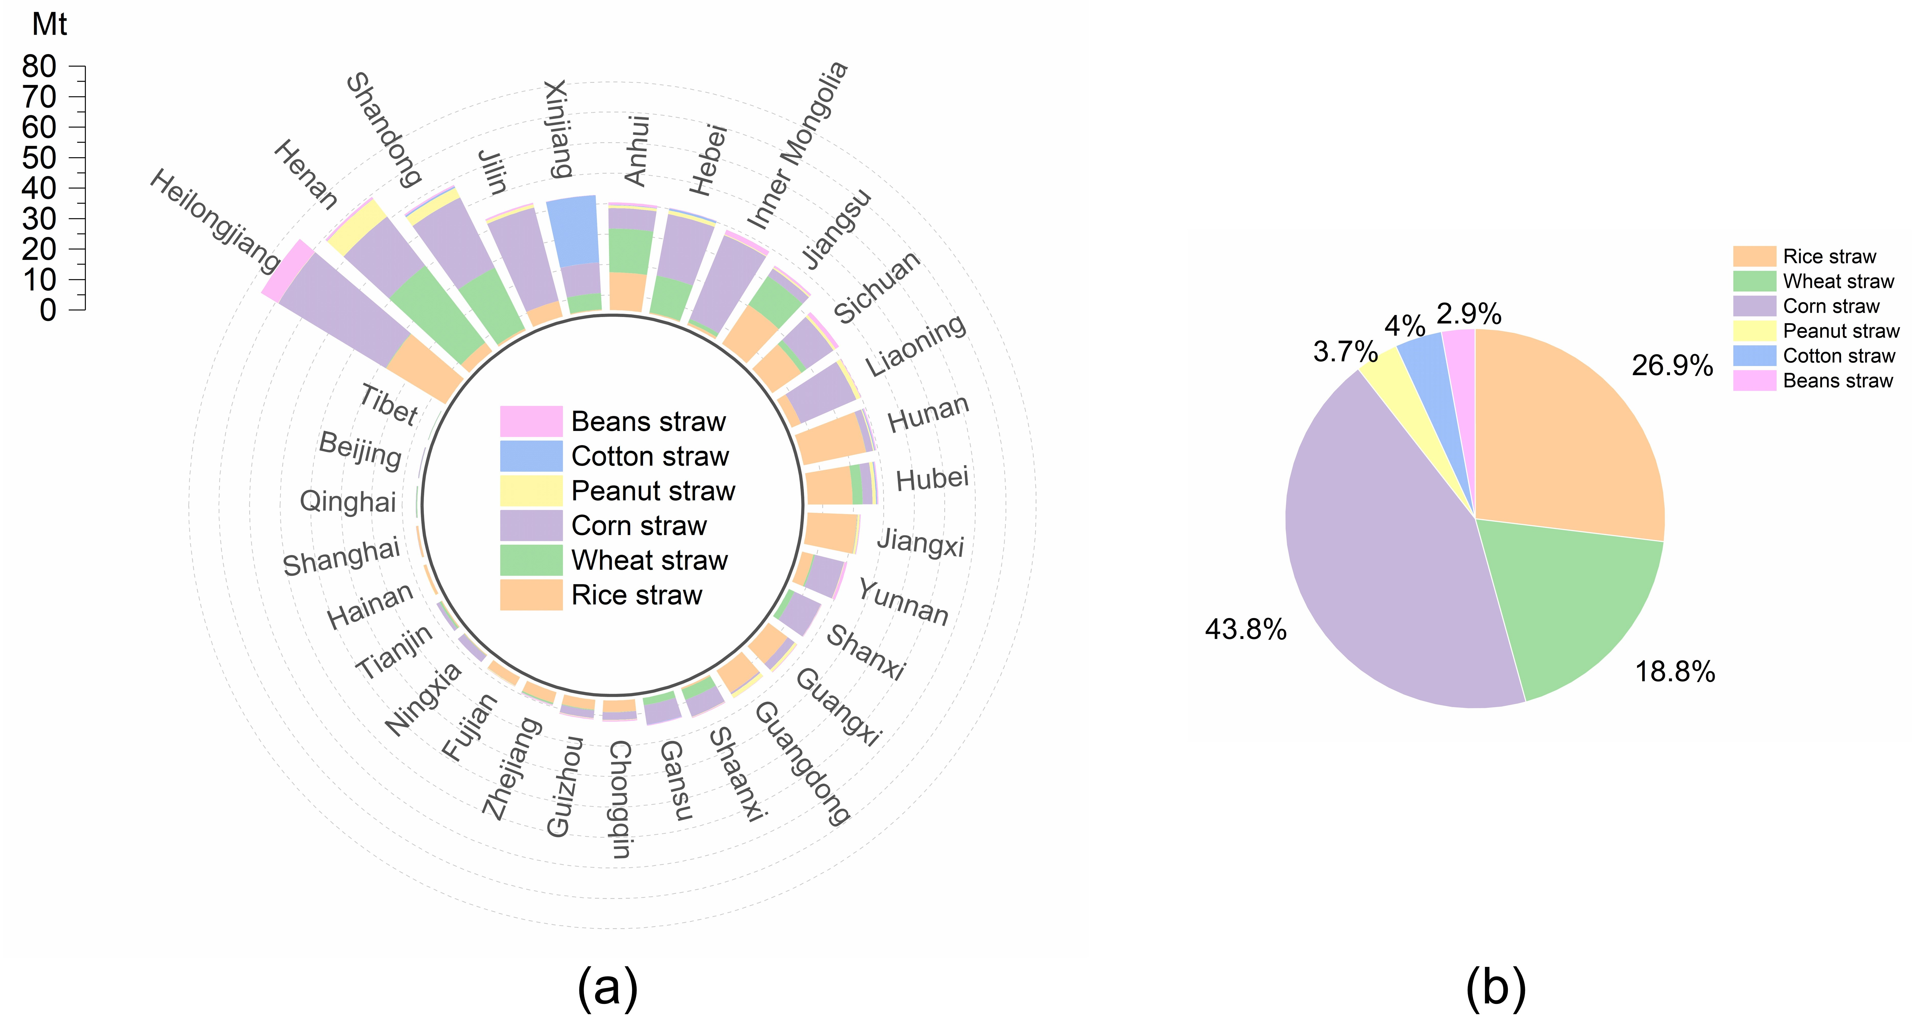
Figure 3. Resource potential estimation of six crop straws in China. (a) Province-level distribution of crop straw resource potential in China (lacking the data of Taiwan, Hong Kong, and Macao); (b) The amount proportion of different crop straws in China.

Furtherly, Figure 4a shows that SAF from different crop straws also have different TEA and LCA performance. SAF produced from cotton straw has the lowest MSP, while the MSP of SAF from peanut straw is the highest. The MSP order is similar to the rank of straw price, indicating that the feedstock price may be a major factor affecting the cost-effectiveness of SAF. The life cycle GHG emission of SAF from these crop straws is ranked as: wheat straw > rice straw > peanut straw > cotton straw > corn straw > beans straw. Overall, the MSPs of SAF from these crop straws are all higher than that of conventional petroleum jet fuel (PJF) ($ 393/t), while the LCA GHG emission of SAF is much lower than that of PJF (3.8 t CO₂e/t PJF). A single-point sensitivity analysis of critical parameters in TEA and LCA models is conducted, and Figure 4b-c show the results with corn straw as the feedstock. Improving the SAF production yield can significantly reduce the MSP and enhance the decarbonization capacity of SAF simultaneously. Besides, the feedstock price and steam cost also have great impacts on the MSP calculation of SAF, and the consumption of fertilizer and electricity in the farming process plays an influential role in the LCA model. The sensitivity analysis of SAF from other crop straws also shows similar trends. In order to increase the comparability of TEA and LCA performance, a comprehensive analysis is proposed to calculate the decarbonization cost of SAF from different crop straws, as shown in Eq. (2):
$$Decaronization cost=\frac{{MSP}_{SAF}-{MSP}_{PJF}}{{LCA}_{PJF}-{LCA}_{SAF}}$$ | (2)

As shown in Figure 4d, the decarbonization cost of SAF from straws is ranked as: peanut straw > rice straw > beans straw > wheat straw > corn straw > cotton straw. Combining the SAF production potential of these straws, cotton straw can be applied as a promising feedstock for the early industry application of SAF when the demand of SAF is not high.
With the support of the above analysis results, the decarbonization potential of SAF in China’s aviation sector can be estimated. Figure 4e shows annual PJF consumption and GHG emission in China’s aviation sector from 2005 to 2022. The consumption of PJF increased dramatically until 2019, but plummeted subsequently due to the strike of the COVID-19. Fortunately, now China’s aviation industry is gradually recovering from the impact of the epidemic and is expected to return to or even exceed the pre-epidemic level in the next few years. Therefore, we assume the jet fuel consumption in 2023 is comparable to that of 2019 to calculate the decarbonization potential in China under different SAF blending ratios. According to the ASTM D7566 standards, the blending ratio of SAF produced via G-FT method is no more than 50 %, so 50 % is set as the highest blending ratio scenario. As shown in Figure 4f, at low blending ratio (<10 %), SAF is mainly produced from cotton straw due to the lowest decarbonization cost. With the further increase of blending ratio, corn straw has become the major feedstock for SAF production owing to the abundant reserves and moderate decarbonization cost. If the SAF blending ratio reaches 50 %, about 60 Mt CO₂e emission can be reduced, accounting for 43 % of the emission for China’s aviation sector in 2023.

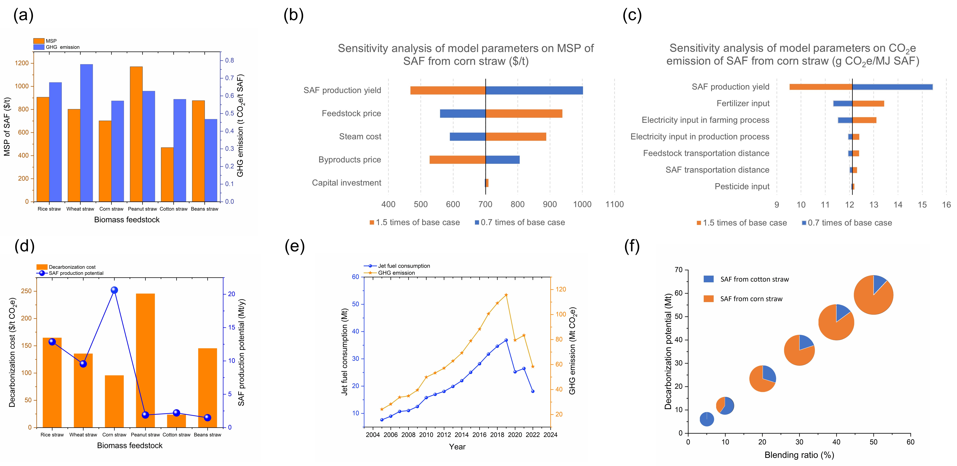
Figure 4. Comprehensive analysis based on techno-economic analysis and life cycle assessment of sustainable aviation fuel (SAF) from different crop straws. (a) Minimum selling price (MSP) and greenhouse gas (GHG) emission of SAF from different crop straw feedstocks; (b) Sensitivity analysis of model parameters on MSP of SAF from corn straw; (c) Sensitivity analysis of model parameters on GHG emission of SAF from corn straw; (d) Decarbonization cost and SAF production potential from different crop straw feedstocks; (e) Annual petroleum jet fuel consumption and GHG emission in China’s aviation sector from 2005 to 2022; (f) Cost-effective straw-to-SAF production strategies and decarbonization potential under different SAF blending ratios, the area of the pie represents the demand of SAF under corresponding SAF blending ratio, blue and orange parts represent the proportion of SAF produced from cotton straw and corn straw respectively.
  - Conclusions
An integrated resource-technology-economy-environment analysis (RTEEA) framework is conducted to evaluate the decarbonization of sustainable aviation fuel (SAF) in China’s aviation sector. The minimum selling price (MSP) and greenhouse gas (GHG) emission of SAF from six crop straws in China have been calculated via techno-economic analysis (TEA) and life cycle assessment (LCA) respectively. Compared with conventional petroleum jet fuel (PJF), SAFs from crop straws via G-FT synthesis have higher MSP and much lower GHG emission. Comprehensive analysis shows that cotton straw is an ideal feedstock for the early industrial production of SAF due to the lowest decarbonization cost, but its low reserves may be difficult to support large scale SAF production. In the long run, corn straw, which has abundant reserves and moderate decarbonization cost, is a promising biomass feedstock to produce SAF. When the SAF blending ratio reaches 50 %, about 60 Mt CO₂e emission can be reduced, which accounts for 43 % of the emission for China’s aviation sector in 2023, showing the huge decarbonization potential of SAF from straws via G-FT synthesis.
References
Alherbawi et al., 2021, A novel integrated pathway for Jet Biofuel production from whole energy crops: A Jatropha curcas case study, Energy Conversion and Management 229: 113662.
Cavalett et al., 2018, Contribution of jet fuel from forest residues to multiple Sustainable Development Goals. Nature Sustainability 1: 799-807.
Chen et al., 2021, Identifying the main crops and key factors determining the carbon footprint of crop production in China, 2001–2018. Resources, Conservation and Recycling 172: 105661.
Gao et al., 2016. An integrated assessment of the potential of agricultural and forestry residues for energy production in China. GCB Bioenergy 8: 880-893.
Lee et al., 2023, Life cycle analysis of gasification and Fischer-Tropsch conversion of municipal solid waste for transportation fuel production. Journal of Cleaner Production 382: 135114.
Li et al., 2019, Comprehensive Life Cycle Evaluation of Jet Fuel from Biomass Gasification and Fischer–Tropsch Synthesis Based on Environmental and Economic Performances. Industrial & Engineering Chemistry Research 58: 19179-19188.
Okolie et al., 2023, Multi-criteria decision analysis for the evaluation and screening of sustainable aviation fuel production pathways. iScience 26: 106944.
Vardon et al., 2022, Realizing “net-zero-carbon” sustainable aviation fuel. Joule 6: 16-21.
Wang et al., 2022, Techno-economic analysis of renewable jet fuel production: The comparison between Fischer-Tropsch synthesis and pyrolysis. Energy 239: 121970.

