Design and planning green hydrogen supply chains: characterization and optimization
Filipa Braz Silva,^{a*} Cátia da Silva,ª Ana Paula Barbosa-Póvoaª
ªCEG-IST, Instituto Superior Técnico, University of Lisbon, Av. Rovisco Pais, 1049-001 Lisboa, Portugal
filipa.b.silva@tecnic.ulisboa.pt
Abstract
Society faces urgent challenges requiring collaboration between energy and climate policies, especially in industry and transport. Green Hydrogen (GH2) is a key component of the European Union's strategy for a hydrogen-based, carbon-neutral economy, promoting sustainable growth, job creation, and energy security. Successful integration of hydrogen (H2) into the future energy landscape depends on reducing costs and optimizing infrastructure. However, the environmental benefits of the hydrogen economy are hindered by a lack of infrastructure and significant capital investments. Establishing a future hydrogen supply chain efficiently necessitates a strategic model accounting for changing requirements and cost-effective infrastructure design. This study addresses these challenges by developing a multi-period Mixed-Integer Linear Programming (MILP) model for GH2 supply chain design and planning, aiming to minimize overall costs while meeting industrial demand using renewable sources. The research provides insights into choosing renewable feedstock sources, centralized or decentralized production, and hydrogen storage, evaluating liquid and gaseous hydrogen forms. Diverse scenarios cover GH2 options, transportation modes, storage, penetration rates, and economies of scale, offering a comprehensive framework. Applied in a Portuguese case study, the model contributes practically to implementing a sustainable GH2 supply chain in Portugal focused on the Industrial sector needs.
Keywords: green hydrogen, supply chain, renewable energy source, design and planning
  - Introduction
Climate change, environmental pollution, and biodiversity loss have far-reaching economic, social, and quality of life implications. The European Commission has introduced "Fit for 55," a comprehensive set of legislative proposals aimed at achieving carbon neutrality by 2050, with an interim target of at least a 55% reduction in greenhouse gas emissions by 2030 (European Commission, 2021). In this context, the shift from fossil fuels to renewable energies, particularly green hydrogen, is of considerable importance. Many European Union member states, including Portugal, have unveiled their national energy and climate plans, emphasizing their national hydrogen strategies. Portugal, favored with abundant renewable energy resources, holds a strategic position in the European hydrogen landscape. Its commitment to renewable energy aligns seamlessly with the EU's hydrogen strategy, making it an ideal candidate to explore hydrogen's potential as a sustainable energy carrier. Portugal has set ambitious goals to reduce emissions and promote renewable energy sources, recognizing hydrogen's promise as a clean energy alternative. In line with these plans, Portugal has also adopted its National Strategy for Hydrogen (EN-H2), aiming to position the country as a major player in the global hydrogen industry. EN-H2's macro-objectives for 2030 include deploying 2% to 5% of green hydrogen in the industrial energy consumption sector. This paper emerges in this context, aiming to analyze and assist decision-makers in designing and planning green hydrogen supply chains (GHSC), particularly for the Portuguese case, to meet the future hydrogen demand of the industrial sector. Such supply chains are instrumental in Portugal's pursuit of carbon neutrality. This paper is pivotal in advancing the development of a sustainable and environmentally friendly energy ecosystem in Portugal, in harmony with broader European clean energy objectives.
  - Literature Review
Supply chain (SC) integrates business processes to acquire raw materials, transform them, distribute products, and share information, aiming for operational efficiency and competitiveness. Decision-support tools categorize SC decisions as strategic, tactical, and operational. Hydrogen supply chain design (HSCD) involves investment and operational decisions to meet demand, covering facility types, locations, capacities, and transportation networks (Sgarbossa et al., 2023). A holistic view across all processes proves effective for optimization. HSCD optimization falls into single-objective (cost minimization) and multi-objective categories, with emerging trends emphasizing sustainability (Cantú et al., 2021). Literature predominantly focuses on grey hydrogen production, but some studies explore green hydrogen with renewable sources. Moreno-Benito et al. (2017) developed an optimisation-based approach for hydrogen infrastructure and emphasised the needs for further works. Câmara et al. (2019) considers solar, wind, hydroelectric, and biomass in Portugal to meet hydrogen demand in the transportation sector by producing hydrogen only in liquified form. The physical form of hydrogen (liquid or gaseous) influences transportation and storage decisions, with trade-offs differing for each that needs future research. Additionally, research often concentrates on the transportation sector, overlooking comprehensive supply chain design for industrial clusters. Despite these contributions, literature gaps persist, including the lack of research focused on hydrogen supply chain deployment. In this work, we address this gap and develop a comprehensive model for Green H2 supply chain, where H2 penetration over time should be explored considering both liquid and gas forms.
  - Problem description and model characterization
This study considers the design and planning of Green Hydrogen Supply Chains, exploring a multiperiod context and different hydrogen penetration levels, which is generically represented in Figure 1. In this framework, the main stages correspond to: (i) the distribution of energy from suppliers to plant facilities, (ii) the production and storage of hydrogen, and, finally, (iii) the distribution of hydrogen to the demand points. Given: (i) locations of potential or existing entities in the supply chain; (ii) capacity of energy source suppliers; (iii) capital and operating costs for hydrogen transportation, production, and storage facilities; (iv) time horizon in study; (v) distance between entities; (vi) product demand by each industry cluster in each period considered; (vii) H2 product form. The objective is to obtain: (i) the structure of the SC network; (ii) the transport network between entities; (iii) the flow of energy and H2 transported between entities; (iv) production and storage levels; (v) the capacity of production and storage facilities over time. In order to minimize total discounted costs while meeting the potential future industrial H2 demand.
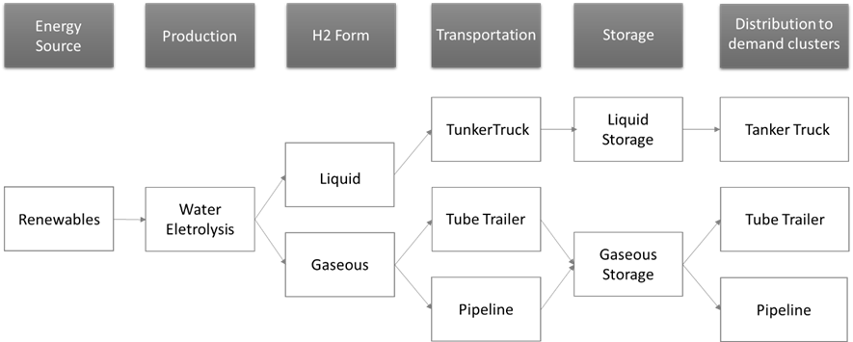
To solve this problem, it is developed an optimisation model (MILP), based on Forghani et al. (2023) by adding new relevant considerations. The model was extended to incorporate the availability and logistics of energy sources for hydrogen production, and it only focuses on the production of GH2. Additionally, H2 was analysed not only on its gaseous form but also on its liquid form. It focuses on the most eco-friendly hydrogen production method, ignoring carbon emissions constraints. Lastly, this work intends to satisfy the demand of H2 from the industry sector. The objective function is represented in Equation (1) and intends to minimize the total discounted costs (TDC) of the GHSC while meeting demand requirements during different periods. Costs for each period are discounted back to the present time at a certain discount rate to account for the time value of money. The costs related to the construction of GHSC are applied over time by considering the specific capital costs incurred in each period, as production and storage facilities can be extended gradually over periods – costs incur in the previous year of each period, so that infrastructures are ready to operate for the whole period. Additionally, it considers daily operating, transportation, and energy source related costs – incur for each one of the years.
Figure 1: Green Hydrogen Supply Chain
$$\min{TDC}=\sum_{t∈T}{\left(\frac{{TI}_{t}}{{\left(1+β\right)}^{t}}+N\left({TO}_{T}+{TT}_{t}+{ESC}_{t}\right)×\sum_{a=1}^{y}{\frac{1}{{\left(1+β\right)}^{yt-\left(y-a\right)}}}\right)}$$ | (1)
The TDC minimization can be divided in the following components: (i) ${TI}_{T}$ represents the total capital cost associated with the production plants, storage facilities, and pipelines; (ii) ${TO}_{T}$ corresponds to the total operating cost of the production plants, storage facilities, and pipelines; (iii) ${TT}_{T}$ represents the total transportation cost associated with the pipeline and tube trailer transport modes; (iv) ${ESC}_{t}$ denotes the total costs for the energy source consumed in each period of time and represents an innovative constrain compared to basis model. The regular equations for demand fulfilment, material balance, transportation and capacity limitations are among the defined constraints.
  - Case Study
To validate the effectiveness of the model, it is applied to the Portuguese context with the aim of assisting stakeholders in choosing the most appropriate configurations based on the evolution of the Hydrogen adoption level, need that was recently identified in Portugal. The 18 districts of Portugal are the subsets of locations or possible locations in which entities are located. The time frame is of 25 years and divided in periods of 5 each one representing 5 years to analyse the evolution of hydrogen demand from 2025 to 2050 – aligning with the year set by the International Energy Agency for achieving net-zero emissions. The model is demand-driven and the need for hydrogen is predetermined by estimating the potential hydrogen demand for energy-intensive industries in Portugal within the main sectors: Chemical industry; Iron and steel; Non-ferrous metals; Non-metallic minerals; Paper and printing; and Refineries. The penetration rate was defined based on the targets/ indicative trajectories to be met defined by the national Portuguese H2 strategy. For the renewable energy sources availability, data from the 3 more relevant sources in this category are considered: hydroelectric, wind, and solar. Water electrolysis as the technology to produce GH2 was considered. Three different sizes of H2 production plants are studied: small, medium, and large. Each type of plant and storage facility has sets of data to produce/ store gaseous hydrogen and liquid hydrogen. The storage time of H2 is assumed to be 10 days. The tanker trucks have been chosen for the transportation of liquid hydrogen on roads, while the tube trailers and a pipeline system have been explored for hydrogen in its gaseous form. Only distances between districts were considered, while local distances were not.
  - Results Analysis
Results obtained through scenario analysis and sensitivity analysis are presented. The scenarios analysed are: i) Case A – includes a penetration profile that meets the average values for the targets/ indicative trajectories; ii) Case B – includes a penetration profile that meets the maximum values for the targets/ indicative trajectories; iii) Case C - includes a penetration profile that meets the minimum values for the targets/ indicative trajectories; iv) Case D - includes the benefits of economies of scale in production and storage facilities. For each one of these scenarios, hydrogen is assessed in its liquid and gaseous form. However, detailed results for both forms are only presented for Case A, as it is revealed as the most representative case: (i) Case A.1 - represents hydrogen in its liquid form; (ii) Case A.2 - represents the gaseous form of H2 with only on-road transportation; (iii) Case A.3 – represents hydrogen in its gaseous form with on-road transportation and a pipeline system. For the other cases (B, C and D) the results presented concern only liquid hydrogen as it resulted always in the less expensive supply chain structure between the 3 different options. Additionally, Case D.1 is an extension of Case D by considering the possible installation of a higher storage capacity. From the analysis of these cases, the obtained values are stated in Table 1.
Table 1 - Results for main scenarios.

Scenario | TDC (M€) | Centralization Degree | No of Plants | No of storage facilities (capacity in t) | Transportation units
A.1 | 17,006 | 78% - 91% | 5 medium  9 small | 4 (100), 4(250), 7(1000) | 64 tanker trucks
A.2 | 17,732 | 79% - 81% | 5 medium  10 small | 4(100), 2(250), 5(500), 5(1000) | 224 tube trailers
A.3 | 17,613 | 82% - 89% | 5 medium  9 small | 1(50), 1(100), 1(250), 4(500), 6(1000) | 53 tube trailers + 727 km pipeline
B | 20,504 | 87% - 96% | 6 medium  4 small | 1(100), 1(250), 4(500), 7(1000) | 76 tanker trucks
C | 13,086 | 87% - 96% | 5 medium  3 small | 1(50), 2(100), 3(250), 1(500), 6(1000) | 52 tanker trucks
D | 14,517 | 100% | 2 large | 1(50), 1(100), 1(250), 4(500), 6(1000) | 90 tanker trucks
D.1 | 14,457 | 100% | 2 large | 1(50), 1(100), 1(250), 2(4000) | 35 tanker trucks

The key finding from the scenario analysis indicates that liquid hydrogen appears to be the more cost-effective choice for deploying an H2 supply chain. The scenario with the lowest costs, 13,086 M€, involves a lower penetration of H2 (Case C), where lower production rates contribute to reduced overall costs, particularly when production costs hold a significant share of the total costs. Conversely, the optimistic scenario (Case B), characterized by the highest values of TDC, 20,504 M€, emerges as the most expensive. The moderate scenario (Case A.1) has an overall TDC of 17,006 M€ and is represented in Figure 2. The second least expensive scenario is Case D.1 with a TDC of 14,457 M€. This scenario considers economies of scale in production plants and the potential installation of higher storage capacity. Notably, as the main entities of this SC configuration are presented in Figure 2, this scenario strategically designates Setúbal and Coimbra as the primary hydrogen production hubs, minimizing the need for tanker trucks due to centralized storage facilities and large consumers having plants with large capacities within their districts. Higher centralization degrees are observed in scenarios linked to economies of scale (see Table 1 and Figure 2), with liquid hydrogen displaying higher centralization rates compared to compressed hydrogen.
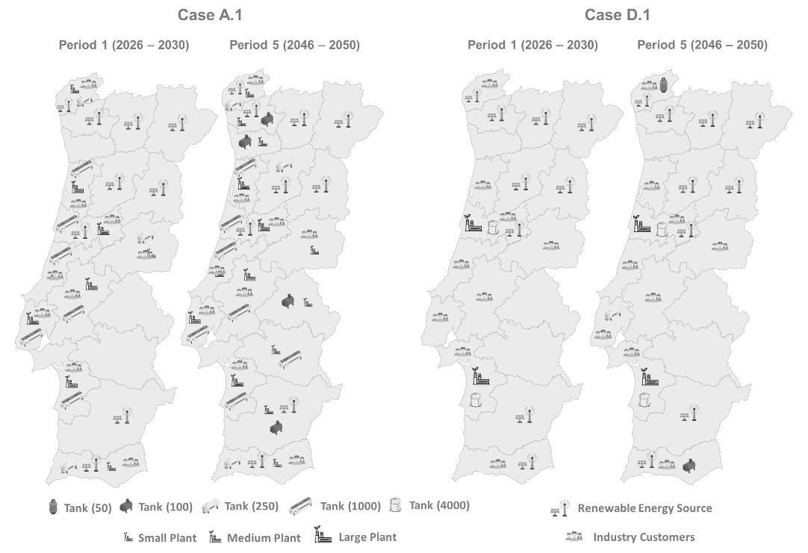
Figure 2: SC design for periods 1 and 5 of Case A.1 and Case D.1
Additionally, a sensitivity analysis was performed on the discount rate, storage time of hydrogen, electricity costs and capital cost of liquid hydrogen production plants. The study found that variations in electricity cost and discount rate significantly affect the overall TDC but not the SC structure. The average number of days H2 is stored significantly impacts the SC's structure and storage facility dimensions (see Figure 3). Therefore, it is crucial to consider this factor when planning the SC design. Also, it was verified that until a 75% increase in capital cost of liquid H2 plants, liquid hydrogen SC is the preferred option, supporting again the idea of a liquid hydrogen SC (see Figure 3).
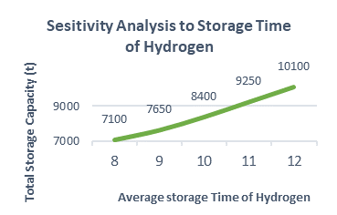
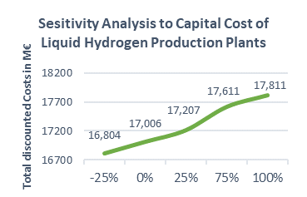
  - Conclusions
Figure 3: Sensitivity analysis to H2 storage time and capital cost of liquid H2 production plants
This work defines an optimization tool for designing green hydrogen supply chains, focusing on Portugal. The aim is to assist key investors and/or politicians in developing a sustainable energy ecosystem aligned with European clean energy objectives. Results are expected to inform infrastructure and technology decisions for each supply chain component, considering the availability of renewable energy resources and potential industrial hydrogen demand while minimizing total discounted costs. Optimal solutions consistently favour liquid hydrogen over gaseous one for the chosen scenarios, even with a 75% increase in the capital cost of liquid hydrogen plants. The study questions the suitability of a pipeline system for H2 distribution in Portugal, favouring tanker trucks, possibly due to the country's size. Moreover, the importance of considering factors such as electricity cost, discount rates, and H2 storage duration in SC design is highlighted.
Despite contributing to existing literature, the work suggests further development, particularly addressing challenges related to data acquisition. Future work should include assessing renewable energy deployment near production facilities to ensure sustainable power sources and addressing uncertainties in solar and wind power. Additionally, the availability of water resources for hydrogen production and detailed research on compressed and liquid hydrogen storage are crucial aspects to explore. Incorporating political incentives, utilizing multicriteria analysis methods and accounting for uncertainties in various chain segments would enhance the model's accuracy.
References
Câmara, D., Pinto-Varela, T., & Barbósa-Povoa, A. P. (2019). Multi-objective optimization approach to design and planning hydrogen supply chain under uncertainty: A Portugal study case. Computer Aided Chemical Engineering, 46, 1309–1314. https://doi.org/10.1016/B978-0-12-818634-3.50219-8
Cantú, V. H., Azzaro-Pantel, C., & Ponsich, A. (2021). A Novel Matheuristic based on bi-level optimization for the multi-Objective design of hydrogen supply chains. Computers and Chemical Engineering, 152. https://doi.org/10.1016/j.compchemeng.2021.107370
European Commission. (2021). “Fit for 55”: delivering the EU’s 2030 Climate Target on the way to climate neutrality.
Forghani, K., Kia, R., & Nejatbakhsh, Y. (2023). A multi-period sustainable hydrogen supply chain model considering pipeline routing and carbon emissions: The case study of Oman. Renewable and Sustainable Energy Reviews, 173. https://doi.org/10.1016/j.rser.2022.113051
Moreno-Benito, M., Agnolucci, P., & Papageorgiou, L. G. (2017). Towards a sustainable hydrogen economy: Optimisation-based framework for hydrogen infrastructure development. Computers and Chemical Engineering, 102, 110–127. https://doi.org/10.1016/j.compchemeng.2016.08.005
Sgarbossa, F., Arena, S., Tang, O., & Peron, M. (2023). Renewable hydrogen supply chains: A planning matrix and an agenda for future research. International Journal of Production Economics, 255. https://doi.org/10.1016/j.ijpe.2022.108674

