Optimal operation of multi-alkaline electrolyzers in green ammonia production systems considering partial-load efficiencies

bingqian.liu@epfl.ch
Abstract
The optimal operation of multiple electrolyzers working in parallel poses challenges when modeled as a mathematical programming problem, often introducing numerous auxiliary binary variables. In this paper, we propose a novel formulation that leverages the convex nature of the non-linear performance curve of electrolyzers. This new formulation concisely describes the optimal operation of electrolyzers without compromising accuracy. The results demonstrate the efficient solvability of the novel formulation using off-the-shelf solvers. We have also observed that considering multiple-unit operation enables a more rational use of hydrogen storage, helping to mitigate the need for frequent start-ups of electrolyzers.
Keywords: Optimal operation; green ammonia production system; multiple-unit electrolyzer operation; partial-load efficiency
  - Introduction
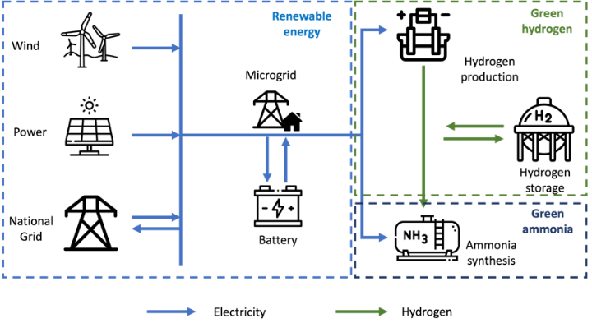
A typical green ammonia production plant, as shown in Fig.1, comprises three main components: renewable energy generation, green hydrogen production, and green ammonia production. The system may also be equipped with electric and hydrogen storage. However, the intermittent nature of renewable electricity introduces challenges, causing the load rate of electrolyzers to vary significantly over short periods. Managing the state transfer and partial-load efficiency of multiple electrolyzers in a system remains a difficult task. In the literature, various approaches aim to simplify this challenge, including the aggregation of electrolyzers and linearization of performance curves. In a recent work of Varela (2021), authors proposed to use binary variables in a Mixed-Integer Linear Programming (MILP) model to represent the state of electrolyzers. It is worth noting that the computational burden increases exponentially with the growing number of electrolyzers.
Figure 1. Structure of a green ammonia production system
In this paper, we introduce a novel MILP model for optimizing the operation of multiple electrolyzers in the system. First, we apply a piecewise linear approximation to address the non-linear performance curve. Then, by leveraging the convex nature of the performance curve, we represent the states of electrolyzers without using binary variables for each of them. This approach not only provides a more precise description of the operation of the electrolyzer, but also reduces the size of the problem and improve resolution efficiency.
  - Problem Description
    - Renewable energy
Renewable energy is generated through existing wind turbines and PV panels in the area. The produced renewable electricity can either be utilized within the system or sold to the grid at a predefined price. Given the intermittent nature of the renewable energy source, the system is allowed to import electricity from the national grid when the renewable energy is insufficient to sustain its operation. The objective of the operational optimization is to minimize the total cost, calculated as the cost of purchasing electricity from the grid subtracted by the revenue generated from selling green electricity to the grid.
    - Green hydrogen
At the green hydrogen production stage, the system is equipped with multiple electrolyzers and a hydrogen storage. All electrolyzers are assumed to share the same technical parameters, including capacity, performance curve and starting-up cost. The hydrogen produced can be stored partially in the hydrogen storage and partially directed to the ammonia synthesis unit.
Each electrolyzer has three different states: production, hot stand-by (HSB), and idle. In the production state, an electrolyzer operates above its minimum load rate to generate hydrogen output. The load rate must not fall below the minimum to avoid safety risks. In the HSB state, an electrolyzer consumes a small amount of power to maintain the suitable temperature of the liquid. While it doesn't produce hydrogen in the HSB state, it can switch to the production state within minutes and without extra energy consumption. An electrolyzer is completely turned off in the idle state and doesn't consume any electric power. When it switches to HSB or production state, it needs time and electric power to heat the liquid, so we need to consider a starting-up cost in this case.
The performance curve of an electrolyzer illustrates the relationship between the production rate and electricity consumption. Typically nonlinear, the performance curve exhibits decreasing marginal efficiency as the production rate rises. Therefore, the performance curve forms a convex curve between its minimum and maximum production rate.
    - Green ammonia
The green ammonia production stage consists of a cryogenic air separation unit, utilized to extract nitrogen from the air, and a synthesis reactor where hydrogen and nitrogen react to produce ammonia with the assistance of a catalyst under specific temperature conditions. In this paper, we aggregate these components into a unified unit, treated as a process that consumes electricity and hydrogen to produce ammonia. It's crucial to ensure that the ammonia synthesis unit operates between its working range. The startup time for an ammonia synthesis unit, transitioning from a completely off state to full operation, typically exceeds one day. To maintain the stability of the ammonia synthesis reactor, we assume the ammonia synthesis unit operates continuously within its working range throughout the investigated time horizon.
  - Mathematical model
Parameters
$$P_{t}^{RE}$$ | Available renewable energy in time step $t$ (kWh)
$$C^{buy}/C^{sell}$$ | Price per kWh of importing/selling electricity to/from the national grid (RMB/kWh)
$$Q_{}^{H_{2},min}/Q_{}^{H_{2},max}$$ | Minimum/maximum hydrogen production rate of electrolyzers (t)
$$B$$ | Number of segments used for piecewise linear approximation
$$a_{b}^{}/o_{b}^{}$$ | Slope/intercept of segment $b$
$$P^{HSB}/P^{SU}$$ | Fixed electricity consumption of HSB state/starting-up (kWh)
$$N^{EL}$$ | Number of electrolyzers in the system
$$η^{elec}/η^{H_{2}}$$ | Efficiency coefficient of the electricity/hydrogen input of the ammonia synthesis unit
$$Q_{}^{{NH}_{3},min}/Q_{}^{{NH}_{3},max}$$ | Minimum/maximum ammonia production rate (t)
$$Q_{}^{{NH}_{3},obj}$$ | Annual ammonia production plan (t)
Variables
$$P_{t}^{RE,use}/P_{t}^{RE,sell}$$ | Renewable energy for self-use/selling to the grid in timestep $t$ (kWh)
$$P_{t}^{grid}$$ | Electricity imported from the national grid in timestep $t$ (kWh)
$$P_{t}^{input}$$ | Total electricity consumed by the system in timestep $t$ (kWh)
$$P_{t}^{EL}/P_{t}^{AS}$$ | Electricity consumed by electrolyzers/ammonia synthesis unit (kWh)
$$Q_{t}^{H_{2}}/Q_{t}^{{NH}_{3}}$$ | Production of hydrogen/ammonia produced by the system in timestep $t$
$$W_{t}/H_{t}/I_{t}$$ | Number of electrolyzers in production/HSB/idle state in timestep $t$
$$SU_{t}$$ | Number of starting-up electrolyzers in timestep $t$
$$P_{t}^{EL,W}/P_{t}^{EL,S}/P_{t}^{EL,S}$$ | Electricity consumption by production-state/HSB-state/starting-up electrolyzers (kWh)
$${SoC}_{t}^{H_{2}}/S_{t}^{H_{2},in}/S_{t}^{H_{2},out}$$ | Storage level/input mass flow/output mass flow of hydrogen storage
$${SoC}_{t}^{elec}/S_{t}^{elec,in}/S_{t}^{elec,out}$$ | Storage level/input energy flow/output energy flow of battery storage
    - Objective function
We aim to minimize the total electricity cost of the system. Other operational costs, such as labor and water, are considered constant due to the fixed ammonia production objective.
$$Obj := \sum_{t=1}^{T}{\left(C^{buy}P_{t}^{RE,use}- C^{sell}P_{t}^{RE,sell}\right)}$$ | (1)
    - Constraints
The total electricity consumed by the system and sold to the grid should not exceed the generated renewable energy.
$$P_{t}^{RE}≥ P_{t}^{RE,use}+P_{t}^{RE,sell}$$ | (2)
The energy balance involves the system's energy consumption, the self-use portion of renewable energy, imported grid electricity, and the utilization of battery storage.
$$P_{t}^{RE,use}+P_{t}^{grid}-S_{t}^{elec,in}+S_{t}^{elec,out}=P_{t}^{input}$$ | (3)
The electricity consumption of the production plant comprises two components: the electrolyzers and the ammonia synthesis unit.
$$P_{t}^{input}= P_{t}^{EL}+ P_{t}^{AS}$$ | (4)
The electricity consumption of the electrolyzers is characterized by a non-linear performance curve, which is approximated piecewise-linearly with $B$ segments. Liu (2021) has proved that in the optimal operation solution, all identical conversion units with convex performance curves in the production state have the same workload. This enables us to aggregate the consumption and production of production-stat electrolyzers as $P_{t}^{EL,W}$ and $Q_{t}^{H_{2}}$. By the nature of the minimization problem, Eq. (5) will yield an equation at the optimal solution.
$$P_{t}^{EL,W}≥ a_{b}^{}Q_{t}^{H_{2}}+ o_{b}^{}W_{t}^{}$$ | $$∀b∈\{1,⋯,B\}$$ | (5)
$$Q_{}^{H_{2},min}W_{t}^{}≤Q_{t}^{H_{2}}≤ Q_{}^{H_{2},max}W_{t}^{}$$ |  | (6)
Electrolyzers in the HSB state consume a minimal amount of energy to maintain the temperature of the liquid. Starting up an electrolyzer from the idle state requires additional energy to heat the liquid and prepare the electrolysis conditions.
$$P_{t}^{EL,S}=P^{HSB}H_{t}$$ | (7)
$$P_{t}^{EL,SU}=P^{SU}{SU}_{t}$$ | (8)
The number of electrolyzers in different states should be consistent with the total number of electrolyzers.
$$W_{t}+H_{t}+I_{t}=N^{EL}$$ | (9)
The number of units starting up is equal to the decrease in idle units.
$$SU_{t}≥I_{t}- I_{t+1}$$ | $$∀t≤T-1$$ | (10)
$$SU_{t}≥0$$ |  | (11)
The inventory balance constraints for electric storage and hydrogen storage.
$${SoC}_{t}^{H_{2}}+S_{t}^{H_{2},in}-S_{t}^{H_{2},out}={SoC}_{t+1}^{H_{2}}$$ | $$∀t≤T-1$$ | (12)
$${SoC}_{t}^{elec}+S_{t}^{elec,in}-S_{t}^{elec,out}={SoC}_{t+1}^{elec}$$ | $$∀t≤T-1$$ | (13)
The electricity and hydrogen consumption of the ammonia synthesis unit.
$$Q_{t}^{{NH}_{3}}=η^{elec}P_{t}^{AS}$$ | (14)
$$Q_{t}^{{NH}_{3}}=η^{H_{2}}(Q_{t}^{H_{2}}-S_{t}^{H_{2},in}+S_{t}^{H_{2},out})$$ | (15)
The ammonia synthesis unit should operate within its working range and achieve the total production objective.
$$Q_{}^{{NH}_{3},min}≤Q_{t}^{{NH}_{3}}≤Q_{}^{{NH}_{3},max}$$ | (14)
$$\sum_{t=1}^{T}{Q_{t}^{{NH}_{3}}}≥Q_{}^{{NH}_{3},obj}$$ | (15)
  - Results
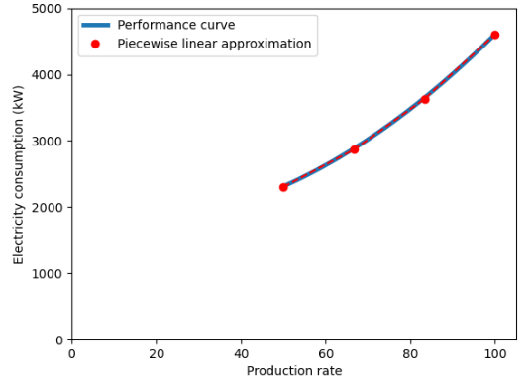
We tested the model, as defined in Section 3, on an actual green ammonia production system located in northern China over one year. In this region, we have a wind farm with a generation capacity of 1.5 GW and 15 MW of PV panels. In the hydrogen production stage, there are 150 electrolyzers, each capable of producing a maximum of 83.75 kilograms of green hydrogen per hour. The working range of each electrolyzer is between 50% and 100%, and the nonlinear performance curve, as well as the piecewise linear approximation, is illustrated in the Fig.2. The ammonia synthesis unit can produce a maximum of 75 tons of ammonia per hour and should operate between 10% and 100% of its capacity. The system is also equipped with a 150 MWh battery storage and a 10-ton hydrogen storage tank. The electricity price purchased from the grid is 0.5 RMB/kWh, and the selling price of green electricity is 0.2829 RMB/kWh. We consider a one-year time horizon and the annual production objective is $3.9×{10}^{5}$ tons.
The proposed MILP model is optimized with solver CPLEX on a computer with 16GB RAM and Intel i9-12900H CPU. The resolution time is 507 seconds, and the solver returns the optimal solution. In contrast, the model employing conventional binary variables ran out of memory without finding a feasible solution.
Figure 2. Nonlinear performance curve of electrolyzers and the piecewise linear approximation
The total cost of purchasing electricity from the gird is $1.25×{10}^{8}$ RMB, and the total revenue from selling renewable energy is $3.92×{10}^{8}$ RMB, resulting in a total revenue of $2.68×{10}^{8}$ RMB. The total input of renewable energy for the year is 5274 GWh, of which 1387 GWh is sold to the grid and 3887 GWh is consumed by the system. The self-use rate is 73.7%. Due to the intermittency of available renewable energy, the system also needs to purchase 249 GWh of electric energy from the grid, leading to a grid dependency of 6.4%.
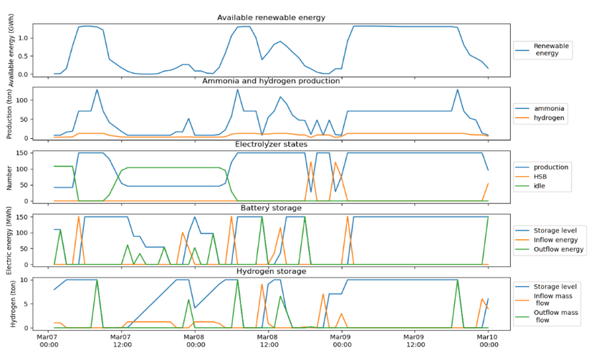
In Fig.3, we illustrate the detailed operation of the system over three consecutive days, from March 7th to March 10th. We observe that there are mainly two periods, on the first day and on the second day, in which the availability of renewable energy is limited. The profile of ammonia production follows the same trend as the availability of renewable energy. Regarding the operation of electrolyzers, we observe that during the long period of limited renewable energy, from 12:00 March 7th to 3:00 March 8th, the optimal operation prefers to switch off the electrolyzers. During the shorter period of limitation, from 18:00 March 8th to 1:00 March 9th, the optimal operation decides to keep electrolyzers in HSB state. The battery storage is charged when sufficient renewable energy is available and discharged when the renewable energy source is limited, resulting in a storage level profile similar to the profile of available renewable energy. The hydrogen storage is utilized in a similar manner, but it is also employed to mitigate frequent starting-up of electrolyzers, as observed from 12:00 March 7th to 3:00 March 8th.
Figure 3. Operation results of three consecutive days
  - Conclusions
In this paper, we developed a novel mixed-integer linear programming model for optimizing the operation of a green ammonia production system. This model considers the partial-load efficiency and state transfer of multiple alkaline electrolyzers. Leveraging the convex performance curve, we establish a priori that all electrolyzers in working state should have the same production rate. Consequently, we can avoid the use of binary variables for each individual electrolyzer, presenting a more concise yet accurate formulation.
The results demonstrate the efficiency of this new model, which can be solved by an off-the-shelf commercial solver in 507 seconds to obtain the optimal operation solution of one year. Furthermore, we have observed that considering the non-linear performance curve and the multiple-unit operation of electrolyzers not only enhances the precision of the model but also allows for a more rational utilization of hydrogen storage in the system, reducing the need for frequent start-ups of the electrolyzers.
References
Varela, C., Mostafa, M., & Zondervan, E. (2021). Modeling alkaline water electrolysis for power-to-x applications: A scheduling approach. International journal of hydrogen energy, 46(14), 9303-9313.
Liu, B., Bissuel, C., Courtot, F., Gicquel, C., & Quadri, D. (2021, February). A hierarchical decomposition approach for the optimal design of a district cooling system. In 10th International Conference on Operations Research and Enterprise Systems (ICORES 2021) (pp. 317-328).

