Fault detection and diagnosis on a gas-lifted oil well network control system
Rafael David de Oliveiraª, Edmary Altamiranda^{b}, Johannes Jäschke^{a*}
ª Department of Chemical Engineering, Norwegian University of Science and Technology (NTNU), Trondheim, Norway.
^{b} Technology Department, Aker BP ASA, Stavanger, Norway.
johannes.jachke@ntnu.no
Abstract
This work proposes a control system for the gas-lifted oil well network that can be robust to minor faults and automatically detect persistent faults that may need maintenance interventions. An offset-free nonlinear model predictive control (NMPC) with a connected fault detection and isolation (FDI) system is evaluated. The FDI system works by systematically analysing the estimated disturbances and providing possible causes for the lack of performance of the controller. The methodology is evaluated through numerical simulations, and the results suggest that a simple disturbance model on the outputs can increase the robustness of the NMPC. Furthermore, faults on the pressure sensors, choke valves and reservoir can be isolated based on the estimated disturbances.
Keywords: Process control, Fault detection, Subsea operation, nonlinear model predictive control, gas-lift control.
  - Introduction
Gas-lift is an artificial lift method that consists of injecting gas into the wells to raise oil and consequently increase productivity. The amount of gas to be injected in each well will depend on the total amount of gas available, the gas-oil-ratio of each well, the upstream processing capabilities, process stabilization requirements and the equipment degradation conditions. The optimal gas injection rate can then be computed using metrics such as economics, when oil production is maximized or stability, when the bottom-hole pressure is kept constant. An automatic control system can be applied to reach these metrics in all these scenarios. Many methods have been proposed in the literature, and solutions go from simple feedback control structures (Krishnamoorthy et al., 2019) to model-based approaches using real-time optimization layers (Krishnamoorthy et al., 2016). Despite the range of proposed control solutions, the implementation in the industry is still challenging. Many solutions have been shown to work well in practice, but the main challenge is maintaining the control loop operation. Faults in Gas-lift systems can lead to decreased production efficiency and associated economic losses, fluctuations in well bore pressure, equipment wear and tear. Early fault detection and isolation for Gas-Lift systems can allow prompt response to support optimized production efficiency and maintenance planning, system stability, minimize downtime, extended equipment life span, cost savings to maximize overall system performance
Fault-tolerant control is a promising solution for these issues (Ojonugwa et al., 2023). However, they are heavily dependent on the pre-defined fault possibilities. A robust controller can be formulated to have a more general approach to dealing with the faults. Nevertheless, a robust controller solves a more complex optimization problem to guarantee robustness. An alternative is to use the offset-free NMPC that can handle disturbances by estimating them using a state estimator. This strategy is considerably easy to implement and has been shown to work for nonlinear models (Morari et al., 2012).
It is crucial that the control layer can handle disturbances and faults. However, quickly identifying the fault is also essential for possible maintenance corrective actions. Detecting faults in a closed-loop system is challenging, and it is a closed problem related to controller performance monitoring (CPM). Fault detection and isolation (FDI) are usually applied to identify faults quickly, and the methods can be based either on process data or models (Rolf, 2006). A monitoring system based on the prediction error sequence and connected with an off-set free linear MPC has already been explored (Pannocchia et al., 2014). Here, we extended that idea for a nonlinear case and directly monitored the estimated disturbance patterns. The main contribution of this work is to propose an offset-free NMPC for the gas-lift system based on a fault detection and isolation layer.
  - Case study: Gas-lifted oil well network

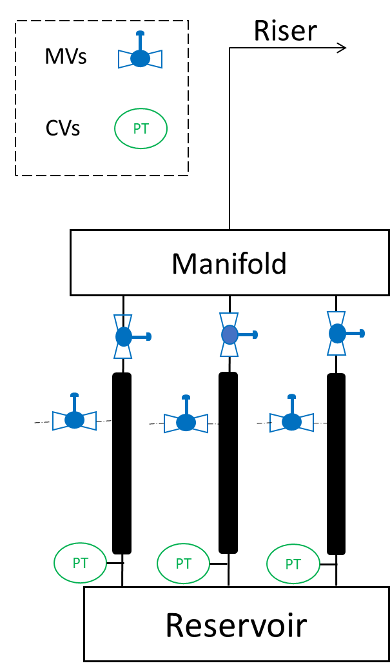
Figure 1 - Illustration of the oil and gas network with artificial
gas-lift.
The case study used on this work is gas-lift well network system (Figure 1), and the model used is based on the work conducted by Krishnamoorthy et al., 2016. The mass balances for each well can be summarized as follows:
${\dot{m}}_{gt}=w_{lg}+w_{rg}-w_{pg}$ , ${\dot{m}}_{ot}=w_{ro}-w_{po}$ | (1)

Where the variable $w_{lg}$ represents the mass flow rate of gas used for gas-lift, while $w_{rg}$ and $w_{ro}$ denote the mass flow rates of gas and oil extracted from the reservoir. Similarly, $w_{pg}$ and $w_{po}$ refer to the mass flow rates of the produced gas and oil. Additionally, $m_{gt}$ and $m_{ot}$ stand for the gas and oil mass holdup within the well. The gas-lift rate ($w_{lg}$), the flow through the choke valves on the top of the wells ($w_{pv}$) and the overall flow rate at the top facility ($w_{t}$) can be controlled by manipulating the opening and closing of valves. In this work, the opening of the valve at the top of the riser was kept constant while the others were used to control the bottom hole pressure (BHP). The valve equations are then used to characterize the flow rates.
$w_{t}=Z_{t}C_{pc}\sqrt{ρ_{w}\left(p_{wh}-p_{out}\right)}$ | (3)
$w_{lg}=Z_{lg}C_{iv}\sqrt{ρ_{a}\left(p_{a}-p_{wi}\right)}$ | (4)
$w_{pv}=Z_{pv}C_{pv}\sqrt{ρ_{w}\left(p_{wh}-p_{m}\right)}$ | (5)

The variable $Z_{lg}$, $Z_{lg}$ and $Z_{pv}$ represents the opening of the gas lift injection valves, production choke valves and the top of the riser valve, respectively. Additionally, $C_{pc}$, $C_{iv}$ and $C_{pv}$ correspond to the valve coefficients. The pressures at different locations are denoted as $p_{wh}$ for wellhead pressure, $p_{out}$ for well outlet pressure, $p_{a}$ for annulus pressure, $p_{m}$ for manifold pressure and $p_{wi}$ for injection point pressure. Furthermore, $ρ_{w}$, $ρ_{m}$and $ρ_{a}$ stand for the densities of the fluids within the well tubes, manifold, and the annulus. By applying the ideal gas law, we can formulate the pressure within the annulus and the average density within the well tube can be expressed as follows:
$ρ_{w}=\frac{m_{gt} + m_{ot} + ρ_{0}L_{r}A_{r}}{L_{w}A_{w}}$ , $ρ_{a}=\frac{Mp_{a}}{T_{a}R}$ | (6)

where $M$ represents the molar mass of the gas-lift gas, $T_{a}$is the temperature within the annulus, and $R$ is the universal gas constant.
$ρ_{w}=\frac{m_{gt} + m_{ot} + ρ_{0}L_{r}A_{r}}{L_{w}A_{w}}$ | (7)

where $L_{r}$, $L_{w}$ and $A_{r}$, $A_{w}$ are the lengths and cross-sectional area of the tubing above and below the gas injection point. The gas and oil flow from the reservoir is given by:
$w_{ro}=PI∙(p_{r}-p_{bh})$ , $w_{rg}=GOR ∙ w_{ro}$ | (8)
where $PI$ is the productivity index, $GOR$ is the gas-oil-ratio and $p_{r}$ the reservoir pressure. The manipulated variables are the opening of the three gas-lift valves as well as the opening of the process valves (Figure 1). The controlled variables are the bottom-hole pressure (BHP) on the three wells. It is assumed that the set-point is given by upper control layers not included in the simulations. Keeping the BHP constant is important to stabilize the wells since many phenomena, such as slugging and casing heading, can lead to unstable wells that cause safety problems. It was assumed that the measurements available are the pressures at the annulus, wellhead, manifold, riser head, and the BHP. Besides that, the oil and gas production rate at the wellhead, riser head and the gas-lift rate are also measured. Random white noise was added to the measurements in all the simulations.
  - Offset-free Nonlinear MPC
A nonlinear MPC (NMPC) controller was chosen to control the gas-lift system. NMPC is a suitable controller for multi-variable systems since it automatically decides the value of all the manipulated variables without the need for pairing or the use of split-range controllers. Also, NMPC formulation as an optimization problem makes it easy to impose process constraints. NMPC needs all the states from the plant as input, and since they are not all measured quantities, a state estimator is needed. NMPC has inherent robustness since it is based on feedback entering the solution of the open-loop dynamic optimization problem through the initial condition states. However, it is known that an offset between the controlled variables setpoints and the measured variables can happen for larger disturbances and model mismatch. Single-loop controllers can deal with this offset by integrating the error. A similar effect can be achieved using NMPC by integrating the model error using a disturbance model (Morari et al., 2012). It was demonstrated that if the number of integrating disturbances equals the number of measurements, the original system is observable, and a stationary point can be achieved, then a zero offset is reached (Morari et al., 2012). The disturbances can enter the nonlinear model either in the inputs or the outputs. Also, the disturbance can enter in a linear or nonlinear way. Including the disturbances on the outputs can better handle different disturbances. However, depending on the type of disturbance, the controller can be sluggish. On the other hand, assuming that the disturbances are on the inputs can show better results, but how to properly set the influences of the disturbances on the states is still an open research question. Finally, the disturbance needs to be estimated using an augmented state vector, and then a state estimator is needed. This work applied an offset-free NMPC for the gas-lifted oil well network system, assuming that all the disturbances are on the output. An extended Kalman Filter (EKF) was implemented to estimate the states and the disturbances.
  - Fault detection on the control system
The methodology proposed in this paper is illustrated in Figure 2. The measurements are collected from the plant through sensors subjected to sensor faults ($f_{s}$), e.g., sensor bias. The EKF uses the data to estimate the states and disturbances sent to the offset-free NMPC. The controller will compute the best control action but is subjected to faults ($f_{c}$), e.g., tunning issues. The control action sent to the actuator can also have different faults ($f_{a}$) depending on the type of actuator; in the case of valves, some faults can be characterized by changes in the flow coefficient ($C_{v}$) (Ojonugwa et al., 2023). Finally, the control action will be implemented in the plant subjected to disturbances and faults ($f_{p}$) that will cause a model mismatch between the controller and the plant. This methodology was evaluated on the gas-lift system network. All the simulations were performed in MATLAB using the Casadi package. The optimal control problem was solved using the orthogonal collocation method.
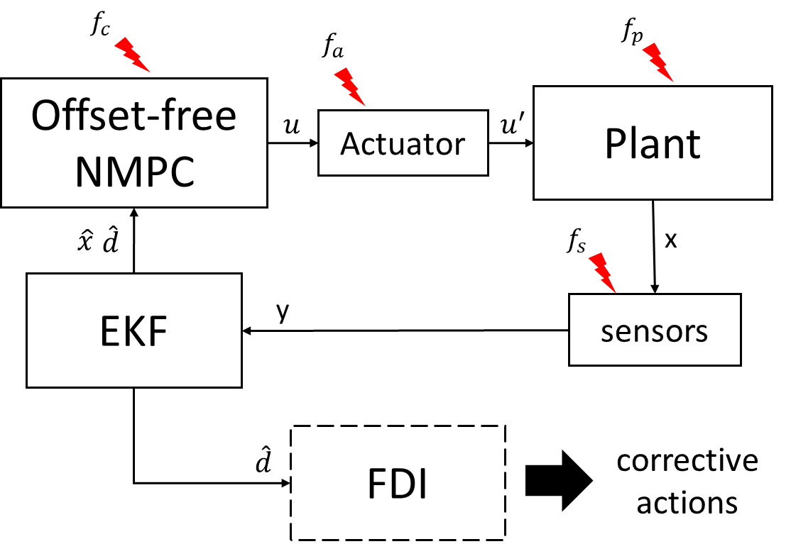
Figure 2 – Block diagram of the control structure and the FDI layer.
  - Results

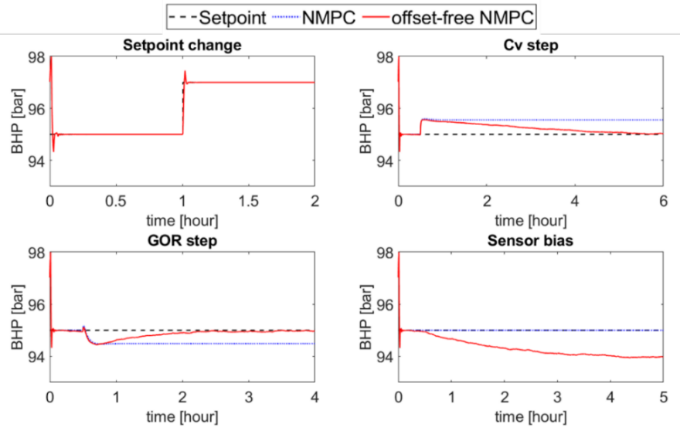
Figure 3 – Results of the simulations of the NMPC and offset-free NMPC on the gas-lift system network for a setpoint change and three faults in the system.
Four scenarios were simulated with a 10% change on the BHP setpoint, flow coefficient of the process valve, gas-oil-ratio (GOR) and a sensor bias on the BHP sensor. Figure 3 shows the true value of the BHP on one of the wells against time for the four scenarios. The performance of the offset-free NMPC is compared against the standard NMPC. As can be seen, no difference can be noted in the setpoint change. However, the offset-free NMPC could make the offset zero when the faults on the GOR occurred. Nevertheless, the controller was slower to achieve that. The only case in the standard NMPC performed better was when a sensor bias was added to the BHP sensor. The small bias on the sensor didn’t affect the NMPC trajectory. However, the offset-free NMPC makes the measurement quantity biased towards offset-free, not the true value. That situation exemplifies that it is essential to identify the source of fault or disturbance. Figure 4 shows the estimated disturbance at the end of the time window for the four cases. The different patterns on the estimated output disturbances make it possible to conclude that the faults can be isolated. That information can be helpful in maintenance interventions.
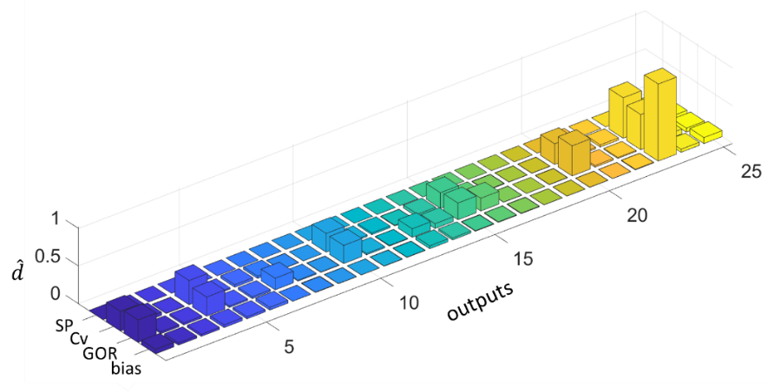
Figure 4 – Estimated disturbance in each output for the four cases scenarios.
  - Conclusions
This work presented an offset-free NMPC for a gas-lift oil well network system. An FDI layer was connected to the disturbance estimation to identify possible faults in the control system and the process. The results demonstrated the offset-free NMPC's efficiency in handling disturbances and the possibility of identifying faults based on those estimated disturbances. In future works, a dynamic change of the disturbance model based on the FDI can be explored. It is expected this monitoring system can aid the future implementation of gas-lift control and optimization strategies in the industry.
Acknowledgement: The authors acknowledge financial support from the Norwegian Research Council through the AutoPRO Project (RN: 309628).
References
A. Ojonugwa, D. Odloak, and F. K. Junior, 2023.,“Fault-Tolerant Control of Gas-Lifted Oil Well.” IEEE Access 11: 24780–93.
G. Pannocchia, A. De Luca, and M. Bottai. 2014. “Prediction Error Based Performance Monitoring, Degradation Diagnosis and Remedies in Offset-Free MPC: Theory and Applications.” Asian Journal of Control 16 (4): 995–1005.
I. Rolf, 2006. Fault-Diagnosis Systems: An Introduction from Fault Detection to Fault Tolerance. Springer Science & Business Media.
K. Dinesh, B. Foss, and S. Skogestad. 2016. “Real-Time Optimization under Uncertainty Applied to a Gas Lifted Well Network.” Processes 4 (4): 52.
K. Dinesh, K. Fjalestad, and S. Skogestad. 2019. “Optimal Operation of Oil and Gas Production Using Simple Feedback Control Structures.” Control Engineering Practice 91 (October): 104107.
M. Morari, and U. Maeder. 2012. “Nonlinear Offset-Free Model Predictive Control.” Automatica 48 (9): 2059–67.

