A lumped parameter approach for determining the pressure gradient in gas-liquid annular flows
Nicolò Varallo^{a,*}, Giorgio Besagniª, Riccardo Mereuª
Politecnico di Milano, Department of Energy, Via Lambruschini 4a, 20156 Milano, Italy
Corresponding author: nicolo.varallo@polimi.it
Abstract
This study defines a statistic-derived lumped parameter approach to determine the pressure gradient in two-phase annular flows. The statistical model was defined by coupling: (1) the ordinary least squares method (OLS) to determine the relationship between the variables, (2) the variance inflation factor (VIF) to check for multicollinearity issues, and (3) the least absolute shrinkage and selector operator (LASSO) to select the relevant predictors. Finally, a lumped parameter approach is derived based on the classification and regression tree (CART) approach. The model identifies the liquid and gas Reynolds numbers, the liquid phase properties, the pipe diameter, and the surface tension as significant variables influencing the two-phase pressure gradient.

Keywords: Downwards annular flow, pressure gradient, statistical analysis, lumped parameter approach.
  - Introduction
Two-phase gas-liquid annular flows are observed in a broad range of industrial processes, such as production and pipeline systems for oil and gas distribution, steam generators, boiling water reactors, and emergency core cooling facilities for the protection of nuclear reactors (Zhu et al., 2021).
Annular flow occurs in a vertical pipe at a very high gas flow rate and low liquid velocity when the gas pushes the liquid closer to the wall, allowing the maintenance of the liquid film. It is hence characterised by a central gas core surrounded by a thin liquid film flowing along the pipe wall. Interfacial waves appear along the streamwise direction due to the shear generated by the gas. Additionally, gas bubbles are entrained in the liquid film and liquid droplets in the gas core.
One of the most relevant flow properties at the global scale is the pressure drop along the pipe. To this end, this study proposes a statistic-derived lumped parameter approach for determining the pressure gradient in two-phase gas-liquid annular flows.
A dataset has been created from literature correlations, considering different operating conditions, pipe diameters, and fluid properties.
The paper is structured as follows. Section 2 presents the variables used to conduct the statistical analysis, Section 3 describes the statistical approach, and the results are discussed in Section 4. Finally, conclusions are drawn, and future studies are proposed.
  - Variables
    - Pressure gradient correlations
Two approaches can be used to calculate the pressure gradient. The former deems the two-phase flow as a pseudo-fluid characterised by suitably averaged properties of the liquid and gas phases. The latter, named the separated flow approach, considers the two-phase flow as artificially divided into two streams, each moving through its dedicated pipe, with the assumption that the velocity of each phase remains constant within the zone occupied by the phase (Xu et al., 2012).
The separated flow approach is used in this study, and it can be classified into two categories: the $Φ_{l}^{2}$, $Φ_{g}^{2}$ based method and the $Φ_{lo}^{2}$, $Φ_{go}^{2}$ based method. $ϕ_{l}^{2}$, $Φ_{g}^{2}$, $Φ_{lo}^{2}$, and $Φ_{go}^{2}$ are two-phase friction multipliers. Consequently, all correlations based on the separated flow approach obtain the two-phase frictional pressure gradient from one of the following expressions.
$${\left.\frac{Δp}{ΔL}\right|}_{tp,f}=Φ_{l}^{2}{\left.\frac{Δp}{ΔL}\right|}_{l}=Φ_{g}^{2}{\left.\frac{Δp}{ΔL}\right|}_{g}=Φ_{lo}^{2}{\left.\frac{Δp}{ΔL}\right|}_{lo}=Φ_{go}^{2}{\left.\frac{Δp}{ΔL}\right|}_{go}$$ | (1)
In Equation (1), ${\left.{Δp}/{ΔL}\right|}_{tp,f}$ is the two-phase frictional pressure gradient, ${\left.{Δp}/{ΔL}\right|}_{l}$ is the frictional pressure gradient which would exist if the liquid phase is assumed to flow alone, ${\left.{Δp}/{ΔL}\right|}_{g}$ is the frictional pressure gradient which would exist if the gas phase is assumed to flow alone, ${\left.{Δp}/{ΔL}\right|}_{lo}$is the frictional pressure gradient which would exist if the total mixture is assumed to be liquid, and ${\left.{Δp}/{ΔL}\right|}_{go}$ is the frictional pressure gradient which would exist if the total mixture is assumed to be gas.
The first and most important empirical model based on the separated flow approach was proposed by Lockhart and Martinelli in 1949. They proposed empirical curves that link the two-phase friction multiplier, $Φ_{l}$, to the Lockhart and Martinelli parameter, defined as
$$X={\left(\frac{{\left.{Δp}/{ΔL}\right|}_{l}}{{\left.{Δp}/{ΔL}\right|}_{g}}\right)}^{1/2}$$ | (2)
Chisholm (1967) developed a mathematical expression for the Lockhart and Martinelli 1949 empirical curves, which has been widely employed for the calculation of the pressure gradient:
$$Φ_{l}=1+\frac{C}{X}+\frac{1}{X^{2}}$$ | (3)
In Equation (3) $C$ is a constant that depends on the characteristics of the flow under investigation. Based on the previous expression, many mathematical derivations have been developed.
Some years later, Chisholm (1972) provided a mathematical representation of the Baroczy graphical procedure, which predicts the pressure gradient for steam-gas mixtures in smooth tubes for evaporating flows. The obtained equations are also applicable to predict the pressure gradient for different two-phase fluids and link the two-phase friction multiplier, $Φ_{lo}^{2}$, to a physical coefficient defined as
$$Γ={\left(\frac{{\left.{Δp}/{ΔL}\right|}_{go}}{{\left.{Δp}/{ΔL}\right|}_{lo}}\right)}^{1/2}$$ | (4)
As in the case of the Lockhart-Martinelli equation, many researchers have based their correlations on the Chisholm expression. Finally, Friedel (1979) proposed a separated flow model-based correlation for the two-phase friction multiplier, considering surface tension effects through the Weber number, $We$. The Froude number, $Fr$, was also included to account for the importance of flow inertia against the external force.
The correlations for the two-phase friction multiplier used in this study are reported in Table 1, Table 2, and Table 3.
    - Variables selection
Starting from the correlations presented in Table 1, Table 2, and Table 3, the pressure gradient dataset has been defined by varying the operating conditions, phase properties, and pipe diameter. In particular, the variables applied to the correlations and used as predictors for the statistical analysis are listed below.
- Gas Reynolds number: from 10 000 to 40 000.
- Liquid Reynolds number: from 2 000 to 5 500.
- Pipe diameter: from 10 mm to 35 mm.
- Fluids: the correlations are usually applied and validated with different gas-liquid pairs. These include the flow of air-water and the condensation of vapor-water and halogenated refrigerants. The independent variables that characterize the fluids are the gas and liquid densities and dynamic viscosities ($ρ_{g}, ρ_{l}, μ_{g}, μ_{l}$), along with surface tension $σ$ for the interaction between the fluids. The fluids considered are: (I) air-water at 22 °C and 50 °C, (II) vapor-water at saturation temperature and atmospheric pressure, (III) refrigerants at saturation temperature and atmospheric pressure (R22, R314a, R125, R32, R236ea, R114, R152a, R12).
The average value obtained from the different correlations is used to build the dataset, resulting in 3 696 data points with 8 independent variables. As these variables have a left-skewed distribution, they are used in the statistical method as log-transformed.
  - Methods
The statistical method was defined by coupling the ordinary least squares method (OLS) to determine the relationship between dependent and independent variables, the variance inflation factor (VIF) to check for multicollinearity issues, and the least absolute shrinkage and selector operator (LASSO) to select the significative predictors. Finally, based on the regression results, the classification and regression tree approach (CART) is used to segment the dataset and to define a lumped parameter approach for determining the pressure gradient. The statistical procedure is shown in Figure 1.

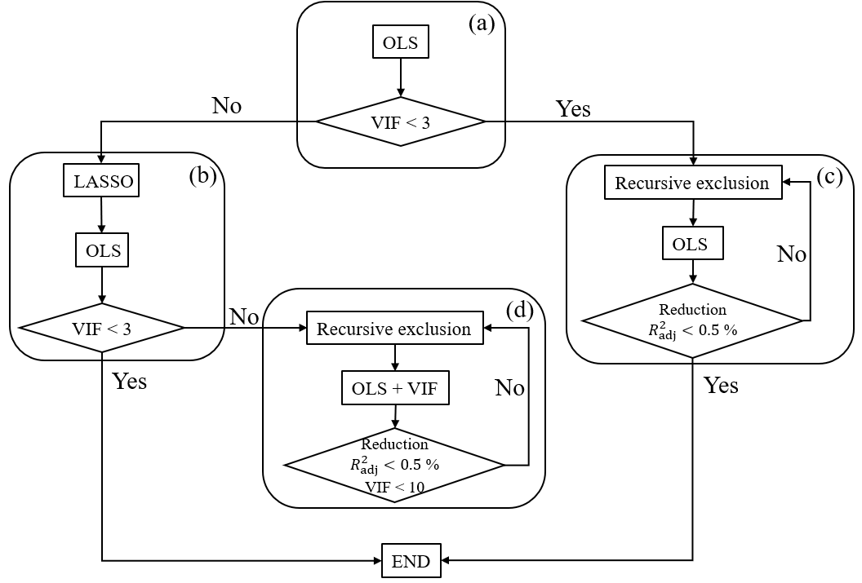
Figure 1. OLS-VIF-LASSO procedure.
Table 1. Two-phase friction multiplier derived from Lockhart and Martinelli (1949). In the table $x$ is the gas volume fraction, $D_{h}$ is the pipe diameter, and $G$ is the mass flux.
Author | Correlation | Notes
Chisholm, 1967 | $$Φ_{l}^{2}=1+\frac{C}{X}+\frac{1}{X^{2}}$$ | $C=5$ for viscous-viscous flow, $C=10$for turbulent-viscous flow  $C=12$for viscous-turbulent flow, $C=20$ for turbulent-turbulent flow
Hasan and Rhodes, 1967 | $$Φ_{l}^{2}=1+\frac{C}{X}+\frac{1}{X^{2}}$$ | $$C=3.218{\left(\frac{2000}{G}\right)}^{0.3602}{\left(\frac{ρ_{l}}{ρ_{g}}\right)}^{0.262}$$
Mishima and Hibiki, 1996 | $$Φ_{l}^{2}=1+\frac{C}{X}+\frac{1}{X^{2}}$$ | $$C=21(1-e^{-3190 D_{h}})$$
Sun and Mishima, 2009 | $$Φ_{l}^{2}=1+\frac{C}{X}+\frac{1}{X^{2}}$$ | $$C=1.79{\left(\frac{Re_{g}}{Re_{l}}\right)}^{0.4}{\left(\frac{1-x}{x}\right)}^{0.5}$$
Awad and Muzychka, 2004 | $$Φ_{l}^{2}={\left[1+{\left(\frac{1}{X^{2}}\right)}^{0.307}\right]}^{1/{0.307}}$$
Muzychka and Awad, 2010 | $$Φ_{l}^{2}=1+\frac{C}{X}+\frac{1}{X^{2}}$$ | $C=18.02;m=1.014$ for turbulent-turbulent flow

Table 2. Two-phase friction multiplier derived from Chisholm (1972). In the table $x$ is the gas volume fraction, $L_{a}$ is the Laplace constant, and $G$ is the mass flux.
Author | Correlation | Notes
Chisholm, 1972 | $Φ_{lo}^{2}=1+\left(Γ^{2}-1\right)[B_{CH}x^{0.875}+x^{1.75}]$ | $$B_{CH}=\left\{\begin{aligned}{55}/{\sqrt{G}}, &0<Γ≤9.5 \\ {520}/{Γ\sqrt{G}}, &9.5<Γ≤28 \\ {15000}/{Γ^{2}\sqrt{G}}, &Γ>28\end{aligned}\right.$$
Tran et al., 1999 | $$Φ_{lo}^{2}=1+\left(4.3Γ^{2}-1\right)[{Nx}^{0.875}{\left(1-x\right)}^{0.875}+x^{1.75 }]$$ | $$N=\frac{{\left[σ/{g\left(ρ_{l}-ρ_{g}\right)}\right]}^{0.5}}{D}$$
Uller-Steinhagen and Heck, 1986 | $$Φ_{lo}^{2}=Γ^{2}x^{3}+[1+2x\left(Γ^{2}-1\right)]{\left(1-x\right)}^{1/3}$$
Xu and Fang, 2012 | $$Φ_{lo}^{2}=Γ^{2}x^{3}+[1+2x\left(Γ^{2}-1\right){\left(1-x\right)}^{1/3}]\left[1+1.54{\left(1-x\right)}^{0.5}{La}^{1.47}\right]$$

Table 3. Two-phase friction multiplier derived from Friedel (1979). In the table $x$ is the gas volume fraction.
Author | Correlation
Friedel, 1979 | $$Φ_{lo}^{2}={\left(1-x\right)}^{2}+x^{2}\frac{ρ_{l}}{ρ_{g}}\frac{f_{go}}{f_{lo}}+\frac{3.24x^{0.78}{\left(1-x\right)}^{0.224}}{Fr_{tp}^{0.045}We_{tp}^{0.035}}{\left(\frac{ρ_{l}}{ρ_{g}}\right)}^{0.91}{\left(\frac{μ_{g}}{μ_{l}}\right)}^{0.19}{\left(1-\frac{μ_{g}}{μ_{l}}\right)}^{0.7}$$
Friedel, 1980 | $$Φ_{lo}^{2}={\left(1-x\right)}^{2}+x^{2}\frac{ρ_{l}}{ρ_{g}}\frac{f_{go}}{f_{lo}}+\frac{5.7x^{0.7}{\left(1-x\right)}^{0.14}}{Fr_{tp}^{0.09}We_{tp}^{0.007}}{\left(\frac{ρ_{l}}{ρ_{g}}\right)}^{0.85}{\left(\frac{μ_{g}}{μ_{l}}\right)}^{0.36}{\left(1-\frac{μ_{g}}{μ_{l}}\right)}^{0.2}$$
Cavallini et al., 2002 | $$Φ_{lo}^{2}={\left(1-x\right)}^{2}+x^{2}\frac{ρ_{l}}{ρ_{g}}\frac{f_{go}}{f_{lo}}+\frac{1.26x^{0.6978}}{We_{go}^{0.1458}}{\left(\frac{ρ_{l}}{ρ_{g}}\right)}^{0.3278}{\left(\frac{μ_{g}}{μ_{l}}\right)}^{-1.181}{\left(1-\frac{μ_{g}}{μ_{l}}\right)}^{3.477}$$
  - Results
The overall fit model is based on the adjusted coefficient of determination, which is equal to 97.33%. Table 4 shows the regression results given by the OLS-VIF-LASSO procedure shown in Figure 1.
Table 4. Regression model results for the log-transformed pressure gradient.
 | Coefficient ($β$) | Standard error | $t$-value | $$Significance$$ | VIF
Intercept | 5.527 | $$5.943×{10}^{-2}$$ | 93 | *** | -
$Re_{g}$ [-] | $$4.976×{10}^{-5}$$ | $$4.695×{10}^{-2}$$ | 105.985 | *** | 1
$Re_{l}$ [-] | $$2.235×{10}^{-4}$$ | $$4.098×{10}^{-6}$$ | 54.543 | *** | 1
$D_{h}$ [mm] | $$-1.534×{10}^{2}$$ | $$5.499×{10}^{-1}$$ | -278.932 | *** | 1
$ρ_{l}$ [kg/m³] | $$-2.872×{10}^{-4}$$ | $$3.937×{10}^{-5}$$ | -7.293 | *** | 3.62
$μ_{l}$ [kg/m³] | $$1.053×{10}^{-3}$$ | $$3.986×{10}^{-1}$$ | 26.414 | *** | 2.05
$σ$ [N/m] | 35.56 | $$4.762×{10}^{-1}$$ | 74.670 | *** | 5.27

By definition of linear regression, a change of a variable $x_{j}$ of $Δx_{j}$, when the rest of the model variables are kept constant leads to a change in the log-transformed variable ${Δy}/{y=β_{j}Δx_{j}}$. The log-transformation applied to the pressure gradient, $Δp/L$, is $y = ln(Δp/L)$, so it can be derived that the relative change in the pressure gradient due to the change in $x_{j}$ is ${Δ(Δp/L)}/{({ΔP}/L)=e^{β_{j}Δx_{j}}-1}$.
The influence of the phases velocities is studied varying the gas and liquid Reynolds numbers. Increasing the gas Reynolds number by 1000 increases the pressure gradient of +5.1 %. The same was found for the liquids Reynolds number since an increase of 100 in its value, results in an increase in the pressure gradient of +2.3%. Increasing the pipe diameter by 1 mm implies a reduction in the pressure gradient of -14.2%. Another relevant predictor identified by the model is the surface tension. An increase of 1 mN/m in the surface tension leads to an increase in the pressure gradient of +3.6%.
Finally, the model excluded the gas properties, but both the density and viscosity of the liquid are significant predictors. In particular, the increase in the liquid density decreases the pressure gradient (-2.9% for $Δρ_{l}=100$ kg/m³), while the increase in the liquid viscosity increases it (+10.5% for $Δμ_{l}=0.1$ mPas).
The graphical representation of the results, provided by the regression tree (Figure 2), can be immediately used to determine the pressure gradient, once the operating conditions, phase properties, and pipe diameter are known.

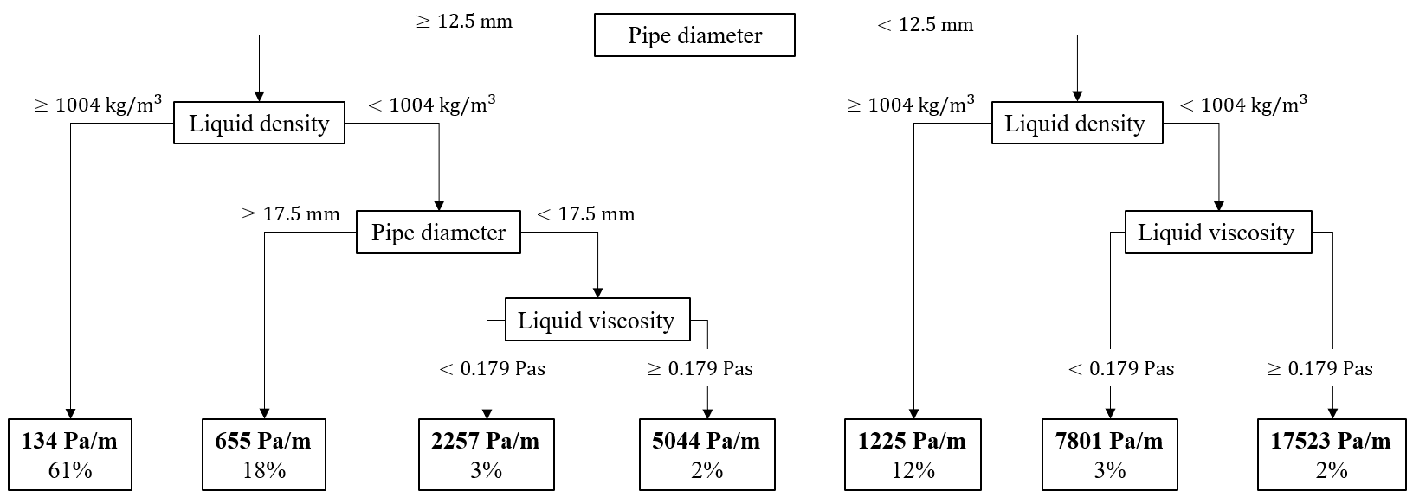
Figure 2. Regression tree.
  - Conclusions
This study proposed a statistics-derived lumped parameter model to determine the pressure gradient in two-phase annular flows.
The statistical model implemented identifies the pipe diameter, the gas and liquid Reynolds numbers, the liquid phase properties, and the gas-liquid surface tension as significative predictors. An increase in the phases Reynolds numbers increases the pressure gradient. Conversely, an increase in the liquid density and a decrease in the liquid viscosity reduces the pressure gradient, and the same was found for an increase in the pipe diameter.
The proposed approach could be applied to other operating conditions and flow regimes as a further development.
References
A. M. Aliyu, L. Lao, A. A. Almabrok, H. Yeung, 2016, Interfacial shear in adiabatic downward gas/liquid co-current annular flow in pipes, Exp. Therm. Fluid Sci., 72, 75-87.
M. M. Awad, Y. S. Muzychka, 2004, A simple asymptotic compact model for two-phase frictional pressure gradient in horizontal pipes, ASME International Mechanical Engineering Congress and Exposition, 47098.
A. Cavallini, G. Censi, D.D. Col, G.A. Longo, L.Rossetto, 2002, Condensation of halogenated refrigerants inside smooth tubes, HVAC&R Res., 8, 4.
D. Chisholm, 1967, A theoretical basis for the Lockhart-Martinelli correlation for t wo-phase flow, Int. J. Heat Mass Transf., 10, 1767-1778.
D. Chisholm,1972, Pressure gradients due to friction during the flow of evaporating two-phase mixtures in smooth tubes and channels. Int. J. of Heat Mass Transfer, 16, 347-358.
L. Friedel, 1979, Improved friction pressure drop correlations for horizontal and vertical two-phase pipe flow, European two-phase group meeting, Ispra, Italy.
L. Friedel, 1980, Pressure drop during gas/vapour-liquid flow in pipes, Int. Chem. Eng, 20, 352-367.
A.R. Hasan, E. Rhodes, 1983, Effects of mass flux and system pressure on two-phase friction multiplier, Chem. Eng. Commun, 17, 209-229.
R.W. Lockhart, R.C. Martinelli, 1949, Proposed correlation of data for isothermal two-phase, two-component flow in pipes, Chem. Eng. Prog, 1, 39-48.
K. Mishinma, T. Hibiki, 1996, Some characteristics of air-water two-phase flow in small diameter vertical tubes, Int. J. Multiph. Flow, 22, 703-712.
H. Müller-Steinhagen, K. Heck, 1986, A simple friction pressure drop correlation for two-phase flow in pipes, Chem. Eng. Process, 20, 297-308.
Y.S. Muzychka, M.M. Awad, 2010, Asymptotic generalizations of the Lockhart-Martinelli method for two phase flows, J. Fluids Eng., 132
L. Sun, K. Mishima, 2008, Evaluation analysis of prediction methods for two-phase flow pressure drop in mini-channels, Int. J. Multiph. Flow, 35, 47-54.
T.N. Tran, M.C. Chyu, M.W. Wambsganss, D.M. France, 1999, Two-phase pressure drop on refrigerants during flow boiling in small channels: an experimental investigation and correlation development, Int. J. Multiph. Flow, 26, 1739-1754 .
C.C. Wang, C.S. Chiang, D.C. Lu, 1997, Visual observation of two-phase flow pattern of R-22, R-134a, and R-407C in a 6.5-mm smooth tube, Exp. Therm. Fluid Sci., 15, 395-405.
Y. Xu, X. Fang, X. Su, Z. Zhou, W. Chen, 2012, Evaluation of frictional pressure drop correlations for two-phase flow in pipes, Nucl. Eng. Des., 253, 86-97.
Y. Xu, X. Fang, 2012, A new correlation of two-phase frictional pressure drop for evaporating flow in pipes, Int. J. of Refrigeration, 35, 2039-2050.
F. Zhu, C. Yan, A. Liu, H. Gu, S. Gong, 2021, Droplet size of vertically upward annular flow in a narrow rectangular channe, Chem. Eng. Res. Des., 174, 107-115.

