Achieving Flexibility in High Throughput Liquid Handing experimentation by smart System Design
Simon Seidelª, Peter Neubauerª, Mariano Nicolas Cruz-Bournazouª
ª Chair of Bioprocess Engineering, Department of Biotechnology, Faculty III, Technische Universität Berlin, Berlin, Germany
simon.seidel@tu-berlin.de
Abstract
Automation and data handling have become essential in the developments of Laboratory 4.0, liquid and robotic object handling, and laboratory digitalization. However, existing systems seldom offer comprehensive and adaptable integrated platforms, restricting seamless integration and flexible experiments. There is a constant need to synchronize hardware automation with data handling and computational workflows to facilitate development of automated lab processes in today’s R&D.
Addressing this, we introduce a distributed micro-service based robotic control platform for biolabs, designed to simplify system orchestration for high throughput experiments through features such as easy modifiability, alongside efficient hardware integration. This development includes a hardware-software infrastructure utilizing microservices, digital twins, among others, and incorporates miniaturized systems developed in-house, steering towards meeting the requisites of Laboratory 4.0 and alleviating longstanding challenges faced in automation and digitalization in this sector.
Keywords: Micro-Service Based Infrastructure, Laboratory 4.0, Digital Twin, Laboratory Digitalization, and Integration

  - Introduction
The advancement of liquid handling stations in biolabs has been complemented by the introduction of various auxiliary devices like filtering stations, pumping units, washers, and cooling/heating units, including compact shakers and specialized microscopes. While the integration of physically larger equipment can present challenges, such as pipetting issues and reduced parallel processing capability, the trend is shifting towards smaller-scale, distributed systems(Anantanawat et al., 2019; Haby et al., 2019; Hemmerich et al., 2018; Hertzberg & Pope, 2000; Pereira & Williams, 2007). This trend highlights the need for scalability and flexibility in labs, adopting an edge-focused approach where each device operates semi-independently. Devices such as mini bioreactors, diverse well plates, organ-on-chip systems, and microfluidic devices are well suited to be integrated in such distributed framework. Their integration into an automated platform enhances experimental capabilities and overall lab performance.

We present a comprehensive system designed for high-throughput liquid handling in biolabs. The system integrates diverse technologies and methodologies, including process orchestration, on-demand simulations, and flexible workflow design in Cylc v8 and Apache NiFi. It utilizes a Tecan liquid handler and an array of smart devices for enhanced flexibility and efficiency in experimentation. The paper is structured to first describe the setup and concludes with a demonstration of an experimental run using the entire system.
  - Software, Hardware and Methodology
The comprehensive setup consists of various devices and software which are each described in the following sections. First a hardware description is provided in the section 2.1, then a software description and the methodology is provided in section 2.2.
    - Physical setup description
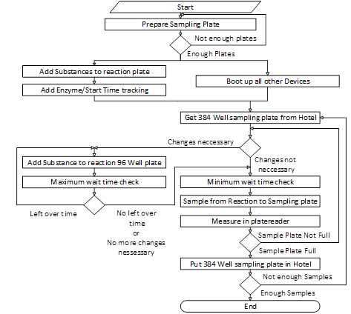
The setup is built in and around a Tecan Evo 200 (Tecan, Switzerland) liquid handler (LiHa). It features a variety of devices, which are physically and virtually integrated. The LiHa pipetting head can pipet eight liquids in any configuration, while the 384 needle head can pipet a large number of liquids in parallel. By placing all devices close to each other in and adjacent to the platform, the given setup can perform high throughput experimentation. The 384 needle washing station (Tecan, Switzerland) can wash and cool the needles, depending on the used liquid, e.g. washing and cooling liquid. The plate reader M1000 (Tecan, Switzerland) measures samples with less than one second per well. The thermal device (inhouse development) can reach temperatures from -20 to 100 degrees Celsius within 12 independent sections of one 96 well plate. Each section consists of 4 wells, resulting in 48 independently controlled wells.
Figure 1: This workflow outlines the procedure for the enzymatic characterization process. Initially, all necessary substances are stored within the liquid handling system. The process is then executed according to a predefined workflow implemented in Cylc v8.
    - Methodology and Software Components
A variety of systems are necessary for the integration of the devices for the process (ref. section 2.2.1). The main central component is the Laboratory orchestration system (ref. section 2.2.2) This system uses an Workflow management (ref. section 2.2.3) and other subsystems (ref. section 2.2.4).
      - Experiment Procedures
For the purpose of this study, the authors established an enzyme characterization process setup aimed at high-throughput experimentation to demonstrate the performance of the system. The initial phase involves preparing the liquid handling station by adding enzymes, substrates, and stock substances. The system tests different combinations of initial conditions for each enzymatic reaction in a 96 well plate and samples from each well several times. In total 48 reactions are run in parallel. The comprehensive process is outlined in Figure 1.
      - Laboratory Orchestration
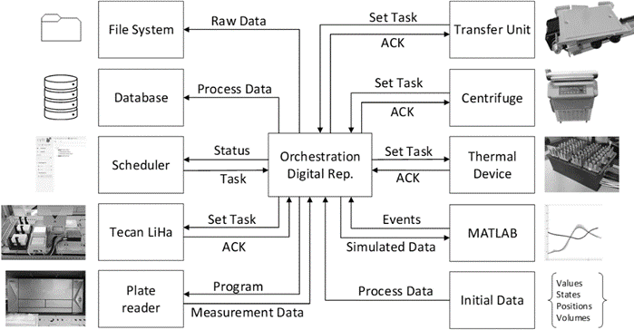
The orchestrator oversees the liquid handling procedures, coordinating equipment such as the Tecan liquid handler, thermal devices, centrifuges, transfer units, wash stations, and plate readers (ref. Figure 2). It tracks the locations and statuses of components like vials and multi-well plates and maintains records of measurement data and sample origins. Additionally, the orchestrator updates information based on pipetting actions and adjusts for changes in liquid levels and well conditions. It ensures procedural consistency, prevents unfeasible command execution, and handles hard- and software communication through the Apache NiFi based data infrastructure.
Figure 2: The complete Apache Nifi based communication Infrastructure condensed into one diagram. The laboratory orchestration is the central element for the used automated setup in the biolab. This scheme shows which Software and devices are included into the system and what type of data is being transferred.
      - Workflow Management and Experiment Execution
Cylc v8 is instrumental in creating dynamic, parallel and cycling workflows that vary in complexity, thereby enhancing the flexibility and integration of the experimental process. Its user interface allows for quick modifications and easy integration of new steps into existing workflows (ref. Figure 1)
      - Additional Software
MATLAB is utilized for simulating physical, chemical, and biological processes in experiments, using mechanistic models for an optimal design of experiments. It performs estimations and simulations, which are then fed back into the system for efficient experiment management.
Apache NiFi connects the lab's devices, enables the creation of new device connections, data routing between devices and software communication within the digital infrastructure. It features robust data management, data storage during communication failures, and a user interface for troubleshooting and visualization in complex setups. Apache NiFi also facilitates data processing and transformation, ensuring compatibility and seamless communication across various platforms.
  - Results
The performance of the system was evaluated based on its data handling capabilities, flexibility, and the integration of various hardware and software components. The orchestrator efficiently managed real-time data export and analysis, including the automatic calculation of reaction initiation times. This was tested in an experiment where measurements from three 384-well plates is reassigned online to individual wells in a 96-well plate (ref. Figure 3).
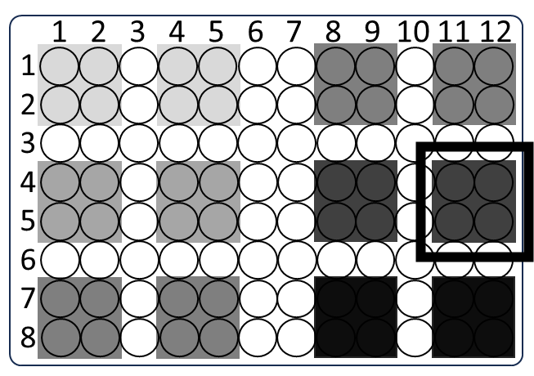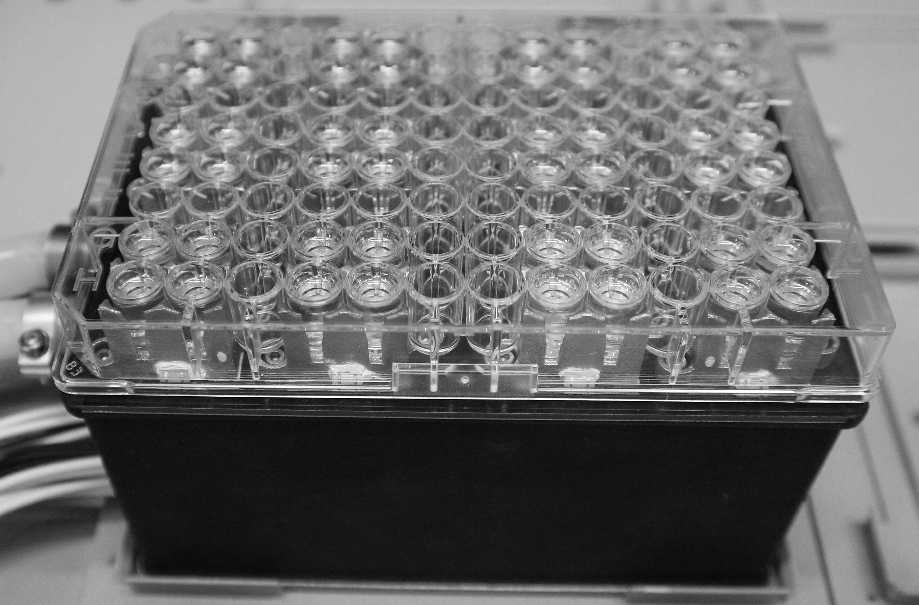

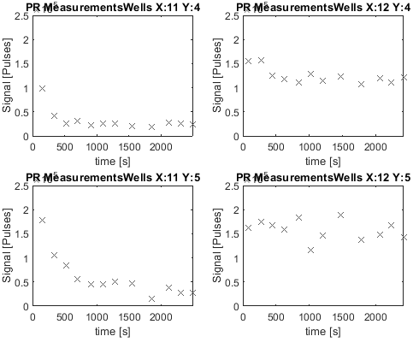 | 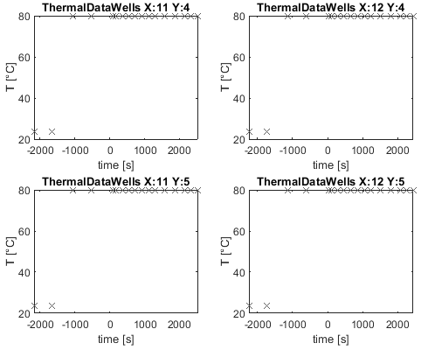
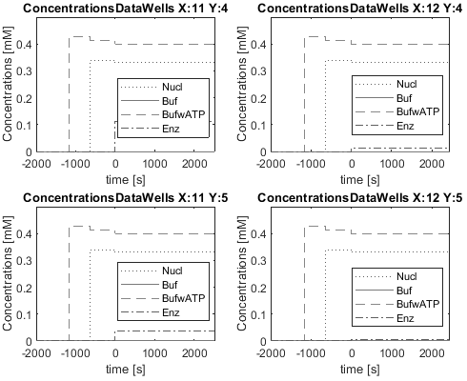 | 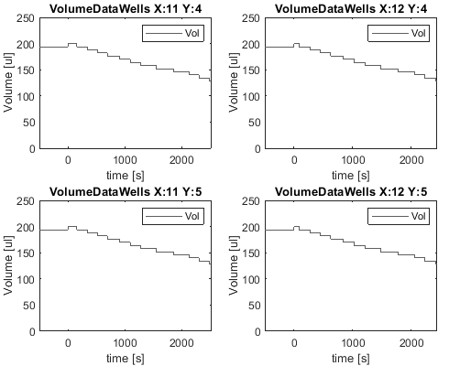
Figure 3: Exemplary intermediate result of an ongoing screening as it is represented in Matlab. The data is from a single 96 well plate 4 well segment is displayed in the upper left scheme and upper right picture. The time zero seconds in the plots represents the time of enzyme addition in the main 96 Well plate. The top four plots on the left show plate reader measurements from 384 Well measurements plates for samples from the four well block. The upper right four plots show the temperature measurements taken during the experiment. The bottom left plots show calculated concentrations from the four wells and the bottom right graphs show the total volume in each of the four wells.

The setup can overcome various problems and errors. This adaptability allowed stretching and rerunning of certain steps during the execution.
  - Discussion
The integration of hardware and software components in a high-throughput screening process, as described is enabled using a distributed digital infrastructure. The setup has proven to be effective in enhancing efficiency, accuracy and throughput in high-throughput screenings or characterisation, precisely processing larger and diverse data volumes.
  - Conclusion
The setup of laboratory components and software enhance scalability and flexibility in modern labs. Distributing experimental tasks to specialized agents allows for modular lab design, improves reproducibility in automated experiments, and supports inter-laboratory collaboration. In fields that rely on high-throughput screening, such as pharmacology, genomics, and biochemistry, the ability to process a vast amount of experiment data quickly and accurately is expedient in the ability to develop biotechnological products.

References
Anantanawat, K., Pitsch, N., Fromont, C., & Janitz, C. (2019). High-throughput Quant-iT PicoGreen assay using an automated liquid handling system. BioTechniques, 66(6), 290–294. https://doi.org/10.2144/btn-2018-0172
Haby, B., Hans, S., Anane, E., Sawatzki, A., Krausch, N., Neubauer, P., & Cruz Bournazou, M. N. (2019). Integrated Robotic Mini Bioreactor Platform for Automated, Parallel Microbial Cultivation With Online Data Handling and Process Control. SLAS Technology, 24(6), 569–582. https://doi.org/10.1177/2472630319860775
Hemmerich, J., Noack, S., Wiechert, W., & Oldiges, M. (2018). Microbioreactor Systems for Accelerated Bioprocess Development. Biotechnology Journal, 13(4), 1700141. https://doi.org/10.1002/biot.201700141
Hertzberg, R. P., & Pope, A. J. (2000). High-throughput screening: New technology for the 21st century. Current Opinion in Chemical Biology, 4(4), 445–451. https://doi.org/10.1016/S1367-5931(00)00110-1
Kong, F., Yuan, L., Zheng, Y. F., & Chen, W. (2012). Automatic Liquid Handling for Life Science: A Critical Review of the Current State of the Art. SLAS Technology, 17(3), 169–185. https://doi.org/10.1177/2211068211435302
Leung, C. M., de Haan, P., Ronaldson-Bouchard, K., Kim, G.-A., Ko, J., Rho, H. S., Chen, Z., Habibovic, P., Jeon, N. L., Takayama, S., Shuler, M. L., Vunjak-Novakovic, G., Frey, O., Verpoorte, E., & Toh, Y.-C. (2022). A guide to the organ-on-a-chip. Nature Reviews Methods Primers, 2(1), 33. https://doi.org/10.1038/s43586-022-00118-6
Pereira, D. A., & Williams, J. A. (2007). Origin and evolution of high throughput screening: Origin and circumscribed history of HTS. British Journal of Pharmacology, 152(1), 53–61. https://doi.org/10.1038/sj.bjp.0707373
Zhu, Y., Zhang, Y.-X., Cai, L.-F., & Fang, Q. (2013). Sequential Operation Droplet Array: An Automated Microfluidic Platform for Picoliter-Scale Liquid Handling, Analysis, and Screening. Analytical Chemistry, 85(14), 6723–6731. https://doi.org/10.1021/ac4006414

