Enhanced sustainable natural gas production using biomass biodigestion and gasification integrated with solid oxide electrolysis cell
Meire Ribeiro Domingosª, Daniel Flórez-Orrego^{a,b}, Dareen Dardorª, François Maréchalª
ªFederal Polytechnic School of Lausanne, IPESE group, Sion, Switzerland.
^{b}Faculty of Minas, National University of Colombia, Medellin, Colombia.
meire.ribeirodomingos@epfl.ch
Abstract
In this work, a computational approach is used to identify the operating conditions and arrangements that minimize the consumption of energy resources for sustainable natural gas production. The gasification process of the digestate derived from the biodigestion unit as well as the high temperature electrolysis system are modelled using Aspen Plus® software, whereas the OSMOSE Lua platform handles the solution to the optimization problem of minimum energy consumption and the total cost of the chemical plant. Breakthrough technologies played an important role to reduce the intermittency of renewable energy sources. The effective CO₂ management and storage systems ensure a reliable supply of sustainable natural gas, even during times of high electricity demand and market volatility. This can increase plant revenues, but indirect emissions from the electricity mix remain a challenge to decarbonizing important commodities.

Keywords: process integration, sustainable natural gas, renewable energy, solid oxide electrolysis, gasification
  - Introduction
Biomethane is a renewable fuel produced from waste-derived biomass (biowaste), which offers significant reductions of greenhouse gas emissions and resource consumption. Biomethane is currently produced via anaerobic digestion of wet biowaste followed by upgrading processes in order to achieve grid specifications. An alternative production strategy is the gasification of the biowaste with downstream cleaning, conditioning, methanation, and final upgrading of obtained syngas (Domingos et al., 2023).
Hydrogen production from water electrolysis has recently drawn attention as a versatile solution for balancing intermittent renewable electricity generation, particularly from sources like wind and solar. In addition, integrating water electrolysis to biomass energy conversion processes may offers the potential for a complete transformation of biogenic carbon into biofuels. In fact, hydrogen could be added to biomass gasification syngas in order to balance the syngas composition before the biofuel production step. The biogenic CO₂ may also come from biodigestion processes, thus further increasing the sustainable natural gas yield. Thus, in this work, a systematic approach that considers time-varying energy demands in view of the seasonal energy costs and the intermittency of renewable energy resources is addressed aiming the integration of anaerobic digestion, gasification and high temperature electrolysis in order to enhance the sustainable natural gas production. The optimal CO₂ management using storage systems is also assessed to demonstrate this operating strategy role in future energy systems.
  - Methods
    - Process modeling and simulation
Figure 1 illustrates the proposed integrated sustainable natural gas production using anaerobic digestion, digestate gasification and high temperature electrolysis. The biodigestion process is modelled considering a biomethane potential of 300 Nm³ CH₄ per t of volatile solids using organic wastes (Wellinger et al 2013). The DMT Carborex MS technology is considered for the biogas upgrading, since it can obtain methane concentration of >99% CH₄, and has a high energy recovery (>98%) consuming only 0.18-0.22 kWh/Nm³ and presenting <0.5% methane loss. The CO₂ is also recovered in the upgrading system with a purity above 99.5% (Lems et al., 2008). The upgraded biomethane is marketed and the CO₂ rich stream follows to the biomethane production.
In addition, the anaerobic digestion process produces the digestate, that can be further gasified to enhance the methane production. The ultimate mass-based digestate composition is set to 36.04%C, 5.14%H, 31.66%O, 2.28%N, 1.85%S and 23.03%ash, whereas the mass-based proximate analysis is considered as 5.96% moisture (after drying), 11.1% fixed carbon, 59.91% volatiles, 23.03% and ash in balance (Chen et al., 2017). The initial moisture of the digestate is assumed as 50%. The digestate gasification system shown in Fig. 1 operates at atmospheric pressure and uses steam as gasification medium (Kinchin and Bain, 2009). The combustion and gasification processes occur in separate columns, thus avoiding the dilution with nitrogen of the syngas produced. After leaving the gasifier, the syngas is treated to remove tars and impurities. A fraction of the char produced in the pyrolysis step is combusted to supply the heat required by the endothermic drying, pyrolysis and reduction reactions. The syngas subsequently follows to shift reactors and to a CO₂ capture unit in order to adjust the composition to be suitable for the methanation reaction (H₂/CO₂ 4:1).
The CO₂ captured in the syngas purification unit could be liquefied and stored in a tank at -50 °C and 7 bar (1,155 kg/m³). Liquefied CO₂ can be later regasified and fed to a methanation system, in which the hydrogen necessary is provided by a high temperature solid oxide electrolyzer. The solid oxide electrolyzer (SOEC) operates at 1 bar, 800 °C, steam conversion rate of 81%. The SOEC system is modelled considering the concentration, ohmic and activation overpotentials (Ni et al 2006).
The methanation system is based on the TREMP® process (Topsøe, 2009), in which a series of methanation beds are intercooled either by recycling or indirect inter-cooling in order to achieve higher reactants conversion.
The simulations are performed in the Aspen Plus® software (Aspentech, 2015), using the Peng-Robinson EoS with Boston-Mathias modifications as thermodynamic model. the Perturbed-Chain Statistical Associating Fluid Theory (PC-SAFT) is used to model the physical absorption of CO₂ with dimethyl ethers of polyethylene glycols (DEPG).
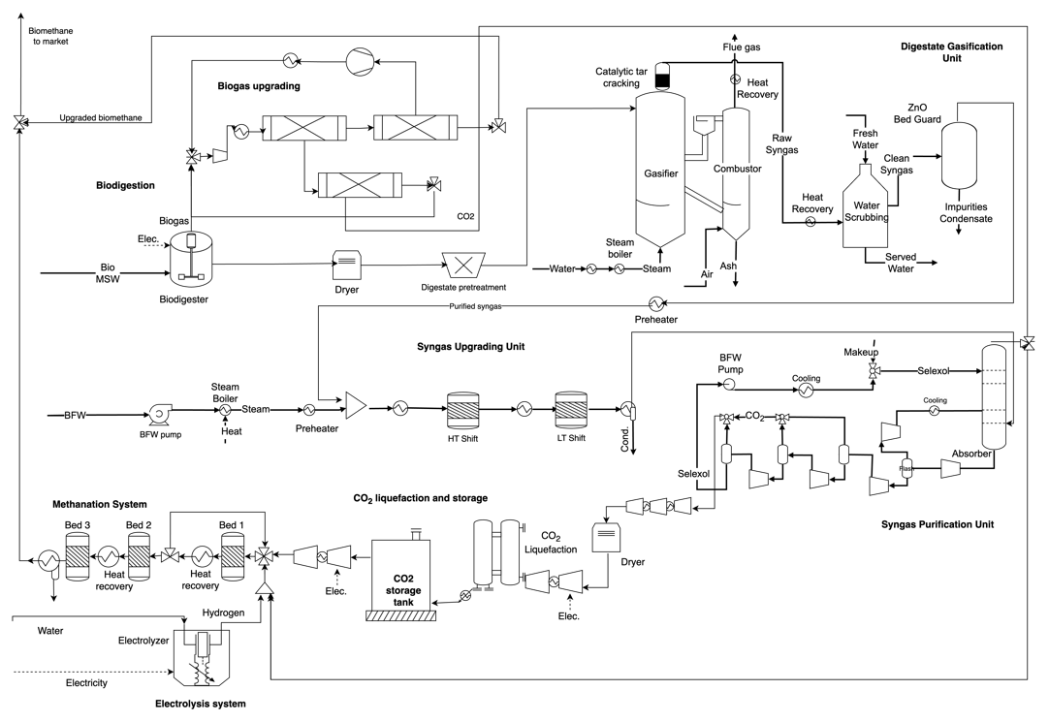
Figure 1. Integrated biomethane production considering anaerobic digestion, gasification and high temperature electrolysis.

    - Optimization problem definition

The new energy technologies in Fig. 1 require a redefinition of the energy balance for traditional biomethane plants. A systematic method and computational tool are needed for the complex energy integration and optimization problem. The OSMOSE Lua platform is used to determine the minimum energy requirements (MER) and solve the energy integration problem (Domingos et al., 2023). OSMOSE follows a two-step approach, in which the nonlinearities are limited to the Aspen Plus® models and it is considered that those representative values can be scaled linearly. The slave problem consists of a mass and energy integration framework and it is developed as a mixed-integer linear programming (MILP) problem described in Eqs. (1-5). The goal is to minimize the objective function, Eq. (1), and determine the binary variables y_{w} related to the selection of a given utility unit ω, and its corresponding continuous load factor, f_{w}, as well as the investment cost associated to the implementation of these technologies. In summary, the optimization problem accounts for the trade-off between buying the new technologies and affording the operating costs and revenues that are associated to a certain operating scenario.
$$\min_{\begin{aligned}f_{ω},y_{ω} \\ R_{r},W\end{aligned}}\left[f_{MSW}×{(B.c)}_{MSW}{+ f}_{\begin{aligned}power \\ grid\end{aligned}}×{(W.c)}_{\begin{aligned}power \\ grid\end{aligned}}+f_{envEm}×{(m.tax)}_{envEm}+f_{water}×{(B.c)}_{water}-f_{CH4}×{\left(B.c\right)}_{CH4}+\frac{z_{equip}*AF}{N_{hours per year}}\right]$$ | (1)
Subject to:
Heat balance at the temperature interval (r):
(2)
Balance of produced/consumed power:
(3)
Existence and size of the utility unit:
(4)
Feasibility of the solution (MER):
and | (5)
where:
N_{w} is the number of units in the set of utility systems; B is the exergy flow rate (kW) of the resources entering or leaving the integrated energy system; c stands for the buying costs of the waste feedstock (0.001 EUR/kWh) and the electricity consumed (for March-October assumed as 0.001 EUR/kWh, and for November-February as 0.15 EUR/kWh), along with the CO₂ taxation set as 120 EUR/t_{CO2} (IEA, 2021), as well as for the selling price of the marketable CH₄ (0.07 EUR/kWh); q is the heating/cooling flow rates supplied by the selected utility systems (kW); W is the power domestically produced by either the utility systems (i.e. steam network) or the chemical processes (e.g. expanders); or imported from/exported to the grid (kW); AF is the annualization factor; N_{hours per year} is the number of operative hours per year (8760 h); Z_{equip} is the investment cost (EUR).
The electricity price assumption allows us to model the seasonal energy costs of intermittent and renewable energy resources, as well as the factors that affect energy and CO₂ management in the integrated production system in this case study.
Equations (6) and (7) are the balance equations for the amount of liquefied gas stored in the tanks, being that the continuous variable f_{tank} accounts for the optimization variable of the tank capacity, and the mass or energy coming in or out the storage systems depend on the operating capacities of the energy systems (f), which are also optimized for each time step t.
(6)
(7)
  - Results and discussion
The results of the optimal processes parameters for the integrated case are summarized in Table 1. During the March-October period, the methane production via the SOEC route and using biogenic CO₂ coming from either the gasification and from the anerobic digestion, is activated, as an adaption to lower electricity prices and more affordable renewable energy. This can be also noticed in Fig. 3, where the stored CO₂ is preferably used in the months in which the electricity price is low, avoiding a large import of costly electricity from the grid. Carbon abatement units and liquid fuel storage are essential advanced energy conversion technologies that ensure the reliable operation of cogeneration systems, especially for electricity supply.
The integrated setup presented 6.2 MEUR/y of annualized investments costs and -16.4 MEUR/y of operating costs, which reinforces that the operating strategy can be attractive to increase the operating revenues leading to a lower total cost of the plant. In addition, in the months where the electrolyzer is activated, the indirect emissions from the electricity grid can reach 0.54 kg_{CO2}/kg_{CH4}. Thus, the indirect emissions associated electricity supply chain still represent a challenge for the decarbonization of the extended production process.

Table 1. Optimal process parameters for the integrated case.
 | Mar-Oct | Nov-Feb
Feedstock MSW consumption (MJ/kg_{CH4}) | 51.69 | 118.86
Utility electricity cosumption (MJ/kg_{CH4}) | 30.77 | 1.06
Water from market (m³/kg_{CH4}) | 0.001 | 0.000
Indirect CO₂ emissions from electricity¹ (kg_{CO2}/kg_{CH4}) | 0.54 | 0.02
Rankine cycle power generation (MJ/kg_{CH4}) | 4.12 | 4.59
CH₄ production from biogas (MJ/kg_{CH4}) | 7.65 | 17.58
CH₄ production from SOEC + bioCO₂ (MJ/kg_{CH4}) | 28.25 | 0.00
CH₄ production from gasification (MJ/kg_{CH4}) | 14.10 | 32.42
- The indirect CO₂ emissions associated with the fossil fuel consumption in the upstream supply chains is assumed as 62.63 gCO₂ per kWh of electricity (Flórez-Orrego et al., 2015).

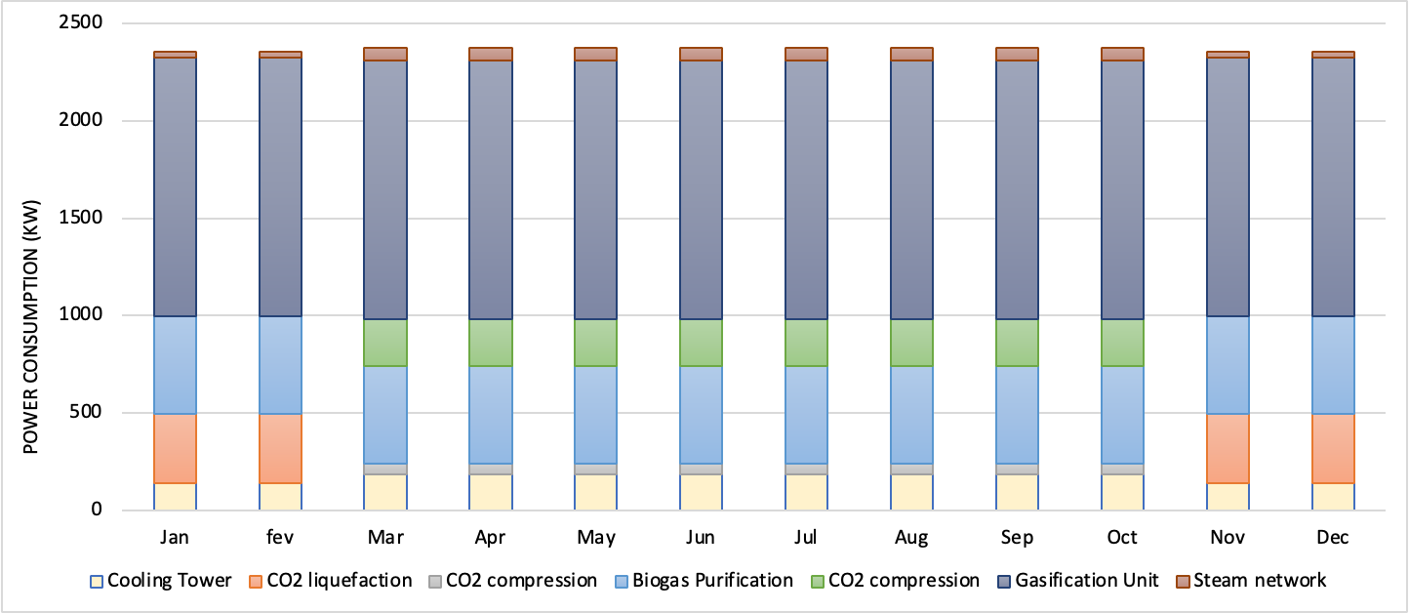
Figure 2. Monthly power consumption. During Mar-Oct the SOEC power consumption is 30.7 MW.
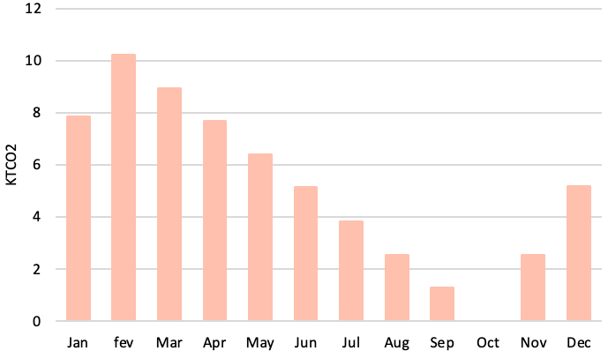
Figure 3. Monthly CO₂ storage.
  - Conclusions
In this work a systematic analysis of the integration of a gasification system and a solid oxide electrolyzer into an anaerobic digestion plant that processes the organic fraction of the municipal solid waste is assessed. To mitigate the seasonal electricity fluctuations of renewable electricity generation, a strategy involving the storage and utilization of CO₂ streams is also investigated. This process is employed for the production of methane exclusively during periods of low-cost electricity, utilizing a power-to-gas methodology that capitalizes on surplus electricity generated by prosumers throughout the non-peak months. The integration of power-to-gas systems with liquefied gas storage units has demonstrated its significance as a pivotal strategy, ensuring a synergistic supply for operational needs. Biogenic CO₂ sources and an electric input with a low carbon load can enhance the potential of power-to-gas plants to act as a CO₂ sink, however the indirect contributions of electricity grid emissions are still a challenge for the decarbonization strategies. For future works, an incremental financial analysis that incorporates the uncertainty related to the acquisition and selling costs of the feedstock and fuels produced will be performed through Monte Carlo method, by simulating the stochastic variation of the commodities price profiles.
  - Acknowledgments
MD thank European Union’s Horizon Europe Research and Innovation programme under Grant Agreement No. 101084288.
References
M.E.G.R. Domingos et al., 2023. Process modeling and integration of hydrogen and synthetic natural gas production in a kraft pulp mill via black liquor gasification. Renewable Energy, 219, p.119396.
A. Wellinger et al., 2013. The biogas handbook: science, production and applications. Elsevier.
R. Lems et al, 2008. “Next generation biogas upgrading using highly selective gas separation membranes” Showcasing the Poundbury project. DMT Environmental Technology: Joure, The Netherlands.
G. Chen et al., 2017. Air gasification of biogas-derived digestate in a downdraft fixed bed gasifier. Waste management, 69, pp.162-169.
C. M. Kinchin, R. L. Bain. 2009. Hydrogen Production from Biomass via Indirect Gasification: The Impact of NREL Process Development Unit Gasifier Correlations, Technical Report NREL/TP-510-44868, May 2009. National Renewable Energy Laboratory.
H. Topsøe, 2009. From solid fuels to substitute natural gas (SNG) using TREMP Topsøe Recycle Energy-efficient Methanation Process.
M. Ni et al., 2006. A modeling study on concentration overpotentials of a reversible solid oxide fuel cell. Journal of Power Sources, 163(1), pp.460-466.
Aspentech, 2011. Aspen physical property system - physical property methods V7.3.
Statista, 2023. Natural gas prices for households in the European Union (28 countries) from 2014 to 2022, semi-annually. Available at: https://www.statista.com/statistics/460305/natural-gas-prices-for-households-in-eu-28/. Accessed 01 Nov 2023.
O.W. Awe et al., 2017. A review of biogas utilisation, purification and upgrading technologies. Waste and Biomass Valorization, 8, pp.267-283.

