Optimizing Circular Economy Pathways: Multi-Criteria Decision-Making Tool for Chemical Recycling of Plastic Wastes
Virgil Cabo^{a,b}, Adrián Pacheco-López^{b}, Grégoire Léonardª, Antonio Espuña^{b}*
ªDepartment of Chemical Engineering, Université de Liège, Allée de la Chimie B6a, Liège Sart Tilman, 4000, Belgium
^{b}Department of Chemical Engineering, Universitat Politècnica de Catalunya, Escola d’Enginyeria de Barcelona Est, C/ Eduard Maristany 16, Barcelona 08019, Spain
*antonio.espuna@upc.edu
Abstract
The escalating crisis of waste mismanagement underscores the need for innovative treatment strategies, highlighting the inadequacy of conventional evaluation methods in the face of evolving waste management techniques. This study introduces a robust tool applying two decision-making methodologies to an existing multi-objective optimization framework. This framework can assess various waste-to-resource transformation processes, which was applied to the case of mixed plastic waste management within the circular economy. It yielded a set of 16 Pareto optimal recycling pathways according to four competitive objectives. Here, this new decision-making tool is applied to those Pareto solutions using user inputs as weight parameters to systematically rank them according to criteria weighting. Eventually, its capability is tested by a sensitivity analysis, assessing the robustness of solutions.
Keywords: circular economy, multi-criteria decision-making, sensitivity analysis, TOPSIS, PROMETHEE.
- Introduction
The growing crisis of plastic waste mismanagement presents a complex global challenge characterized by escalating waste accumulation, resource depletion, and extensive environmental degradation. Conventional methods for evaluating the vast array of treatment options for plastic pollution are becoming increasingly insufficient, as highlighted by the continuously evolving landscape of waste management techniques (Chawla et al., 2022). In response, the circular economy paradigm offers a promising shift, focusing on closing material loops and transforming waste into valuable resources. To facilitate this transition towards more sustainable plastic waste management, a comprehensive ontological framework was developed. It was designed to systematically generate and assess various waste-to-resource transformation pathways, optimizing trade-offs between different objectives such as economic viability and environmental impact. Initially, these pathways are pre-assessed based on a global performance indicator, then a superstructure is built, and multi-objective optimization is solved, leading to a set of Pareto optimal solutions (Pacheco-López et al., 2023). However, the existing framework did not address the decision-making (DM) step and had the limitation of analyzing only two criteria simultaneously. To bridge this gap, the tool introduced in this paper integrates two established multi-criteria decision-making (MCDM) methods: TOPSIS (Technique for Order Preference by Similarity to Ideal Solution) (Çelikbilek and Tüysüz, 2020) and PROMETHEE (Preference Ranking Organization Method for Enrichment Evaluations) (Maity and Chakraborty, 2015). By combining TOPSIS's capacity for straightforward comparative analysis with PROMETHEE's depth in pairwise preference evaluation, the tool achieves a balanced and thorough assessment. The adoption of these methodologies also ensures that the tool's evaluations are methodologically sound, reliable, and transparent. The tool is further enhanced by a sensitivity analysis feature, critically evaluating the robustness of the optimal solutions against uncertainties in the user’s criteria weighting. The integration of these DM methods within the ontological framework provides decision-makers with a systematic method to navigate the complex landscape of sustainable recycling and fortifying the application of the circular economy.
- Methodologies
  - Tool description
The tool developed in this work is a Python-based application, providing full compatibility with the existing ontological framework that was partially developed in Python. The system is designed to be user-friendly, efficiently transforming complex datasets into actionable insights. It is structured into three main functional areas:
Data gathering: This step involves importing the decision matrix. The tool captures essential user inputs, including the classification of each criterion as beneficial or non-beneficial and their corresponding weights, and the choice of normalization method.
Data processing: At the core of the tool's analytical capabilities, this section undertakes the necessary mathematical computations as per the selected DM method.
Sensitivity analysis: The sensitivity analysis is designed to evaluate the resilience and reliability of the DM outcomes, especially focusing on the stability of the initially top-ranked solution under uncertain criteria weighting conditions.
Generating weight sets from probability distributions: The sensitivity analysis component of the tool is tailored to account for the variability inherent in DM. User inputs determine confidence intervals for each criterion's weight, which are then used to establish the standard deviations of the corresponding normal distributions. The tool subsequently creates a multitude of unique weight sets by randomly combining these sampled weights across all criteria allowing for an extensive exploration of potential weight variations.
Assessing the stability of the top-ranked solution: Here, the tool determines the frequency with which the initially best-ranked solution maintains its position across various weight scenarios. By applying these diverse weight sets in the DM models, the tool tracks the performance of the initial top solution in each scenario, providing a quantitative measure of its stability.
The sensitivity analysis component is a vital functionality, offering a nuanced understanding of the DM outcomes' robustness. It ensures that the tool not only identifies the optimal solution under given parameters but also evaluates the impact of uncertainties inherent to criteria weighting on this choice.
  - Normalization of the dataset
Normalization in MCDM ensures criteria comparability but can introduce biases based on the method used, becoming a crucial choice (Sałabun et al., 2020). The tool employs either min-max or vector normalization to scale all criteria to a uniform range by choice of the user according to data characteristics. The choice of min-max normalization can significantly affect the data distribution in the case of objectives/criteria varying in small ranges. Alternatively, vector normalization maintains the original data distribution, suitable for preserving relative differences.
  - TOPSIS
The TOPSIS method is structured to systematically evaluate alternatives based on their similarity to ideal solutions. The steps are as follows:
Weight normalized decision matrix: The process begins by weighting the normalized decision matrix. The values in the normalized matrix are multiplied by the normalized weights for each criterion, reflecting the relative importance as determined by the user.
Determine Utopian and Nadir points: The utopian point is established using the highest values across all criteria, while the Nadir point is based on the lowest values. These hypothetical points represent the most and least desirable outcomes, respectively.
Compute Euclidean distances: Here the Euclidean distances of each alternative from both the utopian and nadir points are calculated. This calculation determines how close or far each alternative is relative to the most and least desirable outcomes.
Evaluate performance and rank alternatives: Performance scores for each alternative are derived from these distances, indicating their relative proximity to the ideal solution. The alternatives are then ranked based on these scores, with the highest-scoring alternative considered the most preferable.
  - PROMETHEE
PROMETHEE is a DM method that is based on pairwise comparisons between alternatives, assessing their relative performances based on a set of criteria. The methodology includes the following steps:
Define Preference Function: Preference functions are used to determine the degree of preference between two alternatives for each criterion. While various types of preference functions exist, our tool employs the Gaussian preference function.
Calculate differences in evaluations: For each criterion, the difference in evaluations between each pair of alternatives is computed. These differences form the foundation for assessing preferences between alternatives.
Determine preference values: By applying the Gaussian preference function to the calculated differences, the preference value for each pair of alternatives is calculated.
Compute global preference values: The global preference value for each pair of alternatives is derived by summing the products of the preference values and the weights of the criteria.
Calculate net outranking flows and rank alternatives:
Positive and negative outranking flows: These measures represent the extent to which an alternative is preferred or not over all the others.
Net outranking flow: Calculated as the difference between the positive and negative outranking flows, this value provides the net preference score for each alternative. Alternatives are then ranked based on their net outranking flows.
- Case study
The case study uses the dataset generated by the ontological framework described in the introduction (Pacheco-López et al., 2023), with a special focus on the chemical recycling of plastic waste. This dataset includes 16 Pareto optimal alternatives, each representing a unique chemical recycling process configuration. These processes include the sorting of plastic wastes, several types of pyrolysis under different temperature conditions, and several separation steps for pyrolytic gas and oil products. The evaluation of these alternatives based on profit, environmental impact on human health (HH), ecosystems, and resources are presented in Table 1. For this study, an objective reduction strategy was applied to the dataset by removing one of the criteria due to the large correlation observed between the environmental impacts on human health and ecosystems. To avoid double counting an underlying parameter that governs those criteria, the criterion related to environmental impact on human health was arbitrarily chosen for exclusion. This simplification ensures a more accurate and unbiased analysis of the remaining criteria.
The analysis was conducted using both the TOPSIS and PROMETHEE DM methods, with the same weighting maintained between both methods for each criterion to facilitate a consistent comparison. For the same reason, the confidence intervals for the sensitivity analysis were set at ±20% for all criteria and remained constant across the application of both methods. Additionally, in this case, both methods employed min-max normalization.
Table 1. Decision matrix of the chosen Pareto optimal configurations used in the case study (Pacheco-López et al., 2023). HH: Human Health.
Config. number | Profit (€/h) | Impact on HH (DALY/h) ·10 | Impact on Ecosystems (species·yr/h) ·10⁴ | Impact on Resources (USD2013/h) ·10⁻⁴
1 | 566.4 | 2.474 | 5.532 | 4.082
2 | 2 701.8 | 2.496 | 5.576 | 4.094
3 | 4 223.2 | 2.518 | 5.625 | 4.124
4 | 5 381.6 | 2.539 | 5.674 | 4.156
5 | 6 091.8 | 2.561 | 5.720 | 4.192
6 | 6 222.0 | 2.583 | 5.766 | 4.214
7 | 6 271.6 | 2.605 | 5.814 | 4.220
8 | 6 272.6 | 2.626 | 5.862 | 4.213
9 | 6 273.6 | 2.648 | 5.910 | 4.205
10 | 6 274.6 | 2.670 | 5.958 | 4.198
11 | 5 843.3 | 2.640 | 5.890 | 4.151
12 | 5 324.8 | 2.624 | 5.853 | 4.103
13 | 4 575.1 | 2.606 | 5.811 | 4.056
14 | 3 815.9 | 2.594 | 5.785 | 4.008
15 | 3 002.1 | 2.582 | 5.760 | 3.961
16 | 2 227.8 | 2.571 | 5.734 | 3.914
- Results and discussion
  - Multi-criteria decision-making
As shown in Figure 1, the comparative analysis using TOPSIS and PROMETHEE methodologies yielded a consistent set of least favorable alternatives—7, 11, 8, 9, and 10—across both methods. However, the nuance lies in their performance on the profit criterion; while these alternatives score near the upper bound for profit, they suffer significant trade-offs in the other criteria, illustrating a disproportionate balance. This pattern suggests that the methods are robust, particularly in identifying alternatives where an incremental profit gain is offset by larger compromises elsewhere.
For the most viable alternatives, both TOPSIS and PROMETHEE recognized the same top four options, although in a different order, proving the tool's reliability. PROMETHEE's preference for alternative 3 over 16, in contrast to TOPSIS, underscores its capacity for identifying more balanced choices that do not necessarily excel in a single criterion at the expense of others. This reflects a key characteristic of PROMETHEE: the emphasis on relative advantage rather than absolute performance, which can lead to different prioritizations of alternatives compared to TOPSIS.
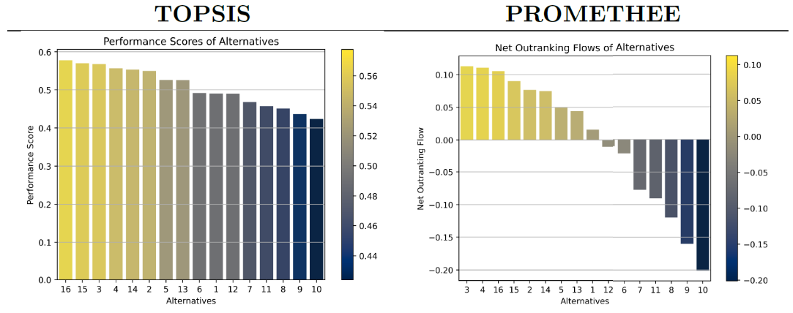
Figure 1: Comparative outcomes of TOPSIS and PROMETHEE methodologies with uniform weighting for each criterion.
  - Sensitivity analysis
The sensitivity analysis, conducted with a ±20% uncertainty in the criteria weighting and based on 10 000 generated weight sets, provides a probabilistic understanding of each alternative's robustness within the DM process. The ridgeline plots showing the density distributions of the results for each alternative and both methods are presented in Figure 2. The width of the peaks in the plots is of particular interest; it directly reflects the stability of the alternatives. Narrow peaks denote a high degree of stability, indicating that an alternative's ranking is less sensitive to weight fluctuations. On the contrary, wider peaks suggest greater instability, with the alternative's ranking likely to vary more significantly with changing weights.
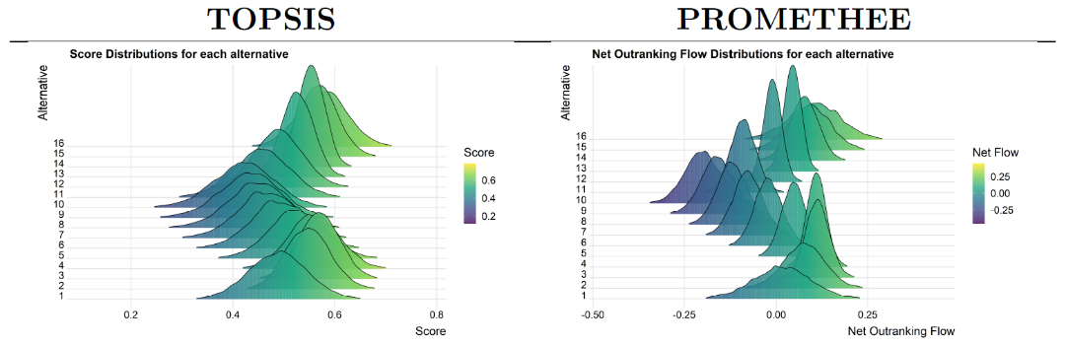
Figure 2: Comparative results from the sensitivity analysis using TOPSIS and PROMETHEE methods with equal weighting and confidence intervals for each criterion.
Numerically, for TOPSIS, the top-ranked alternative 16 maintains its position in 43.23% of the scenarios, signaling a relatively high degree of stability but not complete dominance, while alternative 3 is top-ranked in 19.43% of them. Similarly, in PROMETHEE, alternative 3 remains at the top in 17.92% of the cases, showing that the best solution is more challenged by the other leading alternatives. For instance, alternative 16 is preferred in 41.96% of the scenarios, due to its noticeably wider distribution versus alternative 3. A closer examination of the plots reveals that distributions for alternatives 3 and 4 show clear stability, in contrast to the broader spread for alternatives 15 and 16, suggesting a wider range of performance outcomes for these under varying weights. This difference in variability between the leading solutions, less noticeable in the TOPSIS plot, corroborates the numerical findings that PROMETHEE's top-ranked alternative faces more competition from its contenders. These findings pose a critical decision for stakeholders: choosing an alternative requires a careful assessment between achieving peak performance in certain scenarios at the risk of poor performance in others, versus selecting an option that offers reliable and consistent performance across various scenarios. This decision is guided by the decision-makers risk tolerance, which must balance the pursuit of occasional excellence with the potential cost of underperformance in different circumstances.
- Conclusions
This study has introduced an MCDM tool that has been effectively applied to the domain of chemical recycling of plastic wastes. Utilizing the TOPSIS and PROMETHEE methods, the tool has evaluated a dataset of 16 Pareto optimal alternatives, illustrating its capability to systematically assess and rank them according to different criteria preference weights. The sensitivity analysis conducted has provided valuable insights into the stability of these alternatives, revealing how their rankings resist the variability in criteria weighting. Looking ahead, one direction for research lies in determining the most suitable weighting of criteria, potentially guided by local sustainability policies and regulatory frameworks. This could ensure that the chosen recycling pathway aligns with specific environmental objectives and legislative requirements. Another direction for future research is the application of the tool to different datasets, possibly within the broader scope of sustainability. The quality of the dataset is critical; accurate and reliable data supports the tool’s ability to generate credible recommendations. Finally, enhancing the tool with additional DM methods could provide a wider range of analytical perspectives, making it an adaptable instrument in the pursuit of sustainable solutions.
- Acknowledgments
Grant CEPI, PID2020-116051RB-I00, funded by MCIN/AEI/10.13039/501100011033 and “ERDF A way of making Europe”, by the “European Union”.
References
Çelikbilek, Y., Tüysüz, F., 2020. An in-depth review of theory of the TOPSIS method: An experimental analysis. Journal of Management Analytics 7, 281–300. https://doi.org/10.1080/23270012.2020.1748528
Chawla, S., Varghese, B.S., A, C., Hussain, C.G., Keçili, R., Hussain, C.M., 2022. Environmental impacts of post-consumer plastic wastes: Treatment technologies towards eco-sustainability and circular economy. Chemosphere 308, 135867. https://doi.org/10.1016/J.CHEMOSPHERE.2022.135867
Maity, S.R., Chakraborty, S., 2015. Tool steel material selection using PROMETHEE II method. International Journal of Advanced Manufacturing Technology 78, 1537–1547. https://doi.org/10.1007/s00170-014-6760-0
Pacheco-López, A., Gómez-Reyes, E., Graells, M., Espuña, A., Somoza-Tornos, A., 2023. Integrated synthesis, modeling, and assessment (iSMA) of waste-to-resource alternatives towards a circular economy: The case of the chemical recycling of plastic waste management. Comput Chem Eng 175, 108255. https://doi.org/10.1016/j.compchemeng.2023.108255
Sałabun, W., Watróbski, J., Shekhovtsov, A., 2020. Are MCDA methods benchmarkable? A comparative study of TOPSIS, VIKOR, COPRAS, and PROMETHEE II methods. Symmetry (Basel) 12. https://doi.org/10.3390/SYM12091549

