Personalized Supply Chain Solutions for Sustainable Fashion: Leveraging Social Media Insights and Machine Learning
Sarah Hassaan,ª Sumaya A. Rahman,ª Roberto Baldacci,ª Brenno C. Menezes^{a*}
ªDivision of Engineering Management and Decision Sciences, College of Science and Engineering Hamad Bin Khalifa University, Qatar
bmenezes@hbku.edu.qa
Abstract
The fast fashion industry's rapid growth in clothing consumption since the 1990s has caused a significant global waste problem. Despite producing 80 billion new garments annually, only 1% is recycled, and 73% ends up in landfills. Before the arrival of fast fashion, the fashion industry typically operated on a two-season model. The shift to a 52-season model disrupted traditional cycles causing an imbalance in sustainable product development which is further increased by the nonconverging consumer needs and the clothing manufacturing. To create uniform symmetry between fashion suppliers and retailers, we must enhance information exchange between retailers and consumers to implement sustainable practices and boost business performance effectively. To achieve this, we propose a framework that analyzes consumer interactions on social media platforms like Instagram and TikTok, which are renowned pioneers of trends. Through this analysis, our framework employs real-time sentiment analysis techniques to identify positive emotional responses with user comments and likes and data image processing methodologies to extract garment types from media content. Subsequently, machine learning algorithms can be employed to select the most matching clothing items available on online markets based on user geographic location to offer consumers personalized recommendations based on their social media activity. Through our application, the data can be aggregated and transmitted to manufacturers who can utilize the advanced image, color, and style analysis techniques to dynamically adjust production and inventory with real-time decision-making techniques, enabling a more precise comprehension and prediction of market trends and reducing waste. This systematic analysis may create deep insights into consumer preferences, feedback, and engagement patterns, facilitating highly tailored product offerings and elevating the overall standard of customer satisfaction.
Keywords: fashion, supply chain, sustainability, artificial intelligence, optimization.
  - Introduction
The fast fashion industry, commanding a substantial global market share, has witnessed exponential growth since the latter half of the 20th century. Its strength lies in promptly meeting consumer demands and producing affordable clothing mirroring the latest fashion trends. These practices enable a continual flow of clothing from production to the consumer's wardrobe, closely following rapidly changing market trends. Although such industries created a booming effect on the development of supply chains, their manufacturing strategies led to a significant build-up of surplus inventory. The industry's extensive reliance on mass production of vast quantities of synthetic and petroleum-based garments in developing countries has resulted in significant textile waste. It forces manufacturers to employ various methods to offload excess garments through secondary distribution channels, deep discount rates to consumers, or disposed of in landfills.
Without a change in current practices in manufacturing and supply chains of any kind of product, emissions will surge by 2.7 billion metric tons by 2030, breaching the IPCC's 1.5°C limit for global temperatures (Wren, 2022). A survey by the Boston Consulting Group underscores the pressing need for action, projecting a potential 62% increase in global textile waste to 148 million tons by 2030 (Ponnambalam et al., 2023). Also, the rapid change in trends causes a mismatch between consumer demand and manufacturer production, which leads to the overproduction of fashionable garments. Most fast fashion industries face an alarming excess inventory, with 80% eventually finding its way to landfills (Goel and Michaelides, 2022).
With the focus on collecting real-time data from the user’s social media, retailers and manufacturers alike can benefit from more accurate forecasting to meet the high turnover rates of fast fashion, limiting the need for overproduction. In turn, this limits the environmental impact of the high volume of textile waste turnover generated by the rapidly changing fashion cycles. Furthermore, the user of the application will also benefit from a personalized fashion recommendation. The proposed framework can finally result in an application with a target focus on three stakeholders: consumers, retailers, and the designers/manufacturers, to bridge the gap between production and consumption.
  - Literature review
A fundamental shift toward sustainability and zero-waste practices in the fashion sector is crucial to address these issues. Given the challenges in achieving efficient and on-demand production, extensive research has been conducted to harness the potential of artificial intelligence (AI) and machine learning (ML) technologies to provide comprehensive solutions essential for enhancing sustainability within the sector and engaging all stakeholders in the value chain. By doing so, the fast fashion industry can continue to cater to consumer demands while significantly minimizing its environmental impact.
For example, Wang et al. (2022) and Yang (2022) present an interactive, personalized garment design recommendation system that uses intelligent techniques. Their research offers personalized recommendations, efficient decision-making, and dynamic suggestions to improve user satisfaction by supporting fashion designers as they rapidly generate optimal design solutions. However, the research is limited to the proposed system's market growth and the integration of their proposed model with the existing fashion workflows. Furthermore, no transparency is presented between the manufacturers, retailers, and end-users.
In addition, Papachristou et al. (2021) and Kotouza et al. (2021) focus on utilizing machine learning techniques to enhance the clothing manufacturing process to respond more effectively to brand demands. Their system includes components for data retrieval, user interface, and personalized garment design recommendations for fashion designers, and it primarily extracts meaningful attributes from images and textual data from various sources. Their research can be enhanced by incorporating the extraction of data from videos considering the popularity of short-form videos on social media platforms. These videos often showcase the latest trends, customized trends as well as reviving old trends which can provide insights into user preferences through comments, likes, and dislikes. Another gap in these authors, like the research of Wang et al. (2022) and Yang (2022), is that the primary focus is on the fashion design of the garments, neglecting the supply chain transparency between the retailers and users, leaving the potential of creating a user-centric recommendation which our research aims to address.
Furthermore, Santos et al. (2021) take a more novel approach and propose a digital twin-based system to support operational planning in fast fashion companies. While their work enhances decision-making and resource allocation, it primarily addresses the operational side of the chain. It lacks upstream analysis of consumer trends, preferences, and market behavior. Finally, Wang et al. (2023) create a personalized garment design based on the current market, but access is only limited to the fashion designers. There is also a lack of exploration on the sustainability issues the current supply chains are facing and the mismatch between production and demand leading to overproduction, leaving a gap in the research for the potential comprehensive role of AI to achieve sustainability in the industry.
Even though these studies have made a valuable contribution to the application of AI in fast fashion and supply chains, there are still significant gaps in addressing the challenges of transparency and forecasting. The integration of video data, user-centric recommendations, supply chain personalization, and upstream consumer insights have yet to be incorporated into future research. Bridging these gaps and offering holistic solutions may revolutionize the fast fashion and supply chain landscape. Our proposed framework can inform manufacturers or designers of purchased garments and ensure stores are aligned with their inventory. This can potentially help in the reduction of overproduction and provide valuable insights for fashion designers to understand demand trends, highlighting a crucial gap in exploring further potentials of AI within the fast fashion industry and related logistics and supply chain management.
  - Proposed Framework
To achieve our proposed framework, we suggest the application flow shown in Figure 1. The application represents the artificial intelligence and data analysis occurring, the user represents the consumers using the app, the social media represents the social media platforms that provide video and image content, the retailer represents stores or distributors selling the ready-made garments, and the manufacturer and designers representing those that are creating the garments.
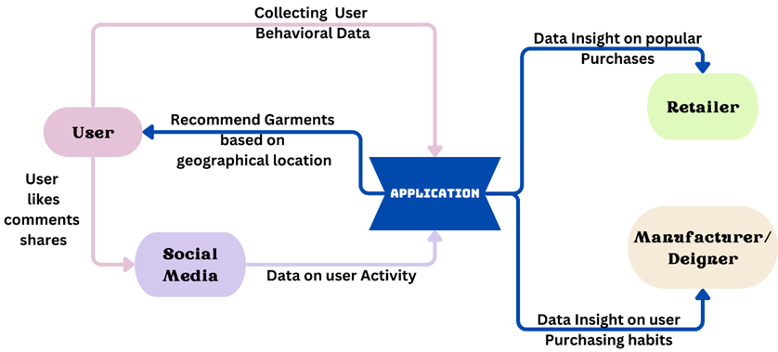
Figure 1: Application flow.
Firstly, the application will be active in the background of the user’s cell phone collecting data on their typical spending habits, previous fashion purchases, geographical location etc. These attributes can help in developing the model using content-based or collaborative filtering to update as the user’s style or fashion sense develops over time. It can also help with the personalized garment recommendation that the application provides to the user. As the user starts to utilize their social media account, the application can record the positive comments, likes and shares made by the user.
Figure 2 shows the interface view of the consumer, retailer, and manufacturer on the application.
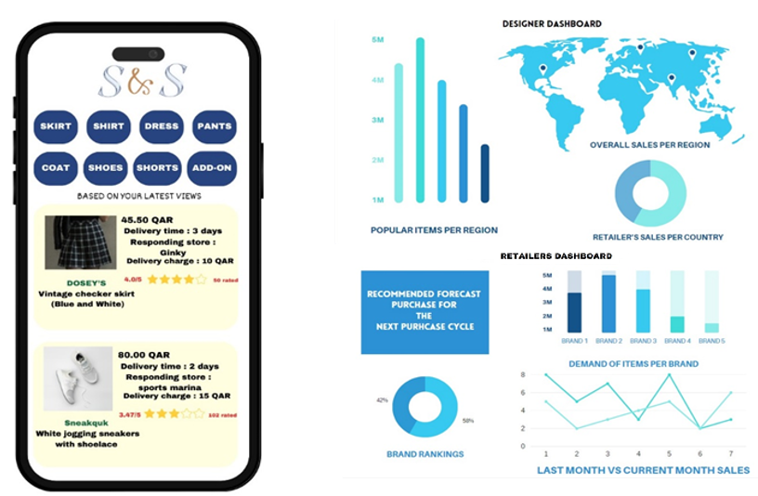
Figure 2: Interfaces shown to the user (left), designers (top right) and retailers (bottom right).
Once the information is collected, data image processing techniques can be applied to the content identifying if any fashion style can be salvaged within a given threshold. Only once the content is above the threshold, we can apply further data image processing methods such as image segmentation to extract the clothing items with other attributes such as color, style, and cut. We can further employ Search Engine Optimization (SEO) to categorize each extracted item. Once this is completed, machine learning algorithms, specifically clustering and regression, can recommend the closest garments (based on fit and geographical location) to the liked content to the user. Only once the user purchases the item does the application record the data for the retailers and designers to use for future forecasting. This can increase the likelihood of the user purchasing due to lesser lead times and refine the variety of options available in the market to achieve an almost or an exact match to the user’s choice. In addition, it can also give valuable insight into the ranking of fashion outfits in each state, country, or region.
The proposed framework can result in an application focusing on three stakeholders:
Consumer: Through tracking the consumers' behavior on social media content (their likes, comments, and shares), we can utilize advanced multimedia analysis techniques by utilizing neural networks, like Convolutional Neural Networks (CNNs) for image analysis or Recurrent Neural Networks (RNNs) for sequential data (such as analyzing user interactions over time). This can help to understand complex patterns and relationships within multimedia content to gain insights on everyone’s fashion preference, creating a personalized recommendation of garments for each user.
Retailer: Data derived from consumer through pattern recognition and trend analysis can assist retailers in identifying top-selling brands and styles, enabling accurate market predictions, and limiting unsold inventory. Monthly sales comparisons can also aid in informed decision-making for product launches, marketing strategies, and inventory management, reducing overstock issues.
Designers/Manufacturers: From both the retailer and consumer’s data, designers, or manufacturers can gain real-time insights into consumer behavior. They may also have access to the sales per region/country to understand which styles and garments are preferred worldwide, curbing excessive garment production. Also, by understanding the market trends in each country, they can forecast which designs to focus on for the upcoming seasons and the expected production for each country.
  - Conclusion
The convergence of personalized supply chain strategies, artificial intelligence applications, and advanced forecasting techniques can hold immense promise for revolutionizing the dynamics of the fashion industry. By tailoring purchasing recommendations to individual preferences, we can enhance consumer engagement and purchasing likelihood, streamlining the vast array of options available. By primarily targeting the fast fashion sector, known for its dynamic and disruptive nature, this innovative concept can resonate strongly within the clothing industry. Its flexibility and inclination toward digital-driven concepts could catalyze the transformation and expansion via data-driven strategies.
Advancements in predictive modeling and deeper data mining techniques can be extremely essential to further enhance the industry's predictive capabilities. Essentially, by combining artificial intelligence with information technologies like ML, data image processing, and natural language processing (NLP), we enable a seamless connection between demand, forecasting, and production. This innovative proposed framework can not only minimize resource wastage but can also addresses critical sustainability concerns, steering the industry towards a more efficient and environmentally conscious future. By mitigating the bullwhip effect and aligning production with evolving consumer preferences, this framework can possibly minimize garment wastage, optimize inventory management for both manufacturers and retailers and grant the flexibility to explore new product offerings while significantly reducing overstock issues.
References

V. Goel, M. Michaelides, 2022, What is the Economic Impact of Fast Fashion?-Economics Research Question, International Journal of Scientific Research in Science and Technology, 9 (5), 571-581.
M. T. Kotouza, A. C. Kyprianidis, S. F. Tsarouchis, A. C. Chrysopoulos, P. A. Mitkas, 2021, Science4Fashion: an end-to-end decision support system for fashion designers. Evolving Systems, 12 (3), 605–624.
E. Papachristou, A. Chrysopoulos, N. Bilalis, 2021, Machine learning for clothing manufacture as a mean to respond quicker and better to the demands of clothing brands: a Greek case study, The International Journal of Advanced Manufacturing Technology, 115, 691–702.
S. G. Ponnambalam, B. Sankaranarayanan, K. Karuppiah, S. Thinakaran, P. Chandravelu, H. L. Lam, 2023, Analysing the Barriers Involved in Recycling the Textile Waste in India Using Fuzzy DEMATEL, Sustainability (Switzerland), 15 (11), 8864.
C. H. Santos, G. T. Gabriel, J. V. S. Amaral, J. A. B. Montevechi, J. A. Queiroz, 2021, Decision-making in a fast fashion company in the Industry 4.0 era: a Digital Twin proposal to support operational planning, The International Journal of Advanced Manufacturing Technology, 116, 1653–1666.
T. Z. T. Ting, J. A. Stagner, 2023, Fast fashion - wearing out the planet. International Journal of Environmental Studies, 80(4), 856–866.
Z. Wang, X. Tao, X. Zeng, Y. Xing, Y. Xu, Z. Xu, P. Bruniaux, J. Wang, 2022, An Interactive personalized garment design recommendation system using intelligent techniques, Applied Sciences, 12(9), 4654.
Z. Wang, X. Tao, X. Zeng, Y. Xing, Z., Xu, P. Bruniaux, 2023, A Machine Learning-enhanced 3D reverse design approach to personalized garments in pursuit of sustainability, Sustainability, 15(7), 6235.
B. Wren, 2022, Sustainable supply chain management in the fast fashion Industry: A comparative study of current efforts and best practices to address the climate crisis, Cleaner Logistics and Supply Chain, 4, 100032.
B. Yang, 2022, Clothing design style recommendation using decision tree algorithm combined with deep learning, Computational Intelligence and Neuroscience, ID 5745457, 10 pages.

