Computational Fluid Dynamics and Trust-Region Methods to Optimize Carbon Capture Plants with Membrane Contactors
Hector A. Pedrozoª, Grigorios Panagakosª, and Lorenz T. Biegler^{a,*}
ªDepartment of Chemical Engineering, Carnegie Mellon University, 5000 Forbes Avenue, Pittsburgh, PA 15213, USA
lb01@andrew.cmu.edu
Abstract
In this study, we extend the trust-region filter method to optimization problems including external functions from Computational Fluid Dynamics (CFD) simulations and equation-oriented Aspen Plus rigorous models. To show the optimization framework, we address the optimal design of an MEA-based carbon capture plant employing hollow fiber membrane contactors, where we formulate an optimal design problem, by considering the minimization of the CO₂ avoided cost of the carbon capture plant. The optimization problem is formulated in Pyomo and solved with IPOPT; the CFD model is implemented in Comsol Multiphysics. We create a framework to process the algorithmic data and run the CFD simulations and Aspen Plus via a Python code. This trust-region filter application leads to an effective strategy to optimize integrated process models, including rigorous CFD models. The implementation is effective in handling data, setting up the rigorous simulators, and automatically running these programs.
Keywords: CFD; trust-region method; optimal design; membrane contactors; EO model
  - Introduction
Current challenges in Process Systems Engineering include the formulation of multi scale optimization problems to shed light on the truth potential of promising technologies for relevant problems, such as the optimal design of carbon capture technologies. Performing multi-scale optimization usually involves the formulation of hybrid optimization problems, where explicit equations along with external functions (also known as black-box functions) are embedded in the mathematical formulation simultaneously (Pedrozo et al., 2022, 2021a). The external functions are usually associated with rigorous models developed in specific programs, so their analytical form is not available.
In order to guarantee finding an optimal solution that satisfies first-order optimality conditions, special solution strategies are required that should be tailored for these hybrid problems. In the present study, we present an optimization framework to formulate mathematical problems including rigorous Computational Fluid Simulations (CFD) in Comsol Multiphysics® and complex Aspen Plus models in the formulation of a nonlinear programming (NLP) mathematical problem, showing that the method works across different platforms. We develop a customized implementation of the trust-region filter method described by Yoshio and Biegler (2021). This method not only ensures optimality conditions but also allows us to tackle integrated process models, which encompass rigorous CFD models. A special feature of this solution strategy is the capability to profit from derivative information to reduce the number of rigorous model calls, and consequently, improving the performance of the algorithm (Biegler et al., 2014).
As case study, we address the optimal design of a relevant carbon capture technology using hollow fiber membrane (HFM) contactors. With growing concerns regarding CO₂ emissions from human and industrial activities, immediate decarbonization solutions are increasingly demanded. Retrofitting existing power and industrial plants with post-combustion carbon capture technology is an attractive short-term strategy in the current context. Among the available technologies, absorption-based carbon capture stands out due to its maturity. In order to enhance the performance of the absorber unit, HFM contactors have been proposed due to their operational flexibility, scalability, modularity, and large interfacial areas (Rivero et al., 2020). We focus on the optimization of an MEA-based carbon capture plant using HFM contactors, where the objective function to be minimized is the CO₂ avoided cost. This problem requires a comprehensive approach and incorporates a rigorous CFD model for partially wetted membrane contactors.
  - Methodology
The general form of this hybrid problem can be represented as follows:
$$\min_{v,w}{f(v,w,y)}$$ | (1.1)
$$s.t. g(v,w,y)≤0$$ | (1.2)
$$y=t\left(w\right)$$ | (1.3)
where $f(v,w,y)$ is the objective function, $g(v,w,y)$ are the inequality constraints (including the variable bounds); $t\left(w\right)$ represents the rigorous (or ‘truth’) model; $y$ are the response variables of these truth models, $w$ are the matching input variables, and $v$ are the remaining variables for the problem.
Trust region methods tackle problem (1) by formulating a trust-region subproblem that includes reduced models (RMs), instead of the rigorous ones, and solving it in a search domain where the RMs are good enough to improve either the objective function or the infeasibility. The trust-region subproblem at iteration k can be expressed as follows:
$$\min_{v,w}{f(v,w,y)}$$ | (2.1)
$$s.t. g(v,w,y)≤0$$ | (2.2)
$$y=r_{k}\left(w\right)$$ | (2.3)
$$\left\|u-u_{k}\right\|≤∆_{k}$$ | (2.4)
where the truth model $t\left(w\right)$ has been replaced by a reduced model $r_{k}\left(w\right)$, and trust region constraints are formulated using the decision variables $u$, the current base point $u_{k}$, and the trust region size $∆_{k}$. When derivative information is available from the truth model, we introduce zero and first order corrections to the RMs to update it. In this way, the RMs are exact at the base point used for the trust region constraint and we could use any reduced model function $\tilde{r}\left(w\right)$ to build them, as shown in Eq. (3). Although these methods provide convergence guarantees for any $\tilde{r}\left(w\right)$, the performance of the algorithm improves significantly when the accuracy of $\tilde{r}\left(w\right)$ improves. Here, we build $\tilde{r}\left(w\right)$ by using the ALAMO approach (Cozad et al. 2014), as follows:
$$r_{k}\left(w\right)=\tilde{r}\left(w\right)+\left(t\left(w_{k}\right)-\tilde{r}\left(w_{k}\right)\right)+{\left(∇t\left(w_{k}\right)-∇\tilde{r}\left(w_{k}\right)\right)}^{T}(w-w_{k})$$ | (3)
  - Process modeling
We apply the trust-region method to an optimal design problem of a carbon capture technology using MEA-based absorption with membrane contactors. The process flowsheet considered for this process is the conventional CO₂ absorption process using only one amine heat exchanger for heat recovery (Pedrozo et al., 2023), where the packing column for absorption has been replaced by membrane contactor modules. This includes absorption unit that operates at counter-current, providing mass transfer area to promote the CO₂ absorption in the liquid solvent. The input streams are a lean solvent stream and flue gas (CO₂-rich gas), while the output streams are the amine CO₂-rich stream and the clean gas. The rich solvent stream is pumped to a heat exchanger to preheat before CO₂ desorption. The regeneration process is carried out in a stripping column, using conventional structured packing. This process includes a reboiler, which represents the main energy consumption of the carbon capture plant. The regenerated solvent is obtained at the bottom of the column, and is fed to the amine heat exchanger for energy recovery. Then, it is mixed with makeup streams and conditioned with a cooler to be recycled at the absorber unit.
Regarding the modeling approaches, the flowsheet is implemented in Pyomo (Hart et al. 2017) and solved with IPOPT (Wächter and Biegler, 2006). The models for the heat exchanger, the pump, and the mixer are formulated using explicit equations, based on the literature (Pedrozo et al., 2021b). On the other hand, the key process units are modeled as external function and calculated using specialized programs. In particular, the truth model for the absorption unit is a rigorous CFD model developed in Comsol Multiphysics®, while the truth model for the regenerator process is implemented in Aspen Plus.
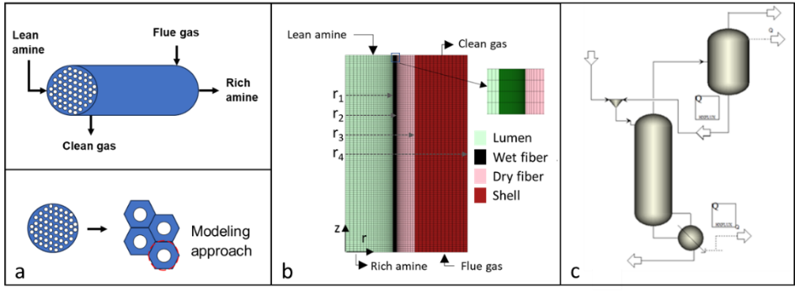
Figure 1: Rigorous models for the absorber and the regenerator. a) Membrane module and modeling approach. b) 2D, partially wetted fiber representation, considering four domains: lumen, wet fiber, dry fiber, and shell. c) Aspen Plus model for the regeneration process
We show a representation of the membrane module in Fig. 1a, where the solvent is fed in the lumen of hollow fiber and the flue gas is in the shell. For the absorber model, we consider homogeneous flow distribution, i.e., same operating condition for each hollow fiber. In this way, we determine a hypothetical shell radius (r₄) for modeling purposes. Therefore, we can model the transport phenomena for one fiber, which is considered to be representative of the system. To build such a model, we use a 2-D axisymmetric approach that allows a detailed description of the transport phenomena within reasonable CPU times (Rivero et al., 2020). The geometric representation ensures accuracy when angular variations are insignificant, and it offers 3D representations of the fiber without the computational overhead of a full 3D CFD simulation. The CFD approach used for membrane contactors enables the incorporation of mass transport processes involving convection, diffusion, and chemical reactions for individual fibers. The mathematical model of the absorption using membrane contactors includes four sections (see Fig. 1b): i) lumen side, ii) wetted membrane, iii) dry membrane, and iv) shell side.
To tackle the numerical problem, we use a mapped meshing technique, including a fine distribution of cells at the gas-liquid interphase, as shown in Fig. 1b. Regarding the derivative information, we leverage the optimization sensitivity module in Comsol Multiphysics® to provide the corresponding data.
The rigorous model for the regeneration process is implemented in Aspen Plus and shown in Fig. 1c. A “RadFrac” block is used to model the column, as discussed in Pedrozo et al., (2023). In order to obtain accurate sensitivity information, the model is run with the equation-oriented (EO) mode in Aspen Plus.
  - Algorithm
We have employed a trust region filter method based on Yoshio and Biegler (2021). In contrast to penalty functions, filter methods construct the constrained optimization problem as a biobjective problem, aiming at minimizing both the objective function and the constraint violation independently. The main algorithm includes the following steps:
- Create reduced models based on Eq. (3), by utilizing information from the rigorous models (i.e., simulations in Comsol Multiphysics® and Aspen EO), including response variable values and their derivatives. The bounds of optimization variables, $u$, are modified based on the trust region size $∆_{k}$, and the base point $u_{k}$.
- Solve the trust region subproblem in Pyomo (problem (2)).
- Store the current optimal solution for input variables $w_{k}^{*}$, decision variables $u_{k}^{*}$, and the objective function $f_{k}^{*}$. Then, configure the rigorous simulation to evaluate the truth model at the $w_{k}^{*}$ point. In the above, * denotes the current optimal solution.
- Run the rigorous simulation to gather information from the truth model, including response variables and their derivatives.
- Store the information from the truth model, denoted as $t\left(w_{k}^{*}\right)$ and $∇t\left(w_{k}^{*}\right)$. Calculate the infeasibility $θ_{k}^{*}=\left\|r_{k}\left(w_{k}^{*}\right)-t\left(w_{k}^{*}\right)\right\|$ at the current iteration $k$ and set the filter (${\text{F}}^{'}$), defined as the union of the existing set of nondominated solutions ($\text{F}$) and the last pair of infeasibility and objective function, i.e., ${\text{F}}^{'}=\text{F }\text{∪}\text{ (}θ_{k}\text{,}f_{k}\text{)}$.
- Utilize the filter to decide if the current optimal solution exhibits sufficient improvement in either feasibility or the objective function (nondominated solution). If positive, accept the current optimal solution and proceed to Step 9. If not, reject the current iteration, contract the trust-region size, and return to Step 1.
- Verify the convergence criterion ($θ_{k}^{*}<ϵ$) to assess if the infeasibility is sufficiently low and if an optimal solution has been reached. If the infeasibility exceeds the target tolerance ($ϵ$), proceed to Step 8.
- Check the switching criterion (see Yoshio and Biegler (2021)) to classify the current optimal solution as an f-step (move to Step 9) or a θ-step (move to Step 10). f-steps are constrained to relatively small infeasibilities.
- For f-step, we have an improvement of the objective function over the infeasibility. The trust region size ($∆_{k}$) is increased and the filter remains unaltered to prevent missing potential optimal solutions in subsequent iterations. Proceed to Step 11.
- For θ-steps, the acceptance of the current optimal solution depends on a reduction in infeasibility, and this information is used to update the filter to promote convergence and enhance accuracy for future iterations. The trust region size ($∆_{k}$) may increase, decrease, or remain unchanged based on the updating criteria (Yoshio and Biegler, 2021).
- Update the base point, and the pair $(θ_{k}\text{,}f_{k})$. Then, return to Step 1.
  - Case study
As a case study, we consider the optimization of a capture plant designed to purify the flue gas generated by a coal-fired power plant. The flue gas has a CO₂ concentration of 15 mol% and a mass flowrate of 288 t/h. As specification design, we consider a CO₂ recovery higher than 90 %. The objective function is the minimization of the CO₂ avoided cost, as calculated in the literature (Pedrozo et al., 2023).
Regarding the optimization variables, we consider the following decision variables for the capture plant: the regenerator height, the output temperature of the amine heat exchanger to preheat the CO₂-rich streams, the mass flow rate of the lean amine stream, the operating temperature of the absorber (isothermal operation), the MEA concentration of the lean amine stream ($w_{MEA}$), the CO₂ molar fraction of the lean stream ($x_{CO_{2}}$), the inner radius of fibers (r₁), the membrane thickness (r₃ -r₁), hypothetical shell radius (r₄), the fiber length ($l_{f}$), and the porosity ($ε$). We note that the rigorous CFD model allows inclusion of geometric features as optimization variables in the optimal design problem.
  - Results
When solving the hybrid optimization problem, which includes a CFD and Aspen EO simulations, through the trust region framework, the problem successfully converges within 33 iterations, as shown in Fig. 2. It is observed that at the beginning of the optimization process, we have an important reduction in the objective function and f-steps in the algorithm, while we mainly obtain important reduction in the infeasibility in the final iterations (θ-steps), until the convergence criterion is achieved (θ<10⁻⁴).
Regarding the CPU time of the solution procedure, it demands 1260 s. The breakdown of this time reveals that running the rigorous model consumes 98% of the total time, while the CPU time associated with solving the optimization subproblems is negligible.
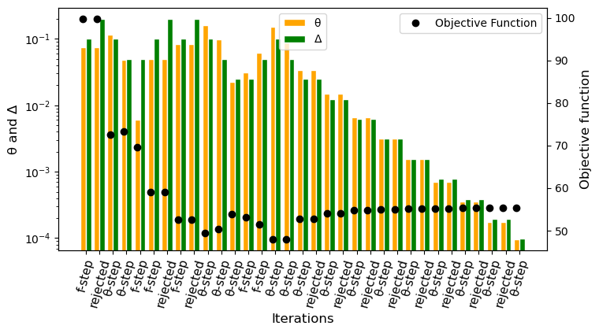
Figure 2: Iterations of the trust-region filter method. θ: infeasibility metric, Δ: trust region size
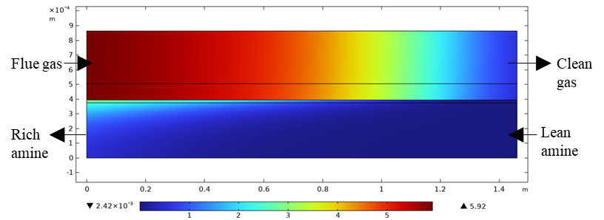
Figure 3: CO₂ molar concentration (mol/m³) profile for a single hollow fiber. ${Re}_{G}$=16.56; $x_{CO_{2}}$=0.15; ${Re}_{L}$=4.55; $w_{CO_{2}}$=5.31 wt%; $w_{MEA}$=40 wt%; $T_{S}$=320 K; r₁=0.375 mm; r₃ -r₁=0.130 mm; r₄ -r₃=0.359 mm; $l_{f}$=1.46 m; $ε$=0.55
The optimal design for the carbon capture plant using HFM contactors exhibits favorable performance metrics, including a CO₂ avoided cost (objective function) of 55.33 $/t-CO₂, and a specific energy demand of 3.46 GJ/t-CO₂ when utilizing MEA solvent. These outcomes indicate that this technology can serve as a viable competitor to traditional absorbers employing structured packing, particularly in certain application when modularity and flexibility are desirable.
Regarding the results associated with the CFD model, Fig. 3 shows the optimal CO₂ concentration profiles in a hollow fiber, including the optimal values for the decision variables associated with the design of the absorber module. Here, we report the Reynolds numbers for the gas (${Re}_{G}$) and liquid (${Re}_{L}$) phase.
  - Conclusions
The trust-region filter method is a potent tool to build optimization frameworks to address hybrid problems that include external functions from specialized codes (e.g., CFD simulations). Our framework shows proficiency in data management, Python-based setup of Comsol Multiphysics® and Aspen Plus, and automated program execution. As these platforms are widely used across engineering science, the solution strategy enables the integration of existing rigorous models in NLP formulations. Moreover, our solution strategy is generalizable beyond the tools used in the current demonstration.
We show the efficiency of the method by solving an optimal design problem for a CO₂ capture plant using hollow fiber membrane (HFM) contactors. Numerical results indicate that the CO₂ avoided cost associated with this technology is 55.33 $/t-CO₂.
References
Biegler, L.T., Lang, Y., Lin, W., 2014. Multi-scale optimization for process systems engineering. Comput. Chem. Eng. 60, 17–30.
Cozad, A., Sahinidis, N. V., & Miller, D. C. (2014). Learning surrogate models for simulation‐based optimization. AIChE Journal, 60(6), 2211-2227.
Hart, W. E., Laird, C. D., Watson, J. P., Woodruff, D. L., Hackebeil, G. A., Nicholson, B. L., & Siirola, J. D. (2017). Pyomo-optimization modeling in python (Vol. 67, p. 277). Springer.
Pedrozo, A., Valderrama-Ríos, C.M., Zamarripa, M., Morgan, J., Osorio-Suárez, J.P., Uribe-Rodríguez, A., Diaz, M.S., Biegler, L.T., 2023. Equation-Oriented Optimization Applied to the Optimal Design of Carbon Capture Plants Using Rigorous Models. Ind. Eng. Chem. Res. 62, 7539–7553.
Pedrozo, H.A., Rodriguez Reartes, S.B., Bernal, D.E., Vecchietti, A.R., Díaz, M.S., Grossmann, I.E., 2021a. Hybrid model generation for superstructure optimization with Generalized Disjunctive Programming. Comput. Chem. Eng. 154, 107473.
Pedrozo, H.A., Rodriguez Reartes, S.B., Vecchietti, A.R., Diaz, M.S., Grossmann, I.E., 2021b. Optimal Design Of Ethylene And Propylene Coproduction Plants With Generalized Disjunctive Programming And State Equipment Network Models. Comput. Chem. Eng. 107295.
Pedrozo, H.A., Rodriguez Reartes, S.B., Vecchiettic, A.R., Diaz, M.S., Grossmann, I.E., 2022. Surrogate Modeling for Superstructure Optimization with Generalized Disjunctive Programming. 14th International Symposium on Process Systems Engineering – PSE 2021+, Kyoto, Japan.
Rivero, J.R., Panagakos, G., Lieber, A., Hornbostel, K., 2020. Hollow Fiber Membrane Contactors for Post-Combustion Carbon Capture: A Review of Modeling Approaches. Membranes, 10 (12), 382.
Wächter, A., & Biegler, L. T. (2006). On the implementation of an interior-point filter line-search algorithm for large-scale nonlinear programming. Mathematical programming, 106, 25-57.
Yoshio, N., Biegler, L.T., 2021. Demand-based optimization of a chlorobenzene process with high-fidelity and surrogate reactor models under trust region strategies. AIChE J. 67, e17054.

