Process Design of Carbon-Neutral Routes for Methanol Synthesis
Omar Almaraz, Srinivas Palanki*, Jianli Hu
Dept. of Chemical and Biomedical Engineering, West Virginia University, WV 26506
*srinivas.palanki@mail.wvu.edu
Abstract
Two different microwave-assisted carbon-neutral routes are designed for the manufacture of methanol. The first process involves the dry reforming of methane with carbon dioxide for producing synthesis gas in a microwave reactor, which is subsequently converted to methanol. The second process involves the direct hydrogenation of carbon dioxide in a novel microwave reactor. Simulation results show that both processes can produce 206.5 t/h of methanol at a purity of 99.9%, which is the current production rate of methanol at Natgasoline LLC using the traditional steam reforming process. Furthermore, both novel processes have significant decarbonization potential. Heat integration tools are employed to demonstrate that both processes have energy savings potential.
Keywords: methanol, microwave-assisted, decarbonization.
  - Introduction
Methanol, a versatile and cost-effective alcohol, finds a multitude of industrial applications across various sectors. One primary use of methanol is as a feedstock in the production of chemicals, such as formaldehyde and acetic acid, essential building blocks for the manufacturing of plastics, resins, and coatings. Additionally, methanol serves as a crucial solvent in industries like pharmaceuticals, where it facilitates the extraction and synthesis of various pharmaceutical products. In the energy sector, methanol plays a pivotal role as a clean-burning fuel, both in its pure form and as a component of alternative fuels like biodiesel. Its role as a fuel extends further with the emerging trend of methanol-powered fuel cells for electricity generation. Moreover, methanol is employed in the production of renewable energy sources like biodiesel, contributing to sustainable energy solutions. With its diverse applications, methanol stands as a key player in fostering innovation and sustainability across a spectrum of industrial processes. The global methanol market size was valued at $28.78 billion in 2020 and is projected to reach $41.91 billion by 2026 (Market research, 2023). Methanol has traditionally been produced from natural gas by first converting methane to syngas and then converting syngas to methanol (Aimiuwu et al., 2020). However, this is a very energy intensive process and produces a significant amount of the greenhouse gas carbon dioxide. Hence, is necessary to look for more efficient alternative routes to manufacture methanol.

The search for carbon-neutral routes for the manufacture of chemicals in industrial scale has led to interest in utilizing novel microwave reactors instead of conventional heat sources that utilize the combustion of hydrocarbon fuels which produce greenhouse gases. Microwave-assisted synthesis also offers numerous advantages, including accelerated reaction rates, enhanced selectivity, and improved yields, compared to traditional heating methods. The controlled and uniform heating achieved with microwave reactors has been applied to various chemical processes, such as organic synthesis, catalysis, and polymerization. Notable studies include the work of Kappe (2004) on continuous-flow microwave reactors for organic synthesis, highlighting the potential for scale-up applications. More recently, Yan et al. (2023) demonstrated the use of a novel reactor utilizing microwave/electromagnetic irradiation to produce clean hydrogen.

In this research, two different microwave-assisted carbon-neutral routes are designed for the manufacture of methanol. The first route involves the dry reforming of methane in a novel microwave reactor to produce synthesis gas (syngas), which is subsequently catalytically converted to methanol. The second route involves the reaction of carbon dioxide captured from the atmosphere with green hydrogen using a novel CuO/ZnO/ZrO2 structured catalyst developed at Oakridge National Laboratory to directly form methanol in a microwave reactor. The objective is to produce 206.5 t/h of methanol at a purity of 99.9%, which is the current production rate of methanol at Natgasoline LLC in Beaumont, Texas (USA) using the traditional steam reforming process (Haque et al, 2021).
  - Process Modeling
    - Methodological Framework
The first step in the methodology involves the development of a comprehensive steady-state simulation model for the two different routes mentioned in the previous section. This simulation model is developed using the process simulation software ASPEN Plus by integrating relevant process information, feed specifications, and operating conditions obtained from the literature. Next, a heat exchanger network (HEN) is designed to reduce utility costs using the ASPEN Energy Analyzer (AEA) v11.0 software. The AEA software identifies the optimal configuration of the HEN that maximizes energy efficiency while meeting the targeted utility consumption, capital investment, and surface area requirements by formulating and solving a mixed-integer linear programming problem. By exchanging heat between streams at different temperature levels, the HEN aims to minimize the use of external utilities and enhance the overall process efficiency.

    - Indirect Conversion of Carbon Dioxide to Methanol via Dry Reforming
Figure 1 shows the process flow diagram of the dry reforming process to convert methane to syngas and then to methanol. The objective is to produce 206.5 t/h of methanol at a purity of 99.9%, of methanol. The process is initiated by introducing a natural gas stream sourced from a pipeline. This incoming gas is then split into two separate streams. The initial portion, which is 313.6 kmol/h of natural gas, is utilized as fuel for the separation processes in the form of reboiler duties. Concurrently, the second portion, consisting of 2,339.3 kmol/h of natural gas, undergoes a preliminary separation treatment to remove any free liquids and particles present in the gas stream. The preheated gas stream is directed to reactor 1, where a crucial desulfurization step occurs. Reactor 1 operates at a temperature of 375 °C and a pressure of 100 kPa, ensuring optimal conditions for converting any organic sulphur compounds into H₂S if present. After the desulfurization step, the stream from reactor 1 is combined with CO₂ in a specific ratio of 0.5 CH₄/CO₂, promoting the equilibrium conversion of CH₄ and enhancing overall process efficiency. This mixture is then heated to a temperature of approximately 800 °C, preparing it for the subsequent step in the novel microwave syngas reactor. This reactor operates under specific conditions, at a temperature of 800 °C and a pressure of 100 kPa. Within the microwave syngas reactor, the pretreated natural gas stream undergoes reactions resulting in the formation of syngas—a mixture of carbon monoxide (CO) and hydrogen (H₂). Importantly, these reactions occur in an equilibrium state at low pressure, preventing carbon formation and ensuring the absence of higher hydrocarbons in the resulting gas stream (Pham et al., 2020). Higher pressures (e.g. above 500 kPa) lead to significant coke formation and it is important to avoid such conditions.

Figure 1: Flowsheet for Indirect Conversion of Carbon Dioxide to Methanol via Dry Reforming

To achieve the desired syngas composition, H₂ is added to the product gas stream, maintaining a stoichiometric number around 2 during operation. The resulting gas mixture is then compressed to a pressure of 7.6 MPa using a dedicated compressor. Following compression, the syngas stream is further heated to a temperature of approximately 188 °C, preparing it for subsequent methanol production stages. The heated and pressurized syngas is evenly distributed to twin methanol reactors, operating at a temperature of 254 °C and a pressure of 7.6 MPa. The hydrogenation of CO₂ and CO, facilitated by Cu- and Zn-based catalysts (CuO and Al₂O₃ or ZnO), drives the conversion process, leading to methanol production. Upon exiting the methanol reactors, the gas stream, comprising methanol, water, unreacted H₂, CO, CO₂, CH₄, and N₂, undergoes heat exchange with the reactor's feed gas. The gas stream is subsequently directed to a third reactor for the final conversion stage. Operating at a temperature of approximately 215 °C and a pressure of 7.6 MPa, this third reactor enables the completion of the conversion process, ensuring optimal methanol production. The outlet gas from this reactor consists of methanol, water, and unreacted gases. To separate crude methanol from the gas stream, a separator is employed. This separation step occurs at a temperature of approximately 40 °C and a pressure of 6.7 MPa. Following separation, a portion of the unreacted gas is repressurized and recycled back into the twin methanol reactors, optimizing resource utilization. Another portion of the unreacted gas is purged into the flare, minimizing the buildup of unwanted gases in the system.

The purification of crude methanol involves an additional separator and three distillation columns. Initially, the crude methanol undergoes a depressurization process in the separator, resulting in the venting of an off-gas stream primarily composed of CO₂, H₂, and CH₄. The bottom stream from the separator is then directed to the first distillation column, where further separation occurs. This column effectively separates the remaining CO₂ and trace amounts of other gases, which are subsequently flared. The bottom product from the first column is then pumped to the second distillation column for further separation. Within this column, the desired top product, characterized by a required purity of 99.9 mol% methanol, is collected as a liquid distillate. The bottom product from this column constitutes a mixture of methanol and water, which undergoes the final purification step in the third distillation column. This column enables the collection of methanol with a required purity of 99.9 mol% as a liquid distillate, which is then combined with the top products from the second column. The bottom stream from the third column mainly consists of pure water. The combined flow rate of purified methanol gives a purity of 99.9 mol%.

    - Direct Hydrogenation of Carbon Dioxide to Methanol
Figure 2 shows the process flow diagram of the novel process to directly convert carbon dioxide and methane to methanol.
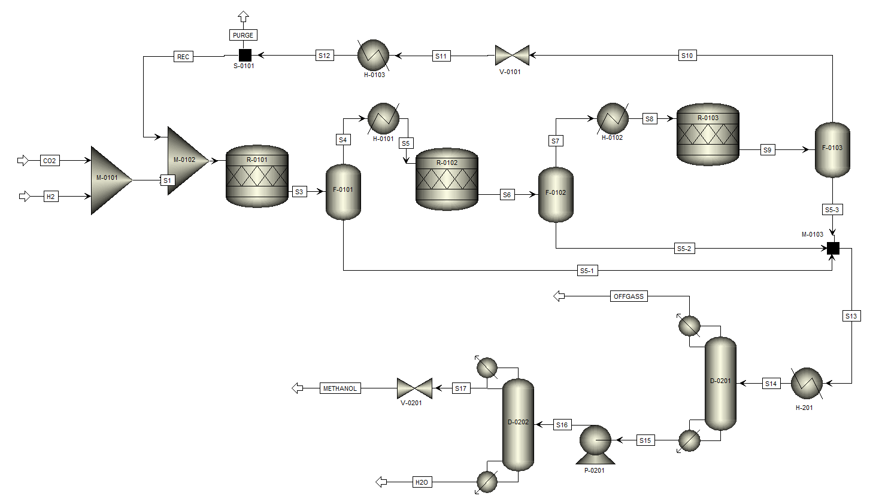
Figure 2: Direct Hydrogenation of Carbon Dioxide and Methane to Methanol
The stream of green H₂ is mixed with CO₂ and utilized for the conversion to methanol directly using a novel CuO/ZnO/ZrO2 structured catalyst (Balyan et al., 2023). Since the conversion is low (13%), it is necessary to utilize three reactors in series with intermediate removal of crude methanol product along with recycle of unreacted reactants as shown in Figure 2. All the reactors are heated using microwave radiation and operate at 160-220 °C and 140-970 kPa. The crude methanol stream is sent to a series of two distillation columns. The first distillation column operates at a pressure of 200 kPa and is utilized to separate the carbon dioxide and other non-condensable gases from the methanol stream. The second distillation column operates at a pressure of 812 kPa and produces a top stream that is 206.5 t/h of 99.9% pure methanol. The bottom stream is mostly water and used elsewhere in the plant as a produced water.
  - Simulation Results
ASPEN Plus software was employed to simulate the process of converting methane to syngas and syngas to methanol. For methane conversion, the RKSoave thermodynamic property method was used, while the NRTL method was employed for syngas conversion to methanol. The microwave reactors were modeled as yield reactors and the experimentally reported results of yield from the literature (Yan et al., 2023; Balyan et al., 2023) were used in the simulations. In the base case simulation of dry reforming without heat integration, the feed stream consisting of 2,325 kmol/h of methane is utilized, resulting in a final product stream of 206.5 t/h of methanol with a purity of 99.9%. In the base case simulation of direct hydrogenation of carbon dioxide to methanol, 20,562 kmol/h of hydrogen is reacted with 6,123 kmol/h of CO₂, resulting in a final product stream of 206.5 t/h of methanol with a purity of 99.9%. This successful conversion showcases the effectiveness of the proposed indirect dry reforming process as well as the direct hydrogenation of CO₂ for methanol production. Table 1 provides a comparison between dry reforming, direct hydrogenation of carbon dioxide and traditional steam reforming. The dry reforming process exhibits remarkable efficiency by utilizing only 36% of the methane compared to the traditional steam reforming process, while the direct hydrogenation of carbon dioxide utilizes no methane. This substantial reduction/elimination of methane consumption is significant from both economic and environmental perspectives, as it allows for the preservation of valuable resources and minimizes the cost and environmental impact of methane extraction and utilization. It is important to note that while the conventional process produces 287.5 kmol/h of CO₂, the dry reforming process consumes 4,079 kmol/h of CO₂ and the direct hydrogenation of CO₂ process consumes 5,287.7 kmol/h of CO₂. While this shows a significant decarbonization potential, it should be noted that the conventional steam reforming process does not utilize any hydrogen whereas both the dry reforming process as well as the direct hydrogenation process utilize significant amounts of hydrogen, which must be produced from green methods to extract the decarbonization potential shown in these simulations. One green method that has shown promise is the use of chemical looping techniques for producing hydrogen with sequestration-ready CO₂ (Riley et al., 2023).
Table 1: Decarbonization Potential of Novel Processes as Compared to Steam Reforming
 | Steam Reforming (kmol/h) | Microwave Dry Reforming (kmol/h) | CO₂ Hydrogenation (kmol/h)
Methane to Syngas | 6,430.0 | 2,325.0 | 0.0
Hydrogen Added | 0.0 | 10,642.7 | 20,562.3
Water Added to Process | 13,506.8 | 0.0 | 0.0
Methanol Produced | 6,455.0 | 6,445.0 | 6,445.0
Total CO₂ Produced | 261.4 | -4,079.1 | -5,287.7

Overall, the base case simulation results highlight the significant potential of the microwave-assisted processes in utilizing carbon dioxide as a valuable feedstock. To achieve optimal operation and enhance energy utilization, a heat exchanger network (HEN) is designed to facilitate efficient heat exchange and minimize utility costs. The heat integration tool within the ASPEN Energy Analyzer software enables the generation of multiple feasible solutions for the HEN optimization. The integration of the HEN within the microwave-assisted process demonstrates its potential in significantly reducing the reliance on hot utility and cold utility consumption. Table 2 shows the comparison
Table 2: Comparison of Heat Duties
 | Steam Reforming (MW) | Microwave Dry Reforming (MW) | CO₂ Hydrogenation (MW)
Base Case Hot Utility | 808.3 | 387.7 | 299.8
Base Case Cold Utility | 1,106.0 | 650.0 | 545.7
Heat Integrated Hot Utility | 165.0 | 137.2 | 121.0
Heat Integrated Cold Utility | 378.1 | 387.4 | 250.9

between the base case and the heat integrated (HI) scenario and it is observed that there are significant improvements in energy utilization. For both novel microwave processes, there are energy savings via heat integration. After heat integration, the CO₂ hydrogenation process utilizes the least amount of hot and cold utilities.
  - Conclusions
The results of this simulation study provide compelling evidence for the significant potential of microwave-assisted dry reforming as well as microwave-assisted direct carbon hydrogenation as promising methods to produce methanol. The novel processes offer numerous advantages over traditional steam reforming techniques, making them attractive alternatives in the field of catalytic methanol production with significant decarbonization potential. One notable advantage of microwave-assisted dry reforming over conventional steam reforming is its lower methane consumption. The consumption of methane can be eliminated in the microwave-assisted direct hydrogenation of CO₂ if hydrogen is produced from green methods and the energy utilized in the separation train is hydrocarbon-free. Both novel processes utilize significant amounts of CO₂, which help in decarbonization. The simulation studies also demonstrate the significant potential in reducing utility costs via the application of heat-integration. Overall, these results highlight the importance of continued research in the field of microwave-assisted reactions for developing carbon-neutral processes.
  - Acknowledgment
This study was supported by the United States Department of Energy.
References
G. Aimiuwu, E. Osagie and O. Omoregbe, 2020, “Process Simulation for the Production of Methanol via CO₂ Reforming of Methane Route,” Chemical Product and Process Modeling, 17:69-79.
S. Balyan, K. Tewari, B. Robinson, C. Jiang, Y. Wang, J. Hu, 2023, “CO₂ Hydrogenation to Olefins in Microwave-Thermal Hybrid Heating Reactor,” Journal of Catalysis Science & Technology (submitted)
M. E. Haque, N. Tripathi, and S. Palanki, 2021, “Development of an Integrated Process Plant for the Conversion of Shale Gas to Propylene Glycol,” Industrial & Engineering Chemistry Research, 60 (1), 399-441.
C.O. Kappe, 2004, “Controlled Microwave Heating in Modern Organic Synthesis,” Angew. Chem. Int. Ed., 43, 6250-6284.
Market Research (2023). Methanol Market by Feedstock (Natural Gas, Coal, Biomass), https://www.marketresearch.com/MarketsandMarkets-v3719/Methanol-Feedstock-Natural-Gas-Coal-30408866/ (accessed 04.04.23)
T. Pham, K.S. Ro, L. Chen, D. Mahajan, T.J. Siang, U.P.M. Ashik, J.I. Hayashi, D.P. Mihn, D.V.N. Vo, 2020, “Microwave-Assisted Dry Reforming of Methane for Syngas Production: A Review,” Environ Chem. Lett., 18, 1987–2019.
J. Riley, M. Bobek, C. Atallah, R. Siriwardane, and S. Bayham, 2023, “Syngas and H₂ Production from Natural Gas Using CaFe₂O₄ - Looping: Experimental and Thermodynamic Integrated Process Assessment,” J. Hydrogen Energy, 48, 29898-29915.
K. Yan, X. Jie, X. Li, J. Horita, J. Stephens, J. Hu, Q. Yuan, 2023, “Microwave-Enhanced Methane Cracking for Clean Hydrogen Production in Shale Rocks,” International Journal of Hydrogen Energy, 48, 41, 15421-15432.

