CHEMICAL ENGINEERING TRANSACTIONS  VOL., 2023 | A publication of
The Italian Association
of Chemical Engineering
Online at www.cetjournal.it
Guest Editors: Sabrina Copelli, Richard Siwek
Copyright © 2023, AIDIC Servizi S.r.l.
ISBN ; ISSN 2283-9216

Improvement of the EFFECTS dispersion model for under expanded turbulent jets
*Mack A., Boot, H.
Gexcon Netherlands B.V., Princenhofpark 18, 3972 NG Driebergen-Rijsenburg, The Netherlands
*andreas.mack@gexcon.com
Recently, the dispersion model in EFFECTS was updated and extensively validated for light gas situations including jet releases and lifting plumes. In the present paper the modifications for gaseous turbulent jets will be discussed. This includes the full release velocity range from low subsonic to supersonic flow under highly under expanded conditions which are highly relevant for the high-pressure storage of hydrogen. In particular, a new model for the calculation of the expanded diameter in combination with an adapted implementation of the Chen and Rodi model was developed.
The models were validated against a wide range of experimental classical and recent data sets including concentration and velocity data. This also includes a wide range of initial densities from lighter than air to heavy gas which will be discussed in this paper. The simulations show excellent agreement with experimental data resulting in less conservative predictions compared with the previous models.
  - Introduction
The transition from fossil fuels to renewable alternative energy carriers (such as hydrogen and ammonia) will play an important role to reduce global CO₂ emissions and support the energy transition. Therefore, it is expected that these energy carriers will be produced, transported, and used at large scale in the future. In order to estimate the consequences and risks due to the accidental release of these new energy carriers, the models applied for these assessments need to be able to properly simulate the unique behaviour of these new energy carriers, which can present strong buoyant behaviour when released into ambient air.
Gexcon’s consequence modelling tool EFFECTS used to contain different dispersion models for neutral and heavy gas dispersion, which were based on a 1-D discretisation, also known as integral models. Since the code was developed in the past with the focus on heavy or neutral gas conditions the simulation of buoyant jets and plumes so far was limited. In EFFETCS v12 the modelling of buoyant plumes including the transition to grounded plumes depending on the release and weather conditions has been significantly improved (Mack et al., 2022).
The present work focuses on the improvement of the modelling of turbulent free jets including highly under expanded gaseous jets from light gas releases such as pressurized hydrogen but also other substances and flow conditions.
  - Modelling turbulent jets
In EFFECTS v12, the modelling of a gaseous jet is modelled as a turbulent free jet in the momentum dominated region; from there the EFFECTS v12 dispersion model is applied which solves the equations of mass, momentum and energy and therefore, can handle all relevant physical effects like buoyancy. The coupling is performed automatically in EFFECTS v12.
    - Expanded turbulent free jets
Turbulent jets have been studied extensively in the past experimentally and analytically (Chen and Rodi, 1980). The analytical models can reproduce the mixing of the jet with the surrounding air relatively accurate at very low computational effort since the concentration scales with the reciprocal of the distance. A widely used analytical model is the one of Chen & Rodi (Chen and Rodi, 1980) which has also been applied in EFFECTS successfully for many years. The concentration distribution of the Chen & Rodi model is:
$\frac{c_{c}\left(x\right)}{c_{s}}=C_{c}\sqrt{\frac{ρ_{s}}{ρ_{a}}} \frac{d}{x}$ (1)
$ρ_{s}$ is the density of source gas at throat, $ρ_{a}$ the density of ambient air, d the throat diameter, $C_{c}$ the concentration coefficient, $c_{s}$ the mass fraction of the source at throat and x is the distance from the throat.
With rising interest for new energy carriers like hydrogen, which is much lighter than the classical gasses from hydrocarbons such as methane, the model was revised and crosschecked with more recent data. It turned out that in the original publication of Chen & Rodi (Chen and Rodi, 1980) the analytical model of the concentration decay scaled with the reciprocal density ratio by mistake, which can be verified by comparison with the scaling of the experimental data results in the same publication. This results in inaccuracies when applying the model for both heavy and light gas dispersion situations. In addition, the concentration fractions have to be interpreted as mass fractions in the Chen & Rodi model, which lead to the mismatch of other models with experimental data in the past as mentioned earlier by Molkov (2012).
The velocity decay at the centreline is:
$\frac{u_{c}\left(x\right)}{u_{s}}=C_{u}\sqrt{\frac{ρ_{s}}{ρ_{a}}} \frac{d}{x}$ (2)
$u_{s}$ is the velocity at throat, $C_{u}$ is the velocity coefficient.
The lateral concentration and velocity distributions are defined as Gaussian distributions:
$\frac{c\left(\frac{r_{j}}{x}\right)}{c_{c}\left(x\right)}=exp\left(-C_{yc} {\left(\frac{r_{j}}{x}\right)}^{2}\right)$ (3)
$\frac{u\left(\frac{r_{j}}{x}\right)}{u_{c}\left(x\right)}=exp\left(-C_{yu} {\left(\frac{r_{j}}{x}\right)}^{2}\right)$ (4)
$r_{j}=\sqrt{y^{2}+z^{2}}$ is the radial distance from the jet axis and $C_{yc}$ and $C_{yu}$ coefficients for the radial distribution of concentration and velocity.
The calculation of the conditions of concentration and velocity at the release location (throat), which are needed as input for the model, are based on the expansion from reservoir conditions to ambient pressure.
The coefficients used in EFFECTS v12 are based on a wide range of experimental data including under expanded releases, which are explained in chapter 2.2. The coefficients are provided in Table 1.
Table 1: Turbulent coefficients used in EFFECTS v12
$$C_{c}$$ | $$C_{u}$$ | $$C_{yc}$$ | $$C_{yu}$$
4.8 | 5.0 | 35 | 94

For low-speed releases, where the exit Mach number is much lower than one, the Chen & Rodi model (equation 2) underpredicts the velocity at the jet centreline. Therefore, a correction by Witze (1974) was applied for exit Mach numbers below 0.3 with a smooth transition to Mach 0.5; above this value, equation 2 is applied (not further discussed here).

    - Under expanded turbulent free jets
For expanded releases, the pressure at the release equals the ambient pressure. Therefore, the initial conditions required for the turbulent jet model like diameter and velocity can be taken directly from the release location, as an expansion from reservoir to ambient conditions. The distributions for concentration and velocity inside the jet can be calculated using equations 1-4. Releases are under expanded when the pressure at the release location is still higher than the ambient pressure; as a rule of thumb, this takes place for reservoir pressures higher than 2bar. The flow is choked at the hole location (at sonic speed, Mach number equals 1) and expands further to ambient pressure at supersonic speed. Due to compression waves from the interaction of the strongly diverging flow with the ambient flow, the flow is recompressed through a normal shock to subsonic flow at the first Mach disk. Depending on the total pressure, multiple expansions/compressions through normal shocks take place (shock train) until the flow passes a final normal shock at Mach 1 (Figure 1a and b).
Since the total pressure in the flow is still higher than the equivalent (or sometimes also notional or fictious), source condition has to be calculated as the flow will further expand outside the vessel leading to a larger release diameter and different flow conditions than at the original hole size.
In the past, many different approaches have been developed to calculate equivalent (also called notional or fictious) source conditions to use the jet models at under expanded conditions. Most of them have been based on sonic flow condition (expanded flow) at the equivalent release position assuming conservation of mass, momentum and/or energy. This equals the flow condition at the final normal shock at the end of the shock train. For highly under expanded jets, some authors have been taken the (subsonic) condition behind the normal shock of the first Mach disk. An overview of different methods has been given in Error! Reference source not found.. Investigating different equivalent source condition models, it was observed that the agreement of the turbulent free jet model was not satisfying for the full range from expanded to highly under expanded conditions without adding corrections for the origin of the release or modifying the model constants (see Table 1). Corrections like a shift the origin are included in some models but are usually fitted to experimental data, are pressure dependent and usually require different corrections for velocity and concentration. Therefore, a different approach was developed for equivalent source conditions:
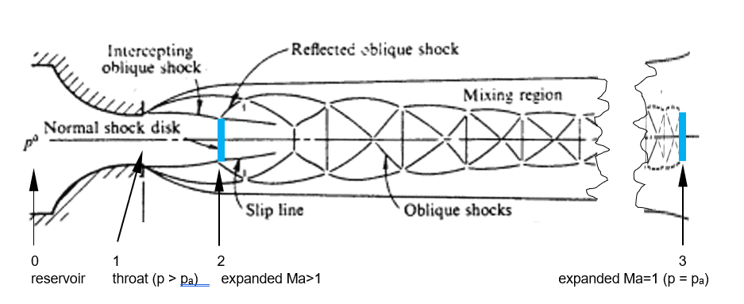
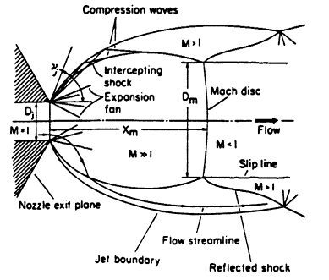

Figure 1a (left): First shock cell in highly under expanded jet (Christ 1966); 1b (right): Shock train in under expanded jet, taken from (Donaldson 1971)
At highly under expanded conditions, the shock train (between position 2 and 3 in Figure 1b) can be quite long since the flow has to dissipate the total pressure to ambient conditions. Compared with the release diameter, the shock train can be much longer (>30-50 diameter) as shown by Bonelli (2013) for hydrogen jets at a pressure ratio of 15. Entrainment at the outer shear layers will already take place before the flow is fully expanded to ambient pressure. Therefore, the new model in EFFECTS v12 expands the flow to the condition in front of the first Mach disk where the flow is fully expanded to ambient pressure (position 2 in Figure 1b); here the equivalent source is located. The corresponding diameter obtained by conservation of mass serves as equivalent source diameter. Usually, at highly under expanded conditions, this corresponds to a static pressure of 1 bar, a Mach number much larger than one and a static temperature lower compared to the one at the release location (position 1 in Figure 1b). Although the static pressure is at ambient pressure (1bar), the total pressure at the equivalent source is still higher than the ambient pressure since the expansion will take place further downstream by the shock train. As mentioned before, the entrainment of ambient air also takes place at the shear layers in the shock train region, in particular for highly under expanded flow. Since the equivalent source location in front of the shock train, this effect will implicitly be taken into account by the new model applied to the turbulent free jet model.
Based on this hypothesis, the equivalent source conditions of the new model are given by a consistent set of conditions (position 2 in Figure 1b); the equations are given applying the ideal gas law.
The equivalent density which is the density at the new expanded position (position 2 in Figure 1b) can be calculated directly by an isentropic expansion from the reservoir condition (position 0 in figure 1b):
$ρ_{eq}=ρ_{2}=ρ_{0}{\left(\frac{p_{a}}{p_{0}}\right)}^{\frac{1}{γ}}$ (5)
$p_{a}$ is the ambient pressure. $p_{0}$ and $ρ_{0}$ are the storage pressure and density.
Conservation of energy is applied to calculate the velocity at position 2:
${u_{eq}= u}_{2}= \sqrt{2 \left(\frac{1}{2}{c_{1}}^{2}+C_{ps}\left(T_{0} \frac{2}{γ+1}-\frac{p_{a}}{ρ_{eq} R_{s}}\right)\right) }$ (6)
with the speed of sound $c_{1}= \sqrt{γ R_{s }T_{1} }$ and temperature $T_{1}= T_{0} \frac{2}{γ+1}$at point 1. (7)
$γ$ is the ratio of specific heat, $C_{ps}$ the specific heat capacity and $R_{s}$ the specific gas constant of the source.
Applying conservation of mass and the (sonic) conditions at the physical hole (position 1 in Figure 1b) the required expanded diameter can be calculated as:
$r_{eq}=r_{2}= \sqrt{\frac{\dot{m}}{π u_{2} ρ_{eq}} }$ (8)
The equivalent temperature and Mach number are:
${T_{eq}=T}_{2}=\frac{p_{a}}{ρ_{2}{ R}_{s}}=\frac{p_{a}}{ρ_{eq}{ R}_{s}}$ (9)
${Ma}_{eq}={Ma}_{2}=\frac{u_{2}}{\sqrt{γ R_{s }T_{2} }}$ (10)
The mass flow rate is conserved throughout the domain:
$\dot{m}=ρ_{1}u_{1}π C_{d} {r_{1}}^{2}= ρ_{2 }u_{2} π {r_{2}}^{2}$ (11)
with $C_{d}$ being the discharge coefficient. The density at the release location (hole, position 1 in Figure 1b) is:
$ρ_{1}=ρ_{0}{\left(\frac{2}{γ+1 }\right)}^{\frac{1}{γ-1}}$ (12)
  - Results
To validate the new model for the equivalent source conditions, a wide range of experiments were simulated with EFFECTS v12 and compared with previous results from EFFECTS v11 and the experimental data. This includes light and heavy gas releases ranging from subsonic to supersonic releases at highly under expanded flow.

    - Under expanded flow conditions
Han et al. (2013) published data for hydrogen releases for reservoir pressures between 100bar and 400bar with leak hole sizes ranging from 0.5mm to 1mm. The simulations with EFFECTS v12 show and excellent agreement for the concentration at the release height compared with the experimental data; the results from EFFECTS v11 are conservative (Figure 2a). Due to the buoyancy of the plume the concentration decay starting at approximately x=8m is reproduced well with EFFECTS v12 which can be seen clearly on Figure 2b (in double logarithmic scale). The data of EFFECTS v11 contains only the data of the turbulent free jet in the non-buoyant region. Simulation results from the other experiments (0.7mm and 0.5mm hole at 100bar and 400bar) also show excellent agreement with the experimental data (not shown here).
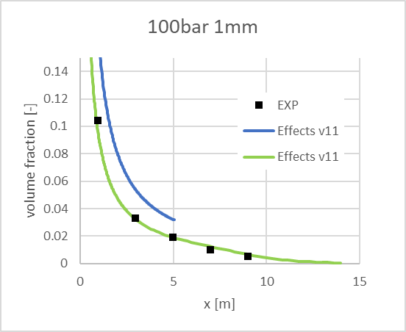
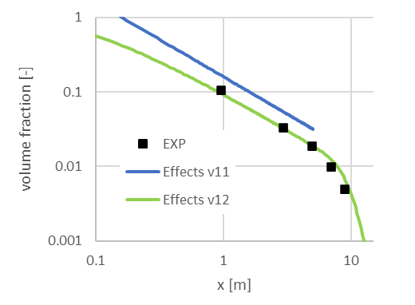

Figure 2a (left): Comparison of simulations of hydrogen release at 100bar from 1mm hole (Han 2013). Figure 2b (right): Data in Figure 2b using a double logarithmic scale.

In 2006 Shell and HSL hydrogen releases have been perfored for different release conditions whereas detailed concentration data at release height is available for the 3mm and 4mm releases from Roberts et al. (2006). The mass flow rates were not explicitly measured during the experimental campaign. Nevertheless, the calculated mass flow rates from EFFECTS v11 and v12 present good agreement with the ones given by Roberts et al. (2006).
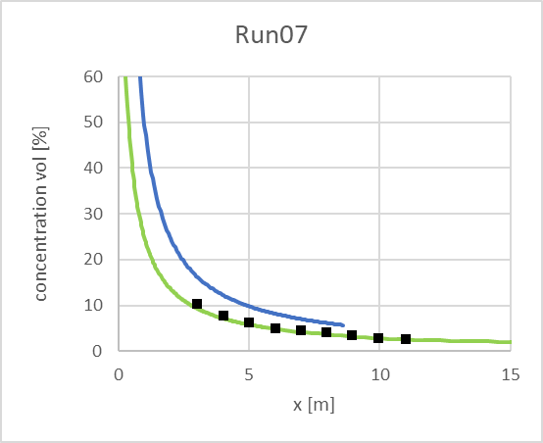
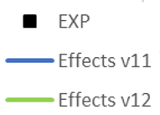
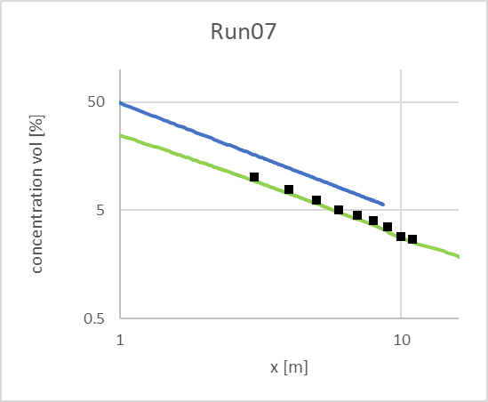

Figure 3a (left): Comparison of simulations of hydrogen release at 100bar from 3mm hole (Roberts et al., 2006). Figure 3b (right): Data in Figure 3b using a double logarithmic scale

The concentration simulated with EFFECTS v12 is in excellent agreement with the experimental data as can be seen from Figure 3. EFFECTS v11 consistently shows an overprediction of the experimental data of approximately a factor of 2. Simulations of other tests (i.e., run 01, 03, 08, 14, 16) under different release conditions showed comparable trends and excellent agreement for EFFECTS v12 with the experimental data (not shown here). Runs 03 and 07 have been conducted under sidewind conditions (Roberts et al., 2006). Therefore, the simulations agree well with the experiments up to a distance of approximately 7m from the release. From there onwards, the simulations overpredict the experimental data due the effect of sidewind which enhanced mixing during the experiments (not shown here).
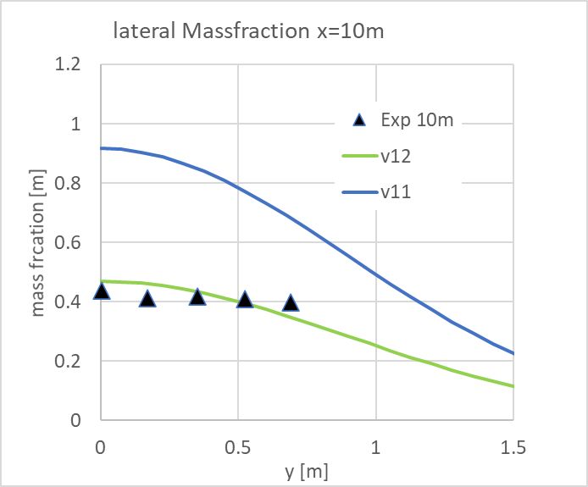
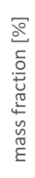
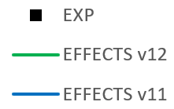
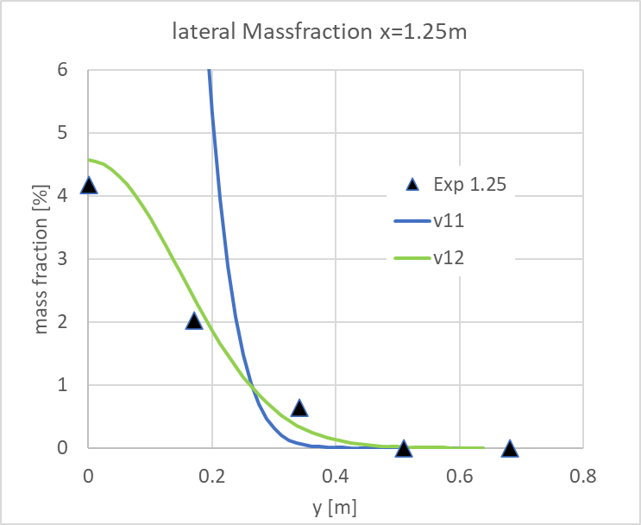
Detailed measurements of concentration and velocity in axial and lateral direction for a release of hydrogen have been performed by INERIS in 2013. The release was at 36bar through a 12mm hole at a release height of 1.5 m (Daubech et al., 2015), (Jallais et al., 2018). EFFECTS v11 shows a consistent overprediction of the concentration data and a lateral distribution that is too narrow (compare Figure 4b). EFFECTS v12 shows excellent agreement with the concentration distributions in axial and lateral direction. The velocity distributions of EFFECTS v11 and v12 show only minor differences. Close to the release, a slight overprediction of the velocity on the axis is observed. Note that the experimental data is not taken on the axis but at y=0.05m. The lateral distributions of the simulations at x=10m show slight deviations from the experimental data but reproduce the plume width well.
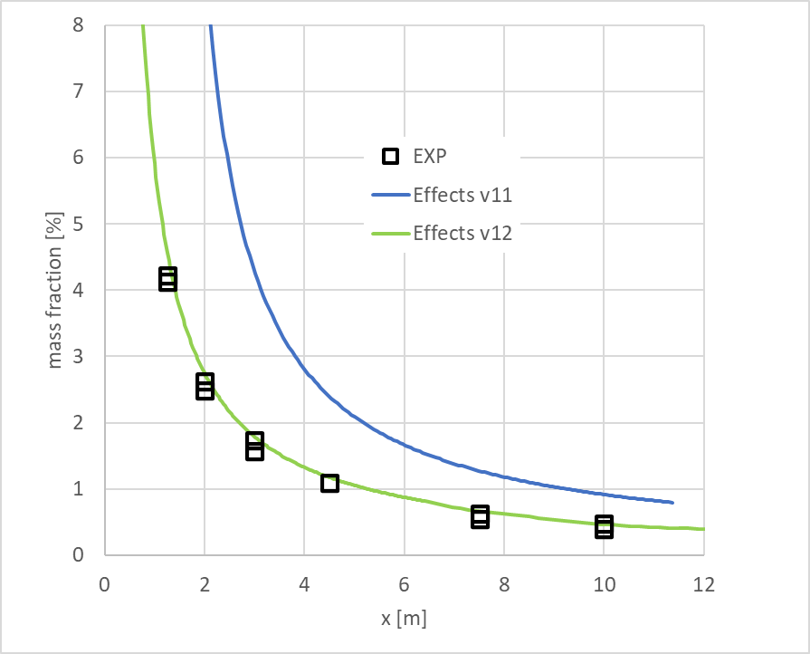

Figure 4: Comparison of mass fraction in downwind direction (left) and lateral direction at x=1.25m (middle) and x=10m (right) of INERIS hydrogen experiment; simulation and experimental data
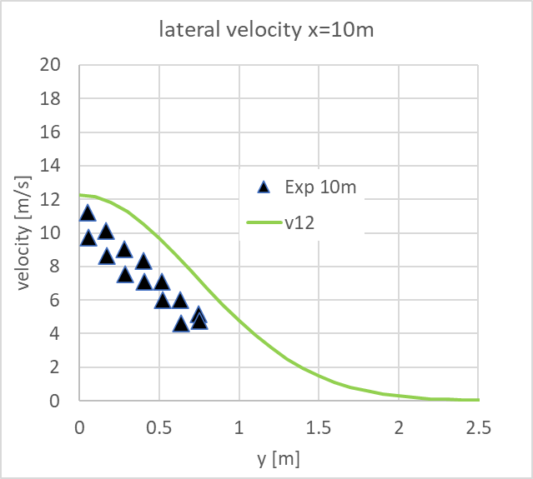
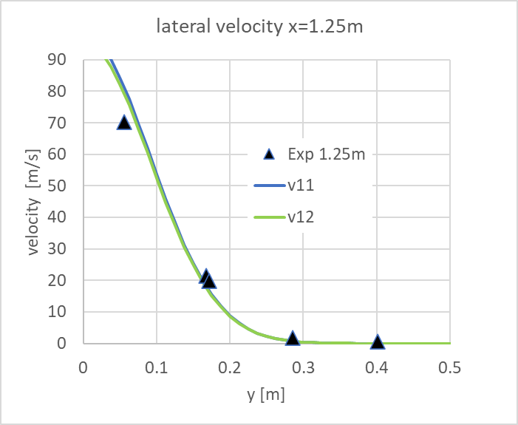
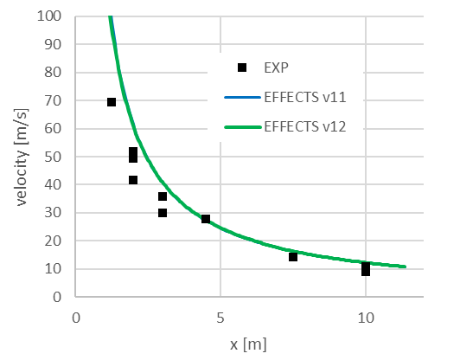

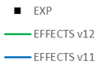

Figure 5: Comparison of velocity distribution in downwind direction (left) and lateral direction at x=1.25m (middle) and x=10m (right) of INERIS hydrogen experiment; simulation and experimental data

    - Additional release conditions
In the previous section, the validation for the release of hydrogen was described. Apart from that, many more validation cases have were simulated, including the validation of releases of substances heavier than air and subsonic releases. Only a selection of these validation cases was included in this paper. Classical data from Birch et al. (1984) and Birch et al, (1987) were simulated and show excellent agreement with experimental data in a wide pressure range for methane (1.14 to 71bar) and ethylene (8bar, see Figure 6, left). In addition, the velocity distributions show good agreement for air at pressures between 1.548 and 31 bar (Figure 6, middle). Comparing the Birch et al. 1987 publications with Birch et al. (1984) it turns out that the
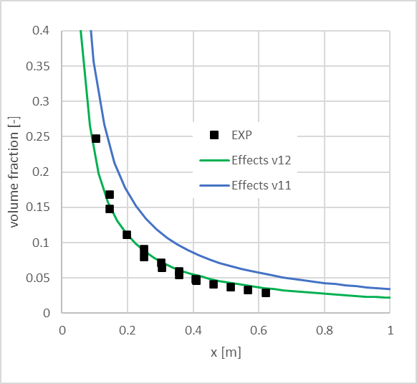
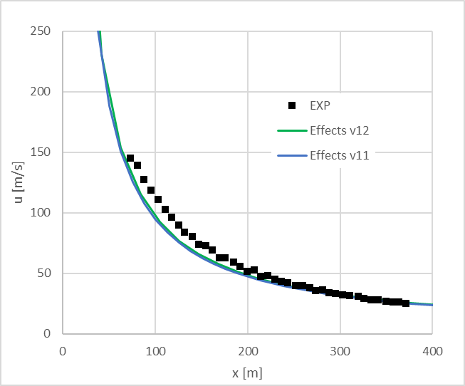
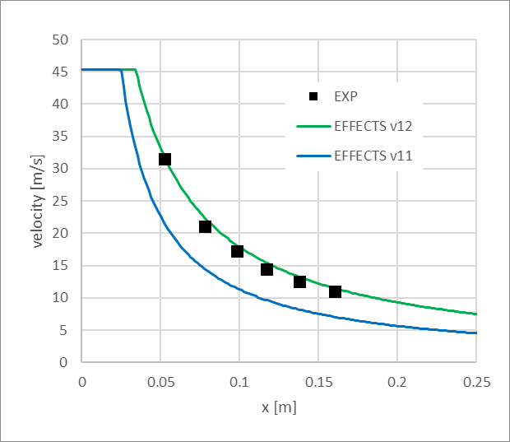

Figure 6: Comparison of simulations and experimental data for a release of: ethylene at 8bar, 2.7mm hole (Birch et al., 1987) (left), air at 31bar, 2.7mm hole (Birch et al., 1984) (middle) and H₂/N₂ mixture (Sautet and Stepowski, 1995) for low speed release of 45m/s, 10mm hole (right)

experimental concentration data has been nondimensionalized in different ways applying a discharge coefficient of 0.85 in the 1984 paper. From the 1987 publication, the absolute concentrations could be reconstructed applying the given discharge coefficient of 1 which was also used during the simulations and the given pseudo-source dimension. Since all experiments have been performed with a contoured Amal type 10120 nozzle, the value for the discharge coefficient can be justified.
For very low Mach number release conditions, the experimental data of Sautet and Stepowski (1995) with a release of a mixture of 80% hydrogen and 20% nitrogen was simulated. Applying the Witze correction shows a significantly improved agreement with the experimental data, compare Figure 6c.
  - Conclusions
The present paper describes the modifications in the EFFECTS v12 turbulent free jet model made to the original Chen & Rodi model including corrections, as well as the new model for an equivalent source for under expanded conditions. The model uses one set of model constants for the entire range of release conditions. The concentration distributions in EFFECTS v12 are less conservative than in EFFECTS v11. The model in EFFECTS v12 has been extensively validated and shows excellent agreement with experimental data for a wide range of conditions from low to high pressure conditions including release substances ranging from light to heavy gas.

References
Birch, A. D., Brown, D. R., Dodson, M. G., & Swaffield, F., 1984, The structure and concentration decay of high pressure jets of natural gas. Combustion Science and technology, 36(5-6), 249-261.
Birch, A. D., Hughes, D. J., & Swaffield, F., 1987, Velocity decay of high pressure jets. Combustion science and technology, 52(1-3), 161-171.
Bonelli, F., 2013, A numerical investigation of turbulent compressible hydrogen jets (Doctoral dissertation, PhD Thesis, School of Engineering, University of Basilicata, Potenza, Italy).
Chen, C.J., Rodi, W., 1980, Vertical turbulent buoyant jets: a review of experimental data. Oxford and New York, Pergamon Press (HMT - Science and Applications of Heat and Mass Transfer. Volume 4).
Crist S., Sherman P.M., Glass D.R., 1966, Study of the Highly Underexpanded Sonic Jet, AIAA Journal, 4, pp68-71
Daubech, J., Hebrard, J., Jallais, S., Vyazmina, E., Jamois, D., & Verbecke, F., 2015, Un-ignited and ignited high pressure hydrogen releases: Concentration–turbulence mapping and overpressure effects. Journal of Loss Prevention in the Process Industries, 36, 439-446.
Donaldson, C.D., Snedeker R.S., 1971, A Study of Free Jet Impingement. Part 1. Mean Properties of Free and Impinging Jets, Journal of Fluid Mechanics, 45, pp281-319
Franquet, E., Perrier, V., Gibout, S., & Bruel, P., 2015, Free underexpanded jets in a quiescent medium: A review. Progress in Aerospace Sciences, 77, 25-53.
Han, S. H., Chang, D., & Kim, J. S., 2013, Release characteristics of highly pressurized hydrogen through a small hole. international journal of hydrogen energy, 38(8), 3503-3512.
Jallais, S., Vyazmina, E., Miller, D., & Thomas, J. K., 2018, Hydrogen jet vapor cloud explosion: a model for predicting blast size and application to risk assessment. Process safety progress, 37(3), 397-410.
Mack, A., Ruiz-Pérez, S., Boot, H., 2023, Extension of the EFFECTS dispersion model for buoyant plume rise including lift-off, Process Safety and Environmental Protection, Volume 176, 747-762.
Molkov, V., 2012, Fundamentals of hydrogen safety engineering. Bookboon.com, ISBN: 978-87.
Roberts, P. T., Shirvill, L. C., Roberts, T. A., Butler, C. J., & Royle, M., 2006, Dispersion of hydrogen from high-pressure sources. In: Institution of Chemical Engineers symposium series. Institution of Chemical Engineers 1999, p. 410.
Sautet, J. C., and Stepowski, D., 1995, Dynamic behavior of variable‐density, turbulent jets in their near development fields. Physics of Fluids, 7(11), 2796-2806.
Witze, P. O., 1974, Centerline velocity decay of compressible free jets. AIAA journal, 12.4: 417-418.
Crist S., Sherman P.M., Glass D.R., 1966, Study of the Highly Underexpanded Sonic Jet, AIAA Journal, 4, 68-71.

