CHEMICAL ENGINEERING TRANSACTIONS  VOL., 2023 | A publication of
The Italian Association
of Chemical Engineering
Online at www.cetjournal.it
Guest Editors: Sabrina Copelli, Richard Siwek
Copyright © 2023, AIDIC Servizi S.r.l.
ISBN ; ISSN 2283-9216

Experimental Parameter Study and Inherent Scattering of Safety Characteristics of Dusts
Stefan H. Spitzer*^{a,b}, Arne Krietschª, Vojtech Jankuj^{c}
ª | Physikalisch Technische Bundesanstalt, Bundesallee 100, 38116 Braunschweig, Germany
^{b} | Bundesanstalt fuer Materialforschung und -pruefung, Unter den Eichen 87, 12205 Berlin, Germany
^{c} | FBI - Technical University of Ostrava, 17. listopadu 2172/15, 708 00 Ostrava, Czech Republic
 | *Stefan.spitzer@ptb.de
Abstract
Safety characteristics are widely used in industrial processes to avoid explosive atmospheres (primary explosion protection) or to mitigate the consequences of an explosion (constructive explosion protection).
Several laboratory parameters influence the determined values when performing the test series such as the beginning pressure and the pre-ignition pressure rise, the ignition source, the ignition energy, the burning duration and volume or the concentration of the combustible substance.
In the different standards for the determination of safety characteristics of dusts there is no statement about the scattering or the deviation when parameters are chosen or occur on the borders of their allowed range. Thus, two laboratories might determine values that are hardly comparable for the same given substance.
This article summarizes some of the influential factors that cause a deviation and shows the inherent scattering of dust tests when all other parameters are kept constant.
It also provides some advice how to minimize the deviation and the scattering with little effort.

  - Introduction
The determination of safety characteristics is one crucial step in the safe design of process plants. Whether the substances used are combustible or not, it is the first step to determine the danger that arises from any process. If one of the substances is combustible, the next steps are to try avoiding combustible atmospheres by keeping the process atmospheres outside the explosive region, avoiding possible ignition sources or to mitigate their impact in case of an explosion.

For gases and vapors the determination is rather easy because they mix perfectly and can be determined under quiescent conditions. For dusts, the mixing is a complex task since dusts settle in gravity and this process is depending on many factors like time, density of the tested substance, mean particle diameter, particle size distribution, and the endeavor to agglomerate. Other parameters are also influencing the determined safety characteristics of dusts like the humidity (Traoré et. al. (2009)), temperature (Lepik et. al. (2014)) and the dispersion system (Zhang et. al. (2020)). The experimental parameter that got investigated intensively is the turbulence decay by igniting at different ignition delay times (Skjold (2003), Chang et. al. (2022), Chen and Chang (2015), Garcia-Agreda et. al (2010)). Unfortunately, this was not investigated yet within the small variation allowed according to the standards.

There are standardized test methods to determine the safety characteristics of dusts in which the experimental parameters and apparatuses are described and stated. However, varying these parameters within the allowed range causes the determined safety characteristic to change.
When all the single parameters are fixed in a given range, their sole variation has a small impact on the determined values but varying many of them leads to subsequent errors where comparability from one laboratory to the other may not be provided anymore. Another topic is the scattering of these test methods. In the standards a minimum number of three tests with the same chosen parameters and concentration of the dust sample is stated and their average value is passed on as the safety characteristic. But there has been little investigation on this scattering and the likelihood of the method to fail with only three tests.
The following parameters are stated in the standards for the determination of safety characteristics of dusts:
- The ignition delay time with 60 ms, no variation (EN 14034-1 to 14034-4 and ASTM1226a)
- The beginning pressure before injection of the dust with 0.4 bar. The variation is indirectly specified with a pressure measurement system that should have an “…accuracy of ± 0.1 bar or better…” (EN 14034-1 to 14034-4). It is not specified in the American standard (ASTM1226a)
- The pre-Ignition pressure rise is indirectly stated with 1013 mbar at ignition minus the before stated 0.4 bar in (EN 14034-1 to 14034-4). It is not specified in the American standard (ASTM1226a)
- The beginning temperature is stated with 20 °C but no range is stated (EN 14034-1 to 14034-4). The American standard has a note, that the value for p_{max} decreases by 15 % if the temperature rises to 40 °C or 50 °C (ASTM1226a)
- The ignition energy is specified with two chemical igniters each having an energy of 5 kJ in the European standard (EN 14034-1 and 14034-2) and in the American standard, though there is a note, that this might be decreased (ASTM1226a)
- The dust concentrations are stated but there is no statement about the accuracy or resolution of the scale

In this paper, several parameters are presented and their impact on the safety characteristics with a visualization, what impact the subsequent errors may lead to. The impact of a small variation of 10 ms for the ignition delay time was investigated for three dust samples. Additionally, the inherent scattering of the safety characteristics p_{max} and (dp/dt)_{max} for one dust sample was investigated.
  - Materials and Methods
Several influencing parameters cause a deviation in the determined safety characteristics. The following were chosen, and their data was taken from other publications to display their influence or calculated:
- Beginning pressure before injection of the dust
- Beginning temperature
- Pre-Ignition pressure rise
No data was found for a very fine variation of the ignition delay time that may be caused by the igniters, so three dusts, lycopodium, niacin and corn starch were investigated varying the ignition delay time in steps of 10 ms. Each test was performed twice, and the results were averaged.
Also, no data was found on the inherent scattering of the dust procedures. 20 tests were performed at two concentrations with the corn starch and two chemical igniters having 1 kJ each.
For these test series a standard 20L-sphere was used, and all other parameters were kept in very narrow ranges with:
- Beginning pressure before injection of the dust at 400 ± 1 mbar
- Pre-ignition pressure rise at 0.64 bar ± 0.01 bar
- Beginning temperature at 20 °C (water jacket)
- Ignition energy of 2 kJ (2 x 1 kJ)
- Weighted dust mass of 10 g ± 10 mg (500 g/m³) or rather 15 g ± 10 mg (750 g/m³)

  - Results and Discussion
Figure 1 displays the values of the maximum explosion pressure for the corn starch dust, tested at concentrations of 500 g/m³ (oxygen in excess) and 750 g/m³, the concentration where the highest values were observed.
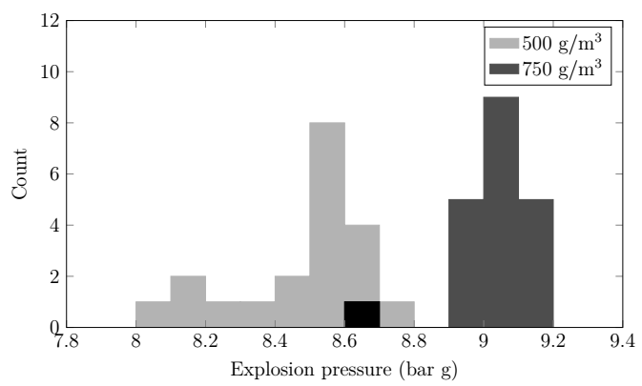
Figure 1: Distribution of the explosion pressures of corn starch for two different concentrations
Except for one outlier with 750 g/m³, the values were with 8.9 bar g to 9.2 bar g less than 2 % apart from each other. The inherent scattering for this dust seemed to be rather small.
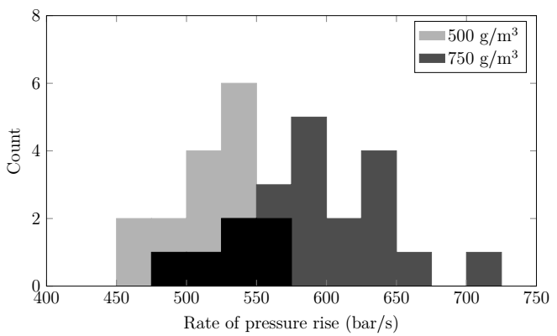
Figure 2: Distribution of the rates of pressure rise of corn starch for two different concentrations
The (dp/dt)-values showed a higher scattering from 475 bar/s to 725 bar/s for a concentration of 750 g/m³ (see figure 2). Because of the rather flat and symmetric histogram the values at the end can’t be seen as outliers and they lay 21 % apart from the average value of 600 bar/s.

In Table 1 the (dp/dt)-values for the variation of the ignition delay time for three different dusts are displayed. It seems to be dust-dependent whether the influence of a slight variation is big or small. While the decrease for niacin is the lowest from 60 ms to 70 ms with only 4 % decrease of the value, the value for corn starch dropped by 10 %. Increasing the ignition delay time more, from 70 ms to 80 ms, these trends swapped and the value for niacin dropped by 25 % while the one for corn starch decreased only by 16 %.

Table 1: Determined (dp/dt)-values of the three dust samples and ratios compared to the 60 ms-value for the variation of the ignition delay time of three different dusts
Dust | 50 ms | 60 ms | 70 ms | 80 ms | 90 ms
Corn Starch | 614 bar/s | 505 bar/s | 452 bar/s | 424 bar/s | 347 bar/s
 | 1.22 | 1 | 0.90 | 0.84 | 0.69
Lycopodium | 548 bar/s  1.01 | 541 bar/s  1 | 516 bar/s  0.95 | 466 bar/s  0.86 | 423 bar/s  0.78
Niacin | 1009 bar/s  1.24 | 810 bar/s  1 | 777 bar/s  0.96 | 604 bar/s  0.74 | 481 bar/s  0.59

This shows that the ignition delay time should not be altered, that even small variations from the igniters may cause a big difference and that there is no simple way to estimate the behaviour for different dusts.

Since the inherent scattering can’t be avoided this was used as the starting point for the following visualization of the influence for the parameters. The influence for the pressure before injection was calculated with the ideal gas law and varied by 100 mbar, which is the accuracy of the pressure measurement system according to the standards. The decrease/increase for the variation of the pre-ignition pressure rise is taken from Spitzer et. al. (2022). The influence of the beginning temperature was also calculated with the ideal gas law and, since the range is not defined at all, a range of ± 10 K was chosen.

Figure 3 illustrates how much the value for p_{max} might deviate with a variation of the five chosen factors. All the factors are still within the allowed range according to the standards. It should be mentioned that it is very unlikely, that one testing institute ends up at the maximum or minimum value for all experimental parameters. Nevertheless, this unlikely event can occur. Especially the blue line would lead to the unsafe design of safety measures while the red line might lead to overpriced safety measures. Also, in this worst-case scenario, the stated value from a facility at the lower end would be only 57 % compared to one from the high end. Adjusting the beginning pressure within 20 mbars, the pre-Ignition pressure rise from 0.62 bar to 0.68 bar and the beginning temperature with 5 K would lead to a maximum difference of 19 % in a worst-case scenario.

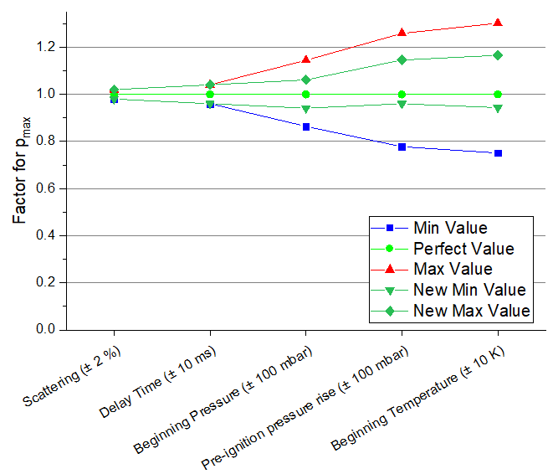
Figure 3: Factor for the determined value of p_{max}
In Figure 4 it is displayed how the experimental parameters influence the values of (dp/dt)_{max}. Again, it should be mentioned that this shows the outcome of a worst-case scenario of two facilities varying all parameters to one side, but the outcome is rather terrifying with the lowest stated value being only 29 % of the highest one. Even when all parameters are narrowed like before, the lowest value is with 41 % from the highest still far from comparability.
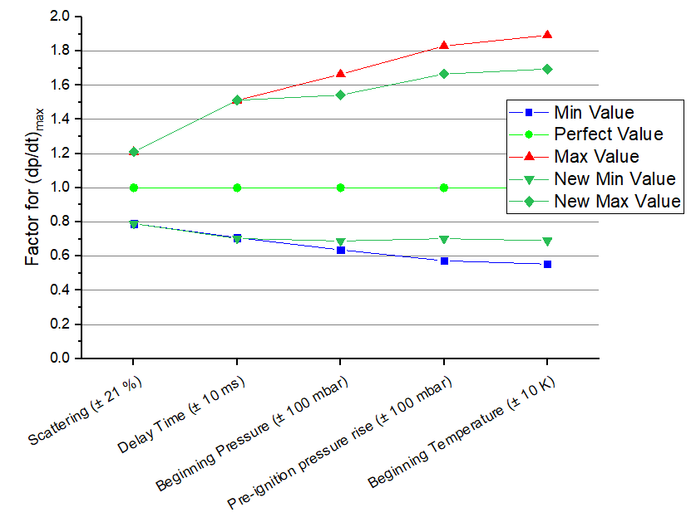
Figure 4: Factor for the determined value of (dp/dt)_{max}
Expecting the scattering to totally vanish with three tests, assuming, that the ignition delay time is not varied and narrowing all the other parameters in the suggested range leads to a min to max difference of 14 % which seems to be within a reasonable range. This should be considered when varying the experimental parameters or when they are implemented loosely.

Table 2 gives an overview of the influence of the single parameters for p_{max} and (dp/dt)_{max}.
Table 2: Upper and lower factor for experimental parameters determining p_{max} and (dp/dt)_{max} of dusts
 | p_{max} |  | (dp/dt)_{max}
 | Lower | Higher | Lower | Higher
Scattering (determined with corn starch) | 0.98 | 1.02 | 0.79 | 1.21
Delay Time ± 10 ms - Corn starch  - Lycopodium  - Niacin | 0.97  0.97  0.98 | 1.03  1  1 | 0.9  0.95  0.96 | 1.22  1.01  1.25
Beginning pressure ± 100 mbar | 0.9 | 1.1 | 0.9 | 1.1
Pre-ignition pressure rise ± 100 mbar | 0.9 | 1.1 | 0.9 | 1.1
Beginning Temperature + (30 – 40) K | 0.85 (ASTM1226) |  | unknown | unknown
Beginning Temperature ± 10 K | 0.97 | 1.04 | 0.97 | 1.04
Beginning Temperature ± 5 K | 0.98 | 1.02 | 0.98 | 1.02

  - Conclusions
It was shown that there are many parameters that influence the safety characteristics p_{max} and (dp/dt)_{max} of dusts. Some parameters can be left unaltered since their variation doesn’t affect the determined values linearly. Others should be implemented in a narrower range to avoid high discrepancies between different test laboratories.
First of all, a range for the beginning temperature should be inserted in the standards and the measured value should be stated in the report which is already mandatory in the European standard, but often this is not done.
The allowed range for the beginning pressure and the pre-ignition pressure rise should be narrowed in the standards since their variation causes at least a linear correlation for the determined values.
The scattering should always be kept in mind when determining safety characteristics and it may also be stated for a better comparison between different facilities.
Since the igniters have a scattering on the ignition delay time, it might be beneficial to replace the chemical igniters by two exploding wires since their behaviour is predictable.
By implementing all these changes, the comparison of several values from different facilities will be easier.
Acknowledgments
The authors would like to thank Dr. Martin Schmidt for providing the dusts and the chemical igniters, and Sara Salih and Dorian Tempier for conducting the dust tests.
References
ASTM 1226 – 12a - Standard Test Method for Explosibility of Dust Clouds, ASTM International, West Conshohocken, 10.1520/E1226-12A
ASTM E1515 – 2007 - Standard Test Method for Minimum Explosible Concentration of Combustible Dusts, ASTM International, West Conshohocken, 10.1520/E1515-07
Chang, X., Bai, C., Zhang, B., and Sun, B. The effect of ignition delay time on the explosion behavior in non-uniform hydrogen-air mixtures. International Journal of Hydrogen Energy, 2022. 10.1016/j.ijhydene.2022.01.026
Chen, J. and Zhang, Q. Flow characteristics of dusts dispersed by high-pressure air blast in 20 L chamber. Engineering Computations, 2015. 10.1108/EC-12-2013-0298
DIN EN 14034-1:2011 - Determination of explosion characteristics of dust clouds – Part 1: Determination of the maximum explosion pressure p_{max} of dust clouds, Beuth-Verlag, Berlin, 10.31030/1709463
DIN EN 14034-1:2011 - Determination of explosion characteristics of dust clouds – Part 2: Determination of the maximum rate of explosion pressure rise (dp/dt)_{max} of dust clouds, Beuth-Verlag, Berlin, 10.31030/1709464
DIN EN 14034-1:2011 - Determination of explosion characteristics of dust clouds – Part 3: Determination of the lower explosion limit LEL of dust clouds, Beuth-Verlag, Berlin, 10.31030/1709465
DIN EN 14034-1:2011 - Determination of explosion characteristics of dust clouds – Part 4: Determination of the limiting oxygen concentration LOC of dust clouds, Beuth-Verlag, Berlin, 10.31030/1709466
Garcia Agreda, A., Di Benedetto, A., Russo, P., Salzano, E., and Sanchirico, R. The role of ignition delay time on the deflagration index in a 20l bomb. 6th International Seminar on Fire and Explosion Hazard (ISFEH6), 2010
Lepik, P., Mynarz, M., Serafin, J., & Bernatik, A., 2014, Explosion limits of industrial spirit and their affecting by temperature. Process Safety Progress, 33(4), 380–384. 10.1002/PRS.11675
Skjold, T. Selected aspects of turbulence and combustion in 20-litre explosion vessels. Master’s thesis, University of Bergen, 2003. URL: https://hdl.handle.net/1956/1631
Stefan S. H., Askar E., Benke A., Janovsky B., Krause U., Krietsch A., 2022, Influence of pre-ignition pressure rise on safety characteristics of dusts and hybrid mixtures, FUEL, 10.1016/j.fuel.2021.122495
Traoré, M., Dufaud, O., Perrin, L., Chazelet, S., & Thomas, D., 2009, Dust explosions: How should the influence of humidity be taken into account? Process Safety and Environmental Protection, 87(1), 14–20. 10.1016/J.PSEP.2008.08.001
Zhang, J., Sun, L., Sun, T., & Zhou, H., 2020, Study on explosion risk of aluminum powder under different dispersions. Journal of Loss Prevention in the Process Industries, 64, 104042. 10.1016/J.JLP.2019.104042

