CHEMICAL ENGINEERING TRANSACTIONS  VOL., 2023 | A publication of
The Italian Association
of Chemical Engineering
Online at www.cetjournal.it
Guest Editors:
Copyright © 2023, AIDIC Servizi S.r.l.
ISBN ; ISSN 2283-9216

Modelling of Fireballs Generated after the Catastrophic Rupture of Hydrogen Tanks
Leonardo Giannini^{a,}*, Gabriele Tincani^{b}, Giulia Collina^{b}, Ernesto Salzano^{b}, Valerio Cozzani^{b}, Federico Ustolinª
ª Department of Mechanical and Industrial Engineering, Norwegian University of Science and Technology NTNU, Richard Birkelands vei 2B, 7034 Torndheim, Norway
^{b} Dipartimento di Ingegneria Civile, Chimica, Ambientale e dei Materiali, Università degli studi di Bologna, Via Terracini 28, 40131 Bologna, Italy
leonardo.giannini@ntnu.no
The interest towards hydrogen skyrocketed in the last years. Thanks to its potential as an energy carrier, hydrogen will be soon handled in public and densely populated areas. Therefore, accurate models are necessary to predict the consequences of unwanted scenarios. These new models should be employed in the consequence analysis, a phase of risk assessment, and thus aid the selection, implementation, and optimization of effective risk-reducing measures. This will increase safety of hydrogen technologies and therefore favour their deployment on a larger scale. Hydrogen is known to be an extremely flammable gas with a low radiation flame compared to hydrocarbons. However, luminous fireballs were generated after the rupture of both compressed gaseous and liquid hydrogen tanks in many experiments. Moreover, it was demonstrated that conventional empirical correlations, initially developed for hydrocarbon fuels, underestimate both dimension and duration of hydrogen fireballs recorded during small-scale tests (Ustolin and Paltrinieri, 2020). The aim of this study is to obtain an analysis of hydrogen fireballs to provide new critical insights for consequence analysis. A comparison among different correlations is conducted when predicting fireball characteristics during the simulation of past experiments where both gaseous and liquid hydrogen tanks were intentionally destroyed. All the models employed in this study are compared with the experimental results for validation purposes. Specific models designed for hydrogen can support the design of hydrogen systems and increasing their safety and promote their future distribution.

  - Introduction
The REPowerEU ambitious strategy for hydrogen implementation foresees a great increase in the domestic renewable hydrogen production within the European union (European Commission, 2022), thus implying a vast-scale diffusion of hydrogen technologies, even in high densely populated areas. However, safety aspects of hydrogen technologies still constitute a bottleneck to their implementation for several reasons, one of them being hydrogen’s high flammability, which could promote the occurrence of hazardous scenarios and accidents (Campari et al, 2023). Hence, the definition of safety procedures for hydrogen handling encompasses several different challenges. More precisely, the very low minimum ignition energy of 0.017 mJ (Ono et al, 2007) is just one characteristic that raises concern among scientists and engineers. Moreover, the occurrence of rare, yet severe phenomena referred to as hydrogen fireballs is deemed to be not only critical in terms of safety, but also in terms of perceived risk, which limits the public acceptability of these technologies. In fact, the concreteness of disastrous scenarios is known to socially impact hydrogen refuelling stations, making them more challenging to site, permit, and operate, thus limiting the development of a widespread hydrogen infrastructure (Huijts et al, 2019). For these reasons, the necessity of specific and reliable models describing hydrogen fireballs arises as a first-order variable in the development of the hydrogen value chain, therefore affecting the overall energy transition scenario. This work proposes new models which aim to estimate both the duration and the diameter of hydrogen fireballs. These models are considered as an evolution of the ones often found in literature, since they are developed for hydrogen and based on experiments concerning both pressure vessel bursts (PVBs) and liquid hydrogen (LH₂) boiling liquid expanding vapor explosion (BLEVE). In particular, the proposed models aim at the description of the fireball generated during the recently concluded “Safe Hydrogen Fuel Handling and Use for Efficient Implementation” project (SH₂IFT, 2021) and in this paper a comparison with other experimental hydrogen fireballs is performed for validation purposes. However, there still is a deep need for new experimental activities to further validate and improve these models. Experimental studies can in fact help improving the accuracy and reliability of the new models by providing more data on real-world conditions and scenarios. These studies can also help identify different hazards or factors that may influence the behaviour of hydrogen fireballs, thus leading to better safety standards and practices.

  - Hydrogen Fireballs
BLEVEs and PVBs are defined as explosions involving the catastrophic rupture of a vessel. A BLEVE is characterized by the violent burst of a boiling liquid, which involves both the rapid expansion of the gaseous phase and the flashing of a fraction of the liquid phase, as a consequence of rapid depressurization (Ustolin et al, 2020). A PVB may show a similar aftermath, but it is characterized by the burst of a vessel containing gas at elevated pressure (CCPS, 2010). In both cases, the high mechanical energy released (Ustolin et al, 2022) implies consequences that are often severe, involving generation of pressure waves, fragments projection and, if the released fluid is flammable, fireballs. Hence, a distinction of fireballs from BLEVEs and PVBs is provided below, to describe the different experiments the proposed models are based on.
    - Fireballs from BLEVEs
Hydrogen BLEVEs are rare scenarios, often classified as atypical accident scenarios (Ustolin et al, 2020). In addition, experiments concerning these explosions and their major consequences (i.e., hydrogen fireballs) are also difficult to be found in literature, and a limited number of data is currently available. Moreover, the cryogenic conditions of liquid hydrogen (LH₂) impose considerable costs for the purchase of specific equipment, reducing the availability of experimental evidence and data. Within this work, two important set of experiments were considered to study the fireball generated from hydrogen BLEVEs:

- “Cold” LH₂ BLEVEs from safety tests conducted by BMW car manufacturer in the 1990s (Pehr, 1996) hereafter BMW tests.
- “Hot” LH₂ BLEVE from the SH₂IFT project (SH2IFT, 2021), hereafter SH₂IFT test.

Where “cold” and “hot” indicate the event triggering type, being “cold” a cutting charge located on the exploding vessel and “hot” implying the presence of a propane burner placed under the LH₂ tank to engulf it in a fire. The experiments resulted in the generation of fireballs, which were unique in terms of their fundamental characteristics (i.e., duration and diameter). More precisely, the mass content is deemed to be a crucial parameter for the development of the fireball, which is also confirmed by several models in literature (Roberts, 1981). During the execution of the SH₂IFT test, a leakage of LH₂ happened before the BLEVE event, which reduced the initial mass (27 kg of LH₂) to an unknown value. This event affected both the fireball dimension and duration, but a hydrogen mass ranging between 13 kg and 27 kg is deemed as a plausible value at the moment of the explosion. Moreover, the exact mass of LH₂ is also unknown for the BMW tests, since the experimental data indicate a hydrogen mass ranging from 1.8 kg and 5.4 kg. Therefore, it is expected that these uncertainties affect the overall accuracy of the models. However, the obtained results suggest that further tests could validate these findings, as explained in Sec. 4.
    - Fireballs from PVBs
Similarly to the LH₂ BLEVE, a hydrogen fireball is likely to occur as a consequence of a H₂ PVB. Experimental hydrogen PVBs are usually conducted to investigate the consequences of loss of containment scenarios involving high pressure vessels, such as hydrogen vessels designed for the automotive sector. Hence, data are available for different pressure levels, ranging from 34.5 MPa to almost 100 MPa for different experiments, which in some cases simulate PVBs generating from road accidents (Zalosh, 2007). In particular, the following experiments are considered in this paper:

- PVBs triggered by propane flames applied to different vessel types (type III and IV) without pressure relief valves (PRVs), hereafter, Zalosh-1 test (Zalosh and Weyandt, 2005) and Zalosh-2 test (Zalosh, 2007).
- Fire tests conducted on different types of high-pressure hydrogen vessels (type III and IV), hereafter Tamura-1 test, and Tamura-2 test (Molkov, 2021).
- Fireball generated by a cup head failure of a type III vessel, hereafter Shen tests 2018 (Shen, 2018)

Table 1 summarizes the experiments and provides the available measures concerning fireball diameters and durations:
Table 1: Experimental data for hydrogen BLEVEs and PVBs (abbreviation: FB: fireball).
Test | Year | Type [-] | Mass Content [kg] | Pressure Burst [MPa] | FB diameter [m] | FB duration [s]
BMW | 1996 | BLEVE | 1.80 ÷ 5.40 | < 1.29 | 20 | 4.0
SH₂IFT | 2021 | BLEVE | 27.00 | 5.00 | 26 | 5.0
Zalosh-1 | 2005 | PVB | 1.64 | 35.70 | 8 | 2.0
Zalosh-2 | 2007 | PVB | 1.87 | 34.50 | 24 | 2.0
Tamura-1 | 2006 | PVB | 1.41 | 99.50 | 18 | 2.0
Tamura-2 | 2006 | PVB | 1.37 | 94.50 | 18 | 2.0
Shen | 2018 | PVB | 3.90 | 43.70 | 7 ÷ 8 | 1.5

It is worth noticing that three out of the seven tests reported in Table 1 are described as flattened fireballs, hence characterized by a particularly elongated horizontal dimension. As it will be discussed in Section 4, the experiments that resulted in the flattened fireball are Tamura-1, Tamura-2, and Zalosh-2 tests (Makarov, 2021).

  - Methodology
The models proposed within this work are obtained by fitting the experimental data of the BMW and SH₂IFT tests. Hence, the PVBs experiments are reported to investigate the models’ accuracy for these events and for validation purposes. Before discussing these models, the adopted methodology is explained in Sections 3.1 and 3.2.
    - Literature Correlations
Several empirical correlations can be found in literature to predict dimensions and duration of fireballs generated after the loss of containment of flammable fuels. Among these formulae, the Hord equation (Hord, 1972) gained the most appeal (Eq. 1). This correlation considers the fireball diameter as a function of the fuel mass, while the fireball duration can be evaluated considering it as momentum-driven or buoyancy-driven (Eq. 2 and Eq. 3). Again, this distinction is based on the fuel mass contained in the exploding vessel, as reported below.
$$\text{D = }\text{7.93} {{\text{m}}_{f}}^{1/3}$$ | (1)
$\text{t }\text{= 0.45 }{{\text{m}}_{f}}^{1/3}$ momentum-driven | (2)
$\text{t }\text{= 2.60 }{{\text{m}}_{f}}^{1/6}$ buoyancy-driven | (3)
Where D indicates the fireball diameter in meters, t its duration in seconds, and ${\text{m}}_{f}$ being the fuel mass in kilograms. These equations, in accordance with others found in literature, consider the fireball as spherical. However, recent studies (Makarov, 2021) propose different empirical correlations (Eq. 4 and Eq. 5) to estimate the diameter of a hydrogen fireball, considering it to develop in a hemispherical shape.
$${\text{D}}_{hms}\text{ = 9.8 }{{\text{m}}_{H_{2}}}^{1/3}$$ | (4)
$${\text{D}}_{hms_cons}\text{ = 19.5 }{{\text{m}}_{H_{2}}}^{1/3}$$ | (5)
Where ${\text{D}}_{hms}$ and ${\text{D}}_{hms_cons}$ indicate the hydrogen fireball diameter in meters considering it as hemispherical (Eq. 5 being more conservative) and ${\text{m}}_{H_{2}}$being the hydrogen mass in kilograms. Eq. 5 predicts particularly conservative results, since it is based on a flattened fireball experiment (obtained by placing an obstacle above the exploding tank) which resulted in an increased horizontal dimension (Makarov, 2021).
    - Proposed Correlations
As mentioned, the models proposed within this work are obtained by fitting the experimental data of the BMW and the SH₂IFT tests and tuning existing correlations described in Sec. 3.1. The correlations aim at predicting both diameter and duration of hydrogen fireballs. Eq. 6 and Eq. 7 estimate the fireball diameter fitting the BMW and the SH₂IFT tests respectively, while Eq. 8 and Eq. 9 calculate the fireball duration. In addition, Eq. 8 and Eq. 9 are conceived to predict the fireball duration similarly to the buoyancy-driven case, but they are built fitting the experimental data of both the BMW and the SH₂IFT BLEVEs respectively. In fact, the buoyancy-driven model is more accurate for hydrogen fireballs than the momentum-driven, as it is shown below.
$\text{D = 16.44 }{{\text{m}}_{f}}^{1/3}$ BMW-fit | (6)
$\text{D = 10.97 }{{\text{m}}_{f}}^{1/3}$ SH₂IFT-fit | (7)
$\text{t}\text{ = 3.63 }{{\text{m}}_{H_{2}}}^{1/6}$ BMW-fit | (8)
$\text{t}\text{ = 3.26 }{{\text{m}}_{H_{2}}}^{1/6}$ SH₂IFT-fit | (9)
In accordance with the models found in literature, these correlations are also based on the fuel mass contained in the exploding vessels, so a high accuracy in the mass measurement is deemed as necessary for future experimental tests.

  - Results and Discussion
The obtained results (Figure 1a) show how the models proposed with this work (Eq. 6 and Eq. 7) generally overestimate the PVBs fireball diameters, with the exception of the flattened fireball of the Zalosh-2 test, which was characterized by an exceptionally higher horizontal dimension. Figure 1a also depicts the two new models, named BMW-fit (Eq. 6) and SH₂IFT-fit (Eq. 7), which fit the data of the BMW and SH2IFT BLEVE experiments, respectively. The uncertainties concerning the mass values at moment of the explosion are also illustrated in Figure 1a and 1b, along with the PVBs and BLEVEs experimental data. Given these results, it could be speculated that the hydrogen mass prior the SH₂IFT BLEVE was closer to the expected value of 13 kg, thus implying a leakage of about 14 kg of hydrogen (thin dashed line with black circles). This aspect could be also inferred by taking into account the experimental data of the BMW tests (thin dashed line with black squares) which might indicate that the 20 m fireball diameter was obtained with a filling value close to 5.4 kg of LH₂. Moreover, Eq. 6 seems to accurately predict the dimensions of both the Tamura fireballs, which were described as flattened. In addition, the measured fireball dimensions are higher for the LH₂ BLEVEs, with the exception of the results of flattened fireballs (Tamura-1, Tamura-2, and Zalosh-2 tests). Interestingly, both Eq. 1 (Hord, 1972) (blue curve) and Eq. 4 (Makarov, 2021) (green curve) underestimate the fireball diameters for LH₂ BLEVEs, while the fitting equation of the extremely flattened fireball obtained for the Zalosh-2 test (red line) results in the most conservative prediction.
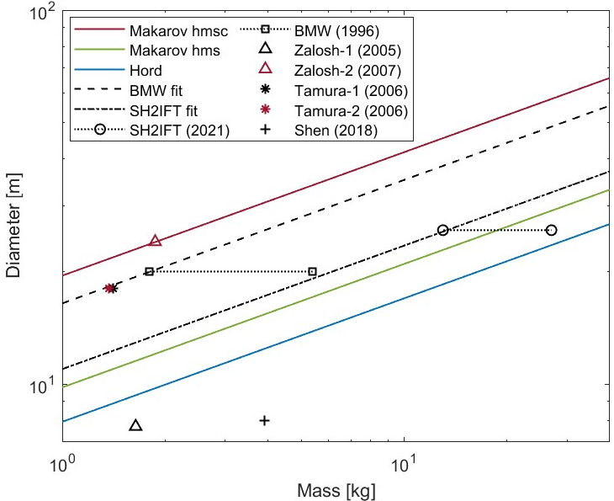 | 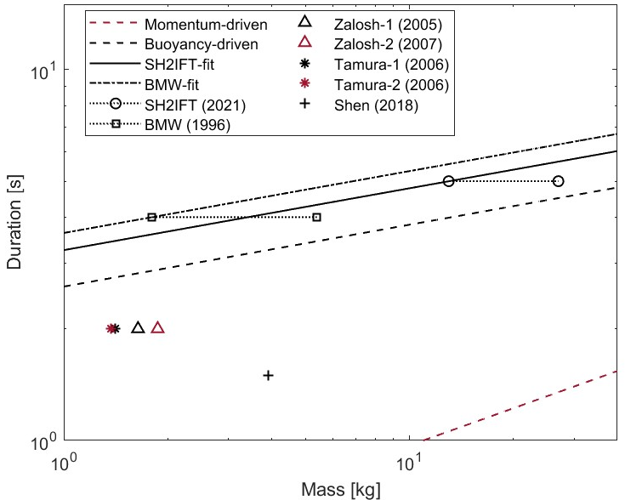
a) | b)

Figure 1: Comparison between experimental data and predictions fireball (a) diameters and (b) durations for different hydrogen masses. The uncertainties concerning the liquid hydrogen BLEVE masses are indicated by the thin dashed lines.

While the flattening of fireballs resulted in a relevant scattering of the experimental diameters, the data concerning the fireball durations seem to show more consistency. Figure 1b illustrates this aspect, since each PVB experiment resulted in a fireball duration of around two seconds, except for the Shen test, in which a shorter duration was measured for a higher hydrogen mass with respect to the other experiments. On the other hand, the fireballs generated from BLEVEs seem to show longer durations with respect to the ones generated by PVBs. This aspect can be also noted in Table 2, which collects the calculation errors for the BMW-fit model. This model produced the most conservative estimations for the fireball duration, and it was developed considering the exploding mass equal to 1.8 kg of LH₂.

Table 2: Comparison between the experimental results and the most conservative model (BMW-fit) outcomes.
 | Experimental data |  | Simulation
Test | Diameter [m] | Duration [s] | Diameter [m] | Duration [s] | Diameter Error [%] | Duration Error [%]
BMW | 20 | 4.0 | 20 | 4.0 | 0 | 0
SH₂IFT | 26 | 5.0 | 38 | 5.5 | 46 | 11
Zalosh-1 | 8 | 2.0 | 23 | 3.9 | 188 | 96
Zalosh-2 | 24 | 2.0 | 20 | 4.0 | -15 | 103
Tamura-1 | 18 | 2.0 | 18 | 3.8 | 2 | 92
Tamura-2 | 18 | 2.0 | 18 | 3.8 | 2 | 89
Shen | 7 ÷ 8 | 1.5 | 30 | 3.9 | 275 | 160

As mentioned, the obtained results could be a hint indicating that the hydrogen fireballs are more likely to behave in a more buoyancy-driven manner, given the hydrogen extremely low density, and therefore high buoyancy in air. However, Eq. 3 seems to underestimate the duration of the BLEVE fireballs, which could affect the predictions on the overall thermal dose, ultimately leading to an underestimation of the related hazard. Hence, the models proposed with this work seem to overestimate the fireball durations, but further experimental evidence is needed to investigate their suitability. Furthermore, the effect of hydrogen elevated buoyancy should be investigated with respect to the fireball duration, since it appears that the buoyancy-driven model might be more suitable than the momentum-driven one, even if CCPS (2010) suggests applying Eq. 3 to masses higher than 30,000 kg, which are three orders of magnitude higher than the ones considered in this work. One may recommend estimating the fireball duration by means of the buoyancy-driven model for the PVBs, and the correlations developed in this work for BLEVEs. Finally, the building of an ad-hoc model to estimate both LH₂ fireballs diameter and duration is deemed as necessary, since conventional models seem to provide possible hazardous underestimations. Hence, additional experimental data is needed to validate the new models and provide reliable evidence concerning the mass involved in the explosion, which seems to be the main parameter in the hydrogen fireball development.

  - Conclusions
Conventional models aimed at the prediction of fireballs behaviour and generated by vessels loss of integrity have proven not to be suitable for hydrogen accidental scenarios. In fact, an overall underestimation of both the fireball dimension and duration was obtained with respect to experimental hydrogen BLEVEs. Hence, new models were built based on experimental data of LH₂ BLEVEs obtained during the BMW tests and the SH₂IFT project, which seem to achieve more conservative predictions. In addition, the necessity of new experimental evidence concerning this hazardous scenario was underlined. Moreover, the implications of the lack of specific models describing the consequences of LH₂ ignited releases (e.g., liquid hydrogen fireballs) is deemed to potentially affect the safety of hydrogen equipment in general, thus ultimately inhibiting the spread of hydrogen technologies.

Nomenclature

BLEVEs – boiling liquid expanding vapor explosion.
D – fireball diameter.
D_{hms} – hemispherical fireball diameter.
D_{hmsc} – hemispherical conservative fireball diameter.
FB – fireball.
LH₂ – liquid hydrogen.
PVBs – pressure vessel bursts.
t – fireball duration.

Acknowledgments

This work was undertaken as part of the research project Safe Hydrogen Fuel Handling and Use for Efficient Implementation (SH₂IFT), and the authors would like to acknowledge the financial support of the Research Council of Norway under the ENERGIX programme (Grant No. 280964). This work was undertaken as part of the ELVHYS project No. 101101381 supported by the Clean Hydrogen Partnership and its members and the European Union. UK participants in Horizon Europe Project ELVHYS are supported by UKRI grant numbers 10063519 (University of Ulster) and 10070592 (Health and Safety Executive).

References

Campari A., Akel A., Ustolin F., Alvaro A., Ledda A., Agnello P., Moretto P., Patriarca R. and Paltrinieri N., 2023, Lessons Learned from HIAD 2.0: Inspection and Maintenance to Avoid Hydrogen-Induced Material Failures, Computers and Chemical Engineering, DOI: 10.1016/j.compchemeng.2023.108199.
CCPS, 2010, Guidelines for Vapor Cloud Explosion, Pressure Vessel Burst, BLEVE, and Flash Fire Hazards, JOHN WILEY SONS & American Institute of Chemical Engineers, ISBN: 9780470251478.
European Commission, 2022, REPowerEU: A plan to rapidly reduce dependence on Russian fossil fuels and fast forward the green transition, ec.europa.eu/commission/presscorner/detail/en/ip_22_3131.
Hord, J., 1972, Explosion criteria for liquid hydrogen test facilities, NBS Report.
Huijts N., de Vries G. and Molin E., 2019, A positive Shift in the Public Acceptability of a Low-Carbon Energy Project After Implementation: The Case of a Hydrogen Fuel Station, Sustainability, 11, 2220, DOI: 10.3390/su11082220.
Makarov D., Shentsov V., Kuznetsov M. and Molkov V., 2021, Hydrogen Tank Rupture in Fire in the Open Atmosphere: Hazard Distance Defined by Fireball, Hydrogen, 2, 134-146, DOI: 10.3390/hydrogen2010008.
Molkov V., Cirrone D., Shentsov V., Dery W., Kim W. and Makarov D., 2021, Dynamics of blast wave and fireball after hydrogen tank rupture in a fire in the open atmosphere, International Journal of Hydrogen Energy, 46, 4644 – 4665, DOI: 10.1016/j.ijhydene.2020.10.211.
Ono R., Nifuku M., Fujiwara S., Horiguchi S. and Oda T., 2007, Minimum ignition energy of hydrogen–air mixture: Effects of humidity and spark duration, Journal of Electrostatics, 65, 87-93, DOI: 10.1016/j.elstat.2006.07.004.
Pehr K., 1996, Aspects of safety and acceptance of LH₂ tank systems in passenger cars, International Journal of Hydrogen Energy, 21.5, 387–395, DOI: 10.1016/0360-3199(95)00092-5.
Roberts A. F., 1981, Thermal radiation hazards from releases of LPG from pressurized storage, Fire Safety Journal 4.3, 197–212, DOI: 10.1016/0379-7112(81)90018-7.
SINTEF Industry, 2021, SH2IFT - Safe Hydrogen Fuel Handling and Use for Efficient Implementation www.sintef.no/projectweb/sh2ift/sh2ift-partners/.
Shen C., Ma L., Huang G., Wu Y., Zheng J., Liu Y. and Hu J., 2018, Consequence assessment of high-pressure hydrogen storage tank rupture during fire test, Journal of Loss Prevention in the Process Industries, 55, 223-231, DOI: 10.1016/j.jlp.2018.06.016.
Ustolin F., Giannini L., Pio G., Salzano E. and Paltrinieri N., 2022, On the Mechanical Energy Involved in the Catastrophic Rupture of Liquid Hydrogen Tanks, CHEMICAL ENGINEERING TRANSACTIONS, 91, 421-426, DOI: 10.3303/CET2291071.
Ustolin F., Landucci G. and Paltrinieri N., 2020, An innovative and comprehensive approach for the consequence analysis of liquid hydrogen vessel explosions, Journal of Loss Prevention in the Process Industries, 68, 104323, DOI: 10.1016/j.jlp.2020.104323.
Ustolin F. and Paltrinieri N., 2020, Hydrogen fireball consequence analysis, Chemical Engineering Transaction, 82, 211–216, DOI: 10.3303/CET2082036.
Zalosh R. and Weyandt N., 2005, Hydrogen fuel tank fire exposure burst test, SAE Technical Papers, DOI: 10.4271/2005-01-1886.
Zalosh R., 2007 Blast Waves and Fireballs Generated by Hydrogen Fuel Tank Rupture During Fire Exposure, Firexplo, 23–27.

