CHEMICAL ENGINEERING TRANSACTIONS  VOL., 2023 | A publication of
The Italian Association
of Chemical Engineering
Online at www.cetjournal.it
Guest Editors: Sabrina Copelli, Richard Siwek
Copyright © 2023, AIDIC Servizi S.r.l.
ISBN ; ISSN 2283-9216

Repercussions on the safety management system of inspection activity after a major accident
Romualdo Marrazzo^{a,}*, Paolo Bragatto^{b}
ªVAL-RTEC, ISPRA. Via V. Brancati n. 48 - 00144 Roma, Italia
^{b} Università Campus Biomedico di Roma, via Àlvaro del Portillo, 21 – 00128 Roma
*romualdo.marrazzo@isprambiente.it
The article is aimed at representing the inspection activity following a major accident occurred in Italy at an upper tier Seveso establishment. It highlights the repercussions on the safety management system and the related lessons learned for technical evaluation and control activities, starting from the consideration that apparently minor events, originated by problems of an electrostatic nature during relatively simple plant operations, could give rise to major accidents. In addition to the possible human cause linked to errors of operators, a series of elements concerning technical and organizational aspects are discussed.
  - Introduction
The problem of accumulation of electrostatic charges in presence of flammable substances has been a well-known danger for decades, also due to the many accidents of the past occurred in the process industry. During the phase of handling flammable substances, it is essential to implement all the necessary plant and organizational measures to prevent sparks from igniting vapors and causing explosions and fires. Although these assumptions, accidents of this type continue to happen even in sites that fall under the Seveso III Directive, moreover subject to strict controls.
The interested event started when two operators, that were concluding the loading phase of Di-Methyl-Carbonate (DMC) in a reactor from metal sheet drums through a flexible pipe, inclined the last drum to facilitate the suction. During the extraction phase of the loading nozzle, the ignition of DMC vapors was produced which led to the explosion of the drum with immediate fire of the whole product, with a limited impact area and a limited duration but, unfortunately, with very severe consequences for operators.
It should be remembered that accidents due to the accumulation of electrostatic charges during the transfer of fluids from small tanks of various types in unsuitable conditions (use of insulating materials, failure to connect electricity between the tanks, absent grounding, etc.) are possible events, even if not necessarily with such dramatic consequences as in the case described. As a reference the BARPI/ARIA accident database have been considered. ARIA reports all the accidents related to the use of dangerous chemical substances in all French industrial sites, most of them not included in Seveso Legislation. ARIA has no equals in other countries, for completeness and openness of information. In the period 2011-2015, 5 events, like the one discussed are reported. Fortunately, for these events, there were no victims, although in two cases there were workers with rather serious injuries, as well as important economic losses for the companies (ARIA. 2015).
  - Methods
In case of a major accident, the Legislative Decree 105/2015 (GU. 2015), the Italian implementation of Directive 2012/18/EU - Seveso III Directive (EU. 2012), imposes an inspection after the event. A commission is charged by Ministry of Ecological Transition (formerly Ministry of Environment), and it is made up by 3 members from: National Institute for Environmental Protection and Research (ISPRA - Istituto Superiore Protezione e Ricerca Ambientale); National Fire Brigades (CNVVF – Corpo Nazionale Vigili del Fuoco); National Workers’ compensation Authority (INAIL – (Istituto Nazionale Assicurazione Infortuni sul Lavoro). The inspection consists of collecting evidence through acquisition and verification of documentation, on-site visit and inspection on the state of the plants and equipment, interviews with workers representatives, occupational physician, internal staff and subcontractors.
The commission investigates the dynamics of the event in order to learn lessons for preventing major accidents and mitigating their consequences, collecting information and data through the e-MARS (Major Accident Reporting System) database. The commission must prepare a final technical report, which states the analysis of the technical and organizational factors related to the accidental causes, the description of the dynamics and consequences of the event, with a focus on the corrective actions taken by the operator in reference to the Safety Management System (SMS) issues (Wood, M. 2018).
Reporting an event into e-MARS, on behalf of the European Commission, is compulsory for EU Member States when a Seveso establishment is involved, and the event meets the criteria of a “major accident” as defined by Annex VI of the Seveso III Directive. The e-MARS database is a lesson learned database in accordance with the purpose stated in the Directive 2012/18/EU. The purpose of the e-MARS is to facilitate exchange of lessons learned from accidents and near misses involving dangerous substances in order to improve chemical accident prevention and mitigation of potential consequences (EU. 2020).
  - Site and Event description
The event occurred in general chemicals manufacture, an upper tier Seveso establishment, and consisted of a Flashfire during upload of Di-Methyl-Carbonate (DMC) under vacuum condition in a reactor from metal sheet drums through a flexible pipe. These are the main characteristics of the accident and the reason for reporting in the e-MARS database, as indicated in the Annex VI of Seveso III Directive: substance involved (indicated in the Annex 1 of the Directive 2012/18/EU); injury to persons (1 death).
    - Site and installation
The site description is in the Lombardia Region - north of Italy and it is the headquarters of an international industrial group.
It is a chemical establishment for the manufacture of auxiliary products for textile industry with the following production departments:
- RS1: chemical synthesis processes
- RS2: mixtures, formulations and simple synthesis reactions
- Drying: products are subjected to a drying process to be sold in the form of powders packed in sacks or big-bags
- Hydrolyzation: production of phosphorous acid and hydrochloric acid by phosphorus trichloride
These plants are connected to: Storage areas and warehouses for raw materials, intermediate and finished products in cylindrical tanks, drums or IBC (Intermediate Bulk Container), bags; Technical facilities, laboratories, offices and services.
The RS1 unit, where the event occurred, has 20 internal lines of production and 6 external neutralizing units. They are used to produce synthesis finished or intermediate products, through processing of raw materials from storage tanks, drums or warehouses. Each reactor is destined to its own batch processing. The reactor R20, where the event originated, can be used for various types of reactions. The reactors are arranged in two opposite rows with a loft so as to leave a corridor for the internal handling. On the first floor of the loft there are the dashboards. The operator unit mainly operates in the Control Room by PC process.
The loading of raw materials is performed by tank through fixed pipes or by drum placed on the floor through suction pipe or directly from the hatch (solids or powders). The unloading of the product into storage tanks is carried out by foot valve through pump or air/nitrogen pressure. The internal handling of drums or bags is done by trucks.
    - Substance involved
The DMC (CAS n. 616-38-6) is liquid at ambient temperature, used as a reagent for synthesis.
The substance is classified: Highly flammable liquid and vapor (H225) and falls under Seveso III Directive, Annex I, Part 1 as P5c - FLAMMABLE LIQUIDS. The product is purchased in drums of metal sheet of 200 liters capacity, which are kept in storage at the plant for subsequent use.
The quantity of substances involved in the event is about 10 kg (estimated by the operator).
    - Accident dynamic and consequences
On 10/09/2013, at 4:00 am, two operators were concluding the loading phase of Dimethyl carbonate in the R20 of the RS1 from 200 liters metal sheet drums, by vacuum suction with flexible pipe connected to the reactor, for a total of 849 kg (open cycle transfer), as shown in the diagram in Figure 1.
To empty the 4th drum (10-15 lt. remaining), it was inclined to facilitate the suction. Probably in the next step of extraction of the loading nozzle, it was produced the ignition of DMC vapors.
The explosion of the drum then occurred with bottom detachment and consequent immediate fire of the whole product, with a limited impact area (about 2 mt.) and a limited duration of the entire event of about 10 min.
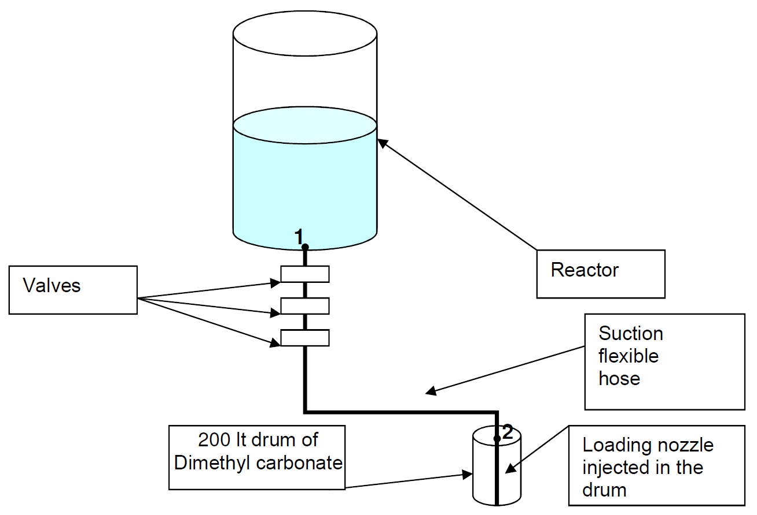
Figure1: Connection diagram of the reactor to the drum
As shown in the diagram in the Figure 2 below, The first operator, responsible for handling of flammable, was hit by a presumable flash fire of DMC and seriously injured. He was transferred to a specialized center for the treatment of the burns. Later he died after 10 days of hospitalization because of burns on most of the body.
The second operator, supporting the handling operations, fell to the ground a short distance away and was slightly injured. He was treated in hospital and then dismissed (bruises and limited burns). He returned to the company after 36 days of injury, having also reported psychological trauma.
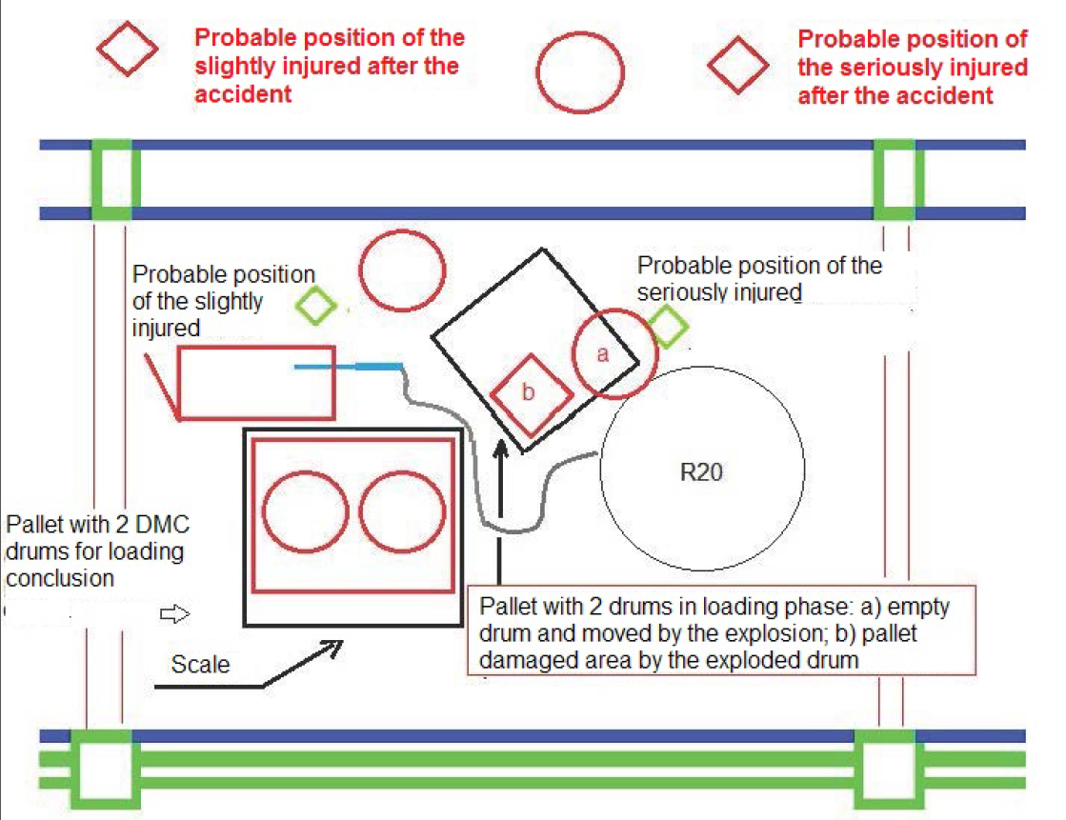
Figure 2: The probable situation during and after the event
  - Results
The technical and organizational factors related to the accidental causes, the consequences of the event, with a focus on the corrective actions in reference to the SMS issues, are described below, as they result from the application of the method referred to in section 2 of the paper.
    - Causes description
The cause of the fire triggering is reasonably to be found in the accumulation of electrostatic charges on the hose and nozzle, both in plastic material, following the repeated insertion and removal of these same in the drums (final phase of the loading operations). Such material is not compatible with the manipulation and handling of flammable substance (dielectric properties). In order to prevent discharges, the IEC 60079-32-1:2013 (IEC. 2013) standard forbids the use of insulating materials for flammable fluid transfer (Smallwood 2015). A couple of hoses made by conductive material were present at the unit, but, unfortunately, they were not in use at the accident time. Antistatic shoes were worn by the operators, but, unfortunately, their protective effect was nullified as the operator climbed onto a pellet to better suck the last drops of liquid from the drum.
The procedure for handling flammable, in force at the time of the event, had generic indications about chemical compatibility, grounding and bonding system and equipment to use, but, according to interviewed workers, there was a substantial shortcoming of training about the matter, which could be the main cause of the errors. As the accident happened at end of the night shift, the fatigue and the haste could have encouraged the choice of the metal plastic hose, much easier to handle.
    - Emergency response
At the time of the event there were in the area only the two operators involved in the accident.
In the early stages (within minutes) the shift supervisor and other department and laboratory workers, following the noise created by the event, rushed from the top floor and the ground floor. Laboratory workers have made some first aid.
The communications officer made the emergency call and alerted H&S Manager and other corporate executives. Ambulances, police, Fire Brigade, medical car arrived on the site.
After the events, the company's staff has completed the interrupted operations, with the approval of the present authorities, solely for the purpose of making safe the reactor.
    - Prevention and mitigation measures taken by the company
The company has quickly issued, as part of the SMS, a new version of the procedure for handling flammable with more detailed and more explicit information about: chemical compatibility of the loading equipment with the properties of the flammable products; grounding system of the containers for the reactor loading; correct and easy identification of specific equipment.
It has been studied by the company a new fixed type loading system of the flammable raw materials, in a closed cycle and/or in a nitrogen atmosphere, from the mobile containers, in order to remotise the possibility of unfitting operation.
The new procedure for handling of flammable raw material consists in basic standards of good practice, as:
- Using nozzles of stainless steel and conductive pipe that are chemically compatible with the specific loading raw materials
- Loading possibly from the foot valve of the container in order to avoid turbulence
- Do not exceed the loading speed of 100 l/min (av. speed of 1 m/s)
- Loading possibly by vacuum produced in the container in which the raw material loading is carried out
- Loading the raw material in exact order as described in the manufacturing process
- Checking the correct grounding system in case of conductive equipment (stainless steel nozzle and/or conductive pipe)
- Check regularly the electric continuity of the “nozzle + conductive pipe” equipment (electrical bonding) - every 6 months
- Do not climb on wooden pallets
- Keep the packed containers separated from each other
In the new procedure there are also tables with operational instructions and easy identification of equipment for compatibility, containers and loading instructions and charts of the equipment for the case of DMC loading.
    - Actions taken by the Competent Authorities in the short term
The Medical Prevention Department - Office of prevention and safety at the workplace, intervened at the scene (5.30 am) to rescue the injured, providing the prohibition on the use of the installation ending at 15.00 on the same day, to allow the making safe of the reactor. The day of the accident, it ordered the requisition of equipment in use at the time of the accident (drums, hoses and loading nozzle), and the remaining Personal Protective Equipment.
The Regional Fire Brigade, following the accident, charged a working group to acquire more information through “on site” inspection and documentation request to the company about: Accident circumstances; Hazardous substances; Accident consequences for human and environment; Emergency measures taken; Measures taken to limit the effects in the medium and long term and to avoid any recurrence.
An SMS inspection was conducted after the event to verify the suitability of the operator MAPP (Major Accident Prevention Policy) carrying out a planned and systematic examination of the systems being employed at the establishment, whether of a technical, organisational or managerial nature, including specific information about corrective actions taken by the operator in order to overcome the criticalities emerged as a result of the accident happened. In the following there are the findings of the inspection commission:
- Temporary Suspension of the DMC use within the site until the completion of evaluations relating to Quantitative Risk Analysis and the ending of the judiciary inquiry
- Implementation of the new procedure for the flammable handling, checking the development of “on site” training events through learning verification (SMS Inspection requirement)
- Obligation of grounding system for all containers and the periodic check of the equipment electrical continuity (Local Fire Brigade requirement)
- Replacement of all nozzles for the flammable transferring with loading nozzles of stainless steel and conductive pipe
- Medical interviews of the workers with psychologists of the department of clinical psychology hospital about Post-Traumatic Stress Disorder (PTSD)
  - Discussion
    - Control techniques and protection from accidental triggering due to electrostatic charges
In order to avert and/or avoid the negative effects deriving from the accumulation of electrostatic charges with the relative possible accidental ignition of vapors in the event of operations involving flammable substances, it is necessary that the work areas have own and suitable characteristics in order to ensure correct earthing of the entire area involved and of the operators. In addition to having static dissipative characteristics (Electro Static Dissipative - ESD), the floor or any covering or finish must guarantee correct earthing towards a prearranged and well-marked earth point (Earth Bonding Point - EBP).
Where a dissipative floor is available, it is therefore possible to equip the operator with antistatic PPE for grounding him during the normal course of work activities and duties. The PPE for operators, which may include shoes, gowns, gloves, jackets, etc., must be able to guarantee and/or complete the correct drainage towards a prearranged mass of the charges generated or accumulated by the human body in movement.
A further determining factor for electrical continuity between two bodies and therefore for effective and safe grounding is, as mentioned, "cleaning" and/or "routine maintenance". Where one already operates on high resistance values (> 108 Ωm), it is quite intuitive that, even if relatively small bodies are accidentally interposed, such as dust, processing residues, dirt or even unsuitable liquids are used for cleaning, the result effective continuity potential rises and in many cases the system goes from being a bad conductor to an effective insulator.
Finally, it is possible to provide a series of examples relating to the protection measures to be respected, depending on the work area, including some types of PPE - ESD: proceed with the earthing of conductive objects and devices; always wear suitable footwear on floors with a total electrical resistance of person to ground of no more than 108 Ωm; avoid materials and objects with low electrical conductivity, including plastic materials; decrease non-conductive surfaces; avoid ducts and conductive metal containers, coated within an electrical insulation, in the processes of transport and filling of substances/powders (USI. 2001).
    - Repercussions on the approach to corporate safety culture
Based on the above description of the accident, it can be assumed that the risk generated by the accumulation of electrostatic charges, during the loading/unloading/transfer operations of flammable products from small containers, and of substances in liquid form, has been underestimated by the site manager. In the risk analysis carried out for the plant, in fact, there were no such accident hypotheses and the consequent possible damage scenarios, although there was a series of conditions such as to generate a trigger and a consequent fire/explosion scenario, i.e. the load of flammable product, the accumulation of electrostatic charges as a trigger, etc. It is possible to hypothesize that this type of risk has not been estimated also in relation to the ease of execution and the repetitiveness of this type of operation, considering them to be of a "routine" type within the production economy of the production unit and therefore of the establishment. In this regard, it is necessary to remember that all the causes that may result in an unexpected event, from "near misses" to real accidents, must always be investigated by evaluating their impacts, including those considered not significant, characterized by a low probability of occurrence.
The poor training, the fatigue and the haste of the night shift, and the possible negligence represent the effects of an inadequately developed and implemented corporate safety culture. Any type of "shortcut", which could allow immediate savings in time and money, always involves unnecessary risks.
Problems and criticalities in the organizational vision of top management, in terms of safety culture, produce effects on the behaviour of workers, consequently emphasizing any operational error possibly linked to the human factor. The shift supervisor, the department head, the HSE managers and the top management, including the site manager, must always show their commitment to prevention and safety, by monitoring the correct implementation of specific risk activities. All workers, in turn, must demonstrate adequate knowledge of issues related to prevention and safety, acquired through active participation in the "training" programs provided in the establishment and the consequent use of correct work instructions (MAHB. 2015).
  - Conclusions
The paper, focusing on the inspection activities carried out following an accidental event that occurred at an Italian chemical establishment, has made it possible to learn some lessons, with the relative return of experience, about corporate safety culture, with reference to apparently minor events that could lead to major accidents. The event, originated in fact from situations attributable to the field of prevention and safety in the workplace, has evolved into a major accident, pursuant to the Seveso III directive:
- Ending of loading operation (4th drum, 15 lt. remaining): likely negligence and haste of the workers
- Wrong equipment (loading nozzle and hose in plastic material)
- High speed of loading in conjunction with the drum position (inclined)
- Minimum amount of a “Seveso” flammable substance involved in the event (10 kg.)
- Short duration of the event (10 min.)
- Limited area of impact (2 mt.)
- One seriously injured worker (1 death) and one slightly injured
The control of the risk induced by the accumulation of electrostatic charges, during the operations of transferring flammable products, must be implemented through specific management measures, and in particular: implementation of correct operating procedures, provided with adequate information regarding the chemical compatibility of the materials, the type of containers involved, the loading instructions; identification of specific tools and equipment, with particular reference to the loading system, grounding system, protective devices; detailed "training" activity, implemented through the management of "on-site" sessions with consequent learning verification; consideration of the need to use closed-loop transfer systems.
Finally, during the assessments carried out by the Competent Authorities and the inspections carried out on industrial establishments, it is important to pay attention to the technical and management systems put in place to prevent the specific risks of transferring flammable liquids from containers of small dimensions (drums, bags, IBCs, etc.), operations that are often the source of accidents in the industrial field. More generally, events with a low probability must certainly be included in the risk analysis, when the safety conditions are mainly based on the correct execution of procedures. The levels of reliability of the procedures, based on organizational and human factors, can never be considered so high as to exclude accident scenarios. It should in fact be emphasized that, since hazardous substances are involved, the events in question must be foreseen in the SMS, taking account of the overlaps with occupational safety management, according to current legislation - Legislative Decree 81/08 (GU. 2008) and, where present, voluntary standards including UNI ISO 450001:2018 (UNI. 2018).
References
ARIA. 2016. www.aria.developpement-durable.gouv.fr/
EU. 2012. Directive 2012/18/EU of the European Parliament and of the Council of 4 July 2012 on the control of major-accident hazards involving dangerous substances, amending and subsequently repealing Council Directive 96/82/EC Official Journal of the European Union 55 L197
EU. 2020. emars.jrc.ec.europa.eu/en/emars/content
GU 2008. DECRETO LEGISLATIVO 9 aprile 2008, n. 81 Attuazione dell'articolo 1 della legge 3 agosto 2007, n. 123, in materia di tutela della salute e della sicurezza nei luoghi di lavoro. (GU Serie Generale n.101 del 30-04-2008 - Suppl. Ordinario n. 108)
GU. 2015 DECRETO LEGISLATIVO 26 giugno 2015, n. 105 “Attuazione della direttiva 2012/18/UE relativa al controllo del pericolo di incidenti rilevanti connessi con sostanze pericolose”. (Gazz. Uff. 14 luglio 2015, n. 161, S.O.)
IEC. 2013 IEC TS 60079-32-1:2013 “Explosive atmospheres - Part 32-1: Electrostatic hazards, guidance”. Technical Specification. 2013-08-20
MAHB. 2015. Safety culture, leadership and enforcement: What does it mean for Seveso inspection? Lee Allford, Maureen Wood, Zsuzsanna Gyenes, Mark Hailwood. MAHB.EC-JRC
USI. 2001. Safety in hazardous Areas Working Group - Unione Sicurezza Informazione (USI): “Tecniche di controllo e protezione da innesco accidentale dovuto a cariche elettrostatiche”, Rev.2 del 2001-08-04
UNI. 2018. UNI ISO 45001:2018. Sistemi di gestione per la salute e sicurezza sul lavoro - Requisiti e guida per l'uso
Wood, M. 2018. Analysing accidents and lessons learned: You can’t improve what you don’t measure. Chemical Engineering Transactions. Vol. 67, # 150
Smallwood, J. 2015 The new standard on avoidance of electrostatic hazards Institution of Chemical Engineers Symposium Series 160 proceeding of Hazards 25 Edinburgh.

