CHEMICAL ENGINEERING TRANSACTIONS  VOL., 2023 | A publication of
The Italian Association
of Chemical Engineering
Online at www.cetjournal.it
Guest Editors:
Copyright © 2023, AIDIC Servizi S.r.l.
ISBN ; ISSN 2283-9216

Biomethane Compression Unit: a Methodological Approach Aimed at Decreasing the Atex Zones Hazardousness
Roberto Lauriª
ªInail, Department of Technological Innovations and Safety of Plants, Products and Human Settlements, Via del Torraccio di Torrenova 7, 00133 Rome, Italy
r.lauri@inail.it
The smart combination of renewable energy sources will be fundamental for developing the energy systems of the future and achieving carbon-neutrality by 2050. Biomethane, produced by biogas upgrading, is a renewable alternative to natural gas and it is able to decrease the greenhouse gas (GHG) emissions in multiple sectors. Indeed, this gaseous biofuel can be used in applications such as heating, transport and electric energy generation, since it has the same properties as natural gas. It can be directly injected into the existing gas network as a low-carbon alternative to natural gas. The strategic biomethane role determines a particular attention to potential hazards associated with its production. In particular, one of the main hazards is the possible formation of potentially explosive atmospheres due to accidental releases from components, such as valves, compressors, flanges, etc. The biomethane compression is the most hazardous phase of its production process, because it occurs in an indoor place (compression unit) and it is characterized by the highest pressure values. The paper is focused on biomethane compression unit and it illustrates a methodological approach aimed at decreasing the Atex zones hazardousness.

  - Introduction
The European Commission estimates that 350 TWh or 33 billion cubic meters of biomethane could be produced per year in 2030, which equal around 10% of the projected European Union natural gas use (Alberici et al., 2021). This biofuel quantity would save about 110 Mt CO₂ emissions or around 6% of the required effort to achieve 55% GHG reduction. The biomethane production and deployment offer significant greenhouse gas savings and have positive impacts on rural employment. In Europe, there is a significant potential to scale up the production of sustainable biomethane in the next years. This can simultaneously offer environmental and social benefits. Nowadays, this gaseous biofuel is not available in large quantities and needs to be rapidly scaled up to exploit its full potential. Besides technical innovations, this requires a more liquid european biomethane market and that stakeholders are incentivized to produce and trade this biofuel in the most optimal way. About 90% of globally produced biomethane is generated by the anaerobic digestion (Rafiee et al., 2021), followed by different upgrading treatments. Production alternatives include thermal and hydrothermal gasification.
Today, the average digester in Europe has a biogas production capacity of 290 Nm³/h, although large variations exist in several countries. It would be feasible and cost-efficient to increase the new digesters capacity to at least 500 Nm³/h, preferably even larger (Pavicic et al., 2022). This can be achieved by national support schemes, which can also encourage economies of scale, for example by not providing premiums for small scale biogas plants. This scenario requires a particular attention to the potential hazards associated with biomethane production. One of the main hazards is the possible formation of potentially explosive atmospheres due to accidental biofuel releases from components, such as flanges, valves, compressors, etc. In appropriate ratios, the mixture of air and biomethane has explosive properties (Travnicek and Kotek, 2015). In particular, the biomethane compression is the most hazardous phase of its production process, because it occurs in an indoor place (compression unit) and it is characterized by the maximum pressure values, which can exceed 70-80 bar. Therefore, the choice of operating parameters (air velocity and flow) of the forced ventilation system becomes extremely important for diluting the explosive mixture, decreasing the Atex zones hazardousness and their persistence time. The paper illustrates a methodological approach aimed at the optimization of the dilution degree of biomethane compression unit. This optimization depends on minimum air velocity, which has to be ensured by the artificial ventilation system. The dilution degree is one of parameters required by International Standard IEC EN 60079-10-1 for classifying the zone (hazardous or non-hazardous) generated by a potential release source and its optimization can make the Atex zones less hazardous. This parameter is a ventilation efficiency measure to dilute a flammable gas (or mixture) release to a safe level. The best condition is characterized by gaseous biofuel concentrations (in air), which are below its lower flammability limit (Nguemna et al., 2022).
  - Material and Methods
The proposed approach is based on International Standard IEC EN 60079-10-1, which is used to classify the areas (Atex zones), where a potentially explosive mixture could form. The zones classification (Table 1) depends on three following parameters (IEC, 2021):
- source release grade (continuous, primary or secondary);
- dilution degree (high, medium or low);
- ventilation availability (good, fair or poor).

Table 1: Classification of hazardous zones due to potentially explosive atmospheres (IEC EN 60079-10-1)
 | Dilution degree
Release Grade
 | High |  |  | Medium |  |  | Low
 | Ventilation availability
 | Good | Fair | Poor | Good | Fair | Poor |  | Good, fair or poor
continuous | (Zone 0 NE)ª Non hazardous | (Zone 0 NE)ª  Zone 2 | (Zone 0 NE)ª  Zone 1 | Zone 0 | Zone 0  +  Zone 2 | Zone 0  +  Zone 1 |  | Zone 0
primary | (Zone 1 NE)ª  Non hazardous | (Zone 1 NE)ª  Zone 2 | (Zone 1 NE) ª  Zone 2 | Zone 1 | Zone 1  +  Zone 2 | Zone 1  +  Zone 2 |  | Zone 1 or Zone 0^{b}
secondary | (Zone 2 NE)ª  Non hazardous | (Zone 2 NE)ª  Non hazardous | Zone 2 | Zone 2 | Zone 2 | Zone 2 |  | Zone 1 or Zone 0^{b}
Glossary
“+” means “surrounded by”.
ªZone 0 NE, 1 NE and 2 NE indicate areas, which have negligible extents.
^{b} Zone 0 can be generated in poor states of ventilation.

The first parameter is determined by the analysis of components (valves, flanges, compressors, etc.) operating conditions, whereas the others mainly depend on natural ventilation (outdoor places) or forced ventilation (indoor places). The dilution degree is determined (IEC, 2021) by the diagram (Figure 1) reported in the mentioned Standard. The approach goal is the detection of minimum ventilation velocity (u_{w}), which is able to achieve the best dilution degree for the examined case study. In the paper, the attention is focused on the biomethane compression unit. In order to determine u_{w}, the volumetric release characteristic (Q_{c}) has to be calculated. This parameter is expressed by the following equation (IEC, 2021):
Where:
- W_{g} (kg/s) is the overall mass flow of flammable compound (biomethane);
- ρ_{g} (kg/m³) indicates the gas or vapour density (the parameter is linked to ambient pressure and temperature) and it is calculated by the ideal gas law;
- LFL (4 % v/v) is the lower flammability limit of biomethane.
In case of gaseous release, W_{g} depends on flow conditions (sonic or subsonic), which are determined by the following equations (Casal, 2018):
Where:
- p_{in} (Pa) is the pressure inside the vessel or component;
- p_{atm} (101325 Pa) indicates the atmospheric pressure;
- γ (dimensionless parameter) = c_{p}/c_{v} (heat capacities ratio).
The heat capacities ratio depends on temperature and it can be calculated by the Langen equations:

With reference to methane, the values of a, a’ and b are shown in table 2.

Table 2: Langen parameters
a (J/kg K) | a’ (J/kg K) | b (J/kg K²)
1,710 | 1,210 | 0.276

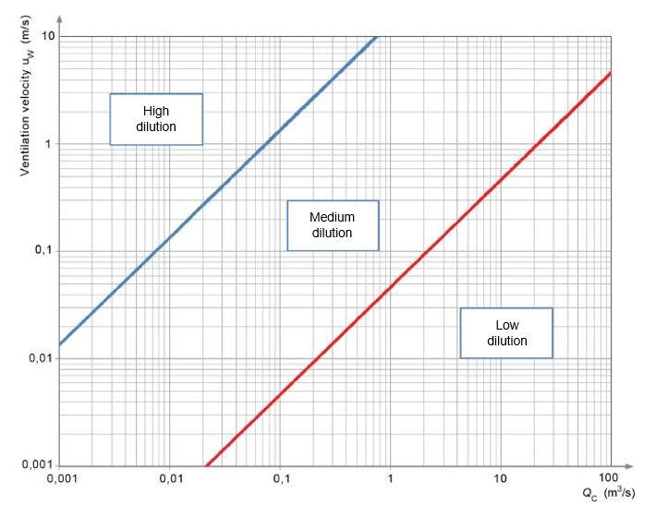
Figure 1: Dilution degree assessment (IEC EN 60079-10-1)

In indoor places, such as the compression unit, W_{g} depends on mass flows (M_{i}) released by the potential sources included in the building. M_{i} is calculated by the following equations (Lauri, 2022):
Where:
- A (m²) is the hole area;
- C_{d} indicates the discharge coefficient (dimensionless parameter), which is lower than 1;
- PM_{b} (16 kg/kmol) is the molecular weight of biomethane;
- Z (dimensionless parameter) is the compressibility factor;
- R (8,314 J/kmol K) is the universal gas constant;
- T represents the biofuel release temperature (K).

  - Biomethane compression unit
In the biomethane production plants, the compression unit (Figure 2) increases the biofuel pressure, which depends on intended purpose. Indeed, in case of biomethane injection into the natural gas network, the pressure can usually vary from 40 bar to 80 bar, whereas, in case of compressed natural gas (CNG) production, it is about 220-230 bar. A typical compression unit is composed by:
- compressor;
- anti-explosive electric motor;
- cooling unit;
- connection pipeline;
- control valves;
- safety valves;
- blow-down valve;
- control cabinet.

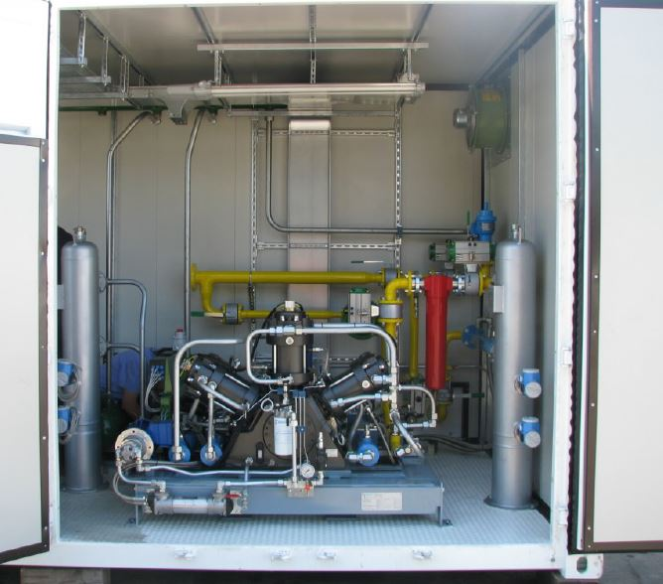

Figure 2: Biomethane compression unit

Multi-stage reciprocating compressors are generally used to increase the biofuel pressure. On multi-stage machines, intercoolers are usually provided between stages. They are heat exchangers, which remove the compression heat from the gas and reduce its temperature to value existing at the compressor intake. With reference to these compressors, the leak is the main source of inefficiency (Matsumura et al., 1992) and it can become dangerous in case of flammable gases releases. Areas of high leak frequency from reciprocating compressors include flanges, valves and fittings located on compressors (Zimmerle et al., 2015). However, the highest volume of gas loss is associated with piston rod packing systems and blowdown open-ended lines (Gas Processors Suppliers Association, 2004). The reciprocating compressor is equipped with safety valves aimed at limiting the discharge and inter-stage pressure and ensuring a safe machine operating. The safety valves (SV) are set to open at pressures, which are slightly higher than the normal discharge pressure of the compressor. With reference to classification of Atex zones, the compressor can be considered as a source of secondary grade (the emission is not expected during the normal operating or release duration would be extremely short) release, whereas the safety valves are sources of primary grade release, because their emission can occasionally occur during the operating. The compression unit is a complex engineering system, which can be affected by failures of several components (flanges, control valve, compressor, etc.), which can generate uncontrolled biomethane releases. Leaks from flanges are due to the gaskets, whereas those from control valves are due to the stem packing. Regarding the possible formation of Atex zones in the compression unit, the forced ventilation system is extremely important, because it has three basic functions:
- the prevention of explosive mixture formation;
- the zone extent decrease;
3) the shortening of explosive atmosphere persistence time.

  - Results and discussion
In indoor places, such as the compression unit, in order to detect the minimum ventilation velocity, which is able to achieve the best dilution degree, the worst scenario has to be examined. This is due to maximum biomethane emission from secondary grade source. In particular, the largest mass flow depends on the maximum biofuel pressure. In the compression unit, there are several potential sources (pressure and flow control valves, flanges, compressor, etc.) of secondary grade, but only the largest has to be considered, because the emission from the secondary grade source is not expected during the normal operating or its duration is extremely short. Therefore, the simultaneous emission from the secondary grade sources is extremely unlikely. Components, which release biomethane because of wrong maintenance or catastrophic failure, are not considered potential emission sources.
As reported in IEC EN 60079-10-1, the overall secondary release is the largest individual secondary release combined with the overall primary release (IEC, 2021), which is given by the sum of the individual primary releases (M_{i primary release}) combined with the overall continuous release (M_{i continuous release}):
The methodological approach is composed by the following phases (Figure 3):
- to individuate all the potential sources of biomethane release and their emission degree (table 3);
- to consider the worst scenario (under the same conditions, reported in equations 6 and 7, it is due to the maximum biofuel pressure);
- to assess the biomethane flow conditions (equations 2 or 3);
- to calculate the mass flows released from all potential sources (equations 6 or 7);
- to individuate the secondary grade source, which releases the maximum mass flow;
- to apply the equation 8 (IEC, 2021), referred to indoor places, for calculating W_{g};
- to calculate ρ_{g} by the ideal gas law;
- to calculate Q_{c} (equation 1);
- to use the diagram, reported in Figure 1, for detecting the minimum u_{w}, which has to be ensured by the forced ventilation system for achieving the best dilution degree.
The dilution degree is obtained as a function of Q_{c}. Indeed, in order to find the minimum u_{w}, it is sufficient to draw a vertical line (Figure 1) from the calculated value of volumetric release characteristic. The dilution degree is successively given by the intersection of values displayed on abscisses and ordinates axis.

Table 3: Biomethane release sources (compression unit)
Release sources |  | Emission grade | Flow (sonic or subsonic) |  | M_{i} (kg/s)
control valve  flange |  | secondary  secondary | ………………………  ……………………… |  | ………  ………
safety valve |  | primary | ……………………… |  | ………
compressor |  | secondary | ……………………… |  | ………
……………. |  | ………….. | ……………………… |  | ………

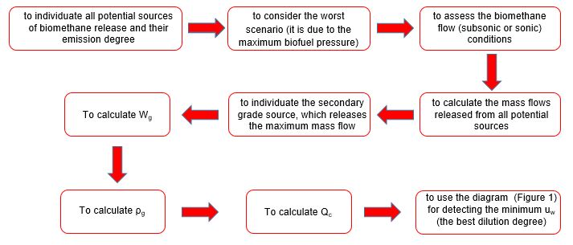
Figure 3: Methodological approach phases
In case of gaseous biofuel release, the minimum ventilation velocity has to be ensured, whereas, in leaks absence, u_{w} has to comply with UNI EN ISO 7730. The methodological approach goal is aimed at avoiding the low dilution, which could generate hazardous scenarios (the air and biomethane cloud could be ignited) due to the significant concentration of potentially explosive atmosphere or to its lasting persistence after the release is stopped. However, the high dilution is not always obtainable, because it depends on emission sources number and biomethane pressure and temperature (these last two parameters influence M_{i}). In particular, the most critical scenarios are due to biomethane injection into first class pipeline (its operating pressure is higher than 24 bar) or to CNG production (the biofuel pressure is about 220-230 bar). This approach can be particularly useful, because it can be used during the early stage of design of an artificial ventilation system for defining the minimum air velocity or during its operating for adjusting this parameter. With reference to Table 1 application, the dilution degree optimization can decrease the Atex zones hazardousness and ensure a safer operating of the compression unit. Indeed, the areas hazardousness decreases from zone 0 to zone 2.

  - Conclusions
Biomethane is a storable and flexible energy source with a high greenhouse gas saving potential and it has the ability to generate negative emissions. Furthermore, this gaseous biofuel can be transported through existing gas infrastructure. With reference to these properties, it becomes an appealing fuel in order to achieve a climate neutral energy system. The coming increase of the number of biomethane production plants requires a specific attention to potential hazards associated with their operating. One of the main hazards is the possible formation of potentially explosive atmospheres in indoor places, such as the compression unit, where the correct choice of operating parameters (air velocity and flow) of forced ventilation system is fundamental for preventing the explosive mixtures formation or decreasing the Atex zones hazardousness. The proposed approach is aimed at the dilution degree optimization, which could avoid the low dilution into the biomethane compression unit. Indeed, this condition could generate dangerous scenarios due to the high concentration of potentially explosive atmosphere (air/biomethane) or to its excessive persistence time after the release is stopped. The biomethane production pressure is the key parameter for the method application, because it strongly influences the mass flows released by the potential sources included in the compression unit. The next step could be represented by the use of specific software, which is able to study the biomethane release from the compression unit components (flanges, valves, etc.). This solution could improve the W_{g} calculation accuracy and therefore the u_{w} detection could become more rigorous. The methodological approach has the advantage that it can be applied both to the ventilation system design stage and during its operating for adjusting the minimum ventilation velocity.

References
Alberici S., Moultak M., Peters J., 2021, Gas for Climate: the Future Role of Biomethane, Guidehouse, Utrecht, The Netherlands.
Casal J., 2018, Evaluation of the Effects and Consequences of Major Accidents in Industrial Plants, Elsevier, Eastbourne, UK.
Gas Processors Suppliers Association (Ed), 2004, Engineering Data Book, Gas Processors Suppliers Association, Tulsa, USA.
IEC (Ed), 2021, IEC EN 60079-10-1: Classification of Areas-Explosive Gas Atmospheres, IEC, Geneva, Switzerland.
Lauri R., 2022, Biomethane production: pressure Influence on classification of Atex zones, Chemical Engineering Transactions, 91, 73-78.
Matsumura M., Kato M., Hirata T., 1992, Behavior and Analysis of Reciprocating Compressor Valve, Kobelco Technology Review, 14, 20-24.
Nguemna L., Lauri R., Incocciati E., Pietrangeli B., Majone M., Micolucci F., Gottardo M., Valentino F., 2022, Acidogenic fermentation of food waste and sewage sludge mixture: effect of operating parameters on process performance and safety aspects, Process Safety and Environmental Protection, 163, 158-166.
Pavicic J., Mavar K., Brkic V., Simon K., 2022, Biogas and biomethane production and usage: technology development, advantages and challenges in Europe, Energies, 15, 2940-2968.
Rafiee A., Khalilpour K.R., Prest J., Skryabin I., 2021, Biogas as an Energy Vector, Biomass and Bioenergy, 144, 1-20.
Travnicek P., Kotek L., 2015, Risks associated with the production of biogas in Europe, Process Safety Progress, 34, 172–178.
Zimmerle D.J., Williams L., Vaughn T.L., Quinn C., Subramanian R., Duggan G.P., Willson B., Opsomer J.D., Marchese A.J., Martinez D.M., Robinson A.L., 2015, Methane Emissions from the Natural Gas Transmission and Storage System in the United States, Environmental Science and Technology, 49, 9374-9383.

